SMART STORE MANAGEMENT SYSTEM (STOREMANAGER)

Course: Data Structures and Algorithms (CSD201)
Semester: FA2026

STUDENT INFORMATION
Field | Details
Full Name | Lê Tiến Minh-SE203487
Full Name | Nguyễn Đức Anh-SE203469
Instructor | NguHCV / FPT University
Report Number | Report 1
Class | SE2027
Project Topic | Store Management System

REPORT 1 — Case Study Analysis & Problem Decomposition
Objective: Perform case study analysis focused on a specific data structure problem. Apply Computational Thinking tools (Decomposition, Pattern Recognition) and formulate a Research Question.

1.1 Case Study Overview
Project Title: Smart Store Management System (StoreManager).
Problem Statement:
Các siêu thị hiện đại xử lý hàng chục nghìn mặt hàng (SKU) và phục vụ hàng trăm khách xếp hàng vào giờ cao điểm. Việc tìm kiếm giá sản phẩm bằng mảng duyệt tuyến tính ($O\left(n\right)$) gây tắc nghẽn quầy thu ngân. Thử thách cốt lõi là thiết kế hệ thống có tra cứu barcode trong thời gian $O\left(\log{n}\right)$và điều phối hàng chờ $O\left(1\right)$.
Scope of the System:
- Quản lý kho hàng & tồn kho
- Quét barcode tra cứu giá
- Hàng chờ thường FIFO
- Làn ưu tiên khách VIP Max-Heap
- Tính tiền, chiết khấu và in hóa đơn.
1.2 Decomposition — Breaking Down the System
Apply Decomposition to identify core data structures and functional modules within the system.
1.2.1 Core Data Structures Identified
Module | Data Structure Used | Justification
Product Search / Barcode Scanner | Binary Search Tree (BST) | Enables O(log n) average-case key lookup by productId. Drastically reduces search latency compared to an O(n) linear scan when the catalog exceeds 10,000 items.
Inventory Catalog Storage | Doubly Linked List (DLL) | Provides flexible dynamic memory allocation without fixed-capacity array overhead. Supports O(1) insertion at head/tail and bidirectional forward/backward catalog traversal.
General Checkout Line | Queue (FIFO) | Strictly guarantees first-in, first-out order for fair customer service. Enqueue and dequeue both run in constant time O(1).
VIP Customer Priority Line | Binary Max-Heap | Keeps the highest-priority customer at the root (O(log n) enqueue/dequeue). Automatically serves VIP/Gold members before regular customers.

1.2.2 Functional Modules Breakdown
List all functional modules of your system:
- Module 1 — Inventory Management Module: Responsible for stocking products, modifying prices, managing stock quantities, and warning when inventory falls below minimum safety thresholds.
- Module 2 — Barcode Scanner & Search Module: Indexes products into the Binary Search Tree and executes sub-linear search queries using product ID keys.
- Module 3 — Checkout & Queueing Module: Routes arriving shoppers into either the normal FIFO queue or the VIP Max-Heap priority queue, and manages cashier service dispatching.
- Module 4 — Cashier & Billing Module: Dequeues customers, scans cart items against the BST, updates inventory stock, applies membership discounts, and prints structured receipts.
- Module 5 — Analytics & Performance Module: Logs completed invoices, calculates gross and net revenue, and benchmarks algorithm execution times.

1.3 Pattern Recognition
Identify recurring data organization patterns applicable to your system.
Patterns Identified:
Pattern | Description | Applied Where in System
Binary Search Tree Lookup | O(log n) divide-and-conquer retrieval by key | Quét barcode mã sản phẩm tại quầy thu ngân (ProductBST.search)
FIFO Queue Processing | First-in, first-out sequential order | Làn xếp hàng thanh toán thông thường (CheckoutQueueFIFO)
Priority Queue (Heap) | Highest-priority element retrieved first | Làn thanh toán ưu tiên dành cho hội viên VIP (VIPCustomerHeap)
Bidirectional Traversal | Forward and backward list iteration | Duyệt kiểm kê danh mục kho hàng (InventoryLinkedList)

Justification:
These patterns directly mirror the physical operations of a supermarket. The BST prevents the POS register from freezing during price lookups (O(log n) instead of O(n)), the FIFO queue prevents queue jumping and keeps service fair, and the Max-Heap enables loyalty-tier differentiation with only O(log n) overhead per customer. The main trade-off is that a plain BST can degrade to O(n) on skewed input, whereas a linked list is simpler but always linear.

1.4 Flowchart & Mind Map
1.4.1 System Mind Map
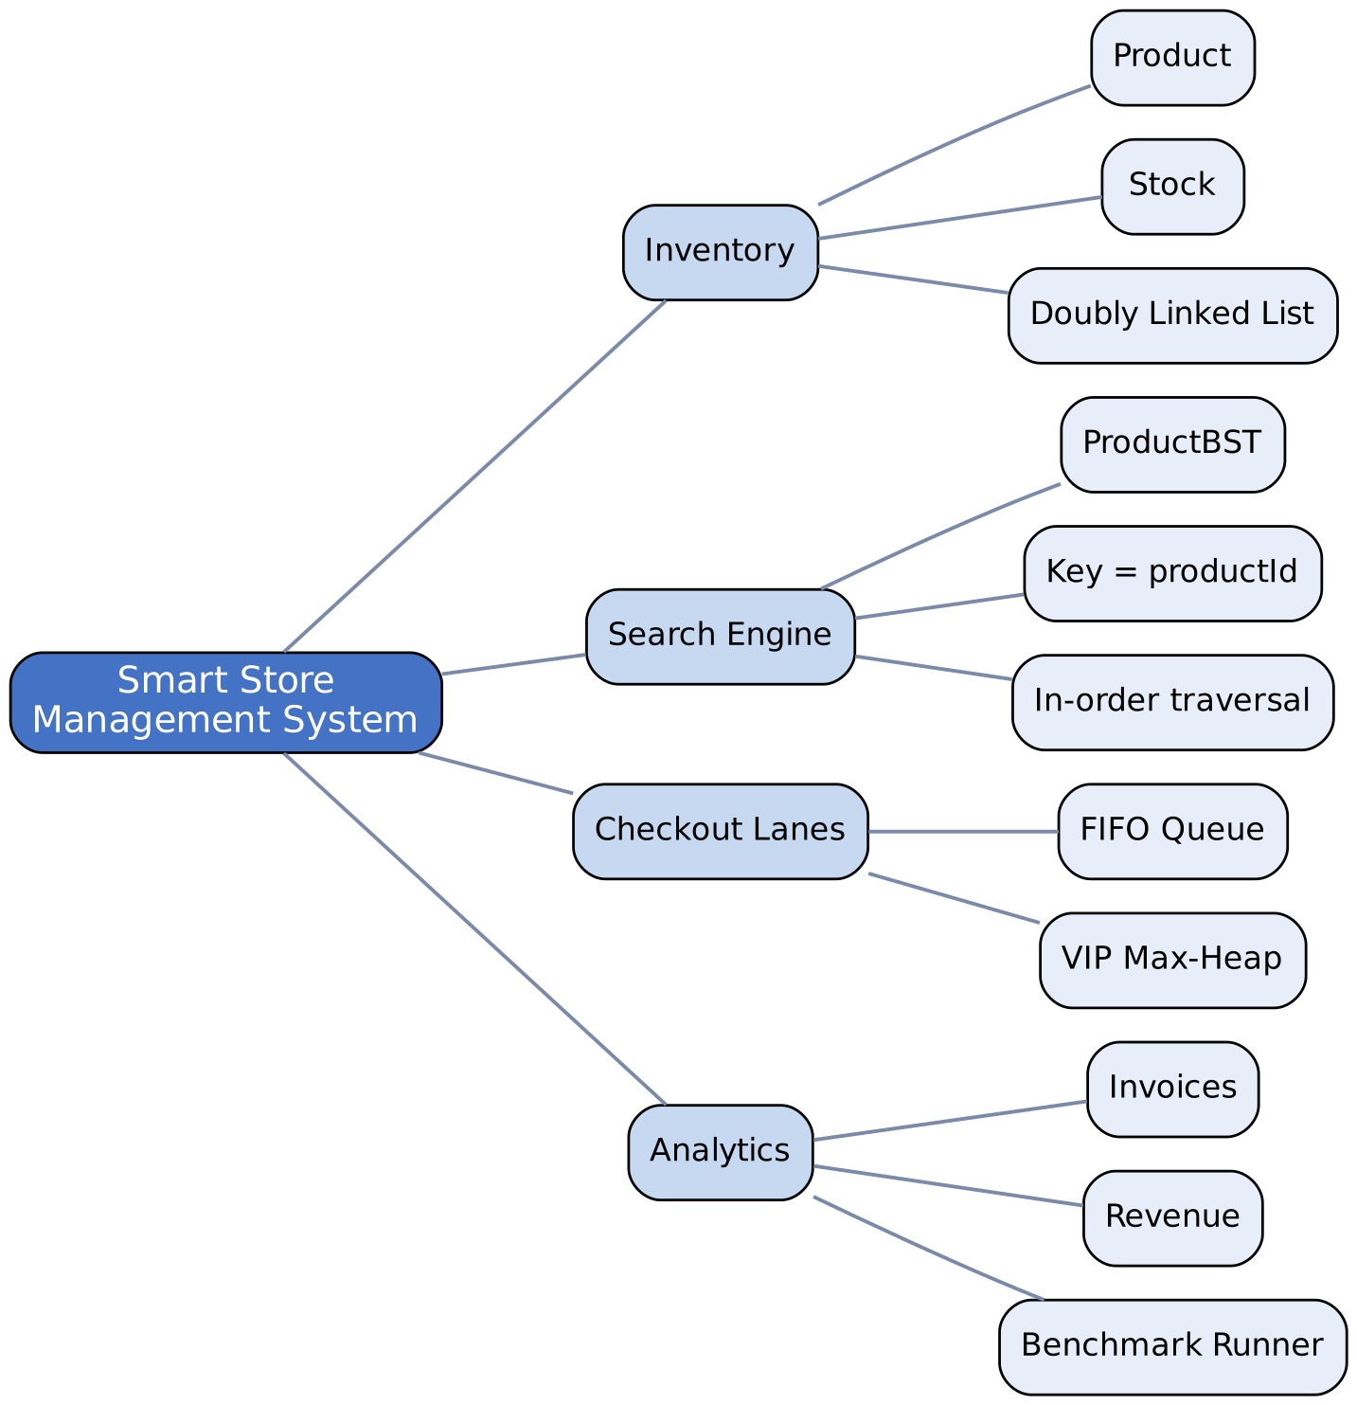
Caption: Mind map visualizing the main components and relationships of the Smart Store Management System (StoreManager).
1.4.2 Initial Logic Flowchart
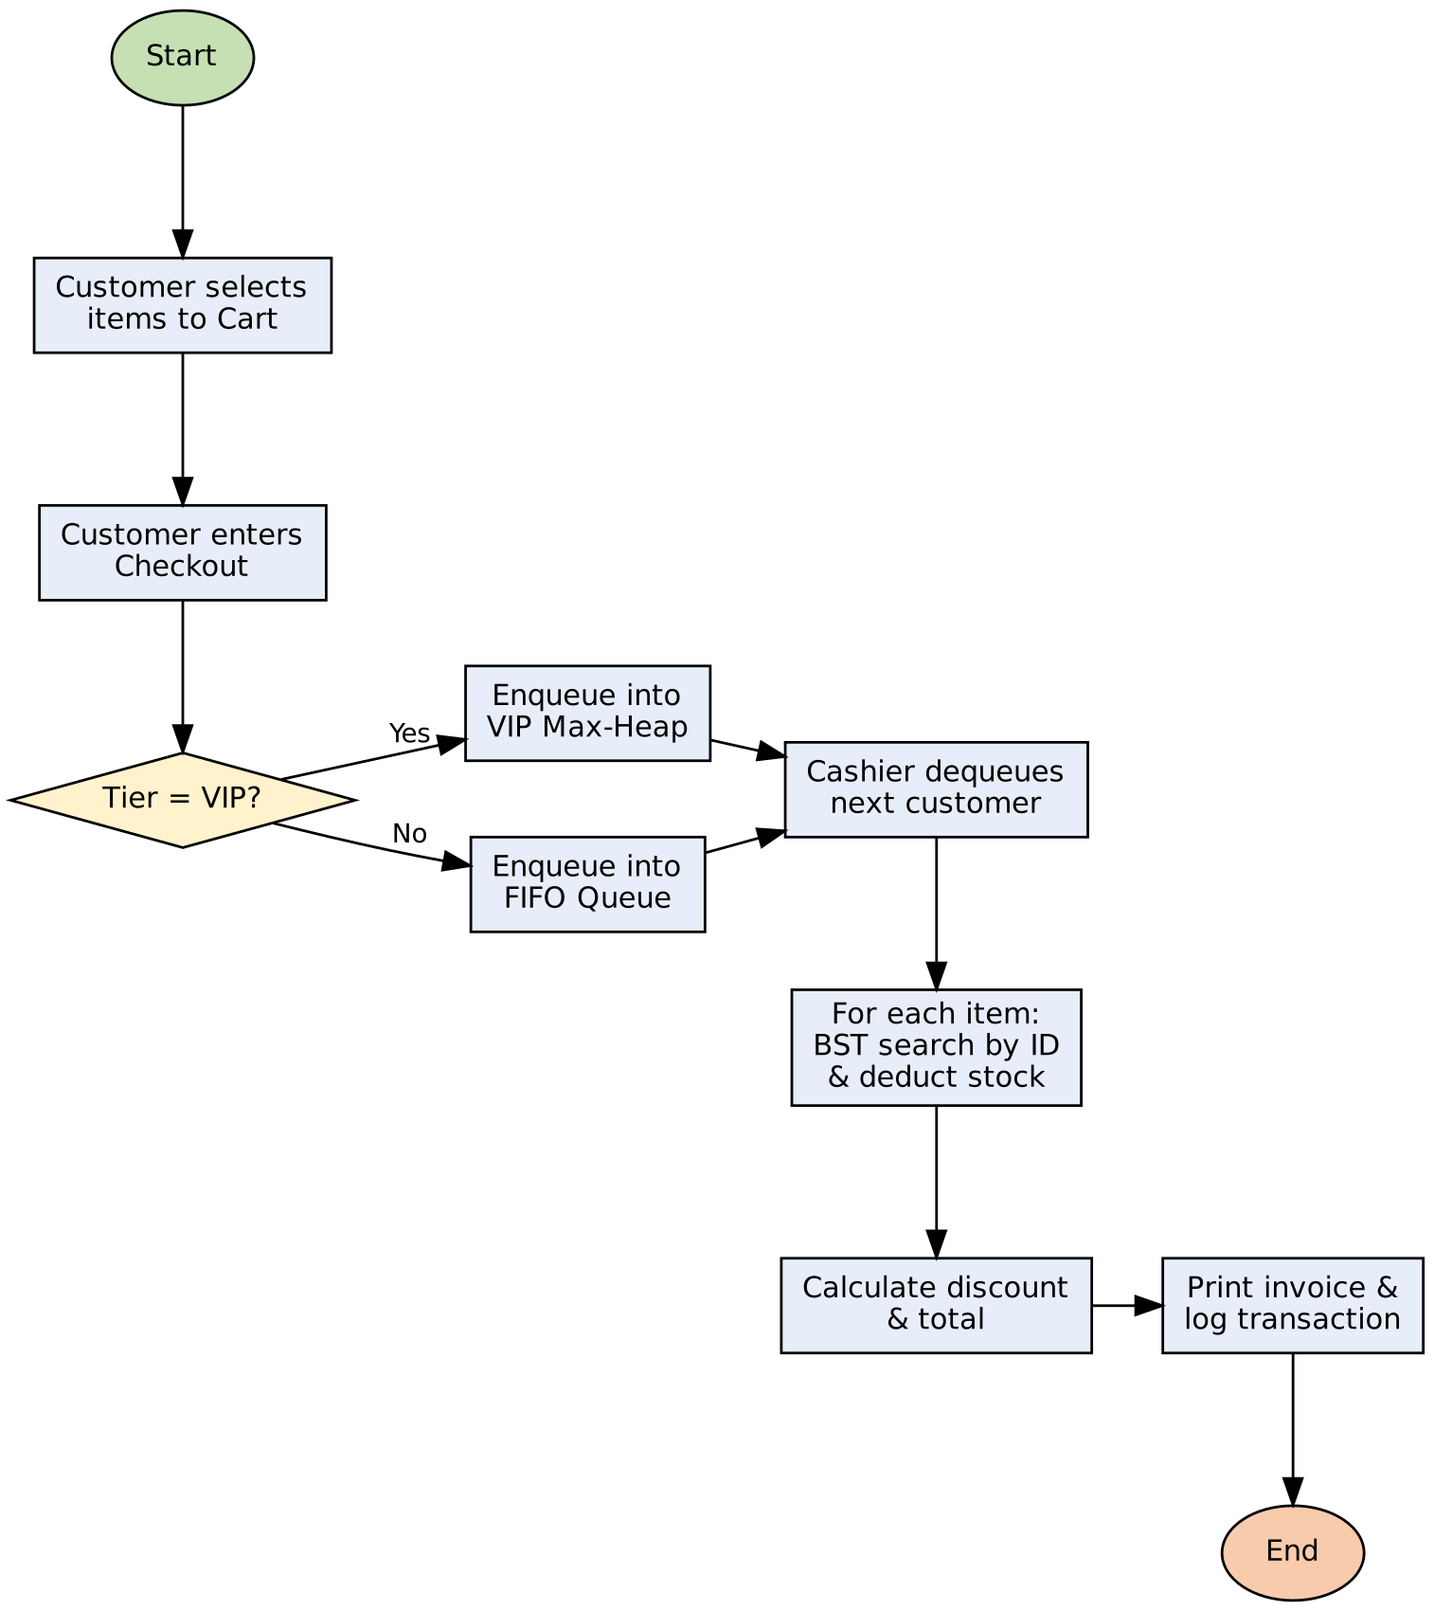
Caption: Flowchart depicting the customer checkout logic flow (queue selection, BST lookup, billing).

1.5 Research Question (RQ)
Formulated Research Question:
"How does the integration of a Binary Search Tree (BST) for barcode lookup and a Binary Max-Heap for customer queueing affect search latency and queue throughput compared to linear linked-list structures in retail store management systems scaling up to N = 30,000 products?"
Why this RQ matters:
In real-time retail systems, cashier response times directly determine customer checkout throughput. Evaluating theoretical Big-O complexity against empirical wall-clock measurements shows whether hierarchical tree structures provide a justifiable performance advantage over simpler linear collections at large dataset scale.

