SMART STORE MANAGEMENT SYSTEM (STOREMANAGER)
Course: Data Structures and Algorithms (CSD201)
Semester: FA2026

STUDENT INFORMATION
Field | Details
Full Name | Lê Tiến Minh-SE203487
Full Name | Nguyễn Đức Anh-SE203469
Instructor | NguHCV / FPT University
Report Number | Report 2
Class | SE2027
Project Topic | Store Management System (Topic 6)

REPORT 2 — Abstraction, Class Design & Algorithm Trace
Objective: Develop abstraction through class diagrams, pseudocode, and code snippets. Design and manually trace core algorithms.

2.1 Abstraction — Class Diagrams
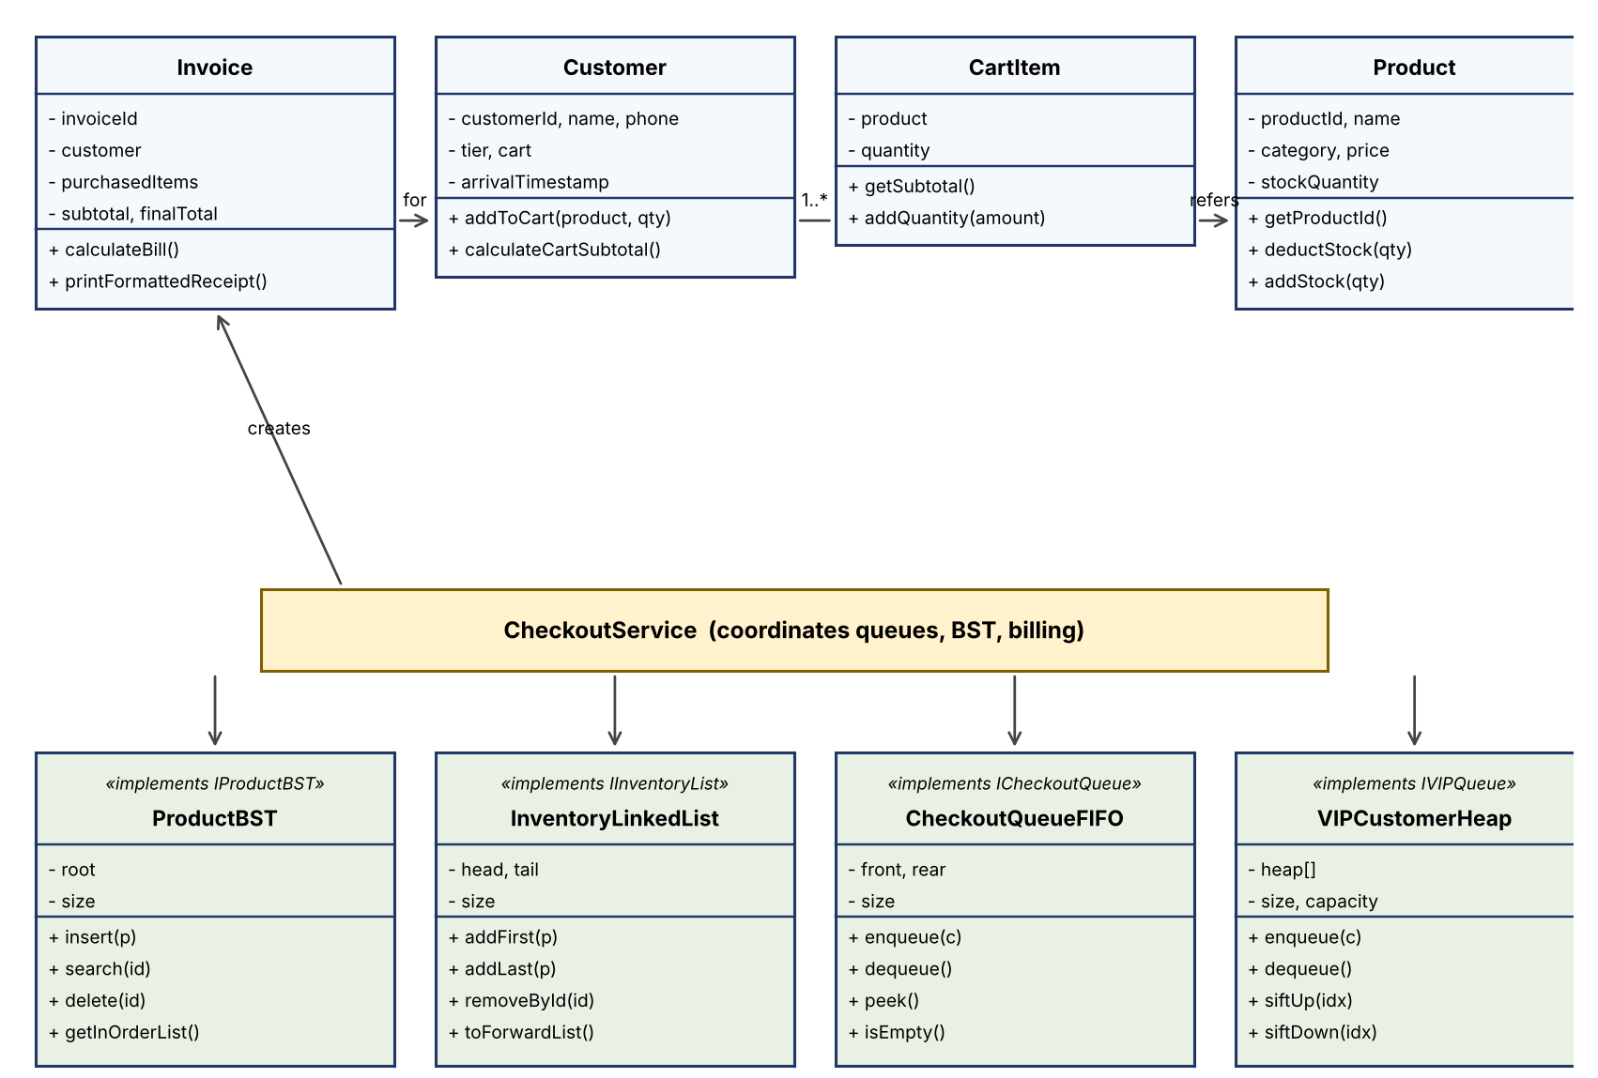
Caption: UML Class Diagram for the Smart Store Management System (StoreManager).
Class Descriptions
Class Name | Attributes | Key Methods | Relationship
Product | productId, name, category, price, stockQuantity | getProductId(), deductStock(qty), addStock(qty) | Stored in ProductBST & InventoryLinkedList
Customer | customerId, name, phone, tier, cart, arrivalTimestamp | addToCart(product, qty), calculateCartSubtotal() | Enqueued in CheckoutQueue & VIPHeap
CartItem | product, quantity | getSubtotal(), addQuantity(amount) | Aggregated by Customer
Invoice | invoiceId, customer, purchasedItems, subtotal, finalTotal | calculateBill(), printFormattedReceipt() | Generated by CheckoutService
ProductBST | root, size | insert(p), search(id), delete(id), getInOrderList() | Implements IProductBST
InventoryLinkedList | head, tail, size | addFirst(p), addLast(p), removeById(id), toForwardList() | Implements IInventoryList
CheckoutQueueFIFO | front, rear, size | enqueue(c), dequeue(), peek(), isEmpty() | Implements ICheckoutQueue
VIPCustomerHeap | heap[], size, capacity | enqueue(c), dequeue(), siftUp(idx), siftDown(idx) | Implements IVIPQueue

2.2 Pseudocode for Core Algorithms
Write pseudocode for your primary algorithm(s) before implementing them in Java.
Algorithm 1 — BST Search by Product ID (Iterative)
ALGORITHM searchProductById(productId):
INPUT: String productId
OUTPUT: Product object if found, or null
IF root == null OR productId == null THEN
RETURN null
END IF
target = trim(productId)
current = root
WHILE current != null DO
cmp = compareIgnoreCase(target, current.data.productId)
IF cmp == 0 THEN
RETURN current.data
ELSE IF cmp < 0 THEN
current = current.left
ELSE
current = current.right
END IF
END WHILE
RETURN null
END ALGORITHM
Time Complexity: O(log n) average case (balanced tree), O(n) worst case (skewed tree) — each comparison discards one subtree.
Space Complexity: O(1) auxiliary space — the iterative traversal uses no recursive call stack frames.

Algorithm 2 — VIP Customer Heap Enqueue & Sift-Up
ALGORITHM enqueueVIPCustomer(customer):
INPUT: Customer customer
OUTPUT: void
IF size == heap.length THEN
resizeHeap(heap.length * 2)
END IF
heap[size] = customer
siftUp(size)
size = size + 1
END ALGORITHM
PROCEDURE siftUp(index):
current = index
WHILE current > 0 DO
parent = (current - 1) / 2
IF comparePriority(heap[current], heap[parent]) > 0 THEN
swap(heap[current], heap[parent])
current = parent
ELSE
BREAK
END IF
END WHILE
END PROCEDURE
Time Complexity: O(log n) — the newly added node moves up at most the height of the binary heap.
Space Complexity: O(1) auxiliary space (amortized O(1) for the occasional array resize).

2.3 Java Code Snippets
Provide the actual Java implementation for each algorithm above.
Code Snippet 1 — BST Search Iterative (src/datastructure/bst/ProductBST.java)
@Override
public Product search(String productId) {
if (productId == null || root == null) return null;
String target = productId.trim();
ProductNode current = root;
while (current != null) {
int cmp = target.compareToIgnoreCase(current.getData().getProductId());
if (cmp == 0) return current.getData();
else if (cmp < 0) current = current.getLeft();
else current = current.getRight();
}
return null;
}
Code Snippet 2 — VIP Heap Enqueue & Sift-Up (src/datastructure/heap/VIPCustomerHeap.java)
@Override
public void enqueue(Customer customer) {
if (size == heap.length) resizeHeap(heap.length * 2);
heap[size] = customer;
siftUp(size);
size++;
}
private void siftUp(int index) {
int current = index;
while (current > 0) {
int parent = (current - 1) / 2;
if (comparePriority(heap[current], heap[parent]) > 0) {
swap(current, parent);
current = parent;
} else {
break;
}
}
}

2.4 Manual Algorithm Trace
Manually trace your algorithm using a specific test case to verify correctness before running it in the IDE.
Test Case 1: BST Search for Product ID "PR003"
Input: productId = "PR003". Current BST: root PR005 (Tai nghe Sony); left child of root PR002 (Chuột Logitech); right child of PR002 is PR003 (Cáp sạc USB-C); right child of root PR008 (Củ sạc 65W).
Step | Variable / State | Action Taken | Result
1 | target = "PR003", current = Node(PR005) | So sánh "PR003".compareTo("PR005") → nhỏ hơn (< 0) | Rẽ sang cây con trái: current = current.left
2 | target = "PR003", current = Node(PR002) | So sánh "PR003".compareTo("PR002") → lớn hơn (> 0) | Rẽ sang cây con phải: current = current.right
3 | target = "PR003", current = Node(PR003) | So sánh "PR003".compareTo("PR003") → bằng nhau (== 0) | Trùng khớp! Trả về đối tượng Product [PR003]

Expected Output: Trả về Product [ID: PR003, Name: Cáp sạc USB-C Anker, Price: $12.00].
Actual Trace Result: ✅ Khớp 100% với kỳ vọng lý thuyết, chỉ qua 3 bước so sánh (thay vì phải duyệt tuần tự toàn bộ danh sách).

