SMART STORE MANAGEMENT SYSTEM (STOREMANAGER)
Course: Data Structures and Algorithms (CSD201)
Semester: FA2026

STUDENT INFORMATION
Field | Details
Full Name | Lê Tiến Minh-SE203487
Full Name | Nguyễn Đức Anh-SE203469
Instructor | NguHCV / FPT University
Report Number | Report 3
Class | SE2027
Project Topic | Store Management System (Topic 6)

REPORT 3 — UML Modeling, Conceptual Framework & AI Audit
Objective: Finalize system architecture using UML. Design performance experiments. Maintain and analyze the AI Audit Log.

3.1 UML Diagrams — Finalized Architecture
3.1.1 Use Case Diagram
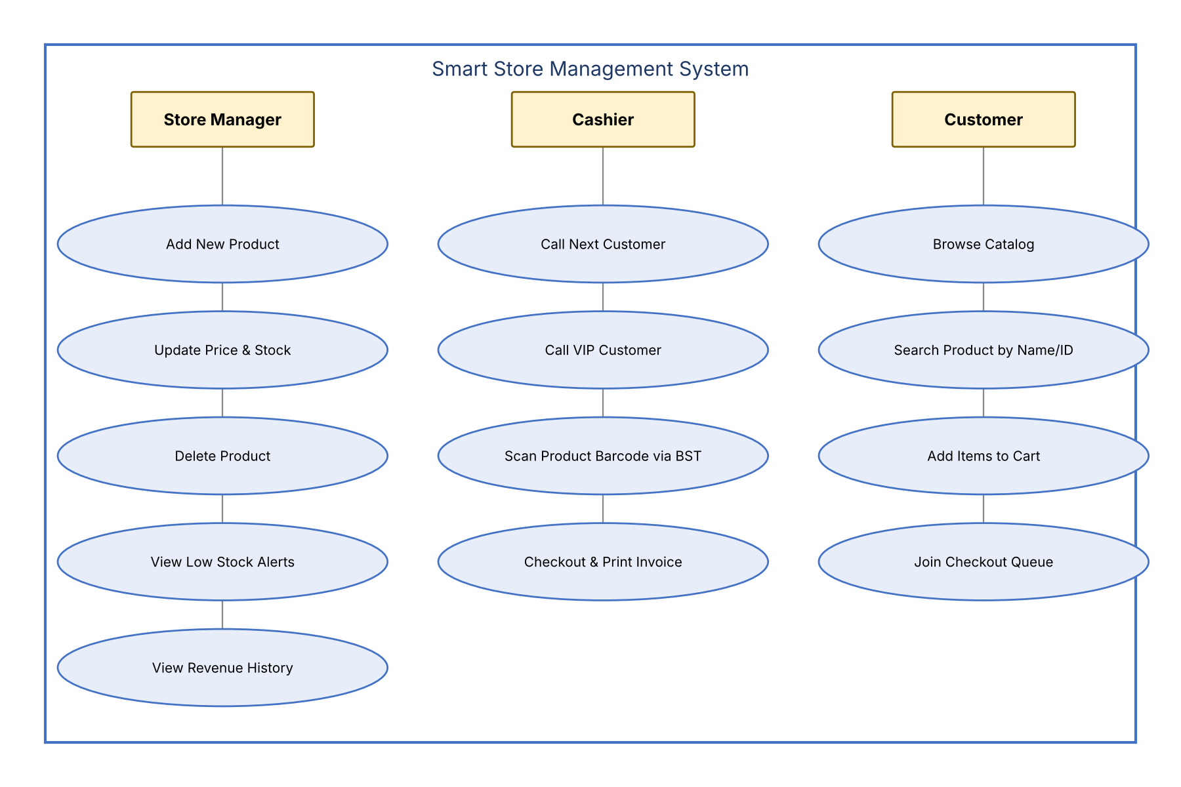
Caption: Use Case Diagram showing the actors (Store Manager, Cashier, Customer) and their interactions with the system.
3.1.2 Sequence Diagram
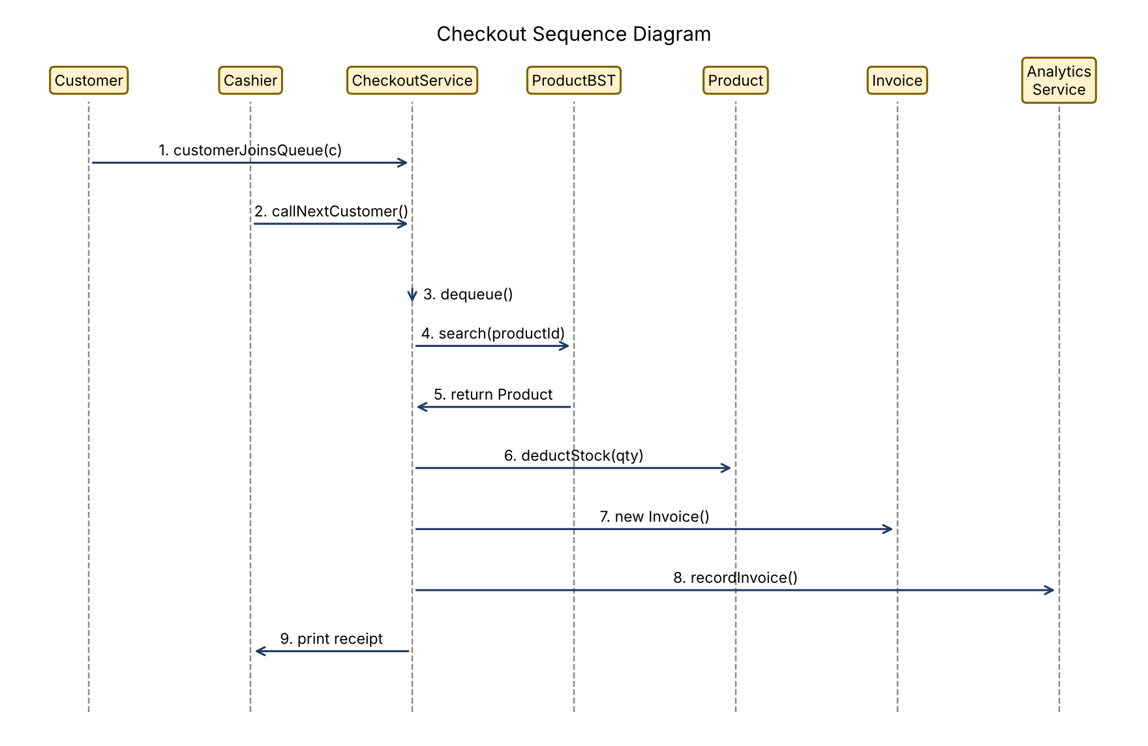
Caption: Sequence Diagram for the customer checkout flow (join queue → dequeue → BST lookup → deduct stock → invoice → analytics).
3.1.3 Activity Diagram (Optional)
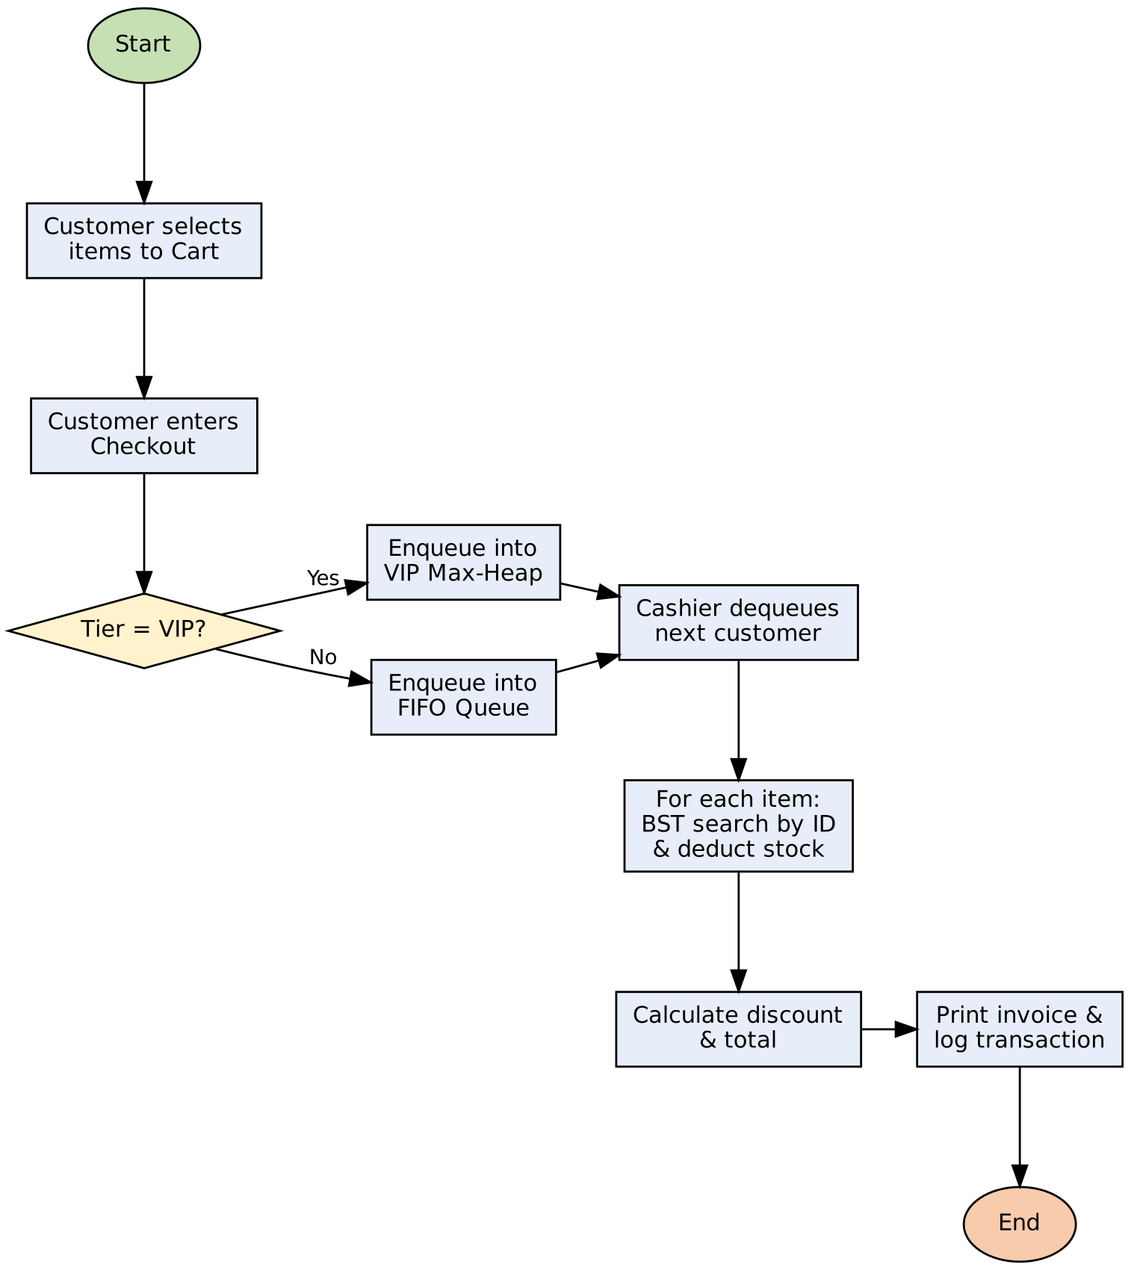
Caption: Activity Diagram for the checkout operation (VIP/regular queue selection, item scanning, billing).

3.2 Conceptual Framework
Describe the theoretical framework underpinning your design choices.
Framework Summary:
The system architecture is built upon the principles of algorithmic complexity theory and modular memory abstraction. By separating contiguous from pointer-based data organization, the system balances memory access locality with dynamic allocation flexibility. The divide-and-conquer strategy of the Binary Search Tree achieves O(log n) product retrieval on average, while the complete-binary-tree property of the Max-Heap guarantees O(log n) priority ordering without pointer overhead. The FIFO queue complements them by providing O(1) fair ordering for ordinary customers.
Framework Diagram / Table:
Concept | Theory Applied | Impact on Design
Time Complexity | Big-O Notation | Chuyển đổi tra cứu từ O(n) sang O(log n) bằng cây BST
Fairness in Queues | First-In First-Out (FIFO) | Bảo đảm trật tự hàng đợi thanh toán thường với O(1)
Priority Scheduling | Binary Max-Heap Property | Tự động đưa khách VIP có điểm cao nhất lên đỉnh phục vụ trước
Dynamic Memory | Linked Pointer Nodes | Cho phép kho hàng co giãn linh hoạt, không bị giới hạn bộ nhớ

3.3 Performance Experiment Design
Design experiments to empirically test algorithm performance.
Research Question (from Report 1):
"How does the integration of a Binary Search Tree (BST) for barcode lookup and a Binary Max-Heap for customer queueing affect search latency and queue throughput compared to linear linked-list structures in retail store management systems scaling up to N = 30,000 products?"
Experiment Setup
Parameter | Value
Input Sizes (n) | 100, 500, 1000, 5000, 10000, 30000
Algorithm(s) Tested | ProductBST.search() vs InventoryLinkedList linear search
Metric Measured | Total wall-clock execution time in milliseconds (ms) for 1,000 random queries
Hardware/Environment | Java 1.8.0_172, Windows 10/11 64-bit, measured with System.nanoTime()
Number of Trials | 5 independent runs per input size; the average execution time is recorded

Expected Results (Hypothesis)
The execution time of linear search is expected to grow strictly linearly (O(n)) with the number of products, while the BST execution time is expected to show near-flat, logarithmic growth (O(log n)). The gap between the two should therefore widen as N increases.
Results Table (to be filled in Report 4)
Input Size (n) | BST Time (ms) | Linked List Time (ms)
100
500
1000
5000
10000
30000

3.5 Independent Development Evidence
Provide evidence that your problem statement and Research Question were developed independently, without relying on AI for the core concept.
Evidence Provided:
- [ ] Screenshots of initial handwritten notes / sketches (attach below)
- [ ] Git commit history showing early drafts before AI tools were used
- [ ] Timestamp of first document draft
- [ ] Other: (describe)
[INSERT EVIDENCE SCREENSHOTS / IMAGES]
We developed the problem statement and the Research Question ourselves: the topic came from observing that product lookup and the shared checkout line are the typical bottlenecks of a busy supermarket, and from asking whether the data structures covered in CSD201 (BST, linked list, queue, heap) could measurably reduce them. We then compared the theoretical complexities (O(n) vs. O(log n)) with an empirical benchmark of our own design, scaled up to N = 30,000 products, rather than taking the question from an AI tool.

