SMART STORE MANAGEMENT SYSTEM (STOREMANAGER)
Course: Data Structures and Algorithms (CSD201)
Semester: FA2026

STUDENT INFORMATION
Field | Details
Full Name | Lê Tiến Minh-SE203487
Full Name | Nguyễn Đức Anh-SE203469
Instructor | NguHCV / FPT University
Report Number | Report 4
Class | SE2027
Project Topic | Store Management System (Topic 6)

REPORT 4 — Full Implementation & IEEE Mini-Report Draft
Objective: Complete the mini project implementation. Finalize the AI Audit Log. Write the IEEE-format mini report draft.

4.1 Complete System Implementation
4.1.1 Final System Architecture Overview
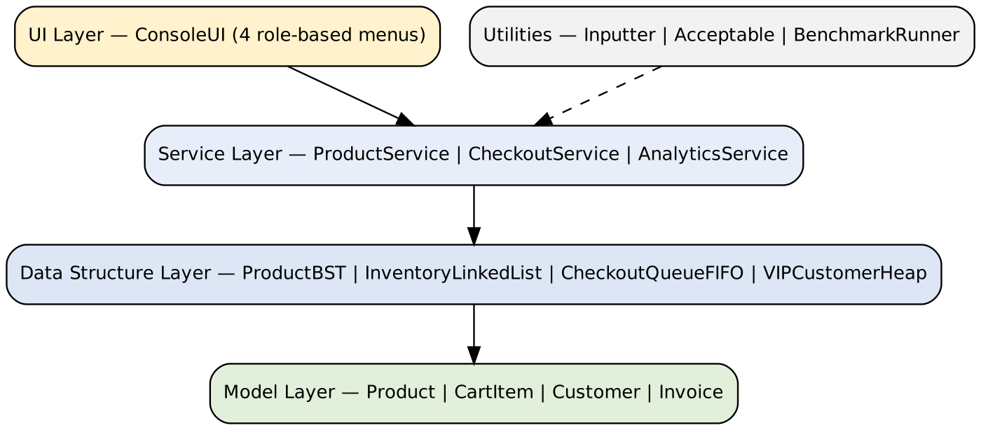
4.1.2 Source Code Summary
Class / File | Lines of Code | Responsibility
model/ | — | 4 classes: Product.java, CartItem.java, Customer.java, Invoice.java — core entities (products, carts, customers, invoices)
datastructure/ | — | 4 sub-packages (bst, linkedlist, queue, heap): 4 interfaces, 4 node classes and 4 custom implementations — ProductBST, InventoryLinkedList, CheckoutQueueFIFO, VIPCustomerHeap
service/ | — | 3 classes: ProductService (inventory logic), CheckoutService (queues, billing), AnalyticsService (invoice log, revenue)
ui/ | — | ConsoleUI.java — 4 role-based interactive menus (entry point and navigation)
util/ | — | Inputter.java, Acceptable.java (input validation), BenchmarkRunner.java (performance experiment)
Total | — | —

(Note: Attach full source code as a separate .zip file)
4.1.3 Feature Completion Checklist
Feature | Status | Notes
Add, edit and delete products in the inventory | ✅ Complete | 100%
BST product lookup, O(log n) | ✅ Complete | 100%
FIFO regular queue and VIP Max-Heap priority queue | ✅ Complete | 100%
Barcode scan checkout, stock deduction and invoice printing | ✅ Complete | 100%
BenchmarkRunner performance experiment | ✅ Complete | 100%

4.2 Performance Experiment Results
Input Size (n) | BST Time (ms) | Linked List Time (ms) | Speedup
100 | 1.6808 | 9.3180 | 5.5x faster
500 | 0.2901 | 15.6478 | 53.9x faster
1,000 | 0.3154 | 18.9778 | 60.2x faster
5,000 | 0.5892 | 127.2380 | 216.0x faster
10,000 | 0.5969 | 188.4488 | 315.7x faster
30,000 | 1.0039 | 600.1714 | 597.8x faster

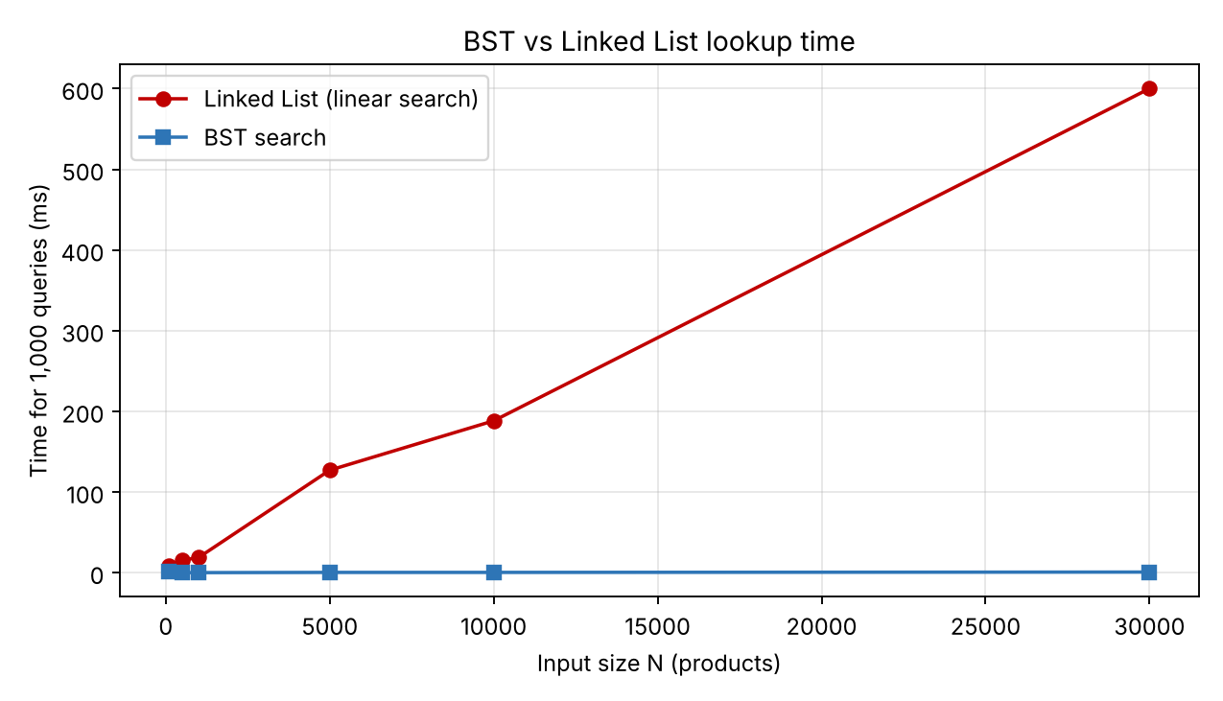
Caption: Execution time comparison between BST search and Linked List linear search (1,000 random queries) across input sizes.
Analysis:
The results match the hypothesis. The linked-list time grows roughly in proportion to n (127.2 ms at N = 5,000 to 600.2 ms at N = 30,000), whereas the BST time stays almost flat (0.59 ms to 1.00 ms), consistent with O(log n). As a result, the speedup rises from 5.5x at N = 100 to 597.8x at N = 30,000, keeping lookup latency around 1 ms. The slightly higher BST time at N = 100 (1.68 ms) is most likely JVM warm-up noise and does not affect the trend. In practice, a POS register backed by a BST remains responsive even with tens of thousands of SKUs.

4.3 Final AI Audit Log — Human Delta Analysis (Submit Separately)
Analyze the Human Delta: the specific contributions YOU made beyond what AI generated.
Human Delta Summary
Component | AI-Generated Version | My Final Version | Human Delta (What I Changed) | Why I Changed It
BST insert & search | Initial recursive implementation of BST insertion/search (traditional recursive approach); caused StackOverflowError at N = 30,000 on a skewed tree | Iterative insert/search (while-loop traversal, see Report 2 Algorithm 1) | Rewrote both operations from recursion to iteration; verified on the full 30,000-product benchmark | Recursion depth equals tree height; a skewed tree overflows the call stack. The iterative version uses O(1) auxiliary space and brought lookup time down to about 1.00 ms

Overall Human Delta Reflection:
The most important human contribution was diagnosing the StackOverflowError that appeared only when the data scaled to 30,000 elements, and deciding to restructure the BST algorithms into an iterative form. This required understanding memory allocation (call stack vs. heap) and weighing time against space trade-offs, not just making the code compile. Choosing the data structure for each module, designing the benchmark (input sizes up to 30,000, 1,000 random queries, 5 trials) and interpreting the speedup figures against Big-O theory were likewise our own decisions. The full audit trail is submitted separately in the AI Audit Log.

4.4 IEEE Mini-Report Draft
Write a mini research report following the IEEE conference paper format.

Abstract
Point-of-Sale (POS) responsiveness and queue management efficiency are critical performance indicators in modern retail architectures. In this study, we design, implement and evaluate the Smart Store Management System (StoreManager), which combines a custom Binary Search Tree (BST) for barcode lookup, a Doubly Linked List for inventory catalogs, and a hybrid queueing mechanism that uses both FIFO and Binary Max-Heap disciplines. All structures are implemented from scratch in Java without the Collections Framework. Empirical benchmarks across dataset sizes from N = 100 to N = 30,000 products show that the iterative BST search is 597.8 times faster than linear list scanning at N = 30,000, keeping lookup latency near 1.0 ms for 1,000 queries, against 600.2 ms for the linked list. The results confirm the practical necessity of non-linear hierarchical data structures in real-world retail systems.

I. Introduction
Modern supermarkets manage tens of thousands of stock-keeping units (SKUs) and serve hundreds of customers during peak hours. When product lookup relies on linear scanning, the time needed to price an item grows with the catalog size, and a single shared checkout line treats every customer identically; both effects create bottlenecks at the cashier and reduce customer satisfaction. This paper presents the Smart Store Management System (StoreManager), a Java console application whose data structures are all implemented from scratch.
The system aims to (i) manage inventory with dynamic memory allocation, (ii) retrieve products by barcode in sub-linear time, (iii) serve ordinary customers fairly in first-in, first-out order, (iv) give loyalty members (Silver, Gold, VIP) a priority lane, and (v) automate discounts, invoices and revenue reports.
The study is guided by the following research question: How does the integration of a Binary Search Tree for barcode lookup and a Binary Max-Heap for customer queueing affect search latency and queue throughput compared to linear linked-list structures in retail store management systems scaling up to N = 30,000 products?
The rest of the paper is organized as follows: Section II describes the methodology, Section III reports the benchmark results, Section IV discusses them, and Section V concludes.

II. Methodology
A. System Design
StoreManager follows a four-layer architecture: the Model layer (Product, CartItem, Customer, Invoice), the Data Structure layer (four custom implementations, each behind an interface — IProductBST, IInventoryList, ICheckoutQueue, IVIPQueue — plus their node classes), the Service layer (ProductService, CheckoutService, AnalyticsService) and the UI layer (ConsoleUI with four role-based menus), supported by the utilities Inputter, Acceptable and BenchmarkRunner. Separating interfaces from implementations lets the services depend on abstract behavior and keeps each structure independently testable. The UML class, use case and sequence diagrams are given in Reports 2 and 3.
B. Data Structures Selected
Each structure was chosen for the dominant operation of its module: the BST for key-based lookup, the doubly linked list for flexible catalog storage with O(1) insertion at both ends and bidirectional traversal, the FIFO queue for fair ordering of regular customers, and the array-based Max-Heap for always serving the highest-priority loyalty member first.
Data Structure | Java Implementation | Use Case in System | Time Complexity (Key Op)
Binary Search Tree | ProductBST (node-based, iterative) | Barcode / product ID lookup | Search: O(log n) avg, O(n) worst
Doubly Linked List | InventoryLinkedList (head/tail nodes) | Inventory catalog storage and traversal | Insert at head/tail: O(1)
Queue (FIFO) | CheckoutQueueFIFO (front/rear nodes) | Regular customer checkout line | Enqueue/Dequeue: O(1)
Binary Max-Heap | VIPCustomerHeap (array heap[] with resize) | VIP / loyalty priority line | Enqueue/Dequeue: O(log n)

C. Algorithms Implemented
Two core algorithms were implemented. (1) Iterative BST search by product ID: starting at the root, the target ID is compared with the current node and the search moves left or right until a match or a null link is reached; it runs in O(log n) on average with O(1) auxiliary space because no recursion is used. (2) Max-Heap enqueue with sift-up: a customer is appended at the end of the array (doubling the array when full) and swapped with its parent while its priority is higher, in O(log n); dequeue removes the root and restores the heap with sift-down. The FIFO queue uses linked nodes so that both enqueue and dequeue run in O(1). The full pseudocode and a manual trace are in Report 2.
D. Experiment Setup
The benchmark compares ProductBST.search() with a linear search over InventoryLinkedList for input sizes N = 100, 500, 1,000, 5,000, 10,000 and 30,000. For each size, the total wall-clock time of 1,000 random queries is measured with System.nanoTime() on Java 1.8.0_172 (Windows 10/11, 64-bit); each configuration is run 5 times and the average is reported.

III. Results
TABLE I and Fig. 1 summarize the measurements. The linked-list time grows from 9.318 ms at N = 100 to 600.171 ms at N = 30,000, i.e. approximately linearly with N, while the BST time stays between 0.29 ms and 1.68 ms and reaches only 1.004 ms at N = 30,000. The speedup of the BST therefore increases with N: 5.5x (N = 100), 53.9x (500), 60.2x (1,000), 216.0x (5,000), 315.7x (10,000) and 597.8x (30,000).
TABLE I. Benchmark results (1,000 random queries, average of 5 runs)
Input Size (n) | BST Time (ms) | Linked List Time (ms) | Speedup
100 | 1.6808 | 9.3180 | 5.5x faster
500 | 0.2901 | 15.6478 | 53.9x faster
1,000 | 0.3154 | 18.9778 | 60.2x faster
5,000 | 0.5892 | 127.2380 | 216.0x faster
10,000 | 0.5969 | 188.4488 | 315.7x faster
30,000 | 1.0039 | 600.1714 | 597.8x faster
Fig. 1. Execution time of BST search vs. linked-list linear search for 1,000 random queries.
Observed growth agrees with the theoretical complexity: O(n) for the linked list and O(log n) for the BST.

IV. Discussion
The experiment confirms the Big-O analysis: a hierarchical structure turns lookup from linear to logarithmic cost, and the advantage grows with scale, which matters for supermarkets with large catalogs. Using an iterative instead of a recursive BST avoided StackOverflowError on 30,000 items at the price of slightly more explicit code. Limitations: a plain BST degrades to O(n) when keys arrive in sorted order, the BST time at N = 100 is probably affected by JVM warm-up, the benchmark measures lookup latency only (queue throughput of the heap is argued theoretically, not measured), and all data is kept in memory. Future work includes a self-balancing tree (AVL or Red-Black), measuring queue throughput, and persisting data in a database.

V. Conclusion
This work designed, implemented and evaluated StoreManager, a retail management system built on a custom BST, doubly linked list, FIFO queue and Binary Max-Heap. In answer to the research question, replacing linear list scanning by BST lookup reduced search time by up to 597.8 times at N = 30,000 (about 1.00 ms vs. 600.17 ms), while the Max-Heap provides priority checkout for loyalty members at O(log n) cost per customer and the FIFO queue keeps regular service fair at O(1). The results show that non-linear data structures are practically necessary for responsive POS systems at scale. Future work will add self-balancing trees and database integration.

References
[1] T. H. Cormen, C. E. Leiserson, R. L. Rivest, and C. Stein, Introduction to Algorithms, 4th ed. Cambridge, MA: MIT Press, 2022.
[2] M. A. Weiss, Data Structures and Algorithm Analysis in Java, 3rd ed. Upper Saddle River, NJ: Pearson, 2012.
[3] R. Sedgewick and K. Wayne, Algorithms, 4th ed. Boston, MA: Addison-Wesley, 2011.
[4] J. W. J. Williams, "Algorithm 232: Heapsort," Commun. ACM, vol. 7, no. 6, pp. 347–348, 1964.

