## Exercise 1

EYEWITNESSNEWS

E: 4

Y: 1

W: 2

I: 1

T:1

N: 2

S: 3

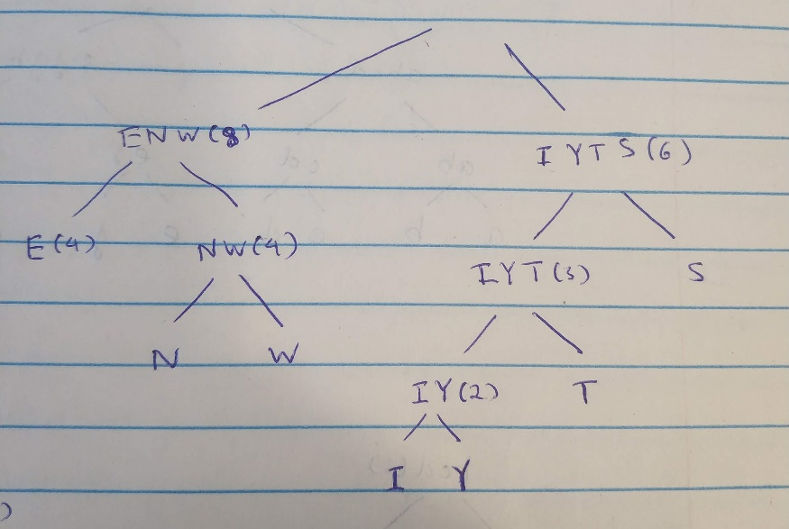

E 00, N 010, W 011, I 1000, Y 1001, T 101, S 11

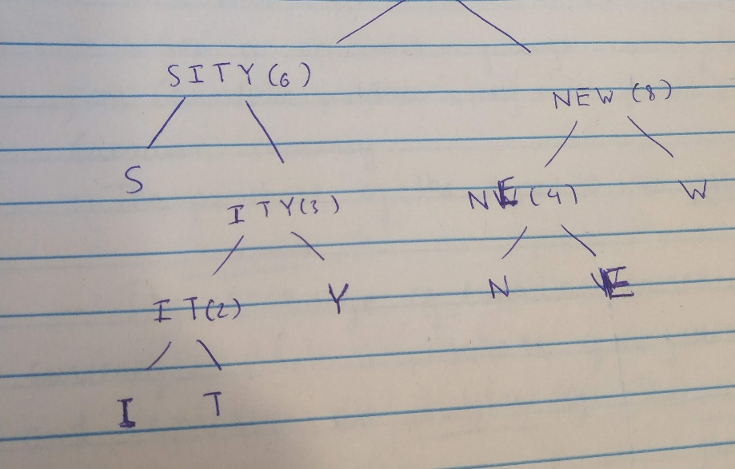

S 00, I 0100, T 0101, Y 011, N 100, E 101, W 11

Number of bits of 2 encoded messages have same length

3.

There are no best wat to construct trie

It does not depend on our choices building the trie

## Exercise 2

1.

|  |  |
| --- | --- |
| a | 1 |
| b | 1 |
| c | 2 |
| d | 3 |
| e | 5 |
| f | 8 |
| g | 13 |
| h | 95 |

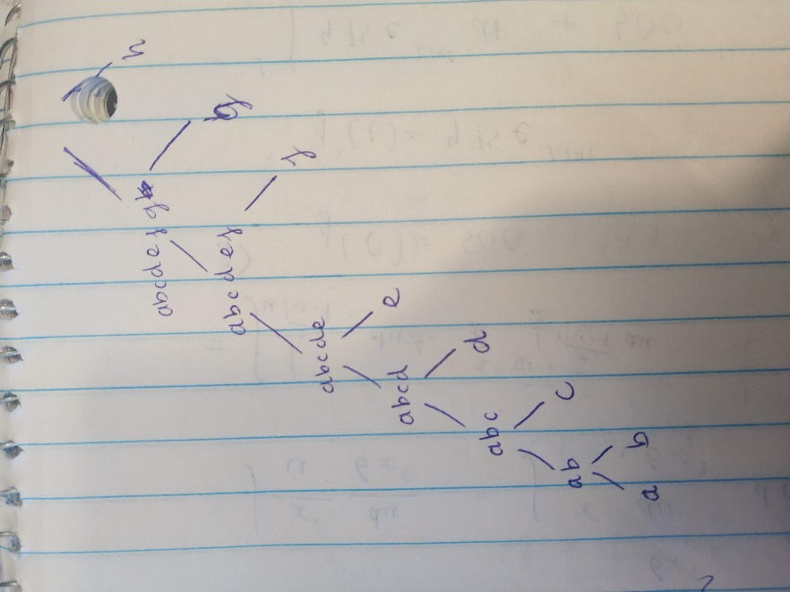

Length of encoded file: = 7+7+6*2+5*3+4*5+3*8+2*13+95=206 bits

2.

|  |  |
| --- | --- |
| a | 16 |
| b | 16 |
| c | 16 |
| d | 16 |
| e | 16 |
| f | 16 |
| g | 16 |
| h | 16 |

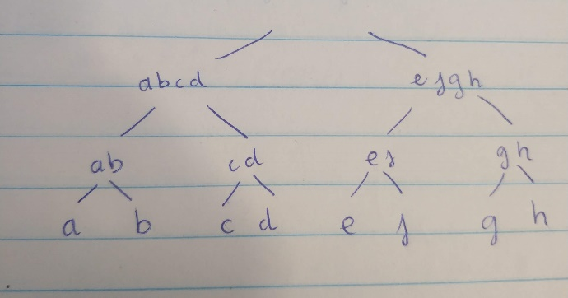

Length of encoded file 3*16*8 = 384 bits

## Exercise 4

No

Because it is impossible to compress 1 file again and again and make it 10% smaller after each compression, file size will become nearly 0 bits if we do that many times

## Exercise 4

3.

O(d*logd)

4.

O(logd)