

Requirement & Design Specification

**Global Assess Management System (GAMS)**

**Version: 1.0**

– Hanoi, August 2022 –

# Record of Changes

|  |  |  |  |  |
| --- | --- | --- | --- | --- |
| Version | Date | A* M, D | In charge | Change Description |
| V1.0 | 15/2 | A | KienNTHE11 |  |
|  |  |  |  |  |
|  |  |  |  |  |
|  |  |  |  |  |
|  |  |  |  |  |
|  |  |  |  |  |
|  |  |  |  |  |
|  |  |  |  |  |
|  |  |  |  |  |
|  |  |  |  |  |
|  |  |  |  |  |
|  |  |  |  |  |

*A - Added M - Modified D - Deleted

Contents

Record of Changes 2

I. Overview 4

1. System Context 4

2. User Requirements 4

2.1 Actors 4

2.2 Diagrams 5

2.3 Descriptions 6

3. System Functionalities 6

3.1 Screens Flow 6

3.2 Screen Authorization 6

3.3 Non-UI Functions 7

II. Functional Requirements 8

1. Feature Name1 8

1.1 SubFeature Name1.1 8

1.2 SubFeature Name1.2 8

2. User Authentication 8

2.1 User Register 8

2.2 User Login 8

2.3 Password Reset 8

2.4 User Profile 8

3. System Administration 9

3.1 Master Data 9

3.2 User Management 10

III. System Design 10

1. Database Design 10

1.1 Database Schema 10

1.2 Table Descriptions 10

2. Code Packages 11

2.1 Package Diagram 11

2.2 Package Descriptions 11

# I. Overview

## 1. System Context

*[Gives the overall description about the product with some introduction and the context diagram. The context diagram presents the boundary and connections between the system you’re developing and everything else in the universe. This identifies external entities (or terminators – software, hardware, human components, and other systems) outside the system that interface to it in some way, as well as data, control, and material flows between the terminators and the system.]*

<<Sample: The Cafeteria Ordering System is a new software system that replaces the current manual and telephone processes for ordering and picking up meals in the Process Impact cafeteria. The context diagram below illustrates the external entities and system interfaces for release 1.0. The system is expected to evolve over several releases, ultimately connecting to the Internet ordering services for several local restaurants and to credit and debit card authorization services.

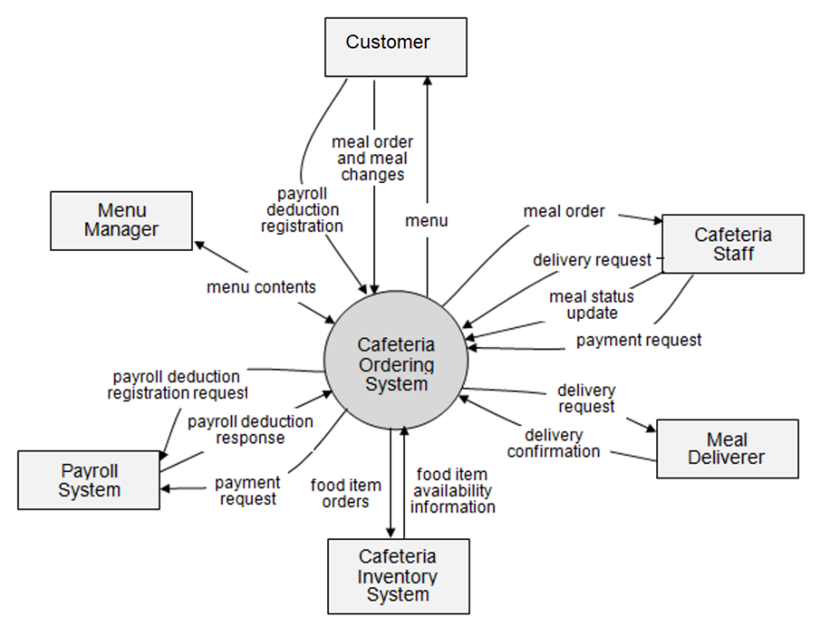

>>

## 2. User Requirements

### 2.1 Actors

*[An actor is someone/something that interacts with the system.*

* *The only external entities that interact with the system*
* *﻿Actors are outside the system and not part of it*
* *﻿A user is an individual, whereas an actor represents the role played by all users of the same type*
* *There are other types of actors in addition to or in place of human actors: external systems, I/O devices, or timers*

*Following are some questions you might ask to help user representatives identify actors*

* *Who (or what) is notified when something occurs within the system?*
* *Who (or what) provides information or services to the system?*
* *Who (or what) helps the system respond to and complete a task?*

*This part gives the description of system actors, you can follow the table form as below]*

|  |  |  |
| --- | --- | --- |
| **#** | **Actor** | **Description** |
| 1 | Administrator | Actor description here.. |
| 2 | Menu Manager | .. |
| 3 | … |  |

### 2.2 Diagrams

*[A use case (UC) describes a sequence of interactions between a system and an external actor that results in the actor being able to achieve some outcome of value. The names of use cases are always written in the form of a verb followed by an object. Select strong, descriptive names to make it evident from the name that the use case will deliver something valuable for some user.*

*Following are some questions you might ask to help user representatives identify use cases*

* *What will the actor use the system for?*
* *Will the actor create, store, change, remove, or read data in the system?*
* *Will the actor need to inform the system about external events or changes?*
* *Will the actor need to be informed about certain occurrences in the system?*

*In this section, you need to provide the UC diagram(s) to show the actor-UCs and UC-UC relationships like the sample below. You can have multiple UC diagrams for the system, each diagram is for one actor or one workflow]*

#### 2.2.1 UCs for Guest

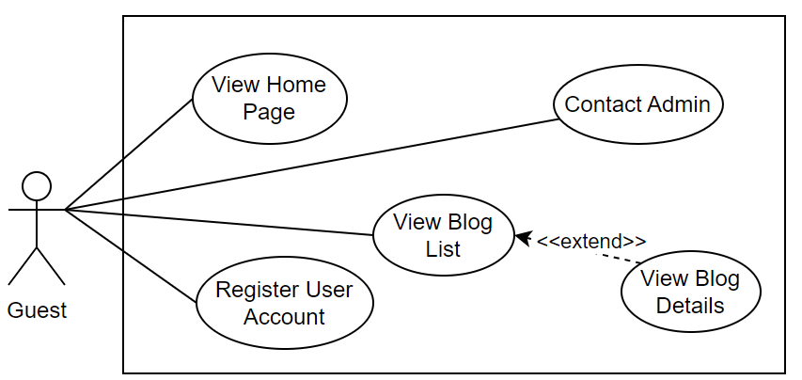

#### 2.2.2 UCs for Student

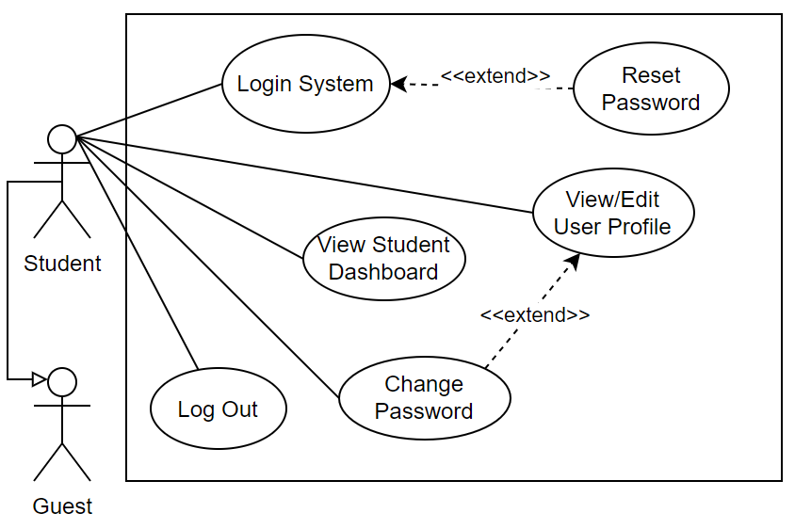

#### 2.2.3 …

### 2.3 Descriptions

*[This part describes the use cases, you can follow the table form as below]*

|  |  |  |  |
| --- | --- | --- | --- |
| **ID** | **Use Case** | **Actor(s)** | **Use Case Description** |
| 01 | [Use Case Name] | Actor List | [Brief description for each UC in the form of “As a <type of user>, I want <some goal> so that <some reasons>” or in other form that we can have overall understanding of the UC] |
| 02 | Register User Account | Guest (New User) | As a new user, I want to register an account with my full name, email and password so that I can access the features of the system |
| 03 | Login System | Registered User | As a user with a specific role, I want to be redirected to the appropriate page after login so that I can immediately access the features relevant to my role |
| 04 | Reset Password | Registered User | Reset Password: As a registered user, I want to request a password reset by entering my email so that I can regain access to my account if I forget my password |
| 05 | View Menu | Patron | .. |
| 06 | Order a Meal | Patron | .. |
| 07 | … |  |  |

## 3. System Functionalities

*[Provide functionality overview of software system: screen flow, screen descriptions, system user roles, screen authorization, non-screen functions, ERD]*

### 3.1 Screens Flow

*[This part shows the system screens and the relationship among screens. You can draw the Screens Flow for the system in the form of diagram as below.]*

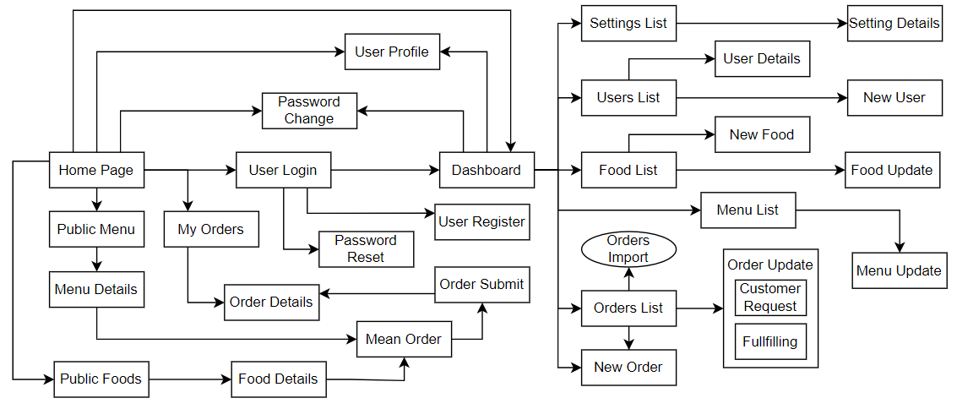

### 3.2 Screen Authorization

*[Provide the system roles authorization to the system features (down to screens, and event to the screen activities if applicable) in the table form as below – replace Role-Name1, Role-Name2,… with your specific system user role names]*

|  |  |  |  |  |
| --- | --- | --- | --- | --- |
| **Screen** | **Role-Name1** | **Role-Name2** | **Role-Name3** | **…** |
| <<Screen Name1>> | X |  | X | X |
| <<Screen Activity>> |  |  | X | X |
| <<Screen Name2>> | X |  | X |  |
| Query All Data | X |  |  |  |
| Query Own Data |  |  | X |  |
| Add New Data |  |  | X | X |
| Update All Data |  |  |  | X |
| Update Own Data |  |  |  | X |
| Delete Data |  |  |  |  |
| … |  |  |  |  |

### 3.3 Non-UI Functions

*[Provide the descriptions for the non-screen system functions, i.e batch/cron job, service, API, etc.]*

|  |  |  |  |
| --- | --- | --- | --- |
| **#** | **Feature** | **System Function** | **Description** |
| 1 | <<Feature Name>> | <<Function Name1>> | <<Function Name1 Description>> |
| 2 | … |  |  |

# II. Functional Requirements

*[Provide descriptions about the system’s functions/screens. The functions/screens are grouped by the system features, and even sub-features if needed. For the screens, you need to provide the screen layouts (mock-up screens) and relevant specifications if needed]*

## 1. Feature Name1

### 1.1 SubFeature Name1.1

#### 1.1.1 Screen/Function Name1

*[Content #1: UI layout (Mockup screen prototype)]*

*[Content #2: brief descriptions of the screen/function, mapped to the relevant use cases]*

*[Content #3: provide further descriptions for the screen’s components/fields using table format below]*

|  |  |
| --- | --- |
| **Field Name** | **Description** |
| Field Name1 | Field description: data type min/max length or value, initial data, etc. |
| Field Name2 | … |
| ***Field Group-Name1*** | |
| Field Name3 | … |
| Field Name4 | … |
| ***Field Group-Name2*** | |
| … | … |

#### 1.1.2 Screen/Function Name2

…

### 1.2 SubFeature Name1.2

…

## 2. User Authentication

### 2.1 User Register

…

### 2.2 User Login

…

### 2.3 Password Reset

…

### 2.4 User Profile

…

## 3. System Administration

### 3.1 Master Data

#### 3.1.1 Setting List

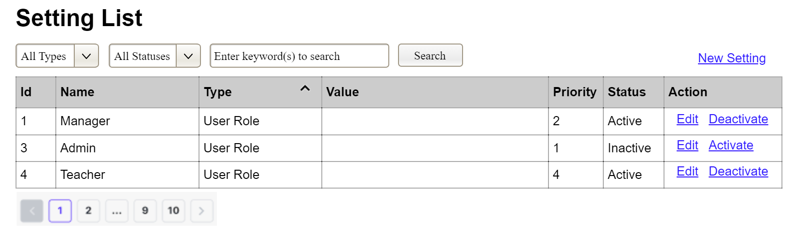

(3)

(2)

(1)

This screen allows the Administrator to:

* View Setting List: view list of current master data.
* Filter Setting List: filter master data by data types, statuses
* Search Settings: enter keyword(s) to search master data by their names or values
* Sort Setting List: sort mater data list (ascending, descending) by clicking column headers

On the screen, s/he can also

* Activate/Deactivate Setting: change status of a specific inactive/active master data
* Choose to go to the Setting Details screens for adding new or updating an existing master data by clicking the New Setting or Edit link.

**Field Description**

|  |  |
| --- | --- |
| **Field Name** | **Description** |
| (1) | Initial values: all the active setting names with null or blank type  Hover the mouse to show the field name: “Setting Type” |
| (2) | Initial values: All Statuses, Active, Inactive (default value “All Status”)  Hover the mouse to show the field name: “Setting Status” |
| (3) | The change-status action is Activate or Deactivate depending on the current status of the relevant setting (Inactive or Active, respectively). |

#### 3.1.2 Setting Details

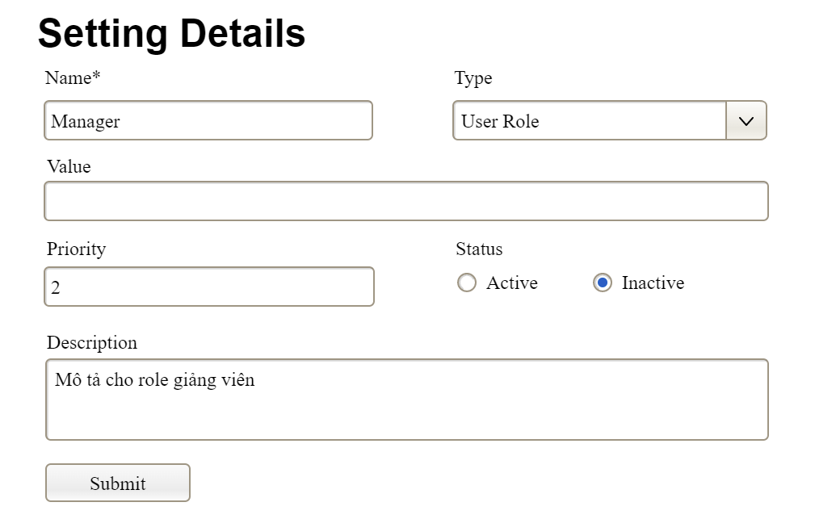

This screen allows the Administrator to:

* Add New Setting: add new master data.
* Update Setting Details: update details of a specific master data

**Field Description**

|  |  |
| --- | --- |
| **Field Name** | **Description** |
| Name | Data type: non-digit string, max length of 20 characters |
| Type | Initial data values: all active setting names (with null or blank type) |
| Value | Data type: any string, max length of 100 characters |
| Priority | Data type: a positive integer |
| Description | Data type: any string, max length of 200 characters |

### 3.2 User Management

#### 3.2.1 User List

…

#### 3.2.2 User Details

…

# III. System Design

## 1. Database Design

*[Provide the tables relationship like example below]*

### 1.1 Database Schema

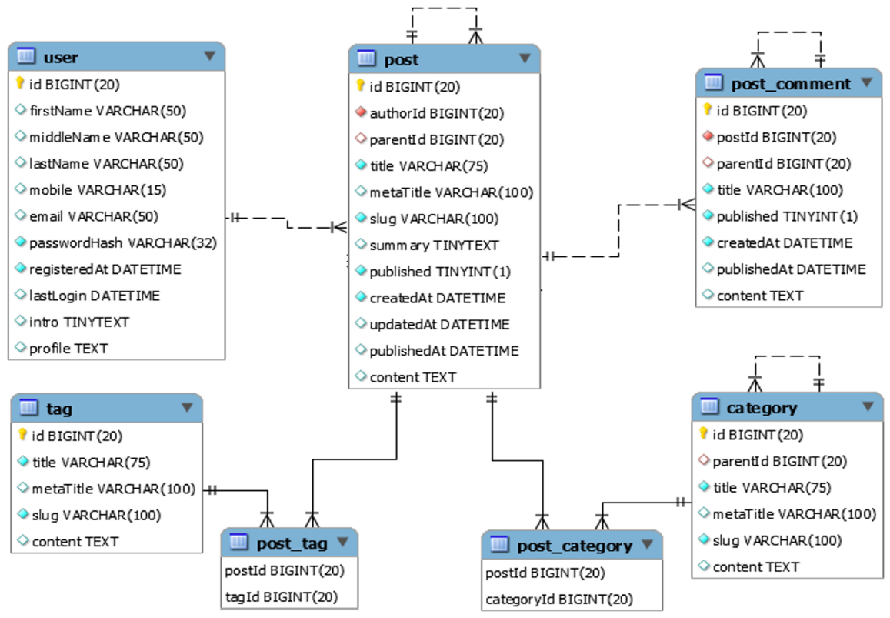

### 1.2 Table Descriptions

|  |  |  |
| --- | --- | --- |
| **No** | **Table** | **Description** |
| *01* | *<Table name>* | *<Description of the table>*  *- Primary keys: <<list of primary key fields>>*  *- Foreign keys: <<list of foreign key fields>>*  *- Unique keys:<<list of unique field or unique field set>>* |
| *02* | *<Table name2>* | *…* |

## 2. Code Packages

*[Provide the package diagram for the system (or sub systems) and package description similar to sample diagram and using description table format below]*

### 2.1 Package Diagram

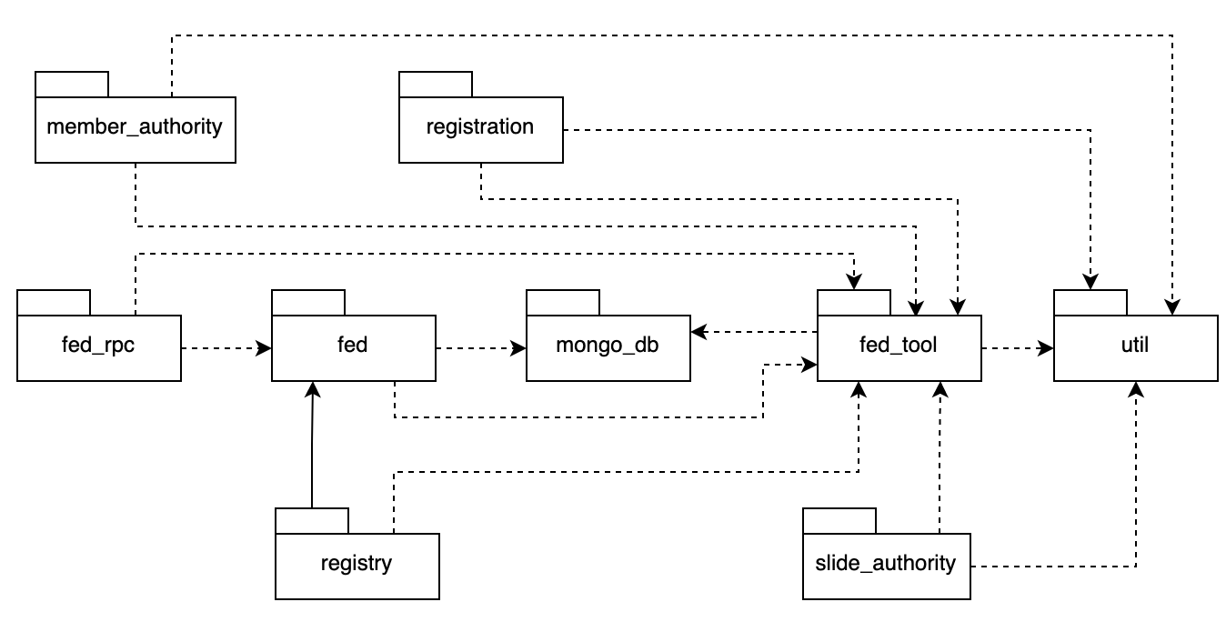

### 2.2 Package Descriptions

|  |  |  |
| --- | --- | --- |
| **No** | **Package** | **Description** |
| *01* | *member_authority* | *<Description of the package: purpose, contents,..>* |
| *02* | *registration* | *<Description of the package: purpose, contents,..>* |
| *03* | *…* |  |