Hyper-V installation on Windows 10

## Step 1: Prerequisites

The following prerequisites are required to successfully run Client Hyper-V on Windows 10:

* Windows 10 Operating System
* 64bit processor with [Second Level Address Translation](http://en.wikipedia.org/wiki/Second_Level_Address_Translation) (SLAT)
* 4GB system RAM at minimum
* BIOS-level Hardware Virtualization support

## Step 2: Setting Up Hyper-V

1. Ensure that hardware virtualization support is turned on in the BIOS settings  
      
   [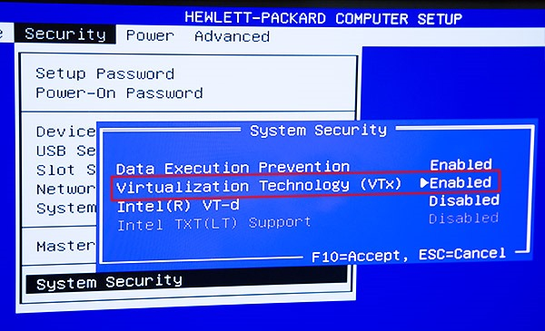](https://msdnshared.blob.core.windows.net/media/TNBlogsFS/prod.evol.blogs.technet.com/CommunityServer.Blogs.Components.WeblogFiles/00/00/00/48/12/6116.HVW8a.jpg)
2. Save the BIOS settings and boot up the machine normally
3. Click the search icon (magnified glass) on the taskbar
4. Type**turn windows features on or off** and select that item   
      
   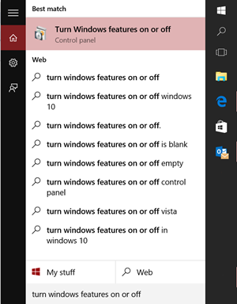
5. Select and enable **Hyper-V  
      
   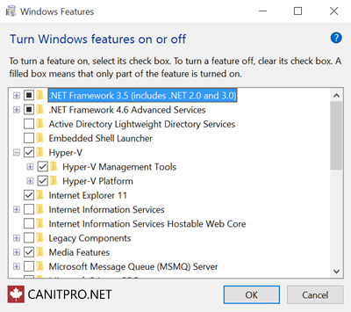**
6. If Hyper-V was not previously enabled, **reboot** the machine to apply the change.   
      
   **NOTE:**As a best practice, configure networking for the Hyper-V environment to support external network connections. Also ensure that a virtual switch has been created and is functional.