Time series graphics

### ts objects

y <- ts(c(123,39,78,52,110), start=2012)  
y

## Time Series:  
## Start = 2012   
## End = 2016   
## Frequency = 1   
## [1] 123 39 78 52 110

### Time plots

library(fpp)

## Loading required package: forecast

## Warning: package 'forecast' was built under R version 3.6.2

## Registered S3 method overwritten by 'quantmod':  
## method from  
## as.zoo.data.frame zoo

## Loading required package: fma

## Loading required package: expsmooth

## Loading required package: lmtest

## Loading required package: zoo

##   
## Attaching package: 'zoo'

## The following objects are masked from 'package:base':  
##   
## as.Date, as.Date.numeric

## Loading required package: tseries

library(forecast)  
library(ggplot2)  
  
class(melsyd)

## [1] "mts" "ts"

head(melsyd)

## Time Series:  
## Start = c(1987, 26)   
## End = c(1987, 31)   
## Frequency = 52   
## First.Class Business.Class Economy.Class  
## 1987.481 1.912 NA 20.167  
## 1987.500 1.848 NA 20.161  
## 1987.519 1.856 NA 19.993  
## 1987.538 2.142 NA 20.986  
## 1987.558 2.118 NA 20.497  
## 1987.577 2.048 NA 20.770

autoplot(melsyd[, "Economy.Class"]) + ggtitle("Economy class passengers: Melbourne-Sydney") +  
 xlab("Year") + ylab("in Thousands")

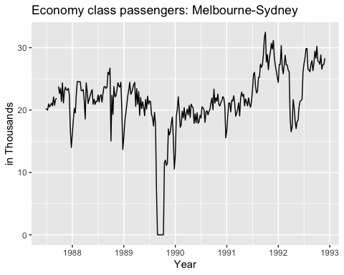

head(a10, 10)

## Jan Feb Mar Apr May Jun Jul Aug Sep  
## 1991 3.526591 3.180891 3.252221  
## 1992 5.088335 2.814520 2.985811 3.204780   
## Oct Nov Dec  
## 1991 3.611003 3.565869 4.306371  
## 1992

class(a10)

## [1] "ts"

autoplot(a10) + ggtitle("Antidiabetic drug sales") +  
 ylab("$ in million") + xlab("Year")

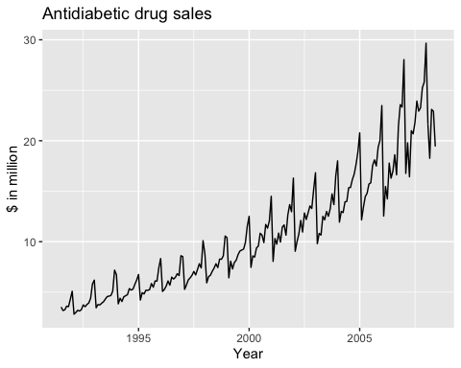

### Seasonal plots

ggseasonplot(a10, year.labels = TRUE, year.labels.left = TRUE) +   
 ylab("$ million") + ggtitle("Seasonal plot: antidiabetic drug sales")

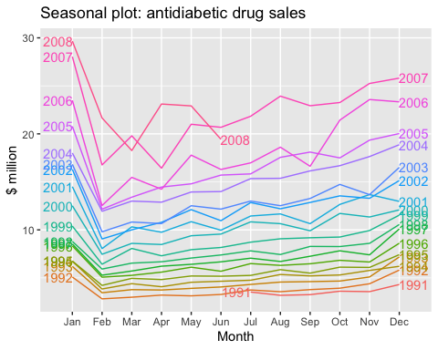

The data from each season are overlapped.

ggseasonplot(a10, polar=TRUE) + ylab("$ million") +   
 ggtitle("Polar seasonal plot: antidiabetic drug sales")

