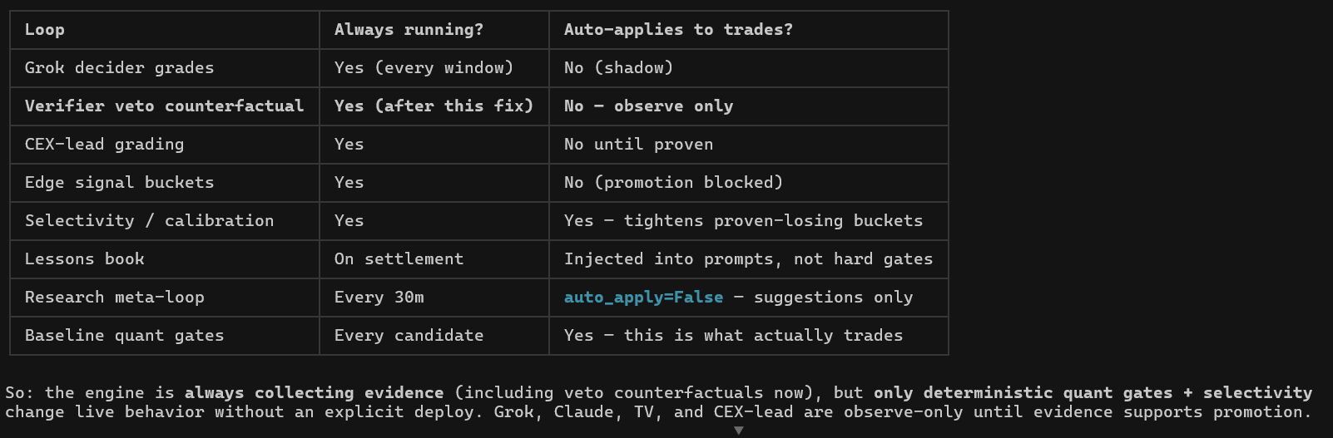
Below is 3 AIs think about your table description of bot loop architecture
- First AI
Quant verdict: this structure is directionally correct.
It separates:
Evidence collection = always on
Trading authority = only deterministic quant gates + proven selectivity
AI / Grok / Claude / TV / CEX-lead = observe-only until promoted
That is the right safety architecture.
What is good
Grok decider shadow only — good. It can grade every window, but it must not affect trades.
Verifier veto counterfactual observe-only — good. This is exactly how to test “would veto improve PnL?” before making it live.
CEX-lead grading observe-only — good. Useful signal, but dangerous to auto-apply before proof.
Edge signal buckets promotion blocked — good. Buckets should not become live just because they look good over small sample.
Lessons book into prompts, not hard gates — good. Avoids overfitting from one bad session.
Research meta-loop suggestions only — good. It can recommend improvements, not change behavior automatically.
Baseline quant gates are what actually trade — correct. That keeps the bot deterministic and auditable.
Main risk
The one live adaptive piece is:
Selectivity / calibration = Yes — tightens proven-losing buckets
That is acceptable only if Cursor enforces strict proof:
n >= minimum sample size
negative PnL
negative expectancy after costs
Wilson upper bound below breakeven
out-of-sample or counterfactual improvement
no stale bucket blocking
Otherwise this becomes an overfitting machine that blocks good trades and lets bad ones pass.
What I would require before trusting it
Tell Cursor to prove these in the report:
1. What actually trades:
baseline_quant_gates
selectivity_calibration only if proven
2. What never trades:
Grok
Claude
TradingView
CEX-lead
research meta-loop
lessons book
3. For every live selectivity block:
bucket
n
win rate
PnL
avg win
avg loss
breakeven
Wilson upper bound
why it is allowed to block
4. Counterfactual:
PnL if block disabled
PnL if block enabled
trades skipped
losses avoided
wins skipped

- Second AI
As governance architecture, this is genuinely well-disciplined — better than most systematic stacks I've seen. The core instinct is right: keep everything in shadow/counterfactual mode and let only deterministic, fast gates touch the live book. The counterfactual-veto logging in particular is the correct way to evaluate a gate without paying for it (standard off-policy eval), and auto_apply=False on the research meta-loop is the kind of restraint that prevents the classic "the optimizer quietly rewrote production" blowup.
That said, the thing I'd stare at hardest is the one row that breaks the pattern: selectivity/calibration is the only loop that auto-applies, and it "tightens proven-losing buckets." That's where all your real risk now lives, and it's a trailing-performance feedback loop. Tightening based on recent realized PnL is structurally a momentum bet on your own strategy's recent results — it's regime-dependent and it whipsaws. You'll tighten exactly into a bucket that's about to mean-revert back to profitable, and in a regime break you'll tighten on the old regime's evidence right when you want to do the opposite. If there's no regime-aware override or decay on that, it's the most likely source of a slow bleed.
The questions I'd want answered before trusting any of the "No until proven" rows:
- What is "proven," numerically, and is it multiple-testing corrected? You've got many parallel buckets and loops all generating evidence. Without a Benjamini-Hochberg / held-out-validation discipline, you will promote noise — some buckets clear any naive t-stat bar by luck alone. The promotion machinery is only as good as the bar, and the table shows the machinery, not the bar.
- Are the LLM graders versioned? Grok/Claude grading in shadow is fine, but the moment the model or the prompt changes, your accumulated track record is invalid — it's a different estimator. If "evidence supports promotion" is summing across prompt/model versions, that number is meaningless. Non-stationarity of the grader is easy to forget.
- The lessons book is a soft backdoor. "Injected into prompts, not hard gates" sounds harmless, but if lessons shift the graders' grades, and grades later get promoted, you've routed influence into live behavior through a channel that never passed the statistical gate. It's also a clean path for lookahead contamination if lessons are derived from settled outcomes and re-applied to lookalike setups.
And the uncomfortable meta-point: none of this is edge. It's selection and governance scaffolding wrapped around the baseline quant gates, and the survivorship runs the wrong way — "what we'd trade now" is the survivor of a selection process on noisy data, so its own backtest is in-sample to that selection. The whole apparatus is justified only if the deterministic gates have a real, stable edge to begin with. This table doesn't show me that they do; it shows me you've built a careful frame around them.
What's the "proven" threshold and how are you handling the multiple-comparisons problem across buckets? That's the load-bearing piece.
- Third AI
Quant Team Assessment: Hermes Agent vCurrent (as of the shared table)
This is a mature, institutional-grade signal governance architecture. The explicit separation between "always collecting evidence" and "only deterministic quant gates + selectivity actually trade" is exactly the right philosophy for a live Polymarket paper-trading system that you intend to harden over time.
What’s Working Well (Strengths)
- Shadow / observe-only discipline is correctly enforced. Grok decider grades, Verifier veto counterfactuals, CEX-lead grading, and Edge signal buckets are all prevented from moving capital until they clear a high bar. This protects you from the classic LLM/ensemble trap: great backtest, live variance explosion.
- Selectivity / calibration is already live and auto-tightening. This is the single most important active risk control you have right now. The fact that it is already de-risking proven-losing buckets without needing a manual deploy is a sign of real engineering maturity.
- Lessons book + Research meta-loop create a proper online learning flywheel. Injecting settled outcomes into prompts is low-risk and high-information. The 30m meta-loop cadence is reasonable for now (though we’ll revisit frequency later).
- Baseline quant gates remain the sole execution authority. This is the correct conservative default. Everything else is research until proven.
Quant Concerns & Open Questions
The architecture is sound, but the live edge is currently bottlenecked by whatever is inside "Baseline quant gates". Everything else is still in research/sandbox mode. That creates two risks:
- Edge concentration risk If the baseline gates are carrying most of the load and they start to decay (regime shift, fee impact, liquidity changes on Polymarket 5m markets, or simple alpha decay), the system has limited live diversification. The other four layers that could add orthogonal edge are still blocked or shadow-only.
- Promotion criteria clarity We need crisp, pre-defined statistical gates for promotion. Right now it reads as "until evidence supports promotion" — which is philosophically correct but operationally vague. What are the exact hurdles?
  - Minimum number of trades / rolling window
  - t-stat or expectancy threshold (and is it purged / walk-forward?)
  - Correlation to existing baseline gates (to avoid redundant risk)
  - Contribution to max drawdown or tail events
  - Calibration slope / Brier score improvement
- Verifier veto still observe-only (post-fix) A working counterfactual veto is extremely high-value for a 5m market (you can kill trades that look good on surface features but fail on deeper microstructure or cross-venue signals). Why is it still blocked? What specific evidence is missing?
- Edge signal buckets promotion blocked This feels like the most immediate missed alpha. If these buckets are genuinely showing edge in shadow, what is the concrete blocker (data quality, statistical significance, implementation risk, or something else)?
- Grok decider grades in pure shadow LLMs can surface non-linear, narrative, and on-chain flow signals that pure quant features miss. But they are high-variance. The current "every window, shadow only" posture is correct. The next logical step is calibrated probability outputs + explicit confidence thresholding before any promotion path opens.
Recommendations (Prioritized)
Immediate (next 1–2 weeks)
- Define and document the exact promotion scorecard for each observe-only component (minimum trades, statistical tests, correlation limits, drawdown impact). Make it version-controlled.
- Build a champion-challenger paper book for the strongest blocked items (start with Edge signal buckets + Verifier veto). Run them at 10–20% notional of the main book so you get direct P&L attribution without material risk.
- Add regime awareness to the baseline gates (even a simple realized vol percentile or funding spread filter). 5m BTC directionality is very different in low-vol grind vs post-news / options expiry regimes.
Medium term
- Move Selectivity/Calibration from "tightens proven-losing buckets" to a full feature importance + incremental Sharpe attribution dashboard. You want to see which baseline signals are actually carrying the edge vs which are just not losing badly enough to be culled yet.
- Consider a lightweight false discovery rate adjustment (Benjamini-Hochberg or similar) across the bucket/signal evaluation process. With multiple parallel research loops you will eventually face multiple-testing inflation.
- Revisit Research meta-loop frequency. For a 5m horizon market, 30m might be slightly too slow for fast regime adaptation. Test whether 15m or event-driven (large CEX move, whale flow, etc.) improves adaptation without excessive compute.
Overall Verdict
The system is correctly conservative. You are not forcing new signals live just because they look good in research. That patience is what keeps drawdowns survivable.
The current live P&L is almost entirely determined by the strength and stability of the Baseline quant gates + the selectivity layer that sits on top. Everything else is correctly parked in evidence-collection mode.
Next ask from our side: If you can share (or point us to) the latest performance attribution — P&L by bucket/gate, recent calibration plots, win rate by regime, and any obvious decaying signals — we can give a much more precise diagnosis on where the live edge is actually coming from and which of the blocked modules should be prioritized for promotion testing.
This architecture has the right bones. Now it’s about accelerating the evidence pipeline without compromising the guardrails you’ve already built.

