American Sign Language Recognition
Minh Binh NGUYEN, Duy The VO, Tin Thanh DANG
Bach Khoa University, Ho Chi Minh City, Vietnam
dttin@gmail.com, 1510517@hcmut.edu.vn, 1511984@hcmut.edu.vn
Abstract. Sign Language is the best way for the deaf to communicate with the general public. However, this type of language is not learnt by everyone. Therefore, it is essential to create a Real-time Sign Language Translation system which helps people understand the deaf. In reality, this language requires the movement of the whole body consisting of hands, limbs, head as well as facial expression. Creating a system which can translate that is really a big problem because it demands a large number of algorithms and data. Hence, we chose “Hand Gestures” to research and make a system to recognize it. Machine learning using SVM is an effective method for this problem. Our goal is to create a system with best accuracy and best performance.
Keywords: ASL, machine learning (ML), SVM.
- Thanks
We are extremely grateful to Mr. Tin Thanh DANG, who conducted us to complete this project. Besides, we would like to give sincere thanks to Tan Nhu Nhat DOAN and Hung Hong NGUYEN, who sent us some necessary documents and gave us helpful advices.
Thank you for all!
- Introduction
In this project, we chose American Sign Language (ASL) [1] instead of British Sign Language (BSL) because it is more popular and simple (ASL needs only one hand to describe the alphabet, whereas BSL needs two).
Firstly, we had studied some ways for solving this problem and then realized that machine learning (ML) [2] was the best. ML is the subfield of computer science that “gives computers the ability to learn without being explicitly programmed”. In recent years, ML has rapidly developed and become an effective tool for processing images, communicating with people, etc. Therefore, we decided to choose ML.
After that, we had to choose the suitable one in many algorithms of ML such as Support Vector Machine (SVM), K-means Clustering, K-nearest neighbors, Convolutional Neural Network (CNN), etc [3]. Our final choice was SVM [4].
Finally, we used Python 3.6.4 for programming because it supported image processing very well and it was easy to learn.
In ASL alphabets, there are 24 alphabets in “static gestures” and 2 in “dynamic gestures” (J & Z), as shown in Fig.1 . Each type requires different ways to recognize, which will be presented deeply in section III.
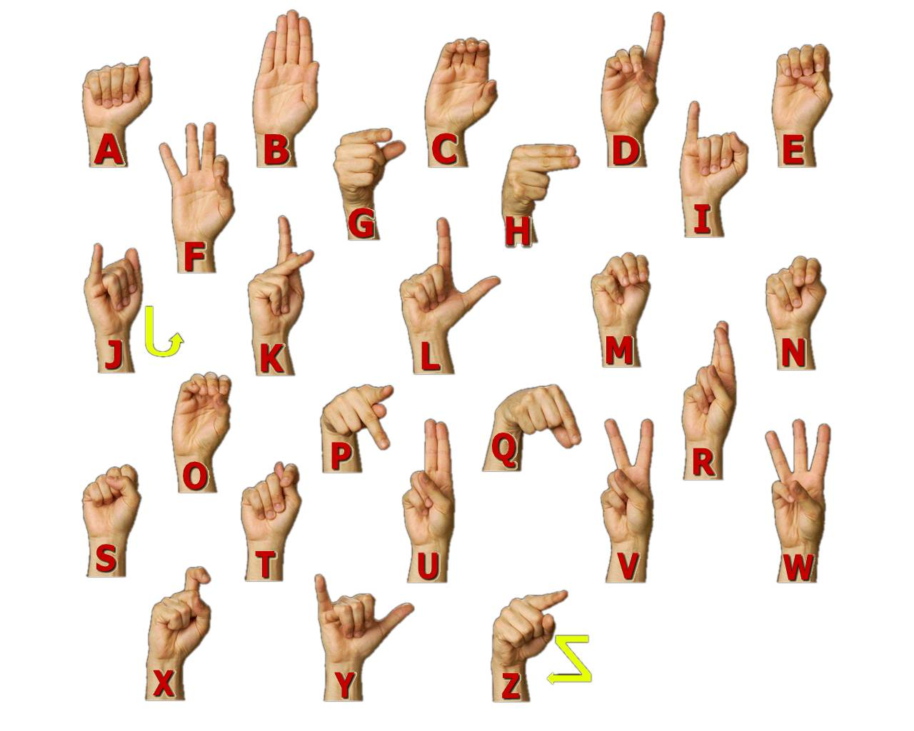
Fig. 1. The ASL Alphabets
To achieve best performance, the background should be white or green wall, the room is enough large and bright.
- Build the system
  - Creating dataset
Except Z, we pictured 700 images for each alphabet.
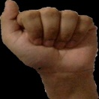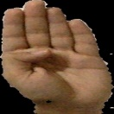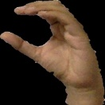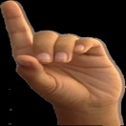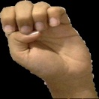
A B C D E
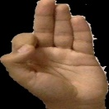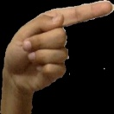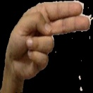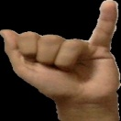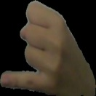
F G H I J
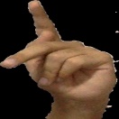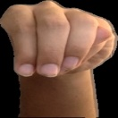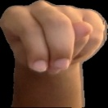
K L M N O
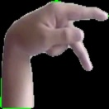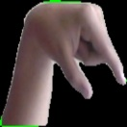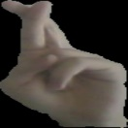
P Q R S T
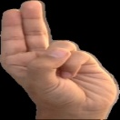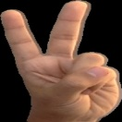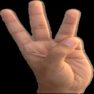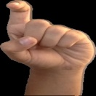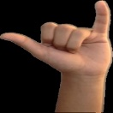
U V W X Y
Fig. 2. Dataset
  - SVM Train
First, we chose 2 values C and gamma, which affect the performance of the system.
Each image was computed HOG feature [5], then we put all of those values in one vector. Therefore, we had many vectors of each image, which were used to train SVM.
After training, we got the file train.xml. When using the program, this file will be loaded, so we don’t need to train any longer.
  - Main program
We used YCrCb color. When running the program, firstly adjust the values Y, Cr, Cb min and max so that the program can detect the hand and remove interference from the environment as much as possible.
If you want the system to recognize “static gestures”, raise your hand in front of the webcam such that it is in the blue-border square and hold the gesture in 40 frames (about 0.5s), the system will put the corresponding alphabet on the screen. To make it easy, we put a yellow alphabet which is the predicted alphabet on the left top of the screen and the red alphabet at the bottom of the screen for the right alphabet.
Now we will talk about how the system recognizes J and Z.

J. The first frame of J coincides with that of I. Therefore, if you let your hand in gesture I in 10 frames, the text “J Ready” will appear. If you still hold that gesture until 40 frames, the system will know that you want describe “I”, then print the red alphabet I and the text “J off”. If you move your hand according to the gesture J, the system will get the direction of that movement. After that, it will check the final frame of your hand. Only when two conditions are satisfied (resembling gesture J), the red alphabet J is printed.

Z. Recognition of Z is similar to J. The first frame of Z coincides with that of D. However, there are some differences. Because the first and the final frame of Z are alike, we didn’t use the method of recognizing J and used the direction – method instead. To describe Z, the fingertip moves in certain directions. If the system gets those directions, it will print the red alphabet Z.
- Result
We did 25 test for each alphabet. The table below is the result
Alph. | N⁰ of tests | N⁰ of successes | Rate(%)
A | 25 | 23 | 92
B | 25 | 24 | 96
C | 25 | 24 | 96
D | 25 | 22 | 88
E | 25 | 22 | 88
F | 25 | 22 | 88
G | 25 | 24 | 96
H | 25 | 22 | 88
I | 25 | 23 | 92
J | 25 | 22 | 88
K | 25 | 22 | 88
L | 25 | 25 | 100
M | 25 | 21 | 84
N | 25 | 23 | 92
O | 25 | 22 | 88
P | 25 | 23 | 92
Q | 25 | 23 | 92
R | 25 | 23 | 92
S | 25 | 22 | 88
T | 25 | 22 | 88
U | 25 | 23 | 92
V | 25 | 25 | 100
W | 25 | 24 | 96
X | 25 | 22 | 88
Y | 25 | 23 | 92
Z | 25 | 23 | 92
- Conclusion
In this paper, we present how we studied ASL, the method of recognizing it, the process of creating our program and the results we got.
We are happy that this program executed well. It can recognize exactly above 80%. Some failures are probably because of the dataset and the room’s brightness. Besides, although we don’t like adjust YCrCb by hand, we haven’t still found the solution to improve that yet. Therefore, we have two missions in near future: make the program automatically adjust YCrCb proper with the environment and improve the dataset.
Finally, we hope that this program can be used in real life for help people understanding the deaf.

References
- Lane, Harlan, Pillard, Richard, French, Mary : Origins of the American Deaf-World, pp. 17-44, Gallaudet University Press (2000).
- Bishop, Christopher M. : Pattern recognition and Machine Learning, Springer (2006).
- Jason Brownlee : https://machinelearningmastery.com/a-tour-of-machine-learning-algorithms/ (2013).
- Kecman, Vojislav : Learning and Soft Computing — Support Vector Machines, Neural Networks, Fuzzy Logic Systems, The MIT Press, Cambridge, MA (2001).
- Satya Mallick, https://www.learnopencv.com/tag/hog/, last accessed 2017/01/30.

