Comprehensive Assignment 01
Evidence
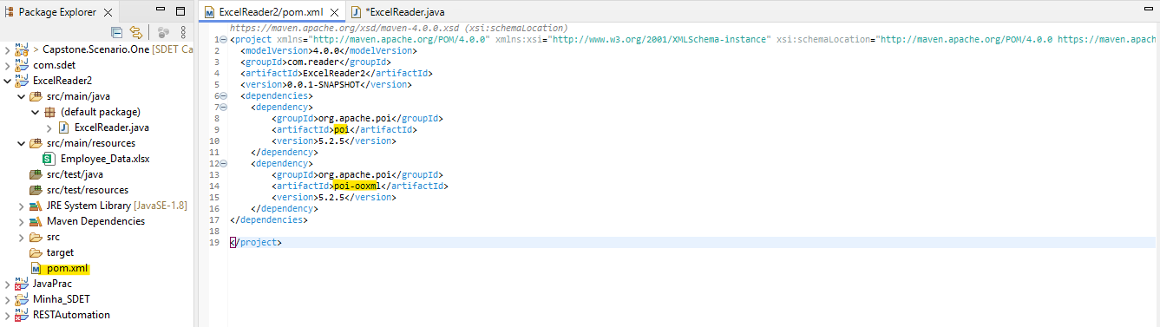

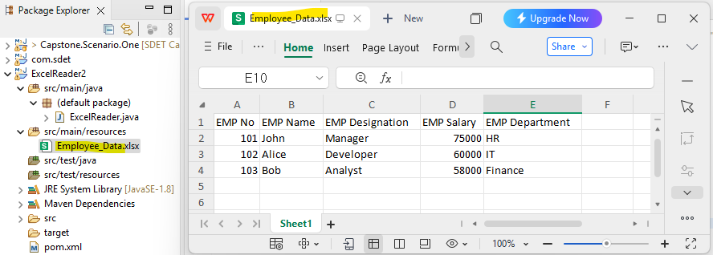

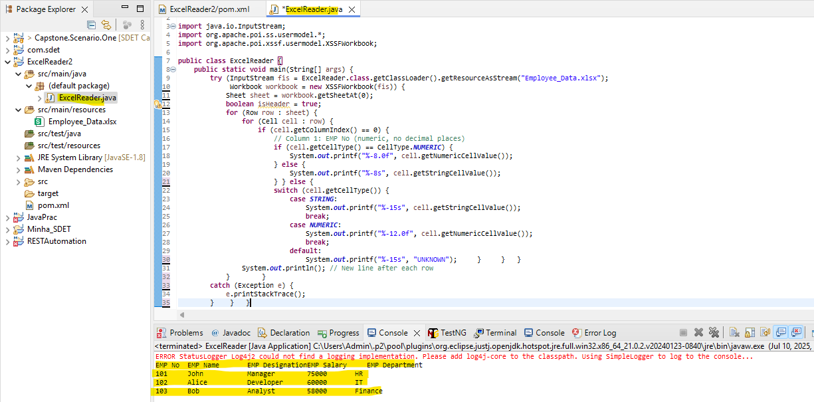

//package com.reader;
import java.io.InputStream;
import org.apache.poi.ss.usermodel.*;
import org.apache.poi.xssf.usermodel.XSSFWorkbook;

public class ExcelReader {
public static void main(String[] args) {
try (InputStream fis = ExcelReader.class.getClassLoader().getResourceAsStream("Employee_Data.xlsx");
Workbook workbook = new XSSFWorkbook(fis)) {

Sheet sheet = workbook.getSheetAt(0);

boolean isHeader = true;

for (Row row : sheet) {
for (Cell cell : row) {
if (cell.getColumnIndex() == 0) {
// Column 1: EMP No (numeric, no decimal places)
if (cell.getCellType() == CellType.NUMERIC) {
System.out.printf("%-8.0f", cell.getNumericCellValue());
} else {
System.out.printf("%-8s", cell.getStringCellValue());
}
} else {
// Columns 2–5
switch (cell.getCellType()) {
case STRING:
System.out.printf("%-15s", cell.getStringCellValue());
break;
case NUMERIC:
System.out.printf("%-12.0f", cell.getNumericCellValue());
break;
default:
System.out.printf("%-15s", "UNKNOWN");
}
}
}
System.out.println(); // New line after each row
}

} catch (Exception e) {
e.printStackTrace();
}
}
}

