Comprehensive Assignment 02
Evidence
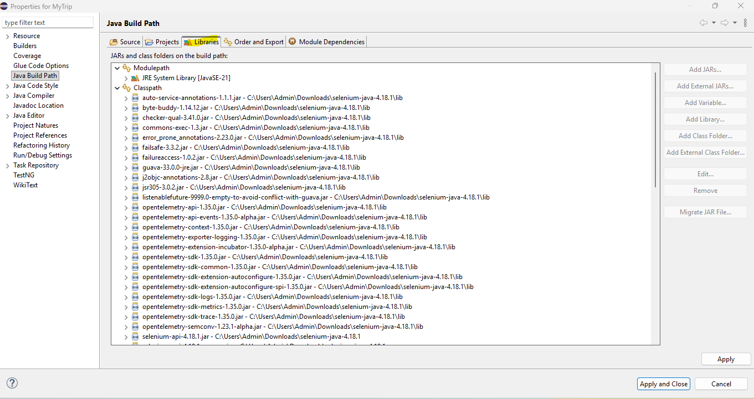
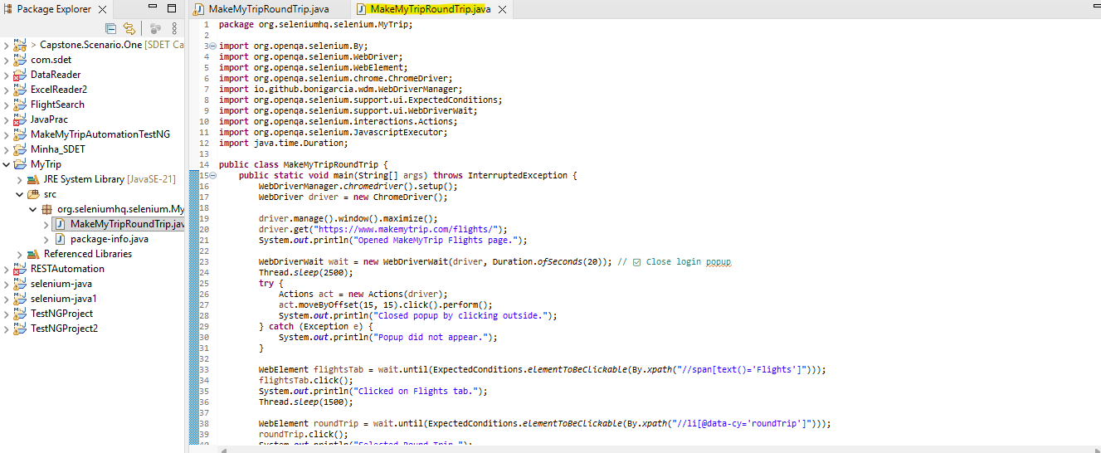
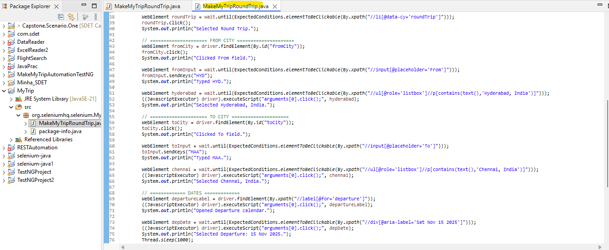
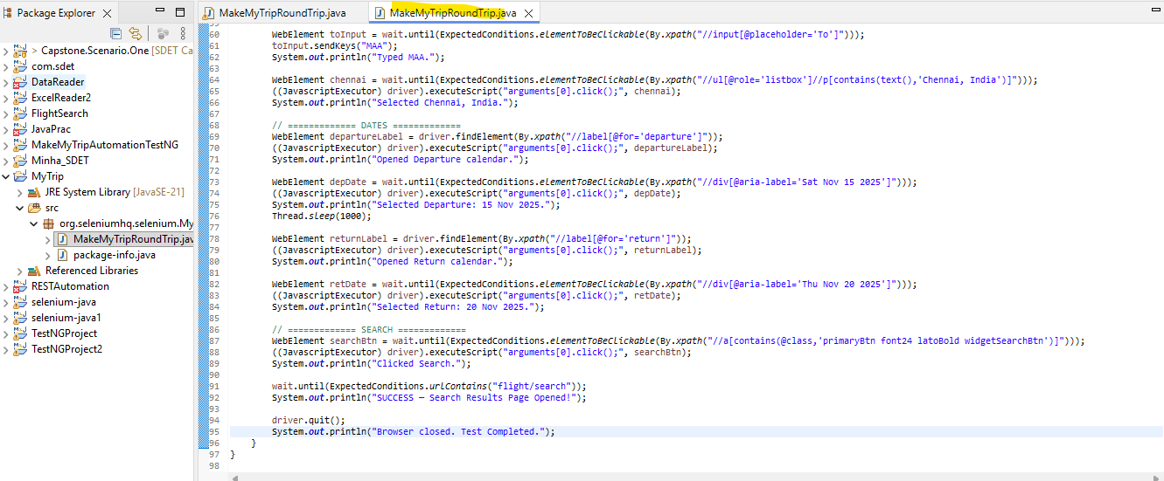
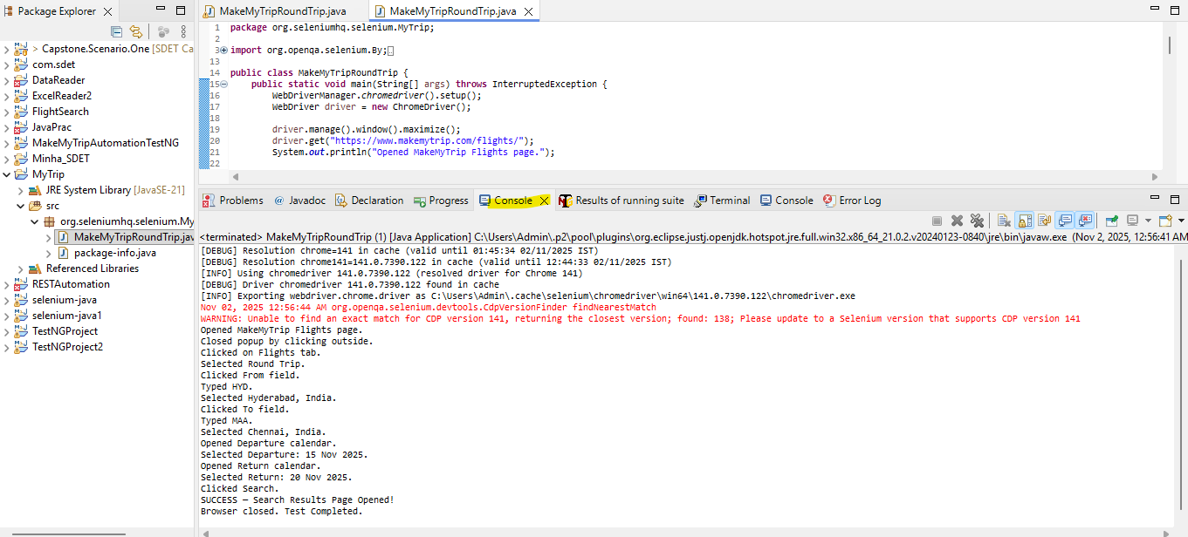
package org.seleniumhq.selenium.MyTrip;

import org.openqa.selenium.By;
import org.openqa.selenium.WebDriver;
import org.openqa.selenium.WebElement;
import org.openqa.selenium.chrome.ChromeDriver;
import io.github.bonigarcia.wdm.WebDriverManager;
import org.openqa.selenium.support.ui.ExpectedConditions;
import org.openqa.selenium.support.ui.WebDriverWait;
import org.openqa.selenium.interactions.Actions;
import org.openqa.selenium.JavascriptExecutor;
import java.time.Duration;

public class MakeMyTripRoundTrip {
public static void main(String[] args) throws InterruptedException {
WebDriverManager.chromedriver().setup();
WebDriver driver = new ChromeDriver();

driver.manage().window().maximize();
driver.get("https://www.makemytrip.com/flights/");
System.out.println("Opened MakeMyTrip Flights page.");

WebDriverWait wait = new WebDriverWait(driver, Duration.ofSeconds(20)); // ✅ Close login popup
Thread.sleep(2500);
try { Actions act = new Actions(driver);
act.moveByOffset(15, 15).click().perform();
System.out.println("Closed popup by clicking outside.");
} catch (Exception e) {
System.out.println("Popup did not appear."); }

WebElement flightsTab = wait.until(ExpectedConditions.elementToBeClickable(By.xpath("//span[text()='Flights']")));
flightsTab.click();
System.out.println("Clicked on Flights tab.");
Thread.sleep(1500);

WebElement roundTrip = wait.until(ExpectedConditions.elementToBeClickable(By.xpath("//li[@data-cy='roundTrip']")));
roundTrip.click();
System.out.println("Selected Round Trip.");

// ===================== FROM CITY =====================
WebElement fromCity = driver.findElement(By.id("fromCity"));
fromCity.click();
System.out.println("Clicked From field.");

WebElement fromInput = wait.until(ExpectedConditions.elementToBeClickable(By.xpath("//input[@placeholder='From']")));
fromInput.sendKeys("HYD");
System.out.println("Typed HYD.");

WebElement hyderabad = wait.until(ExpectedConditions.elementToBeClickable(By.xpath("//ul[@role='listbox']//p[contains(text(),'Hyderabad, India')]")));
((JavascriptExecutor) driver).executeScript("arguments[0].click();", hyderabad);
System.out.println("Selected Hyderabad, India.");

// ===================== TO CITY =====================
WebElement toCity = driver.findElement(By.id("toCity"));
toCity.click();
System.out.println("Clicked To field.");

WebElement toInput = wait.until(ExpectedConditions.elementToBeClickable(By.xpath("//input[@placeholder='To']")));
toInput.sendKeys("MAA");
System.out.println("Typed MAA.");

WebElement chennai = wait.until(ExpectedConditions.elementToBeClickable(By.xpath("//ul[@role='listbox']//p[contains(text(),'Chennai, India')]")));
((JavascriptExecutor) driver).executeScript("arguments[0].click();", chennai);
System.out.println("Selected Chennai, India.");

// ============= DATES =============
WebElement departureLabel = driver.findElement(By.xpath("//label[@for='departure']"));
((JavascriptExecutor) driver).executeScript("arguments[0].click();", departureLabel);
System.out.println("Opened Departure calendar.");

WebElement depDate = wait.until(ExpectedConditions.elementToBeClickable(By.xpath("//div[@aria-label='Sat Nov 15 2025']")));
((JavascriptExecutor) driver).executeScript("arguments[0].click();", depDate);
System.out.println("Selected Departure: 15 Nov 2025.");
Thread.sleep(1000);
WebElement returnLabel = driver.findElement(By.xpath("//label[@for='return']"));
((JavascriptExecutor) driver).executeScript("arguments[0].click();", returnLabel);
System.out.println("Opened Return calendar.");

WebElement retDate = wait.until(ExpectedConditions.elementToBeClickable(By.xpath("//div[@aria-label='Thu Nov 20 2025']")));
((JavascriptExecutor) driver).executeScript("arguments[0].click();", retDate);
System.out.println("Selected Return: 20 Nov 2025.");

// ============= SEARCH =============
WebElement searchBtn = wait.until(ExpectedConditions.elementToBeClickable(By.xpath("//a[contains(@class,'primaryBtn font24 latoBold widgetSearchBtn')]")));
((JavascriptExecutor) driver).executeScript("arguments[0].click();", searchBtn);
System.out.println("Clicked Search.");
wait.until(ExpectedConditions.urlContains("flight/search"));
System.out.println("SUCCESS — Search Results Page Opened!");

driver.quit(); System.out.println("Browser closed. Test Completed."); }}

