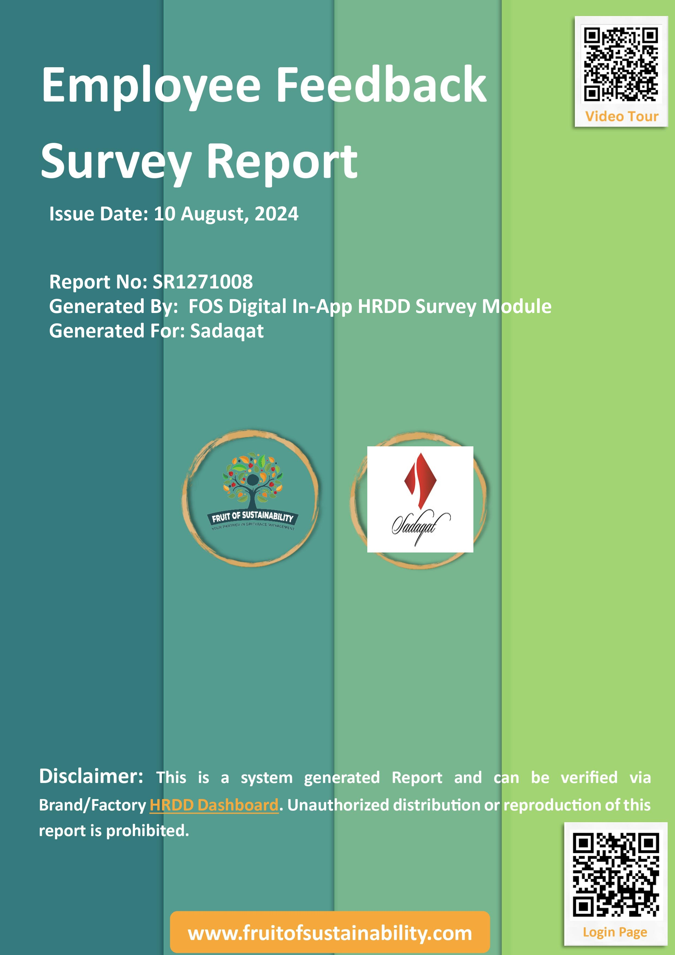

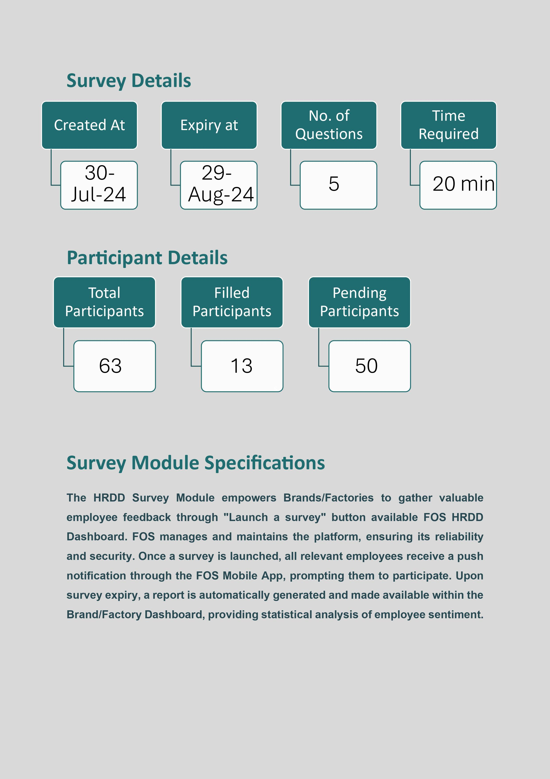

**Survey Report**

|  |  |
| --- | --- |
| Title | Description |
| Sadaqat (Test Survey) | For testing purpose |

**Q1. Testing "Test" Question Type**

**Responses:**

|  |
| --- |
| **Response 1** Login |

|  |
| --- |
| **Response 2** Login |

|  |
| --- |
| **Response 3** Login |

|  |
| --- |
| **Response 4** Login |

|  |
| --- |
| **Response 5** Complaint |

|  |
| --- |
| **Response 6** File a complain |

|  |
| --- |
| **Response 7** 1st one |

|  |
| --- |
| **Response 8** Check complaint status |

|  |
| --- |
| **Response 9** Login |

|  |
| --- |
| **Response 10** Login |

|  |
| --- |
| **Response 11** Login |

|  |
| --- |
| **Response 12** The meeting with the ResourceInn team went Great. Moeez Ghauri from ResourceInn said the API is ready and he will double check with his support team and share the credentials with Junaid Sb. FOS team has already shared the required employee data column headers with the ResourceInn team. As soon as we have access to this, we will integrate the dashboards/portals on the same working day parking all JJ teams in the relevant spots. The FOS IDs will be shared to JJ employee via SMS. And, the Flex designs will be shared to you before the starting of onsite deployment Training sessions at JJ head office and branches. If we get the API from Resourceinn today, we should be able to kick start the onsite deployment training at JJ head office on 8th August Thursday. |

|  |
| --- |
| **Response 13** File a complaint |

**Q2. Testing "TextArea" Question**

**Responses:**

|  |
| --- |
| **Response 1** What kind of long answer as there is no question |

|  |
| --- |
| **Response 2** Gahah |

|  |
| --- |
| **Response 3** Ayesha's here from skp |

|  |
| --- |
| **Response 4** Ayesha's here from skp Ma Sha Allah |

|  |
| --- |
| **Response 5** Testing of survey module is in process |

|  |
| --- |
| **Response 6** Working at FOS as a grievance management officer |

|  |
| --- |
| **Response 7** First one |

|  |
| --- |
| **Response 8** The meeting with the ResourceInn team went Great. Moeez Ghauri from ResourceInn said the API is ready and he will double check with his support team and share the credentials with Junaid Sb. FOS team has already shared the required employee data column headers with the ResourceInn team. As soon as we have access to this, we will integrate the dashboards/portals on the same working day parking all JJ teams in the relevant spots. The FOS IDs will be shared to JJ employee via SMS. And, the Flex designs will be shared to you before the starting of onsite deployment Training sessions at JJ head office and branches. If we get the API from Resourceinn today, we should be able to kick start the onsite deployment training at JJ head office on 8th August Thursday. |

|  |
| --- |
| **Response 9** Did BS psychology from COMSATS Lahore campus |

|  |
| --- |
| **Response 10** Hey I am testing this survey |

|  |
| --- |
| **Response 11** Currently pursuing MS in clinical psychology from COMSATS |

|  |
| --- |
| **Response 12** The meeting with the ResourceInn team went Great. Moeez Ghauri from ResourceInn said the API is ready and he will double check with his support team and share the credentials with Junaid Sb. FOS team has already shared the required employee data column headers with the ResourceInn team. As soon as we have access to this, we will integrate the dashboards/portals on the same working day parking all JJ teams in the relevant spots. The FOS IDs will be shared to JJ employee via SMS. And, the Flex designs will be shared to you before the starting of onsite deployment Training sessions at JJ head office and branches. If we get the API from Resourceinn today, we should be able to kick start the onsite deployment training at JJ head office on 8th August Thursday. The meeting with the ResourceInn team went Great. Moeez Ghauri from ResourceInn said the API is ready and he will double check with his support team and share the credentials with Junaid Sb. FOS team has already shared the required employee data column headers with the ResourceInn team. As soon as we have access to this, we will integrate the dashboards/portals on the same working day parking all JJ teams in the relevant spots. The FOS IDs will be shared to JJ employee via SMS. And, the Flex designs will be shared to you before the starting of onsite deployment Training sessions at JJ head office and branches. If we get the API from Resourceinn today, we should be able to kick start the onsite deployment training at JJ head office on 8th August Thursday. |

|  |
| --- |
| **Response 13** Testing survey |

**Q3. Testing Radio Question answer**

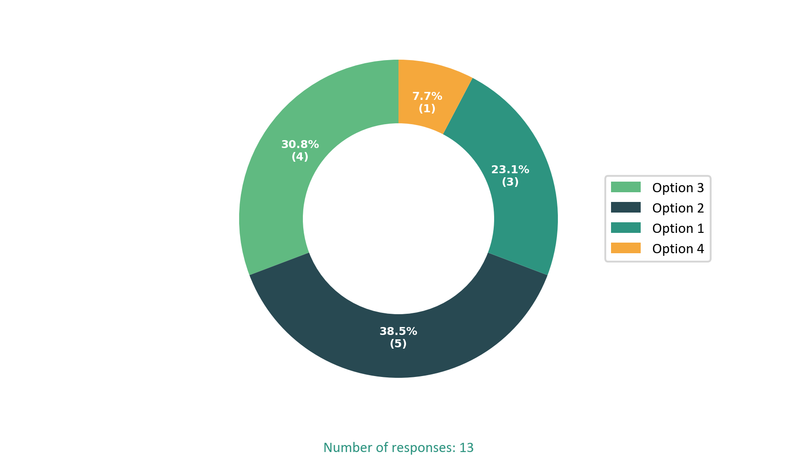

**Q4. Testing Check Boxes**

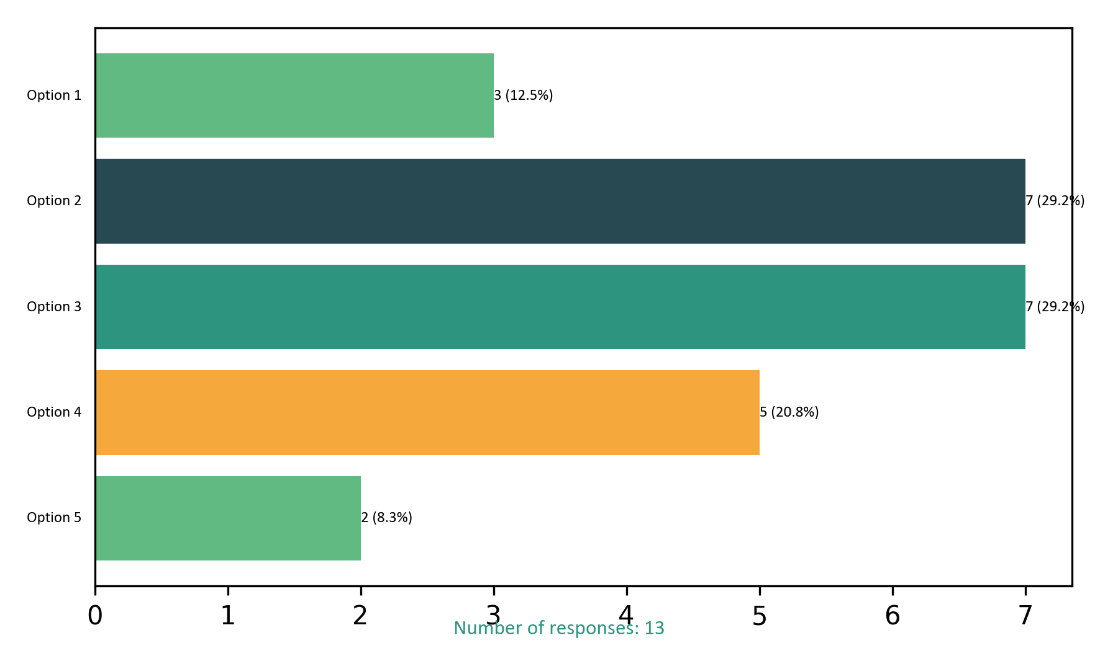

**Q5. Testing Select Question type**

