# MGM’s

# College of Computer Science & IT, Nanded.

# Blood Donation Camp Report 2022

With reference to the circular (NSS/2022-23/256) dated 23/11/2022 , NSS unit of MGM College of CS & IT, Nanded, organized a blood donation camp , on 2nd October 2022 at the college as per the directives of Dr.Shankarrao Chavan Govt. Medical College & Hospital,Vishnupuri-Nanded.

The camp began at 10.00 a.m. with a short inaugural function where team was given a floral welcome.

Indian Red Cross Society Blood Bank members expressed their gratitude to the NSS unit of the college for its continuous endeavor in this regard. Team stressed on the growing need of blood in the state and commended the young volunteers for their noble act.

150 volunteers came forward to donate blood during the camp which included teaching & non-teaching staff, student donors. At the end 78 units of Blood was collected. The blood donors were given lemon juice, Biscuits and tea after donating the blood in order to reenergize themselves.

The blood donors were provided with a blood donation certificate .The medical team was provided with lunch and the camp concluded at around 2.30 p.m.

This was the 1st camp conducted by the NSS unit for this academic year, where in 78 volunteers donated blood.

The blood donation camp was coordinated by Dr.Dahale S.V., NSS coordinator of the college. He was assisted by (Asst Prof.)Mr. Bhosle A.T.,Mr.Shinde S.P. and all NSS Programme Officers.

**Photographs**

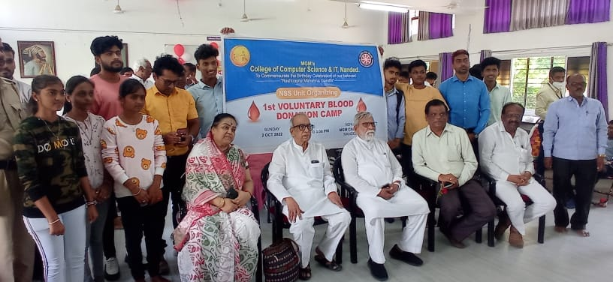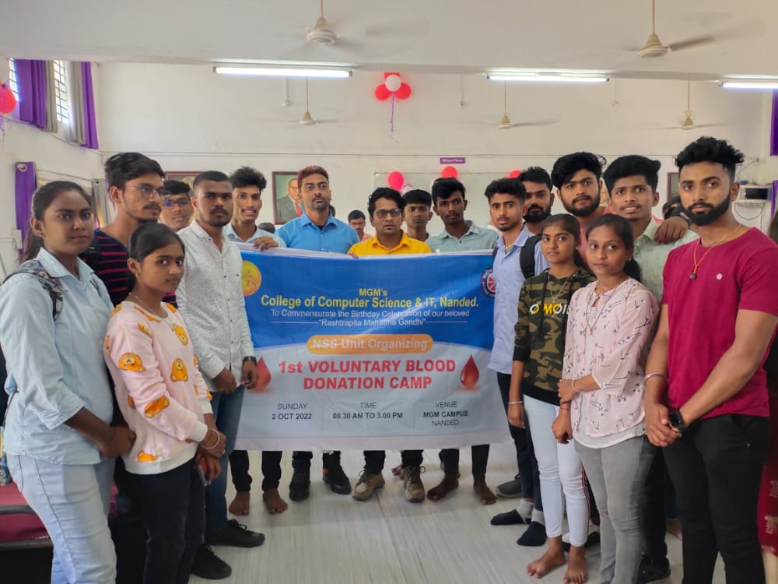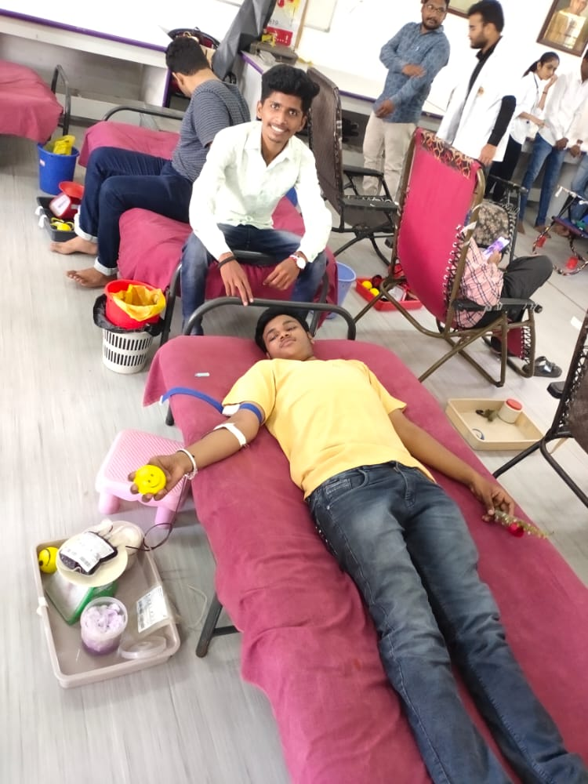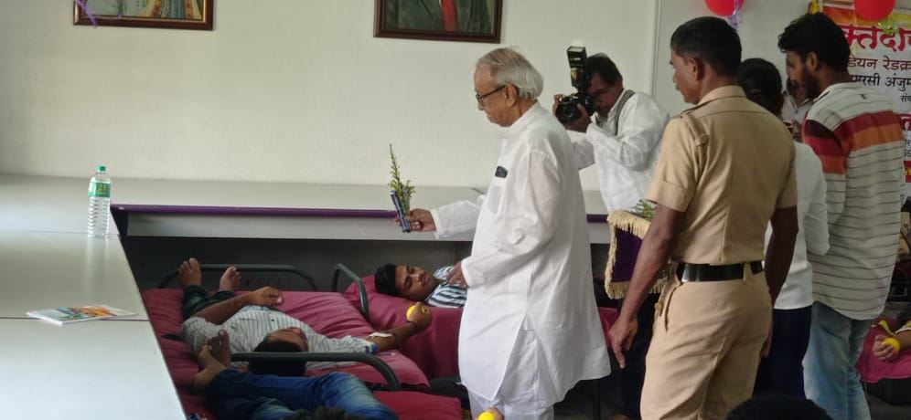 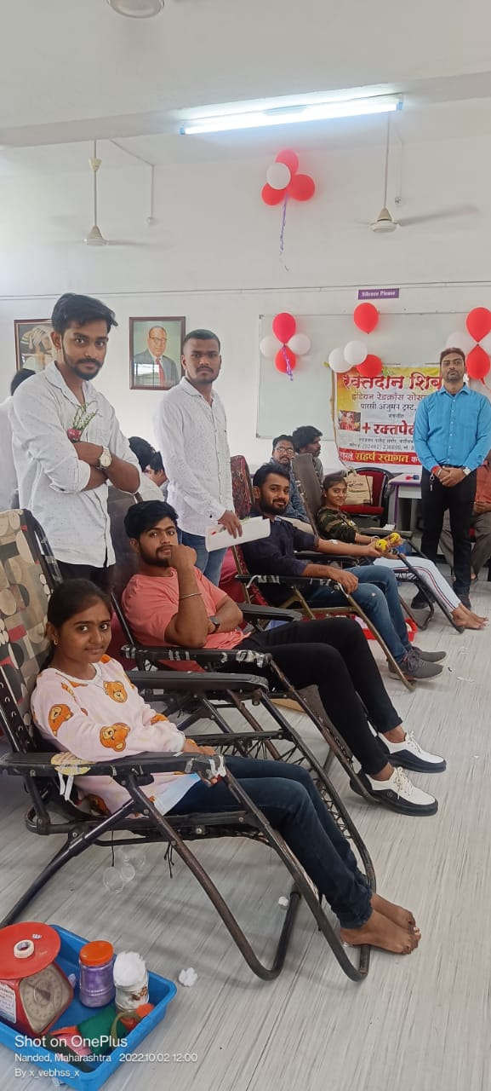

|  |  |  |
| --- | --- | --- |
| **Workshop Coordinator** | **(H.O.D, CS & IT)** | **Principal** |
| Dr. Dahale S.V.  Mr. Bolwar S.S.  Ms. Malge S.M. | Dr. Mrs. Nandedkar K.A. | Prof. Kotgire S.L. |
|  |  |  |