# MGM’s

# College of Computer Science & IT, Nanded.

# Cleanliness Drive Report-2022

With reference to the circular(NSS/2022-23/84) dated 30/07/2022 NSS unit of MGM college of CS & IT Nanded organized Cleanliness Drive on 13 August 2022 for B.Sc.(CS),BCA, B.Sc.(BT),B.Sc.(BI),M.Sc.(SE),M.Sc.(BT),M.Sc.(BI) under Swachh Bharat Swasth Bharat Abhiyaan Programme. The main purpose of this programme was to create awareness among the students regarding Cleanliness and its benefits.

Under this programme, all the students of had to participate. Even all teaching and non-teaching staff were the essential part of this drive. As a part of this Cleanliness Drive, we had to clean the whole college. The sweepers of the college had to be the observers.

Our Principal started the programme by cleaning the corners of the play ground. Then the staff and students followed suit. Some of us picked brooms and started our[job.](https://www.examweb.in/how-to-improve-gd-skills-for-cat-job-interviews-some-tips-1530) Some of the[students](https://www.examweb.in/errors-indian-students-generally-english-10989) did the dusting of the rooms.

And others went to the play ground and started picking wrappers lying scattered there. After collecting them they threw them in to the dustbins. After doing this job for two to three hours, there we gave refreshment to all in the form of bananas and tea.

Thereafter our Principal Dr.Kotgire S.L.delivered the speech telling us the importance of sanitation. He also honored the sweepers of the college for their noble job. In the end we all took oath of keeping our home, locality and city clean. It was a unique experience for all of us. We were curious to be the part of this great drive that could have transformed the face of our country for ever.

**Photographs**

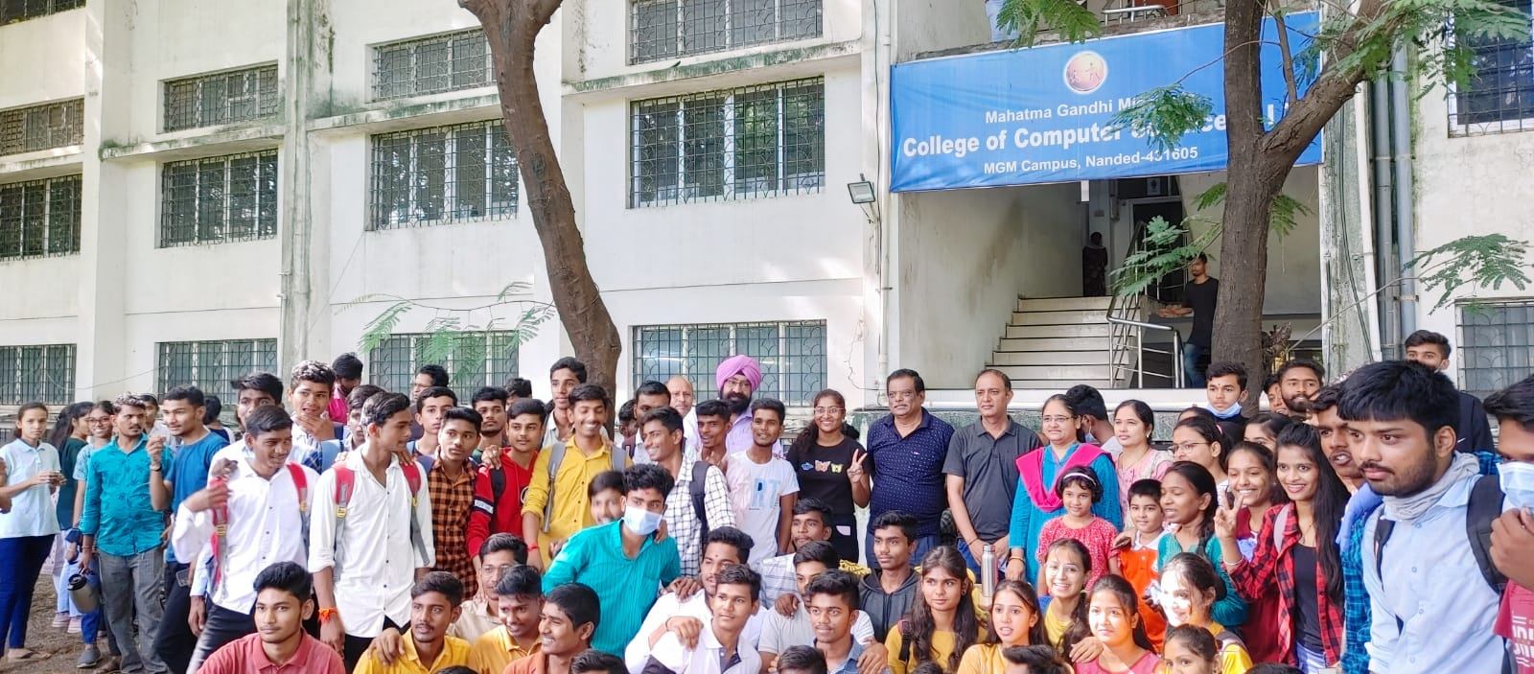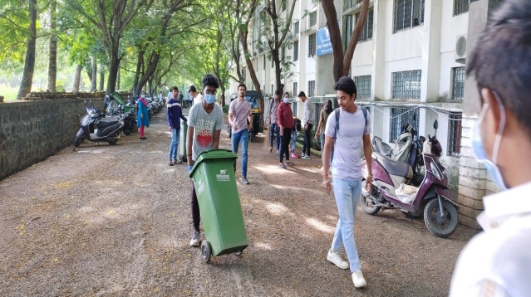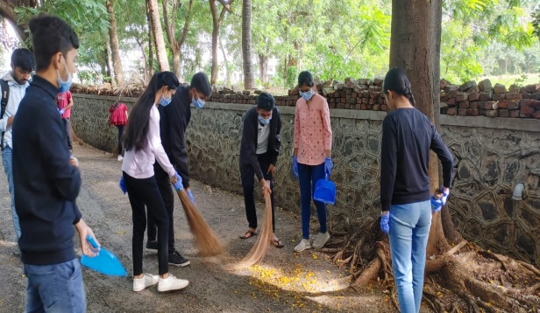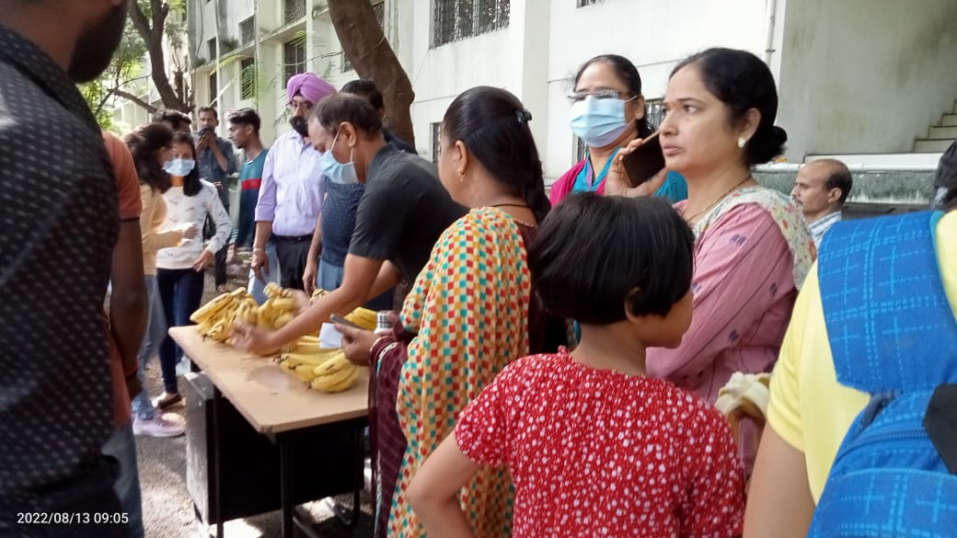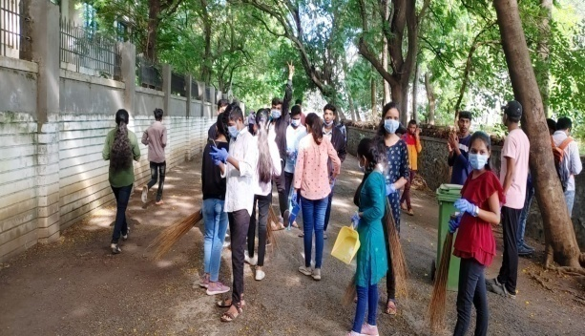

|  |  |  |
| --- | --- | --- |
| **Workshop Coordinator** | **(H.O.D, CS & IT)** | **Principal** |
| Dr. Dahale S.V.  Mr. Bolwar S.S. | Dr. Mrs. Nandedkar K.A. | Prof. Kotgire S.L. |
| Ms. Malge S.M. |  |  |