# MGM’s

# College of Computer Science & IT, Nanded.

**Constitution Day Report 2022**

With reference to the circular(NSS/2022-23/244) dated 12/11/2022 , NSS unit of MGM College of CS & IT,Nanded organized celebration of constitution day on November 26th, 2022 at the college as per the directives of All India Council for Technical Education, Government of India.

The objective of event was to make students aware about the constitution of India. India's Constitution was adopted on November 26, 1949, and came into force on January 26, 1950, marking the beginning of a new era in the history of India. The Government of India, in 2015 decided to observe 26th November as 'Constitution Day' or 'Samvidhan Divas'.

NSS coordinator Dr.Dahale S.V. emphasized the importance of Constitution Day, the significance of its celebration and commemorated the people who contributed to the development of Indian constitution. He highlighted the basic differences of Indian constitution than that of other countries with examples indicating the prerequisites of the constitution such as societal, familial and individual needs.

The preamble of Indian Constitution i.e India to be a sovereign, socialist, secular and democratic republic which is aiming to secure justice, liberty, equality to all citizens and promote fraternity to maintain unity and integrity of the nation were stressed in his speech as these rights are necessity and are not a privilege**.**

**Photographs**

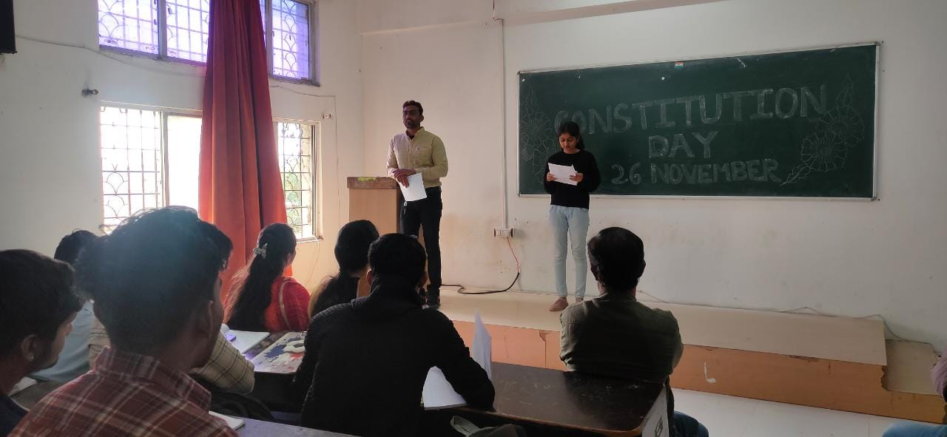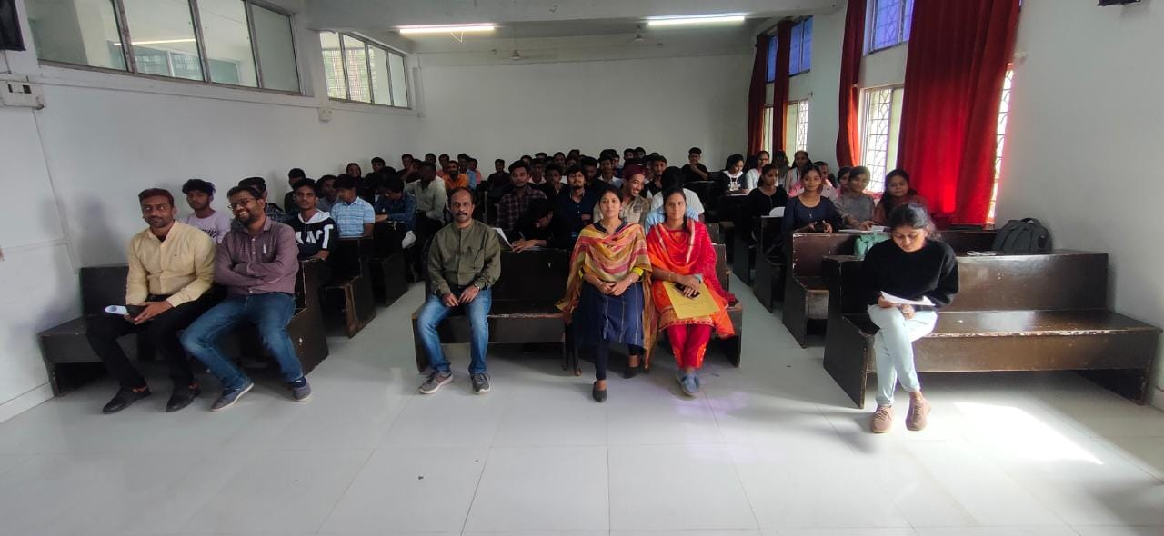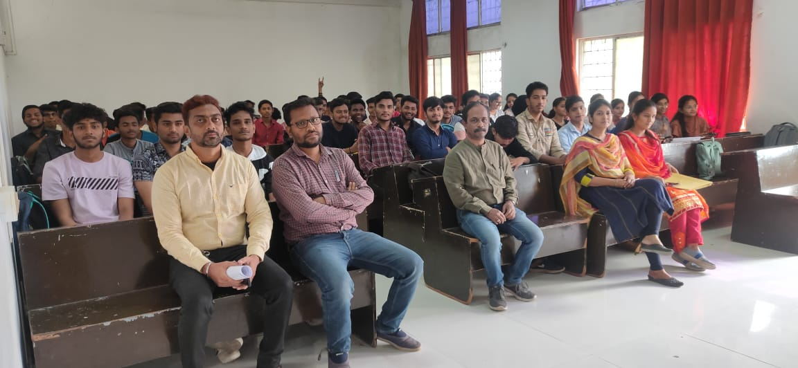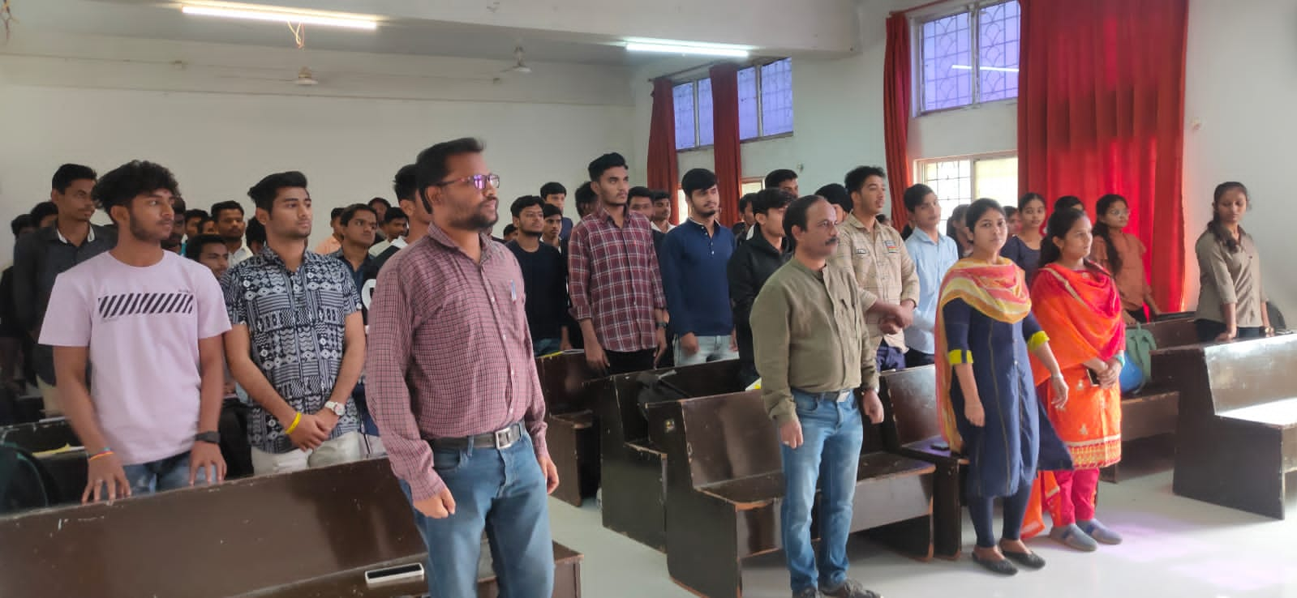

|  |  |  |
| --- | --- | --- |
| **Workshop Coordinator** | **(H.O.D.CS & IT)** | **Principal** |
| Dr. Dahale S.V.  Mr. Bolwar S.S.  Ms. Malge S.M. | Dr. Mrs. Nandedkar K.A. | Prof. Kotgire S.L. |