# MGM’s

# College of Computer Science & IT, Nanded.

# Unity Run Report-2022

NSS unit of MGM College of CS and IT -Nanded ,organized “Unity Run” on 31 October 2022 to commemorate the birth anniversary of the first Home Minister and the ‘Iron Man’ of India,Sardar Vallabhbhai Patel. Hundreds of students and several teaching and non-teaching staff of the College enthusiastically participated in it.

The event started at 11 AM in the College with an address by Principal, Dr. Shirish Kotgire. In short speech, Dr. Kotgire S.L. remembered Sardar Patel’s legacy and commended his tenuous efforts in integrating over 565 princely states into the Union of India with his astute administrative abilities and iron will. He remarked that Sardar Vallabhbhai Patel was one of the founding fathers of India who was solely responsible for the unification of modern India that earns him the title, the ’Bismarck of India’. He reiterated that the young citizens and the staff of the college must ensure that the Unity of Nation remains intact at all cost. Furthermore, he promised that College will organize several programmes every year to mark his legacy. Later Dr. Kotgire also administrated all the participants the oath to protect the integrity of India.

After the pledge, the unity march proceeded in the college campus. Subsequently, the participants were served refreshments. The entire event was organized by the NSS Activity Committee with Dr.Dahale S.V. as its convenor.

To further express its gratitude and reiterate College’s commitment to educate the students to preserve the unity of the Nation.

**Photographs**

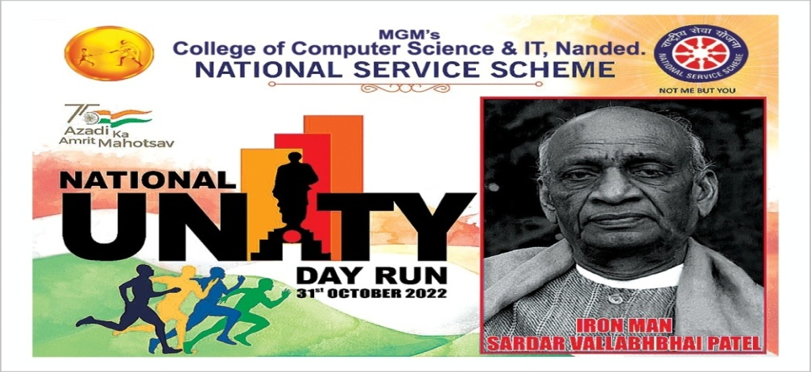

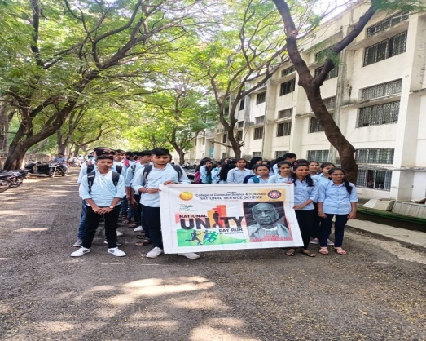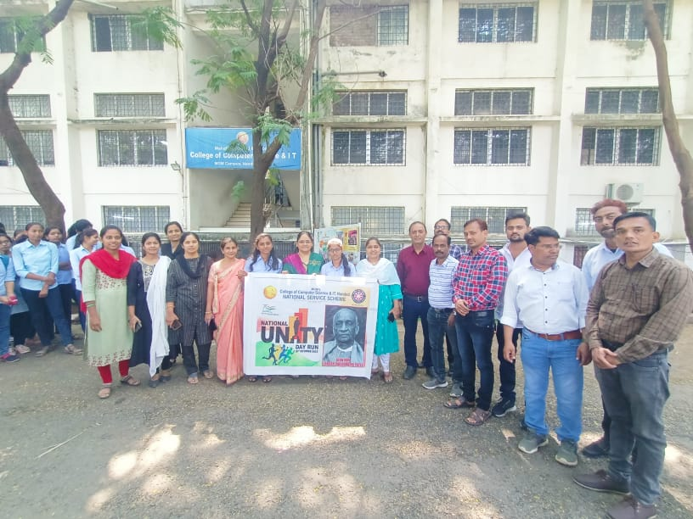

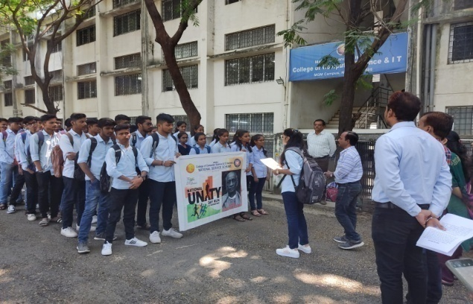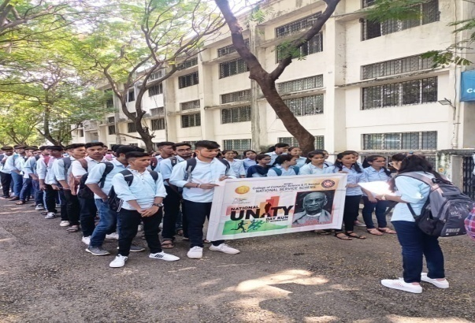

|  |  |  |
| --- | --- | --- |
| **Workshop Coordinator** | **(H.O.D, CS & IT)** | **Principal** |
| Dr. Dahale S.V.  Mr. Bolwar S.S. | Dr. Mrs. Nandedkar K.A. | Prof. Kotgire S.L. |
| Ms.Malge S.M. |  |  |