# MGM’s

# College of Computer Science & IT, Nanded.

**Voter ID Registration Camp Report 2022**

With reference to special activity from the NSS unit of MGM college of CS & IT, Nanded, organized the Voter ID Registration Camp on 5 December 2022 in the college campus.

The College Principal, Dr.Korgire S.L. honored the chief guests, Collector of Nanded Dist. Mr.Abhijit Raut.

H.O.D. of CS & IT department Dr. Mrs. Nandedkar K.A. honored Deputy Election Officer of Nanded Dist. Smt. Deepali Motiyele, Tahsildar of Nanded Dist.Smt. Snehalata Swami, Niab Tahsildar of Nanded Dist.Smt.Urmila kulkarni

H.O.D. of BT & BI department Dr.Cherekar M.N. honored Sub divisional officer of Nanded Dist. Mr.Vikas Mane.

Honorable Mr.Abhijit Raut explained the importance of voting in the election process. He insisted all the eligible students submit their new voter application form to the NSS Volunteers.

Principal Dr.Kotgire S.L. insisted the students should come forward to vote in all the elections to participate in the democratic process.

Totally 200 students get benefitted from this camp. This Voter Registration Camp was coordinated by the NSS unit coordinator Dr.Dahale S.V.

**Photographs**

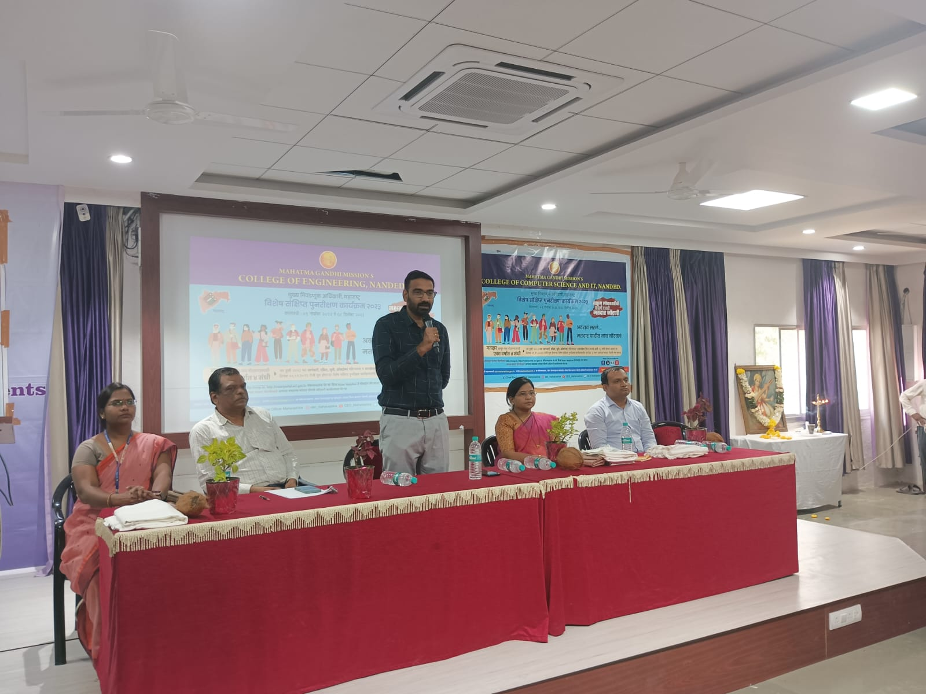

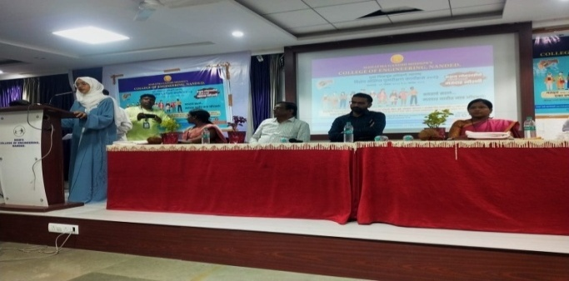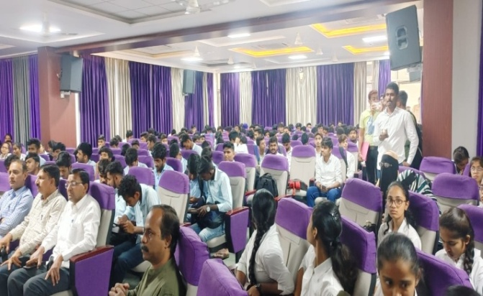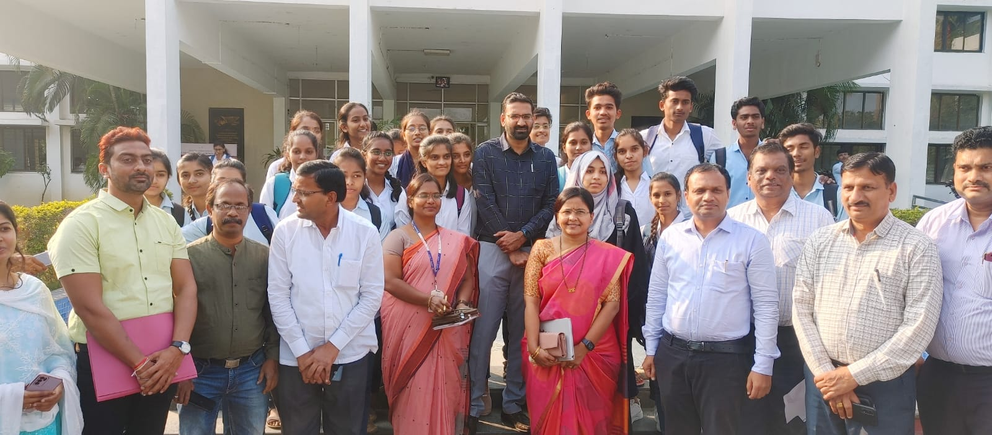

|  |  |  |
| --- | --- | --- |
| **Workshop Coordinator** | **(H.O.D.CS & IT)** | **Principal** |
| Dr. Dahale S.V.  Mr. Bolwar S.S.  Ms. Malge S.M. | Dr. Mrs. Nandedkar K.A. | Prof. Kotgire S.L. |