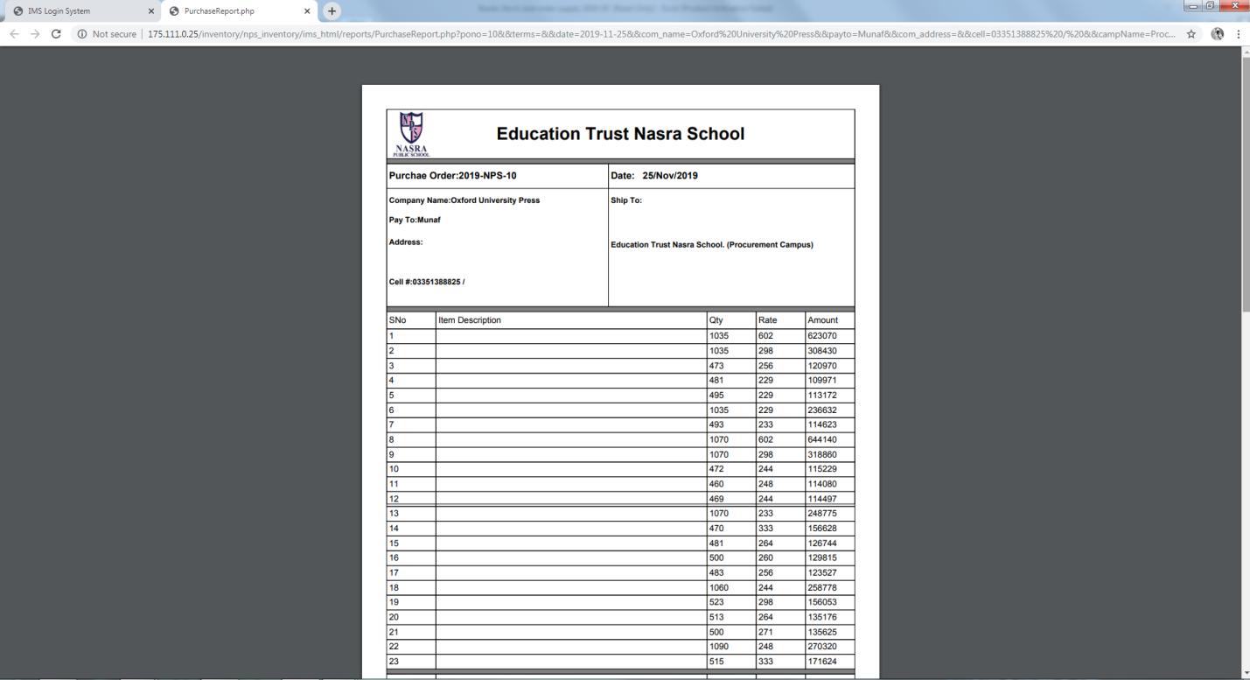

This is Purchase Order. We cannot see the item name in it. Also we need Education Trust Nasra School logo in the report. This is NPS logo.

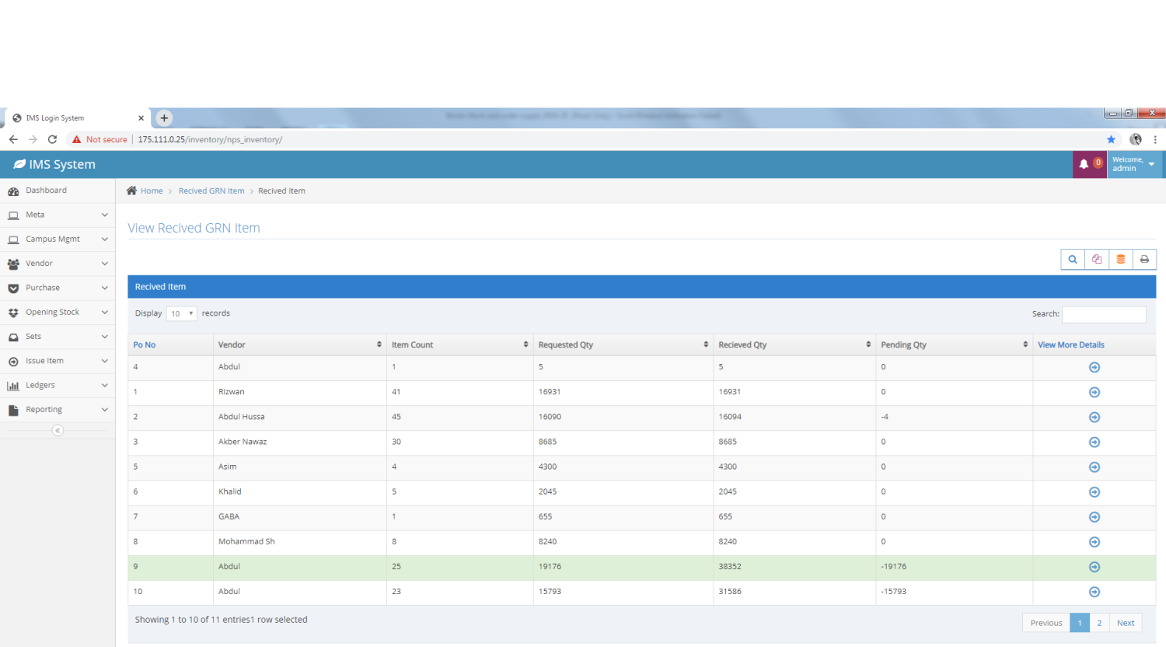

In this Picture, Items are received against PO. But somehow each items when received got duplicated.

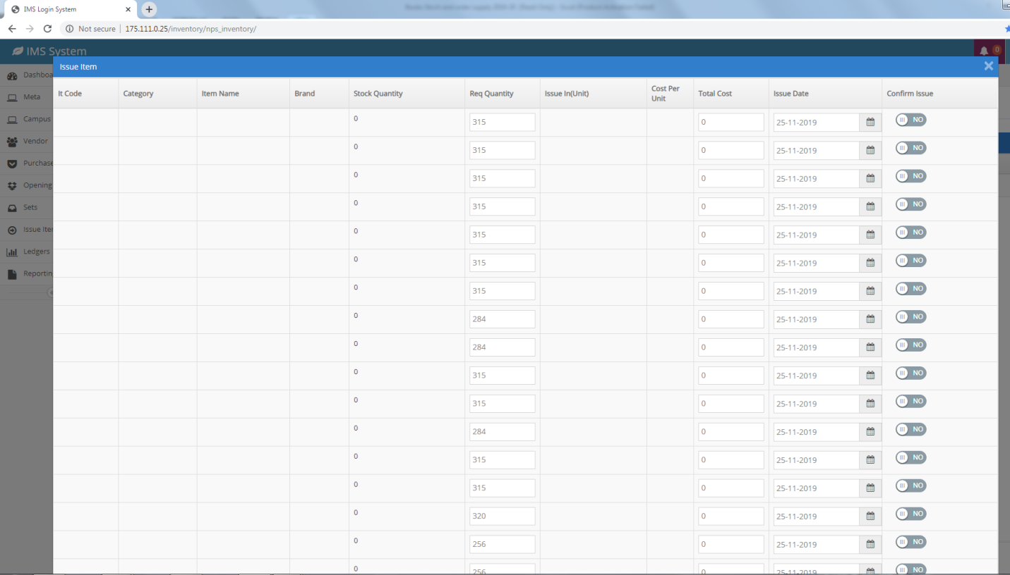

A request was made from Saddar Campus ID. No alert was raised to admin ID. Also when we are trying to issue items (even though the items requested in this are in stock) it is showing that there is no inventory.

