DEPARTMENT OF COMPUTER SCIENCE AND IT
NED UNIVERSITY OF ENGINEERING & TECHNOLOGY
COMPLEX COMPUTING PROBLEM (CCP)
REPORT
Course Code: CT-351
Course Title: Knowledge Representation & Reasoning
Project Title: | Smart Parking Access & Space Allocation Reasoning System (CarePark-KR)
Selected Domain: | Smart parking: hospital car park access and bay allocation (Car park P, Riverside General Hospital)
Section:
Submission Date: | November 2026

GROUP MEMBERS
S. No. | Student Name | Roll Number | Assigned Contribution
1 | Minhaj Khan | AI-23301 | Problem, knowledge acquisition, frames and script
2 | Faraz Khan | AI-23047 | Semantic network, description logic, expressivity analysis
3 | Raied Khan | AI-23046 | FOL, Horn knowledge base, forward chaining
4 | Sabih Salam | AI-23040 | Backward chaining, website and 3D twin, testing, report

Instructor: Miss Dure Shahwar
CLO: CLO-3 (Design/Analysis) PLO: PLO-10 (Lifelong Learning)
Group: ____ Semester: 7th

Department of Computer Science and IT
Course Code: CT-351 | Course Title: Knowledge Representation & Reasoning
Complex Computing Problem (CCP): Grading Rubric
Student No. | Name | Roll No.
S1 | Minhaj Khan | AI-23301
S2 | Faraz Khan | AI-23047
S3 | Raied Khan | AI-23046
S4 | Sabih Salam | AI-23040

Criteria and scales | 0 (Unsatisfactory) | 1 (Developing) | 2 (Proficient) | S1 | S2 | S3 | S4
Criterion 1: Problem Statement & Motivation | Objective of the project and domain requirements are not clear or described. | Some lack of clarity in objectives/purpose or domain justification. | The project's objectives and domain motivation are clearly stated and justified.
Criterion 2: Structural KR (Frames & Semantic Networks) | Model fails to represent necessary concepts, frames, slots, or semantic relationships. | Model includes frames and semantic networks but lacks complete slots, facets, or default values. | Model meets Proficient criteria with comprehensive, accurate frame structures and semantic networks.
Criterion 3: Formal Logic (FOL & Description Logic) | Logical representations contain major syntax/semantic errors or are missing. | FOL and DL formulas are present but contain minor syntax/quantifier errors. | Model represents domain constraints perfectly using correct FOL formulas and Description Logic axioms.
Criterion 4: Inference Engine (Horn Clauses & Chaining) | Rules are not converted to Horn clauses; failure to execute chaining. | Rules are in Horn clauses, but Forward/Backward chaining traces have minor logical gaps. | Horn clauses are correctly formulated with flawless, detailed Forward and Backward chaining traces.
Criterion 5: Team Participation & Individual Viva | The individual did not contribute to the project and failed to answer viva questions. | The individual contributed partially and demonstrated basic understanding during viva. | The individual contributed significantly and demonstrated mastery of KR concepts during viva.
Total Marks (Out of 10):

Teacher's Signature: ___________________________ Date: _______________

REPORT CONTENTS
1. INTRODUCTION 4
1.1 Selected Domain and Background 4
1.2 Problem Statement and Objectives 4
2. DOMAIN ANALYSIS 5
2.1 Domain Description and Requirements 5
2.2 Entities, Relationships, and Challenges 7
3. KNOWLEDGE REPRESENTATION 10
3.1 Frames 10
3.2 Semantic Networks 16
4. FORMAL LOGIC REPRESENTATION 19
4.1 First-Order Logic (FOL) 19
4.2 Description Logic (DL) 20
5. HORN CLAUSE KNOWLEDGE BASE 24
5.1 Knowledge base 24
5.2 Facts 24
5.3 Rules 24
5.4 Horn clause conversion 25
5.5 Prolog form 26
6. INFERENCE AND REASONING 27
6.1 Forward Chaining 27
6.2 Backward Chaining 31
7. IMPLEMENTATION 35
7.1 Tools and Technologies 35
7.2 Code / Execution 35
8. RESULTS AND DISCUSSION 41
8.1 Results 41
8.2 Discussion 42
9. CONCLUSION 44
9.1 Conclusion and Future Improvements 44
10. REFERENCES 44
11. TEAM PARTICIPATION 44

1. INTRODUCTION

1.1 Selected Domain and Background
The selected domain is smart parking at a hospital: who may drive into Car park P at Riverside General Hospital, and which bay each vehicle should get. A hospital car park is harder than an office or campus car park because the stakes are uneven. An ambulance on a run must never wait, a dialysis patient must reach the unit on time, an on-call cardiologist must be close to the ward, and a visitor arriving outside visiting hours should be kept to the short-stay drop-off bays. The same car park also serves suppliers with delivery slots, staff with badges and shifts, and people with disability badges or wheelchair vans that cannot use the 2.1 m ramp.
Today these decisions are made by a gate guard with a printed list. Decisions differ from guard to guard, a refusal is rarely explained, and when the hospital declares a code red (mass-casualty mode) or the weather turns, the rules change in ways nobody has written down. Every one of these decisions is an inference from facts (who the driver is, what time it is, how tall the vehicle is, which bays are free) through policy rules to a conclusion. That is exactly the kind of problem knowledge representation and reasoning is built for.

1.2 Problem Statement and Objectives
Given the facts about people, vehicles, badges, shifts, appointments, delivery slots, levels, zones and bays for one day, decide for every arriving vehicle whether it is admitted, which bay it gets, how much it pays and what alerts follow, and explain each decision rule by rule. Every refusal must name the first condition that failed. The policy must be written once, as knowledge, and checked for consistency.
The objectives are:
- Model the domain with class frames that carry slots, facets, defaults and demons (at least 25 class frames), a script for a parking visit, and a semantic network with is-a, has-a and part-of links.
- Write the policy in first-order logic with explicit quantifiers, and the vocabulary as a description-logic TBox and ABox with subsumption, membership and disjointness axioms.
- Convert the rules into Horn clauses, and run them with a forward chainer (data-driven) and a backward chainer (goal-driven) that print full traces.
- Handle negation (not banned, no charger, not out of service) safely with stratified negation as failure.
- Check the knowledge base with integrity constraints, and test the system with at least 20 scenarios covering normal days, policy changes, edge cases and bad data.
- Show the reasoning in an interactive 3D digital twin of the car park, so an examiner can watch the day and question any decision.
The system covers one hospital car park with 4 levels, 13 zones, 29 bays and 8 hospital departments, and one full day (Tuesday 10 November 2026) with 15 arriving drivers and 3 cars parked overnight. Times are minutes after midnight (07:05 = 425) and dates are YYYYMMDD integers. It does not take payments, read real sensors or learn from data.
The solution has four layers (Figure 1). The knowledge layer holds 431 facts, 97 Horn rules, 13 integrity constraints and 22 scenarios. The reasoning layer has the forward chainer, the day-replay control layer, the backward chainer with a why-not explainer, and the constraint checker. The representation layer holds the frames, script, semantic network, FOL statements and DL ontology. The interface layer has a command-line program and a web control room with a 3D digital twin. An exporter writes the knowledge base to JSON, so the website runs exactly the same rules.
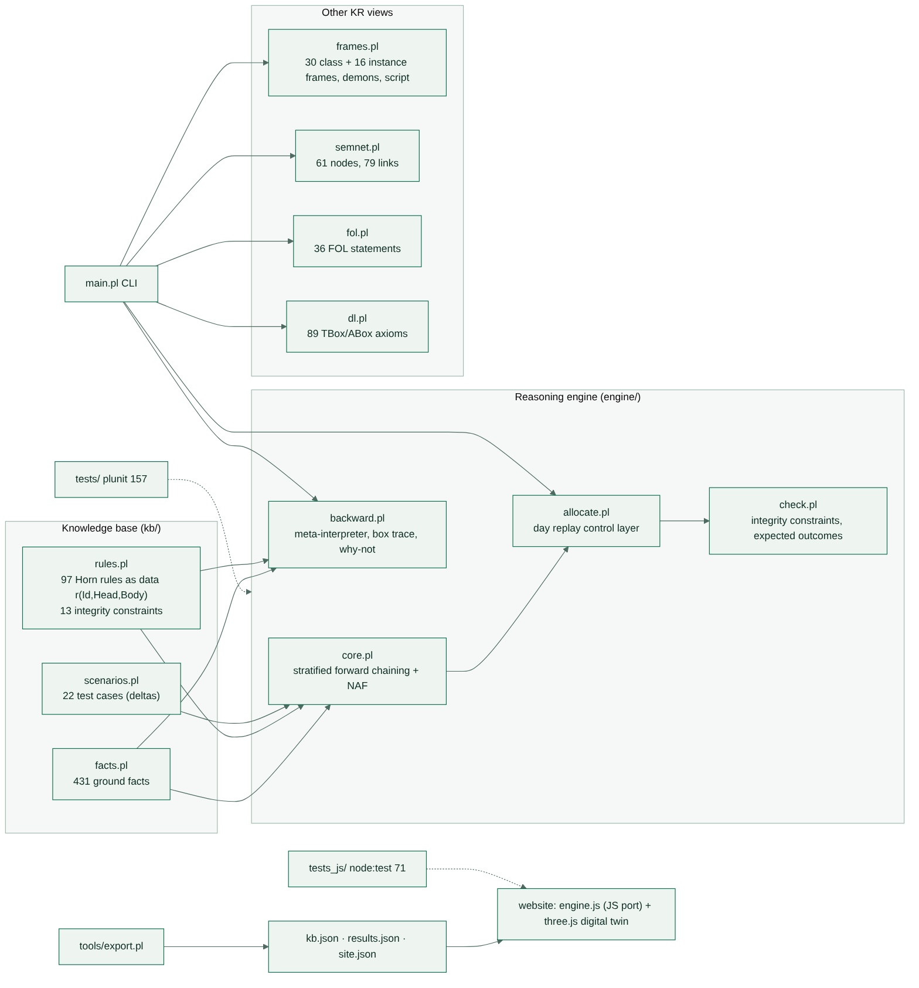
Figure 1: System architecture of CarePark-KR

2. DOMAIN ANALYSIS

2.1 Domain Description and Requirements

2.1.1 Hospital parking domain
Car park P has a ground level with a 4.0 m clearance and three upper levels (L1, L2 and an open roof) reached by an internal ramp with a 2.1 m clearance. The ground level holds the ambulance bays, drop-off bays, accessible bays, the loading bay, EV charger bays and motorcycle bays. L1 holds the on-call, staff, patient and maternity zones; L2 holds the visitor and family zones; the roof is overflow. Bay vs4 is out of service on the day.
Table 1: Levels, zones and bays of Car park P
Level | Route clearance | Zones (kind) | Bays
Ground (g) | 400 cm | z_amb (ambulance), z_drop (drop-off), z_acc (accessible), z_load (loading), z_ev (charger), z_moto (motorcycle) | amb1–2, dr1–2, ac1–2, ld1, ev1–2, mc1–2 (11)
L1 | 210 cm | z_oncall, z_staff, z_patient, z_mat (maternity) | oc1–2, st1–4, pt1–3, mt1 (10)
L2 | 210 cm | z_visit, z_family | vs1–4, fm1 (5; vs4 out of service)
Roof | 210 cm | z_roof (overflow, open air) | rf1–3 (3)

A walking table gives the distance in metres from each of the 13 zones to each of the 8 departments (emergency, cardiology, oncology, maternity, OPD, dialysis, pharmacy, admin), 104 entries in all. The main scenario is one day. Fifteen drivers arrive between 06:40 and 15:05, and three cars parked overnight (Zubair's EV in ev2, Hamid and Lubna in st1 and st2) leave during the day.
Table 2: Drivers on the main scenario day
Driver | Role | Going to | Vehicle | Arrives | What makes the case interesting
Saad | doctor | cardiology | ev_sa (EV, 22%) | 07:05 | on call, low battery
Mariam | nurse | maternity | mc_ma (motorcycle) | 06:40 | first arrival
Areeba | doctor | OPD | suv_ar (SUV) | 07:50 | normal shift
Imtiaz | patient | dialysis | car_im | 07:45 | appointment 08:00
Junaid | supplier | pharmacy | van_ju (260 cm) | 08:40 | delivery slot 08:30–09:30
Faisal | paramedic | emergency | amb_fa (ambulance) | 09:00 | ambulance on a run
Bushra | admin | admin | car_bu | 09:20 | badge expired 31 Oct
Noor | patient | oncology | wv_no (wheelchair van, 230 cm) | 09:45 | disability badge
Kashif | visitor | cardiology | car_ks | 10:15 | outside visiting hours
Sadia | visitor | cardiology | car_sd | 11:30 | with children
Rukhsana | visitor | maternity | car_ru (SUV) | 11:40 | expectant mother
Waqar | visitor | OPD | car_wq | 11:45 | security ban
Ghazala | visitor | emergency | car_gh | 12:40 | declared emergency
Tahir | patient | OPD | car_th | 14:00 | three hours late for 11:00
Yasir | visitor | oncology | car_ya | 15:05 | plate read at 64%

2.1.2 Knowledge acquisition
We collected the documents a hospital estates office would hold: the parking policy for staff, patients, visitors and suppliers; the ambulance bay rules; the disability and maternity bay rules; the delivery slot sheet; the visiting hours (11:00–13:00 and 17:00–20:00); the code red procedure; and the drawings of the car park with its clearances. We then interviewed the process the way a guard runs it, asking "what happens if…" for each kind of driver. Each answer was written as an if-then sentence, for example "a staff member whose badge is in date and who is not banned is cleared". Nouns in these sentences became classes and frame slots, verbs became relations, and repeated patterns ("doctors and nurses are clinicians") became superclasses.
Each requirement then became a test scenario with an expected answer, and we kept refining the knowledge base until every scenario passed. Two errors found this way: the first draft let Noor's 230 cm wheelchair van be sent to the L1 patient zone (fixed by the route clearance check in rule f1), and the first draft charged the roof the same in rain as in dry weather (fixed by k8).

2.1.3 Domain requirements
The rules below came out of knowledge acquisition. The rule numbers in brackets show where each one is implemented.
- An ambulance on an emergency run, or a vehicle whose driver declares an emergency, is admitted at once (a5, a6) and served first (p1, p2).
- A plate must be read with at least 90% confidence to identify the vehicle (s1); otherwise it is refused and sent to a manual check (w9).
- Staff are cleared only with a badge that is in date (s4, a1) and only while on shift, from 30 minutes before the shift start to its end (t1).
- Patients are cleared (a2) and get the patient zone only inside their appointment window, 60 minutes before to 30 minutes after (t2, e6).
- Visitors are cleared (a3); they get the visitor and family zones only in visiting hours (t3, e11, e12), otherwise only the drop-off bays.
- Suppliers are cleared only inside their delivery slot (t4, a4) and use the loading bay (e7).
- Anyone on the security ban list is never cleared (s5, NAF in a1–a4) and raises a security alert (w10).
- A vehicle fits a bay only if its class can use the bay type and its height is within the route clearance of the bay's level (f1).
- Accessible bays are for disability badge holders (e3), chargers for EVs (e5), the on-call zone for on-call doctors (e8), the maternity zone for expectant mothers (e10).
- The bay with the lowest cost is chosen: walking metres to the destination plus the zone penalty (drop-off 300 m, roof 60 m, roof in rain 360 m), plus 120 m for a low-battery EV in a bay without a charger, or 40 m for a charged EV taking a charger (k1–k11).
- Vehicles arriving in the same minute are served by priority: emergency 0, on-call doctor 1, patient in window or expectant mother 2, staff and suppliers 3, visitors 4, everyone else 5 (p1–p10).
- If no candidate bay is free, the vehicle waits and is placed when a bay is released (control layer).
- In code red, visitors lose the visitor, family and roof zones (e11, e12, e15).
- After allocation: a non-emergency vehicle in an ambulance bay is reported, and if it is unregistered a tow is requested (w3, w4); drop-off stays over 15 minutes (30 for emergencies) are flagged (w6–w8); a full EV left on a charger is a charger hog (w5); the maternity ward is told an expectant mother has arrived (w11); the trauma team is alerted for a declared emergency (w13).
- Fees: staff on shift, emergencies and suppliers pay nothing; patients get two hours free then PKR 50 per started hour; visitors pay PKR 100 for the first hour and PKR 50 per extra hour (m1–m7).

2.1.4 Domain constraints
Some requirements are constraints on the result rather than rules that derive facts: no bay holds two vehicles at the same time, no vehicle holds two bays, nothing taller than the clearance goes above ground, and every vehicle has exactly one class and one driver. These are integrity constraints IC1–IC13 (section 5.3) and DL restrictions (section 4.2). The policy also has exceptions the rules must handle: an emergency overrides every other check, a code red overrides visiting hours, and an EV with a low battery prefers a charger even when another bay is closer.

2.2 Entities, Relationships, and Challenges

2.2.1 Domain entities
Table 3: Domain entities
Entity | Description | Important attributes (frame slots)
Person | Anyone who may drive in | name, role, destination, drives, banned, cleared
Staff (Doctor, Nurse, Paramedic, AdminOfficer) | Hospital employees with badges and shifts | badge_expiry, shift_start, shift_end, badge_valid, on_call
Patient | Person with an appointment | appointment_time, appointment_dept, fee_band
Visitor | Person visiting a ward | ward, fee_band
Supplier | Delivery driver with a slot | delivery_from, delivery_to
BadgeHolder, ExpectantMother | Roles that add needs to a person | disability_badge, preferred_zone, notify_ward
Vehicle (Car, SUV, ElectricCar, Van, WheelchairVan, Ambulance, Motorcycle) | What arrives at the gate | plate, class, height_cm, anpr_confidence, arrival, stay_min, battery_pct, occupies
Level | Floor of the car park | floor, clearance_cm
Zone | Group of bays with one purpose | kind, level, bays, penalty_m
Bay (AmbulanceBay, AccessibleBay, ChargerBay, LoadingBay, DropOffBay) | One parking space | bay_type, zone, status, width_m, sensor, charger_kw, max_stay_min
Department | Hospital destination | entrance, walking distance from each zone
Appointment | A patient's booking | patient, time, window

2.2.2 Domain relationships
People are arranged in a class hierarchy by is-a (a Doctor is-a Staff, Staff is-a Person); vehicles likewise (a WheelchairVan is-a Van is-a Vehicle). The facility is arranged by part-of: a bay is part of a zone, a zone is part of a level, a level and the gate are part of the car park, and the car park and the departments are part of the hospital. Has-a links give components: a vehicle has a number plate, an electric car has a battery, a charger bay has a charger, the gate has an ANPR camera and a barrier. Named relations connect individuals: a person drives a vehicle, a staff member works in a department, a patient has an appointment at a department, a visitor visits a ward, a vehicle occupies a bay, and a zone has a walking distance to each department.
Two individuals inherit from two classes at once: Noor is both a Patient and a BadgeHolder, and Rukhsana is both a Visitor and an ExpectantMother. This is why the frame system supports multiple inheritance (section 3.1).

2.2.3 Challenges in representation and reasoning
- Long chains. "Rukhsana gets mt1" depends on about 20 rule firings: her role, the visiting window, her expectant status, the maternity zone, the ramp height, the walking table and the bays already taken.
- Negation. Many rules depend on something being absent: not banned, not out of service, no charger, not an emergency. Negation must be evaluated only after the predicate it negates is complete, so the rules are stratified.
- Defaults and exceptions. Most vehicles are 150 cm tall, but a wheelchair van defaults to 230 cm and an ambulance to 280 cm. Most bays are 2.5 m wide, but an accessible bay is 3.6 m.
- Context changes the rules. Code red closes visitor zones; rain makes the open roof expensive; the time of day decides visiting and appointment windows.
- Competition for bays. The answer for one vehicle depends on who arrived earlier and who has higher priority, so the decision is not a pure logical consequence. A control layer replays the day in time order.
- Explanation. A bare "no" does not help a driver. Every refusal must name the first failing condition.
- Bad data. A car recorded with two classes, a doctor also listed as a visitor, or a badge that expires before it was issued must be caught before any decision is trusted.

2.2.4 Limitations of traditional database systems
A relational database stores every fact well, but it cannot do the reasoning the domain needs:
Table 4: Database vs knowledge-based approach
Need | Relational database | CarePark-KR
Derive new facts (staff → person, ambulance on a run → emergency) | Views written by hand; recursive chains are awkward | 97 rules chained to a fixed point
Negation with a clear meaning | NOT EXISTS with no stratification check | Negation as failure in 3 checked strata
Explain a refusal | Returns no rows | Why-not tree down to the failed fact or comparison
Inheritance and defaults | Not supported | Frames with defaults and if-needed demons
Consistency of the vocabulary | Constraints on single tables | DL disjointness and ∀-restrictions, 13 integrity constraints
Change the policy | Code and schema migrations | Edit the rules file; rules are data

3. KNOWLEDGE REPRESENTATION
Five paradigms describe the same knowledge base, each for what it does best. The facts and Horn rules are the single source; the other views are built over the same facts, and a test checks that they agree.
Table 5: Role of each paradigm in the project
Paradigm | Purpose in this project | Example
Frames and script | Concepts with slots, facets, inherited defaults and demons; the stages of a parking visit | WheelchairVan: height_cm default 230; Staff: badge_valid if-needed
Semantic network | Concepts and individuals with typed links; inheritance by graph walk | amb1 part_of z_amb part_of g
FOL | The exact policy with quantifiers, including what Horn clauses cannot say | ∀p (Banned(p) → ¬Cleared(p))
Description logic | Class hierarchy, disjointness, restrictions, realisation, consistency | AmbulanceBay ⊑ ∀occupiedBy.EmergencyVehicle
Horn clauses | The executable policy, run forward and backward | admitted(V) :- arrival(V,_), identified(V), drives(P,V), cleared(P).

3.1 Frames

3.1.1 Frame architecture
A frame is frame(Name, Kind, Parents, Slots). Kind is class or instance, and Parents is a list, so a frame can inherit from more than one class. Each slot holds a list of facets. The system has 30 class frames and 16 instance frames (engine/frames.pl).
Table 6: Facets used in the frames
Facet | Meaning | Example
value | A fixed value, inherited by every descendant | AmbulanceBay: bay_type value amb
default | Used only when nothing more specific exists | Vehicle: height_cm default 150
type | Kind of filler allowed | Person: banned type boolean
range | Allowed numeric range | Vehicle: height_cm range 80–400
card | How many fillers | Person: drives card 0..2; Zone: bays card 1..*
if_needed | Demon run when the slot is read and has no value | Staff: badge_valid if_needed d_badge_valid
if_added | Demon run when a value is put | Vehicle: occupies if_added d_park

Slot lookup follows a fixed order: (1) a local value on the frame itself; (2) an if-needed demon found on the frame or an ancestor; (3) a value facet inherited along the is-a chain; (4) a default facet. The chain is found breadth-first, so for Noor it is noor → Patient → BadgeHolder → Person → Thing, and a nearer class always wins over a farther one.
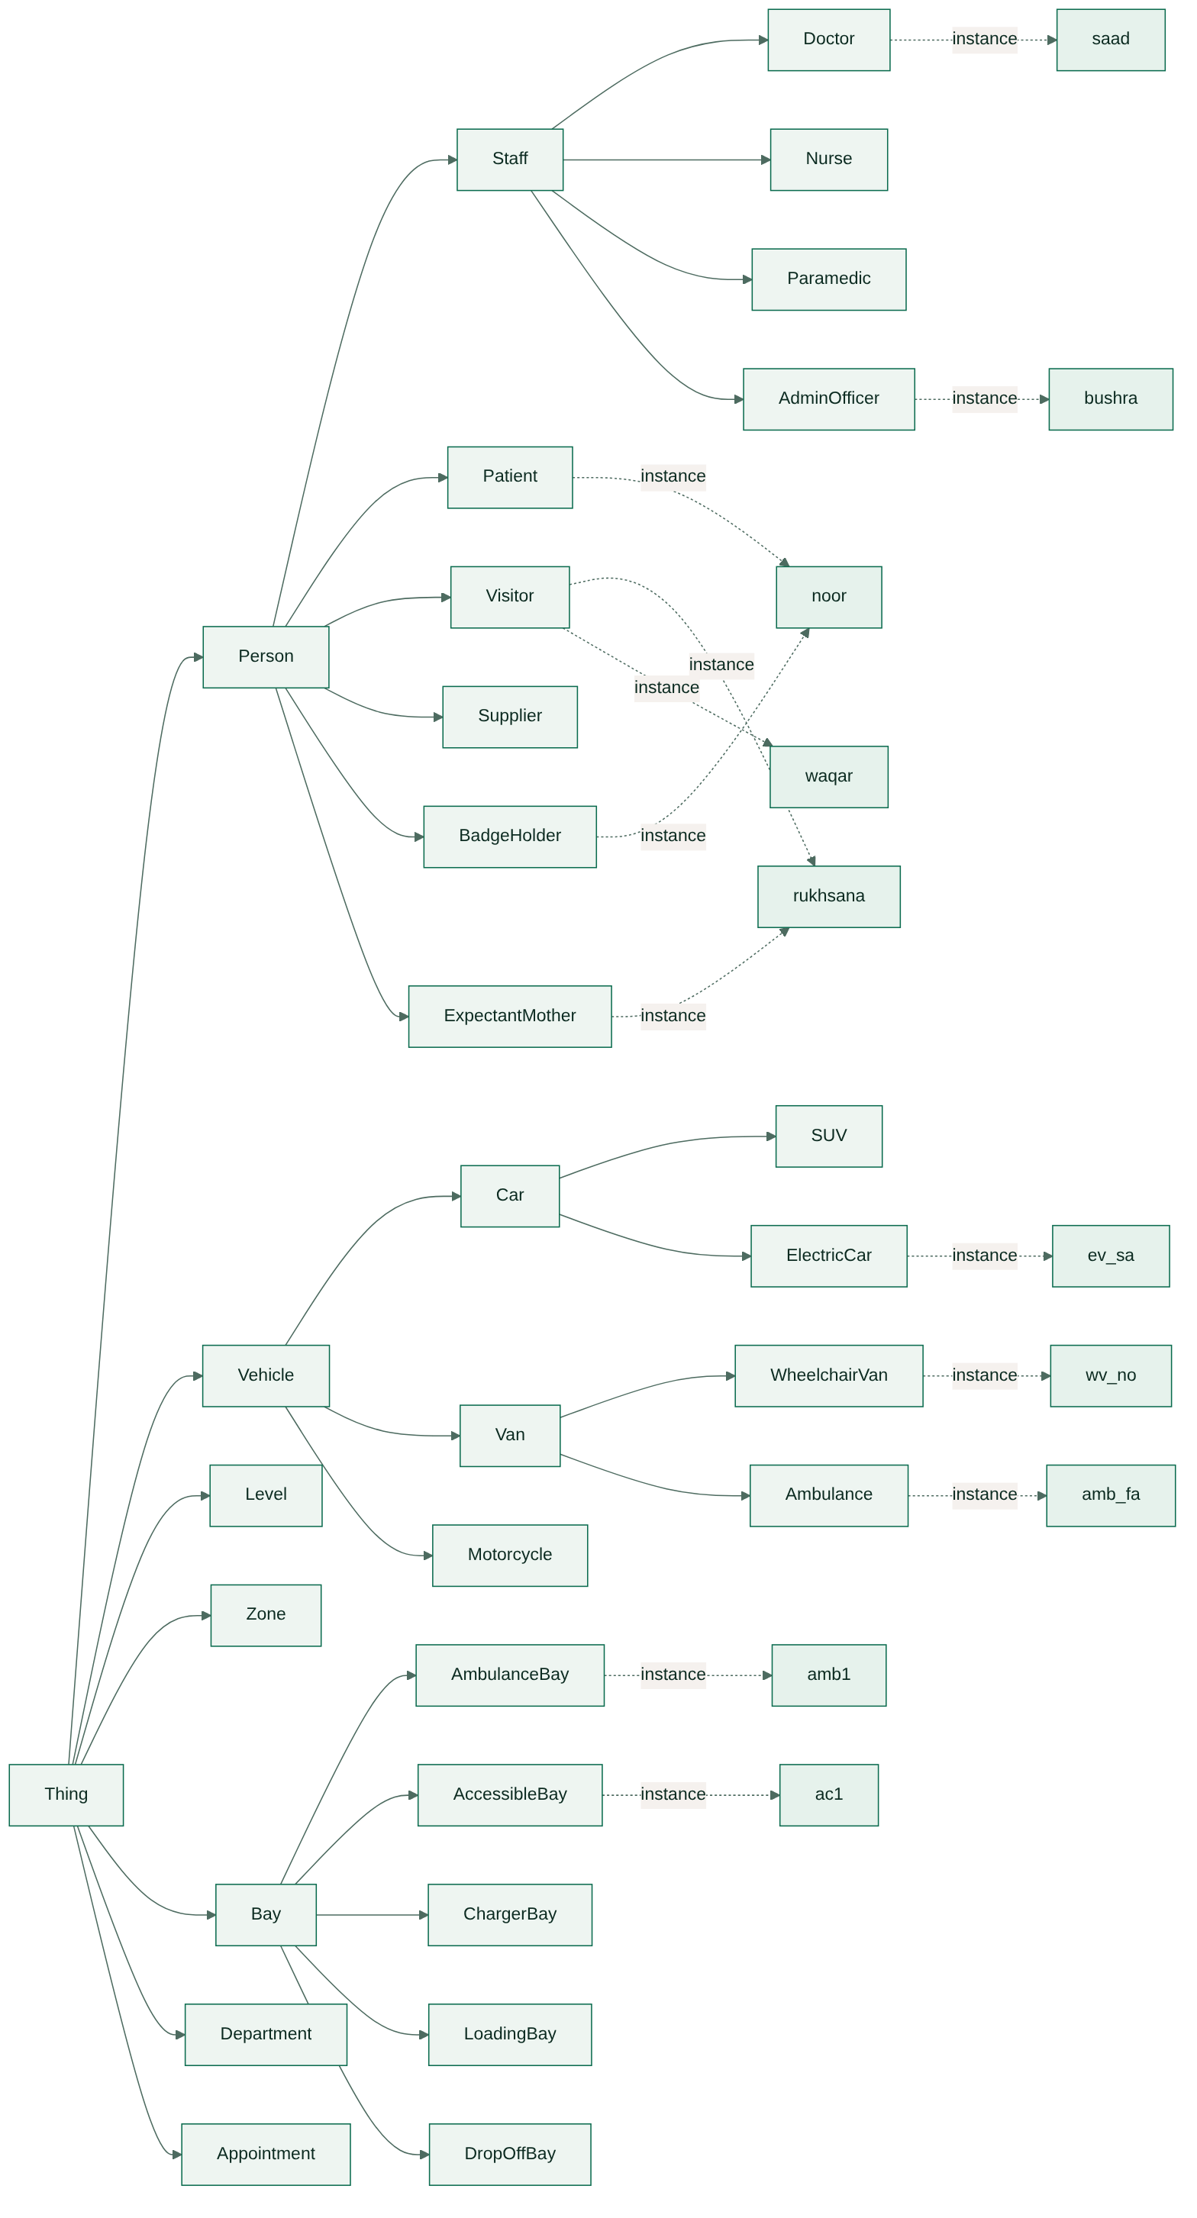
Figure 2: Frame hierarchy with multiple inheritance (dotted arrows: instance frames)

3.1.2 Frame: Person
Person is the root of the people hierarchy. Its six slots are inherited by every role.
Table 7: Frame Person
Slot | Facets | Inherited by
name | type text | all people
role | type role | all people; fixed by each subclass
destination | type department | all people
drives | type Vehicle, card 0..2 | all people
banned | type boolean, default false | all people
cleared | type boolean, if_needed d_cleared | all people

3.1.3 Frame: Staff
Staff is-a Person. Doctor, Nurse, Paramedic and AdminOfficer are its subclasses; Doctor adds on_call (default false), Paramedic fixes destination to emergency, AdminOfficer fixes destination to admin.
Table 8: Frame Staff
Slot | Facets | Inherited by
badge_expiry | type date | all staff
shift_start, shift_end | type minute | all staff
badge_valid | type boolean, if_needed d_badge_valid | all staff
fee_band | default free | all staff
role | value doctor / nurse / paramedic / admin | set by each subclass

3.1.4 Frame: Patient
Patient is-a Person. Its window and fee band are the defaults the policy applies to every patient.
Table 9: Frame Patient
Slot | Facets | Inherited by
appointment_time | type minute | patients
appointment_dept | type department | patients
role | value patient | patients
fee_band | default first 2 h free, then PKR 50/h | patients

3.1.5 Frame: Visitor, Supplier, BadgeHolder, ExpectantMother
These four are siblings under Person. BadgeHolder and ExpectantMother are mixed into other roles by multiple inheritance.
Table 10: Frame Visitor, Supplier, BadgeHolder, ExpectantMother
Slot | Facets | Inherited by
ward (Visitor) | type department | visitors
fee_band (Visitor) | default PKR 100 first hour, PKR 50/h after | visitors
delivery_from, delivery_to (Supplier) | type minute | suppliers
disability_badge (BadgeHolder) | value true | badge holders
preferred_zone (BadgeHolder) | default accessible | badge holders
preferred_zone (ExpectantMother) | default maternity | expectant mothers
notify_ward (ExpectantMother) | default true | expectant mothers

3.1.6 Frame: Vehicle
Vehicle is the root of the vehicle hierarchy. Car (default class car, 4 wheels), SUV (185 cm), ElectricCar (battery, needs_charge demon), Van (260 cm, max_level demon), WheelchairVan (230 cm, rear ramp), Ambulance (280 cm, siren) and Motorcycle (2 wheels, 120 cm) refine it.
Table 11: Frame Vehicle
Slot | Facets | Inherited by
plate | type text | all vehicles
class | type vclass; value set by subclass | all vehicles
height_cm | type integer, range 80–400, default 150 | overridden by SUV, Van, WheelchairVan, Ambulance, Motorcycle
anpr_confidence | type percent | all vehicles
arrival, stay_min | type minute | all vehicles
identified | type boolean, if_needed d_identified | all vehicles
occupies | type Bay, card 0..1, if_added d_park | all vehicles
battery_pct, needs_charge (ElectricCar) | type percent; if_needed d_needs_charge | electric cars
max_level (Van) | if_needed d_max_level | vans and their subclasses

3.1.7 Frame: Bay and its subclasses
Bay holds the defaults for an ordinary space; each subclass fixes its type and size.
Table 12: Frame Bay and its subclasses
Slot | Facets | Inherited by
bay_type | default std; value amb / acc / ev / load / drop in subclasses | all bays
zone | type Zone | all bays
status | default vacant | all bays
width_m | default 2.5; value 3.5 (ambulance), 3.6 (accessible), 4.0 (loading) | all bays
sensor | default ultrasonic | all bays
keep_clear (AmbulanceBay) | value true | ambulance bays
charger_kw (ChargerBay) | default 22 | charger bays
max_stay_min (DropOffBay) | default 15 | drop-off bays

3.1.8 Frame: Level, Zone, Department, Appointment
The facility and booking frames.
Table 13: Frame Level, Zone, Department, Appointment
Slot | Facets | Inherited by
floor (Level) | type integer | levels
clearance_cm (Level) | type integer, default 210 | levels; ground overrides with 400
kind, level (Zone) | type zone_kind; type Level | zones
bays (Zone) | card 1..* | zones
penalty_m (Zone) | default 0 | zones
entrance, walk_from_zone_m (Department) | type text; type table | departments
window (Appointment) | default -60 / +30 min | appointments

3.1.9 Instance frames and demons
Instance frames hold the facts of the day. The first table shows Noor, who inherits from two classes; the second shows Bushra, whose refusal comes from a demon.
Table 14: Instance frame noor (multiple inheritance)
Slot | Value | Where it came from
appointment_dept | oncology | local value
appointment_time | 600 (10:00) | local value
drives | wv_no | local value
role | patient | inherited from Patient
disability_badge | true | inherited from BadgeHolder
preferred_zone | accessible | default of BadgeHolder
fee_band | first 2 h free, then PKR 50/h | default of Patient
banned | false | default of Person
cleared | true | if-needed demon of Person

Table 15: Instance frame bushra (refusal from a demon)
Slot | Value | Where it came from
badge_expiry | 20261031 | local value
badge_valid | false | if-needed demon of Staff: 20261031 < today 20261110
cleared | false | if-needed demon of Person: badge invalid
destination | admin | inherited from AdminOfficer
fee_band | free | default of Staff

Table 16: Demons
Demon | Slot | Procedure
d_badge_valid | badge_valid | true if badge_expiry ≥ today
d_cleared | cleared | false if banned or badge invalid, else true
d_identified | identified | true if anpr_confidence ≥ 90
d_needs_charge | needs_charge | true if battery_pct < 30
d_max_level | max_level | ground_only if height_cm > 210, else any
d_park (if-added) | occupies | records occupied(Bay, Vehicle) when a vehicle is put in a bay

For example, put(ev_sa, occupies, ev1) fires d_park, which adds occupied(ev1, ev_sa); reading ev_sa.needs_charge fires d_needs_charge, which returns true because the battery is at 22%.

3.1.10 Script / event sequence
The PARKING-VISIT script orders a visit into 10 scenes. Each scene has an actor, what happens, and the rules that carry it out (Figure 3). Scene 3 is a branch: an emergency skips scenes 4 and 5. Scene 6 is a second branch: a vehicle that is not cleared stops at the barrier.
Table 17: Script PARKING-VISIT
# | Scene | Actor | What happens | Rules
1 | Approach | Driver | Vehicle joins the queue at gate G1; arrival time recorded | arrival
2 | Plate read | ANPR camera | Plate read with a confidence score; under 90% a guard checks it | s1, w9
3 | Emergency check | Gate controller | Ambulance on a run or declared emergency skips every other check | a5, a6, p1, p2
4 | Identification | Gate controller | Look up the driver's role, badge, appointment, delivery slot or visit | h1–h10, t1–t4
5 | Clearance | Security office | Badge in date, not banned, supplier inside its slot | s4, s5, a1–a4
6 | Entry | Barrier | Opens for an admitted vehicle, otherwise shows the first failing reason | a7
7 | Bay choice | Allocation engine | Fit and height, entitlement, cost, priority; one bay chosen | f1, e1–e15, c1, k9
8 | Guidance | Display board | Bay and route shown; ward or trauma team notified | w11–w13
9 | Parking | Occupancy sensor | Sensor confirms the vehicle; status := occupied | w2
10 | Stay and exit | Monitoring | Drop-off limits, charger use and blocked bays watched; fee charged | w3, w5, w8, m1–m7

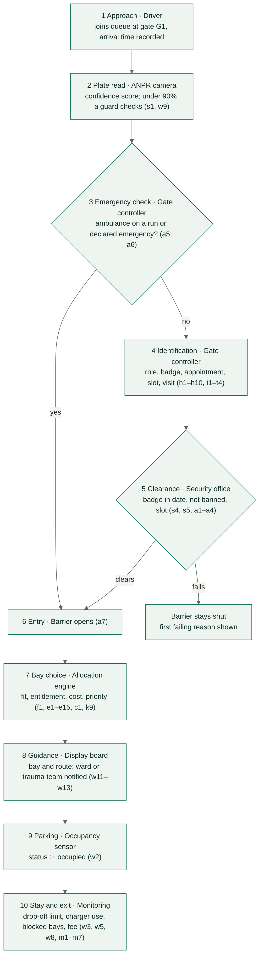
Figure 3: The PARKING-VISIT script

3.2 Semantic Networks

3.2.1 Semantic network design
The semantic network has 61 nodes and 79 labelled links, stored as link(From, Relation, To) (engine/semnet.pl). Class nodes (Person, Bay, Zone…), component nodes (NumberPlate, Battery, ANPRCamera…) and individual nodes (noor, saad, amb1…) share one graph, so inheritance and "how is X related to Y" are both graph walks.

3.2.2 Relationship types
Table 18: Relationship types in the semantic network
Relation | Links | Meaning | Example
is_a | 25 | subclass to superclass | WheelchairVan is_a Van; OnCallDoctor is_a Doctor
instance_of | 16 | individual to class | noor instance_of Patient, noor instance_of BadgeHolder
has_a | 10 | whole to component | Gate has_a ANPRCamera; ElectricCar has_a Battery
part_of | 9 | part to whole | Bay part_of Zone part_of Level part_of CarPark part_of Hospital
drives | 5 | person to vehicle | faisal drives amb_fa
works_in, visits, has, at | 8 | people to departments and bookings | rukhsana visits maternity; appt_noor at oncology
walk_to, occupies, reads, shows, delivers_to, limited_by | 6 | other named relations | Zone walk_to Department; Ramp limited_by Clearance

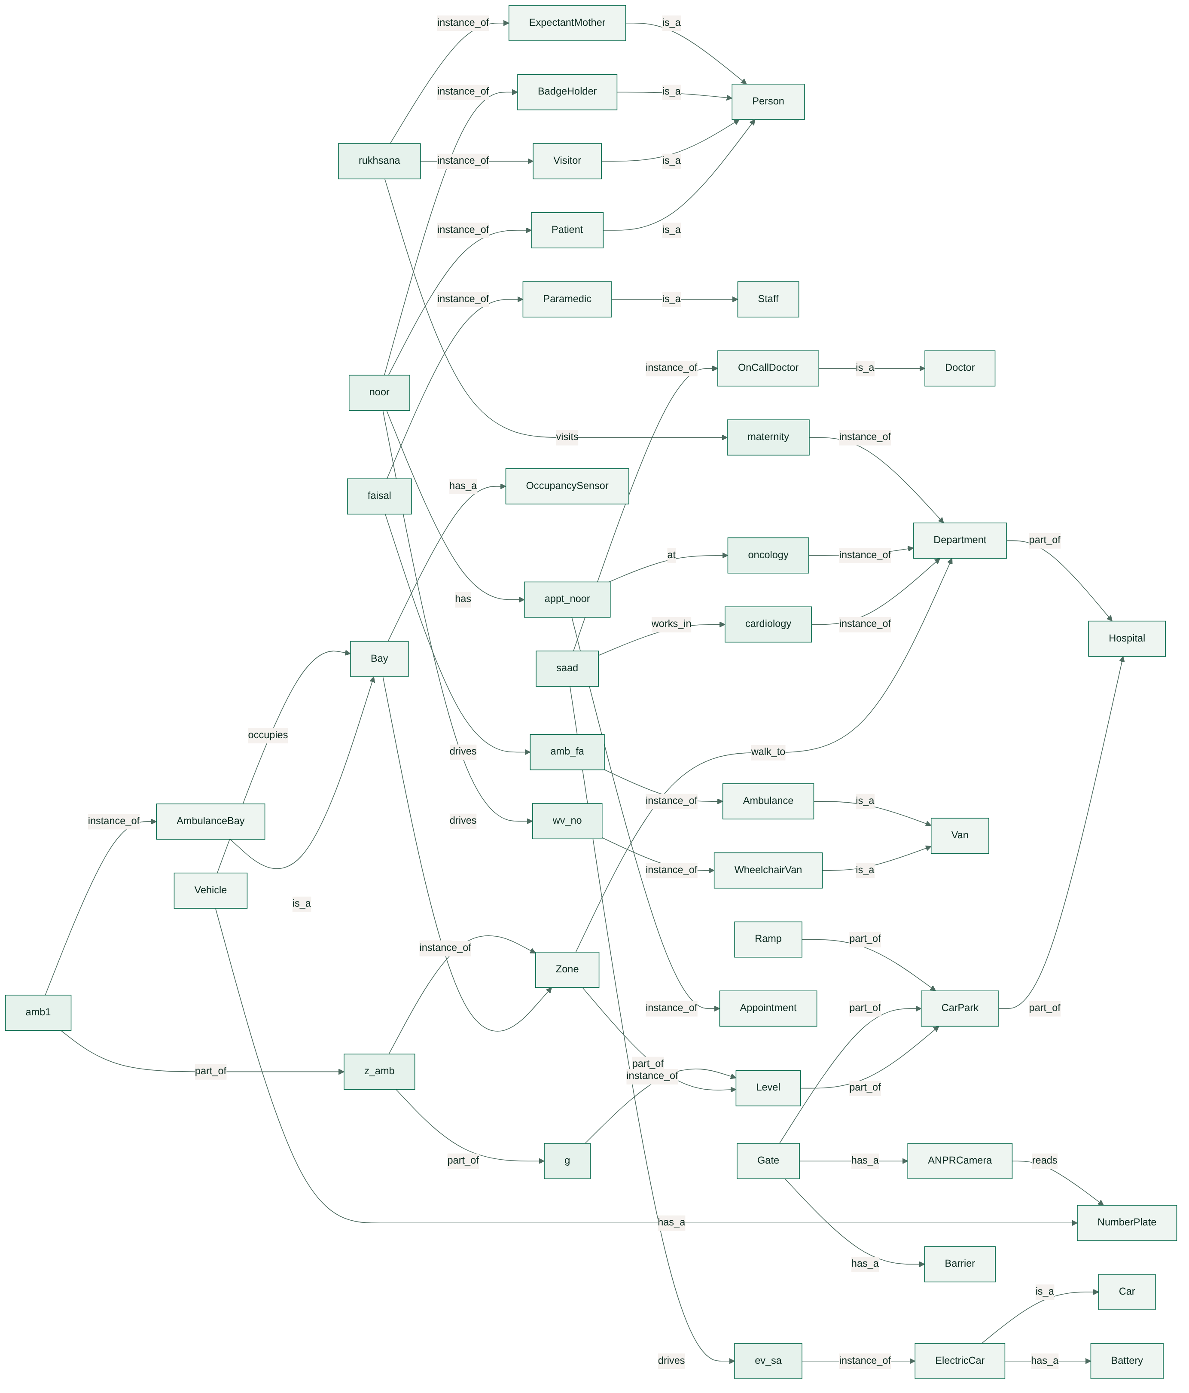
Figure 4: Semantic network (individuals have lower-case names)

3.2.3 Semantic network walkthrough
Four queries show how the network is used (output of swipl main.pl net):
- Classes of ev_sa: follow instance_of to ElectricCar, then is_a to Car and Vehicle. Result: ElectricCar, Car, Vehicle.
- Inherited parts of ev_sa: collect has_a links from each class. Result: Battery (from ElectricCar) and NumberPlate (from Vehicle).
- Part-of chain of amb1: follow part_of upward. Result: z_amb, then g (the ground level).
- Path from noor to oncology: breadth-first search over all links. Result: noor has appt_noor, appt_noor at oncology.
The website draws all 79 links as a force-directed graph; clicking a node lights up every class and part it inherits.

4. FORMAL LOGIC REPRESENTATION

4.1 First-Order Logic (FOL)

4.1.1 Predicates and constants
Constants name individuals (saad, noor, ev_sa, amb1, z_mat, l1, cardiology), roles, classes and numbers. Times are minutes after midnight and dates are YYYYMMDD integers, so comparisons are arithmetic. The knowledge base uses 42 base predicates; the main ones are listed below.
Table 19: Main predicates
Predicate | Meaning
Doctor(x), Nurse(x), Admin(x), Paramedic(x), Patient(x), Visitor(x), Supplier(x) | role of person x
Drives(p,v), Class(v,c), Height(v,h), Anpr(v,c), Arrival(v,t), Stay(v,m) | vehicle facts
Badge(p,i,e), Shift(p,s,e), Appt(p,d,a), Slot(p,a,b), Banned(p), OnCall(p) | permissions and schedule
Type(b,t), InZone(b,z), Kind(z,k), LevelOf(z,l), Clear(l,c), Walk(z,d,m), OutOfService(b) | facility facts
Identified(v), Cleared(p), Admitted(v), Fits(v,b), Entitled(v,z), Candidate(v,b), Cost(v,b,c), Priority(v,n), Alloc(v,b) | derived predicates

4.1.2 Domain facts
Examples of ground facts (the full set has 431):
Doctor(saad) OnCall(saad) Drives(saad, ev_sa) Class(ev_sa, ev) Battery(ev_sa, 22)
Arrival(ev_sa, 425) Anpr(ev_sa, 98) Shift(saad, 420, 1140) Destination(saad, cardiology)
Patient(noor) DisabilityBadge(noor) Appt(noor, oncology, 600) Height(wv_no, 230)
Admin(bushra) Badge(bushra, 20241101, 20261031) Today(20261110) Visitor(waqar) Banned(waqar)
Type(amb1, amb) InZone(amb1, z_amb) LevelOf(z_amb, g) Clear(g, 400) Clear(l1, 210)
Walk(z_mat, maternity, 35) VisitingWindow(660, 780) VisitingWindow(1020, 1200) OutOfService(vs4)

4.1.3 FOL rules
The FOL layer has 36 statements (engine/fol.pl). 15 translate directly into Horn rules; the other 21 need disjunction in the head, existential or uniqueness quantifiers, or a negative conclusion, so they are checked on the finished model instead (section 4.1.5).
Table 20: FOL statements (selection)
Id | Statement | Form
f1 | ∀x (Doctor(x) ∨ Nurse(x) ∨ Admin(x) ∨ Paramedic(x) → Staff(x)) | Horn: h1–h4
f3 | ∀x (Person(x) → Staff(x) ∨ Patient(x) ∨ Visitor(x) ∨ Supplier(x)) | beyond Horn
f4 | ∀v (Vehicle(v) → ∃!c Class(v,c)) | beyond Horn: IC6
f6 | ∀v (Identified(v) ↔ ∃c (Anpr(v,c) ∧ c ≥ 90)) | Horn: s1
f7 | ∀p (BadgeValid(p) ↔ ∃i ∃e ∃t (Badge(p,i,e) ∧ Today(t) ∧ i ≤ t ≤ e)) | Horn: s4
f8 | ∀p (OnShift(p) ↔ ∃s ∃e ∃v ∃t (Shift(p,s,e) ∧ Drives(p,v) ∧ Arrival(v,t) ∧ s − 30 ≤ t ≤ e)) | Horn: t1
f9 | ∀p (InWindow(p) ↔ ∃d ∃a ∃v ∃t (Appt(p,d,a) ∧ Drives(p,v) ∧ Arrival(v,t) ∧ a − 60 ≤ t ≤ a + 30)) | Horn: t2
f11 | ∀p (Banned(p) → ¬Cleared(p)) | beyond Horn: NAF in a1–a4
f12 | ∀p (Staff(p) ∧ BadgeValid(p) ∧ ¬Banned(p) → Cleared(p)) | Horn with NAF: a1
f13 | ∀v (EmergencyVehicle(v) ∨ DeclaredEmergency(v) → Admitted(v)) | Horn: a5, a6
f14 | ∀v ∀p (Arrival(v) ∧ Identified(v) ∧ Drives(p,v) ∧ Cleared(p) → Admitted(v)) | Horn: a7
f16 | ∀v ∀b (Fits(v,b) ↔ ∃c ∃t ∃h ∃z ∃l ∃k (Class(v,c) ∧ Type(b,t) ∧ ClassFits(c,t) ∧ Height(v,h) ∧ InZone(b,z) ∧ LevelOf(z,l) ∧ Clear(l,k) ∧ h ≤ k)) | Horn: f1
f17 | ∀v ∀b ∀h (Alloc(v,b) ∧ Height(v,h) ∧ h > 210 → ∃z (InZone(b,z) ∧ LevelOf(z,g))) | beyond Horn: IC3
f19 | ∀v ∀z (CodeRed ∧ Visitor(v) ∧ Kind(z,visitor) → ¬Entitled(v,z)) | beyond Horn: NAF in e11
f20 | ∀v ∀b (Candidate(v,b) ↔ Admitted(v) ∧ Fits(v,b) ∧ ∃z (InZone(b,z) ∧ Entitled(v,z)) ∧ Usable(b)) | Horn: c1
f22 | ∀v (Admitted(v) ∧ ∃b FreeCandidate(v,b) → ∃!b Alloc(v,b)) | beyond Horn: control layer
f23 | ∀b ∀v₁ ∀v₂ (Alloc(v₁,b,[s₁,e₁]) ∧ Alloc(v₂,b,[s₂,e₂]) ∧ v₁ ≠ v₂ → e₁ ≤ s₂ ∨ e₂ ≤ s₁) | beyond Horn: IC1
f24 | ∀v ∀b ∀t (Alloc(v,b,t) → ¬∃b′ (Free(b′,t) ∧ Candidate(v,b′) ∧ Cost(v,b′) < Cost(v,b))) | beyond Horn: control layer
f26 | ∀v ∀b (Occupies(v,b) ∧ Type(b,amb) → EmergencyVehicle(v)) | beyond Horn: alert w3
f31 | ∀v (Patient(v) ∧ Stay(v,s) ∧ s > 120 → Fee(v, 50·⌈(s−120)/60⌉)) | Horn: m1–m7
f35 | ∀x ¬(Staff(x) ∧ Visitor(x)) | beyond Horn: IC13
f36 | ∃b (Type(b,amb) ∧ ¬OutOfService(b)) | beyond Horn: model check

4.1.4 Quantifier usage
- Universal (∀) states a rule for every individual of a kind: f1 for every doctor, nurse, admin officer and paramedic; f14 for every arriving vehicle.
- Existential (∃) in the body introduces a value the rule needs but does not return: in f6 the confidence c, in f8 the shift times s and e and the arrival time t. In Horn form these become variables that appear only in the body.
- Existential in the head claims something exists: f36 says some ambulance bay is in service; f27 says the driver of a vehicle in an accessible bay holds a badge. Horn clauses cannot conclude existence, so these are checked.
- Uniqueness (∃!) combines existence with equality: f4 (exactly one class) and f5 (exactly one driver). The ≤ 1 part becomes integrity constraints IC5 and IC6.
- Biconditional (↔) defines a predicate completely: f6, f7, f16, f20. The ← direction is the Horn rule; the → direction holds under the closed-world assumption (Clark completion).
- Nested negated existential in f24 states optimality: there is no free candidate bay that is cheaper. It is enforced by the control layer and confirmed by a model check.

4.1.5 Consistency verification
Each of the 21 statements beyond Horn has a check goal that is run on the finished model of the day. On the baseline day all 21 hold. In the bad-data scenarios the checks fail as intended: tc20 breaks f4 (a car with two classes), tc21 breaks f35 (a doctor also recorded as a visitor) and tc22 breaks f33's companion constraint IC9 (a badge that expires before it is issued).

4.2 Description Logic (DL)
The ontology (engine/dl.pl) has 89 TBox axioms: 38 atomic subsumptions, 27 disjointness axioms and 24 definitions and role restrictions. The ABox is built from the facts of the current day, so the reasoner checks the same world the rules decide over.

4.2.1 DL concepts
Atomic concepts: Person, Staff, Doctor, Nurse, Paramedic, AdminOfficer, Patient, Visitor, Supplier, BadgeHolder, ExpectantMother, Vehicle, Car, SUV, ElectricCar, PetrolCar, Van, WheelchairVan, Ambulance, Motorcycle, Bay and its seven subclasses, Zone, GroundZone, UpperZone, Level, Department. Defined concepts: Clinician, OnCallDoctor, OnShiftStaff, ClearedPerson, BannedPerson, EmergencyVehicle, AdmittedVehicle, LowBatteryEV, TallVehicle, UnregisteredVehicle.

4.2.2 DL roles
Table 21: DL roles
Role | Domain → Range | Notes
drives / drivenBy | Person → Vehicle | drivenBy ≡ drives⁻
parkedIn / occupiedBy | Vehicle → Bay | occupiedBy ≡ parkedIn⁻
inZone | Bay → Zone | functional (≤ 1)
onLevel | Zone → Level | functional
badge, shift, slot | Person → Badge / Shift / Slot | used in ClearedPerson and OnShiftStaff
onCall, onRun, declared | Person / Vehicle → {true} | nominals
battery, height, clearance | Vehicle / Level → integer | concrete domains with < 30, > 210, ≤ 210

4.2.3 Subsumption axioms
Staff ⊑ Person Patient ⊑ Person Visitor ⊑ Person Supplier ⊑ Person
BadgeHolder ⊑ Person ExpectantMother ⊑ Person Doctor ⊑ Staff Nurse ⊑ Staff
Paramedic ⊑ Staff AdminOfficer ⊑ Staff OnCallDoctor ⊑ Doctor Clinician ⊑ Staff
Car ⊑ Vehicle SUV ⊑ Car ElectricCar ⊑ Car PetrolCar ⊑ Car
Van ⊑ Vehicle WheelchairVan ⊑ Van Ambulance ⊑ Van Motorcycle ⊑ Vehicle
LowBatteryEV ⊑ ElectricCar AmbulanceBay ⊑ Bay AccessibleBay ⊑ Bay
ChargerBay ⊑ Bay LoadingBay ⊑ Bay DropOffBay ⊑ Bay StandardBay ⊑ Bay
FamilyBay ⊑ Bay ClosedBay ⊑ Bay GroundZone ⊑ Zone UpperZone ⊑ Zone

The reasoner infers 15 further subsumptions by transitivity, for example OnCallDoctor ⊑ Person, LowBatteryEV ⊑ Vehicle and WheelchairVan ⊑ Vehicle.

4.2.4 Disjointness axioms
Staff ⊓ Visitor ⊑ ⊥ Staff ⊓ Supplier ⊑ ⊥ Patient ⊓ Supplier ⊑ ⊥ Visitor ⊓ Supplier ⊑ ⊥
Doctor ⊓ Nurse ⊑ ⊥ Doctor ⊓ Paramedic ⊑ ⊥ Nurse ⊓ Paramedic ⊑ ⊥ Paramedic ⊓ AdminOfficer ⊑ ⊥
Car ⊓ Van ⊑ ⊥ Car ⊓ Motorcycle ⊑ ⊥ Van ⊓ Motorcycle ⊑ ⊥ ElectricCar ⊓ PetrolCar ⊑ ⊥
SUV ⊓ ElectricCar ⊑ ⊥ SUV ⊓ PetrolCar ⊑ ⊥ AmbulanceBay ⊓ AccessibleBay ⊑ ⊥
AmbulanceBay ⊓ StandardBay ⊑ ⊥ GroundZone ⊓ UpperZone ⊑ ⊥ ClearedPerson ⊓ BannedPerson ⊑ ⊥
Person ⊓ Vehicle ⊑ ⊥ Vehicle ⊓ Bay ⊑ ⊥ ... (27 in all)

4.2.5 Definitions and restrictions
Clinician ≡ Doctor ⊔ Nurse
OnCallDoctor ≡ Doctor ⊓ ∃onCall.{true}
EmergencyVehicle ≡ Ambulance ⊓ ∃onRun.{true}
LowBatteryEV ≡ ElectricCar ⊓ ∃battery.(< 30)
TallVehicle ≡ Vehicle ⊓ ∃height.(> 210)
PetrolCar ≡ Car ⊓ ¬ElectricCar ⊓ ¬SUV
UpperZone ≡ Zone ⊓ ∃onLevel.(∃clearance.(≤ 210))
ClearedPerson ≡ (Staff ⊓ ∃badge.ValidBadge ⊓ ¬BannedPerson) ⊔ ((Patient ⊔ Visitor) ⊓ ¬BannedPerson)
⊔ (Supplier ⊓ ∃slot.(∋ arrivalTime))
AdmittedVehicle ≡ EmergencyVehicle ⊔ ∃declared.Emergency ⊔ (Identified ⊓ ∃drivenBy.ClearedPerson)
AmbulanceBay ⊑ ∀occupiedBy.EmergencyVehicle ChargerBay ⊑ ∀occupiedBy.ElectricCar
AccessibleBay ⊑ ∀occupiedBy.(∃drivenBy.BadgeHolder) TallVehicle ⊑ ∀parkedIn.(∃inZone.GroundZone)
Vehicle ⊑ (≤ 1 drivenBy.Person) Bay ⊑ (≤ 1 occupiedBy.Vehicle) Vehicle ⊑ (≤ 1 parkedIn.Bay)

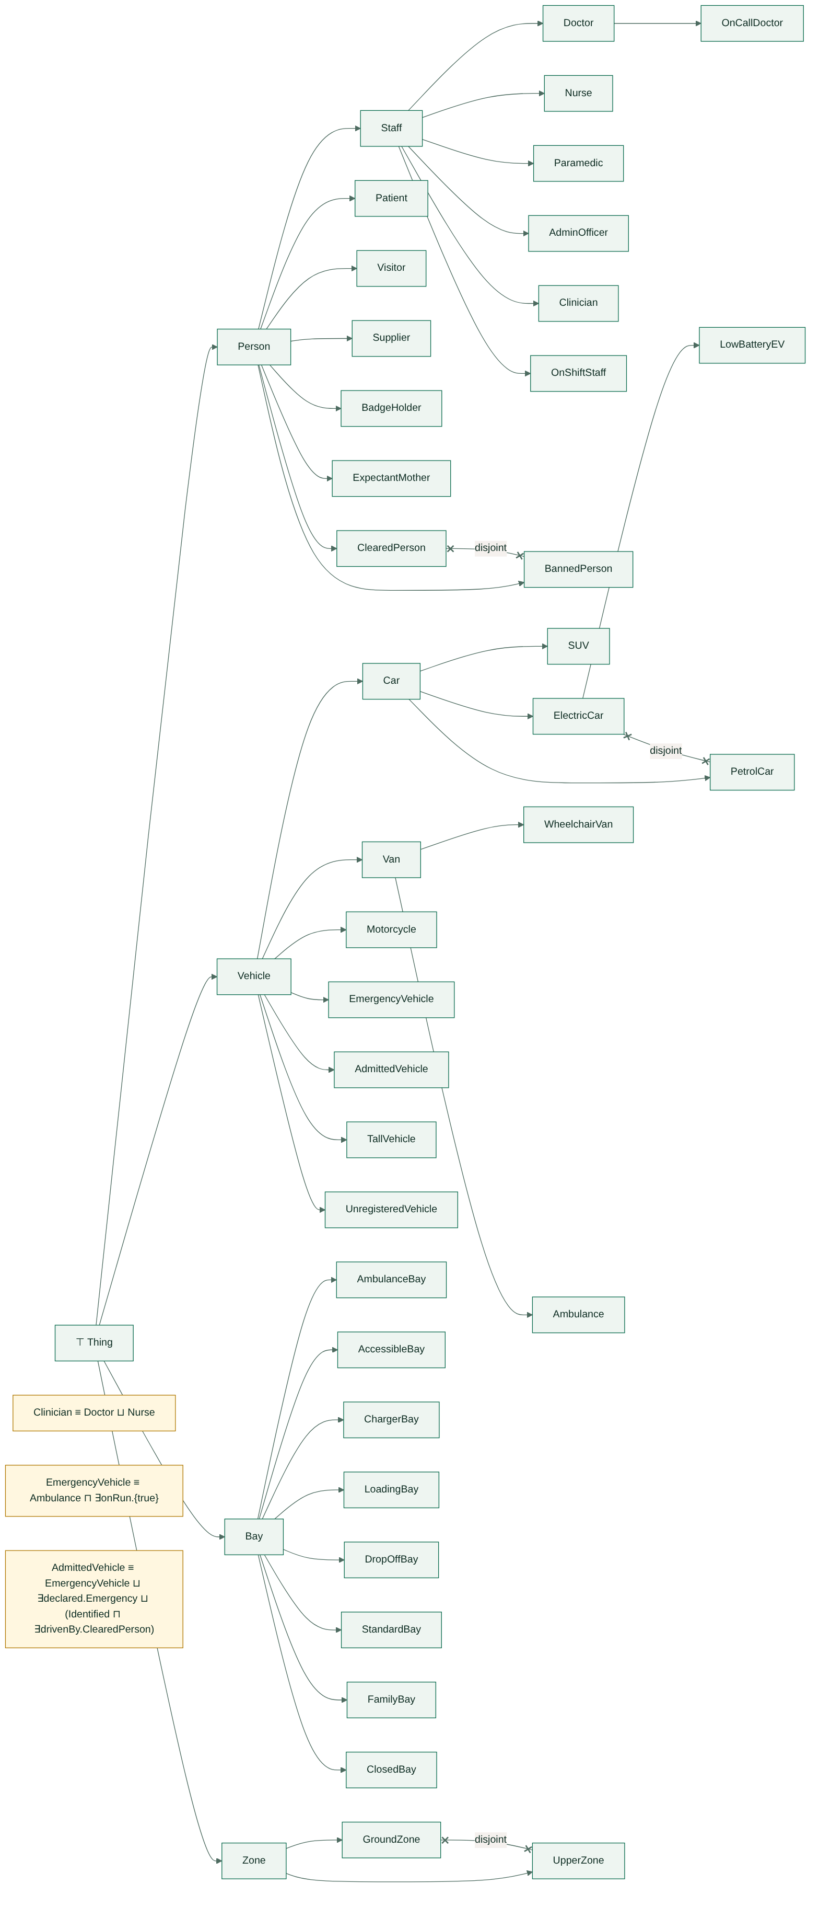
Figure 5: DL concept hierarchy with disjointness and definitions

4.2.6 Membership assertions (ABox) and realisation
Assertions come from the facts: doctor(saad) gives Doctor(saad), bay_type(amb1, amb) gives AmbulanceBay(amb1), drives(noor, wv_no) gives drives(noor, wv_no), and a height over 210 cm gives TallVehicle. Realisation finds the most specific concepts of each individual.
Table 22: Realisation of selected individuals
Individual | Most specific concepts
saad | OnCallDoctor, OnShiftStaff, ClearedPerson
noor | Patient, BadgeHolder, ClearedPerson
rukhsana | Visitor, ExpectantMother, ClearedPerson
waqar | Visitor, BannedPerson
bushra | AdminOfficer, OnShiftStaff (not ClearedPerson: badge expired)
ev_sa | LowBatteryEV, AdmittedVehicle
wv_no | WheelchairVan, TallVehicle, AdmittedVehicle
amb_fa | Ambulance, EmergencyVehicle, TallVehicle, AdmittedVehicle
car_ya | PetrolCar (not admitted: plate unread)
amb1, ev2, z_patient | AmbulanceBay, ChargerBay, UpperZone

4.2.7 DL consistency and interpretation
The consistency check looks for an individual that belongs to two disjoint concepts and for a ∀-restriction broken by an occupant (for example a non-emergency car in an ambulance bay). On the baseline day the result is "ABox consistent". In scenario tc20 Sadia's car is recorded as both a car and an SUV; it is classified as PetrolCar and SUV at once, so the reasoner reports clash(car_sd, SUV, PetrolCar) and the record is rejected (IC6 agrees).
Under the standard interpretation each concept is a set of individuals of the day and each role a set of pairs. For example AdmittedVehicle is interpreted as {ev_sa, mc_ma, suv_ar, car_im, van_ju, amb_fa, wv_no, car_ks, car_sd, car_ru, car_gh, car_th}: the 12 vehicles the rules admit. The DL view and the rule view agree, which is tested.

5. HORN CLAUSE KNOWLEDGE BASE

5.1 Knowledge base
The executable knowledge base is a set of definite Horn clauses with negation as failure in some bodies. Rules are stored as data, r(Id, Head, Body) in kb/rules.pl, so the forward chainer, the backward chainer, the exporter and the website all read the same 97 rules. A body literal is a fact pattern, not(G), or a builtin (lt, le, gt, ge, eq, neq, add, sub, mul, cdiv) that is evaluated once its inputs are bound.

5.2 Facts
The 431 ground facts use 42 predicates.
Table 23: Facts by predicate
Predicate | Count | Predicate | Count | Predicate | Count
walk/3 | 104 | drives/2 | 18 | shift/3 | 8
bay_type/2 | 29 | vclass/2 | 18 | staff_badge/3 | 8
bay_zone/2 | 29 | height/2 | 18 | visitor/1 | 6
class_fits/2 | 21 | stay/2 | 18 | level_floor, level_route, route_clearance | 4 each
anpr/2 | 15 | registered/1 | 18 | doctor, patient, appointment, occupies, since | 3 each
arrival/2 | 15 | destination/2 | 18 | admin, nurse, battery, visiting_window | 2 each
zone_kind/2, zone_level/2 | 13 each | kind_penalty/2 | 13 | 15 others (today, mode, weather, on_call, security_ban …) | 1 each

driver(saad, doctor, cardiology, ev_sa, ev, 150, 98, 425, 600). % expands to role, drives, vclass,
on_call(saad). battery(ev_sa, 22). staff_badge(saad, 20250101, 20271231). % height, anpr, arrival, stay
shift(saad, 420, 1140). appointment(noor, oncology, 600). delivery_slot(junaid, 510, 570).
security_ban(waqar). emergency_run(amb_fa). emergency_declared(car_gh). disability_badge(noor).
expectant(rukhsana). bay(amb1, z_amb, amb). zone(z_amb, g, ambulance). level(l1, 1, 210).
walk(z_mat, maternity, 35). visiting_window(660, 780). out_of_service(vs4). today(20261110).

5.3 Rules
Table 24: Rule groups
Group | Rules | Derives | Phase
h | h1–h18 | taxonomy: staff_member, clinician, person, vehicle, ev, car_like, emergency_vehicle, unregistered (NAF) | 1
s | s1–s7 | sensing: identified, battery_low, charger_bay, badge_valid, banned, code_red, raining | 1
t | t1–t4 | time windows: on_shift, in_appointment_window, visiting_time, delivery_window | 1
a | a1–a7 | cleared(P), admitted(V) | 1
f | f1–f3 | fits(V,B), too_tall(V,L), bay_usable(B) | 1
e | e1–e15 | entitled(V,Z): one or more rules per zone kind, code red variants | 1
c | c1 | candidate(V,B) | 1
p | p1–p10 | priority(V,0..5) | 1
k | k1–k11 | adjusted, ev_adjust, zone_cost, cost(V,B,metres) | 1
m | m1–m7 | fee(V, PKR) | 1
w | w1–w14 | monitoring: occupant, ambulance_bay_blocked, tow_request, charger_hog, dropoff_limit, dropoff_overstay, manual_check, security_alert, notify_ward, route, alert_trauma_team, height_warning | 2

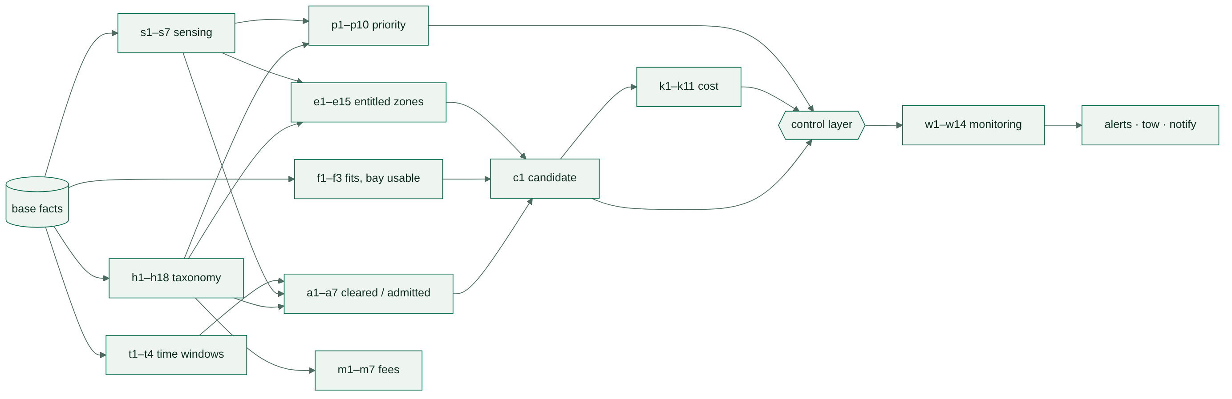
Figure 6: Dependencies between rule groups
Integrity constraints are goals that must have no solution. When one has, the checker prints the witness.
Table 25: Integrity constraints
Id | Violation | Goal
IC1 | one bay, two vehicles at the same time | alloc(V1,B,F1,T1), alloc(V2,B,F2,T2), V1 \= V2, F1 < T2, F2 < T1
IC2 | one vehicle, two bays | alloc(V,B1,_,_), alloc(V,B2,_,_), B1 \= B2
IC3 | vehicle taller than its route clearance | alloc(V,B,_,_), height(V,H), bay_zone(B,Z), zone_level(Z,L), route_clearance(L,C), H > C
IC4 | vehicle class cannot use the bay type | alloc(V,B,_,_), vclass(V,C), bay_type(B,T), not class_fits(C,T)
IC5 | vehicle driven by two people | drives(P1,V), drives(P2,V), P1 \= P2
IC6 | vehicle with two classes | vclass(V,C1), vclass(V,C2), C1 \= C2
IC7 | bay in two zones | bay_zone(B,Z1), bay_zone(B,Z2), Z1 \= Z2
IC8 | shift ends before it starts | shift(P,S,E), E =< S
IC9 | badge expires before it is issued | staff_badge(P,I,E), E < I
IC10 | appointment for someone who is not a patient | appointment(P,_,_), not patient(P)
IC11 | ambulance not driven by a paramedic | vclass(V,ambulance), drives(P,V), not paramedic(P)
IC12 | vehicle in a bay that is out of service | occupies(V,B), out_of_service(B)
IC13 | staff role and visitor role on one person | staff_member(P), visitor(P)

5.4 Horn clause conversion
A Horn clause is a disjunction of literals with at most one positive literal, written Head :- Body. Each FOL rule is converted in four steps: (1) remove → and ↔ (keeping the ← direction of a definition); (2) push ¬ inward; (3) drop the universal quantifiers, since clause variables are implicitly universal, and turn existentials in the body into body-only variables; (4) split a disjunction in the body, or a conjunction in the head, into separate clauses.
Table 26: Conversion of FOL rules to Horn clauses
FOL statement | Clausal form | Horn clause(s)
f1: ∀x (Doctor(x) ∨ Nurse(x) ∨ Admin(x) ∨ Paramedic(x) → Staff(x)) | (¬Doctor(x) ∨ Staff(x)) ∧ (¬Nurse(x) ∨ Staff(x)) ∧ (¬Admin(x) ∨ Staff(x)) ∧ (¬Paramedic(x) ∨ Staff(x)) | h1 staff_member(P) :- doctor(P).  … h4 staff_member(P) :- paramedic(P).
f6: ∀v (∃c (Anpr(v,c) ∧ c ≥ 90) → Identified(v)) | ¬Anpr(v,c) ∨ ¬(c ≥ 90) ∨ Identified(v) | s1 identified(V) :- anpr(V,C), ge(C,90).
f12: ∀p (Staff(p) ∧ BadgeValid(p) ∧ ¬Banned(p) → Cleared(p)) | ¬Staff(p) ∨ ¬BadgeValid(p) ∨ Banned(p) ∨ Cleared(p): two positive literals | a1 cleared(P) :- staff_member(P), badge_valid(P), not banned(P). (¬Banned as NAF)
f13: ∀v (EmergencyVehicle(v) ∨ DeclaredEmergency(v) → Admitted(v)) | (¬EmergencyVehicle(v) ∨ Admitted(v)) ∧ (¬DeclaredEmergency(v) ∨ Admitted(v)) | a5 admitted(V) :- emergency_vehicle(V).  a6 admitted(V) :- emergency_declared(V), arrival(V,_).
f14: ∀v ∀p (Arrival(v) ∧ Identified(v) ∧ Drives(p,v) ∧ Cleared(p) → Admitted(v)) | ¬Arrival(v) ∨ ¬Identified(v) ∨ ¬Drives(p,v) ∨ ¬Cleared(p) ∨ Admitted(v) | a7 admitted(V) :- arrival(V,_), identified(V), drives(P,V), cleared(P).
f20: Candidate(v,b) ↔ Admitted(v) ∧ Fits(v,b) ∧ ∃z (InZone(b,z) ∧ Entitled(v,z)) ∧ Usable(b) | ← direction: one clause; → direction by closed-world completion | c1 candidate(V,B) :- admitted(V), fits(V,B), bay_zone(B,Z), entitled(V,Z), bay_usable(B).
f3: ∀x (Person(x) → Staff(x) ∨ Patient(x) ∨ Visitor(x) ∨ Supplier(x)) | ¬Person(x) ∨ Staff(x) ∨ Patient(x) ∨ Visitor(x) ∨ Supplier(x): four positive literals | not Horn: kept as a model check
f35: ∀x ¬(Staff(x) ∧ Visitor(x)) | ¬Staff(x) ∨ ¬Visitor(x): no positive literal (goal clause) | IC13 :- staff_member(P), visitor(P).

5.5 Prolog form
The key rules as they appear in kb/rules.pl (printed by swipl main.pl rules):
s1 identified(V) :- anpr(V,C), ge(C,90).
s4 badge_valid(P) :- staff_badge(P,I,E), today(T), le(I,T), ge(E,T).
t1 on_shift(P) :- shift(P,S,E), drives(P,V), arrival(V,T), sub(S,30,S0), ge(T,S0), le(T,E).
t2 in_appointment_window(P) :- appointment(P,_,T0), drives(P,V), arrival(V,T),
sub(T0,60,A), add(T0,30,B), ge(T,A), le(T,B).
t3 visiting_time(V) :- arrival(V,T), visiting_window(A,B), ge(T,A), lt(T,B).
a1 cleared(P) :- staff_member(P), badge_valid(P), not banned(P).
a3 cleared(P) :- visitor(P), not banned(P).
a5 admitted(V) :- emergency_vehicle(V).
a7 admitted(V) :- arrival(V,_), identified(V), drives(P,V), cleared(P).
f1 fits(V,B) :- vclass(V,C), bay_type(B,T), class_fits(C,T), height(V,H),
bay_zone(B,Z), zone_level(Z,L), route_clearance(L,Cl), le(H,Cl).
e3 entitled(V,Z) :- drives(P,V), disability_badge(P), admitted(V), zone_kind(Z,accessible).
e11 entitled(V,Z) :- drives(P,V), visitor(P), visiting_time(V), admitted(V),
not code_red, zone_kind(Z,visitor).
c1 candidate(V,B) :- admitted(V), fits(V,B), bay_zone(B,Z), entitled(V,Z), bay_usable(B).
p1 priority(V,0) :- emergency_vehicle(V).
p3 priority(V,1) :- drives(P,V), on_call(P), on_shift(P), admitted(V).
k3 ev_adjust(V,B,120) :- candidate(V,B), battery_low(V), not charger_bay(B).
k8 zone_cost(overflow,P) :- kind_penalty(overflow,P0), raining, add(P0,300,P).
k9 cost(V,B,C) :- candidate(V,B), bay_zone(B,Z), drives(P,V), destination(P,D),
walk(Z,D,W), zone_kind(Z,K), zone_cost(K,Pen), ev_adjust(V,B,A),
add(W,Pen,C1), add(C1,A,C).
w3 ambulance_bay_blocked(B) :- occupant(V,B), bay_type(B,amb), not emergency_vehicle(V).
w4 tow_request(B) :- ambulance_bay_blocked(B), occupant(V,B), unregistered(V).
w8 dropoff_overstay(V) :- assigned(V,B), bay_type(B,drop), stay(V,M),
dropoff_limit(V,L), gt(M,L).

6. INFERENCE AND REASONING
The same rules are run in two directions. The forward chainer starts from the facts and derives everything that follows, which is how the gate decides a whole day. The backward chainer starts from one question ("is car_bu admitted?") and works back to the facts, which is how a single decision is checked and explained.

6.1 Forward Chaining

6.1.1 Algorithm
- Stratify. A predicate used under not must be complete before it is negated. Relaxation over the rule dependency graph places each predicate in a stratum: 3 strata (0, 1, 2) here. For example banned is in stratum 0 and cleared, which tests not banned, in stratum 1.
- Saturate each stratum in turn. In each cycle every rule of the stratum is matched against a snapshot of working memory; builtins are evaluated once bound and not(G) succeeds only if G is not in memory. Each new head instance is added and logged as fire(Cycle, Stratum, Rule, Fact, Bindings). The stratum ends when a cycle adds nothing.
- Replay the day (control layer). Events are taken in time order. At each minute departures go first, then arrivals by priority (0 first) and arrival time. Each vehicle gets its cheapest free candidate bay, ties broken by bay id; a vehicle with no free bay waits and is retried after every departure. This produces assigned(V,B).
- Phase 2. The monitoring rules (w1–w14) saturate over the facts plus assigned/2, in their own strata.
- Check the 13 integrity constraints and the FOL model checks.
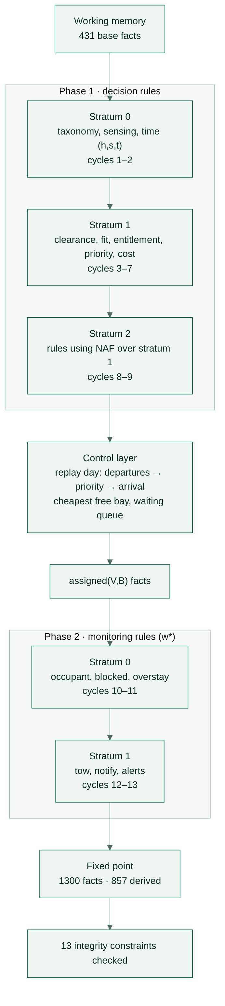
Figure 7: Forward chaining: two phases of stratified saturation with the control layer between them

6.1.2 Initial facts
Working memory starts with the 431 facts of section 5.2. For the trace that follows, the relevant ones are: visitor(rukhsana), expectant(rukhsana), drives(rukhsana, car_ru), vclass(car_ru, suv), height(car_ru, 180), anpr(car_ru, 95), arrival(car_ru, 700), stay(car_ru, 240), destination(rukhsana, maternity), visiting_window(660, 780), the bay, zone and level facts, and walk(z_mat, maternity, 35).

6.1.3 Inference cycles
Table 27: Cycles and strata on the baseline day
Phase · stratum | Cycles | New facts per cycle | What fires
1 · s0 | 1–2 | 427, 11 | taxonomy, sensing, time windows, fits
1 · s1 | 3–7 | 62, 24, 70, 58, 11 | cleared → admitted → entitled, priority, fee → candidate
1 · s2 | 8–9 | 82, 63 | ev_adjust (uses not charger_bay) → cost
2 · s0 | 10–11 | 33, 1 | occupant, route, height warnings, alerts
2 · s1 | 12–13 | 13, 2 | dropoff_limit → dropoff_overstay, manual_check
Total | 13 | 857 | 431 → 1,300 facts at the fixed point

6.1.4 Rules activated and new facts
The trace below follows one decision, how Rukhsana gets bay mt1, through every cycle (from docs/generated/01_forward_trace.txt):
[c1 s0] h9 person(rukhsana) [P=rukhsana]
[c1 s0] s1 identified(car_ru) [V=car_ru, C=95] 95 >= 90
[c1 s0] t3 visiting_time(car_ru) [T=700, A=660, B=780] 11:40 in 11:00-13:00
[c1 s0] f1 fits(car_ru,mt1) [C=suv, T=family, H=180, L=l1, Cl=210]
[c3 s1] a3 cleared(rukhsana) visitor, not banned
[c4 s1] a7 admitted(car_ru) [V=car_ru, P=rukhsana]
[c5 s1] e2 entitled(car_ru,z_drop)
[c5 s1] e10 entitled(car_ru,z_mat) expectant mother
[c5 s1] e11 entitled(car_ru,z_visit) visiting time, not code red
[c5 s1] e15 entitled(car_ru,z_roof)
[c5 s1] p5 priority(car_ru,2) (p9 gives 4 and p10 gives 5; lowest wins)
[c5 s1] m7 fee(car_ru,250) [M=240 min: 100 + 3 x 50]
[c6 s1] c1 candidate(car_ru,mt1) ... and dr1, dr2, vs1-vs3, rf1-rf3
[c8 s2] k5 ev_adjust(car_ru,mt1,0) not an EV
[c9 s2] k9 cost(car_ru,mt1,35) [W=35, Pen=0, A=0]
[c9 s2] k9 cost(car_ru,vs1,80) [W=80]
[c9 s2] k9 cost(car_ru,rf1,210) [W=150, Pen=60]
[c9 s2] k9 cost(car_ru,dr1,480) [W=180, Pen=300]
control 11:40 car_ru -> mt1 (cheapest free candidate, cost 35, priority 2)
[c10 s0] w11 notify_ward(car_ru,maternity)

6.1.5 Final conclusion
Table 28: Decisions on the baseline day
Time | Vehicle | Decision | Cost (m) | Priority
06:40 | mc_ma | mc1 | 170 | 3
07:05 | ev_sa | ev1 | 150 | 1
07:45 | car_im | pt1 | 40 | 2
07:50 | suv_ar | st3 | 70 | 3
08:40 | van_ju | ld1 | 30 | 3
09:00 | amb_fa | amb1 | 10 | 0
09:20 | car_bu | denied: badge_invalid | — | —
09:45 | wv_no | ac1 | 140 | 2
10:15 | car_ks | dr1 | 460 | 4
11:30 | car_sd | fm1 | 85 | 4
11:40 | car_ru | mt1 | 35 | 2
11:45 | car_wq | denied: security_ban | — | —
12:40 | car_gh | dr1 | 20 | 0
14:00 | car_th | dr1 | 420 | 5
15:05 | car_ya | denied: plate_unreadable | — | —

Phase 2 raises: charger_hog(ev_zb, ev2), dropoff_overstay(car_ks), dropoff_overstay(car_th), manual_check(car_ya), security_alert(waqar), notify_ward(car_ru, maternity), alert_trauma_team(car_gh), and height warnings for van_ju, amb_fa and wv_no. Fees: car_ru PKR 250, car_sd 150, car_im 100, car_ks 100, wv_no 50; staff on shift, emergencies and the supplier pay nothing. No integrity constraint is violated.
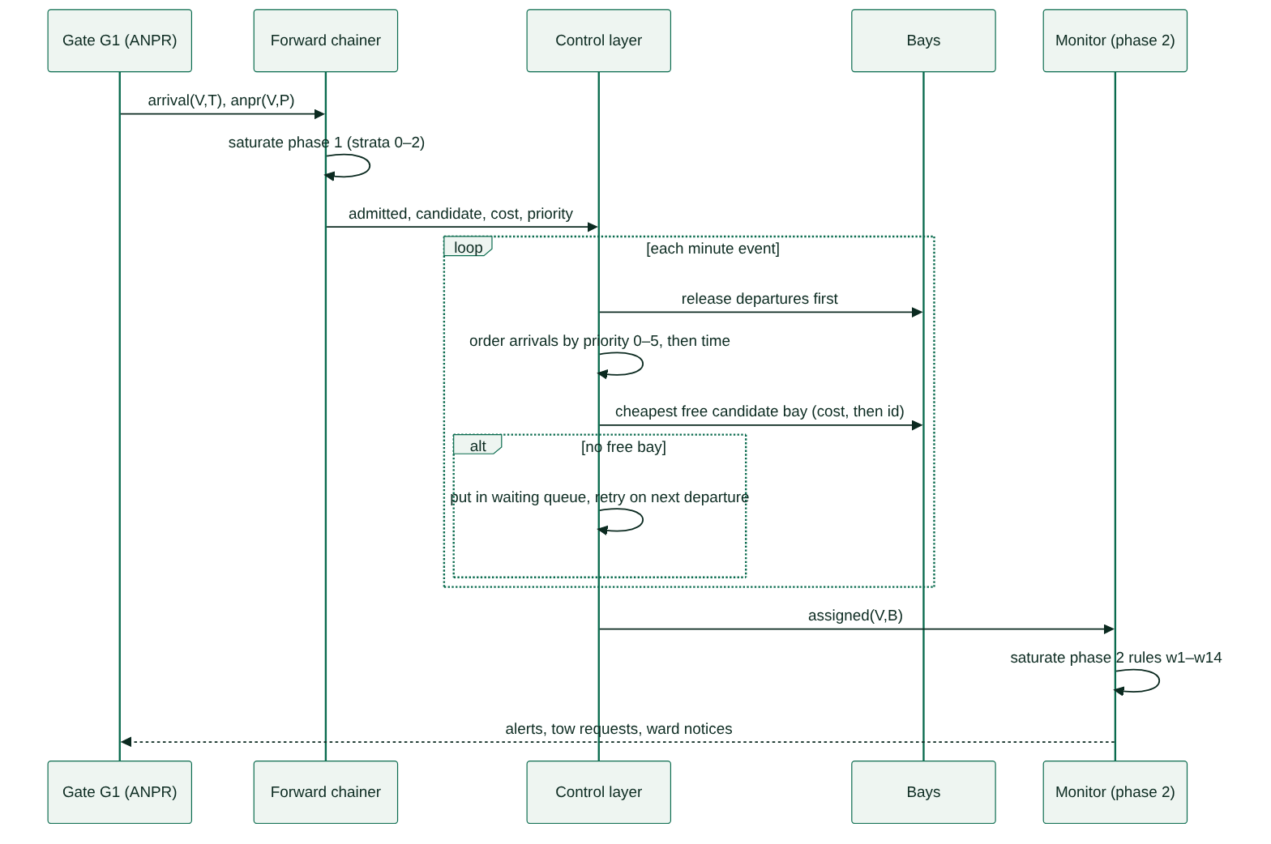
Figure 8: Day replay: gate, forward chainer, control layer, bays and monitor

6.1.6 Selected firings by cycle
Table 29: Selected rule firings (full list: docs/generated/01_forward_trace.txt, 857 firings)
Cycle | Stratum | Rule | New fact
1 | 0 | h1 | staff_member(saad)
1 | 0 | h17 | emergency_vehicle(amb_fa)
1 | 0 | s1 | identified(ev_sa)
1 | 0 | s2 | battery_low(ev_sa)
1 | 0 | s4 | badge_valid(saad)
1 | 0 | s5 | banned(waqar)
1 | 0 | t1 | on_shift(saad)
1 | 0 | t2 | in_appointment_window(imtiaz)
1 | 0 | t4 | delivery_window(junaid)
2 | 0 | h7 | person(saad)
3 | 1 | a1 | cleared(saad)
3 | 1 | a2 | cleared(noor)
3 | 1 | h18 | unregistered (none on the baseline day)
4 | 1 | a5 | admitted(amb_fa)
4 | 1 | a6 | admitted(car_gh)
4 | 1 | a7 | admitted(wv_no)
5 | 1 | e1 | entitled(amb_fa, z_amb)
5 | 1 | e3 | entitled(wv_no, z_acc)
5 | 1 | e5 | entitled(ev_sa, z_ev)
5 | 1 | e8 | entitled(ev_sa, z_oncall)
5 | 1 | p1 | priority(amb_fa, 0)
5 | 1 | p3 | priority(ev_sa, 1)
6 | 1 | c1 | candidate(ev_sa, ev1)
8 | 2 | k3 | ev_adjust(ev_sa, oc1, 120)
9 | 2 | k9 | cost(ev_sa, ev1, 150)
9 | 2 | k11 | cost(car_gh, dr1, 20)
10 | 0 | w5 | charger_hog(ev_zb, ev2)
10 | 0 | w13 | alert_trauma_team(car_gh)
10 | 0 | w14 | height_warning(wv_no)
13 | 1 | w8 | dropoff_overstay(car_ks)
13 | 1 | w9 | manual_check(car_ya)

6.2 Backward Chaining

6.2.1 Algorithm
The backward chainer (engine/backward.pl) is a meta-interpreter over the same rule data. It records a Prolog box-model trace with the ports CALL, EXIT, REDO and FAIL, plus TRY for each rule, and returns a proof tree.
- solve(G): if the depth exceeds 40, fail. If G is not(A), try to prove A: success means not(A) fails, failure means it succeeds (negation as failure).
- If G is a builtin, evaluate it once its inputs are bound: EXIT or FAIL.
- Otherwise log CALL. Try the stored facts first, then each rule r(Id,H,B) in source order: rename its variables, unify H with G, log TRY, and solve the body left to right.
- On success log EXIT; when the caller backtracks log REDO and try the next fact or rule; when nothing is left log FAIL.
- For monitoring goals (w1–w14) the store also holds the assigned(V,B) facts produced by the day replay.
- why_not(G): for a failed goal, take every rule whose head matches, find the first body literal that cannot be proved, and explain that literal the same way, down to a missing fact or a false comparison.
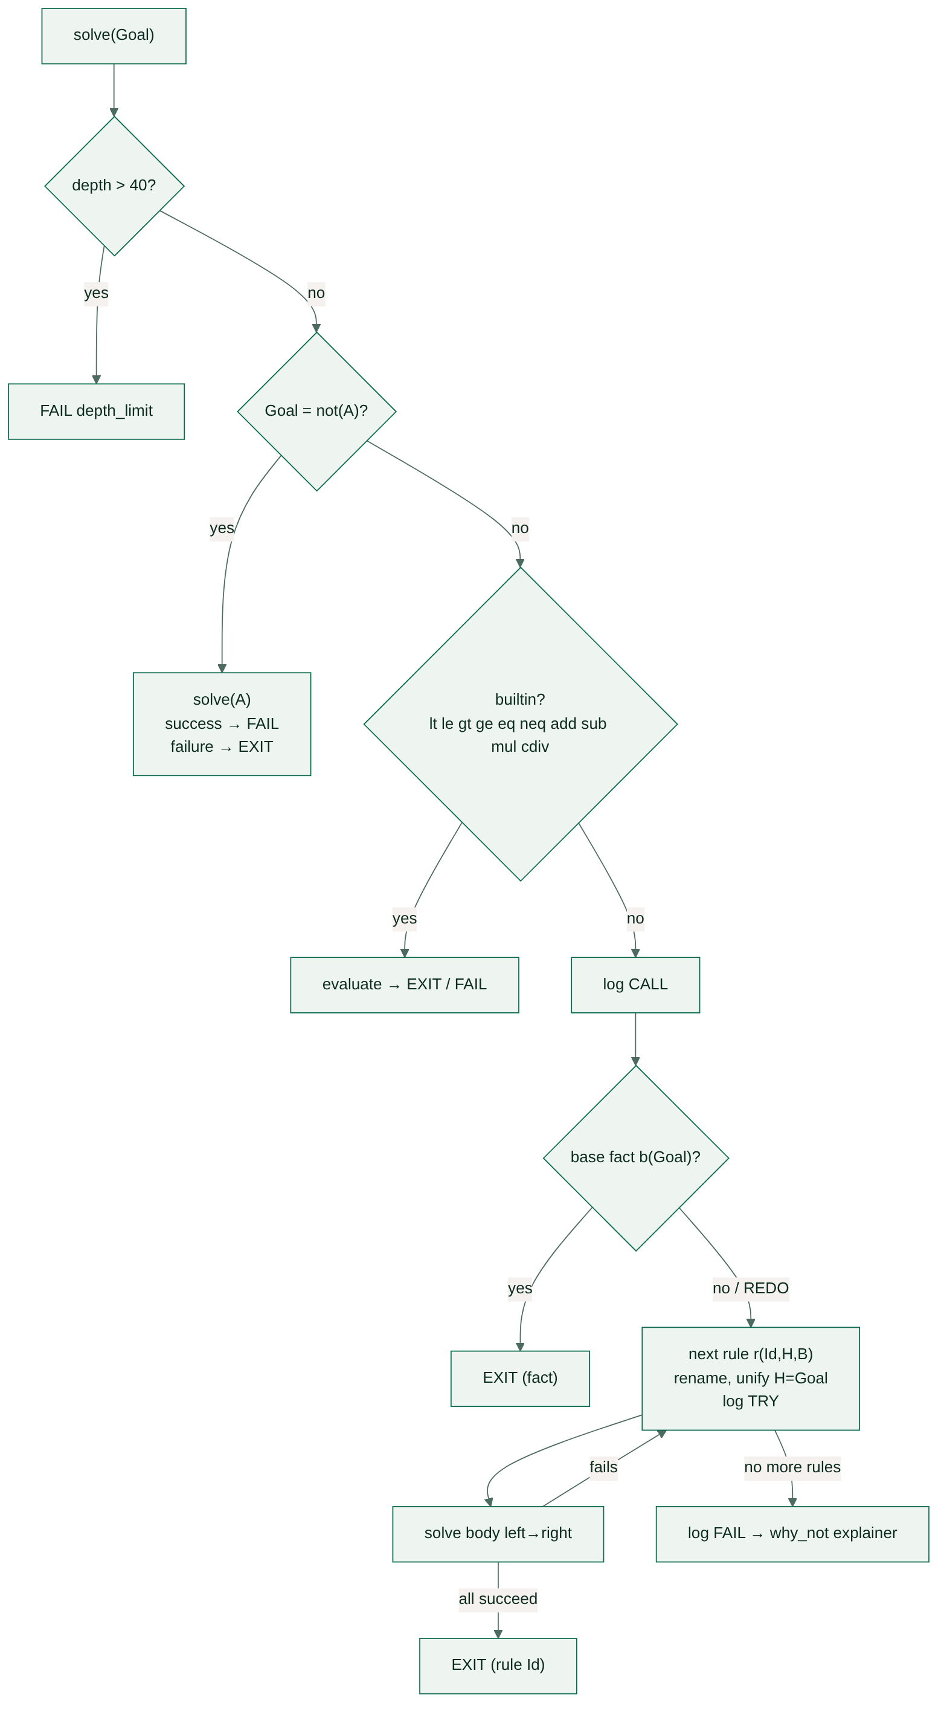
Figure 9: Backward chaining meta-interpreter

6.2.2 Successful proof
Goal: admitted(wv_no), is Noor's wheelchair van admitted? (docs/generated/03_backward_admitted_wv_no.txt)
CALL admitted(wv_no)
try a5: emergency_vehicle(wv_no)
| CALL emergency_vehicle(wv_no)
| try h17: vclass(wv_no,ambulance), emergency_run(wv_no)
| | CALL vclass(wv_no,ambulance)
| | FAIL vclass(wv_no,ambulance)
| FAIL emergency_vehicle(wv_no)
try a6: emergency_declared(wv_no), arrival(wv_no,_)
| CALL emergency_declared(wv_no)
| FAIL emergency_declared(wv_no)
try a7: arrival(wv_no,_), identified(wv_no), drives(_P,wv_no), cleared(_P)
| CALL arrival(wv_no,_) EXIT arrival(wv_no,585)
| CALL identified(wv_no)
| try s1: anpr(wv_no,_C), ge(_C,90)
| | CALL anpr(wv_no,_C) EXIT anpr(wv_no,94)
| | CALL ge(94,90) EXIT ge(94,90)
| EXIT identified(wv_no)
| CALL drives(_P,wv_no) EXIT drives(noor,wv_no)
| CALL cleared(noor)
| try a1: staff_member(noor), badge_valid(noor), not banned(noor)
| | CALL staff_member(noor) h1-h4 tried: doctor/nurse/admin/paramedic(noor) all FAIL
| | FAIL staff_member(noor)
| try a2: patient(noor), not banned(noor)
| | CALL patient(noor) EXIT patient(noor)
| | CALL not banned(noor)
| | | CALL banned(noor) try s5: security_ban(noor) FAIL
| | | FAIL banned(noor)
| | EXIT not banned(noor)
| EXIT cleared(noor)
EXIT admitted(wv_no)

Proof tree
admitted(wv_no) <a7>
arrival(wv_no,585) <fact>
identified(wv_no) <s1>
anpr(wv_no,94) <fact>
ge(94,90) <builtin>
drives(noor,wv_no) <fact>
cleared(noor) <a2>
patient(noor) <fact>
not banned(noor) <naf>

A second successful proof uses the allocation: dropoff_overstay(car_ks) is proved by w8 from assigned(car_ks, dr1), bay_type(dr1, drop), stay(car_ks, 20), dropoff_limit(car_ks, 15) (by w7, since not emergency_declared(car_ks)) and the builtin gt(20, 15).

6.2.3 Failed proof with backtracking
Goal: admitted(car_bu), is Bushra's car admitted? (docs/generated/04_backward_admitted_car_bu_fails.txt)
CALL admitted(car_bu)
try a5: emergency_vehicle(car_bu)
| CALL emergency_vehicle(car_bu)
| try h17: vclass(car_bu,ambulance), emergency_run(car_bu)
| | CALL vclass(car_bu,ambulance) FAIL
| FAIL emergency_vehicle(car_bu)
try a6: emergency_declared(car_bu), arrival(car_bu,_)
| CALL emergency_declared(car_bu) FAIL
try a7: arrival(car_bu,_), identified(car_bu), drives(_P,car_bu), cleared(_P)
| CALL arrival(car_bu,_) EXIT arrival(car_bu,560)
| CALL identified(car_bu) s1: anpr(car_bu,97), ge(97,90) EXIT
| CALL drives(_P,car_bu) EXIT drives(bushra,car_bu)
| CALL cleared(bushra)
| try a1: staff_member(bushra), badge_valid(bushra), not banned(bushra)
| | CALL staff_member(bushra) h3: admin(bushra) EXIT
| | CALL badge_valid(bushra)
| | try s4: staff_badge(bushra,_I,_E), today(_T), le(_I,_T), ge(_E,_T)
| | | CALL staff_badge(bushra,_I,_E) EXIT staff_badge(bushra,20241101,20261031)
| | | CALL today(_T) EXIT today(20261110)
| | | CALL le(20241101,20261110) EXIT
| | | CALL ge(20261031,20261110) FAIL
| | | REDO today, staff_badge: no other facts
| | FAIL badge_valid(bushra)
| | REDO staff_member(bushra): no other rule
| try a2: patient(bushra) FAIL
| try a3: visitor(bushra) FAIL
| try a4: supplier(bushra) FAIL
| FAIL cleared(bushra)
| REDO drives, identified, arrival: no alternatives
FAIL admitted(car_bu)

Why not: admitted(car_bu)
admitted(car_bu) cannot be proved:
a5 blocked at emergency_vehicle(car_bu)
h17 blocked at vclass(car_bu,ambulance) <- no such fact is stored
a6 blocked at emergency_declared(car_bu) <- no such fact is stored
a7 blocked at cleared(bushra)
a1 blocked at badge_valid(bushra)
s4 blocked at ge(20261031,20261110) <- comparison is false
a2 blocked at patient(bushra) <- no such fact is stored
a3 blocked at visitor(bushra) <- no such fact is stored
a4 blocked at supplier(bushra) <- no such fact is stored

Table 30: Why-not explanations for the other refusals
Goal | First failing literal | Reason at the gate
admitted(car_wq) | a3 blocked at not banned(waqar): banned(waqar) holds, so its negation fails | security_ban
admitted(car_ya) | s1 blocked at ge(64,90): comparison is false | plate_unreadable, manual check
fits(wv_no, pt1) | f1 blocked at le(230,210): the 230 cm van exceeds the 210 cm ramp | used in scenario tc11

7. IMPLEMENTATION

7.1 Tools and Technologies
Table 31: Tools and technologies
Tool | Use
SWI-Prolog 9 | Knowledge base, forward and backward chainers, frames, semantic network, FOL and DL modules, command-line program
plunit | 159 Prolog unit tests
JavaScript (ES2020) | Browser port of the reasoning engine (website/engine.js)
Node.js 18+ and node:test | 71 tests that the JavaScript engine matches Prolog on all 22 scenarios; site build
three.js 0.160 | 3D digital twin of the car park
HTML and CSS | Control-room web interface, light and dark themes, phone layout
Mermaid | The 10 diagrams in this report

7.2 Code / Execution

7.2.1 Project structure
CarePark-KR/
Read me first.txt how to open and run everything
README.md
main.pl command-line program and menu
kb/ facts.pl 431 facts: levels, zones, bays, walking table, drivers, badges, shifts
rules.pl 97 Horn rules as data + 13 integrity constraints
scenarios.pl 22 test scenarios as deltas with expected outcomes
engine/ core.pl rule loading, stratification, saturation with NAF and builtins
allocate.pl day replay: departures, priorities, cheapest bay, waiting queue, phase 2
backward.pl meta-interpreter, box-model trace, proof trees, why-not
check.pl integrity constraints and expected-outcome checks
frames.pl 46 frames, facets, demons, PARKING-VISIT script
semnet.pl 61 nodes, 79 links and graph queries
fol.pl 36 FOL statements and model checks
dl.pl 89 TBox axioms, ABox, realisation, consistency
stats.pl the project numbers
tools/ export.pl writes the knowledge base and results to website/*.json
build_site.mjs builds website/index.html
tests/ run.pl + 4 suites (159 tests) tests_js/ engine.test.mjs (71 tests)
website/ index.html, engine.js, kb.json, results.json, site.json, src/ (page, app, 3D twin)
docs/ diagrams/ (10), generated/ (14 trace sheets), screenshots/ (12)
report/ this report (DOCX and PDF)

7.2.2 Knowledge base implementation
Facts are written compactly and expanded by fact/1. One driver/9 line gives the role, destination, drives, vclass, height, anpr, arrival and stay facts; one walk_row/2 line gives the eight walking distances of a zone. Rules are terms r(Id, Head, Body) read with their variable names, so traces print V=car_ru rather than internal variable numbers. Scenarios are deltas: sc(Id, Title, Story, Remove, Add, ExpectedChanges, Checks).

7.2.3 Frame implementation
get(Frame, Slot, Value, Source) follows the lookup order of section 3.1.1 and also returns where the value came from (local value, if-needed demon, inherited, default). put/3 stores a local value and runs any if-added demon. isa_chain/2 computes the breadth-first inheritance order for multiple inheritance.

7.2.4 Forward chaining implementation
strata/1 assigns each derived predicate a stratum by relaxation: a head is at least as high as each positive body predicate and strictly higher than each negated one. saturate/3 runs stratum by stratum; within a stratum it takes a snapshot of working memory, matches every rule with findall, and adds the new facts, until a cycle adds nothing. run_day/2 performs the control-layer replay and then saturates phase 2.

7.2.5 Backward chaining implementation
solve/3 is the meta-interpreter of section 6.2.1. A global counter keeps the trace linear in its length, and a quiet mode switches tracing off for bulk checks. why_not/2 builds the explanation tree; it stops at depth 12 to stay readable.

7.2.6 User interaction and sample queries
Table 32: Commands
Command | Output
swipl main.pl | interactive menu
swipl main.pl day [tc05] | the day for the baseline or any scenario: timeline, decisions, alerts, fees, constraints
swipl main.pl saturate | full forward chaining trace
swipl main.pl prove "admitted(wv_no)" | backward trace and proof tree
swipl main.pl whynot "admitted(car_bu)" | why-not explanation
swipl main.pl scenarios | all 22 scenarios, pass or fail
swipl main.pl frames | net | fol | dl | script | rules | facts | stats | each knowledge view
swipl main.pl export | regenerates the website data
swipl tests/run.pl | 159 Prolog tests
node --test tests_js/engine.test.mjs | 71 JavaScript tests

7.2.7 Sample execution
$ swipl main.pl day
==============================================================================
Baseline day
==============================================================================
431 facts in, 808 derived in phase 1 (decisions), 49 in phase 2 (monitoring)

Decisions
06:40 mc_ma bay mc1, cost 170 m, priority 3, waited 0 min
07:05 ev_sa bay ev1, cost 150 m, priority 1, waited 0 min
07:45 car_im bay pt1, cost 40 m, priority 2, waited 0 min
07:50 suv_ar bay st3, cost 70 m, priority 3, waited 0 min
08:40 van_ju bay ld1, cost 30 m, priority 3, waited 0 min
09:00 amb_fa bay amb1, cost 10 m, priority 0, waited 0 min
09:20 car_bu DENIED (badge_invalid)
...
15:05 car_ya DENIED (plate_unreadable)

Alerts and guidance (phase 2)
charger_hog(ev_zb,ev2)
dropoff_overstay(car_ks)
security_alert(waqar)
notify_ward(car_ru,maternity)
alert_trauma_team(car_gh)
...
Integrity constraints IC1-IC13: []

$ swipl main.pl scenarios
tc01 Ordinary Tuesday (baseline) pass []
tc02 Code red at the emergency department pass []
...
22/22 scenarios pass

$ swipl tests/run.pl
% All 159 tests passed
$ node --test tests_js/engine.test.mjs
# pass 71
# fail 0

7.2.8 Execution screenshots
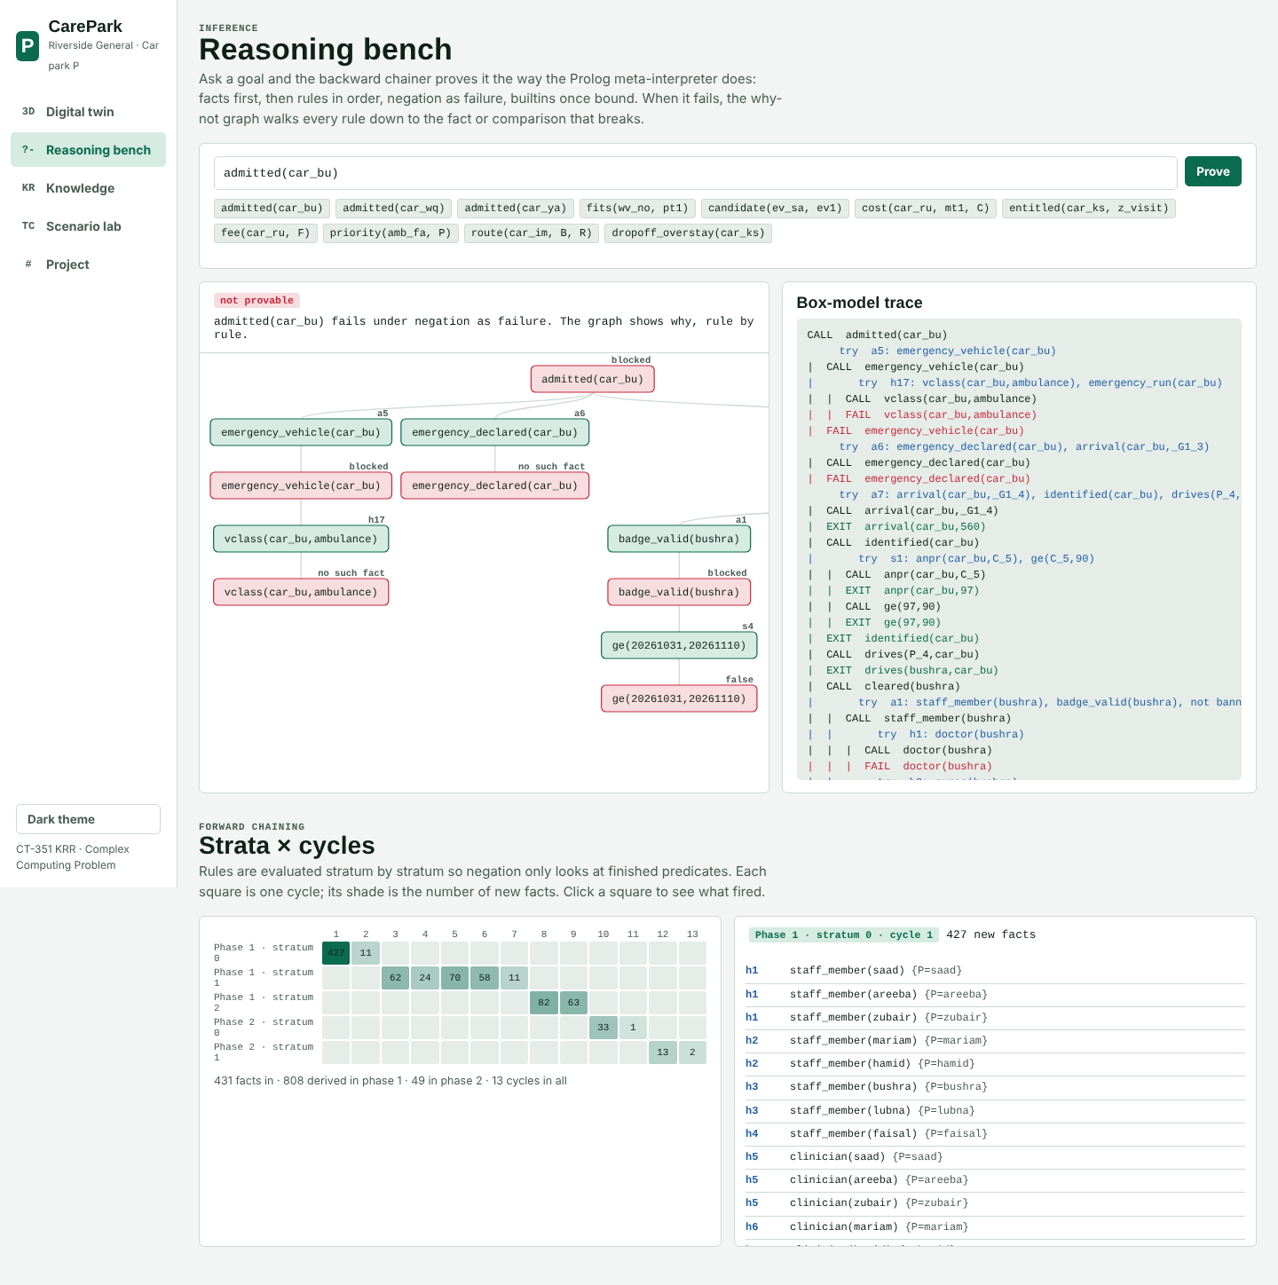
Figure 10: Reasoning bench: why-not graph and box-model trace for admitted(car_bu), with the strata × cycles grid
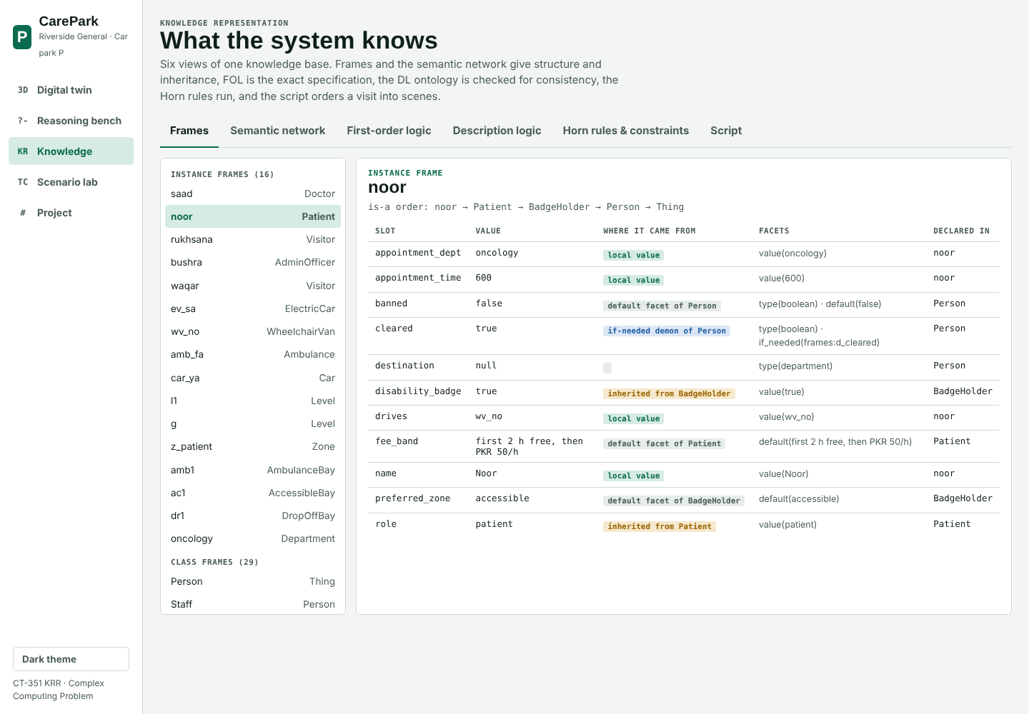
Figure 11: Knowledge view: the noor frame with the source of every slot value
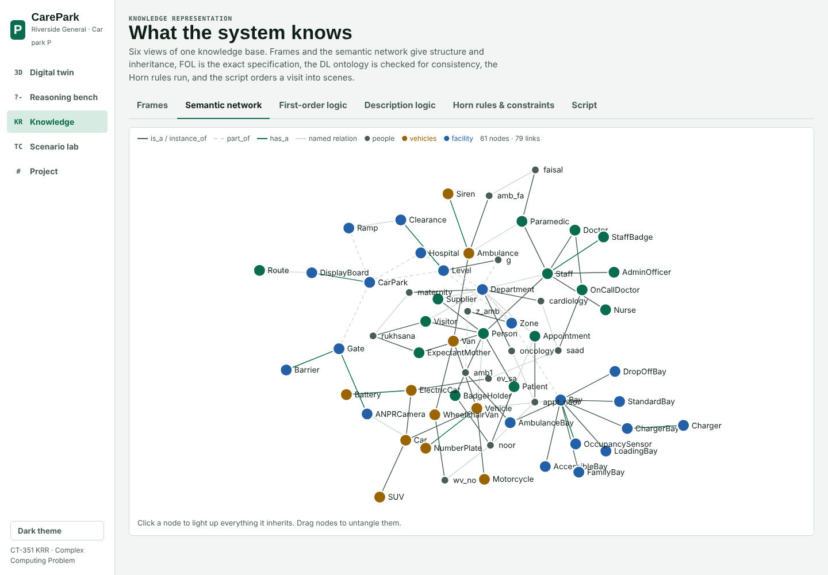
Figure 12: Knowledge view: the semantic network

7.2.9 Project website
The website, CarePark Control Room, opens on a 3D digital twin of Car park P: four levels, 29 bays, the gate with an ANPR barrier, the ramp and the hospital block. Pressing Play or dragging the timeline replays the day, and each car drives to its bay. Clicking a car shows its rule chain, every candidate bay with its cost in metres, the fee and the walking route to its department. The other views are the reasoning bench (any goal, proved in the browser), the knowledge views (frames, network, FOL, DL, rules, script), the scenario lab (22 cases with live pass or fail and a builder for new ones) and the project page. It runs the same rules as Prolog through engine.js, works in light and dark themes and on a phone.
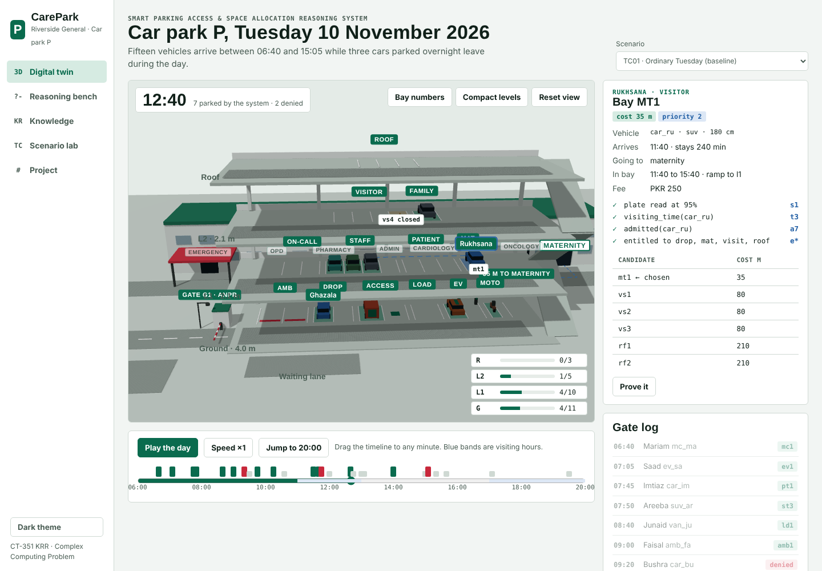
Figure 13: Digital twin at 12:40 with Rukhsana selected in mt1, 35 m from maternity
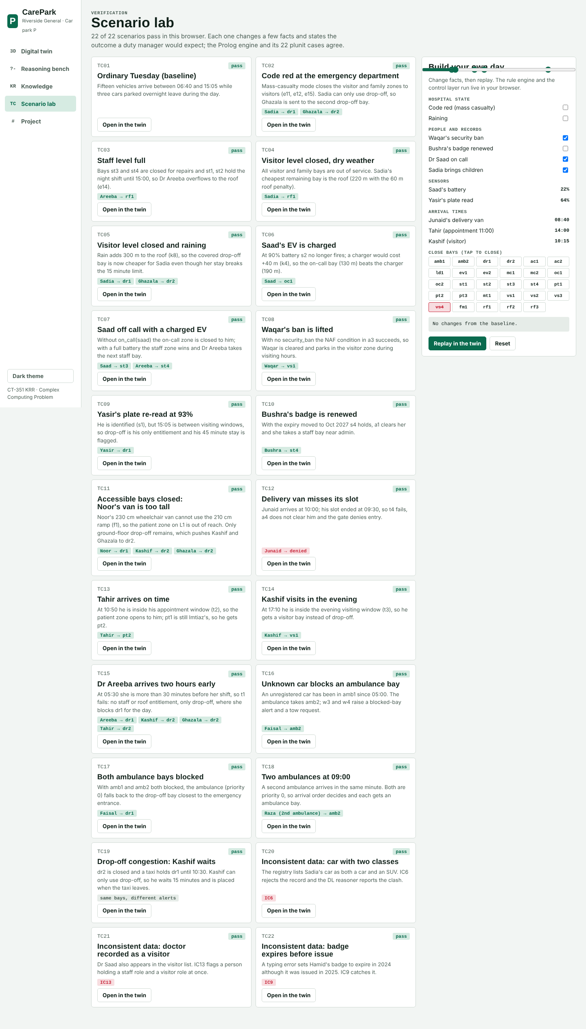
Figure 14: Scenario lab: 22 cases checked live, and the scenario builder

8. RESULTS AND DISCUSSION

8.1 Results

8.1.1 Decisions for the main scenario
On the baseline day 12 vehicles are parked and 3 refused, each for the reason the policy gives: Bushra's badge expired on 31 October (badge_invalid), Waqar is on the ban list (security_ban), and Yasir's plate was read at 64% (plate_unreadable, sent to a manual check). Every parked vehicle got its cheapest free candidate: the ambulance went to amb1 at 10 m from emergency, Saad's low-battery EV took a charger (ev1) even though an on-call bay is nearer, because the 120 m penalty for no charger made oc1 cost 170 m against 150 m, and Noor's 230 cm van was kept on the ground floor in the accessible bay ac1. Kashif arrived outside visiting hours and could only use drop-off, where his 20 minute stay was flagged.

8.1.2 Test cases
Table 33: Test scenarios and results
Id | Scenario | What changes in the reasoning | Expected and obtained | Result
tc01 | Ordinary Tuesday (baseline) | — | 12 parked, 3 denied; 7 key alerts; no IC | Pass
tc02 | Code red at the emergency department | e11, e12, e15 close visitor zones to visitors | car_sd → dr1, car_gh → dr2; overstay(car_sd) | Pass
tc03 | Staff level full | st3, st4 closed; st1, st2 held; e14 overflow | suv_ar → rf1 | Pass
tc04 | Visitor level closed, dry weather | visitor and family bays out of service | car_sd → rf1 | Pass
tc05 | Visitor level closed and raining | k8 adds 300 m to the roof | car_sd → dr1, car_gh → dr2 | Pass
tc06 | Saad's EV is charged | s2 no longer fires; k4 +40 m on chargers | ev_sa → oc1 | Pass
tc07 | Saad off call, EV charged | no on-call entitlement | ev_sa → st3, suv_ar → st4 | Pass
tc08 | Waqar's ban is lifted | NAF in a3 succeeds | car_wq → vs1 | Pass
tc09 | Yasir's plate re-read at 93% | s1 holds; outside visiting hours | car_ya → dr1; overstay(car_ya) | Pass
tc10 | Bushra's badge is renewed | s4 holds, a1 clears her | car_bu → st4 | Pass
tc11 | Accessible bays closed; Noor's van too tall | f1 fails for L1 (230 > 210 cm) | wv_no → dr1, car_ks → dr2, car_gh → dr2 | Pass
tc12 | Delivery van misses its slot | t4 fails, a4 does not clear | van_ju denied: outside_delivery_slot | Pass
tc13 | Tahir arrives on time | t2 holds, patient zone opens | car_th → pt2 | Pass
tc14 | Kashif visits in the evening | t3 holds in 17:00–20:00 | car_ks → vs1 | Pass
tc15 | Dr Areeba two hours early | t1 fails: only drop-off | suv_ar → dr1; ks, gh, th → dr2 | Pass
tc16 | Unknown car blocks an ambulance bay | w3, w4 with unregistered (NAF) | amb_fa → amb2; tow_request(amb1) | Pass
tc17 | Both ambulance bays blocked | priority 0 falls back to drop-off | amb_fa → dr1; two tow requests | Pass
tc18 | Two ambulances at 09:00 | same priority, arrival order decides | amb_rz → amb2 | Pass
tc19 | Drop-off congestion | waiting queue, retried on departure | car_ks waits 15 min | Pass
tc20 | Car with two classes | IC6; DL clash SUV / PetrolCar | IC6 reported | Pass
tc21 | Doctor recorded as a visitor | IC13 | IC13 reported | Pass
tc22 | Badge expires before issue | IC9 | IC9 reported | Pass

8.1.3 Inference accuracy and consistency
- All 22 scenarios give the expected decisions, alerts and constraint results in Prolog (swipl main.pl scenarios: 22/22 pass).
- The JavaScript engine reproduces every Prolog result: decisions, alerts, fees, constraint witnesses, fact counts and cycle counts for all 22 scenarios (71 tests).
- The forward and backward chainers agree: a test proves backward every admitted/1 fact the forward chainer derives, and fails backward on every refused vehicle.
- The DL and rule views agree: the AdmittedVehicle and ClearedPerson concepts contain exactly the individuals the rules admit and clear.
- All 21 FOL statements beyond Horn hold on the baseline model; the three bad-data scenarios are caught by IC6, IC13 and IC9.
- The baseline day runs in under a second: 431 facts, 857 derived, 13 cycles, 1,300 facts at the fixed point.

8.2 Discussion

8.2.1 Whether the objectives were met
Table 34: Objectives against results
Objective | Result
Frames, script, semantic network | 30 class + 16 instance frames with 7 facet kinds and 6 demons; 10-scene script; 61-node, 79-link network
FOL and DL | 36 FOL statements (21 beyond Horn, all model-checked); 89 DL axioms with realisation and consistency
Horn clauses, forward and backward chaining | 97 rules in 3 strata; full forward and backward traces with proof trees and why-not
Safe negation | Stratified negation as failure, checked automatically
Constraints and tests | 13 integrity constraints; 22 scenarios; 159 + 71 automated tests, all passing
Interactive explanation | 3D digital twin and reasoning bench running the same rules in the browser

8.2.2 Expressivity against tractability
Propositional logic has no variables, so every rule must be written once per individual. "A visitor who is not banned is cleared" becomes VisitorWaqar ∧ ¬BannedWaqar → ClearedWaqar, repeated for all 18 people. Candidate(v,b) over 18 vehicles and 29 bays needs 522 atoms, and cost(v,b,c) with every possible cost needs thousands more; adding one bay means rewriting every rule that mentions bays. Times can only be compared with an atom for every minute. Its gain is tractability: satisfiability is decidable (NP-complete in general) and Horn propositional logic is decided in linear time.
First-order logic removes those limits: one rule ∀p (Visitor(p) ∧ ¬Banned(p) → Cleared(p)) covers every visitor, quantifiers state "exactly one driver" and "no cheaper free bay", and comparisons handle time and cost. The price is that entailment in full FOL is only semi-decidable: a prover may run forever on a query that does not follow. FOL is also monotonic, so it cannot say "assume not banned unless told otherwise", and it has no built-in defaults.
Table 35: Expressivity and tractability of the formalisms
 | Propositional | Full FOL | DL | Horn + NAF (used)
Rules for "visitor not banned → cleared" | 18 (one per person) | 1 | 1 definition | 1
Candidate bays | 522 atoms | 1 predicate | 1 role | 1 predicate
Time and cost arithmetic | one atom per value | yes | concrete domains only | builtins on bound values
"Every person has some role" (disjunction) | yes, ground | yes | yes (covering axiom) | no: checked after the run
Rules joining several individuals (cost from zone and department) | ground only | yes | no | yes
Defaults and exceptions | no | no (monotonic) | no | NAF, closed world
Decidability | decidable; NP-complete (Horn: linear) | semi-decidable | decidable; ExpTime for this expressivity | decidable; polynomial

CarePark-KR therefore decides with stratified Horn clauses, the most expressive of these that still answers in polynomial time, and uses FOL and DL to specify and check. What the Horn restriction costs is paid for explicitly: disjunctions (f3) and optimality (f24) are checked on the finished model; uniqueness (f4, f5) and non-overlap (f23) are integrity constraints; negation is negation as failure, sound only under the closed-world assumption, which suits a gate (an unlisted ban does not exist) but not open data. The rules have no function symbols that build new terms and builtins run only on bound values, so forward chaining always reaches a fixed point.

8.2.3 Forward against backward chaining
Table 36: Forward and backward chaining compared
 | Forward chaining | Backward chaining
Starts from | the 431 facts | one goal, e.g. admitted(car_bu)
Work done | derives all 857 facts, most never asked about | only the facts the goal needs (19 calls for admitted(wv_no))
Best for | deciding the whole day at the gate; monitoring | checking or explaining one decision
Negation | safe through stratification | safe through NAF on ground goals
Explanation | the firing log shows when each fact appeared | proof tree and why-not tree show why
Termination | guaranteed (finite fixed point) | depth limit 40

8.2.4 Limitations observed
- Bay choice is greedy in time order: each vehicle gets the cheapest bay free when it arrives, which is not always the best for the whole day (a later patient may find the patient zone taken by an earlier one).
- The closed-world assumption means a missing fact is read as false; a ban entered late would not stop a vehicle already admitted.
- Walking distances are a fixed table; the system does not model lifts that are out of order or blocked corridors.
- The DL reasoner is a structural checker for this ontology, not a full tableau reasoner.
- Times are whole minutes within one day; overnight shifts across midnight would need dates on every time.

9. CONCLUSION

9.1 Conclusion and Future Improvements
CarePark-KR shows that a hospital parking policy can be captured as explicit knowledge and run with explanations. The same knowledge is represented five ways: frames and a script for concepts and procedure, a semantic network for relations, FOL for the exact policy, DL for the vocabulary and its consistency, and 97 Horn clauses that the system executes. Forward chaining decides a whole day of 15 arrivals in 13 cycles; backward chaining proves or refutes any single decision and names the condition that failed. All 22 test scenarios, including code red, rain, height limits, blocked ambulance bays and bad data, give the expected results, and the 3D digital twin lets anyone watch the reasoning happen.
Future improvements:
- Replace the greedy bay choice with a look-ahead that reserves patient and maternity bays for appointments due in the next hour.
- Read live occupancy sensors and ANPR events instead of a scripted day.
- Add probabilistic reasoning for plate reads between 70% and 90% instead of a hard threshold.
- Export the ontology to OWL and check it with a full DL reasoner.
- Add dates to times so overnight shifts and multi-day stays are handled.

10. REFERENCES
- Brachman, R. J. and Levesque, H. J. Knowledge Representation and Reasoning. Morgan Kaufmann, 2004.
- Russell, S. and Norvig, P. Artificial Intelligence: A Modern Approach, 4th ed. Pearson, 2020. Chapters 7–10 (logic, inference, knowledge representation).
- Baader, F., Calvanese, D., McGuinness, D., Nardi, D. and Patel-Schneider, P. (eds.) The Description Logic Handbook, 2nd ed. Cambridge University Press, 2007.
- Minsky, M. A Framework for Representing Knowledge. MIT AI Laboratory Memo 306, 1974.
- Schank, R. C. and Abelson, R. P. Scripts, Plans, Goals and Understanding. Lawrence Erlbaum, 1977.
- Apt, K. R., Blair, H. A. and Walker, A. Towards a theory of declarative knowledge. In Foundations of Deductive Databases and Logic Programming, Morgan Kaufmann, 1988 (stratified negation).
- Clark, K. L. Negation as Failure. In Logic and Data Bases, Plenum Press, 1978.
- Sterling, L. and Shapiro, E. The Art of Prolog, 2nd ed. MIT Press, 1994 (meta-interpreters).
- Wielemaker, J. et al. SWI-Prolog. Theory and Practice of Logic Programming 12(1–2), 2012. https://www.swi-prolog.org
- three.js documentation. https://threejs.org/docs

11. TEAM PARTICIPATION
Table 37: Team participation
S. No. | Name | Roll No. | Contribution
1 | Minhaj Khan | AI-23301 | Problem statement, knowledge acquisition, domain requirements, facts, frames, demons and the PARKING-VISIT script (sections 1–3.1)
2 | Faraz Khan | AI-23047 | Semantic network, description logic TBox and ABox, realisation and consistency, expressivity vs tractability analysis (sections 3.2, 4.2, 8.2.2)
3 | Raied Khan | AI-23046 | FOL formalisation, Horn clause conversion, rules and integrity constraints, forward chainer and day replay (sections 4.1, 5, 6.1)
4 | Sabih Salam | AI-23040 | Backward chainer and why-not explainer, 3D website, JavaScript engine port, testing, report (sections 6.2, 7, 8.1)

