Program 1 :

Aim: Hello world program ( Write a program to Toast hello world)

Source Code:

Activity_main.xml

?xml version="1.0" encoding="utf-8"?>

<androidx. Constraint layout. widget.ConstraintLayout xmlns:android="<http://schemas.android.com/apk/res/android>" xmlns:app="<http://schemas.android.com/apk/res-auto>" xmlns:tools=<http://schemas.android.com/tools>

android:layout_width="match_parent" android:layout_height="match_parent" tools:context=".MainActivity">

<Button android:id="@+id/toastButton" android:layout_width="wrap_content" android:layout_height="wrap_content" android:text="TOAST"

app:layout_constraintBottom_toBottomOf="parent" app:layout_constraintEnd_toEndOf="parent" app:layout_constraintStart_toStartOf="parent" app:layout_constraintTop_toTopOf="parent" />

</android. Constraint layout. widget.ConstraintLay

ActivityMain.java

package com.AZAUSCS012.HelloWorld import androidx.appcompat.app.AppCompatActivity; import android.os.Bundle; import android.view.View;

import android.widget.Button; import android.widget.Toast; public class MainActivity extends AppCompatActivity {

Button ToastButton; @Override

protected void onCreate(Bundle savedInstanceState) { super.onCreate(savedInstanceState); setContentView(R.layout.activity_main);

ToastButton = findViewById(R.id.toastButton); ToastButton.setOnClickListener(new View.OnClickListener() { @Override public void

onClick(View view) {

Toast.makeText(MainActivity.this,"Hello World",Toast.LENGTH_SHORT).show();

}

});

}

}

User Interface:

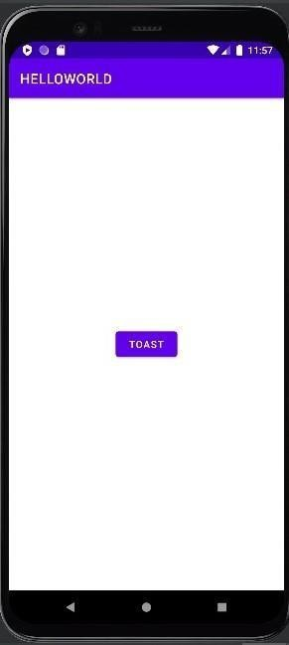

Output

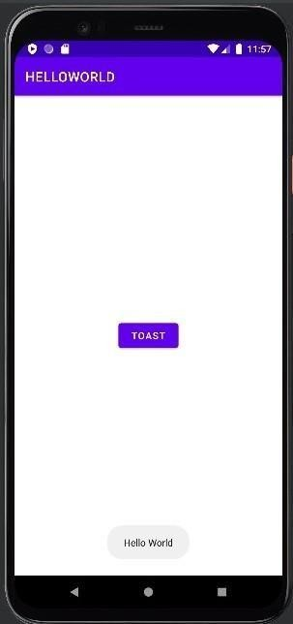

Program 2

Aim: Addition of two numbers (Write a program to add numbers) Source Code:

Activity_main.xml

<?xml version="1.0" encoding="utf-8"?>

<androidx.constraintlayout.widget.ConstraintLayout xmlns:android="<http://schemas.android.com/apk/res/android>" xmlns:app="<http://schemas.android.com/apk/res-auto>" xmlns:tools="[http://schemas.android.com/tools"](http://schemas.android.com/tools) android:layout_width="match_parent" android:layout_height="match_parent" tools:context=".MainActivity">

<EditText android:id="@+id/num1" android:layout_width="wrap_content" android:layout_height="wrap_content" android:layout_marginTop="33dp" android:ems="10" android:hint="Enter num1" android:inputType="number" app:layout_constraintEnd_toEndOf="parent" app:layout_constraintStart_toStartOf="parent" app:layout_constraintTop_toTopOf="parent" />

<EditText android:id="@+id/num2" android:layout_width="wrap_content" android:layout_height="wrap_content" android:layout_marginTop="28dp" android:ems="10"

android:hint="Enter num 2 " android:inputType="number" app:layout_constraintEnd_toEndOf="parent" app:layout_constraintHorizontal_bias="0.502"

app:layout_constraintStart_toStartOf="parent" app:layout_constraintTop_toBottomOf="@+id/num1" />

<Button android:id="@+id/add" android:layout_width="wrap_content" android:layout_height="wrap_content" android:layout_marginTop="36dp" android:onClick="add numbers" android:text="ADD" app:layout_constraintEnd_toEndOf="parent" app:layout_constraintHorizontal_bias="0.498" app:layout_constraintStart_toStartOf="parent" app:layout_constraintTop_toBottomOf="@+id/num2" />

<TextView android:id="@+id/result" android:layout_width="wrap_content" android:layout_height="wrap_content" android:layout_marginTop="27dp" app:layout_constraintEnd_toEndOf="parent" app:layout_constraintHorizontal_bias="0.498" app:layout_constraintStart_toStartOf="parent" app:layout_constraintTop_toBottomOf="@+id/add" />

</androidx.constraintlayout.widget.ConstraintLayout>

ActivityMain.java package com.AZAUSCS012.Addtwonumbers; import android.appcompat.app.AppCompatActivity; import android. os.Bundle; import android.view.View; import android. widget.EditText; import android. widget.TextView; public class MainActivity extends AppCompatActivity {

EditText num1,num2;

TextView result; @Override

protected void onCreate(Bundle saved instance State) { super.onCreate(savedInstanceState);

setContentView(R.layout.activity_main); num1 = findViewById(R.id.num1); num2 = findViewById(R.id.num2);

result = findViewById(R.id.result);

}

public void addNumbers(View v){ double n1,n2,r; n1

= Double.parseDouble(num1.getText().toString()); n2

= Double.parseDouble(num2.getText().toString()); r

= n1+n2; result.setText(String.valueOf(r));

}

}

User Interface

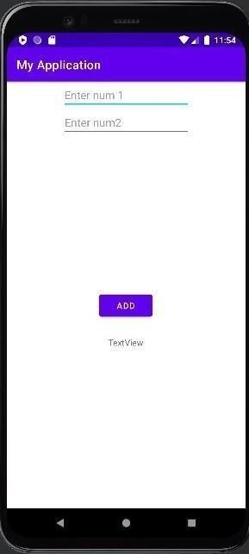o

Output

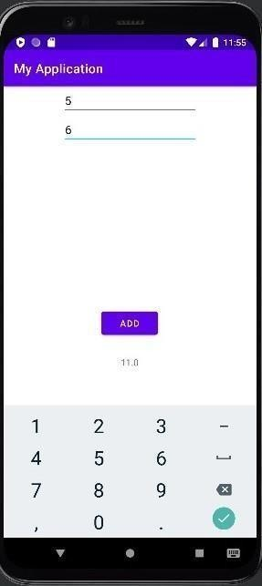

Program 3

Aim= Alert box(write a program to display alert box with ok and cancel) Source code

Activity_Main.xml

<?xml version="1.0" encoding="utf-8"?>

<androidx.constraintlayout.widget.ConstraintLayout xmlns:android="<http://schemas.android.com/apk/res/android>" xmlns:app="<http://schemas.android.com/apk/res-auto>" xmlns:tools="[http://schemas.android.com/tools"](http://schemas.android.com/tools) android:layout_width="match_parent" android:layout_height="match_parent" tools:context=".MainActivity">

<Button android:id="@+id/alert" android:layout_width="wrap_content" android:layout_height="wrap_content" android:onClick="alert me" android:text="ALERT

ME!"

app:layout_constraintBottom_toBottomOf="parent" app:layout_constraintEnd_toEndOf="parent" app:layout_constraintStart_toStartOf="parent" app:layout_constraintTop_toTopOf="parent" />

</androidx.constraintlayout.widget.ConstraintLayout>

ActivityMain.java package com.AZAUSCS012.alert; import androidx.appcompat.app.AlertDialog; import

androidx.appcompat.app.AppCompatActivity; import android.content.DialogInterface;

import android.os.Bundle; import android.view.View; import android.widget.Toast; public class MainActivity extends AppCompatActivity { @Override protected void onCreate(Bundle savedInstanceState) { super.onCreate(savedInstanceState); setContentView(R.layout.activity_main);

}

public void alertme(View v){

AlertDialog dlg = new AlertDialog.Builder(MainActivity.this)

.setTitle("Message")

.setMessage("Alert box is awsome")

.setPositiveButton("ok", new DialogInterface.OnClickListener() { @Override

public void onClick(DialogInterface dialogInterface, int i){ dialogInterface.dismiss();

Toast.makeText(MainActivity.this, "clicked ok!", Toast.LENGTH_SHORT).show();

}

})

.setNegativeButton("cancel", new DialogInterface.OnClickListener() { @Override

public void onClick(DialogInterface dialogInterface, int i) { dialogInterface.dismiss(); Toast.makeText(MainActivity.this,"clicked cancel!",Toast.LENGTH_SHORT).show();

}

})

.create(); dlg.show();}

}

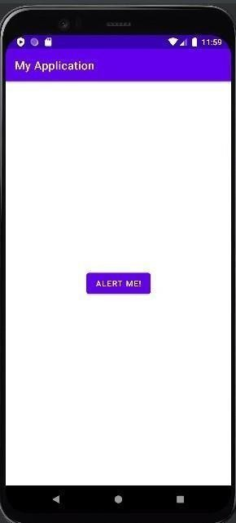UserInterface

Out put

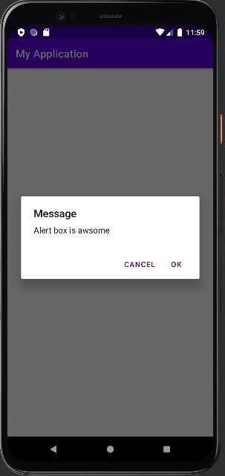

Program4

Ain=Menu program(write a menu program to create menu with three menu item) Source code

Activity_main.xml

<?xml version="1.0" encoding="utf-8"?>

<androidx.constraintlayout.widget.ConstraintLayout xmlns:android="<http://schemas.android.com/apk/res/android>" xmlns:app="<http://schemas.android.com/apk/res-auto>" xmlns:tools="[http://schemas.android.com/tools"](http://schemas.android.com/tools) android:layout_width="match_parent" android:layout_height="match_parent" tools:context=".MainActivity">

</androidx.constraintlayout.widget.ConstraintLayout>

Menu.xml

<?xml version="1.0" encoding="utf-8"?>

<menu xmlns:android="<http://schemas.android.com/apk/res/android>">

<item android:id="@+id/settings" android:title="Settings" /> <item android:id="@+id/contact" android:title="Contact" /> <item android:id="@+id/about" android:title="About Us" />

</menu>

ActivityMain.java package com.AZAUSCS012.menu; import androidx.annotation.NonNull; import androidx.appcompat.app.AlertDialog; import androidx.appcompat.app.AppCompatActivity; import android.content.DialogInterface; import android.os.Bundle; import android.view.Menu; import android.view.MenuInflater; import android.view.MenuItem; import android.view.View; import android.widget.Toast; public class MainActivity extends AppCompatActivity { @Override protected void onCreate(Bundle savedInstanceState) { super.onCreate(savedInstanceState); setContentView(R.layout.activity_main);

}

@Override public boolean onCreatePanelMenu(int featureId, @NonNull Menu menu) {

/ return super.onCreatePanelMenu(featureId, menu); MenuInflater inflater = getMenuInflater(); inflater.inflate(R.menu.menu, menu); return true;

}

@Override public boolean onOptionsItemSelected(@NonNull MenuItem item) {

// return super.onCreatePanelMenu(featureId, menu); MenuInflater inflater = getMenuInflater(); inflater.inflate(R.menu.menu, menu); return true;

}

@Override public boolean onOptionsItemSelected(@NonNull MenuItem item) {

switch (item.getItemId()){ case R.id.settings:

Toast.makeText(MainActivity.this, "Settings", Toast.LENGTH_SHORT).show(); return true; case R.id.contact:

Toast.makeText(MainActivity.this, "Thank you for contacting us !", Toast.LENGTH_SHORT).show();

return true; case R.id.about:

Toast.makeText(MainActivity.this, "Made with ❤", Toast.LENGTH_SHORT).show(); return true; default:

return super.onOptionsItemSelected(item);

}

}

}

User Interface :

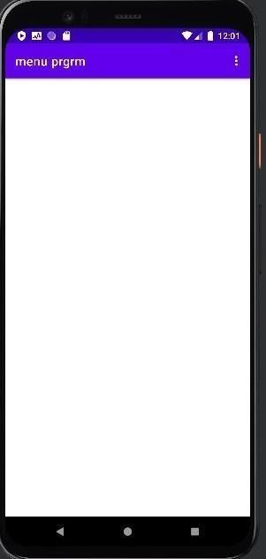

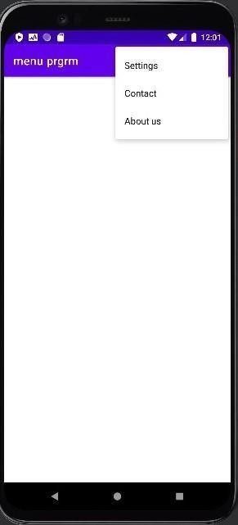Out put

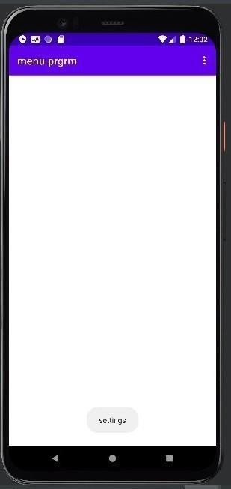

Program 5

Aim=Radio Button(write a program to select gender using Radio button) Source code=

Activity _main.xml

<?xml version="1.0" encoding="utf-8"?>

<androidx.constraintlayout.widget.ConstraintLayout xmlns:android="<http://schemas.android.com/apk/res/android>" xmlns:app="<http://schemas.android.com/apk/res-auto>" xmlns:tools="[http://schemas.android.com/tools"](http://schemas.android.com/tools) android:layout_width="match_parent" android:layout_height="match_parent" tools:context=".MainActivity">

<RadioGroup android:id="@+id/radioGroup3" android:layout_width="wrap_content" android:layout_height="wrap_content" app:layout_constraintBottom_toBottomOf="parent" app:layout_constraintEnd_toEndOf="parent"

app:layout_constraintStart_toStartOf="parent" app:layout_constraintTop_toTopOf="parent">

<RadioButton android:id="@+id/male" android:layout_width="wrap_content" android:layout_height="wrap_content" android:text="Male" android:onClick="isChecked" tools:layout_editor_absoluteX="134dp" tools:layout_editor_absoluteY="320dp" />

<RadioButton android:id="@+id/female" android:layout_width="wrap_content" android:layout_height="wrap_content" android:text="Female" android:onClick="isChecked" tools:layout_editor_absoluteX="151dp" tools:layout_editor_absoluteY="405dp" />

<TextView android:id="@+id/textView4" android:layout_width="wrap_content" android:layout_height="wrap_content" android:layout_marginTop="264dp" android:layout_marginBottom="35dp" android:text="Choose your gender : " app:layout_constraintBottom_toTopOf="@+id/radioGroup3" app:layout_constraintEnd_toEndOf="parent" app:layout_constraintStart_toStartOf="parent" app:layout_constraintTop_toTopOf="parent" />

<TextView android:id="@+id/result" android:layout_width="wrap_conte nt" android:layout_height="wrap_conte nt"

android:layout_marginTop="24dp" android:layout_marginBottom="274 dp" app:layout_constraintBottom_toBot tomOf="parent" app:layout_constraintEnd_toEndOf

="parent" app:layout_constraintHorizontal_bi as="0.498"

app:layout_constraintStart_toStart Of="parent" app:layout_constraintTop_toBotto mOf="@+id/radioGroup3" />

</RadioGroup>

</androidx.constraintlayout.widget.ConstraintLayout>

ActivityMain.java package com.AZAUSCS012.radiobutton; import

androidx.appcompat.app.AppCompatActivity; import android.os.Bundle; import android.view.View; import android.widget.RadioButton; import android.widget.RadioGroup; import android.widget.TextView; public class MainActivity extends AppCompatActivity {

RadioButton radioButton; RadioGroup radioGroup;

TextView result; @Override protected void onCreate(Bundle savedInstanceState) { super.onCreate(savedInstanceState); setContentView(R.layout.activity_main); radioGroup

= findViewById(R.id.radioGroup3); result = findViewById(R.id.result);

}

public void isChecked(View v){ int radioId = radioGroup.getCheckedRadioButtonId(); radioButton

= findViewById(radioId); switch (radioId){ case R.id.male:

result.setText("You selected :" + radioButton.getText()); case R.id.female:

result.setText("You selected :" + radioButton.getText());

}

}

}

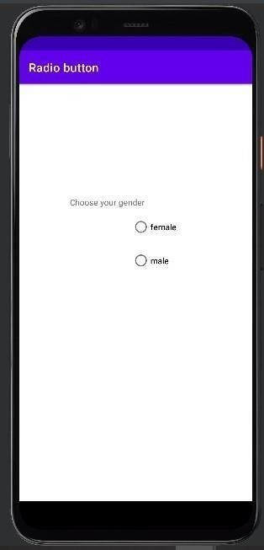User interface=

Out put

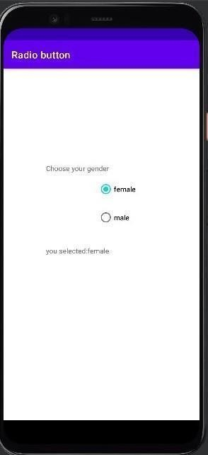

Program 6

Aim=program to spin four item Source code

Activity_main.xml

<?xml version="1.0" encoding="utf-8"?>

<androidx.constraintlayout.widget.ConstraintLayout xmlns:android="<http://schemas.android.com/apk/res/android>" xmlns:app="<http://schemas.android.com/apk/res-auto>" xmlns:tools="[http://schemas.android.com/tools"](http://schemas.android.com/tools) android:layout_width="match_parent" android:layout_height="match_parent" tools:context=".MainActivity">

<Spinner android:id="@+id/spinner" android:layout_width="240dp" android:layout_height="56dp" app:layout_constraintBottom_toBottomOf="parent" app:layout_constraintEnd_toEndOf="parent"

app:layout_constraintStart_toStartOf="parent" app:layout_constraintTop_toTopOf="parent" />

</androidx.constraintlayout.widget.ConstraintLayout>

String.xml

<resourse

<string name=”app_name”>spin</string>

<string -array name=”fruit”>

<item>mango</item>

<item>mango</item>

<item>mango</item>

<item>mango</item>

</string-array>

</resource>

ActivityMain.java package com.AZAUSCS012.spin; import androidx.appcompat.app.AppCompatActivity; import

android.os.Bundle; import android.view.View; import android.widget.AdapterView; import android.widget.ArrayAdapter; import android.widget.Spinner; import android.widget.Toast; public class MainActivity extends AppCompatActivity implements AdapterView.OnItemSelectedListener {

Spinner spinner; @Override protected void onCreate(Bundle savedInstanceState) { super.onCreate(savedInstanceState); setContentView(R.layout.activity_main); spinner

=findViewById(R.id.spinner); ArrayAdapter<CharSequence> adapter =

ArrayAdapter.createFromResource(this,R.array.fruit, android.R.layout.simple_spinner_item); adapter.setDropDownViewResource(android.R.layout.simple_spinner_dropdown_item); spinner.setAdapter(adapter); spinner.setOnItemSelectedListener(this);

}

@Override public void onItemSelected(AdapterView<?> adapterView, View view, int i, long l) {

String choice = adapterView.getItemAtPosition(i).toString(); Toast.makeText(this, choice, Toast.LENGTH_SHORT).show();

}

@Override public void onNothingSelected(AdapterView<?> adapterView) {

}

}

User interface:

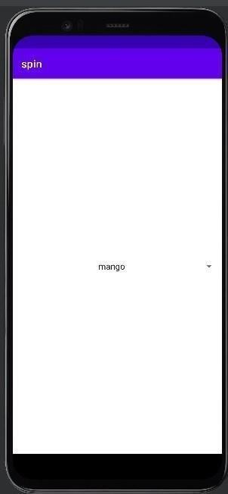

Out put:

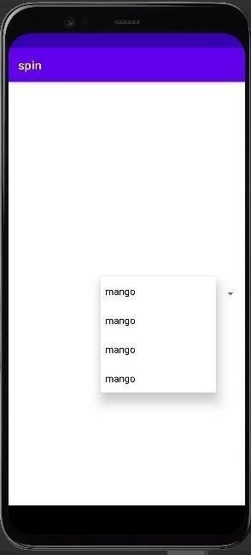

Program 7

Aim=write a program to check the item listed Source code

Activity_Main.xml

<?xml version="1.0" encoding="utf-8"?>

<androidx.constraintlayout.widget.ConstraintLayout xmlns:android="<http://schemas.android.com/apk/res/android>" xmlns:app="<http://schemas.android.com/apk/res-auto>" xmlns:tools="[http://schemas.android.com/tools"](http://schemas.android.com/tools) android:layout_width="match_parent" android:layout_height="match_parent" tools:context=".MainActivity">

<TextView android:id="@+id/textView3" android:layout_width="wrap_content" android:layout_height="wrap_content" android:layout_marginTop="116dp" android:text="Choose your hobby : " app:layout_constraintEnd_toEndOf="parent"

app:layout_constraintStart_toStartOf="parent" app:layout_constraintTop_toTopOf="parent" />

<CheckBox android:id="@+id/checkBox1" android:layout_width="wrap_content" android:layout_height="wrap_content" android:layout_marginTop="80dp" android:text="Cricket" android:onClick="itemCheck" app:layout_constraintEnd_toEndOf="parent" app:layout_constraintHorizontal_bias="0.42" app:layout_constraintStart_toStartOf="parent" app:layout_constraintTop_toBottomOf="@+id/textView3" />

<Check box android:id="@+id/checkBox2" android:layout_width="wrap_content" android:layout_height="wrap_content" android:layout_marginTop="12dp" android:text="Football" android:onClick="itemCheck" app:layout_constraintEnd_toEndOf="pare nt" app:layout_constraintHorizontal_bias="0. 42"

app:layout_constraintStart_toStartOf="pa rent" app:layout_constraintTop_toBottomOf=" @+id/checkBox3" />

<CheckBox android:id="@+id/checkBox3" android:layout_width="wrap_content" android:layout_height="wrap_content" android:layout_marginTop="4dp" android:text="Volley Ball" android:onClick="itemCheck" app:layout_constraintEnd_toEndOf="parent"

app:layout_constraintHorizontal_bias="0.439" app:layout_constraintStart_toStartOf="parent" app:layout_constraintTop_toBottomOf="@+id/checkBox4" />

<CheckBox android:id="@+id/checkBox4" android:layout_width="wrap_content" android:layout_height="wrap_content" android:layout_marginTop="8dp" android:text="Hockey" android:onClick="itemCheck" app:layout_constraintEnd_toEndOf="parent" app:layout_constraintHorizontal_bias="0.421" app:layout_constraintStart_toStartOf="parent" app:layout_constraintTop_toBottomOf="@+id/checkBox1" />

<TextView android:id="@+id/result" android:layout_width="wrap_content" android:layout_height="wrap_content" app:layout_constraintBottom_toBottomOf="parent" app:layout_constraintEnd_toEndOf="parent" app:layout_constraintHorizontal_bias="0.498" app:layout_constraintStart_toStartOf="parent" app:layout_constraintTop_toBottomOf="@+id/checkBox2" app:layout_constraintVertical_bias="0.145" />

</androidx.constraintlayout.widget.ConstraintLayout>

MainActivity.java package com.AZAUSCS012.Iteninlist;

import androidx.appcompat.app.AppCompatActivity; importandroid.os.Bundle;

import android.util.Log; import android.view.View;

import android.widget.CheckBox;

import android.widget.TextView; import java.util.ArrayList;

publicclassMainActivityextendsAppCompatActiviy

{

CheckBox ch1,ch2,ch3,ch4; TextView result;

ArrayList<String> arrayList; @Override protected void onCreate(Bundle savedInstanceState) { super.onCreate(savedInstanceState); setContentView(R.layout.activity_main); ch1 = findViewById(R.id.checkBox1); ch2 = findViewById(R.id.checkBox2); ch3 = findViewById(R.id.checkBox3);

ch4 = findViewById(R.id.checkBox4); result

= findViewById(R.id.result); arrayList = new ArrayList<>();

}

public void itemCheck(View view){ boolean checked = ((CheckBox) view).isChecked(); switch (view.getId()){ case R.id.checkBox1:

if (checked){ arrayList.add(ch1.getText().toString());

}else{ arrayList.remove(ch1.getText().toString());

}

break; case R.id.checkBox2:

if (checked){ arrayList.add(ch2.getText().toString());

}else{ arrayList.remove(ch2.getText().toString());

}

break; case R.id.checkBox3:

if (checked){ arrayList.add(ch3.getText().toString());

}else{ arrayList.remove(ch3.getText().toString());

}

break; case R.id.checkBox4:

if (checked){ arrayList.add(ch4.getText().toString());

}

else{ arrayList.remove(ch4.getText().toString());

}

break;

}

StringBuilder stringBuilder = new StringBuilder(); for(String s : arrayList){

stringBuilder.append(s).append(", "); Log.i("ME",s);

}

result.setText("You Selected : " + stringBuilder.toString());

}

}

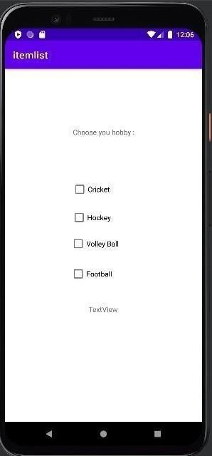User interface:

Out put:

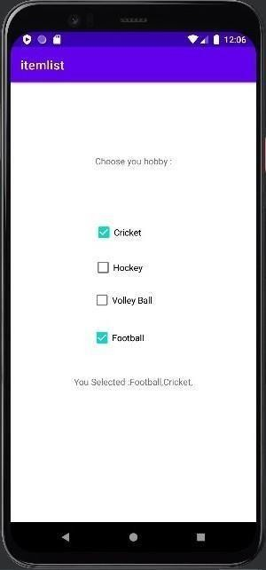

Program 8

Aim=write a program to display images from the local drive of the computer source code Source code=

Activiity_main.xml

<?xml version="1.0" encoding="utf-8"?>

<androidx. Constraint layout. widget.ConstraintLayout xmlns:android="<http://schemas.android.com/apk/res/android>" xmlns:app="<http://schemas.android.com/apk/res-auto>" xmlns:tools="[http://schemas.android.com/tools"](http://schemas.android.com/tools) android:layout_width="match_parent" android:layout_height="match_parent" tools:context=".MainActivity">

<ImageView android:id="@+id/imageView" android:layout_width="377dp" android:layout_height="356dp" android:layout_marginTop="72dp" app:layout_constraintBottom_toTopOf="@

+id/button1" app:layout_constraintEnd_toEndOf="paren t" app:layout_constraintHorizontal_bias="0.6 02"

app:layout_constraintStart_toStartOf="par ent" app:layout_constraintTop_toTopOf="paren t" app:layout_constraintVertical_bias="0.503 "

tools:srcCompat="@tools:sample/avatars"

/>

<Button android:id="@+id/button2" android:layout_width="wrap_content" android:layout_height="wrap_content" android:layout_marginBottom="72dp" android:onClick="setImageView" android:text="Image 2" app:layout_constraintBottom_toBottomOf="parent" app:layout_constraintEnd_toEndOf="parent" app:layout_constraintHorizontal_bias="0.501" app:layout_constraintStart_toStartOf="parent" />

<Button android:id="@+id/button3" android:layout_width="wrap_content" android:layout_height="wrap_content" android:layout_marginBottom="4dp" android:onClick="setImageView" android:text="Image 3"

app:layout_constraintBottom_toTopOf="@+id/button2" app:layout_constraintEnd_toEndOf="parent" app:layout_constraintHorizontal_bias="0.498" app:layout_constraintStart_toStartOf="parent" />

<Button android:id="@+id/button1" android:layout_width="wrap_content" android:layout_height="wrap_content" android:layout_marginBottom="4dp" android:onClick="setImageView" android:text="Image 1"

app:layout_constraintBottom_toTopOf="@+id/button3" app:layout_constraintEnd_toEndOf="parent" app:layout_constraintHorizontal_bias="0.501" app:layout_constraintStart_toStartOf="parent" />

</android. Constraint layout. widget.ConstraintLayout>

MainActivity.java package com. AZAUSCS012.image; import

android.appcompat.app.AppCompatActivity; import android. os.Bundle; import android.view.View; import android.widget.Button; import android.widget.ImageView; public class MainActivity extends AppCompatActivity {

ImageView imageView;

Button Image1, Image2, Image3;

@Override protected void onCreate(Bundle saved instance state) { super.onCreate(savedInstanceState); setContentView(R.layout.activity_main); imageView = findViewById(R.id.imageView); Image1 = findViewById(R.id.button1);

Image2 = findViewById(R.id.button2); Image3 = findViewById(R.id.button3);

}

public void setImageView(View view){ switch (view.getId()){ case R.id.button1:

imageView.setBackgroundResource(R.drawable.image); break; case R.id.button2: imageView.setBackgroundResource(R.drawable.image2); break; case R.id.button3: imageView.setBackgroundResource(R.drawable.image3); break;

}

}

}

User Interface

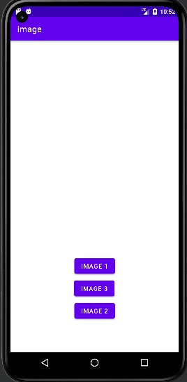

output

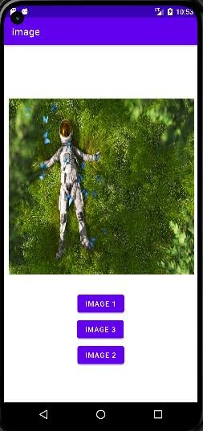 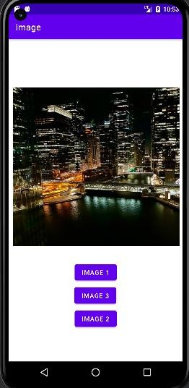

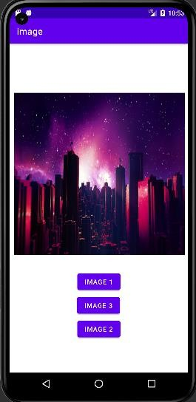

Program 9

Aim : Write a Program to Display the items in a list Source code :

Activity_main.xml

<?xml version="1.0" encoding="utf-8"?>

<androidx.constraintlayout.widget.ConstraintLayout xmlns:android="<http://schemas.android.com/apk/res/android>" xmlns:app="<http://schemas.android.com/apk/res-auto>" xmlns:tools="[http://schemas.android.com/tools"](http://schemas.android.com/tools) android:layout_width="match_parent" android:layout_height="match_parent" tools:context=".MainActivity">

<ListView android:id="@+id/listView" android:layout_width="409dp" android:layout_height="729dp" tools:layout_editor_absoluteX="1dp" tools:layout_editor_absoluteY="1dp" />

</androidx.constraintlayout.widget.ConstraintLayout>

MainActivity.java package com.AZAUSCS012.Itemlist; import

androidx.appcompat.app.AppCompatActivity; import android.os.Bundle; import android.widget.ArrayAdapter; import android.widget.ListView; public class MainActivity extends AppCompatActivity {

ListView listView;

@Override

protected void onCreate(Bundle savedInstanceState) { super.onCreate(savedInstanceState);

setContentView(R.layout.activity_main); listView = findViewById(R.id.listView);

String title[] = {"Google","Faceebook","Netflix","Amazon","Tesla"}; ArrayAdapter<String> adapter = new ArrayAdapter<String>(this, android.R.layout.simple_list_item_1,android.R.id.text1,title); listView.setAdapter(adapter);

}

}

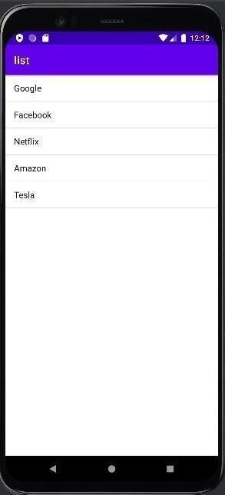UserInterface

output



Program 10

Aim : Fetch data from an EditText and display it in a TextView Source Code :

Activity_main.xml

<?xml version="1.0" encoding="utf-8"?>

<androidx.constraintlayout.widget.ConstraintLayout xmlns:android="<http://schemas.android.com/apk/res/android>" xmlns:app="<http://schemas.android.com/apk/res-auto>" xmlns:tools="[http://schemas.android.com/tools"](http://schemas.android.com/tools) android:layout_width="match_parent" android:layout_height="match_parent" tools:context=".MainActivity">

<EditText android:id="@+id/editText" android:layout_width="wrap_content

"

android:layout_height="wrap_conten t" android:layout_marginTop="244dp" android:ems="10" android:inputType="textPersonName " android:text="Name" app:layout_constraintEnd_toEndOf=" parent" app:layout_constraintHorizontal_bias

="0.497"

app:layout_constraintStart_toStartOf

="parent" app:layout_constraintTop_toTopOf=" parent" />

<TextView android:id="@+id/result" android:layout_width="wrap_content" android:layout_height="wrap_content" app:layout_constraintBottom_toBottomOf="parent" app:layout_constraintEnd_toEndOf="parent" app:layout_constraintHorizontal_bias="0.498" app:layout_constraintStart_toStartOf="parent" app:layout_constraintTop_toBottomOf="@+id/fetch" app:layout_constraintVertical_bias="0.128" />

<Button android:id="@+id/fetch" android:layout_width="wrap_content" android:layout_height="wrap_content" android:layout_marginTop="48dp"

android:text="Fetch" app:layout_constraintEnd_toEndOf="parent" app:layout_constraintHorizontal_bias="0.495" app:layout_constraintStart_toStartOf="parent "

app:layout_constraintTop_toBottomOf="@+i d/editText" />

</androidx.constraintlayout.widget.ConstraintLayout>

MainActivity.java package com.AZAUSCS012.fetch; import

androidx.appcompat.app.AppCompatActivity; import android.os.Bundle; import android.view.View; import android.widget.Button; import android.widget.EditText; import android.widget.TextView; public class MainActivity extends AppCompatActivity {

EditText editText; TextView textView; Button button;

@Override protected void onCreate(Bundle savedInstanceState) { super.onCreate(savedInstanceState); setContentView(R.layout.activity_main); button = findViewById(R.id.fetch); editText = findViewById(R.id.editText); textView = findViewById(R.id.result); button.setOnClickListener(new View.OnClickListener() { @Override

public void onClick(View view) { textView.setText(editText.getText().toString());

}

});

}

}

userinterface

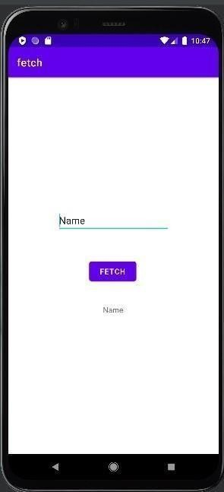

Output

