Richfield Chairs- (User Guide)

|  |  |  |
| --- | --- | --- |
| **Supervisor:** | **Sir Minhaj Tahir Khan** | |
| **Batch:** | **2407E1** | |
| **Serial no:** | **Student Id** | **Student Name** |
| **01** | Student1586500 | Muhammad Shayan |
| **02** | Student1586509 | ArHammad Shaheen |
| **03** | Student1587043 | Ummema Sana |
| **04** | Student1568521 | Abdul Rehman |
| **05** | Student1584631 | Muhammad Shoaib |

Richfield Chairs (Home Page)

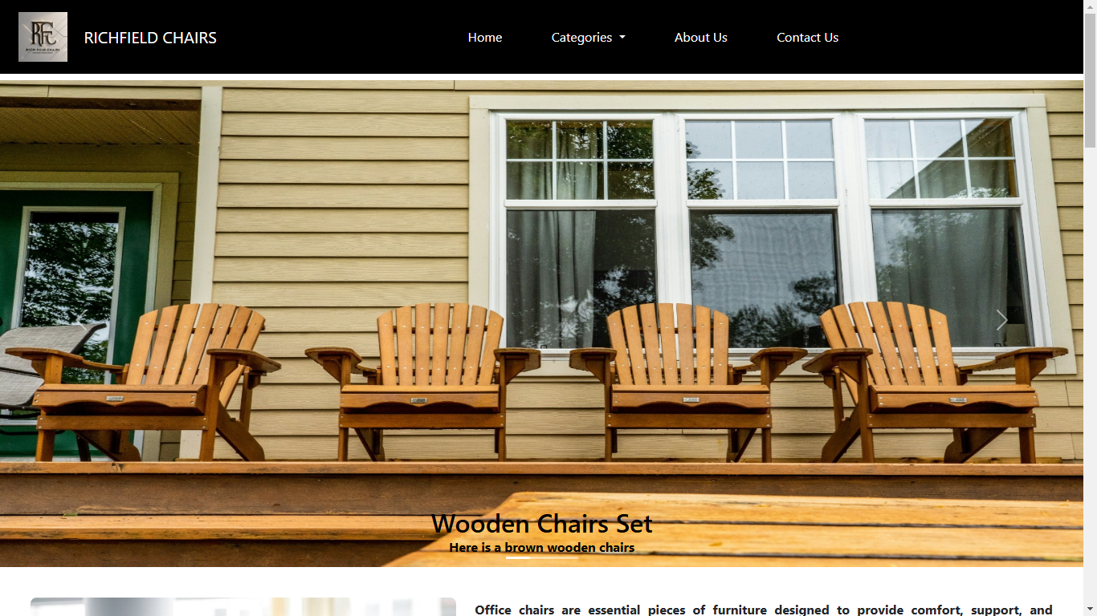

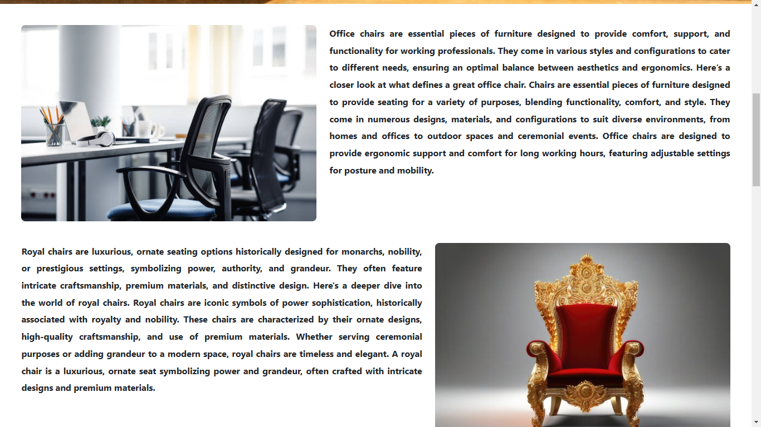

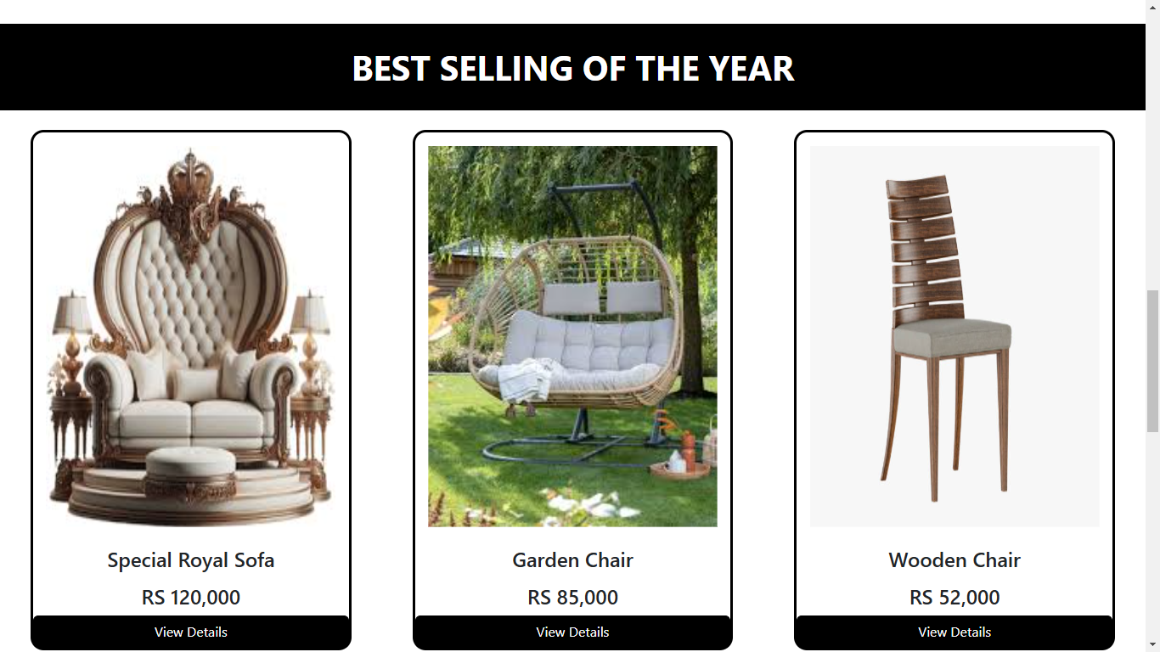

After Clicking View Details





After Clicking View Details

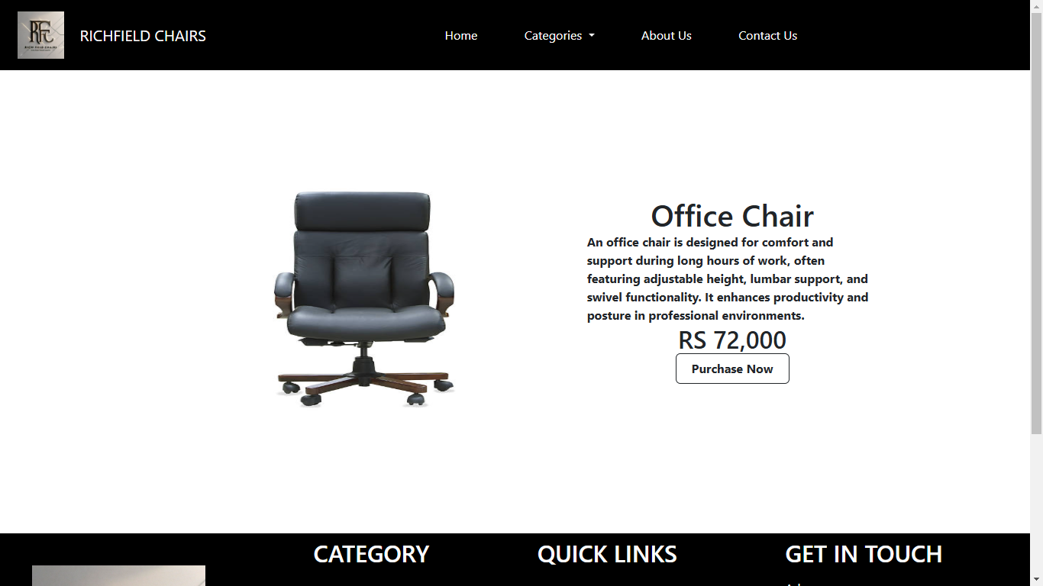

Richfield Chairs (Footer)

