**SCHOOL**

|  |  |  |
| --- | --- | --- |
| Supervisor: | Sir Minhaj Tahir Khan | |
| Batch: | 2407E1 | |
| Serial no: | Student Id: | Student Name: |
| 01 | Student1583705 | FALAH KHAN |
| 02 | Student1586491 | AYESHA |
| 03 | Student1584626 | HANIA RASHEED |
| 04 | Student1586477 | AHSAM SAEED |
| 05 | Student1518113 | SHAHRUKH KHAN |

THE KNOWLEDGE OF ARK

Home (homepage.html)





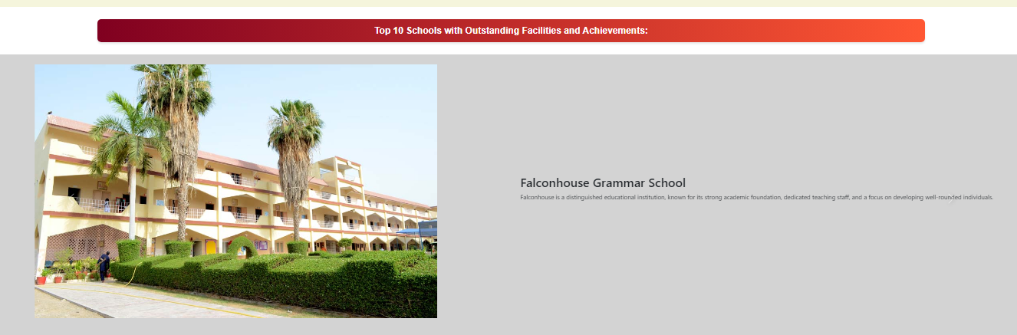

Coding of homepage.html

Footer(Footer.html)



Navbar: (Navbar.html)



Contactpage(Contact.html)

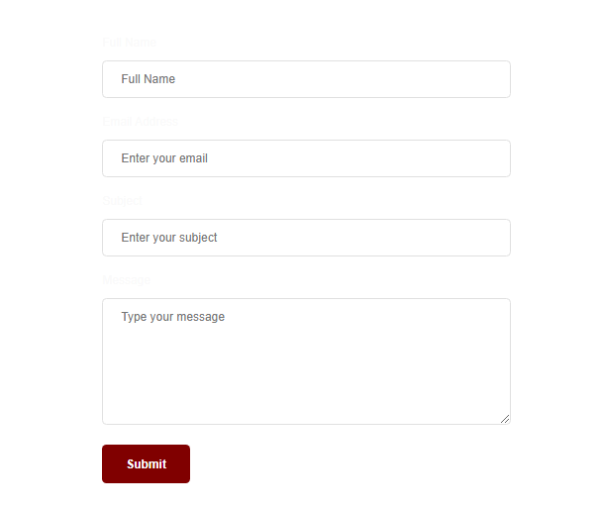

Aboot us (aboutus.html)



**Problem Statement**

Finding a school as per everyone’s choice is now a days is very essential and confusing as

there are many schools in and around the city. Visiting each and every school physically

and getting information is really very difficult. Hence concept of developing

“SchoolsInfo” seems very much needed. SchoolsInfo is a website which provides the

information about the various schools available in the city. People who are interested in

seeking admission for their kids can view this website where they can get to know where

all the schools are situated and what all other facilities are available in that particular

school.

Currently people generally find out the details about the schools from relatives/friends

or visiting schools personally. But this is becoming difficult as many new schools are

being established everywhere. Thus this can be overcome by the proposed system called

“SchoolsInfo” where viewing all schools and related information in particular area from

anywhere.

You are supposed to create a website for them with the below mentioned requirement

specifications.

The website is to be developed for the Windows Platform using HTML5, JavaScript and

Geolocation. The site should work well in all leading browsers including Chrome, IE,

Firefox etc.

**Requirement Specification:**

The Web site is to be created based on the following requirements.

1) The Home Page should be created making use of Sections with a suitable

logo, the header section can be added which will show related images.

2) The site must contain the links to navigate through any category for the

**information.**

3) The site should display a menu which will contain the options for brief

introduction about the various schools , location and any other information if

required.

4) The web site should also provide the option of searching the schools based on

location and facilities.

5) Also have a Site Map option where viewers can see which all schools are available

in our web site and can easily know where it is situated in the city. Their location

should be displayed using GeoLocation API (eg. GoogleMaps)

6) The information about the school should include following major details

- What is the maximum intake capacity of students?

- Whether library is available

- Availability of canteen facility

- Availability of boarding

- What type of sports options available

7) A brief summary of a particular school including list of facilities available,

should be displayed on the Web Page along with the pictures but detailed

features should be stored in individual Word documents which can be

downloaded or viewed by the User who wishes to see the same.

Hardware/ Software Requirements

Hardware

• A minimum computer system that will help you access all the tools in the

courses is a Pentium 166 or better

• 64 Megabytes of RAM or better

Software [Either or Combination as per Course/Sem]

• Notepad/HTML editor/CoffeeCup

• Angular / Angular JS / React / BootStrap

• Dreamweaver / Figma

• MS IE / Chrome / FireFox / Netscape /MS Edge