

**SEO PROPOSAL**

**SPA Services**

**xyz**

**10th June 2020**



**TABLE OF CONTENTS**

|  |  |  |
| --- | --- | --- |
| 01 | CONFIDENTIAL INFORMATION | 03 |
| 02 | LETTER OF THANKS | 04 |
| 03 | WHO ARE WE | 05 |
| 04 | WHAT IS SEO | 06 |
| 05 | WHY INVEST IN SEO | 07 |
| 06 | OUR PROCESS | 08 |
| 07 | WEBSITE ANALYSIS | 09 |
| 08 | KEYWORD RESEARCH | 11 |
| 09 | ON-PAGE OPTIMIZATION | 14 |
| 10 | OFF-PAGE OPTIMIZATION | 16 |
| 11 | MONTHLY REPORTING | 17 |



**CONFIDENTIAL INFORMATION**

This document contains information and data that Outsource in Pakistan considers confidential and exclusive. Confidential Information includes, but is not limited to: corporate information about the company, its’ project management and quality processes, customer and project experiences provided to illustrate our capability.

Any disclosure of Confidential Information to, or use of it by a third party (i.e., a party other than Client), will be damaging to the company.

Ownership of all Confidential Information, no matter in what media it resides, remains with Outsource in Pakistan. Confidential Information in this document shall not be disclosed outside.

Sincerely,

Team Outsource in Pakistan

**LETTER OF THANKS**

Dear Client,

Thank you so much for giving us the opportunity to serve you and your organization with our credible SEO service. It is our pleasure to help you climb and dominate search engines.

This document contains overall Information of how our highly talented professionals will help you to increase your visibility in the major search engine(s) and dramatically increase targeted traﬃc to (clients’ website).We give importance to any suggestions regarding the content, layout formatting, navigation and overall structuring of the provided website.

Outsource in Pakistan has satisfied various clients across the globe. For last many years, we have been appreciated for our prompt website ranking strategies, instant yet successful results and unmatched determination to go beyond the client’s expectations.

Most of your questions should be answered within this oﬀer, in case they are not, don’t hesitate to contact us.

Sincerely,

****Team Outsource in Pakistan



**WHO WE ARE?**

**Full Service Fulfillment**

Elumin is a full service e-commerce fulfillment agency specializing in automation, efficiency, and scaling.

When choosing to partner with Elumin, you can expect:

* Extreme Customer Focus - We learn and understand your business goals first, then develop a custom strategic action plan, acting as a road map for your campaign. We'll use your goals to develop an appropriate system to grow your business.
* No Contracts - We believe in our services and our marketing consultants to deliver a positive return on investment for our clients.
* Data-Driven - Analytical tracking on each project through embedded coding enables our team to make data driven decisions, optimizing conversions in real time.
* Transparent Reporting - We provide custom, in-depth campaign reporting and time tracking so you can easily monitor your ROI.



**WHAT IS SEO?**

**SEO CAN BE CATEGORIZED**

**INTO THREE DIFFERENT ASPECTS:**

* Keyword Research
* ON page Optimization
* OFF Page Optimization

**SEO DEFINITION:**

Search engine optimization (SEO) is the art and science of getting URLs a high placement—also referred to as rank—in the “organic” (i.e., unpaid) section of the search engine results pages (SERPs).

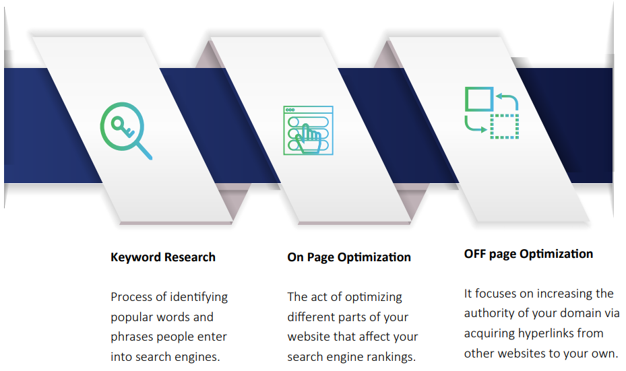



**WHY INVEST IN SEO?**

In today’ world where everything is online, SEO is not a nice addition to your business - it’s a must. SEO influences almost every aspect of your business from boosting web traﬃc and visibility to building your brand and generating high quality leads. Here are just a few reasons why implementing SEO in your business is a decision you’ll hardly ever regret:

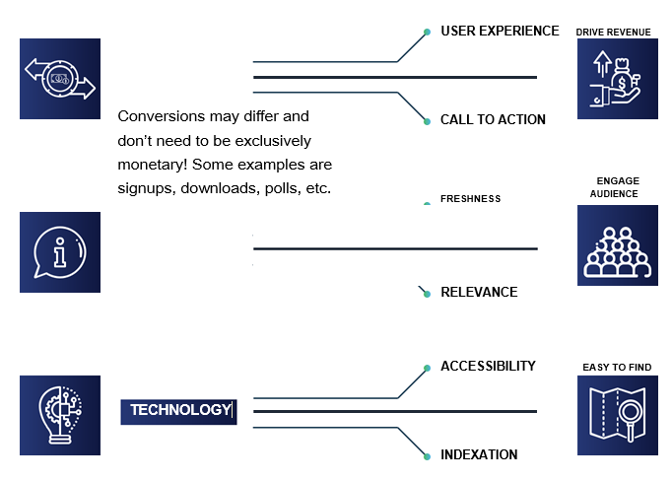



**OUR PROCESS**

Transparency is one of our strongest strengths. We want you to be involved in the whole process, you should be 100% aware of what’s going on with your site.

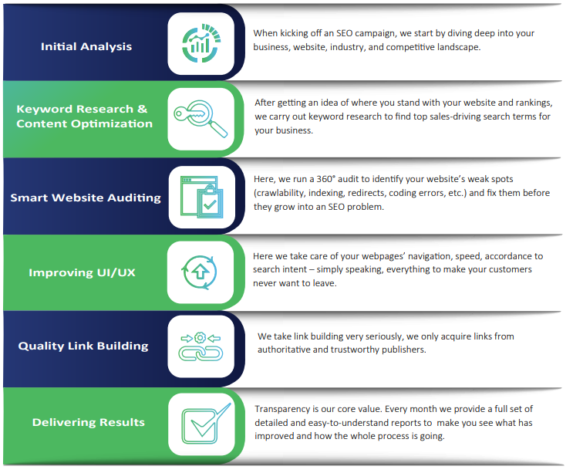



**Website Analysis**

We ran analysis on your website: http://www.purevichy.com/

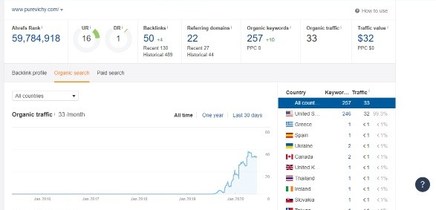



**Referring Domains**

129 websites have given links to your Website.

**Domain Rank**

7 is the Domain Rank of your website. On average 40+ Domain Rank (DR) is considered as good. We can help you to increase that domain rank and make your website’s image better.

**Organic Keywords**

Only 289 keywords are ranked on Search Engines around the Globe

**Organic Traﬃc**

Organic traﬃc is the visitors count driven from search engines. There are 271 visitors on your website in a month.

**Ranked Keywords**

Your website has only 277 keywords ranked in US.

****Your competitor is getting

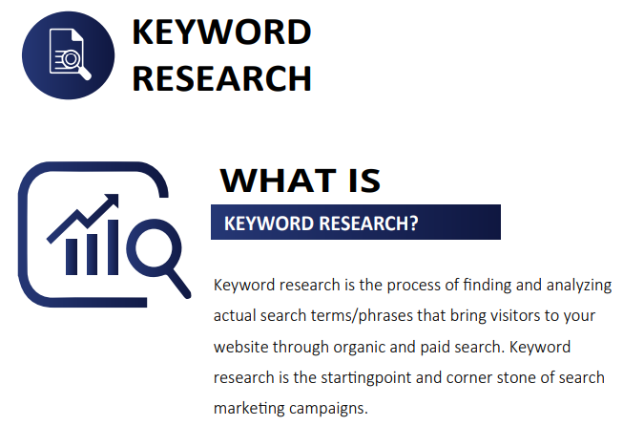

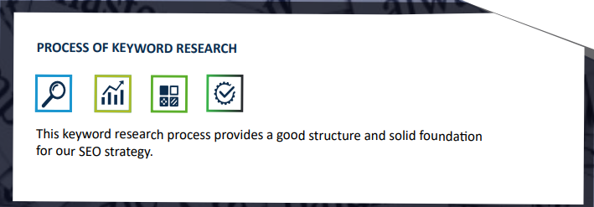



**SUGGESTED KEYWORDS (06 Months)**

|  |  |  |
| --- | --- | --- |
| **Sr. No** | **Keywords** | **Avg. Monthly Searches** |
| 1 | Pure Facial Spa | 1500 |
| 2 | Facial Spa Houston | 1200 |
| 3 | Day Spa Houston TX | 700 |
| 4 | Massage Spa Houston TX | 680 |
| 5 | Skin Day Spa Houston | 640 |
|  | | |







