**Gaming/Competition/League Website**

This website will be a website meant for Call of Duty Gamers to register and play against other teams. This is a typical “league” website. Some examples of similar websites are:

* <https://play.esea.net/> (I like the layout of this best)
* <https://play.eslgaming.com/america> (another big website, but I don’t like layout)

I want this website to be able to do a lot of things. This is what it would be like..

1. When the player/person comes to the website we immediately want them to register a free account and connect their Gamertag. They will also have to choose which platform they play on(PC, Xbox, or PS4), then we need a few other information bits from them as well.
2. Once a player registers, they get a player profile. On their player profile if will have what team they are on(if any), as well as name, location, recent matches, guestbook, friends, and then gameplay statistics that are tracked.
3. If we can, we want the ability to track gameplay statistics. So this might mean that we have to integrate with the PC, Xbox, and PS4 servers somehow. I’m not sure.
4. I Once a player is registered on the website, then they can start posting in the discussion threads, as well as many other things.
5. The website will then run in “seasons”. So say the website launches in April, and we let a lot of people register on the website, well when we hit a certain level of players we will announce our first “season”. At this point, the “create a team” and “Join a team” option’s will be ready for anyone who wants to either join or create a team for this season. The teams are a max of 10 players, with 6 players on the “active roster”. A team can only register to play in the upcoming season if they have a minimum of 6 people on their roster, and have paid the registration fee of $20 per player. Once the team have been confirmed and all paid, then they can join the season.
6. There will be 3 different levels of play. 16 teams in the “Professional” Division, which is invite only. By admins.
   1. There will be a maximum of 64 teams in the “Intermediate Division”, and then lastly there will be a maximum of 128 teams in the “Open division”.
7. For ANY player to play in the upcoming season, they MUST pay the $20 seasonal registration fee that let then join a team or create one.
8. Once spots have been filled and the admins have deemed there to be enough players/teams, then they will “Lock the season”, this means once the season is locked, no one else will be able to create a team.
9. Once the season is locked in. a “Map Rotation” will be announced. This map rotation will be 8 weeks long, with two games played each week.
10. During the 8 weeks, teams will battle it out to see who has the best standings at the end. Once the season is complete, only a few teams from each bracket will be entered into the “Seasons Championship” where they will compete for cash prizes. This will be done bracket style. Double Elimination.
11. Additionally, players will can continue to organize matches outside of “season” play, for free, to hone their skills before they give it a shot In the pay to play seasons.

The player registration will need to a little more in-depth than usual. Before a player can even get to the full registration, they must authenticate themselves by logging into their account. Kind of like this…

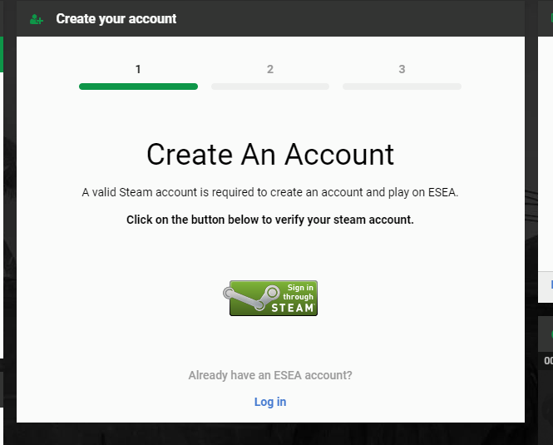

Because the new Call of Duty is cross platform, anyone who plays PC, Xbox, or PS4 can register to play. But they must first authenticate their gamertag. Once confirmed they can then move onto the registration process. At the registration process, the player will then need to fill out his or her profile information. Which includes:

* Name
* Email
* Age
* City and State
* A profile picture
* A signature to use in the forums
* And maybe more options to come

This is just a rough beginning of what I invision, but im sure we will need to talk it through some more with your team.

Also, for the website, I think I want to use a lot of Greys, Blues, whites, and blacks. Modern and sophisticated looking. And if you need to use a brighter color, you can use orange or green.

Looking forward to seeing what you come up with.