Integrity Spray Foam Case Study:

**Introduction:**

Integrity Spray Foam is an awesome fast-growing local business in our community. However, they needed some help when it came to the digital world. When Integrity’s President & Founder reached out to discuss a potential web project with us, we were pretty stoked! Up to this point, we had never had a company in the construction field as a client, so we were eager to get started.

**Project Focus:** Custom Web Design & Development

**Client:** Integrity Spray Foam

**Links:** <https://www.facebook.com/bmattarella> <https://www.instagram.com/integritysprayfoam/> [www.integrityspray.com](http://www.integrityspray.com)

**Rating:** 5 stars

**Next section:** titled: “Included in Project”

* Custom Web Design
* WordPress Development
* Domain Name Research
* Integrated Contact Forums
* Multiple Call to Action’s
* Hosting
* Easy to Use Admin Panel
* 100% Customer Satisfaction

**Next Section:** Include a section with 1 row and 3 columns. Titled “The Outcome”

* I want to put 3 images here in 1 row.
* 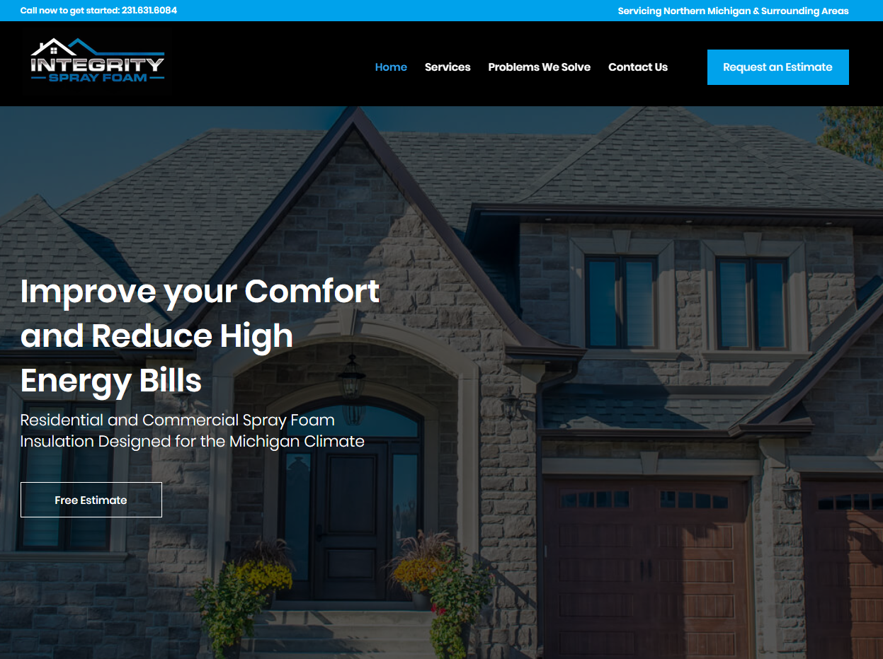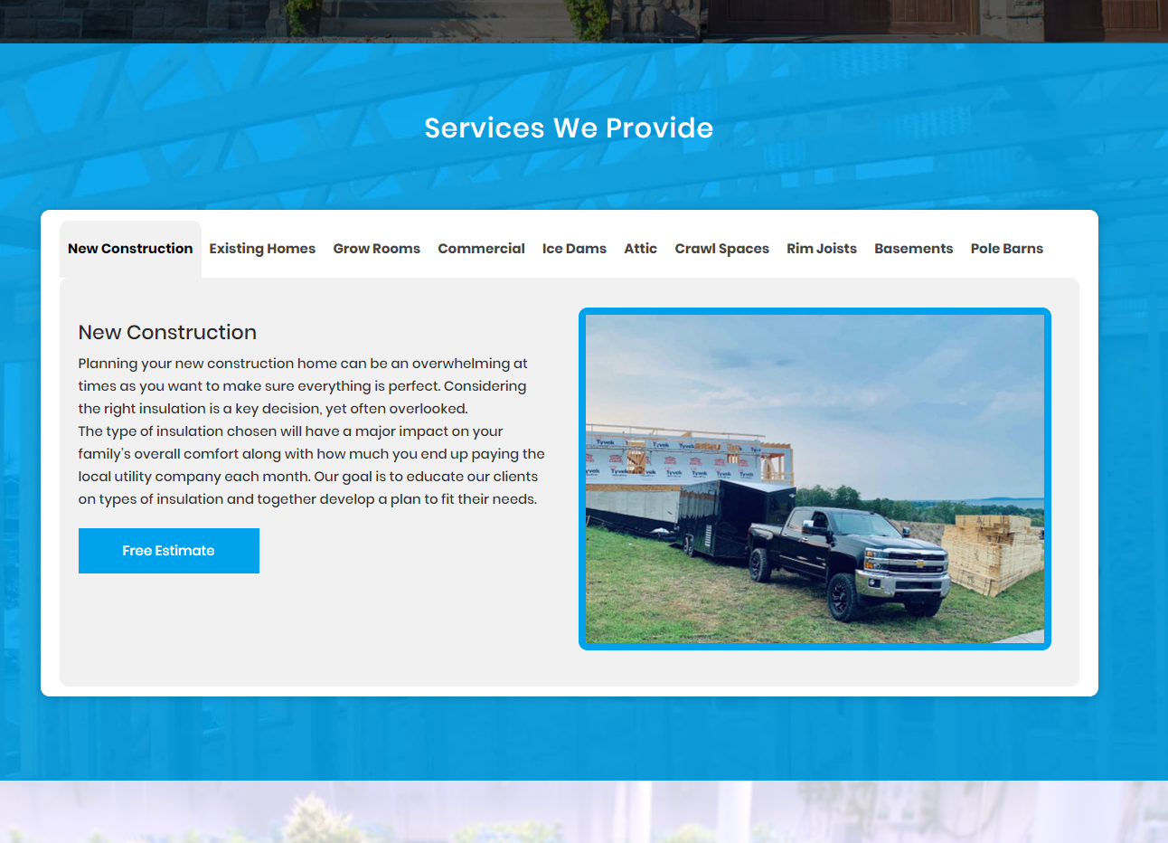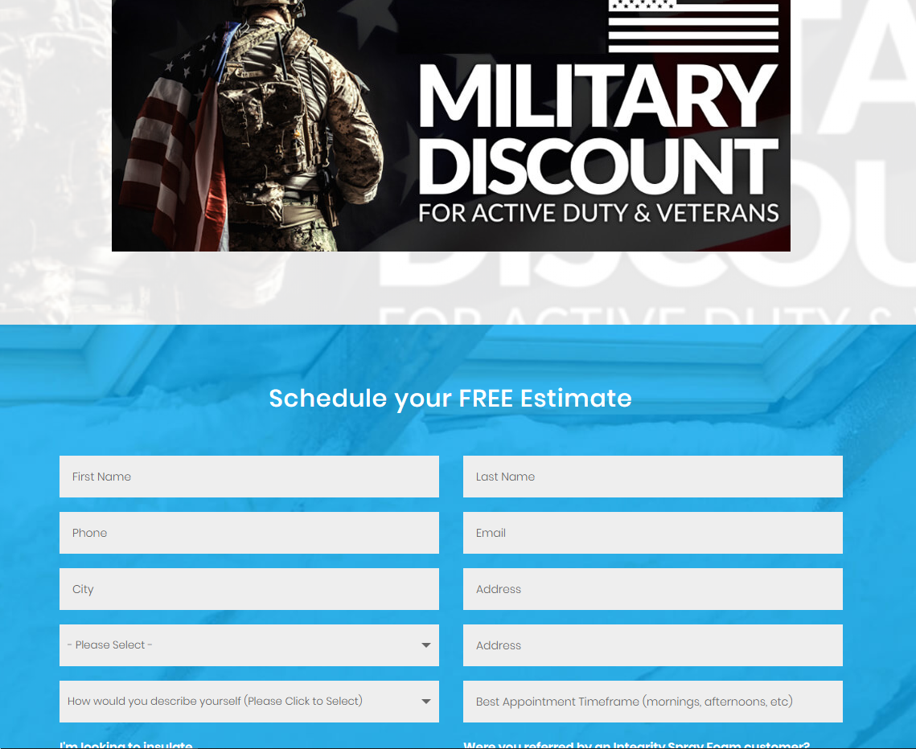

Then at the bottom of this section in the middle I want a button that says “View Project Live” and link to [www.integrityspray.com](http://www.integrityspray.com)

**After that I want his client testimonial:** Growthbound approached my business and me with a marketing plan already in place prior to even knowing if I was interested in doing business with them. I decided to try them out and I can’t be happier with the positive results. Growthbound has consistently provided my team with support that has driven results… they are a company in my words that strives for blowing away expectations after they are already blown. Growthbound has been nothing but professional in all my interactions and is committed to my success. I look forward to working with Growthbound for a long time.

* Brandon M, President of Integrity Spray Foam
* Include client logo.

**Under this, I want a section that says “View more Case Studies” then have 3 other case studies listed below.**

**Under testimonial section I want a new section:** this section shouldn’t have a title, I just want a cool graphic here that takes up the entire section that illustrates our web design costs and how they can get their own custom website for as low as $500.