Content Requirement - Greenfield Services

Tacoma Sewer Repair Services

**Add Content:** <https://www.greenfieldservicesinc.com/emergency-sewer-line-repair-tacoma>

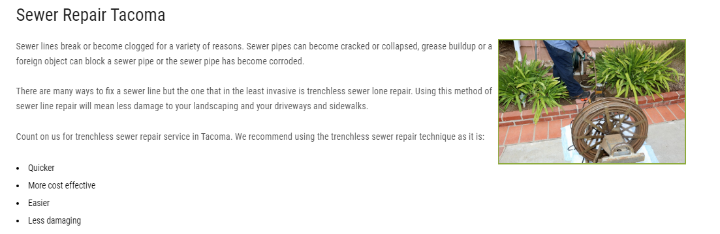

Change heading from "Sewer Repair Tacoma" to "Tacoma Sewer Repair Services"

**Add Word count from 100 to 250 (add 150 words)**

**Keywords No. of times**

Tacoma Sewer Repair Services x2

===========================================

Puget Sound Storm Drain Services

**Create new page:** <https://www.greenfieldservicesinc.com/storm-drain-services-puget-sound-wa>

**Ref:** <https://www.greenfieldservicesinc.com/storm-drain-cleaning-puyallup-wa>

**Ref:** <https://www.greenfieldservicesinc.com/storm-drain-cleaning-tacoma>

**Word count: 400**

**Keywords No. of times**

Puget Sound Storm Drain Services x2

=================================================

Pierce County Washington Vac Truck Services

**Create new page:** <https://www.greenfieldservicesinc.com/vac-truck-services-pierce-county-wa>

**Ref:** <https://www.greenfieldservicesinc.com/vac-truck-services-tacoma-wa>

**Ref:** <https://www.greenfieldservicesinc.com/vac-truck-puyallup-wa>

**Word count: 400**

**Keywords No. of times**

Pierce County Washington Vac Truck Services x2

====================================================

Pierce County Washington Hydro-Excavation Services

**Create new page**: <https://www.greenfieldservicesinc.com/hydro-excavation-pierce-county-wa>

**Ref**: <https://www.greenfieldservicesinc.com/hydro-excavation-puyallup-wa>

**Ref:** <https://www.greenfieldservicesinc.com/hydro-excavation-bellevue-wa>

**Word count: 400**

**Keywords No. of times**

Pierce County Washington Hydro-Excavation Services x2

======================================================

Oil Water Separator

**Create new page:** <https://www.greenfieldservicesinc.com/oil-water-separator>

**Format:** <https://www.greenfieldservicesinc.com/hydro-excavation>

**Ref:** <https://www.greenfieldservicesinc.com/oil-water-separator-renton-wa>

**Word count: 400**

**Keywords No. of times**

Oil Water Separator x3

==========================================================

Hydro Excavator Truck

**Add content:** <https://www.greenfieldservicesinc.com/hydro-excavation>

**Word count: 250**

Heading: Hydro Excavator Truck

**Keywords No. of times**

Hydro Excavator Truck  x2

===========================================================