Gripp Energy Case Study

**Introduction**: Gripp Energy is an ultra-premium energy beverage that has quickly started to disrupt the energy drink industry. Their intent is to provide its customers with a healthy alternative to other energy drinks, and man, they are delicious. After our initial discussions with the leadership team at Gripp Energy, it was determined that they would need a new “fresh” looking website, and professional Social Media Marketing services to go along with it. The Growthbound team got to work doing what we do best and delivered months of social media posts to accompany their brand-new custom website. You can learn more about this project by reading below!

**Project Focus:** Social Media Marketing & Web Development

**Client:** Gripp Energy

**Links:** <https://grippenergy.com/>

<https://www.facebook.com/GrippEnergy/>

<https://www.instagram.com/grippenergy/>

**Rating:** 4.5 Stars

**Included in Project: (Please list these in 2 rows of 5, using a blue checkmark as the bullet)**

* Custom Web Design
* WordPress Development
* E-Commerce Setup
* Integrated Contact Forums
* Easy-to-Use Admin Panel
* Facebook and Instagram page Optimization
* Content Creation
* Scheduled Posting’s
* Market Research & Consulting
* Instagram Growth Hacking

Under these, right in the middle, put “100% Customer Satisfaction”

**The Outcome:**

* **Website Final Delivery**
  + **(Include 3 screenshots from the website here just like you did on the Integrity Case Study, and then include a “View Project Live” button that takes them to www.grippenergy.com)**
* **Social Media Delivery**
  + **Include this screenshot:**
  + 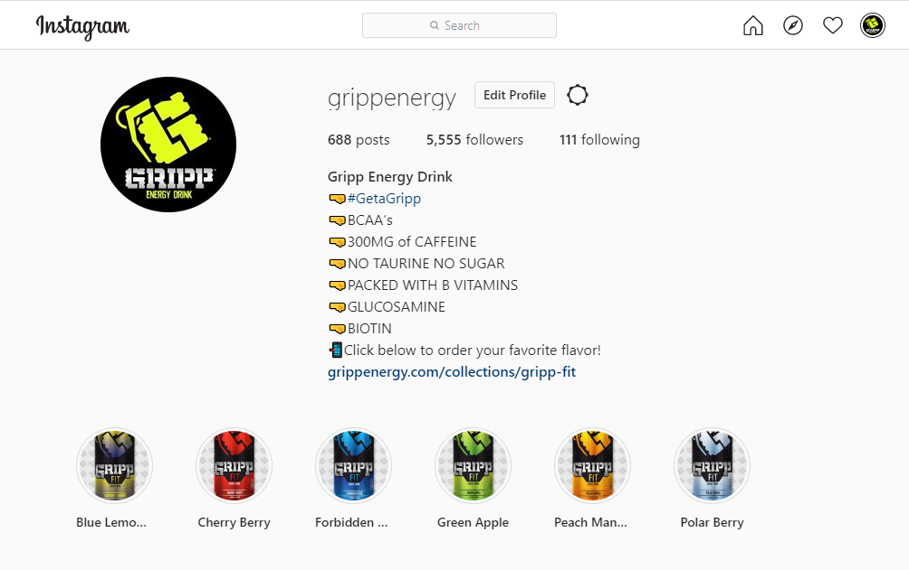
  + **And this screenshot:**
  + 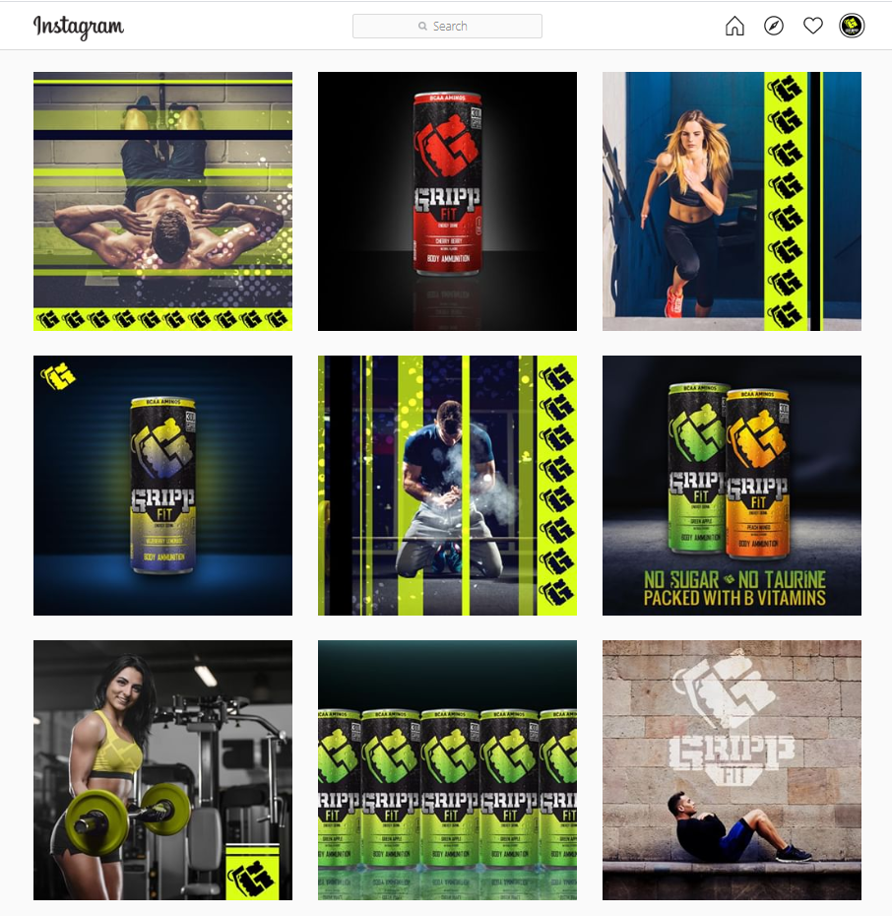
  + **Then underneath these two pictures have a button in the middle that says “View Live Instagram”**

**Under this section, lets add in a testimonial from Ryan who is the Gripp Energy CEO.**