**Eryfotona Actinica Sunscreem**

$50.00

Fast Absorbing ultralight emulsion providing all mineral broad spectrum sun protection. It’s innovative formula contains DNA repairssomes naturally occuring enzymes to help repair sun damage.

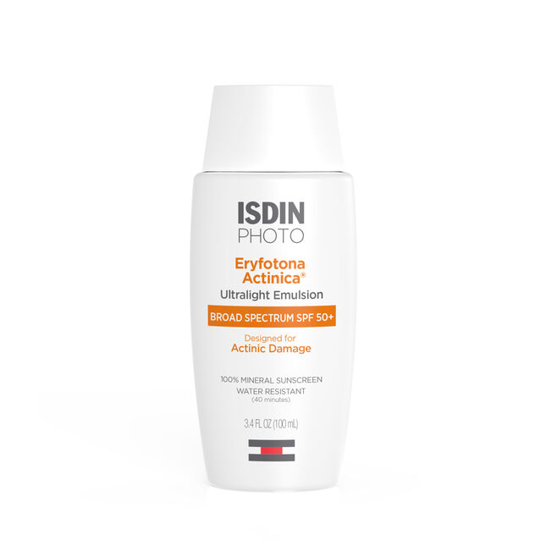

**Melatonik**

$150.00

Your beauty sleep redefined. Melatonik™ is a restorative nighttime serum-in-oil which works while you sleep to help your skin recover from daily stresses. The 3-in-1 formula containing melatonin, bakuchiol and vitamin C stimulates natural antioxidant defenses and helps to restore vitality and elasticity, for radiant, healthy skin.

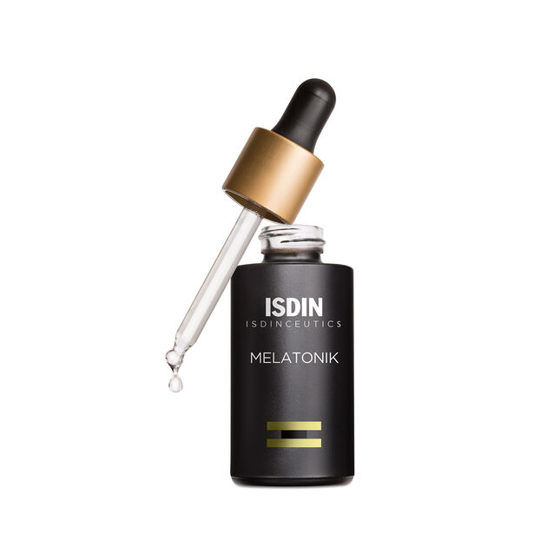

**Eryfotona Ageless Sunscreen Tinted**

$50.00

Eryfotona Ageless is designed to protect skin from the sun while helping to repair existing photodamage. Eryfotona Ageless protects the skin from sun damage with zinc oxide, a 100% mineral sunscreen offering broad spectrum protection. Zinc oxide effectively blocks harmful UV radiation from the sun.

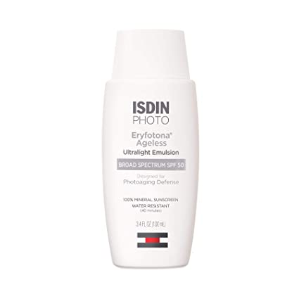

**ISDIN Mineral Brush**

$50.00

Our smooth **mineral powder** leaves the skin feeling softer without using talc while protecting the skin.

