Intrepid Marketing Updates – Jan 19

**Homepage**

1. Sliding banner –

First banner – Use the existing image but zoom out to show the white boats and red boats better. Tagline: Be Bold, Be Fearless, Be Intrepid.   
I do not like the font size, bold and color used, it is very distracting and takes away the focus from the image

Second banner - Use the existing image

Tagline – Use existing. Adjust the font. The text should not take away the focus from the images

Remove all the rest of the images. We will only use 2 for now!

1. Here is the order for the services and the homepage description to be listed;

Brand Management   
We bring your brand vision to life. We take care of all the details to develop a sophisticated brand with a consistent message that shows exactly what you do and how great you are at doing it.

Custom Website Design and Development

Your website is a representation of your products and services. We design and develop top-performing websites that help you convert visitors to leads.

E-commerce

What’s a good product or service if the world cannot enjoy it? We build an online platform that works seamlessly. From the cart to an easy checkout - a shopper’s dream!

Search Engine Optimization

Millions of businesses are competing for the page 1 ranking on Google. Our result-driven team of experts optimize your website to rank organically high on Google by ensuring ethical SEO tactics. We help you drive visitors to your website month over month and allow you to convert them into customers!

Pay Per Click Advertising

We take full control of your PPC campaigns by managing your keyword searches, selecting target channels to pursue, monitoring your campaigns and benchmarking against the competition. We make sure you get the right exposure all the time.

Social Media Marketing

We create social media strategies that fit in perfectly with your business needs. We create impactful content that is clear, concise and optimized for selling. We count the likes; you count the dollars.

E-mail Marketing

We use email as a tool to generate leads for new customers and keep existing ones in the know. Share new products and services or exciting things with your customers. We bring your message together in one powerful bundle- the simple e-mail.

Content Marketing

We get to know your business and then generate content that is meaningful and targeted for your audience. Develop trust with clients through your websites, blogs and newsletters with our quality copy writing.

Graphic Design

We create content that is visually appealing and strategically designed to make an impact to your audience and to your bottom line.

1. Replace this text with:

1. Instead of Recent Works – Our Portfolio

Under this section, highlight the Love Your Skin Spa, Little White Poppy Website and America’s number 1 cleaning on the first 3 boxes. When I launch Jungle Safaris, we will highlight that.

Not “More Works” instead – View More



1. I have noticed a lot of spelling mistakes under “Our Work” section, please make sure all the company names are correct. I am also missing mock-ups on some of my work I sent. Please check.
2. I want us to mention “Glimpse of our Portfolio” on the respective page.
3. Add arrows or indicate to scroll left or right

1. When Jungle Safari launches, we will add the logo on the homepage
2. Add Jabbar consulting logo on the logo section
3. I would like a testimonial section on the homepage. Add “Coming Soon” for now. I am working on getting them from some of my clients
4. We will be merging the How We Work section with the Compass image and instead of Be Bold, Be Fearless and Be Intrepid we will list the 4 methods of hiring us;  
   Campaign Based   
   A’la Carte

No Long term contracts

Cheaper than hiring in-house

1. Recent News to be – Digital Insights and under that add View More with the icon
2. Footer: Update the services with the order as above no. 2   
   Update the Latest News to Digital Insights and add the correct title   
   For the Portfolio section: Remove Sugarcoat desserts logo and replace with Jabbar consulting website mock-ups

**Our Service Page**

1. Replace this image with something simple. I do not like text on the header image. Please only add the title on ALL header images. Also please don’t deviate from the theme design. I would like ALL header images to be in black and white with red transparency.

1. Rearrange all the service tabs same as homepage
2. Add the correct write up – same as homepage
3. Some interesting numbers – 20 + projects launched in 6 months
4. This section will be – Let Us Collaborate and add one more block and heading.  
   Campaign Based   
   A’la Carte

No Long term contracts

Cheaper than hiring in-house

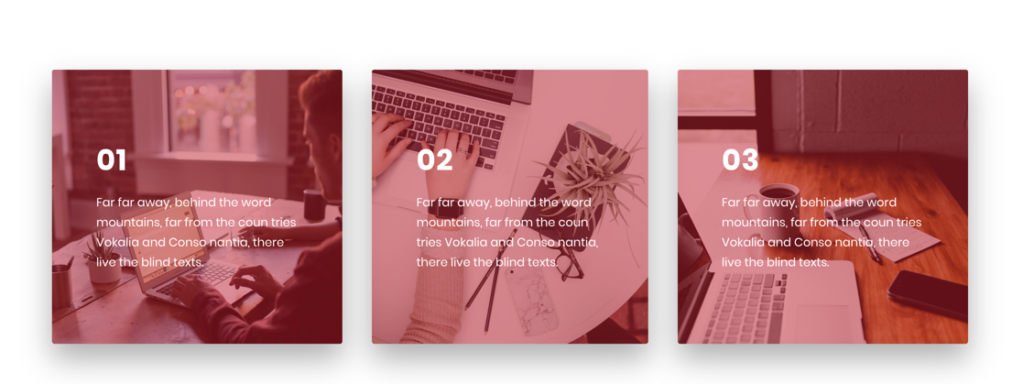

1. Call to action on this button – I want Free Consultation

**Our Work Page**

1. Update the header image and add the red transparency
2. Header title – Glimpse of our Portfolio
3. This page a lot of spelling mistakes. Please make sure a the business names are correctly spelled out.
4. Please mention the job type on all images. For eg: Jabbar consulting website, Sugarcoat Desserts Business card etc.
5. Update the mock-up of Love Your Skin Spa. Please use the first slider image on the mock-up

1. Make sure all the pages have a Call to action button.

**About Us Page**

1. Please replace the header image and add the red transparency
2. How We Work will be Let Us Collaborate
3. I will send you updated text for this block
4. Replace the image with my image – I have already sent this.
5. Name: Preet Bansal. I will send you the write-up for this in a few days.
6. Remove this block – it does not make sense and instead replace this with the Some interested numbers from Our Service Page
7. Call to action – Contact Us Today for a Free Consultation!

**Blogs**

1. The header title will be Digital Insights
2. The header image is good, please use the same design feature as the rest of the headers

**Contact Us Page**

NO change required. I like how the header image looks on this section.

PS: I am trying to set up an [info@intrepidmktg.com](mailto:info@intrepidmktg.com) email. Once it is ready I will let you know. We will have to replace the contact info everywhere

**Each Individual Service pages** – I noticed the header image is the same everywhere. I don’t mind using the same image on every service page, but replace the existing one. I don’t like this image.

<http://myprojectstaging.com/ingrid-marketing/website-development/>

To start with I would like service pages to be simple and a call to action is MUST on all the service pages.

I will send you the text for each service page. Meanwhile please come up with a simple design.

This portfolio section on the footer should be linked to the Our Work page for now. Eventually we will set up a client project page.