Practical Tax Solutions – Fix Errors & Updates

<https://practicaltaxsolutions.net/>

1. 
   1. We need to change the steps in the header to make more sense, and we need to fix an error that that the form gets when it is submitted.
      1. When they submit the form, the page refreshes and goes to a white screen displaying this error: 
2. Insirpation for a form/form design the client likes is this:
   1. 
   2. <https://app.optimataxrelief.com/first-step/?t=224&utm_source=google&utm_medium=ppc&utm_campaign=tax-solutions&device_category=desktop&adgroup=tax-solutions&utm_term=tax%20solution&ad=397190855956&sitetarget=&network=search&matchtype=e&gclid=CjwKCAjwlbr8BRA0EiwAnt4MTkbvEHMSB3dESGc33RfGpIt7et_pyrOoJlt6r2-3ILqWeL-pW4GU1RoCMNAQAvD_BwE>
3. Step 1 of the form should say:
   1. Replace “resolve your tax debt” with “Expert help for IRS tax programs” – but make this text a little smaller.
   2. Under “Expert help for IRS tax programs” put “Our professional tax associates will work with you over the phone and online!”
   3. Directly under that, put a larger heading that says: “How Much Do You Owe?”
   4. Form similar to this, please also include an icon.
      1. “
      2. Form field options:
         1. 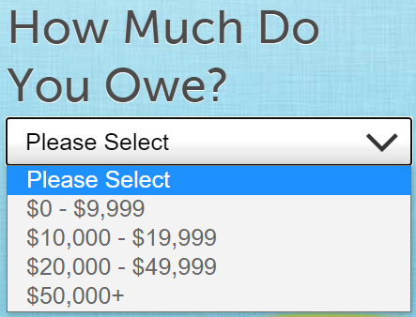
4. Step 2 of the form should say:
   1. 
      1. Please list all 50 states in this drop down menu.
5. Step 3 of the form should say:
   1. 
      1. Please select
         1. Yes
         2. No
6. Step 4 is the final step and should look very similar to this: Please include all the same form fields the way they have them here. Make sure the form boxes are lined up with eachother similar to in the screenshot below.
   1. Please add the “safe, secure and no obligation” under the button
   2. 