Regionality

Prepared for :

Kashif Iqbal

Plan Issued :

2021-01-22

www.outsourceinpakistan.com

+1(609) 281 5203 | info@outsourceinpakistan.com

Suit no. 10 & 11, Ground Floor, Business Avenue, Main Shahra-e-Faisal, Karachi, Pakistan



THANK YOU FOR

TRUSTING US

Please find enclosed our detailed web application development proposal for your kind

consideration.

At Outsource in Pakistan, we are aware that creating client-oriented software takes a mixture of

technical excellence and clear communication and our firm hires only the very best to ensure

you receive both. We know that every client is unique and we strive to deliver an individual,

innovative and affordable proposal every time and to follow it through with an outstanding

delivery which is both on time and within budget.

We have over 7 years of development experience in this area and we have multitude client

database. Please let us know if you would like to get in touch with our existing clients from whom

you will receive nothing but positive endorsements. You may also wish to review our website at

www.Outsource in Pakistan.com to see our portfolio of previous work and learn more about our

organization.

We also pride ourselves on our after-sales client-care including staff-training, technical support

and upgradation.

Finally, we realize that you are very busy and wanted to thank you in advance for your time spent

reviewing our proposal.

Highest Regards,

Team Outsource in Pakistan



Regionality

About Us

Outsource in Pakistan is a creative & digital agency with years of experience, real-time technology, and a

bundle of creative minds that can lead you to success. A perfect blend of technology, creative thinking and

digital craftsmanship enable us to produce eye-catching designs, impacting digital strategies pioneering

online marketing solutions and high-quality websites and application. We are famous for providing

outstanding creative solutions to forward-thinking brands across the globe

1.1 Why Us?

At Outsource in Pakistan, you will get dazzling designs and flawless solutions to all your digital needs. Each

of our bespoke service are tailored to individual requirements of Users, meaning that you will receive a

solution that reflects your unique ethos and brand. Outsource in Pakistan combines strategic thinking and

emerging technologies to provide innovative solutions that consistently break new ground. We deliver

high-quality work through our focus on bidirectional communication, responsive User service, client

education, seamless project management, product quality, and an ethical approach to business.

1.2 Our Services

Branding & Design

Digital Marketing

Services

Web Design

Solutions

App Development

Animation

Content Writing

Outsource In Pakistan | Proposal

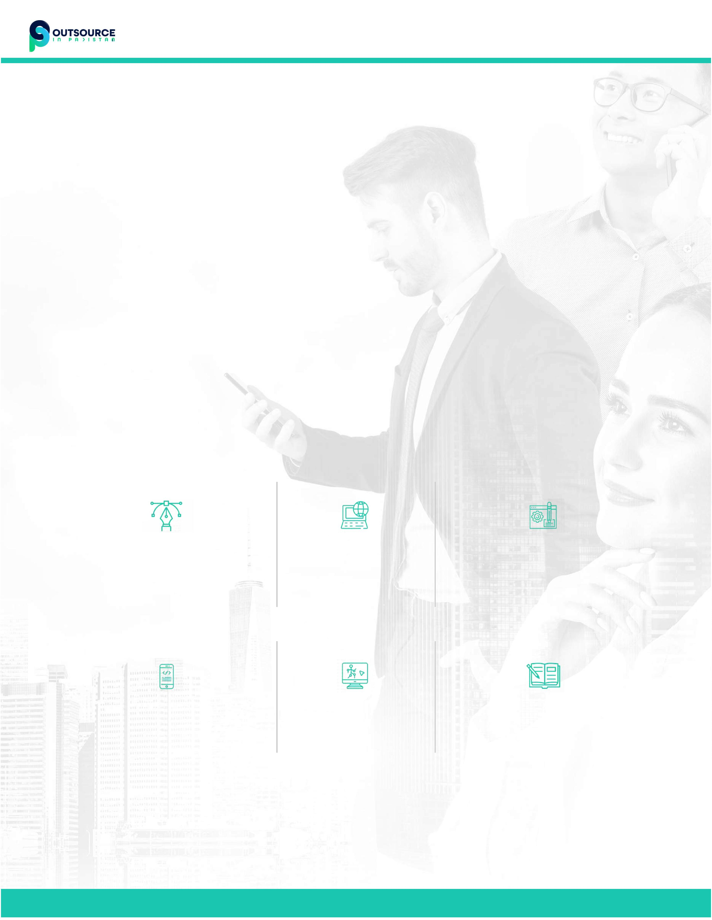

Regionality

How it Works

1. Developing Brand Persona

2. Provide Supporting Tools

3. Lead Generation

4. Live Agent

5. Operational Support

Digital Marketing Agency

We are in Digital Marketing business since last 2 decades. Our top of the notch marketing skills helped us to

expand our online business across the globe. Now you can also take benifit from our experts and grow your

own digital marketing agency in your target market. We start from developing your agency brand, perform

lead generation, close your leads and help you maintain long term relationaship with your Client.

Developing Brand Persona

We focus on deeply analyzing your brand preferences and personality to come up with the right strategies.

The services include the following

Creativity

Detailing

High Quality

Lead Generation

We offer great opportunity to get high- quality lead generation services. The service adds more to your

customer base and multiples you brand's growth the right way.

More Customers

Increased Sales

Generate awareness

Outsource In Pakistan | Proposal



Regionality

Project Overview

This document aims to outline the project's scope, providing a tentative estimation of efforts for brand

awareness. We will run Social Media Campaigns for Facebook, Instagram, and LinkedIn for our targeted

audience of 20 to 50+ Male and Females. The duration of campaign would be 90 days.

SOCIAL MEDIA MANAGER

Your Manager will specialise in creating social media content for your industry.

OFFERS AND EVENTS

Posts created to promote your offers, company news, and events.

ENGAGE AND BUILD TRUST

Posts that engage your ideal customers, demonstrate your industry expertise, and build trust in your brand.

YOUR AUDIENCE

Posts published when your LinkedIn Audience is most active to maximise engagement.

GENERATING LEADS

A direct Campaign Targeting 1,000 of your Ideal Clients every month and driving hot leads directly into your

inbox.

Total Cost

/ 3 Months

Portal

Ad Type

Placement

Budget/Month

$600.00

Impressions

250,000

Reach

125,000

900,000

KPI

Lead

Generation

Newsfeeds

+ stories

Leads

Generation

$1,800.00

Facebook

+

Instagram

Website

Promotion

Newsfeeds

+ stories

$300.00

1,800,000

Clicks

$900.00

$2700.00

Outsource In Pakistan | Proposal



Regionality

Total Cost

/ 3 Months

Portal

Ad Type

Placement

Budget/Month

Impressions

Reach

KPI

Click

through

rate /

Lead

Generation

Newsfeeds

+ Search

LinkedIn

$2500.00

350,000

175,000

$7,500.00

$7500.00

CTR

Outsource In Pakistan | Proposal



Regionality

Assumptions and Exclusions

The scope of the project is as mentioned in the above document

All the Branding material including logo, such as Corporate Images, content will be provided by the customer

(where applicable)

Assets and imagery to be used from our end if not provided by the customer. (30 stock photos per project

only; exceeding this limit will result in extra fee).

The images/pictures/assets provided by the customer will be assumed as copyrighted and liable by the

customer

Anything not stated in the solution description is not part of the project and if included later on, will be charged

extra for unless otherwise agreed by Outsource in Pakistan.

Terms and Conditions

Outsource in Pakistan adheres to the code of conduct as listed by the local government and accepts laws

pertaining to the business correlating directly under the segment Technado Pvt Ltd is working. The terms

and conditions are as below:

Customer is responsible for the marketing and business branding items

The customer/project will be mentionable by OIP as part of Portfolio (If not, please indicate otherwise)

The project that is being undertaken will be the intellectual property of client. Upon completion the source

code and all the relevant files will be handed over accordingly.

OIP will not disclose any business-related information to any unauthorized personnel

Customer will ensure the timely responses to the queries generated by OIP

If in an event of project cancellation by Customer. No refunds will be dispensed.

If in an event OIP cancels the project, OIP will pay off the entire paid amount to the customer.

Outsource In Pakistan | Proposal



Regionality

PAYMENT SCHEDULE

PAYMENT SCHEDULE

Ads Spent

USD 10200

USD 4500

Management Charges

TOTAL

USD 14700

Showzeb Jaffri

Vice-President

1-22-2020

Outsource In Pakistan | Proposal



Regionality

+1(609) 281 5203 | info@outsourceinpakistan.com | www.outsourceinpakistan.com

