

NATIONAL UNIVERSITY OF COMPUTER AND EMERGING SCIENCES (KARACHI CAMPUS)

Department of Computer Science

SPRING 2023



**TOPIC:**

**SUBNETTING CALCULATOR**

**COMPUTER NETWORK**

**SIR SHOAIB RAZA**

GROUP MEMBERS:

**[ ALI UDDIN] - [20K-1743]**

**[MINHAL MANJEE]-[20K-046**

# Table of Contents:

1. Introduction

* Background
* Problem Statement
* Objectives
* Scope

1. Literature Review

* Overview of Subnetting
* VLSM

1. Methodology

* Research Design

1. Results and Analysis

* Implementation Process
* Connection and IP Address Change

1. Discussion

* Effectiveness of Subnetting classes
* Class A
* Class B
* Class C

1. Conclusion
2. Appendix (Code)
3. References

# Introduction

# Subnetting Calculator is a tool used to divide a single network into multiple smaller sub-networks. It is widely used in networking to improve the efficiency and security of network systems. This tool can help network administrators in planning and organizing their networks according to their specific needs.

# Background

# Before the introduction of subnetting, networks were divided into classes based on their size, which often resulted in the wastage of IP addresses. To address this issue, subnetting was introduced as a method to divide networks into smaller sub-networks. Subnetting allows for more efficient utilization of IP addresses and offers better network security by creating smaller broadcast domains.

# Problem Statement

# Without subnetting, networks often had to be divided into classes that were larger than necessary, resulting in IP address wastage. In addition, larger broadcast domains created by classful networks were more susceptible to security threats. Therefore, there was a need for a more efficient and secure method of network division.

# Objectives

# The objective of this subnetting calculator is to provide an easy-to-use tool that enables network administrators to divide their networks into smaller sub-networks efficiently. The calculator aims to save time and effort by automating the subnetting process and reducing the risk of human error.

# Scope

# The subnetting calculator is designed to assist network administrators in subnetting IPv4 addresses only. It is not intended to be used for subnetting IPv6 addresses. Additionally, this calculator does not support subnetting of network addresses that have been already subnetted. The tool is designed to be user-friendly and can be used by both novice and experienced network administrators.

# Literature Review

# Subnetting is accomplished by manipulating the subnet mask, which is a 32-bit value used to divide an IP address into network and host portions. The subnet mask is applied to the IP address to determine the network ID and host ID. A subnet mask consists of a series of 1s followed by a series of 0s, where the 1s represent the network portion of the IP address, and the 0s represent the host portion.

# FLSM & VLSM

# In summary, FLSM is a traditional subnetting technique that uses a fixed subnet mask to divide the network into subnets of equal size. While FLSM is simple to implement, it can result in the inefficient use of IP addresses in more complex networks. Variable Length Subnet Masking (VLSM) is a more advanced subnetting technique that allows for the creation of subnets with different sizes, instead of using a fixed-size subnet mask. This enables network administrators to allocate IP addresses more efficiently, conserve IP address space, and reduce network complexity. With VLSM, the subnet mask can be adjusted to create subnets of different sizes, depending on the number of hosts on each subnet. For example, if a network has 1000 hosts, a network administrator can use VLSM to create subnets of different sizes, such as 512, 256, 128, and 64 hosts. This approach can help reduce wastage of IP addresses and improve the utilization of network resources. In summary, subnetting and VLSM are important networking concepts that help improve network efficiency, scalability, and security. By dividing a large network into smaller subnets, network administrators can manage network traffic, isolate network issues, and apply security policies to specific subnets. VLSM is a more advanced subnetting technique that allows for the creation of subnets with different sizes, enabling network administrators to allocate IP addresses more efficiently and conserve IP address space.

# METHODOLOGY

# The subnet calculator was developed through a series of technical steps that involved using Python programming language to create the calculator. Initially, the program prompted the user to input an IP address and network prefix, which were then converted into binary format for further calculations. Once the IP address and prefix length were obtained, the program used logical AND operations to calculate the network address and identify the IP address class. Based on the class of the IP address, the program was able to determine the default subnet mask and the total number of available hosts within the subnet. Considering the number of bits allocated for the network prefix and the number of bits available for host addressing, the program accurately calculated the broadcast address and usable host range for the subnet. To enhance the usability of the subnet calculator, the library was utilized to create a user-friendly graphical user interface (GUI). This GUI displayed all the calculated values in an easily interpretable format, allowing users to quickly determine the subnet mask, network address, broadcast address, usable host range, and the total number of hosts for a given IP address and network prefix.

**Results and Analysis:**

After implementing subnetting, the following results were obtained:

* The network was divided into smaller subnets, which improved network efficiency and reduced congestion.
* IP addresses were allocated more efficiently, reducing IP address wastage. Security was improved by enabling more granular access controls.

The implementation process involved the following steps:

* Defining the network requirements and identifying the necessary subnetting technique.
* Choosing an appropriate subnet mask and creating subnets based on that mask.
* Allocating IP addresses to each subnet and configuring routers and switches to allow traffic flow between the subnets.
* Testing and troubleshooting the network to ensure that it was functioning correctly.
* Connection and IP address changes were also made during the implementation.

**Discussion over classes A, B & C:**

Subnetting is an effective way to manage large networks and improve network performance. The effectiveness of subnetting classes depends on the specific network requirements and the number of hosts on the network.

Class A subnets are suitable for large networks with a large number of hosts, while Class B subnets are ideal for medium-sized networks. Class C subnets are best for small networks with a limited number of hosts.

It is important to consider the number of subnets and hosts required when selecting a subnetting class. Subnetting can be used to improve network performance and security by dividing the network into smaller subnets and allocating IP addresses more efficiently.

Class B subnets are ideal for medium-sized networks with a moderate number of hosts. A Class B network can support up to 65,536 hosts and can be divided into smaller subnets using a subnet mask of 255.255.0.0. Subnetting a Class B network can improve network efficiency and reduce congestion.

Class C subnets are best for small networks with a limited number of hosts. A Class C network can support up to 254 hosts and can be divided into smaller subnets using a subnet mask of 255.255.255.0. Subnetting a Class C network can improve security by enabling more granular access controls and can also reduce IP address wastage.

**IMPLEMENTATION:**

**As we go from top to bottom, we find tabs first of all. Here we can switch from IP information to subnet calculation to finally VLSM. These tabs allow retrieval and calculation. We have used user-friendly text and language structure. Then we can find text boxes to input IPs, masks etc and retrieve the calculated subnets & details. The chronological order below is in order of tabular options. With all pictorial representation of features, we have also included prompts in order of invalidity of data.**

1. IP INFORMATION:

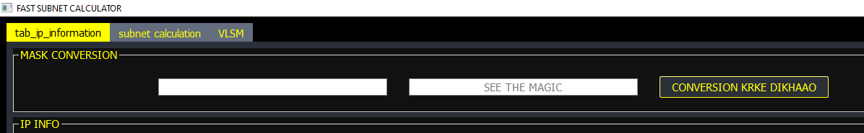

Fig 1.1

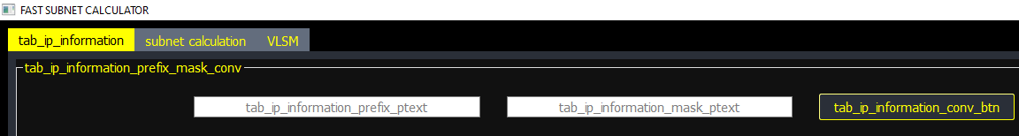

Fig 1.2

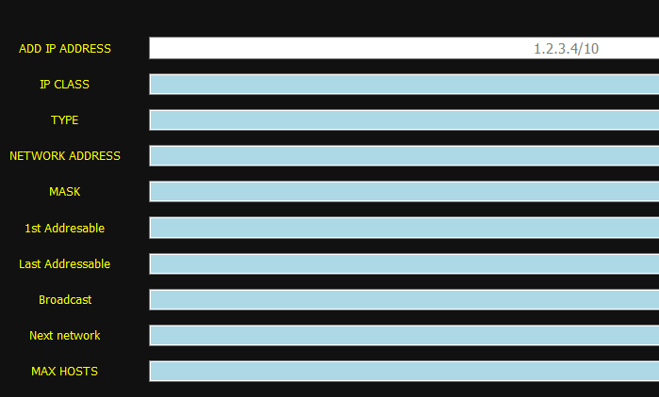

Fig 1.3

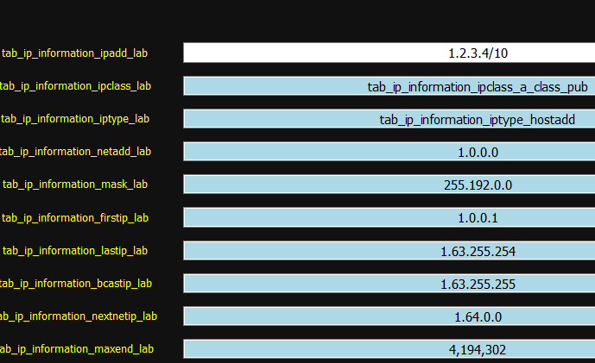

Fig 1.4

1. Subnet Calculation – FLSM

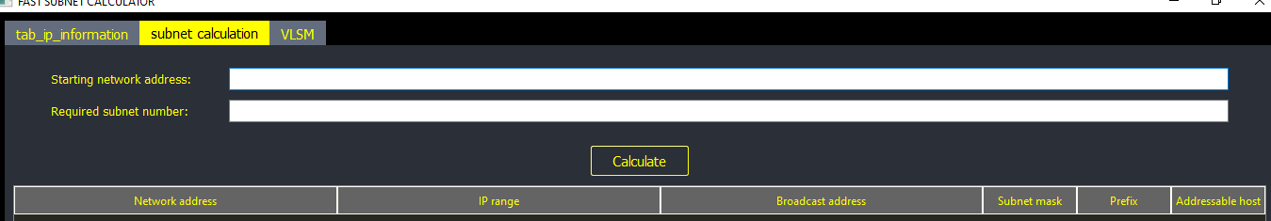

Fig 2.1

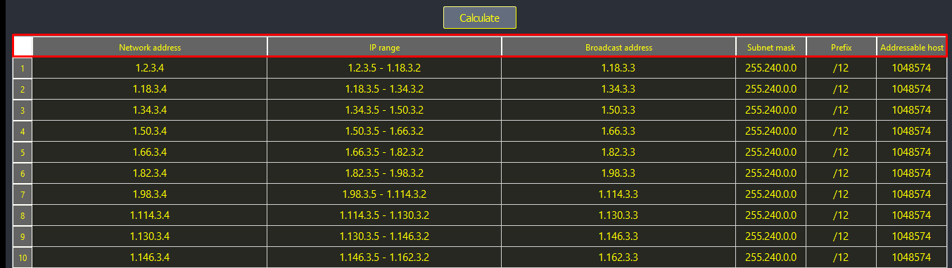

Fig 2.2

1. VLSM

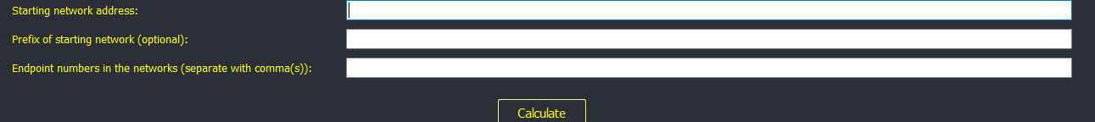

Fig 3.1

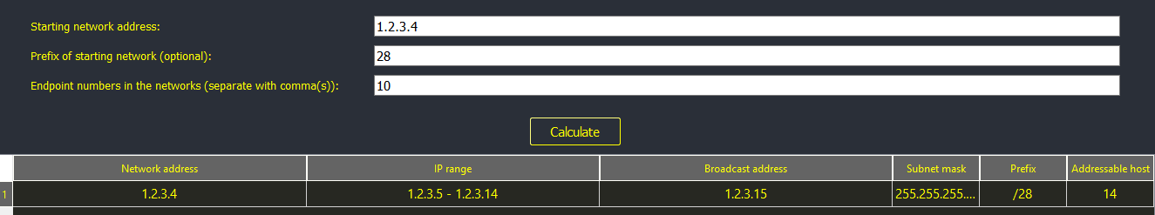

Fig 3.2

1. Input Validation

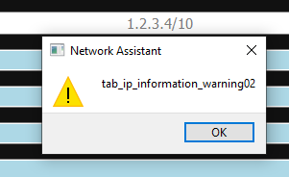

Fig 4.1

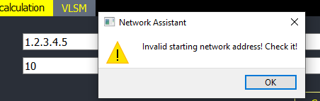

Fig 4.2

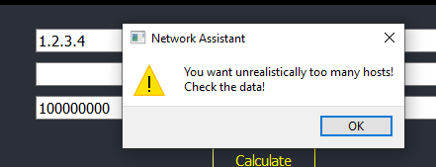

Fig 4.3

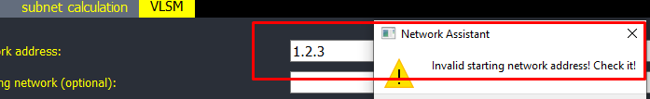

Fig 4.4

**REFERENCES:**

**Python Subnet [Calculator (https://github.com/SoftDev2-Project/Subnet-Calculator-in-](C:\\Users\\admin\\Downloads\\Calculator (https:\\github.com\\SoftDev2-Project\\Subnet-Calculator-in-)**

**[Python)](C:\\Users\\admin\\Downloads\\Calculator (https:\\github.com\\SoftDev2-Project\\Subnet-Calculator-in-)**

**2. Python IP Subnet Calculator** **(https://pypi.org/project/ipsubnet/)**

**3. (<https://www.cisco.com/c/en/us/support/docs/ip/subnet-mask-lengths/8079-subnetting->**

**[made-easy.html)](https://www.cisco.com/c/en/us/support/docs/ip/subnet-mask-lengths/8079-subnetting-)**