**BI techniques**

There are many business intelligence techniques that businesses may use to obtain useful insights in order to make decisions. Here are some BI techniques.

* Data Visualization

In simple terms, data visualization is pictorial representation of a data set. For example, Text-based data graphically visualized as charts, charts, tables, infographics, graphs, and more.

* Data Mining

Data mining is a computer-aided method to reveal previously unknown or unnoticed relationships between data entities. Data mining techniques are used a lot in practice, for example, this technique can be used to analyze shopping carts, consumer buying habits to come up with products that are suitable for the market.

* Predictive Techniques

Predictive Techniques is a BI technique that analyzes past and present data so that probabilities or trends in the future can be predicted. For example, a company that makes headphones, they may use sales data or user feedback data to be able to add features to their products or modify them as appropriate. with future trends that have been predicted.

* On-line Analytical Processing (OLAP)

OLAP is a technique for analyzing data with many different dimensions, its multidimensional aspects allow us to identify problems from different perspectives. The OLAP Core is the OLAP Cube. The OLAP cube is a data structure optimized for very fast data analysis. OLAP cube consists of numerical facts classified by dimensions. For example, in the figure below the dimensions are defined as, Product, Time, Location. Corresponding to each small cube can be sales or quantity of inventory ...

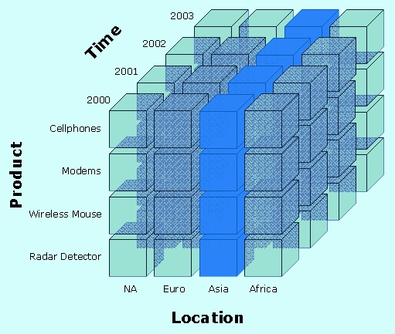

* Analytics

Analytics is a technique that involves studying available data so that meaningful data can be drawn in to capture more detailed information and make more accurate decisions. For example, a service company may research customer data to make decisions that help customers experience better service.