Does Market Concentration Distort
Cross-Sectional Momentum?
Mega-Cap Exposure and Portfolio Implementation in US Equities, 2000-2025
Minhao Qian
MSc Mathematical & Computational Finance, University of Oxford
Final Research Note | September 2026
Data: CRSP / WRDS US equities; Kenneth French Data Library
Licensed CRSP data are excluded from the public repository.

Executive Summary
Question. Does rising US equity-market concentration weaken the informational content of cross-sectional momentum, or does it mainly change the implementation of a value-weighted momentum portfolio?
Sample. CRSP US common equities, monthly formation from January 2000 to December 2025; 601,350 formation observations, 7,423 unique PERMNO securities, and 312 formation months.
Baseline. Mean Rank IC is 0.00768. The VW Q5-Q1 spread is +0.0746% per month and the EW spread is +0.2457% per month; neither is statistically distinguishable from zero under the pre-specified HAC inference.
Mechanism. Excluding the ten largest companies raises the VW spread by +0.1099 percentage points per month in point estimates. The decomposition attributes +0.1114 percentage points to direct weights and approximately zero to re-ranking.
Bridge result. A +10pp rise in aggregate Top-10 market share is associated with a +24.48pp larger Q5-minus-Q1 mega-cap weight gap (HAC6 p<1e-10). After a linear time trend the coefficient remains +9.93pp (p=0.012). The realised direct-weight return effect itself remains noisy.
Validation. Project VW and EW momentum have correlations of 0.875 and 0.917 with Kenneth French Mom over 299 common holding months. CRSP CIZ documentation confirms MthRet includes delisting returns when appropriate.
Conclusion. Market concentration appears more relevant to the portfolio implementation of value-weighted momentum than to the informational content of the momentum ranking itself.

Contents
1. Introduction
2. Related Literature
3. Data and Sample Construction
4. Research Design
5. Baseline Momentum and External Validation
6. Aggregate Market Concentration
7. Mega-Cap Exclusion
8. Mega-Cap Decomposition
9. Concentration-to-Mechanism Bridge
10. Industry Neutralisation
11. Market-Beta Neutralisation
12. Integrated Interpretation
13. What the Evidence Does and Does Not Establish
14. Limitations
15. Conclusion
References
Appendix A. Core Results
Appendix B. Reproducibility and Audit Notes

Abstract
This paper studies whether rising concentration in the US equity market distorts the measured performance of cross-sectional momentum, and whether any distortion reflects weaker stock-ranking information or changes in portfolio implementation. Using CRSP monthly US common-equity data from 2000 through 2025, the analysis constructs a 12-2 momentum signal, evaluates value-weighted and equal-weighted quintile portfolios, measures concentration at the company level, and applies mechanism tests involving mega-cap exclusion, industry neutralisation, market-beta neutralisation, and external validation against the Kenneth French Momentum Factor. The unconditional momentum signal is weak. Aggregate Top-10 concentration does not robustly predict subsequent momentum returns. Excluding the ten largest companies raises the VW spread by about 0.110 percentage points per month in point estimates, and an exact decomposition localises essentially the entire observed difference to direct portfolio weights rather than re-ranking. A final bridge test shows that higher aggregate concentration strongly predicts a larger mega-cap weight imbalance between the winner and loser legs, including after a linear time trend, while the realised direct-weight return effect remains noisy. Industry neutralisation leaves Rank IC almost unchanged, beta hedging reduces realised market beta without revealing a robust hidden premium, and the project momentum series co-moves strongly with Kenneth French Mom. The combined evidence points toward a portfolio-implementation channel rather than a collapse in momentum ranking information.

1. Introduction
US equity-market concentration has increased sharply in recent years. By the end of 2025, the ten largest US-listed companies account for roughly 37% of aggregate market capitalisation in the broad market-state universe used in this study. This matters for quantitative equity research because many cross-sectional signals are evaluated through value-weighted portfolios. When a small number of companies become exceptionally large, realised strategy returns can become highly sensitive to those companies even if the underlying ranking rule has not changed.
The central research question is: does rising market concentration weaken the informational content of cross-sectional momentum, or does it primarily change the implementation of a value-weighted momentum portfolio?
A signal and a portfolio implementation answer different questions. A signal ranks securities; a weighting rule determines how much economic exposure is attached to each rank. In a concentrated market those layers can diverge.
- Signal quality: Rank IC and cross-sectional ordering test whether past-return rankings continue to contain information about next-month returns.
- Portfolio implementation: VW versus EW returns, mega-cap exclusion, and an exact decomposition isolate changes caused by economic weights rather than ranks.
- Systematic exposure: industry and market-beta neutralisation test whether common exposures explain the observed portfolio behaviour.
The paper does not claim that concentration causally creates or destroys momentum. Aggregate concentration regressions are statistically weak. The more informative evidence comes from the portfolio-construction layer: mega-cap exclusion changes VW returns while leaving ranking diagnostics almost unchanged, and the observed exclusion point estimate is almost entirely a direct-weight effect.
The final bridge test strengthens the mechanism. Aggregate concentration strongly predicts the mega-cap weight imbalance between Q5 and Q1, even after a linear trend. It does not precisely predict the realised monthly direct-weight return effect. This is economically coherent: concentration determines exposure; subsequent mega-cap returns determine payoff.

2. Related Literature

2.1 Cross-sectional momentum
Jegadeesh and Titman (1993) establish the classic intermediate-horizon momentum result, showing that stocks with strong past returns tend to outperform stocks with weak past returns over subsequent months. This project follows the same broad empirical tradition but uses momentum diagnostically rather than attempting to re-establish the anomaly over the full historical CRSP sample.
Daniel and Moskowitz (2016) show that momentum returns can be highly state dependent and can experience large crashes, particularly around market rebounds following stressed states. This is relevant to the post-2000 sample and motivates a separate examination of market-beta exposure rather than treating a weak unconditional mean as proof of implementation failure.

2.2 Industry momentum and neutralisation
Moskowitz and Grinblatt (1999) document a substantial industry component in momentum and show that controlling for industry momentum can reduce individual-stock momentum profitability. This provides direct motivation for the FF49 neutralisation exercise used here.

2.3 Market concentration and portfolio structure
Recent work treats financial-market concentration as an economically meaningful state variable rather than a purely descriptive statistic. Research on market concentration, price impact, capital allocation, large-firm valuation, and granular market structure motivates the possibility that a small number of dominant firms can alter portfolio behaviour without becoming standalone return predictors. The present paper asks a narrower empirical question: does concentration alter the information in momentum ranks, the economic weights attached to those ranks, or both?

2.4 Beta and factor implementation
Factor portfolios can inherit systematic exposures. Frazzini and Pedersen (2014) highlight the importance of beta exposure and leverage constraints. In this project, market-beta neutralisation is treated as an exposure diagnostic rather than an assumption that a beta-neutral portfolio must be superior.

3. Data and Sample Construction

3.1 Monthly CRSP sample
The primary sample uses CRSP monthly US stock data obtained through WRDS and spans January 2000 through December 2025. The final investable formation panel contains 601,350 security-month observations, 7,423 unique PERMNO securities, 312 formation months, and 544,090 valid 12-2 momentum observations.
- US common equities.
- NYSE, AMEX, or NASDAQ primary listing.
- Positive formation-month market capitalisation.
- Exclude stocks below the monthly NYSE 20th percentile of market capitalisation.
- Month-end price of at least $5.
- PERMNO as the security identifier; PERMCO as the company identifier for concentration.

3.2 Formation universe versus market-state universe
The signal-investment universe applies the NYSE size screen and $5 price screen. The broader market-state universe retains the common-equity, major-exchange, and positive-market-cap requirements but omits those stricter investability filters. This prevents market concentration from being mechanically conditioned on the same filters used to form momentum portfolios.

3.3 Company-level aggregation
Concentration is measured after aggregating listed share classes to PERMCO. For example, GOOG and GOOGL remain separate securities for returns and ranking but are combined for company-level concentration.

3.4 CIZ monthly returns and delistings
The analysis uses CRSP CIZ MthRet as the monthly total-return field. CRSP File Format 2.0 defines MthRet as daily total return compounded for the period and states that it includes delisting returns when appropriate. The CIZ cross-reference guide further notes that the move to daily-compounded monthly returns also applies to delisting returns. A separate legacy-style DLRET merge is therefore not applied to MthRet.

3.5 Daily beta inputs
Daily beta estimation uses CRSP daily stock total returns, the CRSP value-weighted daily market total return including dividends, and Kenneth French daily RF. The stock history begins in December 1998. The daily market and RF series align on all 6,813 research-period trading dates.
The daily stock extract contained exact duplicate PERMNO-date rows. A dedicated audit showed 16,259 rows in 7,837 duplicated-key groups, with one unique return in every group. Retaining one copy removed 8,422 redundant rows and left no conflicting daily-return observations.

4. Research Design

4.1 Momentum signal
MOM(i,t) = product[s=t-12,...,t-2] (1 + R(i,s)) - 1
The signal uses eleven monthly total returns and skips t-1. Lookback history is constructed on a broader monthly history panel; formation-date investability screens are applied at t rather than retroactively to every month in the lookback. Valid momentum requires contiguous calendar-month history.

4.2 Portfolio formation
Each month, eligible securities are ranked by momentum and sorted into five quintiles. Q5 is the winner portfolio and Q1 the loser portfolio. The Q5-Q1 spread is realised in calendar month t+1. The primary implementation is value weighted using formation-month market capitalisation; equal-weighted returns are a complementary diagnostic. Missing next-month returns are never replaced with zero, and weights are renormalised among observed returns.

4.3 Rank IC and inference
Monthly Spearman Rank IC measures ranking information independently of the value-weighting rule. Newey-West HAC lag 6 is the pre-specified primary inference convention, with lag 12 as robustness. Tests are two-sided and 95% confidence intervals are reported.

5. Baseline Momentum and External Validation

5.1 Baseline results
Outcome | Mean | HAC6 t | HAC6 p | HAC12 p | 95% CI (HAC6)
Rank IC | 0.00768 | 0.957 | 0.339 | 0.349 | [-0.0081, 0.0234]
VW Q5-Q1 | 0.0746% | 0.227 | 0.821 | 0.807 | [-0.570%, 0.719%]
EW Q5-Q1 | 0.2457% | 0.870 | 0.384 | 0.407 | [-0.308%, 0.799%]

The equal-weighted point estimate is more than three times the value-weighted point estimate, but neither portfolio nor Rank IC is statistically distinguishable from zero under the frozen inference rule.

5.2 External validation against Kenneth French Mom
Because momentum is a well-established phenomenon, a weak 2000-2025 mean warrants an external implementation check. The project spread is aligned with Kenneth French Mom by realised holding month: a portfolio formed at t earns its return at t+1 and is compared with French Mom in t+1. The portfolio constructions differ, so the validation criterion is co-movement rather than equality.
Series | Mean monthly | Monthly vol | Corr. with French Mom
Project VW | 0.0746% | 5.564% | 0.875
Project EW | 0.2457% | 4.632% | 0.917
French Mom | 0.2021% | 4.634% | 1.000

Regression | Mom beta | 95% CI | R2 | Alpha p
Project VW on French Mom | 1.051 | [0.906, 1.196] | 0.766 | 0.404
Project EW on French Mom | 0.916 | [0.840, 0.992] | 0.840 | 0.590

The very high correlations and large benchmark-regression R2 values support the timing and construction sanity check. The weak VW mean is not evidence of an obvious one-month alignment error or fundamentally broken momentum implementation.

6. Aggregate Market Concentration
Concentration is measured at the PERMCO company level using Top-5 share, Top-10 share, HHI, and the effective number of firms. Top-10 share falls toward roughly 15% in the mid-2010s and then rises sharply, reaching approximately 37% by end-2025.
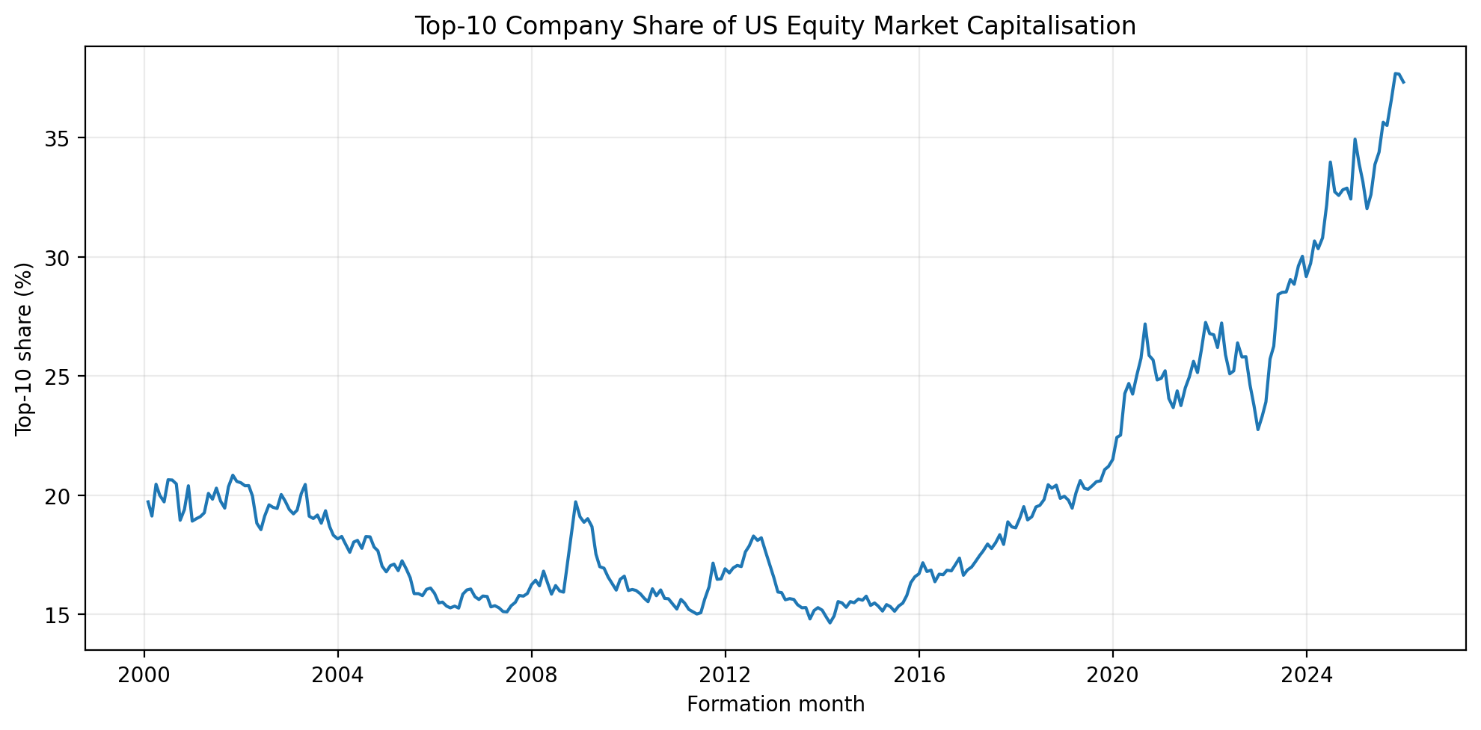
Figure 1. Top-10 company share of US equity-market capitalisation, 2000-2025.
Spread(t+1) = alpha + beta * Top10Share(t) + error(t+1)
Specification | Scale | Estimate | t | p | 95% CI
Top10 -> VW | +10pp | -0.328% | -0.620 | 0.536 | [-1.364%, 0.709%]
Top10 + trend -> VW | +10pp | -0.162% | -0.254 | 0.799 | [-1.408%, 1.084%]
HHI -> VW | +0.01 | -0.609% | -0.723 | 0.470 | [-2.262%, 1.043%]
Top10 -> EW | +10pp | +0.326% | 0.826 | 0.409 | [-0.447%, 1.100%]
Top10 -> Rank IC | +10pp | +0.0063 | 0.506 | 0.613 | [-0.0181, 0.0307]
Lagged Top10 -> VW | +10pp | -0.303% | -0.551 | 0.582 | [-1.381%, 0.775%]

Aggregate concentration does not robustly predict subsequent momentum effectiveness. The sign is not stable across VW, EW, and Rank-IC outcomes, and the primary negative coefficient becomes smaller with a linear trend.

7. Mega-Cap Exclusion
The largest firms are identified each month at the PERMCO level using the broad market-state universe. The primary test removes the Top 10 companies before re-forming momentum quintiles. Top 5 and Top 20 are robustness checks.
Exclusion | Mean VW spread | Change vs baseline | HAC6 p | HAC12 p
Top 5 | 0.1375% | +0.0629 pp | 0.357 | 0.329
Top 10 | 0.1844% | +0.1099 pp | 0.269 | 0.250
Top 20 | 0.2456% | +0.1711 pp | 0.116 | 0.092

For Top-10 exclusion, the approximate HAC6 95% CI for the monthly change is [-0.085%, 0.305%]. The increasing point estimates across Top 5/10/20 are treated descriptively; Top 20 is not promoted based on a smaller p-value.

8. Mega-Cap Decomposition
Exclusion and re-formation change both weights and quintile boundaries. A fixed-rank portfolio therefore preserves original Q1-Q5 membership, removes Top-10 company securities within those portfolios, and renormalises remaining value weights.
Total Change = Direct Weight Effect + Re-Ranking Effect
Component | Mean effect | HAC6 p | HAC12 p | Approx. 95% CI
Direct weight | +0.1114 pp | 0.259 | 0.242 | [-0.082, 0.305] pp
Re-ranking | -0.0016 pp | 0.866 | 0.866 | near zero
Total | +0.1099 pp | 0.269 | 0.250 | [-0.085, 0.305] pp

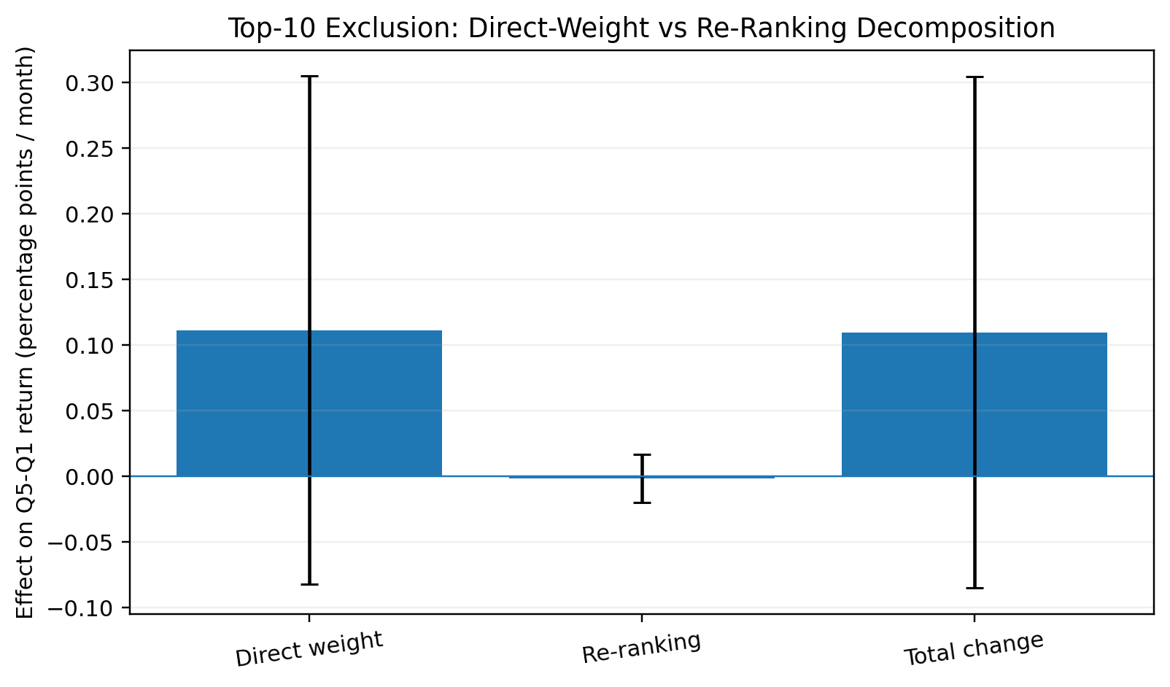
Figure 2. Top-10 exclusion decomposition. Error bars show approximate HAC6 95% confidence intervals.
The decomposition strongly localises the observed exclusion point estimate to direct portfolio weights. It does not establish the population mean direct-weight effect with conventional statistical precision. This distinction between mechanical localisation and statistical precision is central to the final interpretation.
Top-10 companies account on average for 9.95% of Q1 formation weight and 17.66% of Q5 formation weight. The winner portfolio therefore carries substantially more mega-cap exposure on average.

9. Concentration-to-Mechanism Bridge
The decomposition establishes a weight mechanism, but exclusion alone does not prove that the mechanism becomes stronger when the aggregate market is more concentrated. Two bridge specifications were frozen before observing the results.

9.1 Direct-weight return effect
DirectWeightEffect(t) = alpha + beta * Top10Share(t) + error(t)
Per +10pp Top-10 market share, the coefficient is +0.1840 percentage points per month (HAC6 p=0.440; 95% CI [-0.283, 0.651]). With a linear time trend, the coefficient is +0.2748 percentage points with p=0.283. Aggregate concentration therefore does not precisely predict the realised direct-weight return effect.

9.2 Mega-cap weight gap
WeightGap(t) = Top10Weight_Q5(t) - Top10Weight_Q1(t)
Per +10pp aggregate Top-10 share, the primary coefficient is +24.48 percentage points (t=6.60, p<1e-10, 95% CI [17.21, 31.75], R2=0.297). After adding a linear time trend, the coefficient remains +9.93 percentage points (p=0.012, 95% CI [2.18, 17.68]).
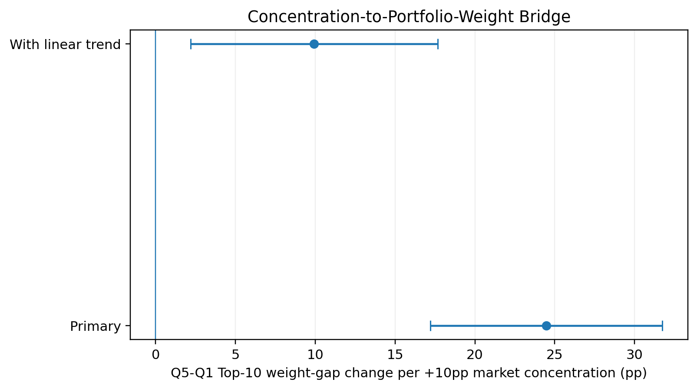
Figure 3. Change in the Q5-minus-Q1 mega-cap weight gap associated with a +10pp increase in aggregate Top-10 market share.
This bridge clarifies the mechanism: concentration strongly changes portfolio exposure geometry, but the realised return effect additionally depends on what the mega-cap stocks subsequently earn. Exposure changes predictably; payoff does not map one-for-one into concentration.

10. Industry Neutralisation
Securities are mapped to contemporaneous FF49 industries using SIC codes. Within each valid industry-month, the equal-weighted industry mean momentum signal is subtracted and global quintiles are re-formed. Industries require at least ten stocks.
Outcome | Raw | FF49-neutral | Change | HAC6 p | Approx. 95% CI
VW spread | +0.0746% | -0.0255% | -0.1001 pp | 0.585 | [-0.459, 0.259] pp
Rank IC | 0.007680 | 0.007625 | -0.000054 | 0.986 | approximately zero

The portfolio-return point estimate declines, but the change is imprecise. More importantly, Rank IC is virtually unchanged. Broad industry common trends therefore do not explain the core ranking result or the mega-cap weight mechanism in this sample.

11. Market-Beta Neutralisation

11.1 Beta estimation
Stock betas are estimated monthly using daily excess-return CAPM regressions. The market-calendar window uses 252 trading days, skips the most recent five trading days before formation, and requires at least 126 valid paired observations. No winsorisation, clipping, forward filling, or imputation is used. Average valid-beta coverage is approximately 97.9%.
R(i,d)-Rf(d) = alpha(i,t) + beta(i,t) * [Rm(d)-Rf(d)] + epsilon(i,d)

11.2 Market-overlay hedge
R_BN(t+1) = R_Eligible(t+1) - beta_LS(t) * R_MKT,excess(t+1)
Metric | Estimate | HAC6 p | Approx. 95% CI
Original VW spread | +0.0746%
Beta-neutral VW spread | -0.0389%
Neutralisation effect | -0.1135 pp | 0.446 | [-0.405, 0.178] pp
Leg-rescaled effect | -0.0578 pp | 0.703 | [-0.354, 0.239] pp
Ex-post beta: raw | -0.381 | 0.00044
Ex-post beta: beta-neutral | -0.158 | 0.0405

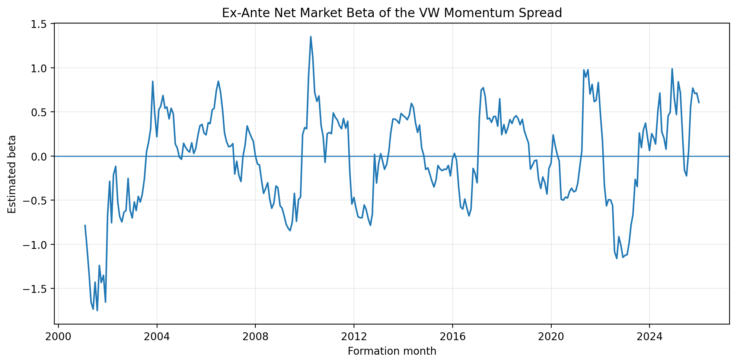
Figure 4. Ex-ante net market beta of the VW momentum spread. Conditional exposure varies substantially through time.
Ex-ante hedging materially reduces realised market exposure but does not reveal a statistically robust hidden momentum premium. Ex-ante neutrality is a formation-date construction property; it does not guarantee zero realised time-series beta.

12. Integrated Interpretation

12.1 Ranking information
There is no clear evidence that rising concentration systematically destroys 12-2 momentum ranking information. Rank IC is weak but positive, does not robustly decline with concentration, remains virtually unchanged after FF49 neutralisation, and the project momentum series co-moves strongly with the established French benchmark.

12.2 Portfolio implementation
This is where the evidence is strongest. The observed Top-10 exclusion point estimate is almost entirely a direct-weight effect, and aggregate concentration strongly predicts the Q5-minus-Q1 mega-cap weight gap. The bridge remains positive after a linear time trend.

12.3 Exposure versus payoff
The paper distinguishes a predictable change in exposure from a noisy change in realised payoff. Rising concentration increases the amount of mega-cap weight imbalance embedded in the long-short portfolio. The monthly return effect remains imprecise because it also depends on future returns of the mega-cap stocks occupying Q5 and Q1.

12.4 Systematic exposures
Industry neutralisation does not materially alter ranking quality. Beta neutralisation changes market exposure but not the main return conclusion. Systematic exposure therefore matters for realised behaviour without explaining away the central portfolio-weight mechanism.

13. What the Evidence Does and Does Not Establish
The strongest findings are structural and diagnostic rather than causal.

13.1 Supported by the evidence
- The observed Top-10 exclusion point estimate is almost entirely a direct-weight effect rather than a re-ranking effect.
- Higher aggregate concentration is strongly associated with a larger mega-cap weight imbalance between Q5 and Q1.
- The project momentum implementation has high external correlation with Kenneth French Mom.
- Industry neutralisation leaves Rank IC almost unchanged.
- Ex-ante market hedging materially reduces realised market beta.

13.2 Not established by the evidence
- A causal fixed return loss from a given increase in concentration.
- A precisely positive population mean return effect from removing mega-cap firms.
- A directly tradable post-cost alpha from the ex-mega-cap portfolio.
- Automatic generalisation from momentum to other cross-sectional signals.

14. Limitations
- The sample begins in 2000 and does not cover the earlier decades in which momentum was originally documented.
- The completed research version studies one signal, 12-2 momentum; conclusions should not automatically be extrapolated to value, reversal, quality, profitability, or low-volatility signals.
- Only 312 formation months and 299 valid performance months limit power for persistent time-series regressors.
- Market concentration is persistent and trending. A linear time trend improves interpretation but does not create causal identification.
- The analysis is observational and focuses on portfolio mechanics and conditional associations rather than a natural experiment.
- Returns are gross of turnover, spreads, market impact, shorting costs, borrow constraints, financing, and operational frictions.
- Beta is estimated rather than observed; conditional beta variation and estimation error explain residual realised beta.
- Robustness tests are dependent diagnostics, not independent discovery tests; smaller p-values are not used to redefine the primary specification.

15. Conclusion
This paper asks whether rising US equity-market concentration distorts cross-sectional momentum. The evidence does not support a simple claim that aggregate concentration systematically destroys momentum ranking ability. The baseline signal is weak over 2000-2025, but the implementation is externally validated against Kenneth French Mom and ranking diagnostics remain broadly stable across mega-cap exclusion and industry neutralisation.
The more informative result lies in portfolio implementation. Removing the ten largest companies raises the VW momentum spread by about 11 basis points per month in point estimates. An exact decomposition localises virtually the entire observed difference to direct portfolio weights rather than re-ranking. The final bridge test connects this mechanism back to aggregate concentration: as the market becomes more concentrated, the mega-cap weight imbalance between the winner and loser portfolios becomes substantially larger, including after a linear time trend.
At the same time, the realised return effect of that weight channel remains noisy and statistically imprecise. Concentration can clearly change exposure without generating a deterministic change in payoff. Industry and beta controls do not reveal a robust hidden momentum premium.
Main conclusion: market concentration appears more relevant to the portfolio implementation of value-weighted cross-sectional momentum than to the informational content of the momentum ranking itself.
For systematic equity research, the practical implication is to separate signal quality, weighting-rule concentration, and systematic factor exposure before declaring that a factor has strengthened or decayed.

References
Daniel, K., & Moskowitz, T. J. (2016). Momentum crashes. Journal of Financial Economics, 122(2), 221-247.
Ehsani, S., Harvey, C. R., & Li, F. Is Sector-Neutrality in Factor Investing a Mistake? Working paper.
Frazzini, A., & Pedersen, L. H. (2014). Betting against beta. Journal of Financial Economics, 111(1), 1-25.
Jegadeesh, N., & Titman, S. (1993). Returns to buying winners and selling losers: Implications for stock market efficiency. Journal of Finance, 48(1), 65-91.
Moskowitz, T. J., & Grinblatt, M. (1999). Do industries explain momentum? Journal of Finance, 54(4), 1249-1290.
Neuhann, D., & Sockin, M. (2024). Financial Market Concentration and Misallocation. Working-paper / journal version as cited in project literature notes.
Center for Research in Security Prices (CRSP). CRSP US Stock & Indexes Database Guide, File Format 2.0 (CIZ).
Center for Research in Security Prices (CRSP). SIZ to CIZ Cross-Reference Guide.
Kenneth R. French Data Library. Momentum Factor (Mom) and daily research factors.

Appendix A. Core Numerical Results

A.1 Baseline and aggregate concentration
Result | Estimate | Inference
Baseline VW spread | +0.0746% / month | HAC6 p=0.821
Baseline EW spread | +0.2457% / month | HAC6 p=0.384
Mean Rank IC | 0.00768 | HAC6 p=0.339
Top10 -> VW | -0.3275 pp per +10pp concentration | p=0.536
Top10 + trend -> VW | -0.1617 pp per +10pp concentration | p=0.799

A.2 Mechanism and neutralisation
Result | Estimate | Inference
ExTop10 improvement | +0.1099 pp/month | p=0.269
Direct-weight component | +0.1114 pp/month | p=0.259
Re-ranking component | -0.0016 pp/month | p=0.866
Weight-gap bridge | +24.48 pp per +10pp concentration | p<1e-10
Weight-gap + trend | +9.93 pp per +10pp concentration | p=0.012
FF49 neutralisation | -0.1001 pp/month | p=0.585
Beta neutralisation | -0.1135 pp/month | p=0.446

A.3 External benchmark validation
Metric | Project VW | Project EW
Correlation with French Mom | 0.875 | 0.917
Mom regression beta | 1.051 | 0.916
95% CI | [0.906, 1.196] | [0.840, 0.992]
R2 | 0.766 | 0.840
Alpha p-value | 0.404 | 0.590

Appendix B. Reproducibility and Audit Notes
- Raw licensed CRSP data are excluded from the public repository.
- Monthly data are cleaned to unique PERMNO-month observations before analysis.
- Momentum was manually validated on extreme cases using calendar-month periods rather than hard-coded natural month-end dates.
- Concentration is measured on a broad market-state universe and aggregated to PERMCO before Top-N and HHI calculation.
- Multiple share classes are combined for concentration but remain separate securities for return analysis.
- CRSP CIZ MthRet is used directly; official documentation states that it compounds daily total returns and includes delisting returns when appropriate.
- Daily stock data were audited for duplicate PERMNO-date observations before beta estimation.
- Daily CRSP market and French RF align on 6,813 research-period trading dates.
- The 252-day / 5-day skip / 126-observation beta rule was frozen before beta-neutral portfolio results.
- HAC6 primary and HAC12 robustness were fixed before concentration and neutralisation interpretation.
- Top-10 is the primary mega-cap exclusion rule; Top-5 and Top-20 remain robustness checks.
- The bridge regressions and external French Mom validation were specified before their results were interpreted.
- External momentum validation is aligned by realised holding month, not formation-month label.

