Short-Horizon Cross-Sectional Equity Alpha
Forecasting, Walk-Forward Validation, and Execution-Aware Portfolio Analysis

Minhao Qian
University of Oxford | MSc Mathematical and Computational Finance
October 2026

Research Project
US equities, CRSP daily data, 1993-2025

Abstract
This study investigates whether short-horizon cross-sectional equity signals contain persistent predictive information and whether that predictability survives realistic implementation constraints. Using U.S. CRSP daily equity data from 1993 to 2025, I construct a point-in-time research pipeline with a five-trading-day open-to-open target, strict walk-forward validation, corporate-action-aware return accounting, liquidity filters, and eight pre-specified daily features.
Short-term reversal emerges as the strongest standalone signal. During the 2003-2019 forward-development period, reversal delivers positive Rank IC, while an eight-feature Ridge combination also remains predictive but does not demonstrate incremental ranking value over the simpler signal. The same pattern survives a single final 2020-2025 predictive holdout: unfitted reversal, univariate reversal Ridge, and the eight-feature Ridge model achieve mean Rank ICs of 0.0158, 0.0160, and 0.0157 respectively. All six holdout years and all five fixed non-overlapping phases show positive mean IC.
The implementation analysis produces a different conclusion. Strict account-level reconstruction reveals that historical corporate-action settlement and successor-security inventory are not always fully identifiable from the available CRSP history. Rather than silently imputing these states, the study preserves unresolved obligations and reports conditional measured-component economics separately from unidentified wealth. Under pre-specified execution, transaction-cost and borrow assumptions, identified fixed trading costs exceed identified gross contribution for both reversal and Ridge portfolios. Because full-account wealth remains unidentified, these conditional results are not interpreted as complete portfolio returns or executable Sharpe ratios.
The central finding is therefore twofold: short-horizon reversal exhibits persistent out-of-sample predictive power, but predictive alpha does not automatically translate into implementable net alpha. Model complexity adds little beyond the simple reversal signal, while turnover, execution frictions, and historical accounting limitations become first-order concerns at the portfolio layer.

Executive Summary
- A simple five-day short-term reversal signal is the strongest standalone predictor in the frozen feature set.
- Predictive information survives the final 2020-2025 predictive holdout: reversal mean Rank IC = 0.0158, with positive annual mean IC in all six years.
- The eight-feature Ridge model remains predictive but shows no demonstrated incremental Rank-IC advantage over reversal.
- Under the pre-specified portfolio implementation, measured trading frictions exceed measured gross contribution on identifiable components.
- Full account wealth is not completely identifiable because some historical corporate-action settlement states cannot be reconstructed reliably from CRSP alone.
- The project therefore distinguishes predictive alpha, model complexity, and executable alpha rather than treating them as equivalent.

1. Introduction
Short-horizon equity return predictability is easy to demonstrate statistically and much harder to establish economically. A cross-sectional signal may rank future returns correctly while failing to survive temporal validation, model complexity, transaction costs, execution constraints, or incomplete historical accounting. This study examines that full chain.
The primary research question is whether simple daily equity characteristics contain persistent information about U.S. stock returns over the following five trading days. The analysis begins with a transparent set of eight pre-specified features: short-term reversal, medium-term momentum, realized volatility, turnover, dollar liquidity, volume shock, overnight gap, and intraday return. Predictive performance is evaluated cross-sectionally using Spearman Rank Information Coefficients under strict temporal and walk-forward procedures.
The second question is whether combining several signals improves forecasting performance beyond the strongest simple characteristic. To address this, I estimate a regularized linear combination using expanding-window Ridge regression. The feature set, regularization strength, estimation schedule, preprocessing rules, and evaluation protocol are fixed in advance. No feature selection or hyperparameter search is performed after observing the development results.
The final question is whether statistically persistent predictive information can be converted into an economically credible market-neutral portfolio. This requires more than translating forecasts into long and short positions. Execution timing, overlapping holding periods, trading costs, short borrowing, liquidity constraints, corporate actions, and incomplete historical account-level settlement information all affect whether a forecast can be interpreted as a realizable trading strategy.
The empirical design therefore separates three objects: predictive information, model value, and implementation economics. A predictive signal need not imply a profitable strategy, and a profitable-looking backtest need not imply that historical execution has been reconstructed correctly.
The study uses CRSP daily U.S. equity data from 1993 through 2025. Development ends in 2019. The 2020-2025 period was held untouched until all predictive specifications were frozen, and was then opened once for final validation. Reversal remains positively predictive in every holdout calendar year and every fixed non-overlapping phase. The eight-feature Ridge model also retains positive predictive information, but does not demonstrate incremental Rank-IC improvement over the simpler reversal signal.

2. Data and Research Design

2.1 CRSP daily equity universe
The baseline universe is designed to represent liquid U.S. common equity rather than the full CRSP security population. Eligibility requires common equity, U.S. incorporation, a corporate issuer, primary listing on NYSE, AMEX, or Nasdaq, and active trading status. The liquidity screen requires observed price above $5, market capitalization above $1 billion, trailing 20-day average daily dollar volume above $20 million, and at least 15 valid observations in the 20-day liquidity window.
These restrictions are frozen before predictive performance is examined. They are universe-design assumptions, not performance-driven filters. The screen reduces the influence of extremely small or illiquid securities and creates a more institutionally plausible setting for later transaction-cost analysis.

2.2 Signal timing and five-day prediction target
Signals are formed using information available through the close of trading day t. The economic horizon is entry at the regular-session open of t+1 and exit at the regular-session open of t+6, spanning five global trading-day intervals. No same-day future information is permitted to influence the signal or planned entry.
The target is not a naive open-to-open price ratio. Corporate actions occurring over the holding interval can change the economic wealth associated with the original position. Where measurable, the frozen target incorporates ordinary and nonordinary distributions, verified share transformations, cash delistings, successor securities, and independently established receivables or claims.
If a required component cannot be identified reliably, the observation remains in the eligible set but its target is marked missing. The project never repairs a missing economic state through interpolation, later prices, arbitrary zero values, or assumed total loss.
Target status | Count
Eligible signal-security observations | 6,699,101
Numeric five-day labels | 6,676,750
Missing entry measurement | 7,596
Cash-only delisting (measurable) | 3,616
Valid entry, unresolved exit wealth | 4,087
Administrative right-censoring | 8,686
Other unresolved corporate action | 1,982

2.3 Point-in-time discipline
All predictors are constructed exclusively from information available by the signal close. Rolling windows use the global trading calendar, missing security observations never shift the intended window, future target availability does not determine whether a signal is constructed, eventual delisting or missing-label outcomes are not used as predictors, and future observations are never used to repair a missing feature. Where corporate-action timing is ambiguous, the affected feature is left missing rather than reconstructed retrospectively.

2.4 Frozen feature set
- Short-term reversal: negative compounded return over the most recent five trading days.
- Medium-term momentum: compounded return over the preceding 55 global trading days, skipping the latest five days.
- Realized volatility: sample standard deviation of daily returns over the latest 20 global trading days.
- Turnover: log-transformed 20-day average trading turnover relative to market capitalization.
- Dollar liquidity: log-transformed 20-day average dollar trading volume.
- Volume shock: log of one plus current dollar volume minus log of one plus the preceding 20-day average, with at least 15 valid prior values.
- Overnight gap: regular-session open relative to the preceding observed close, only when event-free timing is verified.
- Intraday return: regular-session close relative to the same-day open.

2.5 Cross-sectional preprocessing and inference
Raw feature values are preserved. For modeling, each feature is clipped within signal date at the 1st and 99th percentiles and then standardized using the same-date cross-sectional mean and population standard deviation. Missing values remain missing; no forward fill, backward fill, or target-conditioned imputation is used.
The primary forecasting statistic is daily cross-sectional Spearman Rank IC. Because adjacent five-day outcomes overlap, inference uses Bartlett/Newey-West HAC standard errors with lag 4 as the primary specification and lag 20 as sensitivity. Five fixed non-overlapping calendar phases provide an additional robustness view. No inference lag or phase is selected based on observed significance.

2.6 Development and final predictive holdout design
The predictive sample is separated by signal date. Development covers 1993-2019, while the final holdout covers 2020-2025. The holdout remained unopened while feature definitions, preprocessing, Ridge architecture, regularization strength, refit schedule, and inference rules were frozen. The learned models update quarterly during the holdout using only matured past labels, making the final evaluation a prequential test of a frozen updating rule rather than a single fixed-coefficient 2019 model.

3. Baseline Cross-Sectional Signals

3.1 Development-period evidence
The first empirical question is whether any pre-specified daily characteristic contains stable cross-sectional information about returns over the following five trading days. The evidence is highly uneven across signals.
Signal | Mean Rank IC | HAC4 t | Interpretation
Short-term reversal | 0.0299 | 10.63 | Strongest positive baseline
Medium-term momentum | 0.0048 | 1.28 | Weak positive evidence
Realized volatility | -0.0145 | -2.80 | Moderate negative relation
Turnover | -0.0098 | -2.16 | Moderate negative relation
Dollar liquidity | 0.0006 | 0.31 | Little standalone signal
Volume shock | 0.0003 | 0.26 | Little standalone signal
Overnight gap | -0.0057 | -3.66 | Negative short-horizon relation
Intraday return | -0.0207 | -12.15 | Strong inverse relation

Short-term reversal is the strongest standalone predictor. Its sign is positive across all five non-overlapping phases, and the quintile relation is strictly monotonic. Intraday return produces the second clearest result with the opposite sign: stronger open-to-close performance predicts weaker subsequent five-day returns. Realized volatility and turnover are both negative but highly redundant, with feature correlation around 0.675 and IC correlation around 0.948.

3.2 Economic separation
The reversal top-minus-bottom quintile contrast is approximately +40 basis points during the broad development feature evaluation, while intraday return produces an inverse contrast of approximately -30 basis points. These are predictive target contrasts, not portfolio returns: they contain no transaction costs, position sizing, overlapping capital allocation, borrow expense, liquidity constraint, or execution uncertainty.

3.3 Implication for model combination
The baseline results imply that predictive information is concentrated in a small subset of economically simple short-horizon signals. Several remaining variables are weak or redundant. A regularized model may improve stability, but it cannot manufacture independent information that is absent from the predictors. This motivates an intentionally conservative multivariate combination.

4. Walk-Forward Signal Combination

4.1 Model specification
The multivariate baseline is Ridge regression with all eight standardized features, an unpenalized intercept, and fixed regularization parameter lambda = 1. There is no feature selection, manual sign adjustment, PCA, correlation pruning, or hyperparameter grid search. The initial estimation history is 1993-2002, followed by quarterly expanding-window refits from 2003 through 2019. Every fit uses only labels whose required exit and ledger information have matured by the information cutoff.
The training objective is equal-date normalized squared error on the raw five-day target. Predictive performance is still evaluated by Rank IC. This objective/evaluation mismatch is intentional and is not tuned away after seeing results.

4.2 Forward predictive performance
Candidate | Mean Rank IC | HAC4 t | HAC20 t | Key result
Eight-feature Ridge | 0.0134 | 4.81 | 4.52 | Positive forward prediction
Univariate reversal Ridge | 0.0148 | 4.51 | - | Stronger simple benchmark
Equal-weight combination | -0.0038 | - | - | No useful combination evidence

The eight-feature Ridge model is clearly predictive in forward blocks, with positive mean IC in all five fixed phases and 13 of 17 calendar years. However, the stronger research question is whether it improves on reversal. The paired Ridge-minus-reversal mean IC difference is approximately -0.00139 and its confidence interval includes zero. The additional features therefore do not demonstrate incremental ranking power beyond the strongest simple signal.
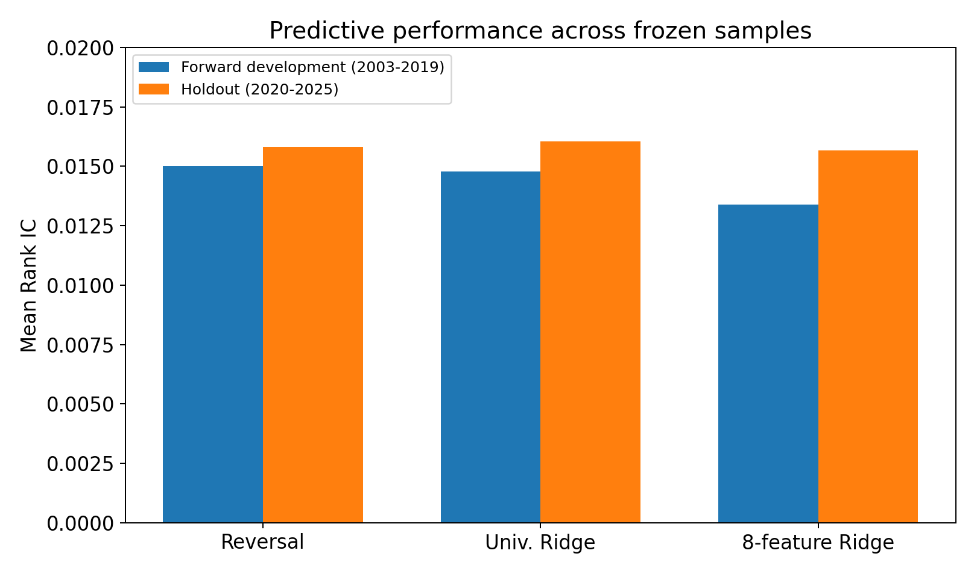
Figure 1. Mean Rank IC in forward development and final predictive holdout. The multivariate Ridge model remains predictive, but its additional complexity does not produce a clear advantage over reversal.

5. Final 2020-2025 Predictive Holdout

5.1 Holdout protocol
The holdout was opened once only after the target, feature definitions, preprocessing, Ridge architecture, lambda, refit schedule, complete-feature policy, and inference rules were frozen. Predictions are saved before future target availability is joined. The holdout contains 1,882,649 eligible signal-security observations, 1,872,680 numeric labels, and 9,969 explicitly missing labels.
Candidate | Mean IC | Median | SD | HAC4 t | HAC20 t | Eval. coverage
Unfitted reversal | 0.015817 | 0.004423 | 0.166844 | 2.287 | 2.157 | 99.45%
Univariate reversal Ridge | 0.016043 | 0.005636 | 0.167257 | 2.318 | 2.183 | 97.89%
Eight-feature Ridge | 0.015672 | 0.012317 | 0.157175 | 2.615 | 2.495 | 97.89%

5.2 Stability across years and phases
All six annual mean ICs are positive for every candidate. All five fixed non-overlapping phase means are also positive, although individual phase or annual confidence intervals are often wide and may include zero. This is evidence of persistent average predictive information, not six or five independent replications.
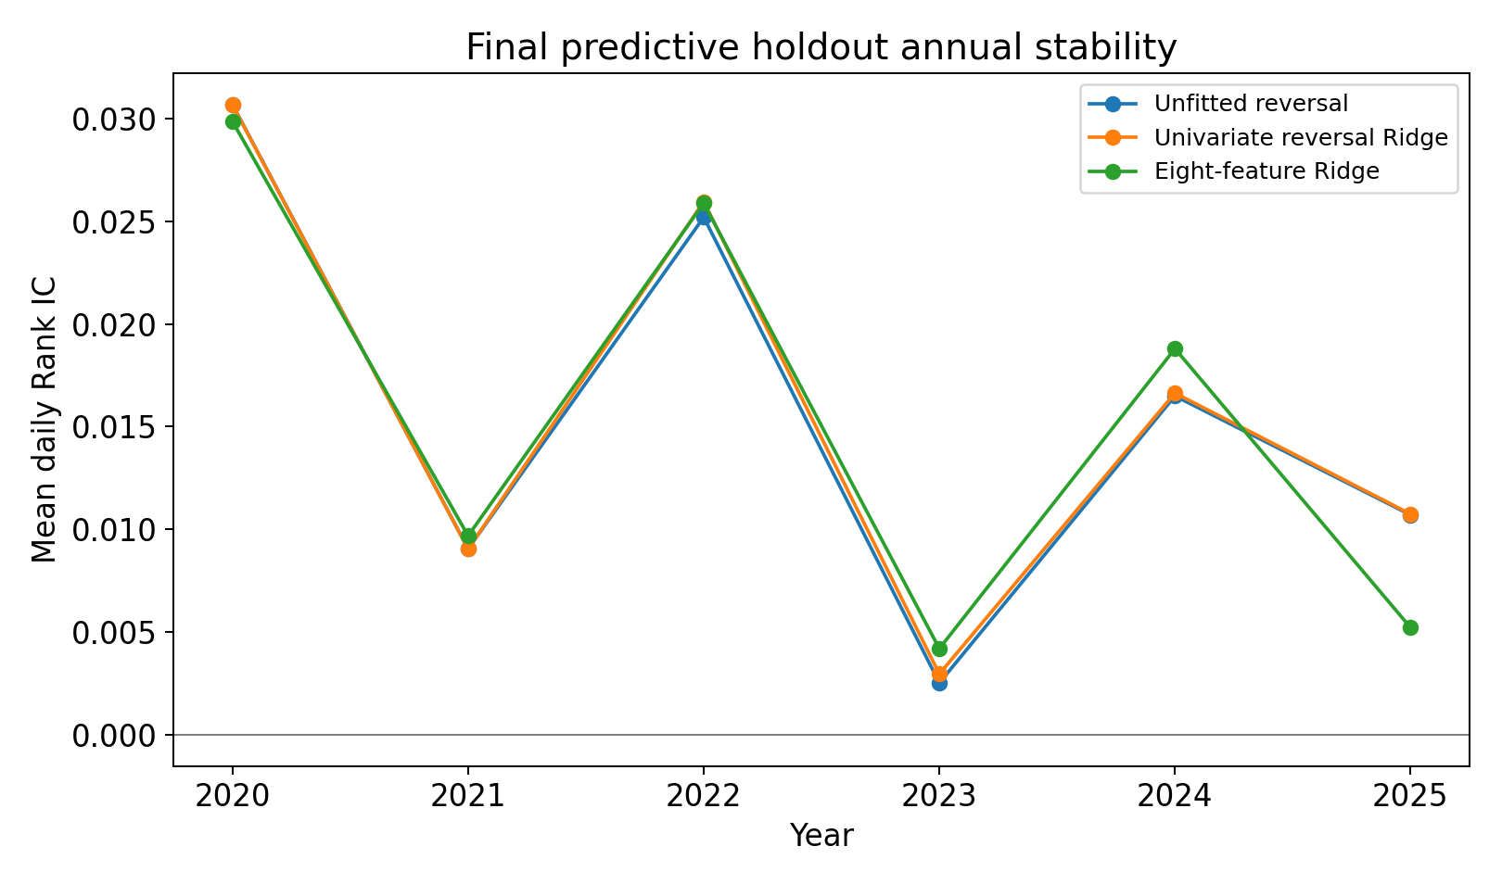
Figure 2. Annual mean Rank IC in the final 2020-2025 predictive holdout. Predictive strength varies materially across regimes, but the annual average remains positive for all three candidates in every year.

5.3 Monotonicity and model comparison
All three aggregate holdout quintile curves increase monotonically. Q5-Q1 five-day target contrasts are approximately 25.22 bp for unfitted reversal, 25.77 bp for univariate reversal Ridge, and 20.76 bp for the eight-feature Ridge model. These are target contrasts rather than portfolio returns.
On identical complete-eight keys, the Ridge-minus-reversal mean daily IC difference is -0.000371, with HAC4 95% confidence interval [-0.006534, 0.005792]. The holdout therefore validates the existence of predictive reversal, but not the value of additional model complexity.

6. Portfolio Construction Framework

6.1 Five overlapping sleeves
A new portfolio sleeve is formed each global trading day. Signals are observed after close t, positions enter at the open of t+1, and are scheduled to exit at the open of t+6. At full deployment, five staggered sleeves coexist. This matches the economic horizon used by the prediction target rather than treating overlapping target returns as if they were daily portfolio returns.

6.2 Cross-sectional mapping and capital
The highest score quintile forms the long side and the lowest score quintile forms the short side. Ties are preserved. Within each side, positions are initially equal-dollar weighted subject to deterministic concentration and liquidity constraints. Reference capital is fixed at $10 million. Each sleeve receives a $2 million side budget, implying planned 200% gross exposure and zero planned dollar net exposure at full deployment. Shares are fixed using the decision close; opening gaps and unresolved holdings prevent certification of realized neutrality, funding or solvency.

6.3 Constraints and costs
- Per-name planned size capped at 2% of the sleeve-side budget ($40,000).
- New-entry modeled flow capped at 1% of trailing 20-day ADV; scheduled exits are reserved.
- Baseline one-way fixed execution allowance: 6 bp.
- Market-impact term: 0.10 x sigma20 x sqrt(participation).
- Baseline short borrow: 100 bp per year, ACT/365, on verified original short-entry notional.
- No cross-sleeve netting in the primary implementation.
- Beta- and sector-neutral constraints are deferred rather than retrofitted after observing results.

7. Historical Execution and Identification Limits

7.1 Why security returns are not enough
A historical portfolio is not fully described by a sequence of security returns. It is an accounting system containing signed share quantities, cash, receivables, successor securities, obligations, settlement timing, borrow liabilities, and execution states. This matters when a security experiences mergers, stock-for-stock acquisitions, delistings, elections, fractional treatment, or missing opening prices.

7.2 Strict reconstruction
The strict implementation never assumes that an unresolved position disappears, never substitutes a later price, never forward-fills a mark, never extends the horizon silently, and never assigns zero wealth or total loss without evidence. Under this rule new orders halt after close 2003-01-13, with no identified resumption through 2019. The five-date fallback also fails on unverified successor quantities after close 2003-03-31.

7.3 Household International / HSBC case study
A detailed 2003 merger case illustrates the difference between economic entitlement and executable account inventory. Contemporaneous legal terms establish that one Household common share converts economically into 2.675 HSBC ordinary shares, equivalent to 0.535 HSBC ADS. That establishes an entitlement ratio. It does not by itself establish the simulated account's election, delivery time, fractional cash treatment, or corresponding short obligation. Event-by-event historical settlement recovery therefore proves non-scalable and is closed as a research branch.

7.4 Generalized unresolved-position framework
The generalized framework quarantines an unresolved position instead of halting the entire candidate. Known quantities, cash claims, borrow obligations, and event identifiers remain recorded, while unknown successor quantity or wealth remains null. A reference-capital reservation proxy prevents the same deployment budget from being reused as though the position had vanished. The reserve is explicitly not wealth, collateral, market value, or a loss bound.

8. Conditional Implementation Economics

8.1 Identification coverage
The generalized framework preserves operational continuity but does not make unknown wealth measurable. Across development, identified asset-component interval coverage is approximately 80.6% for reversal and 80.0% for Ridge. Complete wealth-plus-expense input coverage is approximately 80.1% and 79.5%. Coverage declines through time as unresolved historical obligations accumulate.
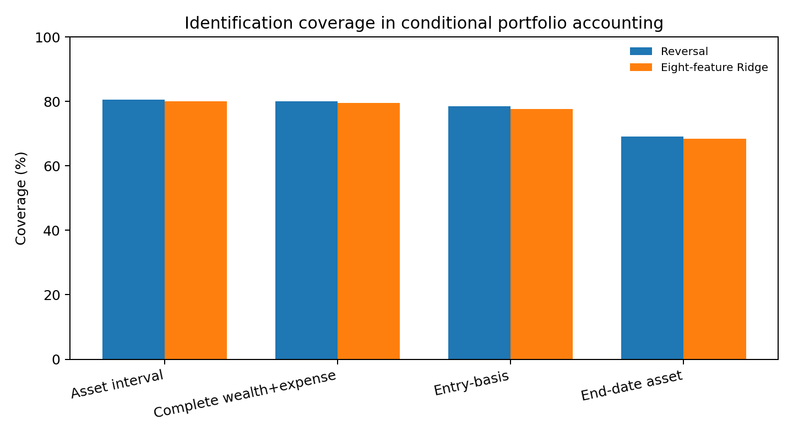
Figure 3. Coverage of key accounting components. Coverage is substantial but incomplete and nonrandom, which prevents partial PnL from being treated as total portfolio performance.

8.2 Conditional measured-component accounting
Daily accounting separates identified gross wealth increments, fixed execution costs, modeled impact costs, borrowing costs, known cash entitlements, and unknown residuals. Unknown values remain null. Known costs are retained even when associated terminal wealth is unresolved. Ratios use the fixed $10 million reference denominator and are labeled conditional measured-component contributions.
Component | Reversal | Eight-feature Ridge
Identified gross contribution | +$13.07m | +$10.82m
Fixed execution costs | -$15.58m | -$15.56m
Modeled impact costs | -$1.01m | -$1.00m
Borrow costs | -$1.70m | -$1.61m
Identified net subtotal | -$5.22m | -$7.35m
Conditional mean contribution | -1.22 bp/day | -1.72 bp/day
Annualized conditional contribution SD | 9.23% | 7.71%

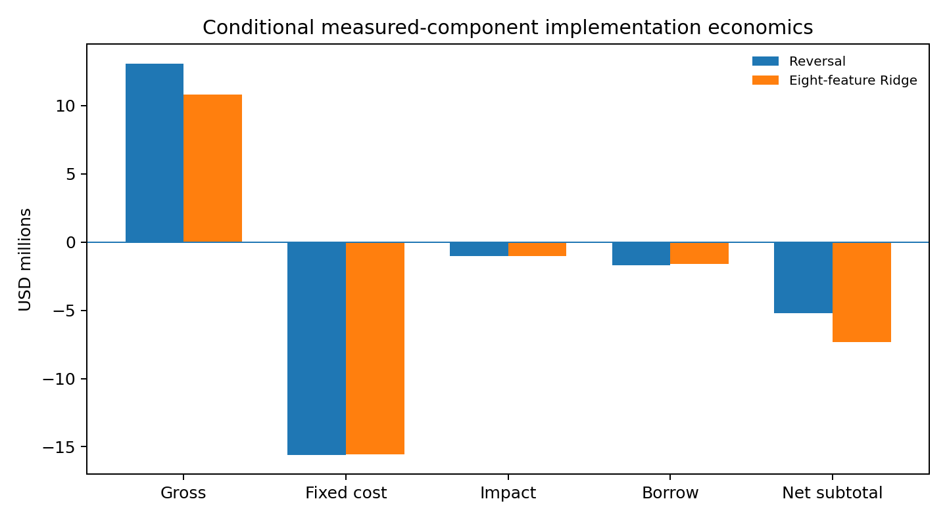
Figure 4. Conditional measured-component economics. Identified fixed execution charges alone exceed identified gross contribution for both candidates under the frozen implementation assumptions.

8.3 Interpretation
The strongest economic observation is that identified fixed execution costs alone exceed identified gross contribution for both candidates, before impact and borrow are added. This is consistent with the strategy structure: short horizon, two-sided trading, daily sleeve formation, and substantial turnover. The result does not prove that the complete historical strategy lost money, because full-account wealth is not identified. It establishes the narrower and defensible claim that trading frictions dominate the measurable gross contribution under the pre-specified implementation.

9. Discussion

9.1 Why reversal may persist
Several mechanisms are consistent with the observed short-horizon reversal: temporary price pressure from liquidity demand, short-lived overreaction, institutional order imbalance, and market-microstructure effects. The strong negative intraday predictor is consistent with a temporary component in recent price strength. The study does not identify a causal mechanism, so these explanations remain hypotheses rather than established channels.

9.2 Why Ridge does not outperform
The feature set contains one dominant simple signal, several weaker predictors, and substantial redundancy. Ridge can stabilize noisy or correlated coefficients, but it cannot create independent information where little exists. The holdout therefore supports a parsimonious conclusion: the multivariate model is predictive, yet greater model complexity does not earn its place through demonstrable incremental out-of-sample ranking power.

9.3 Predictive alpha versus executable alpha
A Rank IC around 1.5% can be meaningful in a large cross-section, but implementation depends on forecast dispersion, breadth, turnover, leverage, concentration, borrow, market impact, and execution. The project demonstrates that statistical forecasting and economic implementation must be evaluated separately. A robust forecast can coexist with unattractive or unidentified net trading economics.

9.4 Backtesting as accounting
The implementation stage suggests a broader methodological lesson: a backtest is not merely a sequence of returns. It is an accounting system. When securities change identity, apparently precise return series may rely on implicit assumptions about successor quantity, settlement, or execution. Preserving unknown states sacrifices a clean Sharpe ratio but strengthens the credibility of the conclusions that remain.

10. Limitations
- Static CRSP extracts allow careful economic timing but do not reconstruct every historical vendor publication or revision vintage.
- Historical corporate-action records do not always identify account election, successor quantity, delivery timing, fractional settlement, or lender treatment of short obligations.
- The transaction-cost model is pre-specified and transparent but is not a reconstruction of realized historical broker spreads, commissions, auctions, or borrow fees.
- Complete historical locate and recall records are unavailable, so the short book does not establish that every position was borrowable at the required time.
- Missing labels and features are nonrandom. Conditional measured-component coverage also declines through time; partial PnL cannot be treated as an unbiased estimate of full performance.
- The predictive model search intentionally stops at regularized linear combination. Boosted trees, neural networks, and extensive hyperparameter search are not tested.
- The portfolio is intentionally naive and not optimized for transaction costs, turnover, risk-factor exposure, or no-trade regions.

11. Conclusion
This study examines short-horizon cross-sectional equity predictability from signal construction through out-of-sample validation and execution-aware portfolio analysis. The strongest empirical result is the persistence of short-term reversal. A simple five-day reversal signal produces positive Rank IC during development and continues to do so in the final 2020-2025 predictive holdout. All six holdout calendar years and all five fixed non-overlapping phases retain positive average predictive information, and the aggregate quintile relation remains monotonic.
A regularized eight-feature Ridge model is also predictive, but it does not demonstrate incremental Rank-IC improvement over the simpler reversal signal in either development or holdout. The principal forecasting information in the chosen feature set therefore appears concentrated in simple short-horizon price reversal rather than unlocked through greater model complexity.
The implementation analysis yields a more cautious conclusion. Translating daily cross-sectional forecasts into a five-sleeve market-neutral portfolio generates substantial turnover. Under frozen transaction-cost and borrowing assumptions, identified trading frictions exceed identified gross contribution on the measurable portion of both candidate portfolios. At the same time, historical corporate-action settlement and account-level successor inventory cannot be identified completely across the full sample, so the study does not report a synthetic full-book NAV, Sharpe ratio, or drawdown.
The broader conclusion is that predictive alpha, model complexity, and executable alpha are distinct objects. In this setting, predictive alpha is supported, incremental value from model complexity is not demonstrated, and profitable implementation is not established. The project therefore illustrates a broader principle of quantitative research: the difficult part is not merely finding a statistically predictive relationship, but determining whether that relationship survives temporal validation, implementation frictions, and the accounting requirements necessary to turn a forecast into an economically credible trading strategy.

Appendix A. Frozen Holdout Evidence
Year | Unfitted reversal | Univariate Ridge | Eight-feature Ridge
2020 | 0.030681 | 0.030666 | 0.029858
2021 | 0.009042 | 0.009034 | 0.009676
2022 | 0.025195 | 0.025954 | 0.025882
2023 | 0.002512 | 0.002946 | 0.004182
2024 | 0.016488 | 0.016630 | 0.018791
2025 | 0.010695 | 0.010737 | 0.005204

All six annual means are positive for all three candidates. Aggregate Q5-Q1 five-day target contrasts are 25.22 bp, 25.77 bp, and 20.76 bp for unfitted reversal, univariate reversal Ridge, and eight-feature Ridge respectively. On identical complete-eight keys, Ridge-minus-reversal mean daily IC is -0.000371 with HAC4 95% confidence interval [-0.006534, 0.005792].

Appendix B. Research Integrity and Reproducibility
- Development specifications were frozen before the single authorized holdout opening.
- 24 quarterly holdout refits were completed; predictions were saved before evaluation-label joins.
- 195 repository tests passed at Stage 5 closure.
- 144 forecast batch files were checksum-verified.
- 2,400 forecasts were independently reconstructed exactly.
- 24 maturity audits reported zero violations.
- Frozen development and Stage 4 artifacts remained byte-identical after holdout evaluation.
- Licensed CRSP row-level data are excluded from the public repository.

References
Hoerl, A. E., & Kennard, R. W. (1970). Ridge regression: Biased estimation for nonorthogonal problems. Technometrics, 12(1), 55-67.
Jegadeesh, N. (1990). Evidence of predictable behavior of security returns. Journal of Finance, 45(3), 881-898.
Jegadeesh, N., & Titman, S. (1993). Returns to buying winners and selling losers: Implications for stock market efficiency. Journal of Finance, 48(1), 65-91.
Lehmann, B. N. (1990). Fads, martingales, and market efficiency. Quarterly Journal of Economics, 105(1), 1-28.
Newey, W. K., & West, K. D. (1987). A simple, positive semi-definite, heteroskedasticity and autocorrelation consistent covariance matrix. Econometrica, 55(3), 703-708.

