9/29/2023

DevOps

Task No # 4

Name: Hamza Idrees

Roll No: 20F-0132

Section: SE-7A

# Task No # 4

## Cloud:

* AWS(Amazon Web Services)

## Why AWS:

* Reliability and High Availability
* Scalability
* Wide range of services
* Cost-effectiveness
* Ecosystem and Support

## Steps to Deploy Application:

* Create an AWS account.

* Select AWS Amplify.

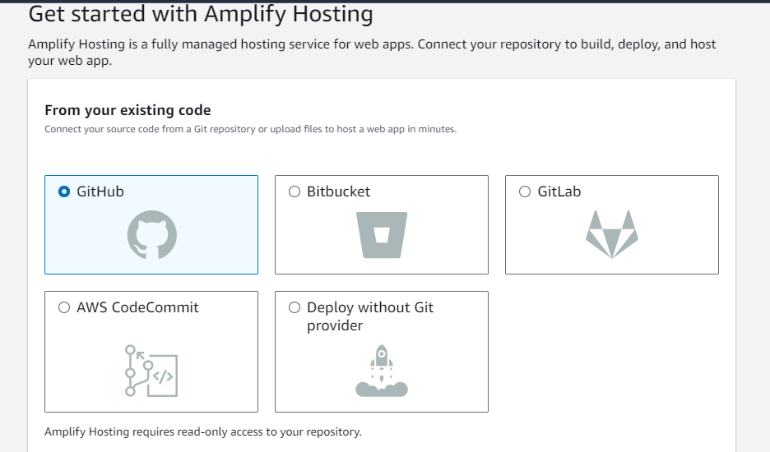

* Select GitHub and continue.

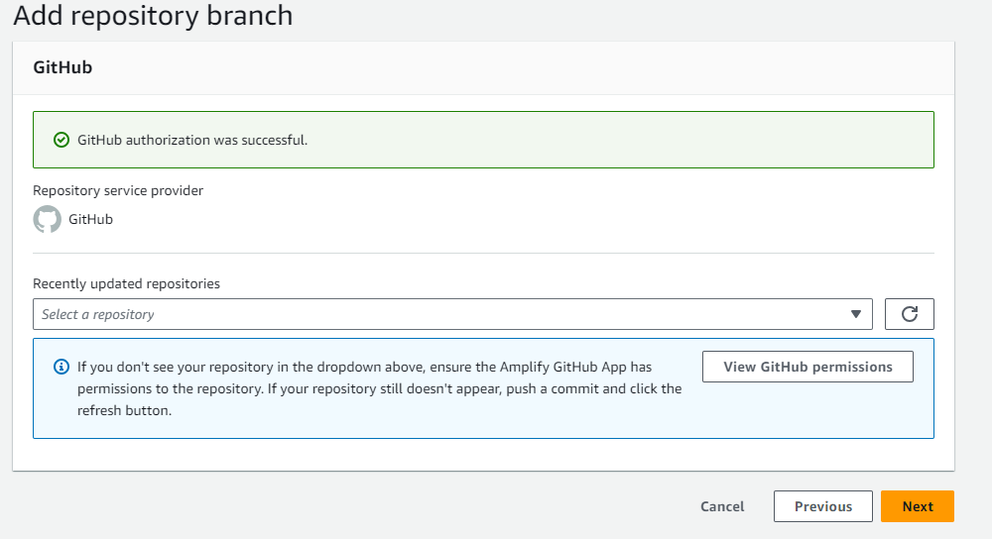

* After selecting GitHub, then choose your repositories from your GitHub, and click on next.

* Choose your app name and continue.

* Save the details and deploy it.

* After completing all the steps, the application will be deployed.

## Deployment Link:

https://main.dcedotji1vlb7.amplifyapp.com/