Task 4: Deploying a Website on Cloud

# Which Cloud and Why?

I have chosen to use AWS cloud for this task and the reason is quite simple on my side. I have worked on GCP (Google Cloud Platform) before, so I thought it would be nice to experience something new and different this time. This was the same thing I did with task 3, where despite having experienced with GitHub Actions, I chose to go with Jenkins so that I could learn something new.

Microsoft Azure was also an option, but AWS is a bit more popular, and I heard that Azure is paid so I chose not to go with Azure.

# Prerequisites and setup:

You need to create an account on AWS and once you have done with all the authentication, only then you are able to deploy something on the cloud. After that you need a repository of code that you want to deploy. You need that repository on some remote version control system for the deployment (I will tell you why in a while)

# Deployment:

For the deployment purpose, I take a very basic next.js project repo. At first, I tried to deploy the given repository but deploying that would simply not have been possible due to the fact we do not have ***.env*** file.

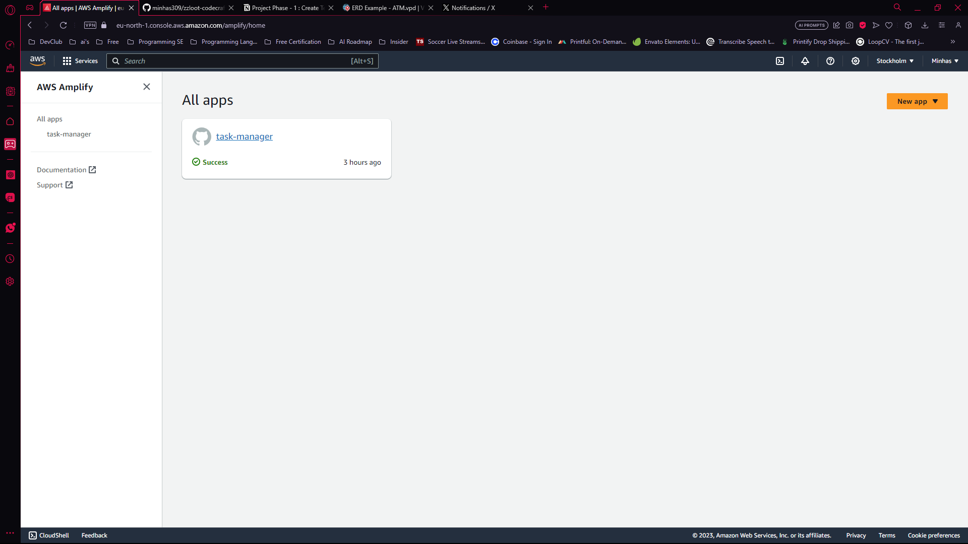After the repository was set up, I went to AWS Amplify for web hosting. This is what it looks like

Then I went to *a new app* and then to *host web app* from there I select *GitHub* and then select the repository from there.

And after that I waited for a while to complete the deployment. And that’s how it is hosted on the website.

You can checkout the hosted site at [deployed website](https://main.d2u2kyodbmrey0.amplifyapp.com).