**Metabase**

# Project Selection:

We have selected project 5 after the group discussion in the meeting. It was a web and Data Analytics.

## Task Assign:

I was assigned Metabase application for installation on my local system.

## Setup:

* First for this I will Install node.js for react native Following are the steps to install node.js:

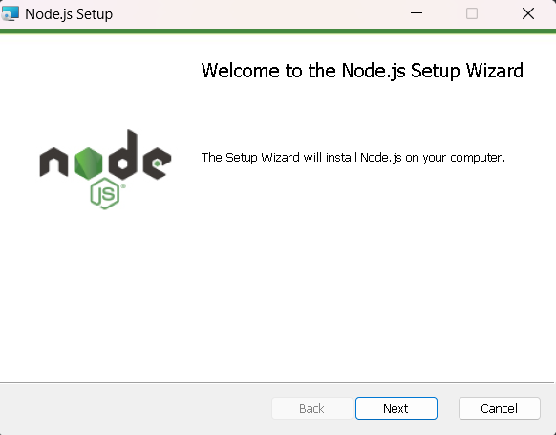

* we also need to add Node.js to PATH in Environment Variables.

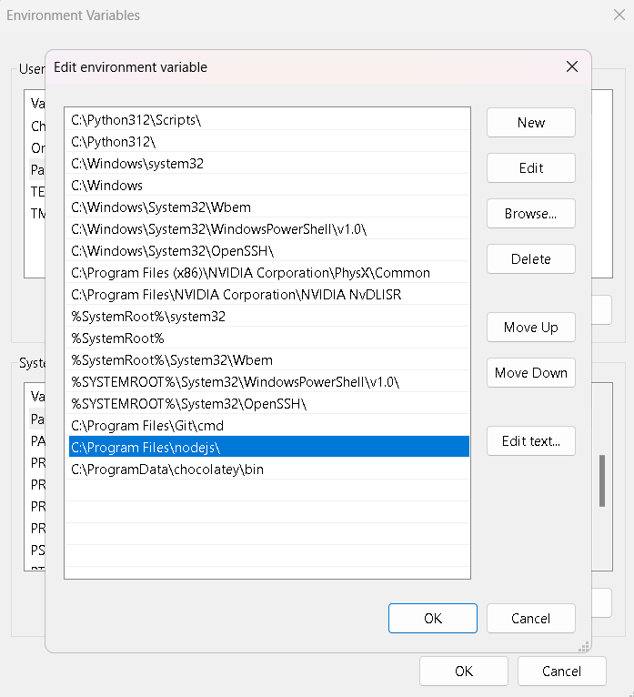

* Know we need to install react native to install react native run the following command:

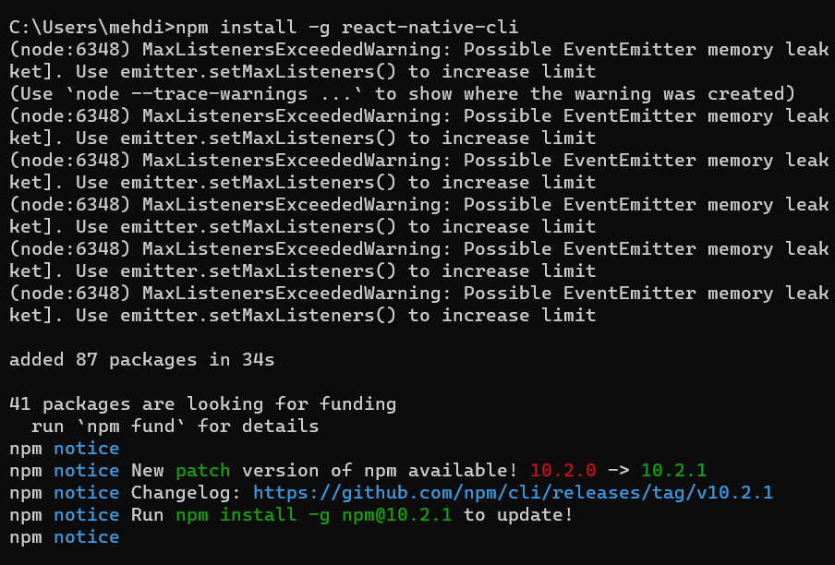

* After That I will install react native tools in visual studio code:

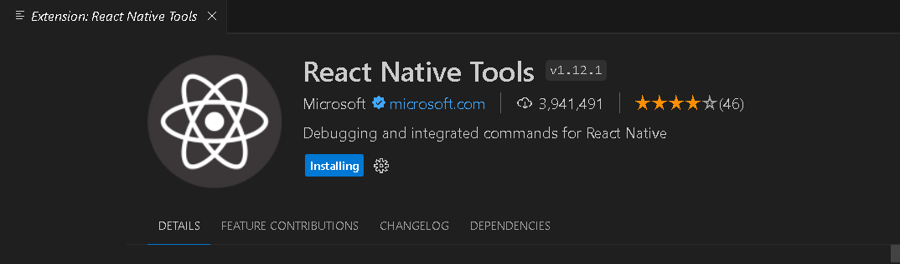

* And I also install Babel JS in vs code:

