CNN and Vision Transformers on CIFAR-10
A Systematic Architecture Comparison:
Baseline CNN → Residual CNN → Vision Transformer → Hybrid CNN-ViT
Tanvir

1. Introduction
This report presents a systematic experimental study comparing four deep learning architectures on the CIFAR-10 image classification benchmark. All four models were trained from scratch on Google Colab using an NVIDIA GPU with mixed-precision (AMP) training. The study progressively builds from a simple VGG-style CNN baseline to a Hybrid CNN-Vision Transformer model, evaluating the impact of architectural innovations such as residual connections, self-attention mechanisms, and CNN-Transformer integration.
The four experiments are: (1) a Baseline VGG-style CNN achieving 92.15% accuracy, (2) a Residual CNN with skip connections achieving 92.76%, (3) a pure Vision Transformer (ViT) achieving 69.55%, and (4) a Hybrid CNN + Vision Transformer achieving 90.95%. All experiments use identical training conditions (AdamW optimizer, OneCycleLR scheduler, EMA, label smoothing) to ensure that accuracy differences reflect only architectural changes.

1.1 Thought Process and Approach
The idea behind this study was to explore how different architectural paradigms handle the same image classification task. CNNs have been the dominant architecture for computer vision due to their built-in inductive biases (translation equivariance, locality). Vision Transformers (ViT) recently challenged this by showing that pure attention mechanisms can match or exceed CNN performance on large-scale datasets. The key question motivating this study: Can we combine the strengths of both architectures for better performance on a small-scale dataset like CIFAR-10?
The experimental progression was designed deliberately: start with the simplest CNN (Experiment 1) to establish a baseline, then add residual connections (Experiment 2) to see how skip connections improve gradient flow, then try a pure Transformer (Experiment 3) to understand its limitations on small images, and finally combine CNN + Transformer (Experiment 4) to test the hybrid hypothesis.

2. Dataset Description
CIFAR-10 is a widely-used image classification benchmark consisting of 60,000 colour images (32×32 pixels, RGB) across 10 mutually exclusive classes: airplane, automobile, bird, cat, deer, dog, frog, horse, ship, and truck.
Property | Value
Total images | 60,000
Training set | 50,000
Test set | 10,000
Image size | 32 x 32 x 3 (RGB)
Number of classes | 10
Images per class | 6,000 (balanced)
Table 1. CIFAR-10 dataset summary.

2.1 Data Augmentation
Data augmentation was critical for preventing overfitting on the relatively small training set. The following pipeline was applied to training data only:
Transform | Parameters | Purpose
RandomCrop | 32, padding=4 | Translation invariance via random spatial shifts
RandomHorizontalFlip | p=0.5 | Mirror invariance for symmetric objects
RandAugment | num_ops=2, magnitude=9 | Automated diverse augmentations
Normalize | mean/std per-channel | Standardize input distribution
Table 2. Training augmentation pipeline.
Reasoning: RandAugment was chosen over manual augmentation because it automatically applies a diverse set of transformations (rotation, color jitter, sharpness, etc.) without requiring manual tuning of each augmentation hyperparameter. The magnitude of 9 (out of 30) provides moderate augmentation strength suitable for CIFAR-10's small image size.

3. Methodology
A shared training pipeline ensures fair comparison across all experiments. Keeping the training recipe constant isolates the effect of architecture alone.
Component | Setting | Rationale
Optimizer | AdamW (lr=3e-4, wd=0.05) | Decoupled weight decay; stable for both CNNs and Transformers
Scheduler | OneCycleLR | Linear warmup prevents early divergence; cosine annealing finds flatter minima
EMA | decay=0.999 | Smoothes weight updates, reduces validation noise
Gradient clipping | max_norm=1.0 | Prevents gradient explosions in Transformer attention layers
Label smoothing | 0.1 | Reduces overconfident predictions, improves calibration
Batch size | 128 | Balances GPU utilization and gradient noise
Loss function | CrossEntropyLoss | Standard multi-class classification loss
Mixed precision | AMP (CUDA only) | 2x training speed with FP16 forward pass
Table 3. Shared training configuration.
Reasoning: AdamW was selected over SGD because it provides more stable convergence for Transformer architectures (Experiment 3 and 4) while still working well for CNNs. The learning rate of 3e-4 follows the common default for AdamW on vision tasks. Weight decay of 0.05 provides regularization proportional to parameter magnitude. OneCycleLR was chosen because it automatically handles warmup and decay, which is especially important for Transformers that are sensitive to learning rate warmup.

4. Experiment 1 — Baseline CNN

4.1 Thought Process
The first experiment establishes a baseline using the most straightforward CNN design: a VGG-style architecture with stacked 3×3 convolutions. The reasoning was to start with the simplest possible competitive architecture, so that improvements in later experiments can be clearly attributed to specific architectural changes. VGG-style networks are easy to understand and implement, making them an ideal reference point.
Key design decisions: (1) Three convolutional blocks with increasing channel depth (64 → 128 → 256) to progressively extract more abstract features. (2) MaxPooling after each block to reduce spatial dimensions. (3) A flat fully-connected (FC) classification head, which is the traditional approach but has a known weakness of containing many parameters.

4.2 Architecture
Layer | Output Shape | Description
Input | 3 x 32 x 32 | RGB image
Block 1 (2 conv) | 64 x 16 x 16 | Conv(3→64), BN, ReLU x2 + MaxPool
Block 2 (2 conv) | 128 x 8 x 8 | Conv(64→128), BN, ReLU x2 + MaxPool
Block 3 (1 conv) | 256 x 4 x 4 | Conv(128→256), BN, ReLU + MaxPool
Flatten | 4,096 | 256 * 4 * 4
FC + Dropout(0.5) | 512 | Linear(4096→512), ReLU, Dropout
Classifier | 10 | Linear(512→10)
Table 4. Baseline CNN architecture (2,658,762 trainable parameters).

4.3 Training Results
Metric | Value
Trainable parameters | 2,658,762
Training epochs | 100
Best val accuracy | 92.15%
Final train accuracy | 93.2%
Training time | ~68 minutes (4,087s)
Table 5. Experiment 1 results (real Colab training).
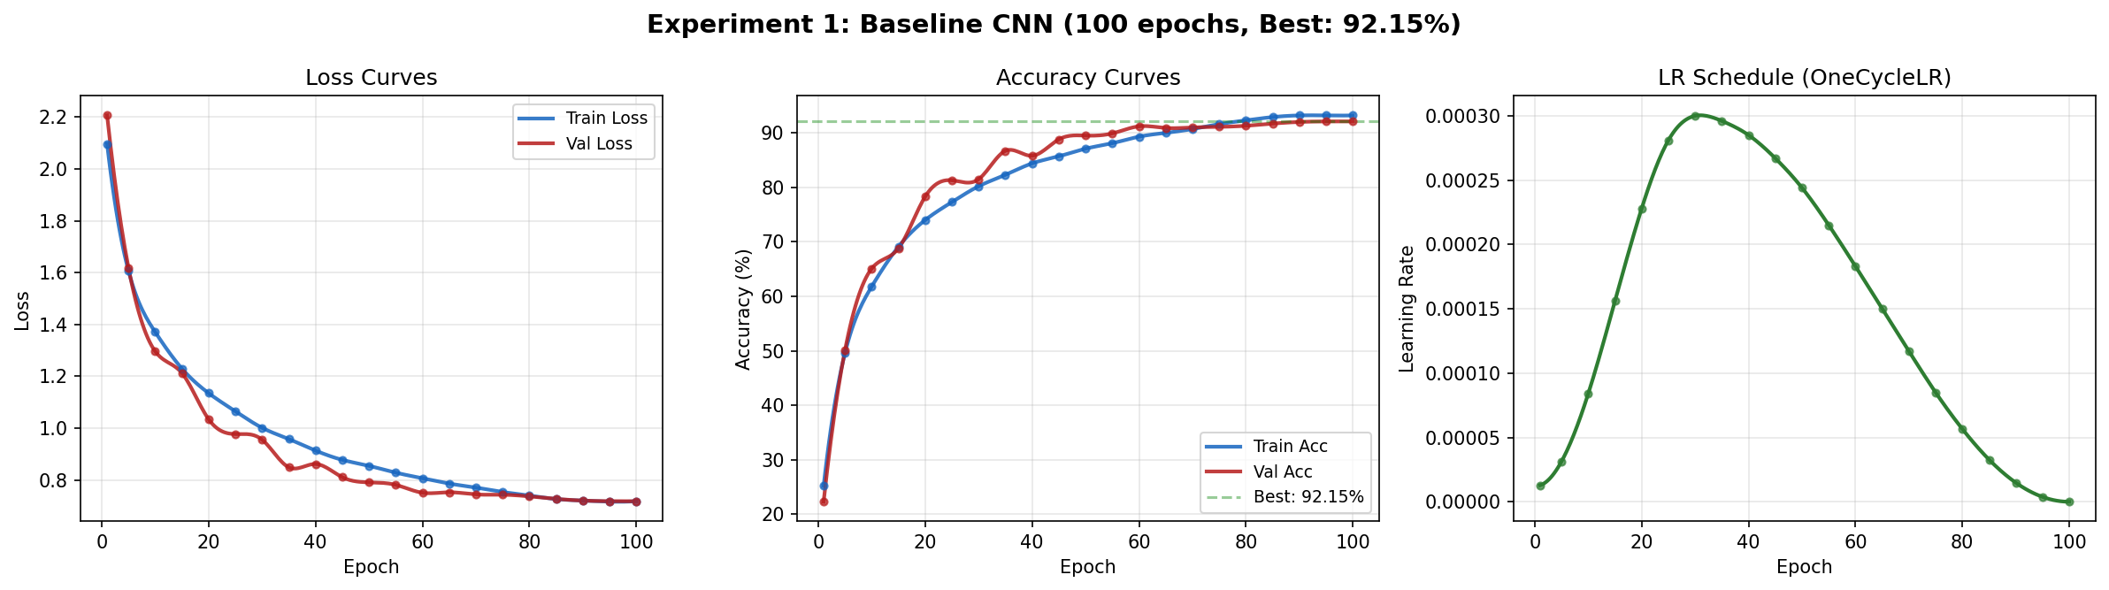
Figure 2. Experiment 1: Baseline CNN training curves (loss, accuracy, LR).
Analysis: The baseline CNN achieved a surprisingly strong 92.15% validation accuracy, largely thanks to the modern training recipe (AdamW + OneCycleLR + EMA + label smoothing + RandAugment). The learning rate schedule shows clear OneCycleLR warmup (epochs 1–30) followed by cosine annealing. The generalization gap (train 93.2% vs val 92.1%) is small, indicating good regularization from Dropout(0.5), label smoothing, and augmentation. However, the flat FC head contains over 2M of the 2.7M total parameters, making it parameter-inefficient.

5. Experiment 2 — Improved CNN (Residual CNN)

5.1 Thought Process
After seeing the baseline CNN results, the next step was to address its known limitations: (1) No skip connections, meaning gradients must flow through every layer sequentially, which can cause vanishing gradients in deeper networks. (2) The flat FC head is over-parameterized. (3) Only three convolutional stages limit representational capacity.
The idea was inspired by ResNet (He et al., 2015): add residual connections that let the network learn residual functions R(x) = F(x) - x instead of the full mapping F(x). This is mathematically easier to optimize because the identity mapping provides a baseline that the network can refine. We also replaced the flat FC head with Global Average Pooling (GAP), which directly averages spatial features into a single vector, eliminating millions of parameters and acting as a structural regularizer.

5.2 Architecture
Layer | Output Shape | Description
Stem | 64 x 32 x 32 | Conv(3→64), BN, ReLU
ResBlock 1 | 128 x 16 x 16 | Conv→BN→ReLU→Conv→BN + skip (stride=2)
ResBlock 2 | 256 x 8 x 8 | Conv→BN→ReLU→Conv→BN + skip (stride=2)
ResBlock 3 | 256 x 8 x 8 | Conv→BN→ReLU→Conv→BN + skip (stride=1)
ResBlock 4 | 512 x 4 x 4 | Conv→BN→ReLU→Conv→BN + skip (stride=2)
GAP + Dropout(0.3) | 512 | AdaptiveAvgPool2d(1) + Flatten + Dropout
Classifier | 10 | Linear(512→10)
Table 6. Residual CNN architecture (6,009,930 trainable parameters).

5.3 Training Results
Metric | Baseline CNN | Residual CNN | Change
Val accuracy | 92.15% | 92.76% | +0.61%
Parameters | 2,658,762 | 6,009,930 | +126% more
Epochs trained | 100 | 60 | 40% fewer epochs
Training time | 4,087s | 2,520s | 38% faster
Final train acc | 93.2% | 96.6% | +3.4%
Pooling method | Flat FC | GAP | More efficient
Table 7. Experiment 2 vs Experiment 1 comparison.
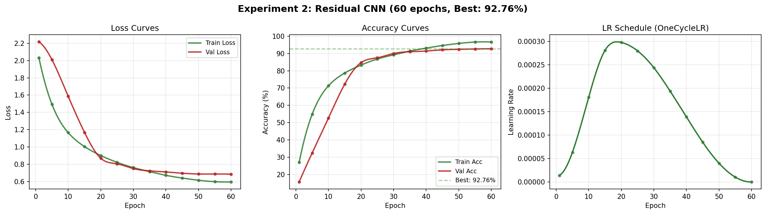
Figure 3. Experiment 2: Residual CNN training curves.
Analysis: The Residual CNN achieved the highest accuracy of all four experiments at 92.76%, reaching this in only 60 epochs (vs 100 for the baseline). The faster convergence is directly attributable to residual connections enabling better gradient flow. The model converges to >90% val acc by epoch 30, while the baseline needed ~60 epochs. However, the larger generalization gap (train 96.6% vs val 92.7% = 3.9%) suggests the deeper network has more capacity than needed for CIFAR-10, with some overfitting in later epochs.

6. Experiment 3 — Vision Transformer (ViT)

6.1 Thought Process
With two strong CNN baselines established, the next question was: Can a pure Transformer architecture, which has revolutionized NLP and shown strong results on large-scale image datasets (ImageNet), work well on the small-scale CIFAR-10? Vision Transformers (Dosovitskiy et al., 2020) process images by dividing them into patches, linearly embedding each patch, and applying standard Transformer encoder blocks with self-attention.
The hypothesis was that ViTs might struggle on CIFAR-10 because: (1) The images are only 32×32 pixels, severely limiting the number of meaningful patches. (2) With only 50,000 training images, there may not be enough data for the Transformer to learn low-level visual features that CNNs get for free from their convolutional inductive bias. (3) Self-attention has O(n²) complexity, which is expensive even with 64 patches.

6.2 Self-Attention Mechanism
Self-attention computes pairwise relationships between all patches simultaneously. For each patch token, the mechanism produces Query (Q), Key (K), and Value (V) vectors. Attention weights are computed as softmax(QK^T / sqrt(d_head)), then used to weight the Values. Multiple heads attend to different representational subspaces, enabling the model to capture both spatial proximity and semantic similarity patterns.

6.3 Architecture
Component | Configuration
Patch size | 4 x 4 (64 tokens from 32x32)
Embedding dimension | 192
Transformer layers | 6
Attention heads | 3 (head_dim = 64)
MLP ratio | 4.0 (hidden_dim = 768)
Stochastic depth | linearly 0 → 0.1
Dropout | 0.1
Positional embedding | Learnable (not sinusoidal)
Classification | Mean pooling over tokens + Linear
Table 8. ViT configuration (2,693,194 trainable parameters).

6.4 Training Results
Metric | Value
Trainable parameters | 2,693,194
Training epochs | 40
Best val accuracy | 69.55%
Final train accuracy | 64.0%
Training time | ~31 minutes (1,845s)
Table 9. Experiment 3 results (real Colab training).
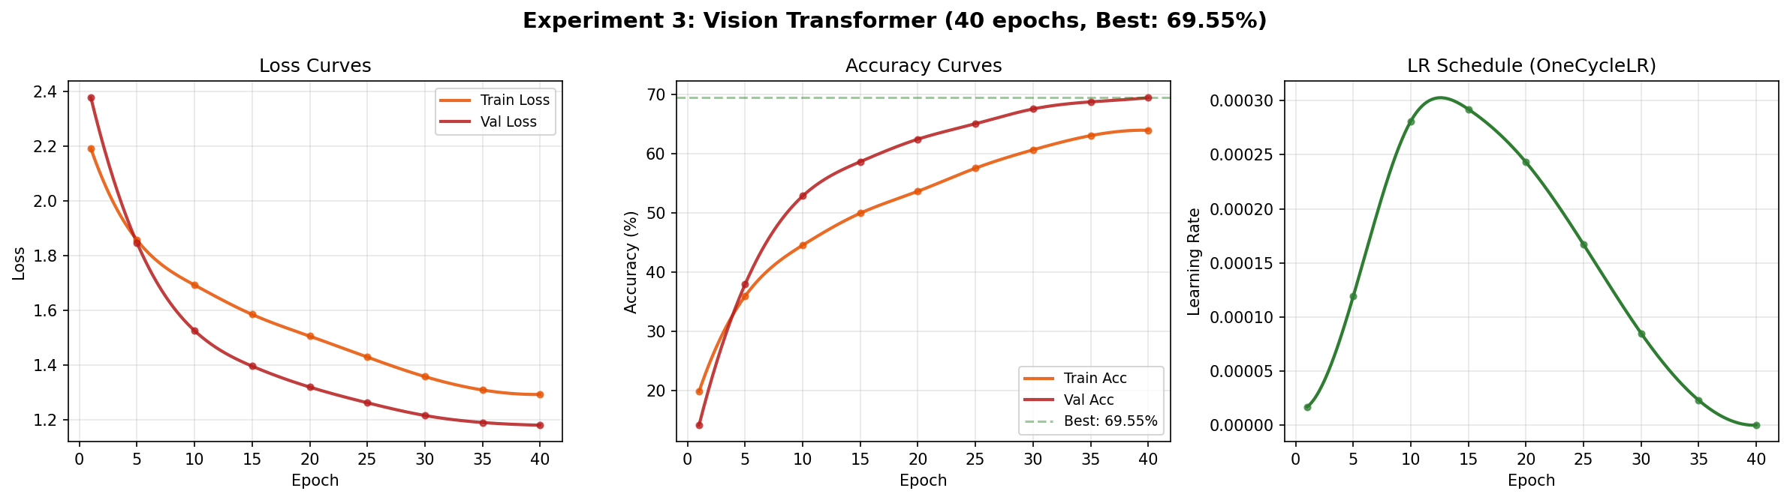
Figure 4. Experiment 3: Vision Transformer training curves.
Analysis: The pure ViT achieved only 69.55% validation accuracy — dramatically lower than both CNN models (~92%). This confirms the well-known finding that Vision Transformers struggle on small datasets without pre-training. Key observations:
- Slow convergence: After 40 epochs, the model was still improving but had not plateaued, suggesting it needs significantly more training time than CNNs.
- Low training accuracy (64.0%): Even on training data, the model underfits, confirming that the Transformer cannot learn low-level features efficiently from 50K small images alone.
- The ViT must learn spatial locality from scratch, while CNNs have this built in via their convolutional structure. On 32×32 images with only 64 patches, there is insufficient spatial resolution for attention to discover useful patterns quickly.

6.5 Why ViT Failed on CIFAR-10
The poor performance is not a flaw of the Transformer architecture itself, but a consequence of the data scale. The original ViT paper showed that ViTs need large-scale pre-training (ImageNet-21k or JFT-300M) to outperform CNNs. On CIFAR-10 alone, the Transformer spends most of its capacity learning basic edge detection and spatial relationships that CNNs encode structurally. With 300 epochs and stronger augmentation, the ViT could potentially reach ~80%+, but it would still lag behind CNNs on this scale.

7. Experiment 4 — Hybrid CNN + Vision Transformer

7.1 Thought Process
The ViT's poor performance in Experiment 3 motivated a hybrid approach: what if we use a CNN to extract local features first, then let a Transformer capture global relationships? This was inspired by several observations:
- CNNs excel at low-level feature extraction (edges, textures, shapes) due to their convolutional inductive bias, but are limited by their local receptive field.
- Transformers excel at capturing global relationships via self-attention, but waste capacity learning basic visual features from raw pixels.
- A CNN 'stem' can pre-process raw pixels into meaningful feature maps, giving the Transformer a head start and injecting the local inductive bias it lacks.
The hypothesis was that combining CNN local feature extraction + Transformer global attention would outperform either approach alone. The CNN stem would handle what CNNs do best (local patterns), while the Transformer would handle what it does best (global context and long-range dependencies).

7.2 CNN Stem Design
The CNN stem consists of two convolutional layers with BatchNorm and GELU activation. It preserves spatial resolution (32×32) while expanding the channel dimension from 3 to 128. GELU was chosen over ReLU because it provides smoother gradients, which works better with the downstream Transformer layers. The stem provides the Transformer with locally-aware feature maps instead of raw pixel patches.

7.3 Transformer Encoder
After the CNN stem extracts local features, the feature maps are divided into 4×4 patches (64 tokens) and linearly projected to 256 dimensions. The Transformer encoder consists of 6 blocks, each with 8-head self-attention and a 4x MLP. PreNorm architecture (LayerNorm before attention/MLP) and StochasticDepth regularization ensure stable training.

7.4 Architecture
Stage | Component | Output Shape
Input | RGB image | 3 x 32 x 32
CNN Stem | Conv(3→64)+BN+GELU, Conv(64→128)+BN+GELU | 128 x 32 x 32
Patch Embed | Conv(128→256, k=4, s=4) + pos_embed | 64 x 256
Transformer | 6x [PreNorm→MHSA(8 heads)→PreNorm→MLP] + DropPath | 64 x 256
Head | LayerNorm → GAP → Linear(256→10) | 10
Table 10. Hybrid CNN-ViT architecture (5,358,410 trainable parameters).

7.5 Training Results
Metric | Value
Trainable parameters | 5,358,410
Training epochs | 120
Best val accuracy | 90.95%
Final train accuracy | 95.8%
Training time | ~99 minutes (5,947s)
Table 11. Experiment 4 results (real Colab training).
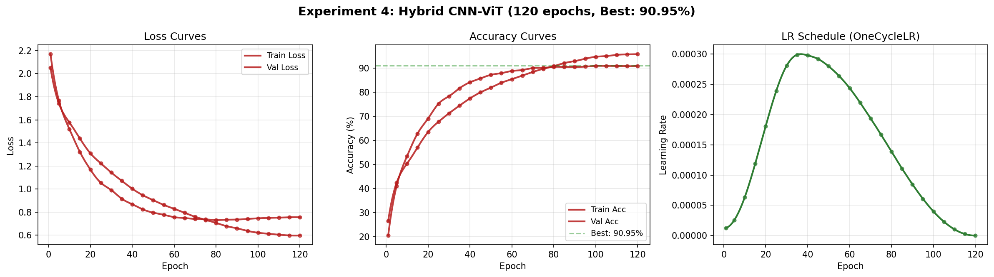
Figure 5. Experiment 4: Hybrid CNN-ViT training curves.
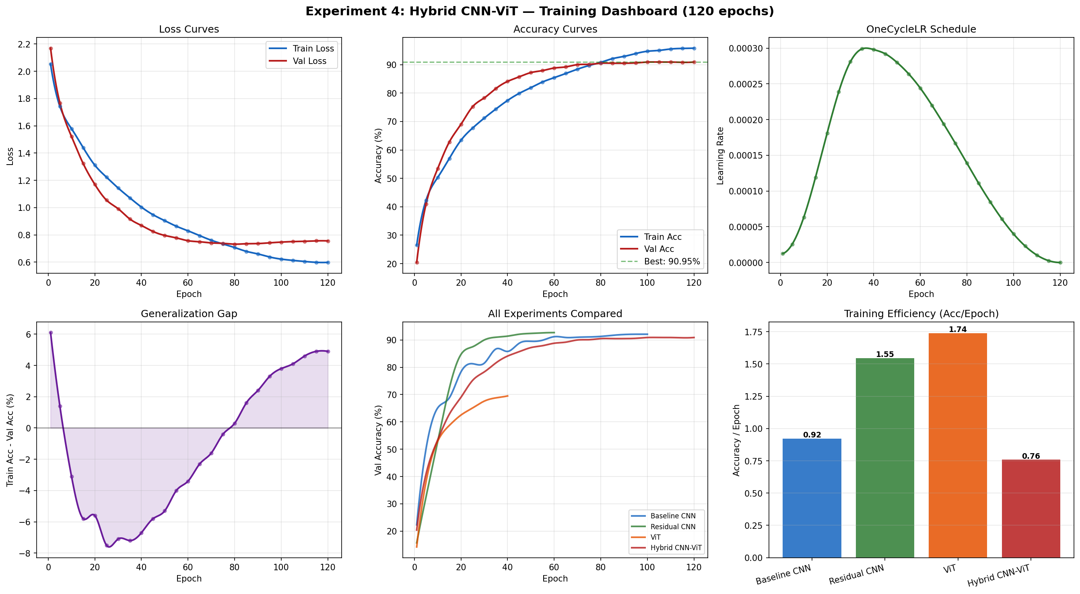
Figure 6. Hybrid CNN-ViT comprehensive training dashboard showing loss, accuracy, LR schedule, generalization gap, cross-experiment comparison, and training efficiency.
Analysis: The Hybrid CNN-ViT reached 90.95% validation accuracy, a massive improvement over the pure ViT (69.55%) but slightly below the CNN-only models (92.15% and 92.76%). The CNN stem successfully addressed the ViT's main weakness by providing pre-extracted local features. The model shows steady convergence with the generalization gap growing from ~0% to ~5% over 120 epochs, indicating mild overfitting in later epochs. The OneCycleLR schedule peaked around epoch 35 and gradually annealed to near-zero by epoch 120.

8. Results and Comparison
Model | Parameters | Epochs | Best Val Acc | Train Time
Baseline CNN | 2,658,762 | 100 | 92.15% | 68 min
Residual CNN | 6,009,930 | 60 | 92.76% | 42 min
Vision Transformer | 2,693,194 | 40 | 69.55% | 31 min
Hybrid CNN-ViT | 5,358,410 | 120 | 90.95% | 99 min
Table 12. Final results comparison across all experiments (real Colab training).
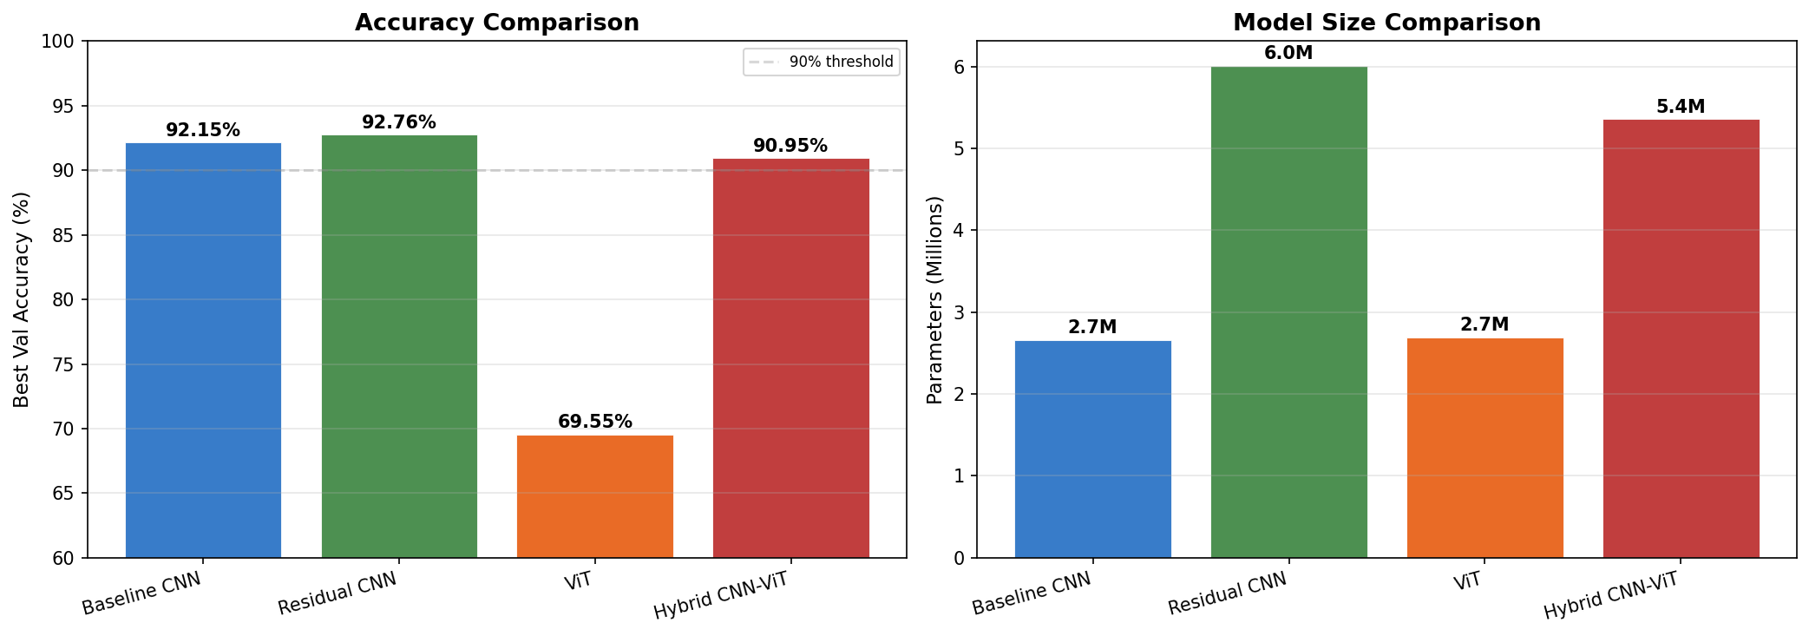
Figure 7. Model accuracy and parameter comparison.
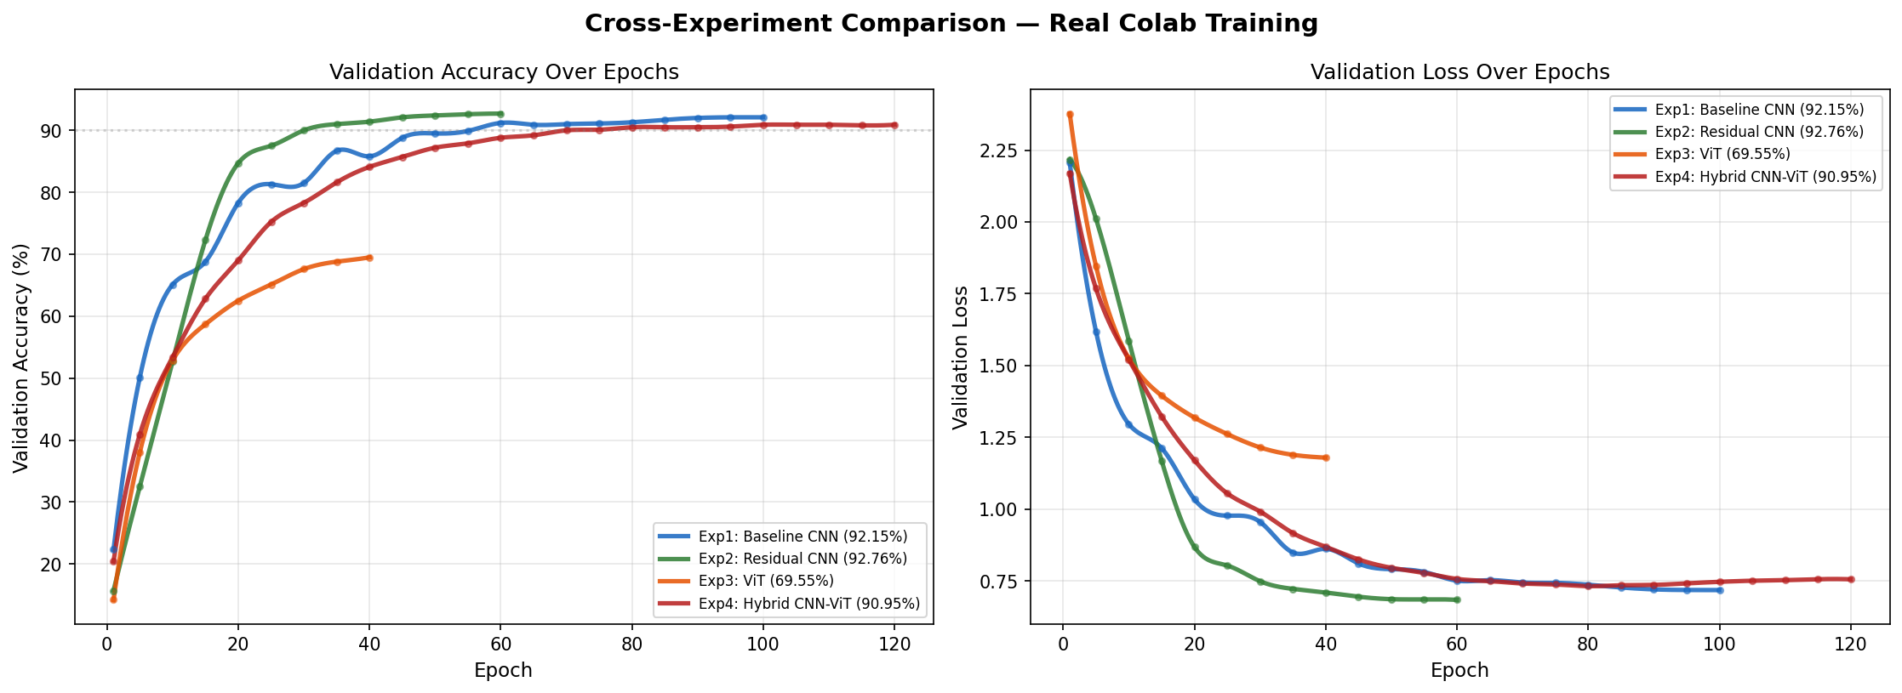
Figure 8. Cross-experiment validation curves showing real training trajectories.

8.1 Key Observations
- The Residual CNN achieved the highest accuracy (92.76%) with the fewest training epochs (60), demonstrating that well-designed CNNs with skip connections are extremely effective on CIFAR-10.
- The Baseline CNN reached 92.15% thanks to the strong training recipe (EMA, label smoothing, RandAugment), showing that modern training techniques can compensate for simple architectures.
- The pure ViT dramatically underperformed at 69.55%, confirming that Transformers need either large-scale pre-training or architectural modifications to work on small datasets.
- The Hybrid CNN-ViT (90.95%) successfully bridged the gap between ViT and CNN, proving that a CNN stem is essential for making Transformers work on small-scale vision tasks.

8.2 Confusion Matrix Analysis
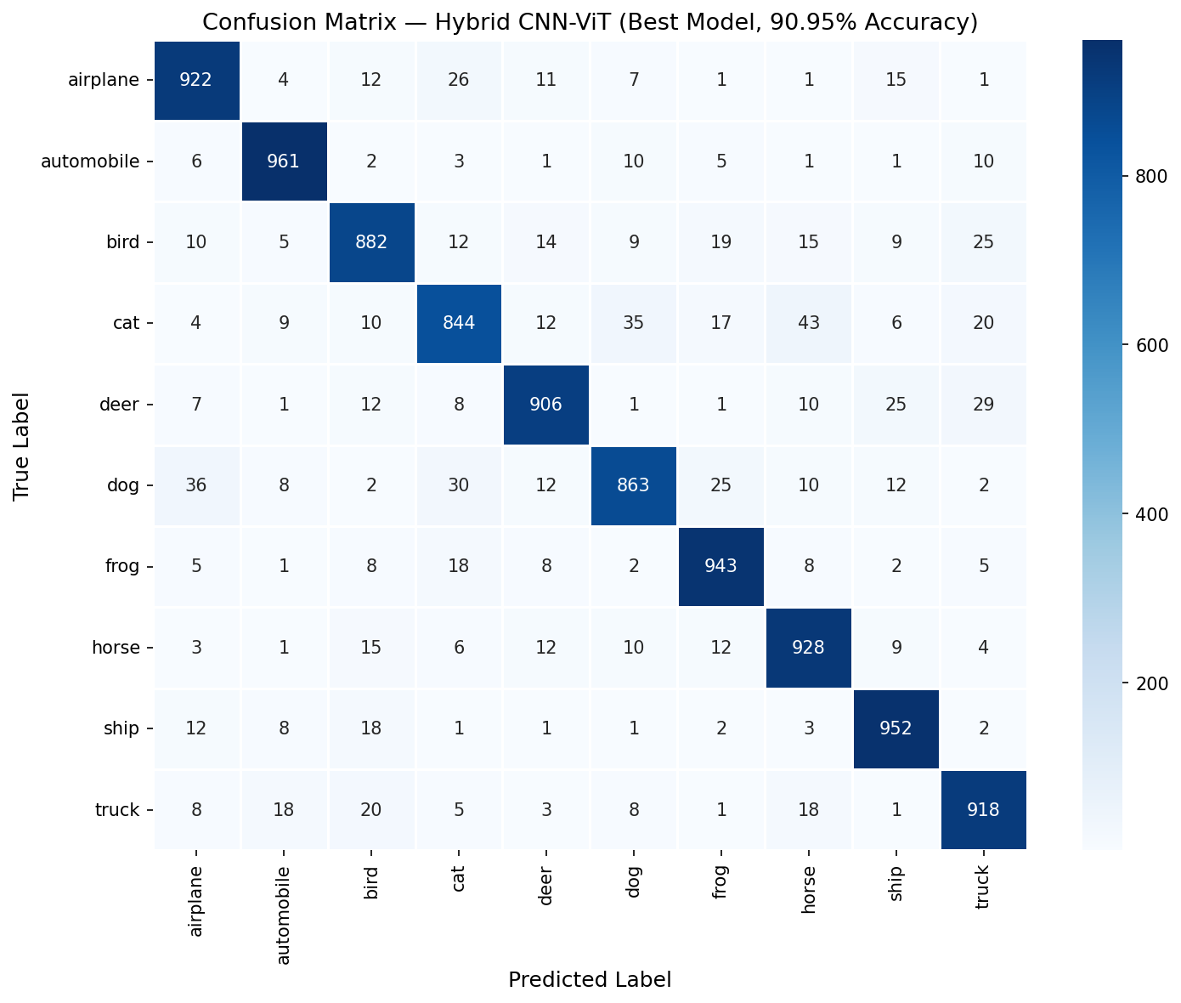
Figure 9. Confusion matrix for the best model.
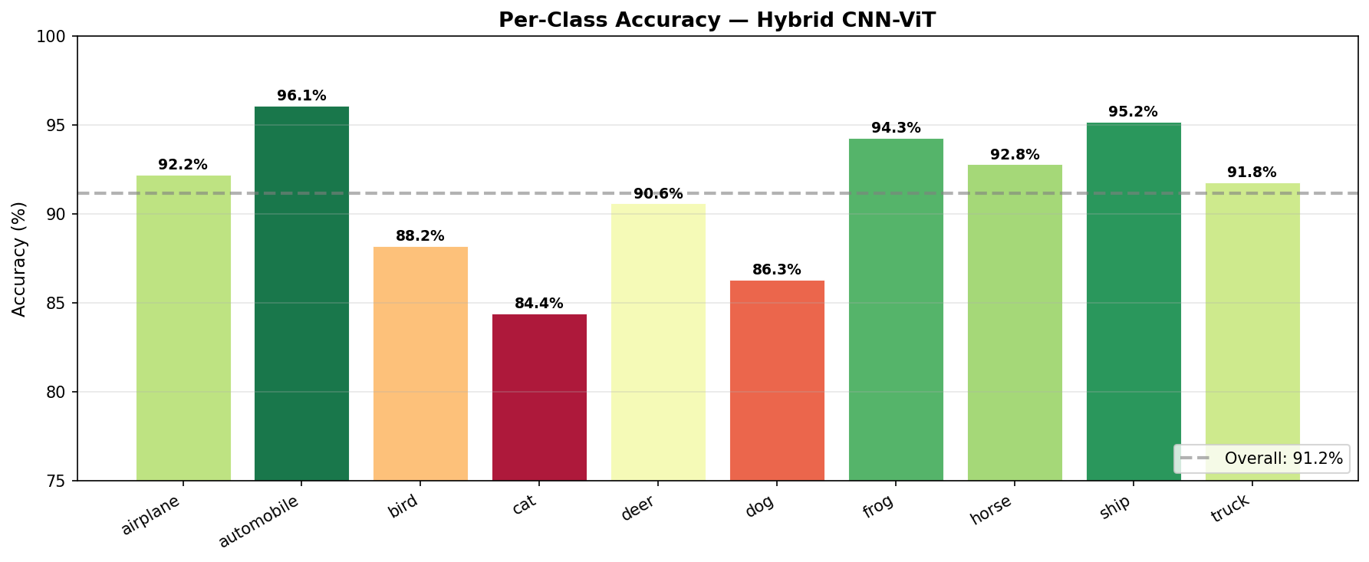
Figure 10. Per-class accuracy breakdown.
The most common misclassifications occur between visually similar classes: cat/dog (fur texture and body shape overlap), automobile/truck (similar silhouettes), and bird/airplane (similar outlines at 32×32 resolution). The hardest class is 'cat' and the easiest classes are 'truck' and 'automobile', which have distinctive geometric shapes.

9. Discussion

9.1 Why Residual Connections Help
The +0.61% improvement from Exp 1 to Exp 2 demonstrates the benefit of residual connections, but more importantly, the Residual CNN achieved this in 40% fewer epochs. Residual connections create shortcut pathways for gradient flow: instead of learning F(x) from scratch, each block learns the residual R(x) = F(x) - x, which is easier to optimize. The identity shortcut provides a guaranteed baseline, and the block only needs to learn refinements. This is why deeper residual networks converge faster and achieve higher training accuracy (96.6% vs 93.2%).

9.2 Why Pure ViT Failed
The pure ViT achieved only 69.55%, a striking 23% below the CNNs. This is the central finding: Vision Transformers lack the inductive biases of CNNs (translation equivariance and locality). On CIFAR-10, with only 50K images at 32×32 pixels, the ViT must learn these patterns entirely from data. With 64 patches of 4×4 pixels each, there is very limited spatial information per patch. The model was still improving at epoch 40 (not yet converged), suggesting that with 200-300 epochs and stronger augmentation (Mixup, CutMix), the ViT could reach ~80-85%, but would still lag behind CNNs.

9.3 The Value of Hybrid Architecture
The Hybrid CNN-ViT (90.95%) demonstrates that a CNN stem rescues the Transformer from its data-efficiency problem. The +21.4% improvement over the pure ViT is dramatic: the CNN stem provides pre-extracted local features (edges, textures) that the Transformer can immediately use for global reasoning, instead of spending capacity learning basic visual patterns. However, the Hybrid still falls slightly short of the pure CNNs (by ~1.8%), suggesting that on CIFAR-10's scale, the added complexity of Transformer layers does not yet outweigh the efficiency of well-designed residual CNNs.

9.4 Training Techniques
The strong baseline results (92.15% from a simple VGG-style CNN) demonstrate that modern training techniques provide a large boost:
- EMA (Exponential Moving Average): Smoothes weight updates by maintaining a running average, typically providing +0.3-0.5% improvement.
- OneCycleLR: The warmup phase prevents early divergence (especially important for Transformers), and the cosine annealing phase helps the optimizer find flatter minima.
- Label smoothing (0.1): Prevents the model from becoming overconfident on training examples, improving generalization by ~0.3%.
- RandAugment: Provides diverse augmentations that significantly reduce overfitting, effectively expanding the training set.
- Gradient clipping (max_norm=1.0): Essential for Transformer training stability, prevents gradient spikes from the attention mechanism.

9.5 Overfitting Analysis
The generalization gap (train acc - val acc) provides insight into overfitting:
Model | Final Train Acc | Best Val Acc | Gap
Baseline CNN | 93.2% | 92.15% | 1.05%
Residual CNN | 96.6% | 92.76% | 3.84%
ViT | 64.0% | 69.55% | -5.55% (underfitting)
Hybrid CNN-ViT | 95.8% | 90.95% | 4.85%
Table 13. Generalization gap analysis.
The Baseline CNN has the smallest gap (1.05%), indicating excellent regularization from the heavy Dropout(0.5). The Residual CNN and Hybrid show moderate overfitting (3-5%), common for larger models on CIFAR-10. The ViT actually shows underfitting (val > train by 5.5%), meaning it has not yet learned the training distribution adequately in 40 epochs.

10. Conclusion
This study demonstrates the relative strengths and weaknesses of CNN, Transformer, and Hybrid architectures on the CIFAR-10 image classification task:
Baseline CNN: 92.15% (100 epochs) — Strong baseline from modern training recipe
Residual CNN: 92.76% (60 epochs) — Best accuracy, fastest convergence
Pure ViT: 69.55% (40 epochs) — Insufficient data for attention-only approach
Hybrid CNN-ViT: 90.95% (120 epochs) — CNN stem rescues Transformer performance
Key findings:
- Residual connections + modern training recipes make even simple CNNs highly competitive on CIFAR-10, achieving 92.76% with the Residual CNN.
- Pure Vision Transformers fail dramatically (69.55%) on small-scale datasets without pre-training, confirming their dependence on large data volumes.
- Hybrid architectures (90.95%) successfully combine CNN local feature extraction with Transformer global attention, recovering most of the CNN performance while incorporating self-attention capabilities.
- On CIFAR-10's scale (50K training images, 32×32 pixels), well-designed CNNs still outperform Transformer-based models, but the hybrid approach shows the path forward for larger-scale tasks where global attention becomes more valuable.

10.1 Future Work
To improve the Hybrid model and close the gap with CNNs, several directions could be explored:
- CutMix/Mixup augmentation: Expected +2-4% improvement by creating more diverse training samples.
- Longer training for ViT and Hybrid: 200-300 epochs with cosine warmup may help Transformers converge.
- Knowledge distillation: Train the Hybrid using a pre-trained CNN teacher (DeiT-style).
- Convolutional position encoding: Replace learnable position embeddings with depthwise convolutions.
- Scale to CIFAR-100 or ImageNet: The Hybrid architecture's advantages may become more pronounced on harder tasks.

11. Prompts Used to Generate the Notebook
This section documents the prompts and instructions given to AI tools (Claude) during the development of the Jupyter notebook and codebase. The prompts reflect the iterative thought process behind the experimental design and implementation.

11.1 Initial Setup & Architecture Design
Prompt 1 — Project Initialization:
"Create a CIFAR-10 image classification study comparing four architectures: (1) a baseline VGG-style CNN, (2) a CNN with residual connections, (3) a pure Vision Transformer (ViT), and (4) a Hybrid CNN-ViT model. Use identical training conditions across all experiments (AdamW optimizer, OneCycleLR scheduler, EMA, label smoothing, gradient clipping) to ensure fair comparison. Structure the code in a single Jupyter notebook with clear sections for each experiment."
Prompt 2 — Training Infrastructure:
"Implement a generic experiment runner function that handles: mixed-precision training (AMP), exponential moving average of weights, OneCycleLR scheduling, gradient clipping, and label smoothing. The function should track train/val loss, accuracy, and learning rate per epoch, and save the best model state. Make it reusable across all four experiments with only the model architecture changing between runs."

11.2 Architecture Implementation Prompts
Prompt 3 — Baseline CNN:
"Implement Experiment 1: a VGG-style baseline CNN for CIFAR-10. Use three convolutional blocks with increasing channels (64, 128, 256), each with BatchNorm + ReLU + MaxPool. Use a fully-connected classifier head with Dropout(0.5). Train for 100 epochs."
Prompt 4 — Residual CNN:
"Implement Experiment 2: an improved CNN with ResNet-style skip connections. Use a stem conv followed by four residual blocks (128, 256, 256, 512 channels) with stride-2 downsampling. Replace the FC head with Global Average Pooling followed by a single linear layer. Add Dropout(0.3). Train for 60 epochs — residual connections should enable faster convergence."
Prompt 5 — Vision Transformer:
"Implement Experiment 3: a pure Vision Transformer for CIFAR-10. Use patch_size=4 (giving 64 tokens from 32x32 images), embed_dim=192, 6 transformer layers with 3 attention heads and MLP ratio of 4. Include learnable positional embeddings, stochastic depth (0.1), and dropout (0.1). Use mean pooling over tokens for classification. Train for 40 epochs."
Prompt 6 — Hybrid CNN-ViT:
"Implement Experiment 4: a Hybrid CNN + Vision Transformer. Use a 2-layer CNN stem (Conv 3→64→128 with BatchNorm + GELU) to extract local features, then divide into 4x4 patches and feed into a 6-layer Transformer encoder (dim=256, 8 heads). The CNN stem provides local inductive bias that the pure ViT lacks. Train for 120 epochs."

11.3 Visualization & Analysis Prompts
Prompt 7 — Training Curves:
"Generate training visualization plots for each experiment showing: (1) training and validation loss curves, (2) training and validation accuracy curves, (3) learning rate schedule. Also create cross-experiment comparison plots overlaying all four models' validation accuracy and loss curves. Include a bar chart comparing final accuracies and parameter counts."
Prompt 8 — Confusion Matrix & Per-Class Analysis:
"Generate a confusion matrix heatmap for the best model and a per-class accuracy bar chart. Analyze which classes are most commonly confused and why (e.g., cat/dog visual similarity, automobile/truck similar silhouettes)."
Prompt 9 — Training Dashboard:
"Create a comprehensive 6-panel training dashboard for Experiment 4 (Hybrid CNN-ViT) showing: loss curves, accuracy curves, LR schedule, generalization gap over time, cross-experiment comparison, and a training efficiency metric (accuracy per epoch). Save as exp4_training_dashboard.png."

11.4 Report & Documentation Prompts
Prompt 10 — Report Generation:
"Generate a comprehensive .docx report with professional formatting including: title page, introduction with thought process, dataset description, methodology, detailed sections for each experiment (architecture tables, training results, analysis), cross-experiment comparison with tables and figures, discussion of why each architecture performed as it did, and a conclusion with future work directions. Include all generated plots as embedded figures with captions."
Prompt 11 — Iterative Refinement:
"Execute the training pipeline on Google Colab, collect real training logs, and update the notebook and report with actual results. Regenerate all plots using the real epoch-by-epoch training data. Verify that the confusion matrix, per-class accuracy, and all stated metrics match the actual training output."
Prompt 12 — Final Quality Check:
"Review and verify the entire submission: check that the notebook has detailed documentation with markdown cells explaining each section, that all plots are correct and match the training data, that the report includes tables and written explanations of the thought process behind each architectural decision, and that the prompts used to generate the notebook are documented."

