**https://www.slideshare.net/AnilkumarPodishetty1/oncology-basicsppt?from_search=11**

**Cell Cycle:** [**https://www.slideshare.net/MerlynH/cell-cycle-46934137**](https://www.slideshare.net/MerlynH/cell-cycle-46934137)

**https://www.slideshare.net/Anshikasingh205906/cell-cycle-cell-checkpoints-cell-cycle-regulators?from_search=0**

**Cytokines:** [**https://my.clevelandclinic.org/health/body/24585-cytokines**](https://my.clevelandclinic.org/health/body/24585-cytokines)

**Cell Injury:**

1. Reversible cell injury
2. Irreversible cell injury

Causes Necrosis or apoptosis

**Apoptosis:**

Programmed cell death. Suppression of cell death by apoptosis is a determinant of the growth of cancer. Initiation phase of apoptosis include increased mitochondrial permeability due to loss of ant-apoptotic protein like Bcl-2, Bcl-x or replacement of pro-apoptotic protein like Bak, Bax, Bim. Cytochrome C and other pro-apoptotic proteins are released, which activate initiator caspases.

**Cellular adaptation**

The cell modify itself to overcome the injurious effect. Intermediate between normal cell and injured cell.

**Types of adaptation:**

1. Atrophy
2. Hypertrophy
3. Hyperplasia
4. Metaplasia

Mutation in tumour development may occur by acquired agents called **carcinogens** or may be **inherent**

**Carcinogens:**

1. Chemical carcinogens
2. Radiant energies
3. Human oncogenic viruses
4. *H.Pylori*

**Chemical carcinogens**

Direct-Chemical carcinogens: Do not require metabolic activation

1. Alkylating agents
2. Anticancer drug: Cyclophosphamide, melphalan, busulfan, chlorambucil may cause lymphomas, leukaemias and other form of cancer.

Indirect-chemical carcinogens: Need metabolic activation

1. Polycyclic aromatic hydrocarbons: e.g. benzopyrene, benzanthracene, dibenzanthracene produced by combustion of tobacco, also produced from animal fat in the process of boiling and smoked meat.
2. Nitrosamine and amides: Formed in the human GIT from nitrostable amines and nitrates used as preservatives, converted to nitrites by bacteria.

Naturally occurring chemical carcinogens: produced by plants and microorganisms.

1. Aflatoxin B1: produced by aspergillus flavus induces mutation in p53 gene causes hepatocellular carcinoma.
2. Betel nuts: squamous cell carcinoma
3. Aromatic amines and azo dies:

# The cell cycle:

The cell cycle is a series of events that take place in a eukaryotic cell leading to its division and the duplication of its DNA to produce two daughter cells. The cell cycle consists of several distinct phases, including interphase and mitotic (M) phase.

1. **Interphase:**
   * **G1 Phase (Gap 1):** The cell grows and performs its normal functions.
   * **S Phase (Synthesis):** DNA replication occurs, resulting in the duplication of the genetic material.
   * **G2 Phase (Gap 2):** The cell continues to grow and prepares for cell division.
2. **Mitotic (M) Phase:**
   * **Mitosis:** The nucleus of the cell divides into two identical nuclei, each with a complete set of chromosomes. Mitosis is further divided into stages: prophase, metaphase, anaphase, and telophase.
   * **Cytokinesis:** The division of the cell's cytoplasm and organelles into two daughter cells.

**Checkpoints:**

1. **G1 Checkpoint (Restriction Point):**

* *Purpose:* Ensures that the cell is ready to commit to cell division.
* *Regulation:* Controlled by external signals, including growth factors and internal signals like the cell's own DNA integrity.
* *Decision:* If conditions are favorable, the cell can proceed to S phase and commit to cell division. If conditions are not suitable, the cell may enter a non-dividing state called G0 or undergo apoptosis (programmed cell death).

1. **G2 Checkpoint:**

* *Purpose:* Checks for DNA damage and ensures completion of DNA replication before entering mitosis.
* *Regulation:* Monitors the cell's DNA integrity and assesses whether DNA replication is complete.
* *Decision:* If DNA is damaged or replication is incomplete, the cell cycle may be arrested to allow for repairs. If everything is in order, the cell can proceed to mitosis.

1. **Metaphase Checkpoint (Spindle Checkpoint):**

* *Purpose:* Ensures proper chromosome attachment to the mitotic spindle fibers before cell division.
* *Regulation:* Monitors the alignment of chromosomes at the metaphase plate.
* *Decision:* If all chromosomes are properly attached, the cell proceeds to anaphase. If there are errors, the checkpoint delays anaphase until the issues are resolved

**Regulation:**

1. **Cyclins and Cyclin-Dependent Kinases (CDKs):**
   * **Cyclins:** These are proteins whose levels oscillate during the cell cycle. Cyclins bind to specific CDKs, forming complexes. There are different types of cyclins associated with different phases of the cell cycle (e.g., G1 cyclins, S cyclins, M cyclins).
   * **CDKs:** Cyclin-Dependent Kinases are enzymes that are inactive on their own but become active when bound to cyclins. The activation of CDKs triggers key events in the cell cycle, such as DNA replication and mitosis.
2. **Cell Cycle Phases and CDK-Cyclin Complexes:**
   * **G1 Phase:** Cyclin D-CDK4/6 complexes drive the cell through G1 and commit it to the cell cycle.
   * **S Phase:** Cyclin E-CDK2 complexes are crucial for DNA synthesis during the S phase.
   * **G2 Phase:** Cyclin A-CDK2 complexes continue to prepare the cell for mitosis.
   * **Mitosis (M Phase):** Cyclin B-CDK1 complexes play a central role in regulating the events of mitosis.
3. **Checkpoints and Checkpoint Proteins:**
   * **G1 Checkpoint:**
     + **p53:** Acts as a tumor suppressor; monitors DNA damage. If DNA is damaged, p53 can arrest the cell cycle to allow for repair or induce apoptosis.
     + **Rb (Retinoblastoma Protein):** Regulates the G1 checkpoint by inhibiting the activity of CDK4/6.
   * **G2 Checkpoint:**
     + **ATM and ATR Kinases:** Respond to DNA damage and coordinate the cell's response, including activation of repair mechanisms or cell cycle arrest.
   * **Metaphase Checkpoint:**
     + **Spindle Assembly Checkpoint Proteins:** Monitor proper attachment of chromosomes to spindle fibers. If attachments are incorrect, they prevent the progression to anaphase.
4. **Cell Cycle Inhibitors:**
   * **p21 and p27:** Inhibit CDKs, acting as brakes on the cell cycle. They are known as cyclin-dependent kinase inhibitors (CKIs).
   * **INK4 Proteins (e.g., p16):** Inhibit CDK4/6, preventing the phosphorylation of Rb and halting progression through the G1 checkpoint.
5. **Ubiquitin-Proteasome System:**
   * **Ubiquitin Ligases (e.g., APC/C):** These enzymes target specific proteins for degradation by the proteasome. In the cell cycle, they regulate the degradation of cyclins, allowing for the timely progression of the cycle.

**The Definition of Cancer**

Cancer is a disease in which some of the body’s cells grow uncontrollably and spread to other parts of the body.

Cancer can start almost anywhere in the human body, which is made up of trillions of cells. Normally, human cells grow and multiply (through a process called [cell](https://www.cancer.gov/Common/PopUps/popDefinition.aspx?id=CDR0000046476&version=Patient&language=en) division) to form new cells as the body needs them. When cells grow old or become damaged, they die, and new cells take their place.

Sometimes this orderly process breaks down, and abnormal or damaged cells grow and multiply when they shouldn’t. These cells may form tumors, which are lumps of tissue. Tumors can be cancerous or not cancerous ([benign](https://www.cancer.gov/Common/PopUps/popDefinition.aspx?id=CDR0000045614&version=Patient&language=en)).

Cancerous tumors spread into, or invade, nearby tissues and can travel to distant places in the body to form new tumors (a process called [metastasis](https://www.cancer.gov/Common/PopUps/popDefinition.aspx?id=CDR0000046710&version=Patient&language=en)). Cancerous tumors may also be called [malignant](https://www.cancer.gov/Common/PopUps/popDefinition.aspx?id=CDR0000045772&version=Patient&language=en) tumors. Many cancers form solid tumors, but cancers of the blood, such as [leukemias](https://www.cancer.gov/Common/PopUps/popDefinition.aspx?id=CDR0000045343&version=Patient&language=en), generally do not.

Benign tumors do not spread into, or invade, nearby tissues. When removed, benign tumors usually don’t grow back, whereas cancerous tumors sometimes do. Benign tumors can sometimes be quite large, however. Some can cause serious symptoms or be life threatening, such as benign tumors in the brain.

**Differences between Cancer Cells and Normal Cells**

Cancer cells differ from normal cells in many ways. For instance, cancer cells:

* 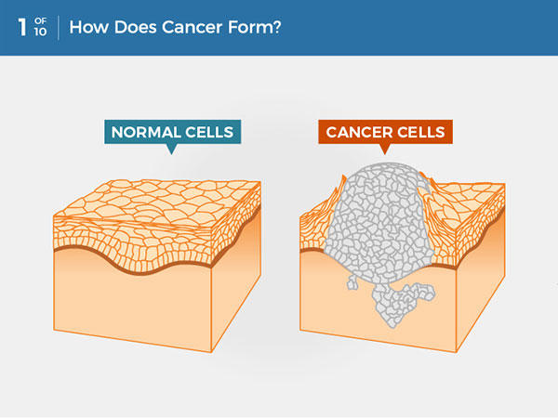Grow in the absence of signals telling them to grow. Normal cells only grow when they receive such signals.
* Ignore signals that normally tell cells to stop dividing or to die (a process known as [programmed cell death](https://www.cancer.gov/Common/PopUps/popDefinition.aspx?id=CDR0000407582&version=Patient&language=en), or [apoptosis](https://www.cancer.gov/Common/PopUps/popDefinition.aspx?id=CDR0000046524&version=Patient&language=en)).
* Invade into nearby areas and spread to other areas of the body. Normal cells stop growing when they encounter other cells, and most normal cells do not move around the body.
* Tell blood vessels to grow toward tumors.  These blood vessels supply tumors with oxygen and nutrients and remove waste products from tumors.
* Hide from the [immune system](https://www.cancer.gov/Common/PopUps/popDefinition.aspx?id=CDR0000046356&version=Patient&language=en). The immune system normally eliminates damaged or abnormal cells.
* Trick the immune system into helping cancer cells stay alive and grow. For instance, some cancer cells convince [immune cells](https://www.cancer.gov/Common/PopUps/popDefinition.aspx?id=CDR0000046356&version=Patient&language=en) to protect the tumor instead of attacking it.
* Accumulate multiple changes in their [chromosomes](https://www.cancer.gov/Common/PopUps/popDefinition.aspx?id=CDR0000046470&version=Patient&language=en), such as duplications and deletions of chromosome parts. Some cancer cells have double the normal number of chromosomes.
* Rely on different kinds of nutrients than normal cells. In addition, some cancer cells make energy from nutrients in a different way than most normal cells. This lets cancer cells grow more quickly.

Many times, cancer cells rely so heavily on these abnormal behaviors that they can’t survive without them. Researchers have taken advantage of this fact, developing therapies that target the abnormal features of cancer cells. For example, some cancer therapies [prevent blood vessels from growing toward tumors](https://www.cancer.gov/about-cancer/treatment/types/immunotherapy/angiogenesis-inhibitors-fact-sheet), essentially starving the tumor of needed nutrients.

**How Does Cancer Develop?**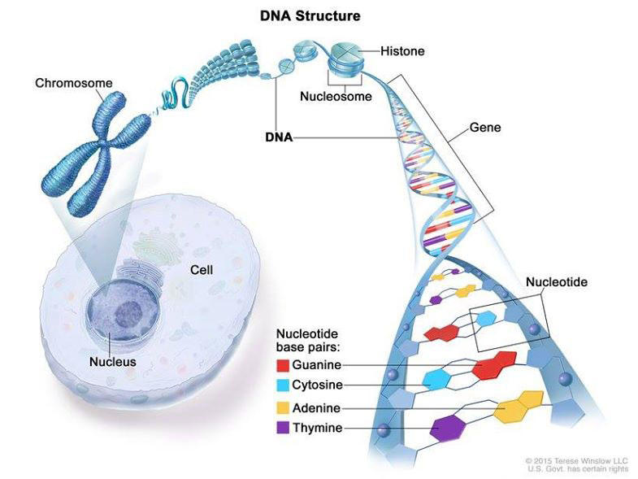

*Cancer is caused by certain changes to genes, the basic physical units of inheritance. Genes are arranged in long strands of tightly packed DNA called chromosomes.*

Cancer is a genetic disease—that is, it is caused by changes to [genes](https://www.cancer.gov/Common/PopUps/popDefinition.aspx?id=CDR0000045693&version=Patient&language=en) that control the way our cells function, especially how they grow and divide.

Genetic changes that cause cancer can happen because of:

* Errors that occur as cells divide.
* Damage to DNA caused by harmful substances in the environment, such as the chemicals in tobacco smoke and [ultraviolet](https://www.cancer.gov/Common/PopUps/popDefinition.aspx?id=CDR0000045934&version=Patient&language=en) rays from the sun. [1]
* They were [inherited](https://www.cancer.gov/Common/PopUps/popDefinition.aspx?id=CDR0000045098&version=Patient&language=en) from our parents.

The body normally eliminates cells with damaged DNA before they turn cancerous. But the body’s ability to do so goes down as we age. This is part of the reason why there is a higher risk of cancer later in life.

Each person’s cancer has a unique combination of genetic changes. As the cancer continues to grow, additional changes will occur. Even within the same tumor, different cells may have different genetic changes.

**Types of Genes that Cause Cancer**

The genetic changes that contribute to cancer tend to affect three main types of genes—[2][proto-oncogenes](https://www.cancer.gov/Common/PopUps/popDefinition.aspx?id=CDR0000641134&version=Patient&language=English), [tumor suppressor genes](https://www.cancer.gov/Common/PopUps/popDefinition.aspx?id=CDR0000046657&version=Patient&language=English)[3], and DNA repair genes. These changes are sometimes called “drivers” of cancer.

Proto-oncogenes are involved in normal cell growth and division. However, when these genes are altered in certain ways or are more active than normal, they may become cancer-causing genes (or oncogenes), allowing cells to grow and survive when they should not.

Tumor suppressor genes are also involved in controlling cell growth and division. Cells with certain alterations in tumor suppressor genes may divide in an uncontrolled manner.

DNA repair genes are involved in fixing damaged DNA. Cells with [mutations](https://www.cancer.gov/Common/PopUps/popDefinition.aspx?id=CDR0000046063&version=Patient&language=en) in these genes tend to develop additional mutations in other genes and changes in their chromosomes, such as duplications and deletions of chromosome parts. Together, these mutations may cause the cells to become cancerous.

As scientists have learned more about the molecular changes that lead to cancer, they have found that certain mutations commonly occur in many types of cancer. Now there are many cancer treatments available that [target gene mutations found in cancer](https://www.cancer.gov/about-cancer/treatment/types/targeted-therapies). A few of these treatments can be used by anyone with a cancer that has the targeted mutation, [no matter where the cancer started growing](https://www.cancer.gov/news-events/cancer-currents-blog/2020/fda-pembrolizumab-tmb-approval-genomic-testing).

**When Cancer Spreads**

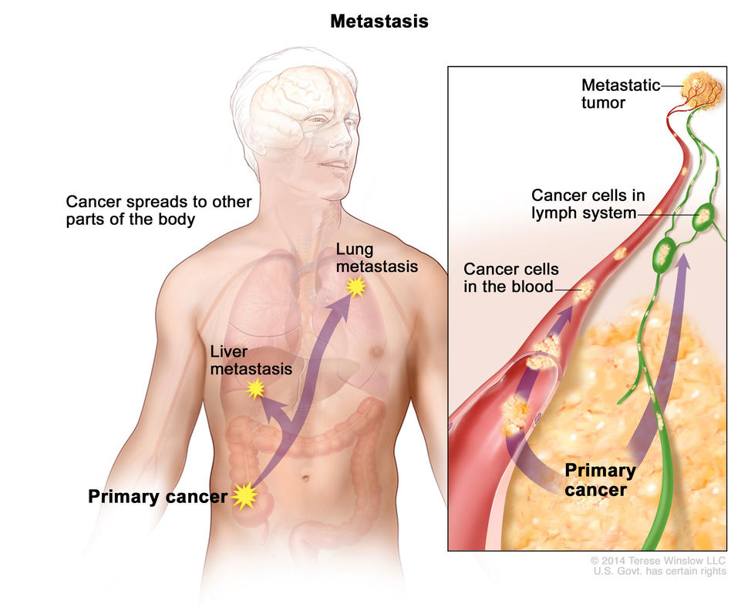

A cancer that has spread from the place where it first formed to another place in the body is called metastatic cancer. The process by which cancer cells spread to other parts of the body is called metastasis.

Metastatic cancer has the same name and the same type of cancer cells as the original, or primary, cancer. For example, breast cancer that forms a metastatic tumor in the lung is metastatic breast cancer, not lung cancer.

Under a microscope, metastatic cancer cells generally look the same as cells of the original cancer. Moreover, metastatic cancer cells and cells of the original cancer usually have some molecular features in common, such as the presence of specific [chromosome](https://www.cancer.gov/Common/PopUps/popDefinition.aspx?id=CDR0000046470&version=Patient&language=English) changes.

*In metastasis, cancer cells break away from where they first formed and form new tumors in other parts of the body.*

In some cases, treatment may help prolong the lives of people with metastatic cancer. In other cases, the primary goal of treatment for metastatic cancer is to control the growth of the cancer or to relieve symptoms it is causing. Metastatic tumors can cause severe damage to how the body functions, and most people who die of cancer die of metastatic disease.

**Tissue Changes that Are Not Cancer**

Not every change in the body’s tissues is cancer. Some tissue changes may develop into cancer if they are not treated, however. Here are some examples of tissue changes that are not cancer but, in some cases, are monitored because they could become cancer:

* **Hyperplasia** occurs when cells within a tissue multiply faster than normal and extra cells build up. However, the cells and the way the tissue is organized still look normal under a microscope. Hyperplasia can be caused by several factors or conditions, including chronic irritation.
* **Dysplasia** is a more advanced condition than hyperplasia. In dysplasia, there is also a buildup of extra cells. But the cells look abnormal and there are changes in how the tissue is organized. In general, the more abnormal the cells and tissue look, the greater the chance that cancer will form. Some types of dysplasia may need to be monitored or treated, but others do not. An example of dysplasia is an abnormal mole (called a [dysplastic nevus](https://www.cancer.gov/Common/PopUps/popDefinition.aspx?id=CDR0000044279&version=Patient&language=en)) that forms on the skin. A dysplastic nevus can turn into melanoma, although most do not.
* **Carcinoma in situ**is an even more advanced condition. Although it is sometimes called stage 0 cancer, it is not cancer because the abnormal cells do not invade nearby tissue the way that cancer cells do. But because some carcinomas in situ may become cancer, they are usually treated.

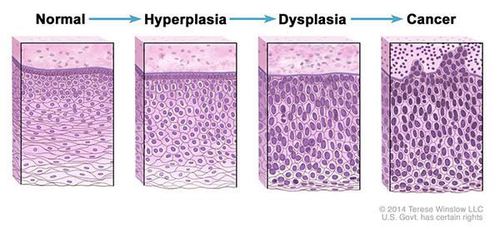

*Normal cells may become cancer cells. Before cancer cells form in tissues of the body, the cells go through abnormal changes called hyperplasia and dysplasia. In hyperplasia, there is an increase in the number of cells in an organ or tissue that appear normal under a microscope. In dysplasia, the cells look abnormal under a microscope but are not cancer. Hyperplasia and dysplasia may or may not become cancer.*

**Types of Cancer**

There are more than 100 types of cancer. Types of cancer are usually named for the organs or tissues where the cancers form. For example, lung cancer starts in the lung, and brain cancer starts in the brain. Cancers also may be described by the type of cell that formed them, such as an [epithelial](https://www.cancer.gov/Common/PopUps/popDefinition.aspx?id=CDR0000045682&version=Patient&language=en) cell or a [squamous cell](https://www.cancer.gov/Common/PopUps/popDefinition.aspx?id=CDR0000046056&version=Patient&language=en).

You can search NCI’s website for information on specific types of cancer based on the cancer’s [location in the body](https://www.cancer.gov/types/by-body-location) or by using our [A to Z List of Cancers](https://www.cancer.gov/types). We also have information on [childhood cancers](https://www.cancer.gov/types/childhood-cancers) and [cancers in adolescents and young adults](https://www.cancer.gov/types/aya).

Here are some categories of cancers that begin in specific types of cells:

**Carcinoma**

Carcinomas are the most common type of cancer. They are formed by epithelial cells, which are the cells that cover the inside and outside surfaces of the body. There are many types of epithelial cells, which often have a column-like shape when viewed under a microscope.

Carcinomas that begin in different epithelial cell types have specific names:

Adenocarcinoma is a cancer that forms in epithelial cells that produce fluids or mucus. Tissues with this type of epithelial cell are sometimes called glandular tissues. Most cancers of the breast, colon, and prostate are adenocarcinomas.

Basal cell carcinoma is a cancer that begins in the lower or basal (base) layer of the epidermis, which is a person’s outer layer of skin.

Squamous cell carcinoma is a cancer that forms in squamous cells, which are epithelial cells that lie just beneath the outer surface of the skin. Squamous cells also line many other organs, including the stomach, intestines, lungs, bladder, and kidneys. Squamous cells look flat, like fish scales, when viewed under a microscope. Squamous cell carcinomas are sometimes called epidermoid carcinomas.

Transitional cell carcinoma is a cancer that forms in a type of epithelial tissue called transitional epithelium, or urothelium. This tissue, which is made up of many layers of epithelial cells that can get bigger and smaller, is found in the linings of the bladder, ureters, and part of the kidneys (renal pelvis), and a few other organs. Some cancers of the bladder, ureters, and kidneys are transitional cell carcinomas.

**Sarcoma**

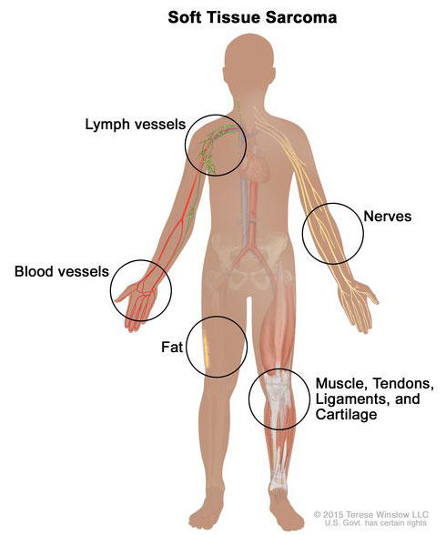

Sarcomas are cancers that form in bone and soft tissues, including muscle, fat, blood vessels, [lymph vessels](https://www.cancer.gov/Common/PopUps/popDefinition.aspx?id=CDR0000269462&version=Patient&language=English), and fibrous tissue (such as tendons and ligaments).

Osteosarcoma is the most common cancer of bone. The most common types of soft tissue sarcoma are [leiomyosarcoma](https://www.cancer.gov/Common/PopUps/popDefinition.aspx?id=CDR0000046027&version=Patient&language=English), [Kaposi sarcoma](https://www.cancer.gov/Common/PopUps/popDefinition.aspx?id=CDR0000045134&version=Patient&language=English), [malignant fibrous histiocytoma](https://www.cancer.gov/Common/PopUps/popDefinition.aspx?id=CDR0000046174&version=Patient&language=English), [liposarcoma](https://www.cancer.gov/Common/PopUps/popDefinition.aspx?id=CDR0000046028&version=Patient&language=English), and [dermatofibrosarcoma protuberans](https://www.cancer.gov/Common/PopUps/popDefinition.aspx?id=CDR0000044276&version=Patient&language=English).

Our page on [soft tissue sarcoma](https://www.cancer.gov/types/soft-tissue-sarcoma) has more information.

**Leukemia**

Cancers that begin in the blood-forming tissue of the [bone marrow](https://www.cancer.gov/Common/PopUps/popDefinition.aspx?id=CDR0000045622&version=Patient&language=en) are called leukemias. These cancers do not form solid tumors. Instead, large numbers of abnormal white blood cells (leukemia cells and leukemic blast cells) build up in the blood and bone marrow, crowding out normal blood cells. The low level of normal blood cells can make it harder for the body to get oxygen to its tissues, control bleeding, or fight infections.

*Soft tissue sarcoma forms in soft tissues of the body, including muscle, tendons, fat, blood vessels, lymph vessels, nerves, and tissue around joints.*

There are four common types of leukemia, which are grouped based on how quickly the disease gets worse (acute or chronic) and on the type of blood cell the cancer starts in (lymphoblastic or myeloid). Acute forms of leukemia grow quickly and chronic forms grow more slowly.

Our page on [leukemia](https://www.cancer.gov/types/leukemia) has more information.

**Lymphoma**

Lymphoma is cancer that begins in lymphocytes (T cells or B cells). These are disease-fighting white blood cells that are part of the immune system. In lymphoma, abnormal lymphocytes build up in [lymph nodes](https://www.cancer.gov/Common/PopUps/popDefinition.aspx?id=CDR0000045762&version=Patient&language=en) and lymph vessels, as well as in other organs of the body.

There are two main types of lymphoma:

Hodgkin lymphoma – People with this disease have abnormal lymphocytes that are called Reed-Sternberg cells. These cells usually form from B cells.

Non-Hodgkin lymphoma – This is a large group of cancers that start in lymphocytes. The cancers can grow quickly or slowly and can form from B cells or T cells.

Our page on [lymphoma](https://www.cancer.gov/types/lymphoma) has more information.

**Multiple Myeloma**

Multiple myeloma is cancer that begins in [plasma cells](https://www.cancer.gov/Common/PopUps/popDefinition.aspx?id=CDR0000046230&version=Patient&language=English), another type of immune cell. The abnormal plasma cells, called myeloma cells, build up in the bone marrow and form tumors in bones all through the body. Multiple myeloma is also called plasma cell myeloma and Kahler disease.

**Melanoma**

Melanoma is cancer that begins in cells that become melanocytes, which are specialized cells that make melanin (the pigment that gives skin its color). Most melanomas form on the skin, but melanomas can also form in other pigmented tissues, such as the eye.

Our pages on [skin cancer](https://www.cancer.gov/types/skin) and [intraocular melanoma](https://www.cancer.gov/types/eye) have more information.

**Brain and Spinal Cord Tumors**

There are different types of brain and spinal cord tumors. These tumors are named based on the type of cell in which they formed and where the tumor first formed in the central nervous system. For example, an [astrocytic tumor](https://www.cancer.gov/Common/PopUps/popDefinition.aspx?id=CDR0000045602&version=Patient&language=English) begins in star-shaped brain cells called [astrocytes](https://www.cancer.gov/Common/PopUps/popDefinition.aspx?id=CDR0000269436&version=Patient&language=English), which help keep [nerve cells](https://www.cancer.gov/Common/PopUps/popDefinition.aspx?id=CDR0000269443&version=Patient&language=English) healthy. Brain tumors can be benign (not cancer) or malignant (cancer).

Our page on [brain and spinal cord tumors](https://www.cancer.gov/types/brain) has more information.

**Other Types of Tumors**

**Germ Cell Tumors**

Germ cell tumors are a type of tumor that begins in the cells that give rise to sperm or eggs. These tumors can occur almost anywhere in the body and can be either benign or malignant.

Our page of [cancers by body location/system](https://www.cancer.gov/types/by-body-location) includes a list of germ cell tumors with links to more information.

**Neuroendocrine Tumors**

Neuroendocrine tumors form from cells that release hormones into the blood in response to a signal from the nervous system. These tumors, which may make higher-than-normal amounts of hormones, can cause many different symptoms. Neuroendocrine tumors may be benign or malignant.

Our definition of [neuroendocrine tumors](https://www.cancer.gov/Common/PopUps/popDefinition.aspx?id=CDR0000044904&version=Patient&language=English) has more information.

**Carcinoid Tumors**

Carcinoid tumors are a type of neuroendocrine tumor. They are slow-growing tumors that are usually found in the gastrointestinal system (most often in the rectum and small intestine). Carcinoid tumors may spread to the liver or other sites in the body, and they may secrete substances such as serotonin or prostaglandins, causing [carcinoid syndrome](https://www.cancer.gov/Common/PopUps/popDefinition.aspx?id=CDR0000339609&version=Patient&language=English).

Our page on [gastrointestinal neuroendocrine tumors](https://www.cancer.gov/types/gi-neuroendocrine-tumors) has more information.

1. Aetiology and epidemiology

   **Genetic factors:** 77 million deaths worldwide can be attributed to malignancy each year. The interplay between the hereditary and environmental risk factors underlying the development of malignancy is becoming clearer.

   It is thought that at least 50% of cases are preventable. 1° prevention strategies focus on modifiable lifestyle and environmental risk factors.

   Genes involved in the development of cancers fall into three categories.

   **Tumour suppressor genes**

   Genes whose function is lost during carcinogenesis. Both allele copies must be inactivated, before the tumour suppressor function is completely lost (absence of normal protein product), i.e. can be classified as recessive.

   * Functional mutations result in loss of growth inhibitory mechanisms.
   * Mutations can be hereditary (germline mutations) or acquired.
   * an example of a tumour suppressor gene—the p53 gene: produces a transcriptional regulator involved in cell cycle control and maintaining genomic integrity
   * 750% of human cancers possess p53 mutations, including breast, lung, pancreas, colon, and brain tumours, and malignancies seen in the inherited Li–Fraumeni syndrome.

   **Proto-oncogenes**

   Genes whose function becomes enhanced in carcinogenesis. Usually play an essential role in controlling cell proliferation, encoding growth factors, growth factor receptors, transcription factors, etc.

   Mutations of oncogenes may impede normal cell cycle regulation, causing uncontrolled cellular replication.

   * Mutation in only one of the proto-oncogene alleles is needed for the mutant gene product to influence downstream events, i.e. mutations are dominant at the cellular level.
   * an example of a proto-oncogene—the Ras gene: encodes a membrane-associated G protein responsible for cellular signal transduction
   * mutated Ras products remain activated, even in the absence of the appropriate growth factor receptor signal
   * mutations in Ras are implicated in 30% of all cancers, including melanoma, lung, and pancreas.

   **DNA repair genes**

   Genes whose usual function is to carry out DNA repair. Functional mutations of DNA repair genes accelerate the accumulation of mutated tumour suppressor genes and proto-oncogenes.

   * An example of a DNA repair gene—the ATM gene: encodes a protein involved in the detection of DNA damage, with an important role in cell cycle progression
   * Multiple double-stranded DNA breaks lead to high rates of chromosomal rearrangements
   * Produces the syndrome of ataxia–telangiectasia, associated with:
   * progressive cerebellar ataxia
   * $↑$ incidence of malignancies (usually lymphomas/leukaemias)
   * Hypersensitive response to treatment with ionizing radiation.

   The relative contribution of the genetic mutation to the cancer varies.
2. Proto-oncogene: A gene involved in normal cell growth. Mutations (changes) in a proto-oncogene may cause it to become an oncogene, which can cause the growth of cancer cells
3. Tumors suppressor gene: A type of gene that makes a protein called a tumor suppressor protein that helps control cell growth. Mutations (changes in DNA) in tumor suppressor genes may lead to cancer. Also called antioncogene.