**IELTS**: International English language testing system. Organizer Cambridge University, British council and IDP. Basically, two types of IELTS available. IELTS Academic for students and IELTS general for migration candidates.

**Requirements to attend the Exam**

* Passport or NID
* Online / Offline Registration
* British Council / IDP Bangladesh
* Time and Date - Website How to take prep
* Cost: BDT 20,250 (Offline/online payment)
* Age Limit: There is no age limit for IELTS.

**Criterions of IELTS academic:**

1. Listening: An audio story will be given to hear. Candidate have to answer some question from that story. 4 recording (4 parts), 40 questions, 30 minutes. (Extra 10 minutes for paper base)
2. Reading a passage candidate have to answer questions. 30 section, 40 questions, 60 minutes. Passage source mainly research paper.
3. Writing: 2 tasks, 60 minutes. 1st describing a visual chart type thing, 2nd writing an assay.
4. Speaking: Communicating with examiner. 3 parts 11- 14 minutes. (paper-based speaking taken different day)

**How to take preparation?**

* Improve your reading, writing, speaking and listening skills.
* Revise basic grammar and practice to use it accurately while writing and speaking.
* Get a habit of using pencil.
* Books: Cam. IELTS Official guide and Liz Grammar, Saimon: grammar in use.
* Learn and use vocabulary with synonyms and antonyms.

**Some sources:**

1. British council: App, course
2. <https://www.youtube.com/playlist?list=PLEnvNvpjnLbHuDg7Bot3VHPLjJK2SYNIM>

**Listening test**

**Basic Instructions**

* The Listening test is the first module.
* 4 Recordings.
* It takes appr minutes
* 10 Question each recording
* In Paper base test: extra 10 minutes to the answer
* Use pencil to answer.

**Questions pattern:** 6 Types of question

* Multiple choice
* Matching
* Plan, map, diagram labelling
* Sentence completion
* Form, note, table, flow-chart, summary completion.
* Short- answer questions.

**1st recording:**

* 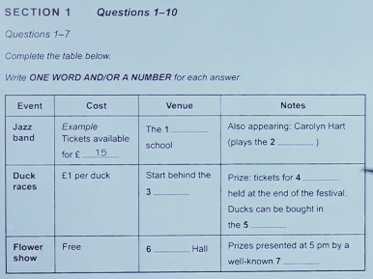Usually it is a conversation of 2 person regarding social context.
* Approximately 30 s will have been provided to read the questions before starting audio.
* After starting recording candidate should answer the questions 1 to 7.
* Then, another same period for answer 8-10.

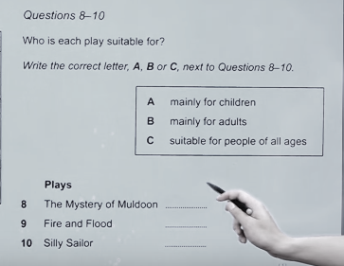

**2nd recording:**

* Similarly, 1st recording it will be recording of social context but speaker will a single person.
* Have to answer 11-16 double MCQ and 17-20 (plan or Map) no. questions

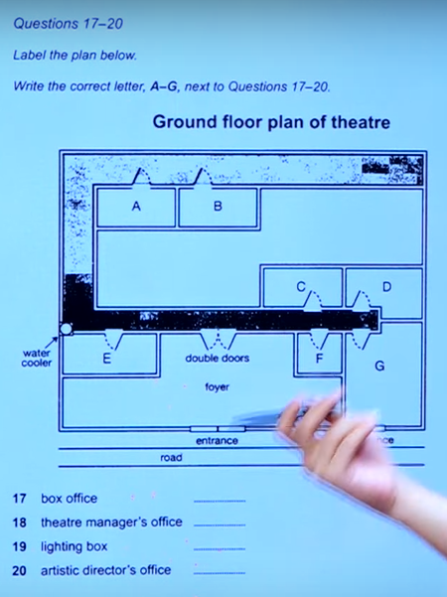

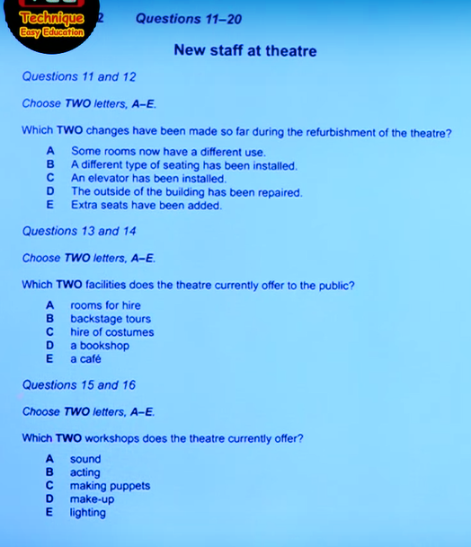

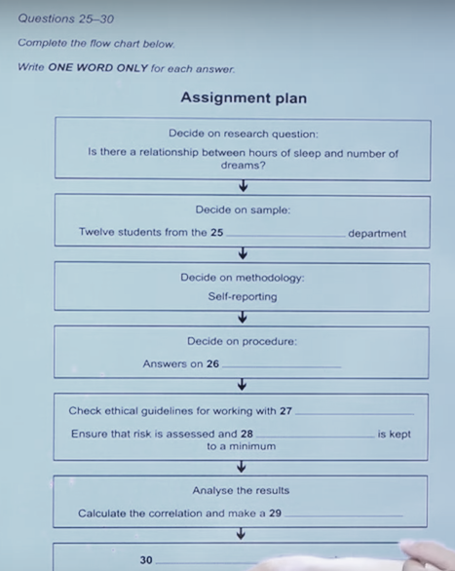**Third Recording: Part 3**

* Academic settings (seminars, lectures, training, tutors and students discussing assignments, etc.)
* Three to four speakers (Most critical)
* MCQ and completing flowchart.

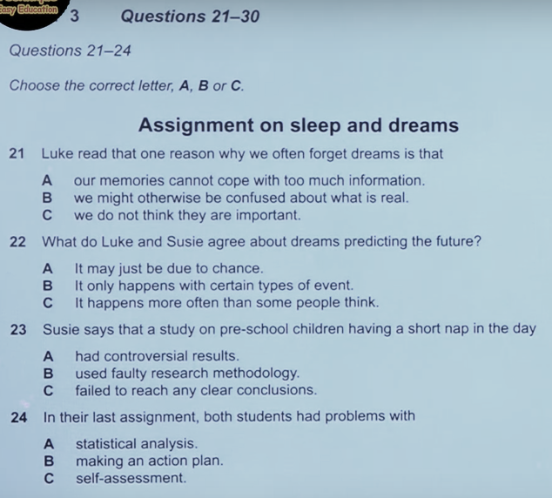

**Fourth Recording: Part 4**

* Only one speaker
* An academic lecture (very often involves a university lecturer speaking on an academic topic)
* A longer lecture

**Tips for Listening**

* Careful about words with similar pronunciation.
* Practice spelling.
* Focus is important.
* Read the questions fast and underline keywords.
* Practice with audio script.
* Identify your weak part or question category and practice it again and again.

**Reading Test**

Designed to test a wide range of reading skills

* Reading for gist,
* Reading for main ideas,
* Reading for detail,
* Skimming,
* Understanding logical argument and
* Recognizing writers' opinions, attitudes and purpose.

**Basic instructions**

* Passage: three
* No. Of questions: 40
* Timing: 60 minutes
* No extra time.

**Passage type and passage source:**

* Three long passages (descriptive and factual to discursive and analytical)
* Source: Books, Journals, Magazines and Newspapers
* Selected for a non-specialist audience but appropriate for students.
* Answer in the answer paper within the time with pencil.
* Each question contains 1 mark, no negative marking.

**Question type:** 11 type question

* Matching features
* Matching sentence endings
* Sentence completion
* Summary, note, table, flow-chart completion
* Diagram label completion
* Short-answer questions
* Matching features
* Matching sentence endings
* Sentence completion
* Summary, note, table, flow-chart completion
* Diagram label completion
* Short-answer questions

**Reading practice guide:**

* Reading habit is important.
* For Fast reading: The Speed Reading Book by Tony Buzan
* Learn vocabulary while reading.
* Make your own dictionary.
* Don't miss spelling.
* Learn about each question category.
* Read daily, read for fun.
* Learn from your mistakes.

**Writing test**

**Basic information:**

* Time: 60 minutes
* Number of Task: 2
* In task 1, You must write a minimum of 150 words. (20 minutes)
* In task 2, You have you write a minimum of 250 words. (40 minutes)

**Academic writing: task 1 (About 30% marks contain)**

* Graph, Table, Chart or diagram asked to describe
* Summarize or explain the information in your own words.
* You may be asked to describe and explain data, describe the stages of a process, how something works or describe an object or event.

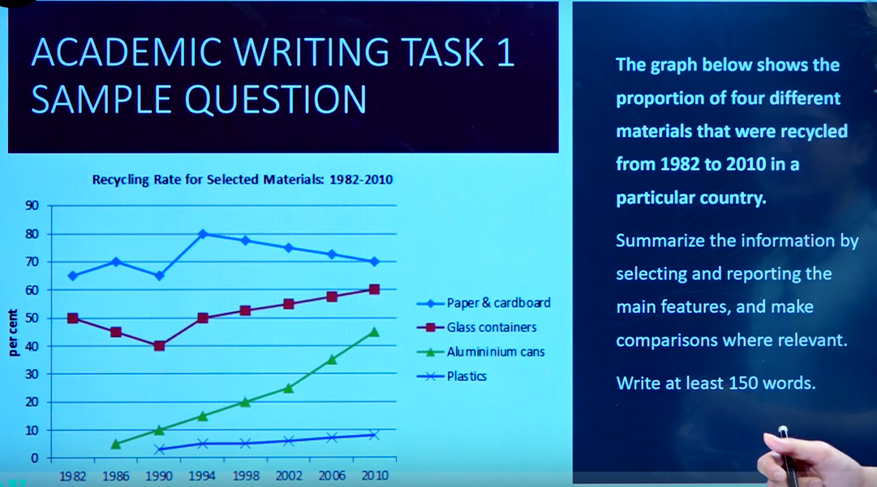

**Academic writing task 2: Essay(About 70% marks contain)**

* Write an essay in response to a point of view, argument or problem.
* Academic or semi-formal/neutral style.
* 250 words, not less.
* Spend 40 minutes.

**Essay sample**

You should spend about 40 minutes on this task. Write about the following topic:

Governments should spend money on railways rather than roads. **To what extent do you agree or disagree with this statement?**

Give reasons for your answer any relevant examples from knowledge or experience. Write at least 250 words.

**Don't Do:**

* They are asked to write at least 250/150 words and will be penalized if their answer is too short.
* Test takers will be penalized for irrelevance if the response is off-topic or is not written as full, connected text.
* They will be severely penalized for plagiarism.
* Finally, test takers should make sure that they do not copy directly from the question paper because this will not be assessed