FeedMe

Testing Report

Client
Michael Wilson

Team 1
Minhaz Mahmud
Kiante Brantley
Seth Mosgin
Giancarlo Mogliazzi
Ines Ngassa

Table of Contents

Page
- Introduction

1.1 Purpose of This Document 3
1.2 References 3

- Testing Process

2.1 Description 3
2.2 Testing Sessions 3
2.3 Impressions of the Process 4

- Test Results 6

Appendix A - Peer Review Sign-off 10

Appendix B – Document Contributions 10

1. Introduction

  - Purpose of This Document

This document is intended for developers, managers, and testers. Various methodologies of testing the system will be discussed. FeedMe.com, like any website with the potential to a lot of user traffic must be thoroughly tested to ensure stability, expose bugs and security vulnerabilities and ensure responsiveness for the user.

  - References

- Systems Requirements Specification (SRS)

2. Testing Process

  - Description

The use cases for the website are outlined in the SRS document and will serve as the basis for which the tests are done. Each team member contributed scenarios that may result in unintended outcomes. We completed testing in various ways. We completed various types of tests including unit testing, white-box testing, penetration-testing, and user testing. Individual parts of the web site were thoroughly tested with both unintelligent and malicious users in mind. After unit tests were completed the parts were integrated and we verified the parts work together.

2.2 Testing Sessions

For each testing session, specify the date, location, time started, time ended, who performed the tests, and which use case(s) was covered.

Date | Location | Time  Started | Time  Ended | Performed By: | Use Case:
03/01/2014 | RLC - Library | 7pm | 11pm | Minhaz, Seth | Register, Login, Logout, Home page
03/02/2014 | Home | 3pm | 4pm | Minhaz | Register, Login, Logout
03/02/2014 | Home | 6pm | 7pm | Kiante, Giancarlo, Ines | Register, Login, Logout, Home page
03/03/2014 | Home | 9pm | 9:30pm | Minhaz | Register, Login
03/03/2014 | Home | 10pm | 10:30pm | Seth Mosgin | Register, Login

2.3 Impressions of the Process

The testing process was fairly effective given the first spiral. We made sure all “intended” usage of the website was tested as well as unexpected and malicious usage.
The website has minimal functionality that includes registration, login and logout. Given the simplistic nature of the website the functions perform quite well. The login and registration pages and navigation bar work quite effectively.

The strongest part of the website thus far is the registration and login process. All data is sanitized and we make sure that SQL injection and various other attacks are not possible. Users cannot access the login and registration pages once they are logged in. The registration process is very straight forward with large enough buttons, font, and text boxes so users are not confused.

All user data is stored in the database when the user registers. The database is also queried when the user attempts to log in. All passwords hashed before being stored in to the database to prevent stolen passwords. The weakest part of the website is that some fields on the registration page allow input that may not make sense. For example email addresses with invalid characters are not yet rejected.

3. Test Results

Testing was conducted using a typical usage scenarios and some testing for scenarios that typical users should not be in. We tested edge and boundary cases to ensure the website correctly handles invalid situations that could result in unintended results on the website.

Testing Suite

User creates a new user:

Use Case
Good Scenario | The user creates a username with a unique username and email with (@umbc.edu) and no empty fields and confirmed password
Bad Scenario | User enters invalid email (non @umbc.edu)  User enters pre-registered email or username  Users password confirmation doesn’t match  User forgets any fields
Purpose | To ensure the user can register given the right inputs and to make sure they cannot register with invalid inputs
Expected results for good scenario | User is successfully registered and forwarded to the login page to sign in with their new credentials.
Expected results for bad scenario | The registration page is refreshed and user is notified of the errors in their input

User attempts to log in:
Use Case
Good Scenario | User enters correct username and correct password
Bad Scenario | User enters wrong username  User enters wrong password  User forgets either field
Purpose | To ensure that users are able to login once they are registered
Expected results for good scenario | The user is forwarded to the home page and their name is displayed in the navigation bar on the top right.
Expected results for bad scenario | The user is brought back to the login page and notified that there was a problem with their inputs. Wrong password or username or missing fields.

User attempts to log out:
Use Case
Good Scenario | After being logged in, the user hits the logout button.
Bad Scenario | Not possible to see the logout button without being logged in, so there are no bad scenarios we can think of yet.
Purpose | To make sure users can log out given they are loggedin.
Expected results for good scenario | User is back at the home page and logged out
Expected results for bad scenario | N/A

Test Results

State the name of the tester for the particular use case. Summarize those test cases from the above that you were not able to execute, for any reason, and briefly explain the difficulty. Summarize those test cases that ran and the actual result was identical to the expected result. Summarize those test cases that ran and the actual result was not the same as the expected result, but was nevertheless correct. Explain the discrepancy. Describe each defect detected. For each defect, outline either a suggested repair or the actual repair you made. In the cases where you successfully removed the bug, or at least tried to fix the bug but were unable to do so, briefly describe any changes you made to the program, including the modules, functions, classes, data structures, etc. affected. Try to explain the underlying logical cause of the defect in the program code.

Registering a user. Performed by Minhaz Mahmud.

- On home page clicking on Register forwards to the register page.


2. Registration page fill out the form:

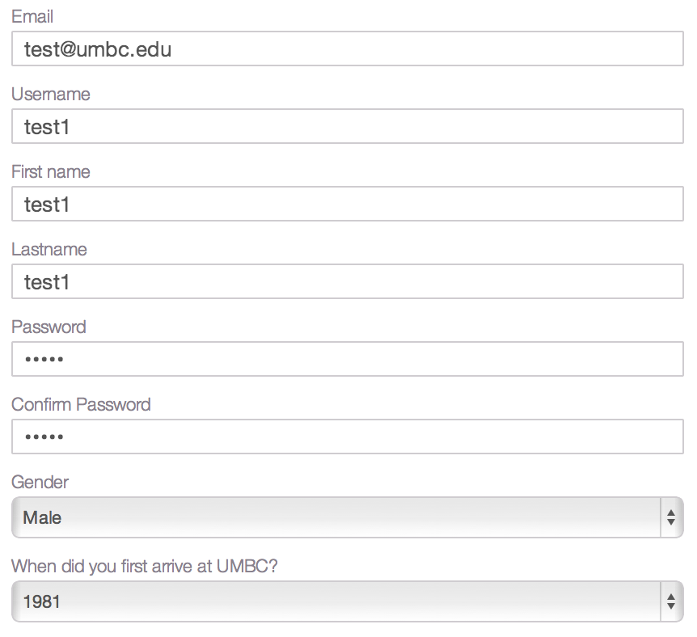

With all valid input the user is forwarded to the login page.

3. Registration with invalid data results in error messages:

With a non umbc email:
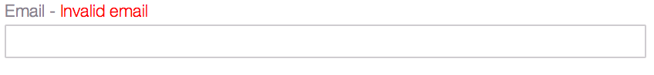

Attempting to register an username or email that is already registered:
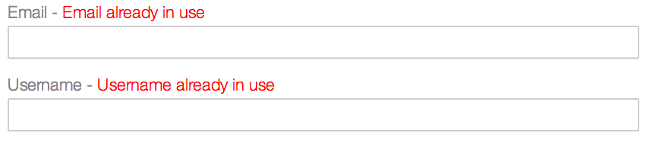

Any missing fields:
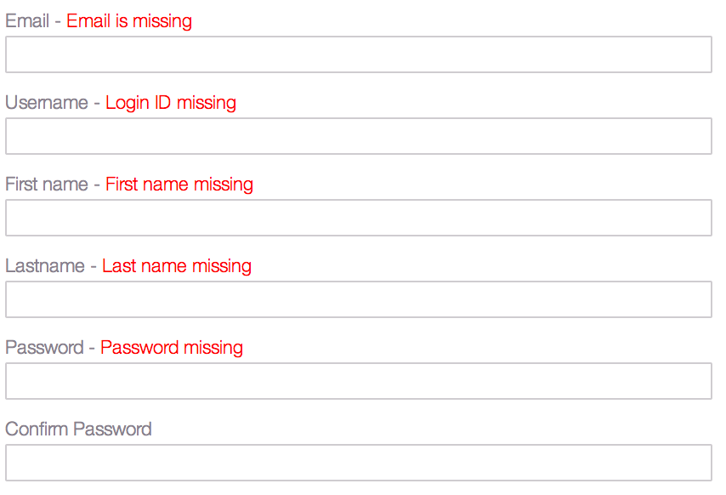

User login. Performed by Seth Mosgin.

- On login page attempting to log in.

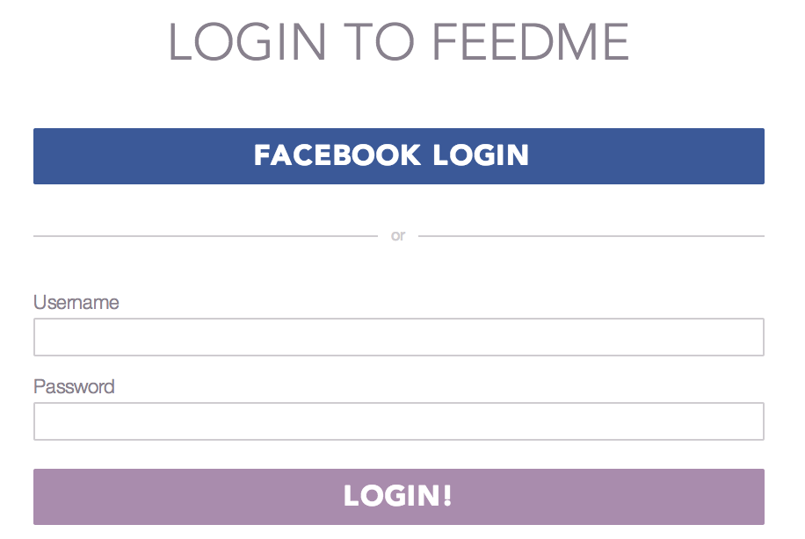

2. With all valid input the user is successfully logged in and gets to the home page with their name on the top right in the navbar.



3. With invalid input:

Missing login or password
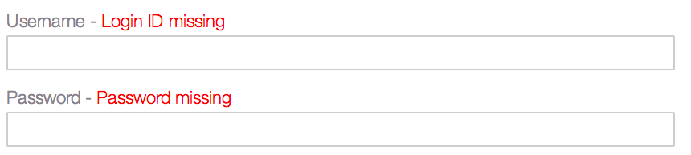

Incorrect username or password:

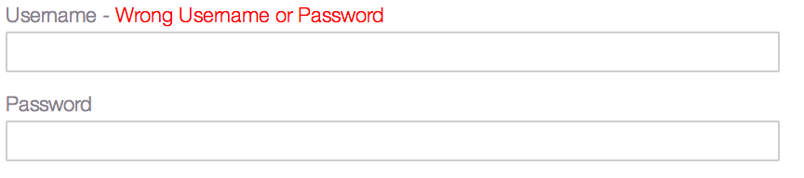

Logout functionality – Tested by Giancarlo Mogliazzi

1. After successful login the users name is on the navigation bar next to the logout button.



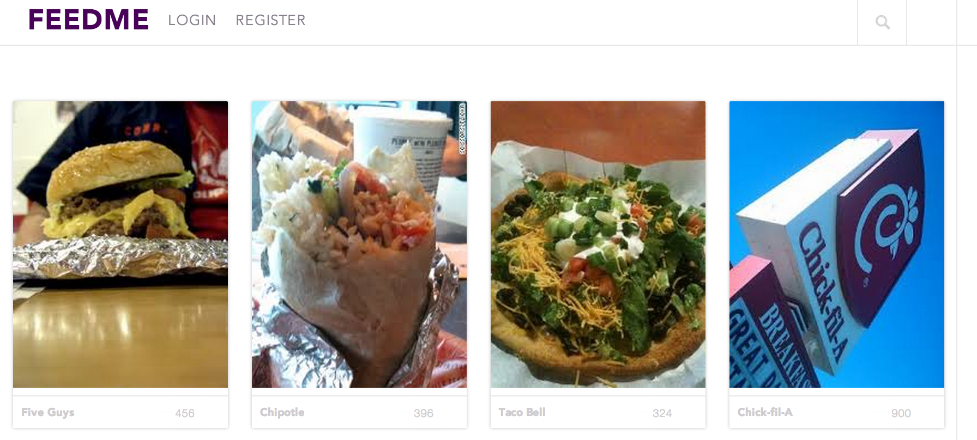
2. Hitting the logout button will take the user to the home page and they will be logged out.
Appendix A – Team Review Sign-off

Name: | Date: | Signature (Print name)
Minhaz Mahmud | 03/03/2014 | Minhaz Mahmud
Kiante Brantley
Seth Mosgin
Ines Ngassa
Giancarlo Mogliazzi

Appendix B – Document Contributions

This document was completed by Minhaz Mahmud for the most part with help from various team members in various capacities.

