_{System Design Document}
_{FeedMe}

_{Client:}
_{Michael Wilson}
_{Team 1:}
_{Giancarlo Mogliazzi}
_{Jessica Ngassa}
_{Kiante Brantley}
_{Minhaz Mahmud}
_{Seth Mosgin}

_{Table Of Contents}

1. Introduction
1.1 Purpose of this document.
1.2 References.
2. System Architecture
2.1 Architectural Design
2.2 Decomposition Description
3. Persistent Data Design
3.1 Database Descriptions
3.2 File Descriptions
5. Appendix A - Agreement Between Customer and Contractor
6. Appendix B - Team Review Sign-off
7. Appendix C - Document Contributions

1.Introduction

1.1 Purpose of This Document

The purpose of this document is to describe the system design of the FeedMe website. Key topics covered in this document include the high level system architecture, lower level class designs, and the persistent data design of FeedMe.

1.2 References

2. System Architecture

2.1 Architectural Design

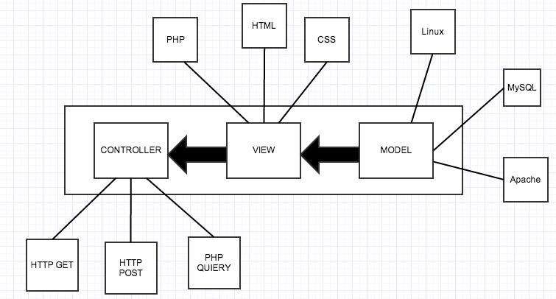

The FeedMe website will be built using the LAMP(Linux, Apache,MySQL, PHP) solution stack. The basic components of LAMP include Models, Views, and Templates, which follows a Model View Controller architecture(MVC).

The model layer consists of the Linux(The operating system),Apache(The web server), and MySQL(The database). All of the data used in our website will be stored on the MySQL server.

The view layer mostly consists of the front-end code involved in the website. HTML and CSS are used to design each web page, and PHP is used to populates the information dynamically into html and then generate the actual html to be sent to the browser.

The controller layer, which talks to the model, would be HTTP GET/POST requests, as well as PHP quieres to our database.

2.2 Decomposition Descriptions

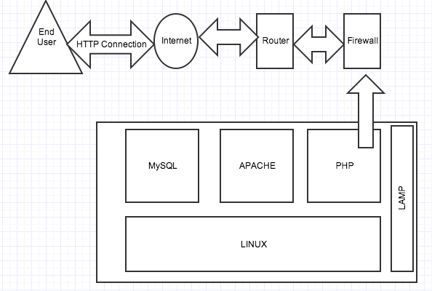

With a LAMP stack, your Operating system, Linux, is the base layer. The other three components are installed on the Linux operating system. Apache, your web server sits on top of your OS. Then, the MySQL database stores all the information served by your webserver(User/Web data), and PHP is used to drive and display all the data, and allow for user interaction. In relation to FeedMe, all of the web pages are dynamic, so PHP scripts send the data from the MySQL database to the website, which will be formatted by HTML and CSS code.

Each time a user is taken to a new page on FeedMe, an HTTP request is sent and a HTTP response and sent back. The Register page currently takes the information entered into the data boxes(Name/Username/Password/Years at UMBC) and is added to a table on the MySQL database. In our upcoming sprints, the search bar will return the result of a query of all the web pages that have to do with the searched tag. Also, the Login page will be able to send an HTTP request to the server. The server will send back a response as to whether or not the certain login credentials are accurate

3. Persistent Data Designs

3.1 Database Descriptions
All user information is kept in a MySQL database in a table named Users. This database was created in PHPmyAdmin. The schema for the Users database is modeled below:

Users Table
Column | Type | Null
member_id | int(11) | No
email | varchar(64) | No
firstname | varchar(100) | No
lastname | varchar(100) | No
login | varchar(100) | No
passwd | varchar(32) | No

3.2 File Descriptions

File | Description
index.php | Home page of the website
register.php | Contains the form for the registration page for the user.
register-exec.php | Handles all of the logic for the registration page. Checks inputs to make sure they are valid and returns appropriate error messages. Writes valid input to the database.
login.php | Contains the login form
login-exec.php | Handles all of the logic for login. Inputs checked against the database to make sure they are correct for successful login.
navbar.php | Contains the navigation bar and logic to display different links based on who is signed in. Displays users name and logout button.
config.php | Contains the database connection information.
scripts/ | contains the register-exec.php, login-exec.php, config.php and other scripts
css/ | contains css files
images/ | contains all images

5. Appendix A – Agreement Between Customer and Contractor

By the end of Spiral 1, The customer requested that we have the login and register process/web pages working. See System Requirements Specification for more information. Additional features will be provided in further development spirals.

When and if future changes to this document occur a drafted new document will be created. Both a hard and electronic copy of both versions will be presented to the client for review. Upon approval, the draft will be finalized and signed off by both parties.

Client

Name _________________________________________ Date

___________________ Print

Name _________________________________________ Date

___________________ Signature

6. Appendix B – Team Review Sign-off

All team members have reviewed this document and agree on both the content and the format. Any disagreements or concerns are addressed in team comments below.

Team

Name ______Minhaz Mahmud_______ Date: 03/03/14

____Minhaz Mahmud___ Print

Name ________Minhaz Mahmud_________________ Date: 03/03/14

____Minhaz Mahmud_____ Signature

Comments: Looks good.

Name ______Kiante Brantley______________________ Date 03/04/14

____Kiante Brantley________ Print

Name ______Kiante Brantley__________________ Date

_____Kiante’ Brantley______ Signature

Comments: Well done

Name __________Seth Mosgin________________ Date 3/04/14

_______Seth Mosgin_____ Print

Name _____________Seth Mosgin_______________ Date 3/04/14

_____Seth Mosgin_______ Signature

Comments: Diagrams are well organized and easy to understand

Name _____Jessica Ngassa_________________ Date 3/04/14

____Jessica Ngassa___ Print

Name _____Jessica Ngassa____________ Date 03/04/14

_____Jessica Ngassa_______ Signature

Comments

Name _________________________________________ Date

___________________ Print

Name _________________________________________ Date

___________________ Signature

Comments

7. Appendix C – Document Contributions

Giancarlo Mogliazzi is the owner of this document. Giancarlo wrote 80% of the content. Minhaz Mahmud contributed by adding in the File and Database information in Section 3

