User Interface Design Document
_{FeedMe}

_{Client:}
_{Michael Wilson}
_{Team 1:}
_{Giancarlo Mogliazzi}
_{Jessica Ngassa}
_{Kiante Brantley}
_{Minhaz Mahmud}
_{Seth Mosgin}

_{Table Of Contents}

1. Introduction
1.1 Purpose of this document.
1.2 References.
2. User Interface Standards
3.User Interface Walkthrough
Appendix A - Agreement between Customer and Contractor
Appendix B - Team Review Sign-off
Appendix C - Document Contributions

1.Introduction

1.1 Purpose of This Document

The purpose of this document is to show the user how to navigate and interact with the FeedMe website. Images will show how FeedMe is interconnected and will display the different kinds of pages within the website, highlighting important features to familiarize users with all that FeedMe has to offer.

1.2 References

2. User Interface Standards

This section contains an overview of the designs standards used in the FeedMe website. There are a few key pages on the FeedMe website. They include: Home, Register, Login, User Profile,Restaurant Profile. Every page will have a navigation bar (See Figure 2.1) at the top with the FeedMe logo on the left side and a search bar on the right. The search bar will allow to user to enter in a query of their choosing.

Figure 2.1: Navigation Bar

The Home screen will have multiple thumbnails of each Top Rated restaurant in the area with common tags that relate to the restaurant. Each thumbnail will also have the number of total reviews for the restaurant. There is a “Login” and “Register” button at the top of the webpage that when clicked will navigate to the Login and Register web pages.(Figure 2.2).

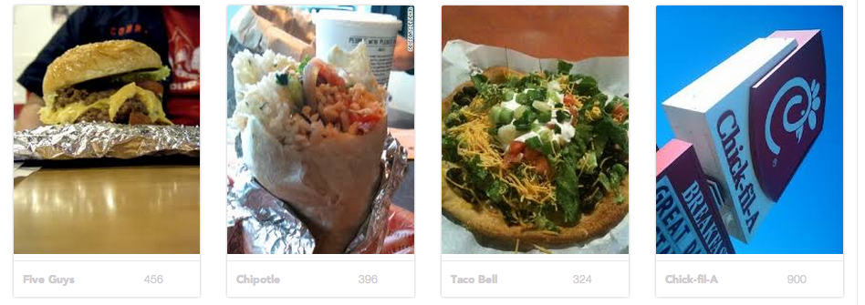
Figure 2.2: Home Page Thumbnails

The Login page contains two buttons user can choose from as well as some text boxes. One button will allow the user to login into the site from Facebook. The other will log-in the user into the website, after the correct account credentials are added in the Username and Password fields. There are also some hyperlinks that link to the Register page and Forgot Password page.

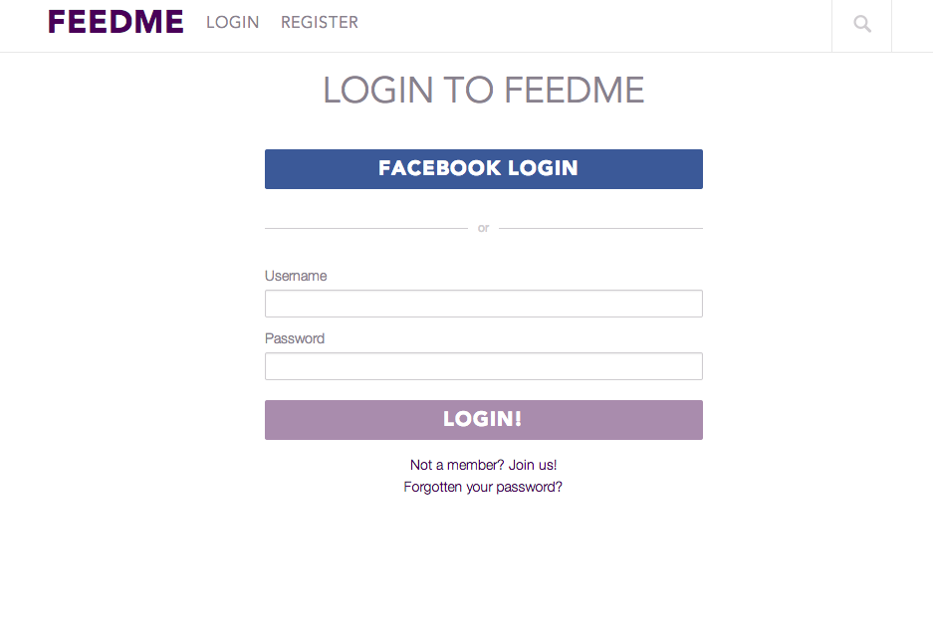
Figure 2.3: Login Page

The Register page contains text boxes, drop down boxes, and some buttons. Here the user will enter their required information(Email,Username,Password,First/Last name,Gender,and Years at UMBC) and hit the “Register By Email” button. They also have a choice of logging in from Facebook.

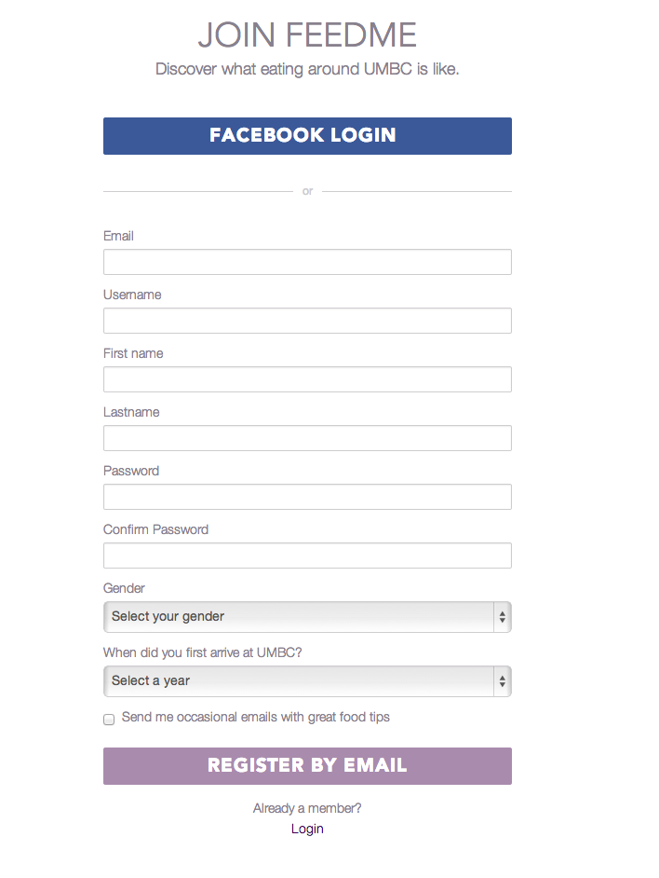
Figure 2.4: Register Page(Shrunken down to save space)

3.1 FeedMe Navigation Diagram
The following navigation diagram or sitemap explains possible user flow throughout the current system.
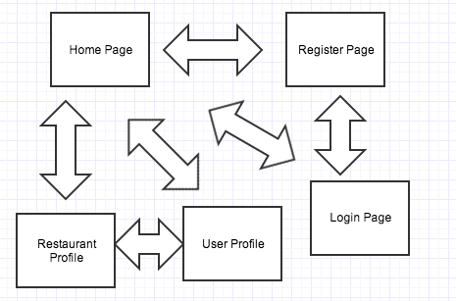

3.2 FeedMe Walkthrough
3.2.1 Login
From the Home page, you can click the “Login” button from the navigation bar to take you to this Login page. On this page you are able to: Search the website, go back to the Home page, login through a Facebook account, go to the Register page and put in account information to get to your personalized Home page. Enter your login information and click the “Login” button.
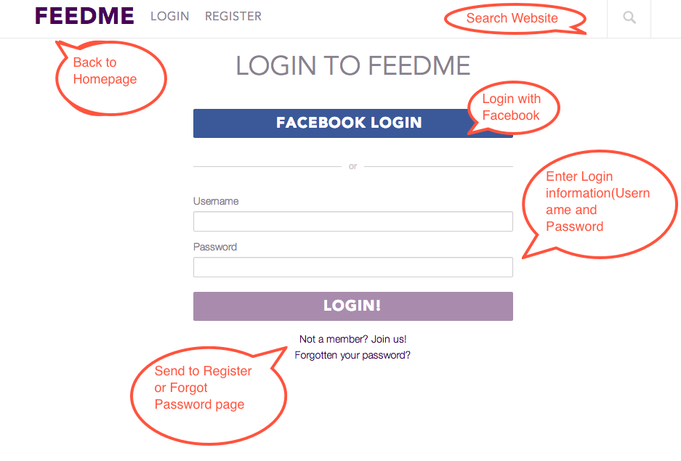
3.2.1 Register
From the Home page, you can click the “Register” button from the navigation bar to take you to this Register page. On this page you are able to: Search the website, go back to the Home page, login through a Facebook account, go to the Login page and put in account information to get to your personalized Home page. Enter in the required information and click the “Register By Email” button to finish registration.
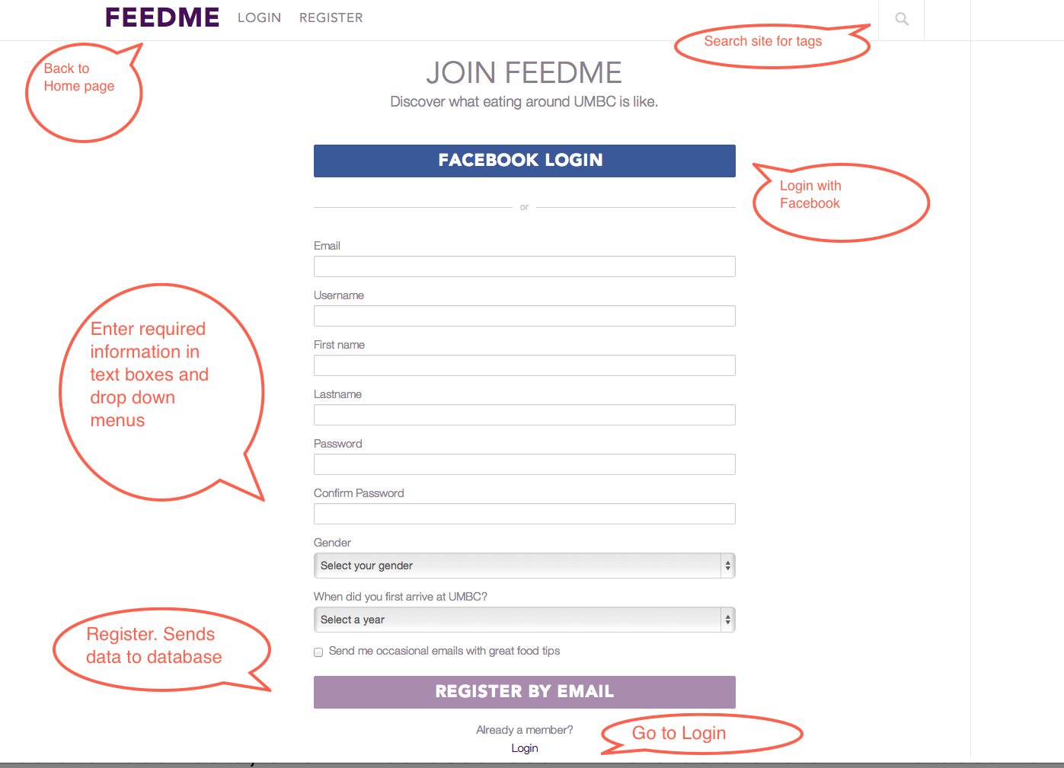
4. Data Validation
There are multiple data entry points on the FeedMe website. They currently include: Entering registration data, and login credentials. Please refer to the table below for further information regarding allowable inputs, their limits, and allowable formats.

4.1 Data Validation Table
Entry Location | Data Types | Limites
Username(Register) | String | Are unique, if a duplicate is found, the username is rejected
Email(Register) | String | Must end with @umbc.edu to verify user is a student
Password(Register) | String | Must be entered twice, for confirmation, or password is rejected

5. Appendix A – Agreement Between Customer and Contractor

By the end of Spiral 1, the customer requested that we have the login and register process/web pages working as well as a basic Home page view. See System Requirements Specification for more information. Additional features will be provided in further development spirals.

When and if future changes to this document occur a drafted new document will be created. Both a hard and electronic copy of both versions will be presented to the client for review. Upon approval, the draft will be finalized and signed off by both parties.

Client

Name _________________________________________ Date

___________________ Print

Name _________________________________________ Date

___________________ Signature

6. Appendix B – Team Review Sign-off

All team members have reviewed this document and agree on both the content and the format. Any disagreements or concerns are addressed in team comments below.

Team

Name __Kiante Brantley_______________ Date 03/04/14

_____Kiante Brantley____ Print

Name __Kiante Brantley_________________ Date 03/04/14

____Kiante’ Brantley_______ Signature

Comments: Nicely explained

Name ______Seth Mosgin___________ Date 03/04/14

______Seth Mosgin_____ Print

Name _______Seth Mosgin______________ Date 03/04/14

_____Seth Mosgin_____ Signature

Comments The walkthrough part in particular is very well done

Name _____________Jessica Ngassa______________ Date 03/04/14

___Jessica Ngassa_____ Print

Name ___________Jessica Ngassa_______________ Date 03/04/14

___Jessica Ngassa____ Signature

Comments

Name ______Minhaz Mahmud________________ Date 03/04/14

___Minhaz Mahmud___ Print

Name ________Minhaz Mahmud_________ Date 03/04/14

__Minhaz Mahmud___ Signature

Comments

Name _________________________________________ Date

___________________ Print

Name _________________________________________ Date

___________________ Signature

Comments

7. Appendix C – Document Contributions

Giancarlo Mogliazzi is the owner of this document. Giancarlo wrote 90% of the content. Minhaz Mahmud assisted with the information in the data validation section.

