Name: Minhazul Abedin
ID: 21-44625-1
Section: C
Semester: Summer 25-26
Final Lab Task 1
Goal-Based Agent: Automated Water Purification System
Code Screenshot:
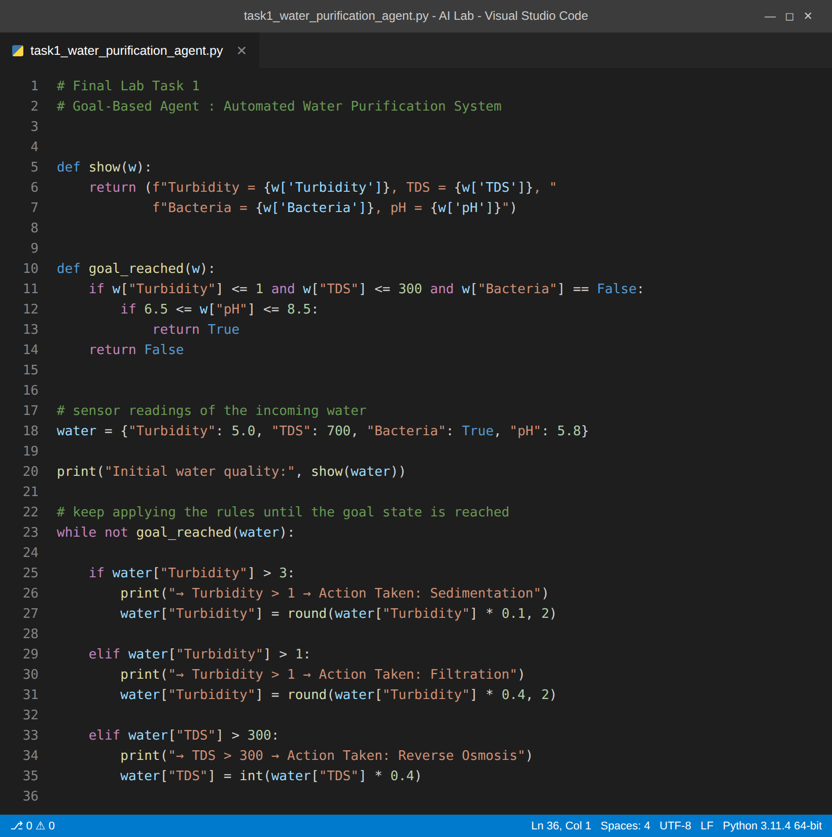
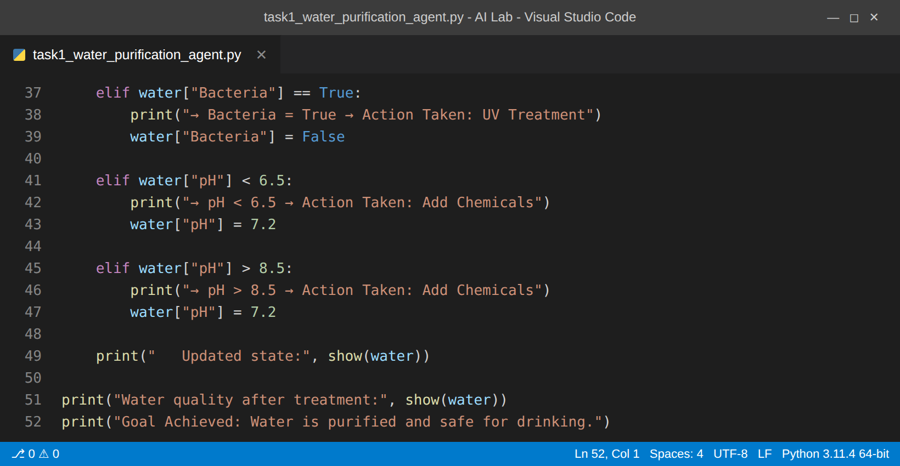
Output Screenshot:
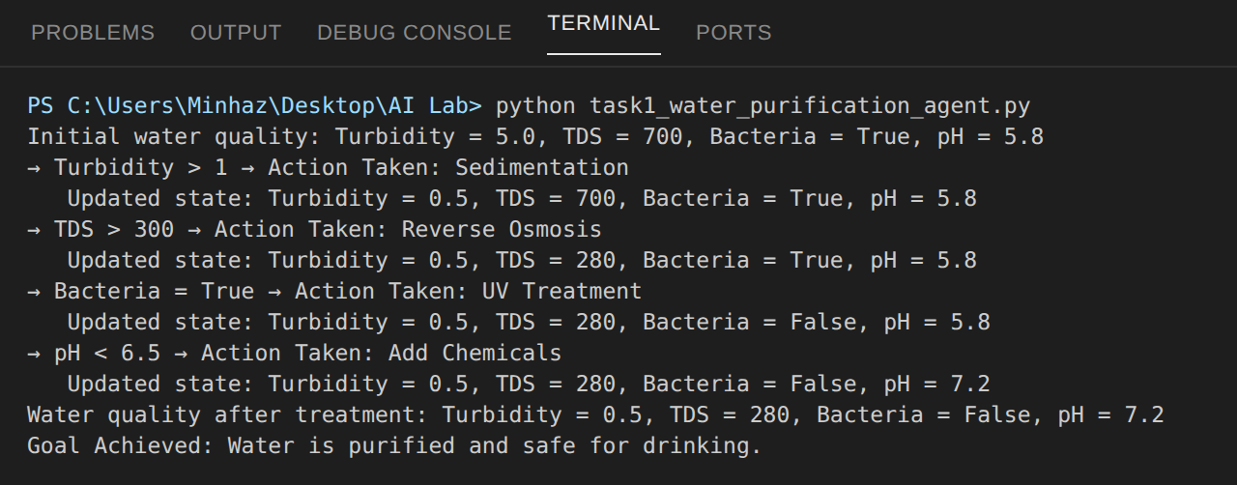

Final Task – 2
Simple Rule-Based Vacuum Cleaning Agent
Code:
# Final Lab Task 2
# Simple Rule-Based Vacuum Cleaning Agent

rows = 4
cols = 4

# 'D' = dirty cell , '.' = clean cell
grid = [
['D', '.', 'D', '.'],
['D', '.', 'D', '.'],
['D', '.', '.', '.'],
['D', 'D', 'D', 'D']
]

def show_grid(r, c):
for i in range(rows):
for j in range(cols):
if i == r and j == c:
print('A', end=' ') # A = agent position
else:
print(grid[i][j], end=' ')
print()
print('--------------------')

row = 0
col = 0
count = 0

print("Initial Environment:")
show_grid(row, col)

while True:

# rule 1 : if the current cell is dirty then clean it
if grid[row][col] == 'D':
grid[row][col] = '.'
count = count + 1
print(f"Cleaned cell at ({row}, {col})")
show_grid(row, col)

# rule 2 : otherwise move to the next cell
if col < cols - 1:
col = col + 1 # move right
elif row < rows - 1:
row = row + 1 # move down
col = 0
else:
break # whole grid is scanned

show_grid(row, col)

show_grid(row, col)
print("Cleaning complete. Total cells cleaned:", count)

Code Screenshot:
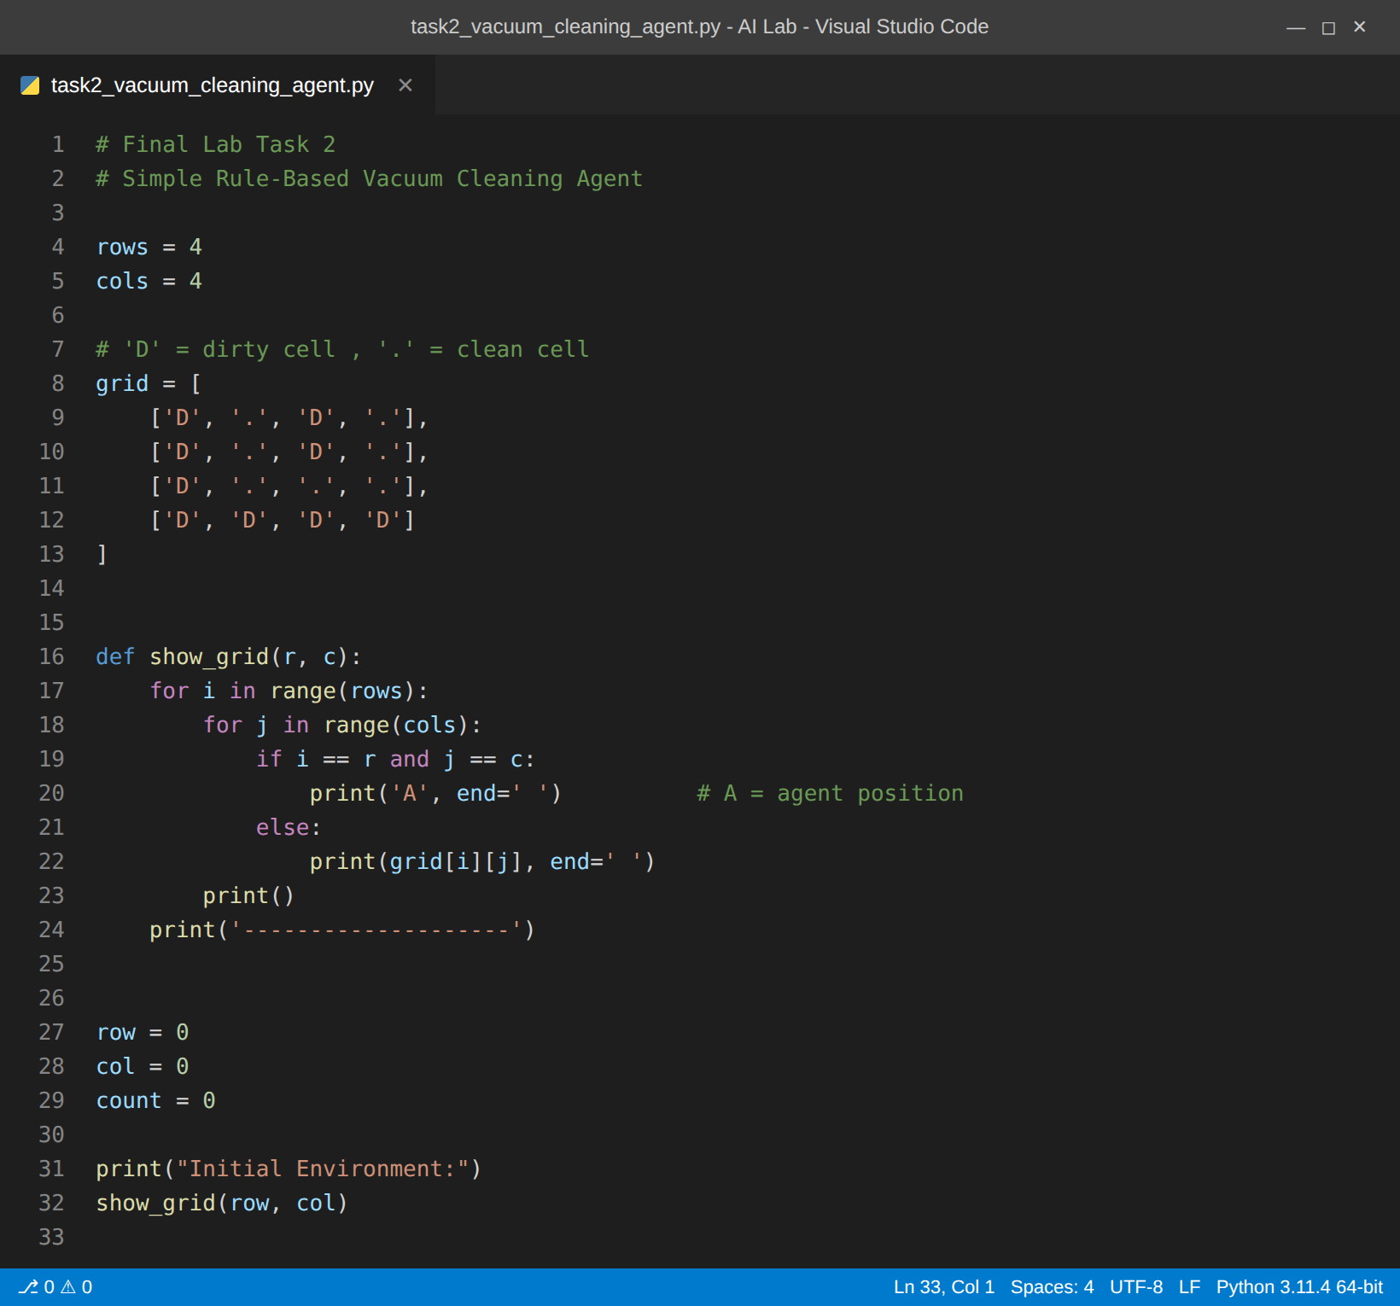
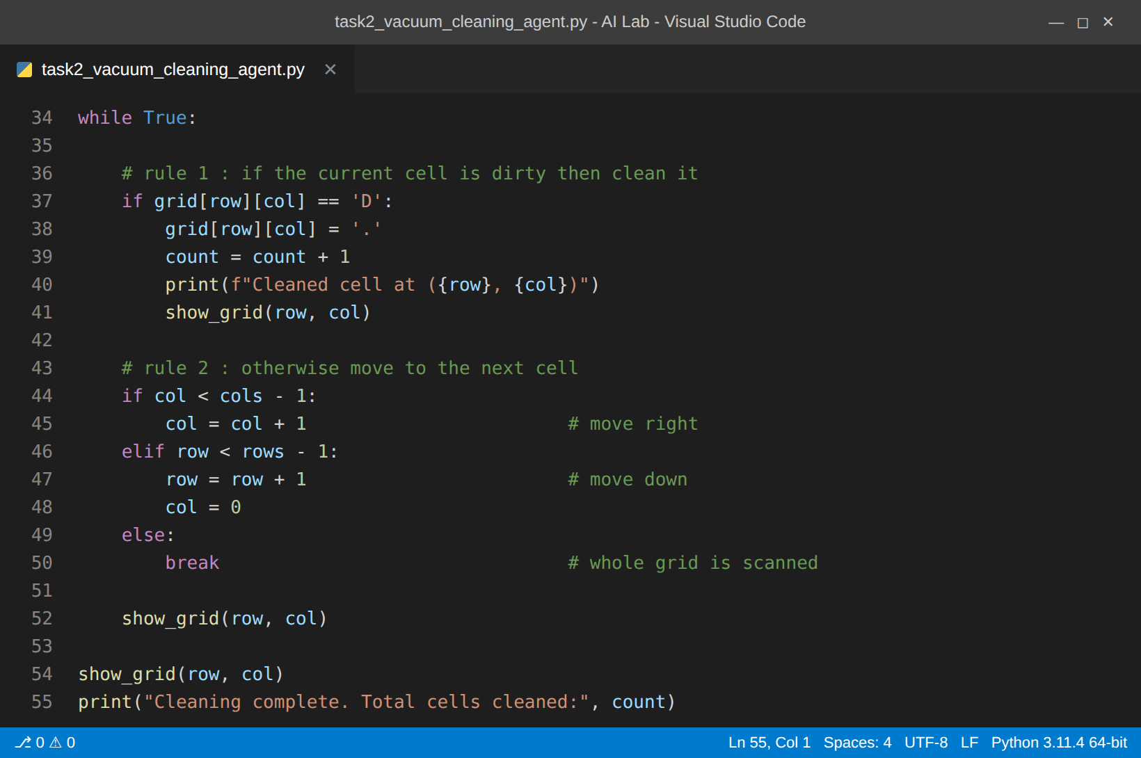
Output Screenshot:
