Project Name: Todo App

# 1. User Stories:

I wanted an application by which I can track my running task. For simply, I want to list down all of my activities that I wanted to do. Second thing is that whenever I complete any task, I can simply mark it has done and delete from List. Third thing is that I can able to see all of my completed task in another section in application. Finally, If I reload my website then it will not remove my task.

# 2. Features:

1. Take user task data by using ***click*** and ***submit*** event handler.
2. Render input data into list.
3. Delete data from list by using ***Click*** event handler.
4. Move deleted data to history section.
5. Store all data into local storage using ***local Storage*** API.

# 3. Flowchart:

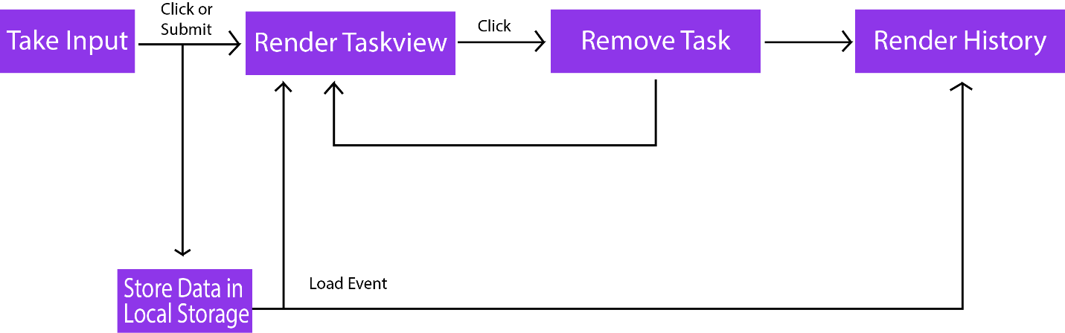

# 4. Architecture:

1. MVC (Model View Controller)
2. OOP (Object Oriented Programming)