Student Name | CSUSM Email | Contribution Percentage

Tasks
- Each team should follow Agile approach to work together to identify work items for your Product Backlog on Trello. Remember to follow the DEEP principle when creating user stories. Pick three from the Product Backlog, and use one of the two user story templates we learned in class to describe the work items. You should also include the information such as estimated story points (with estimation scales), priority, and appropriate details.
- You should start to use your committed time on the project to code, or prototype/learn skills needed in your project.

Problem 1: In this lab report, paste your response to Task 3 (three user stories) below.

Problem 2: Java Programming (you may practice Pair Programming while working on this lab exercise).
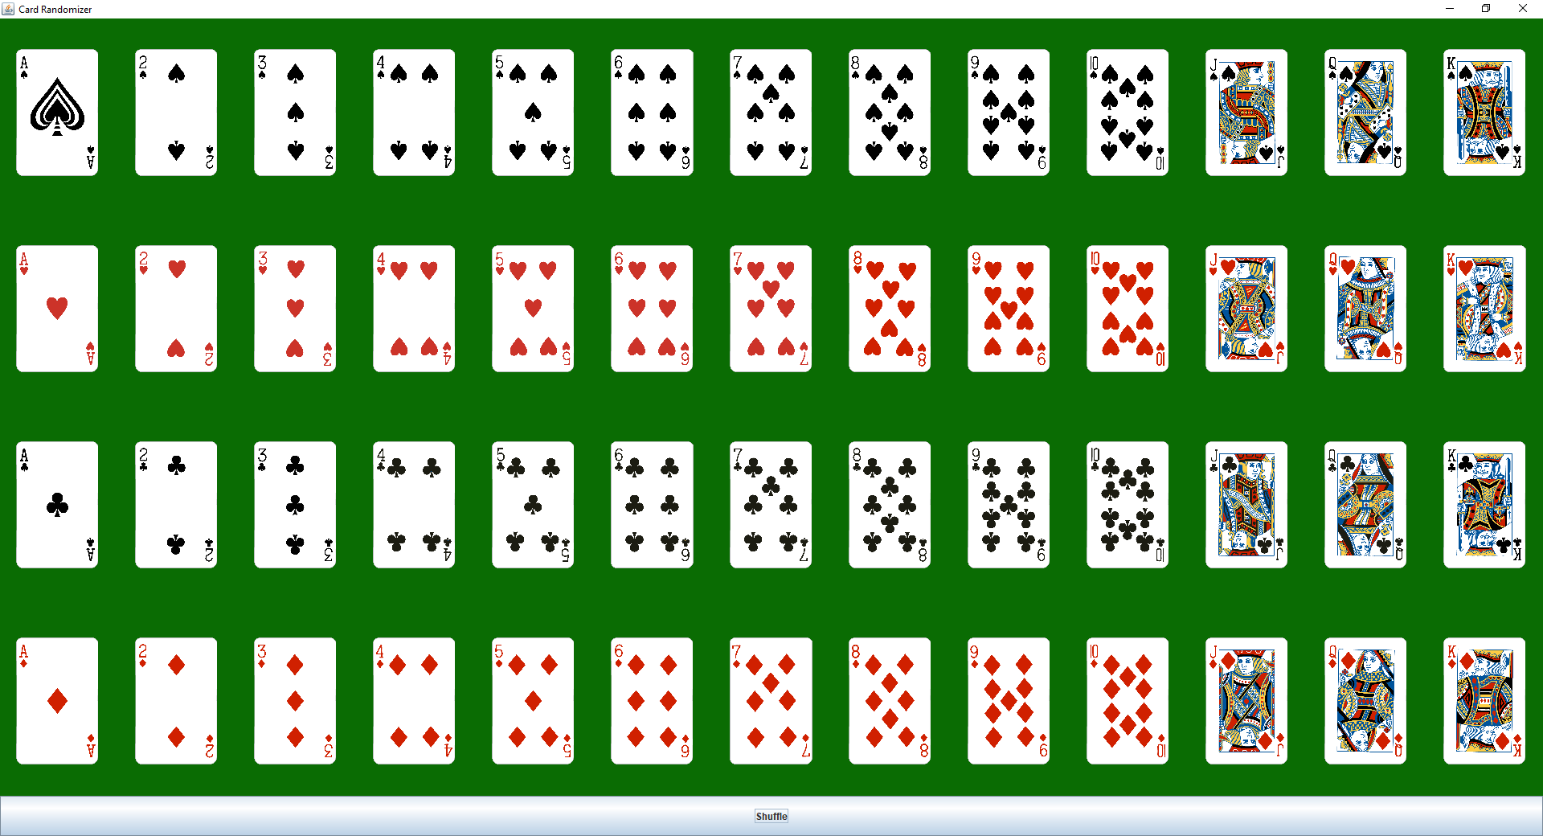
This time we will learn displaying images using javax.swing.ImageIcon. You need to display a lot of images on the GUI. First you need to manually download all poker card images from some sources. You should display all the poker card images on the main GUI, and a button at the bottom. Every time the button is clicked, the poker cards should be shuffled and redisplayed. Use your creativity to implement your GUI.

Solution:
- First, remember to zip the source code files (.java) and submit the zip file, naming it as “370-Lab-X-Team-Y.zip” to the ungraded assignment named “Lab4CodeSubmission”. One submission from each team.
- Paste a screenshot of your system running.
- Save this report in PDF, then each team submit your pdf report to the graded assignment named “Lab4”. One submission from each team.

