

CAPSTONE PROJECT REPORT
Report 3 – Software Requirement Specification

– Hanoi, Oct 2026 –

Table of Contents
Table of Contents 2
Change Log 7
Definition and Acronyms 8
I. Overall Requirements 9
1. Context Diagram 9
2. Main Business Flow 9
2.1 Replenishment, Procurement and Goods Receiving (BF-01) 9
2.2 Defective Goods Isolation and Disposition (BF-02) 10
2.3 Warehouse Transfer and Discrepancy Resolution (BF-03) 11
2.4 Stocktake and Inventory Adjustment (BF-04) 12
2.5 Warehouse Issue and Stock Deduction (BF-05) 13
2.6 Customer Return and Returned Goods Classification (BF-06) 14
2.7 Supplier Return and Inventory Reconciliation (BF-07) 15
3. Conceptual Data Model 16
3.1 Entity Relationship Diagram 16
3.2 Entity Descriptions 17
3.3 Data Business Rules 19
4. User Requirements 20
4.1 Actors 20
4.2 Use Cases (UC) 20
4.3 Use Case Diagrams 23
4.3.1 24
4.3.2 24
4.3.3 24
4.3.4 25
4.3.5 25
4.4 Permission Matrix 25
5. System Functionalities 29
5.1 Screen Inventory 29
a. Screen Flow 29
b. Screen List 29
5.2 External API Inventory 30
5.3 Background Job Inventory 30
II. Use Case Specifications 31
1. Access and Role Management (FE-01) 31
1.1 UC-01: Sign in to the system 31
1.2 UC-02: View account list 31
1.3 UC-03: View account details 32
1.4 UC-04: Create staff account 33
1.5 UC-05: Update staff account 33
1.6 UC-06: Activate or deactivate account 34
1.7 UC-07: Assign roles and operation permissions 35
2. Product, Lot and Unit Management (FE-02) 35
2.1 UC-08: View product list 35
2.2 UC-09: View product details 36
2.3 UC-10: Create product 37
2.4 UC-11: Update product 37
2.5 UC-12: Activate or deactivate product 38
2.6 UC-13: Configure packaging and unit conversion 39
2.7 UC-14: View lot list 39
2.8 UC-15: View lot details 40
2.9 UC-16: Create product lot 41
2.10 UC-17: Update lot information 41
3. Supplier Reference Management (FE-03) 42
3.1 UC-18: View supplier list 42
3.2 UC-19: View supplier details 43
3.3 UC-20: Create supplier 43
3.4 UC-21: Update supplier 44
3.5 UC-22: Activate or deactivate supplier 45
4. Purchase Order and Supplier Confirmation (FE-04) 45
4.1 UC-23: View replenishment request list 45
4.2 UC-24: View replenishment request details 46
4.3 UC-25: Create replenishment request 47
4.4 UC-26: Approve or reject replenishment request 47
4.5 UC-27: View purchase order list 48
4.6 UC-28: View purchase order details 49
4.7 UC-29: Create purchase order 49
4.8 UC-30: Update or cancel purchase order 50
4.9 UC-31: Record supplier confirmation 51
4.10 UC-32: View outstanding receipt quantity 52
5. Goods Receiving and Inspection (FE-05) 52
5.1 UC-33: View goods receipt list 52
5.2 UC-34: View goods receipt details 53
5.3 UC-35: Create goods receipt from purchase order 53
5.4 UC-36: Record actual received quantity and characteristics 54
5.5 UC-37: Classify inspection results 55
5.6 UC-38: Record defects during receiving 56
5.7 UC-39: Record receiving discrepancies 56
5.8 UC-40: Complete accepted goods receipt 57
6. Warehouse and Storage Location Management (FE-06) 58
6.1 UC-41: View warehouse and location list 58
6.2 UC-42: View storage location details 58
6.3 UC-43: Create storage location 59
6.4 UC-44: Update storage location 60
6.5 UC-45: Activate or deactivate storage location 60
6.6 UC-46: Allocate accepted goods to a location 61
7. Inventory by Lot, Location and Status (FE-07) 62
7.1 UC-47: View stock by lot, location, and quality status 62
7.2 UC-48: View inventory balance details 62
7.3 UC-49: Reclassify goods as pending inspection or defective 63
7.4 UC-50: Record disposition of quarantined goods 64
7.5 UC-51: View defective goods list 65
7.6 UC-52: View defective goods details 65
7.7 UC-53: Record defects discovered in storage 66
7.8 UC-54: Create defective goods disposition request 67
7.9 UC-55: Approve or reject defective goods disposition 67
7.10 UC-56: Record approved defective goods disposition 68
8. Location Movement and Warehouse Transfer (FE-08) 69
8.1 UC-57: View location movement list 69
8.2 UC-58: View location movement details 69
8.3 UC-59: Create location movement 70
8.4 UC-60: Confirm actual location movement 71
8.5 UC-61: View warehouse transfer list 71
8.6 UC-62: View warehouse transfer details 72
8.7 UC-63: Create warehouse transfer 73
8.8 UC-64: Record transfer dispatch 73
8.9 UC-65: Record transfer handover 74
8.10 UC-66: Record receipt at destination warehouse 75
8.11 UC-67: Record transfer discrepancy 76
8.12 UC-68: Request transfer discrepancy resolution 76
8.13 UC-69: Approve or reject transfer discrepancy resolution 77
9. Stocktake and Inventory Adjustment (FE-09) 78
9.1 UC-70: View stocktake list 78
9.2 UC-71: View stocktake details 78
9.3 UC-72: Create stocktake 79
9.4 UC-73: Capture system balance at stocktake cutoff 80
9.5 UC-74: Enter actual counted quantities 80
9.6 UC-75: Record recount result 81
9.7 UC-76: Record variance reason 82
9.8 UC-77: View inventory adjustment request list 82
9.9 UC-78: View inventory adjustment request details 83
9.10 UC-79: Create inventory adjustment request 84
9.11 UC-80: Approve or reject inventory adjustment 84
9.12 UC-81: Post approved inventory adjustment 85
10. Warehouse Issue (FE-10) 86
10.1 UC-82: View goods issue request list 86
10.2 UC-83: View goods issue request details 86
10.3 UC-84: Create goods issue request 87
10.4 UC-85: View goods issue list 88
10.5 UC-86: View goods issue details 88
10.6 UC-87: Create goods issue 89
10.7 UC-88: Select issue lots and locations 90
10.8 UC-89: Confirm actual goods issue quantity 90
11. Customer and Supplier Return Stock Handling (FE-11) 91
11.1 UC-90: View customer return list 91
11.2 UC-91: View customer return details 92
11.3 UC-92: Record customer goods return 92
11.4 UC-93: Inspect returned goods 93
11.5 UC-94: Classify returned goods disposition 94
11.6 UC-95: Approve or reject customer return disposition 94
11.7 UC-96: View supplier return request list 95
11.8 UC-97: View supplier return request details 96
11.9 UC-98: Create supplier return request 96
11.10 UC-99: Quarantine goods pending supplier return 97
11.11 UC-100: Approve or reject supplier return request 98
11.12 UC-101: Record actual supplier return dispatch 98
12. Warehouse Reports (FE-12) 99
12.1 UC-102: View inventory movement summary report 99
12.2 UC-103: View stock by lot and location report 100
12.3 UC-104: View purchase order and receipt report 101
12.4 UC-105: View warehouse transfer report 101
12.5 UC-106: View stocktake and adjustment report 102
13. Inventory Audit Trail (FE-13) 102
13.1 UC-107: View stock movement log 102
13.2 UC-108: View stock movement details 103
13.3 UC-109: Trace a product lot through source documents 104
III. Functional Requirements 104
1. Access and Role Management (FE-01) 105
1.1 Sign In 105
1.1.1 SC-01: Sign In 105
1.2 Account List and Details 106
1.2.1 SC-02: Account List and Details 106
2. Product, Lot and Unit Management (FE-02) 107
2.1 Product and Unit Conversion 107
2.1.1 SC-03: Product and Unit Conversion 107
2.2 Lot List and Details 108
2.2.1 SC-04: Lot List and Details 108
3. Supplier Reference Management (FE-03) 109
3.1 Supplier List and Details 109
3.1.1 SC-05: Supplier List and Details 109
4. Purchase Order and Supplier Confirmation (FE-04) 110
4.1 Replenishment Requests 110
4.1.1 SC-06: Replenishment Requests 110
4.2 Purchase Orders 111
4.2.1 SC-07: Purchase Orders 111
5. Goods Receiving and Inspection (FE-05) 113
5.1 Goods Receipts and Inspection 113
5.1.1 SC-08: Goods Receipts and Inspection 113
6. Warehouse and Storage Location Management (FE-06) 114
6.1 Warehouse Locations 114
6.1.1 SC-09: Warehouse Locations 114
7. Inventory by Lot, Location and Status (FE-07) 116
7.1 Inventory by Lot and Status 116
7.1.1 SC-10: Inventory by Lot and Status 116
7.2 Defective Goods and Disposition 117
7.2.1 SC-11: Defective Goods and Disposition 117
8. Location Movement and Warehouse Transfer (FE-08) 118
8.1 Location Movements 118
8.1.1 SC-12: Location Movements 118
8.2 Warehouse Transfers and Discrepancies 119
8.2.1 SC-13: Warehouse Transfers and Discrepancies 119
9. Stocktake and Inventory Adjustment (FE-09) 121
9.1 Stocktake and Counting 121
9.1.1 SC-14: Stocktake and Counting 121
9.2 Inventory Adjustment Requests 122
9.2.1 SC-15: Inventory Adjustment Requests 122
10. Warehouse Issue (FE-10) 123
10.1 Goods Issue Requests 123
10.1.1 SC-16: Goods Issue Requests 123
10.2 Goods Issue and Actual Dispatch 124
10.2.1 SC-17: Goods Issue and Actual Dispatch 124
11. Customer and Supplier Return Stock Handling (FE-11) 125
11.1 Customer Goods Returns 125
11.1.1 SC-18: Customer Goods Returns 125
11.2 Supplier Return Requests 127
11.2.1 SC-19: Supplier Return Requests 127
12. Warehouse Reports (FE-12) 128
12.1 Inventory Reports 128
12.1.1 SC-20: Inventory Reports 128
13. Inventory Audit Trail (FE-13) 129
13.1 Stock Movement Log and Lot Trace 129
13.1.1 SC-21: Stock Movement Log and Lot Trace 129
14. Background Job Inventory 130
14.1 Background Job Scope 130
15. External API Inventory 130
15.1 External API Scope 130
IV. Non-Functional Requirements 131
1. External Interfaces 131
2. Quality Attributes 131
2.1 Usability 131
2.2 Performance 131
2.3 Security 131
2.4 Reliability and Data Integrity 132
2.5 Maintainability and Traceability 132
V. Requirement Appendix 132
1. Business Rules 132
2. System Messages 133
3. Other Requirements 134

Change Log
Date | A/M/D | In Charge | Change Description
09 Oct 2026 | M | Project documentation | Refined all 109 UC specifications; aligned FE names and UI mockups; specified 176 screen fields with proposed SQL Server types, entry requirements, defaults and validations.

A = Added; M = Modified; D = Deleted. This revision date records document editing, not business sign-off.

Definition and Acronyms
Acronym / Term | Definition
WMSD | Warehouse Management System
SRS | Software Requirements Specification
UC | Use Case
FE | Feature
BF | Business Flow
PO | Purchase Order
UoM | Unit of Measure
GR | Goods Receipt
Lot | A tile batch identified by number, tone and actual calibre
Usable stock | Accepted quantity eligible for goods issue or applicable movement
Physical stock | Quantities physically recorded across quality classifications
Cut-off snapshot | Stock balance preserved at the defined stocktake cut-off
N–X–T | Inbound–Outbound–Closing Stock report (local stock ledger terminology)

I. Overall Requirements

1. Context Diagram
The WMSD supports internal tile-warehouse operations: access control, products and lots, suppliers, replenishment, purchase orders, receiving and inspection, storage locations, quality-specific balances, stock movements, stocktake, goods issue, returns, reports and lot traceability. External suppliers and customers are represented by source documents, not by assumed portal-user accounts.
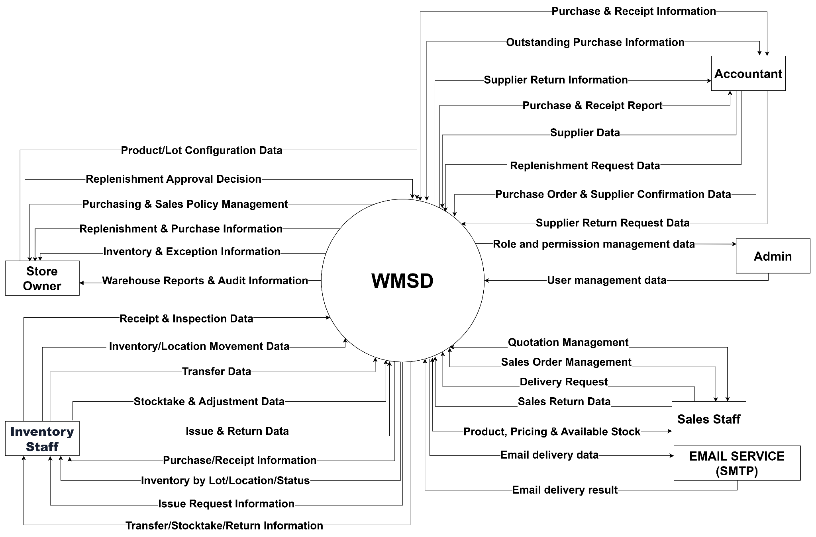
Figure 1. System context diagram — source-defined interacting roles

2. Main Business Flow

2.1 Replenishment, Procurement and Goods Receiving (BF-01)
Trigger: Inventory Staff identifies a replenishment need based on current stock levels and creates a replenishment request for review and approval.
End condition: The replenishment request is rejected without further procurement, or the approved request results in a purchase order and completed goods receipt. Accepted quantities are recorded in inventory by lot, location and quality status, while outstanding purchase quantities are updated.
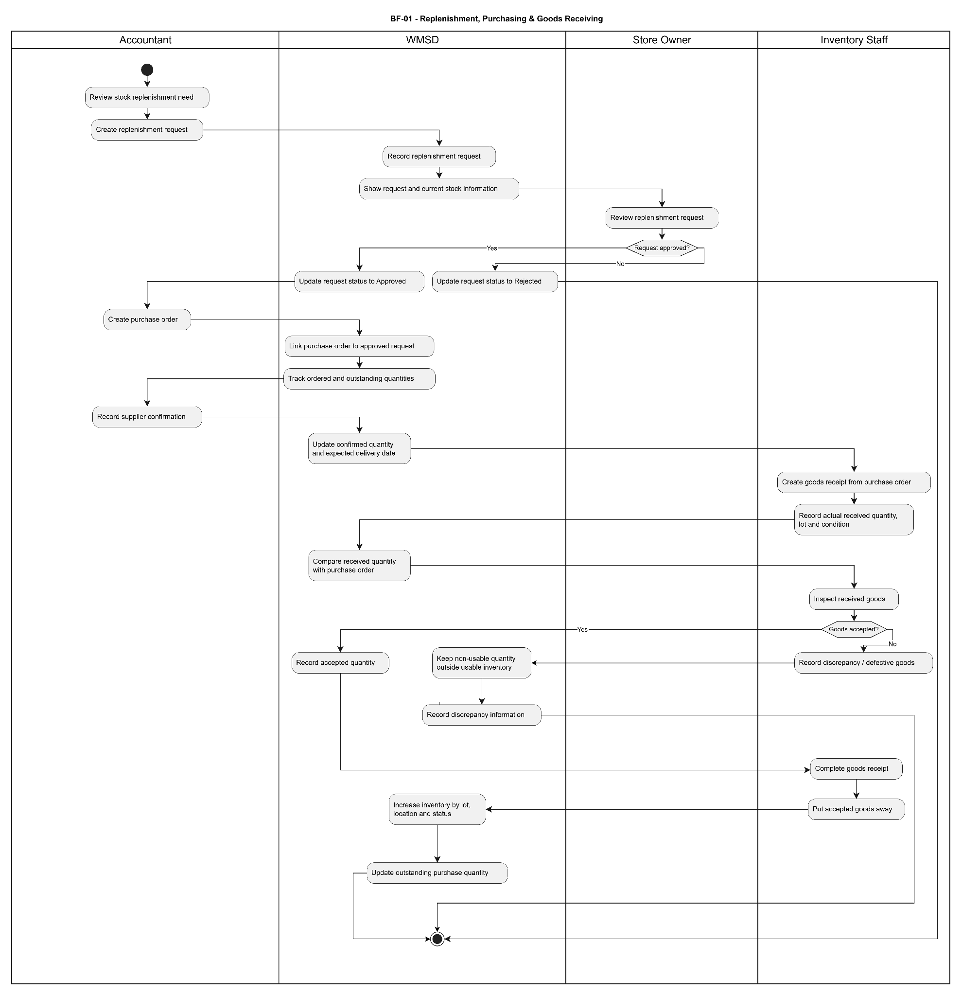
Figure 1. Replenishment, Procurement and Goods Receiving — actor/system workflow.
Decision handling: A rejected replenishment request cannot proceed to purchase order creation. During receiving, accepted goods are recorded as usable inventory, while defective or discrepant quantities are segregated and documented. Only accepted quantities are posted to usable inventory. Outstanding purchase quantities are updated based on actual receipt records.

2.2 Defective Goods Isolation and Disposition (BF-02)
Trigger: Inventory Staff identifies defective, damaged or otherwise non-usable goods during warehouse operations and records the defect information.
End condition: The defective quantity is isolated and its disposition is approved and processed, with inventory quantities, final stock status and movement history updated accordingly. Rejected disposition proposals remain subject to revision and further review.
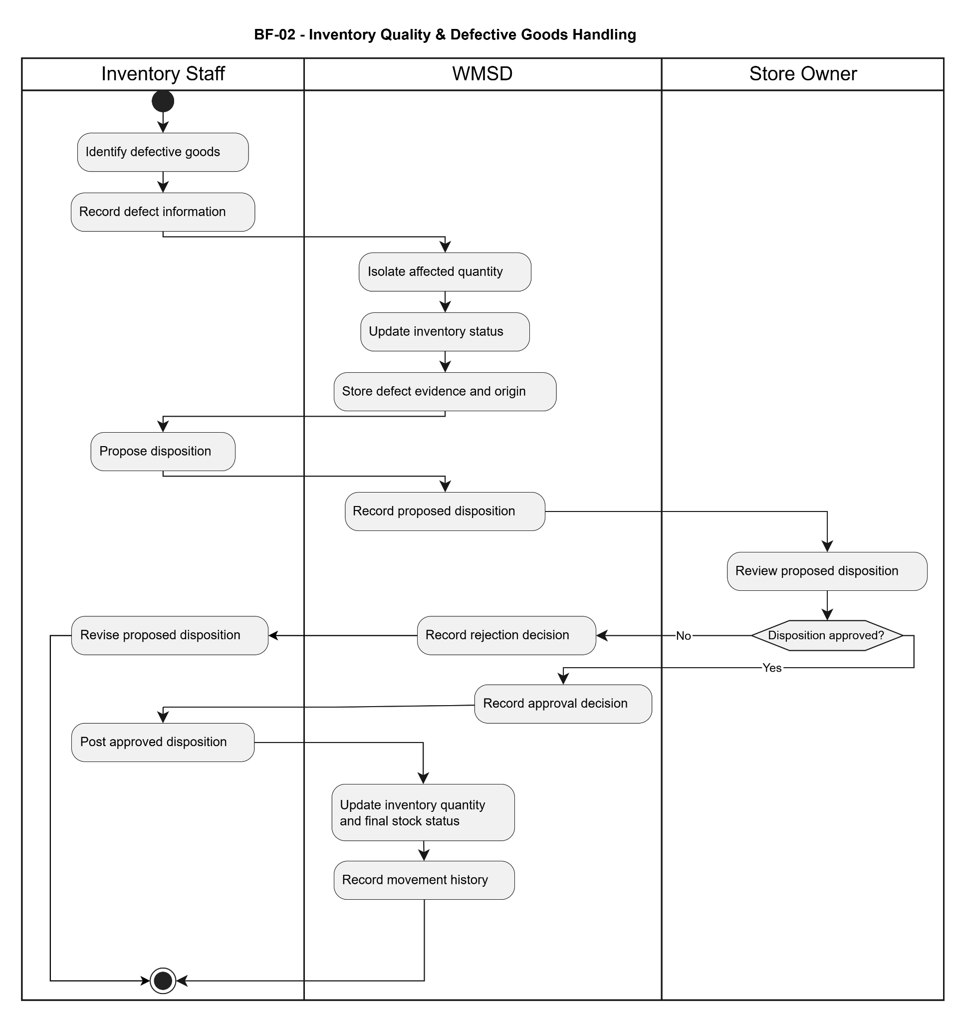
Figure 2. Defective Goods Isolation and Disposition — actor/system workflow.
Decision handling: Identified defective quantities are separated from usable inventory to prevent unauthorized issuing or movement. If a disposition proposal is rejected, the rejection is recorded and the proposal must be revised before further processing. Only approved dispositions may be posted, and the system records the resulting stock changes and movement history.

2.3 Warehouse Transfer and Discrepancy Resolution (BF-03)
Trigger: Warehouse Staff creates a warehouse transfer request to move inventory from a source warehouse to a destination warehouse.
End condition: The transfer is completed after the dispatched and received quantities are reconciled, and the destination inventory is updated. Transfers with unresolved quantity discrepancies remain open until an approved resolution is recorded and applied.
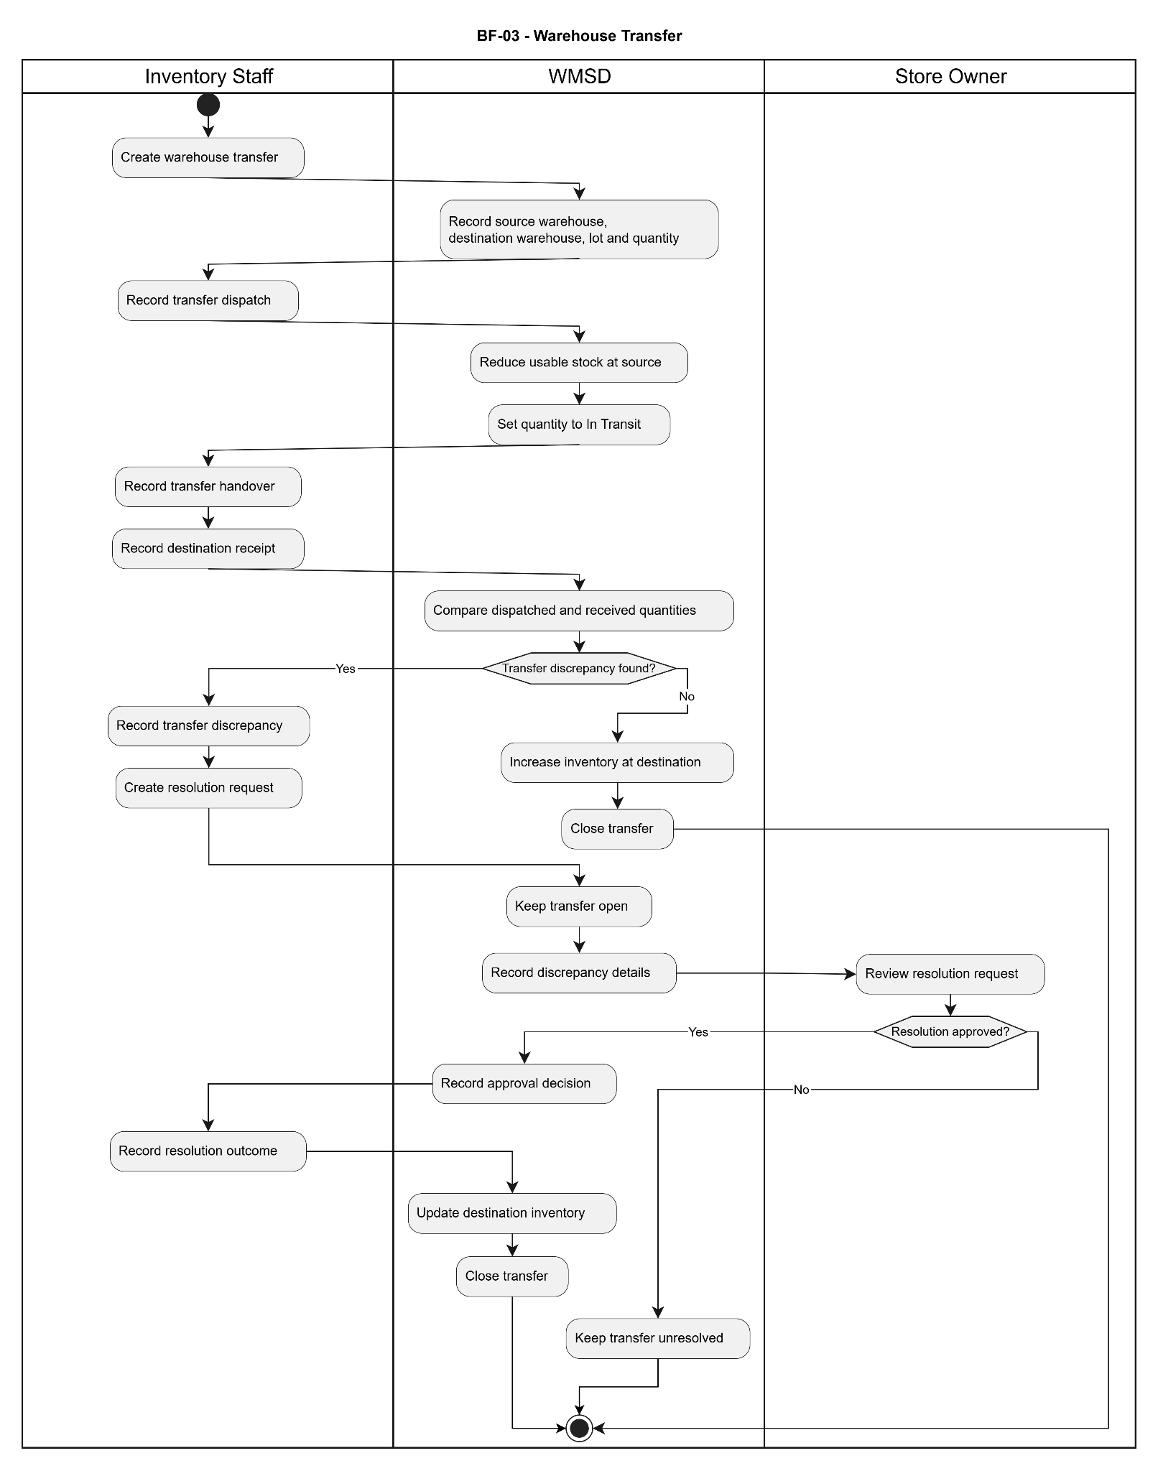
Figure 3. Warehouse Transfer and Discrepancy Resolution — actor/system workflow.
Decision handling: Upon dispatch, the system reduces usable inventory at the source warehouse and records the transferred quantity as In Transit. After receiving, the system compares dispatched and received quantities. Matching quantities allow the transfer to be completed. If a discrepancy exists, the system records the difference and creates a resolution request. Approved resolutions update the relevant inventory balances before closure; rejected or unresolved requests keep the transfer open.

2.4 Stocktake and Inventory Adjustment (BF-04)
Trigger: An authorized user creates a stocktake to verify physical inventory against recorded stock balances at a defined cut-off time.
End condition: The stocktake is completed when no variance is identified, or an approved inventory adjustment is posted for verified discrepancies. Inventory balances and adjustment history reflect the approved results.
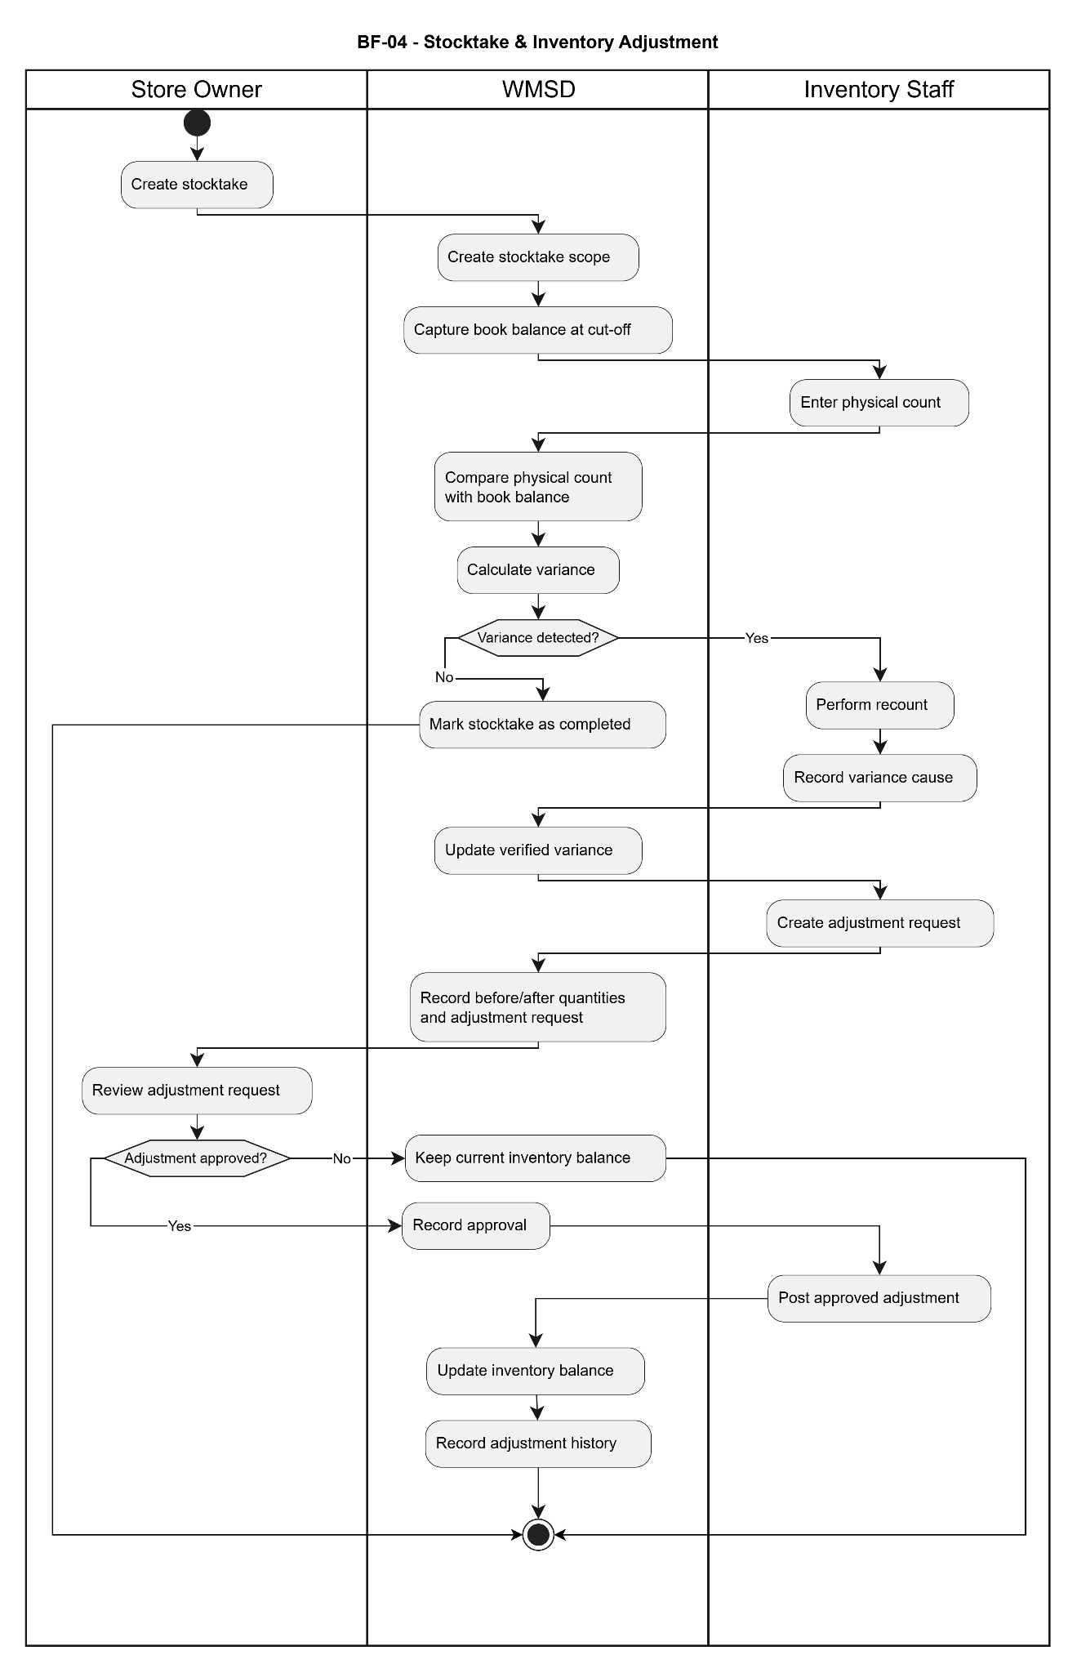
Figure 4. Stocktake and Inventory Adjustment — actor/system workflow.
Decision handling: The system compares physical counts with the book balance captured at the stocktake cut-off. If no variance is detected, the stocktake is marked as completed without an inventory adjustment. If a variance exists, staff performs a recount, records the variance cause and submits an adjustment request. Rejected adjustments do not change inventory balances. Approved adjustments update the inventory and preserve before/after quantities in the adjustment history.

2.5 Warehouse Issue and Stock Deduction (BF-05)
Trigger: An authorized user creates a goods issue request specifying the source reference, products and requested quantities for warehouse fulfillment.
End condition: The actual issued quantities are confirmed, the corresponding inventory is deducted from the selected lots and storage locations, and the goods issue status and inventory movement history are updated.
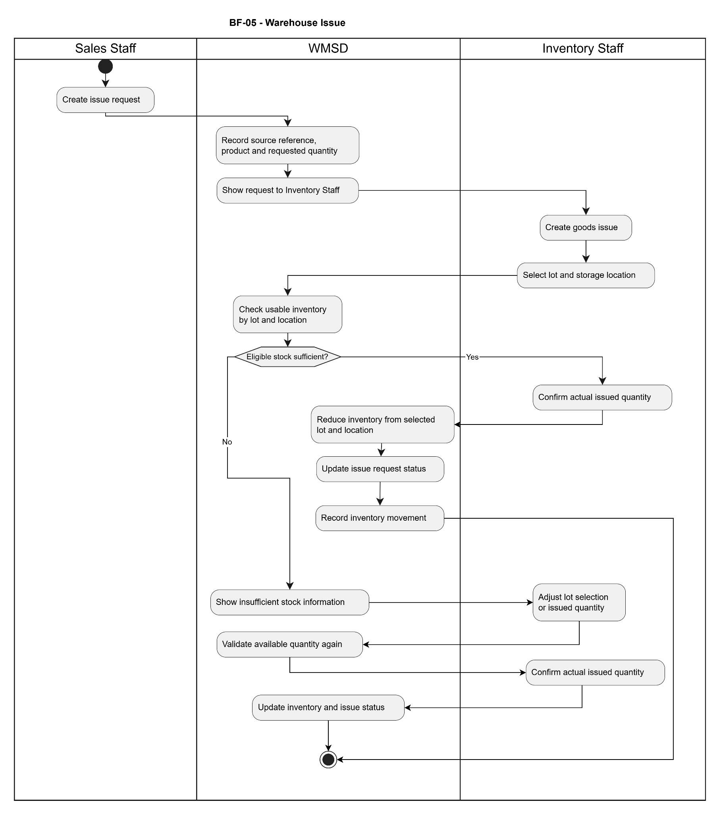
Figure 5. Warehouse Issue and Stock Deduction — actor/system workflow.
Decision handling: Before confirming a goods issue, the system validates usable inventory by lot and location. If sufficient eligible stock is available, the confirmed quantity is deducted and the issue is recorded. If stock is insufficient, the system displays the shortage and requires the warehouse operator to revise the lot selection or issued quantity. Inventory deduction must not proceed until the revised quantities pass validation.

2.6 Customer Return and Returned Goods Classification (BF-06)
Trigger: An authorized user records a customer return against an originating transaction, specifying the returned products, lots, quantities and return reasons.
End condition: Returned goods have been inspected and classified, and an approved disposition has been applied. Reusable quantities are returned to usable inventory, while non-reusable quantities remain isolated under the appropriate stock status.
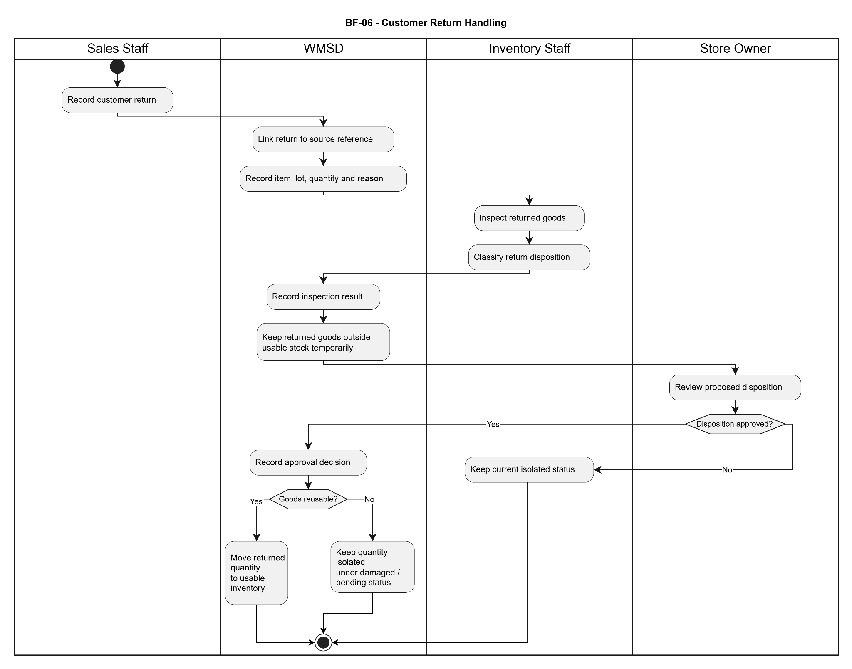
Figure 6. Customer Return and Returned Goods Classification — actor/system workflow.
Decision handling: Returned goods are initially kept outside usable inventory pending inspection and disposition approval. If the proposed disposition is rejected, the returned quantity remains isolated and no usable inventory is increased. If approved, reusable goods are transferred to usable inventory, while damaged or non-reusable goods remain isolated under the corresponding status. Inventory changes must follow the approved classification.

2.7 Supplier Return and Inventory Reconciliation (BF-07)
Trigger: An authorized user creates a supplier return request for goods that must be returned to the supplier, referencing the original receipt, product, lot, storage location, quantity and return reason.
End condition: An approved supplier return is dispatched and completed, with the corresponding stock quantity deducted and its movement history recorded. Rejected returns are documented, and the affected goods remain subject to reclassification and appropriate inventory status handling.
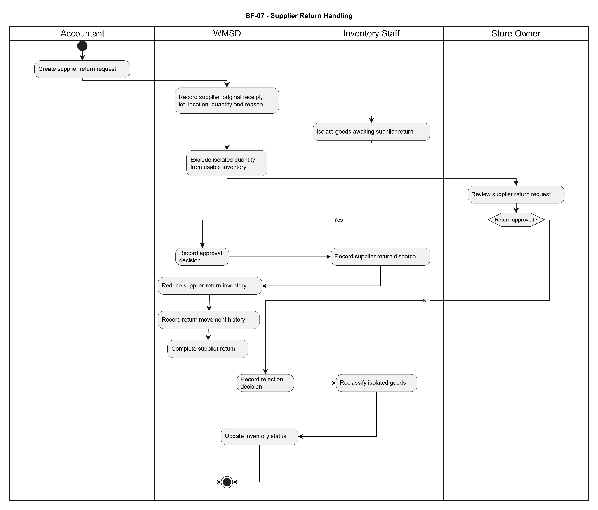
Figure 7. Supplier Return and Inventory Reconciliation — actor/system workflow.
Decision handling: Goods identified for supplier return are isolated and excluded from usable inventory while awaiting approval. If the return is approved, the system records dispatch, deducts the corresponding supplier-return inventory and completes the return with traceable movement history. If rejected, the system records the rejection, requires reclassification of the isolated goods and updates their inventory status without posting a supplier-return dispatch.

3. Conceptual Data Model

3.1 Entity Relationship Diagram
The following Crow’s-Foot conceptual diagram follows the 15 business entities and the attribute-box presentation in the supplied ERD reference. Relationship labels are business verbs. Multiplicities are conceptual and should be confirmed against the final physical data model; PK/FK columns are intentionally omitted.
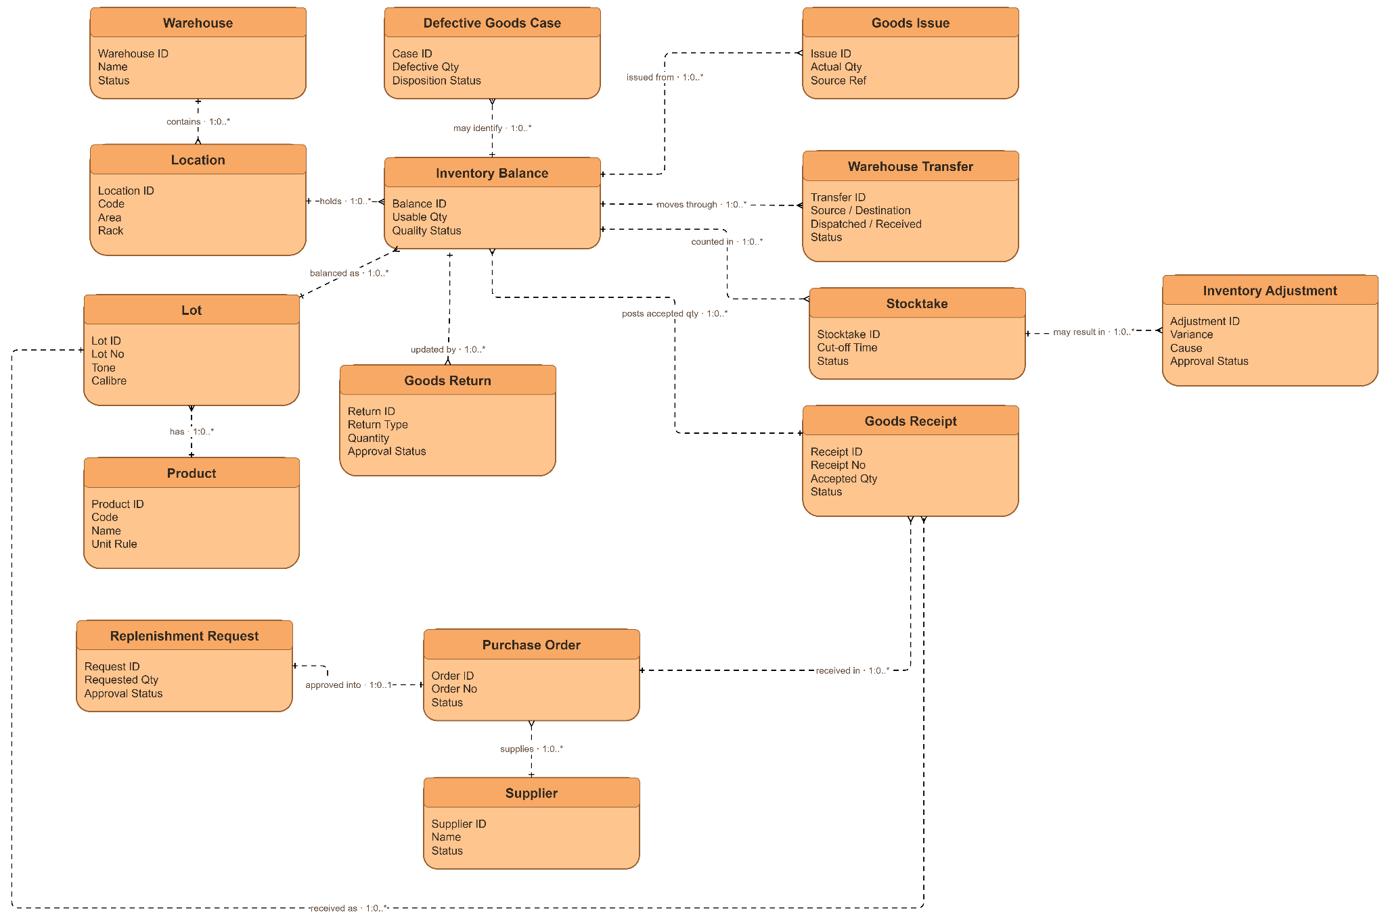

Figure 9. Conceptual entity relationship diagram — entity attributes and labelled cardinalities

3.2 Entity Descriptions
Entity: Warehouse
Field | Value
Purpose | Logical or physical warehouse referenced by put-away, stock, transfer and reporting.
Key business attributes | Warehouse ID, Name, Status
Business identity | Warehouse ID distinguishes warehouse records.
Status / lifecycle | Active or inactive for new selection.
UC traceability | UC-41–46; UC-61–69

Entity: Defective Goods Case
Field | Value
Purpose | Evidence-based record of defective or quarantined goods and authorized disposition.
Key business attributes | Case ID, Lot / Location, Defective Quantity, Disposition Status
Business identity | Case ID identifies the defect incident and links lot/location.
Status / lifecycle | Under review, approved/rejected, handled; technical enum not specified.
UC traceability | UC-49–56

Entity: Goods Issue
Field | Value
Purpose | Physical goods issue created against a source issue request.
Key business attributes | Issue ID, Source Request, Actual Quantity, Status
Business identity | Issue ID references the related issue request.
Status / lifecycle | Prepared and actual issued quantities separately retained.
UC traceability | UC-82–89

Entity: Location
Field | Value
Purpose | An addressable storage place in a warehouse, including area, aisle and rack.
Key business attributes | Location ID, Code, Area, Rack, Status
Business identity | Location code identifies the place within the warehouse.
Status / lifecycle | Active/inactive; cannot deactivate while any quantity remains.
UC traceability | UC-41–46

Entity: Inventory Balance
Field | Value
Purpose | Quantity for a product lot at a warehouse location and quality state.
Key business attributes | Balance ID, Product / Lot, Location, Usable Quantity, Quality Status
Business identity | Unique logical balance scope is warehouse, location, product, lot and quality status.
Status / lifecycle | Accepted, pending inspection, defective, quarantined or in transit as appropriate.
UC traceability | UC-47–56

Entity: Warehouse Transfer
Field | Value
Purpose | Stock transfer documenting source dispatch, handover, receipt and discrepancies.
Key business attributes | Transfer ID, Source / Destination, Dispatched / Received, Status
Business identity | Transfer ID identifies the cross-warehouse transaction.
Status / lifecycle | Planned, in transit, received, discrepancy pending; exact codes to confirm.
UC traceability | UC-61–69

Entity: Lot
Field | Value
Purpose | Actual product batch distinguished by lot, tone and calibre.
Key business attributes | Lot ID, Lot Number, Tone, Actual Calibre, Production Date
Business identity | Identity uses the product and lot-characteristic combination.
Status / lifecycle | Lot record retains link to posted stock movements.
UC traceability | UC-14–17

Entity: Goods Return
Field | Value
Purpose | Customer-return or supplier-return process and its resulting inventory status.
Key business attributes | Return ID, Return Type, Quantity, Approval Status
Business identity | Return ID, type and related source document distinguish returns.
Status / lifecycle | Inspected, pending decision, approved, dispatched/posted as applicable.
UC traceability | UC-90–101

Entity: Stocktake
Field | Value
Purpose | Count period/scope with immutable system balance at its cutoff.
Key business attributes | Stocktake ID, Cut-off Time, Scope, Status
Business identity | Stocktake ID and cutoff distinguish individual inventory counts.
Status / lifecycle | Created, snapshot captured, counted and reconciled; codes to confirm.
UC traceability | UC-70–76

Entity: Inventory Adjustment
Field | Value
Purpose | Request and resulting stock delta for a documented stocktake variance.
Key business attributes | Adjustment ID, Variance, Cause, Approval Status
Business identity | Adjustment ID links the request to its stocktake and approval.
Status / lifecycle | Pending approval, approved/rejected, posted; one valid post only.
UC traceability | UC-77–81

Entity: Product
Field | Value
Purpose | Tile catalogue item and its packaging/unit conversion definition.
Key business attributes | Product ID, Code, Name, Unit Conversion Rule
Business identity | Product code identifies the item; conversions are product-specific.
Status / lifecycle | Active/inactive; historical quantities remain linked.
UC traceability | UC-08–13

Entity: Goods Receipt
Field | Value
Purpose | An individual supplier delivery linked to its purchase order.
Key business attributes | Receipt ID, Receipt / Order Reference, Accepted Quantity, Status
Business identity | Receipt ID identifies each delivery separately.
Status / lifecycle | Receiving, inspected and accepted portions are tracked independently.
UC traceability | UC-33–40

Entity: Replenishment Request
Field | Value
Purpose | Request for stock replenishment requiring Store Manager decision.
Key business attributes | Request ID, Requested Quantity, Approval Status
Business identity | Request ID differentiates submitted proposals.
Status / lifecycle | Pending decision, approved, or rejected; exact system status codes unconfirmed.
UC traceability | UC-23–26

Entity: Purchase Order
Field | Value
Purpose | Supplier order created from an approved replenishment request.
Key business attributes | Order ID, Order Number, Supplier, Status
Business identity | Order number and individual item lines reference the request.
Status / lifecycle | Tracks ordered, confirmed, received and outstanding quantities.
UC traceability | UC-27–32

Entity: Supplier
Field | Value
Purpose | Supplier reference used for purchasing and supplier returns.
Key business attributes | Supplier ID, Name, Status
Business identity | Supplier code distinguishes supplier records.
Status / lifecycle | Active/inactive; inactive suppliers cannot be selected for new orders.
UC traceability | UC-18–22

3.3 Data Business Rules
Rule | Description | Applies To
DR-01 | Product and lot identifiers must distinguish tone/calibre to avoid merging physically different tiles. | UC-10,16,36,47
DR-02 | Box/piece/m² conversions are product-specific and must not retrospectively change posted historical quantities. | UC-13,36,74
DR-03 | A purchase order may have multiple receipts; editing/canceling an outstanding part cannot erase receipts already posted. | UC-30–35
DR-04 | Only accepted goods or subsequently authorized accepted disposition increase usable stock; other quality states remain separate. | UC-37–40,49–56
DR-05 | A location containing stock in any quality state cannot be deactivated; inactive locations are not available for new transactions. | UC-43–46
DR-06 | Movement between locations of the same warehouse does not change overall warehouse quantity. | UC-59–60
DR-07 | Cross-warehouse transfer records dispatch, handover and destination receipt separately; discrepancies require evidence and approval. | UC-63–69
DR-08 | Stocktake compares counted quantity with an immutable system snapshot; later transactions remain separately identifiable. | UC-72–76
DR-09 | Inventory adjustments are posted only for approved requests and cannot be posted twice. | UC-79–81
DR-10 | Goods issue deducts actual issued quantity from the specified eligible lot/location without making available stock negative. | UC-84–89
DR-11 | Customer returns cannot increase usable stock until inspection and the disposition decision are completed. | UC-92–95
DR-12 | Supplier return dispatch does not deduct the same goods twice when they were rejected at receipt. | UC-98–101
DR-13 | Every posted stock movement is traceable to source document, original and resulting quantities, user and time. | UC-107–109
DR-14 | Deactivation of a master record prevents selection for new operations but must not erase historical references. | UC-05,06,12,22

4. User Requirements

4.1 Actors
# | Actor | Description
1 | Store Manager | Creates/maintains products and approves replenishment, defective goods, transfer differences, stocktake adjustments and returns. Views applicable reports.
2 | Accountant | Maintains suppliers, replenishment requests, purchase orders, supplier confirmations and the documented purchasing/receiving views.
3 | Warehouse Staff | Records receipts, inspections, put-away, quality states, stock movement, stocktakes, actual issues and returns; accesses lot traceability.
4 | Sales Staff | Views permitted product/stock data, records dispatch requests and customer returns in the source-defined scope.
5 | Administrator | Manages accounts, roles and access permissions; is not automatically assigned operational warehouse permissions.

4.2 Use Cases (UC)
The list reproduces the 109 source UCs (UC-01–UC-109), retaining their IDs, feature groups and role assignments. Names and descriptions have been faithfully rendered in English. Screen IDs are specification references, not additional business use cases.
ID | Use Case | Feature | Use Case Description
UC-01 | Sign in to the system | FE-01 — Access and Role Management | Access authorized functions according to the assigned account and role.
UC-02 | View account list | FE-01 — Access and Role Management | Search and filter accounts by name, role, and active status.
UC-03 | View account details | FE-01 — Access and Role Management | Display the selected account's information, assigned role, and status.
UC-04 | Create staff account | FE-01 — Access and Role Management | Register an internal user account and select an appropriate role.
UC-05 | Update staff account | FE-01 — Access and Role Management | Edit allowed account information without losing its action history.
UC-06 | Activate or deactivate account | FE-01 — Access and Role Management | Enable or prevent account sign-in while preserving historical documents.
UC-07 | Assign roles and operation permissions | FE-01 — Access and Role Management | Configure view, create, edit, and transaction-recording permissions by role.
UC-08 | View product list | FE-02 — Product, Lot and Unit Management | Search products by item code, name, size, and status.
UC-09 | View product details | FE-02 — Product, Lot and Unit Management | Display tile attributes, packaging specifications, and units of measure.
UC-10 | Create product | FE-02 — Product, Lot and Unit Management | Record product code, category, brand, material, nominal size, and identifying characteristics.
UC-11 | Update product | FE-02 — Product, Lot and Unit Management | Edit allowed attributes without corrupting existing documents or inventory history.
UC-12 | Activate or deactivate product | FE-02 — Product, Lot and Unit Management | Prevent selection on new documents while retaining inventory and history.
UC-13 | Configure packaging and unit conversion | FE-02 — Product, Lot and Unit Management | Define pieces per box and area per piece for box, piece, and square-meter conversion by product.
UC-14 | View lot list | FE-02 — Product, Lot and Unit Management | Search lots by product, lot number, tone, and actual calibre.
UC-15 | View lot details | FE-02 — Product, Lot and Unit Management | Display production date, tone, actual calibre, and related transaction history.
UC-16 | Create product lot | FE-02 — Product, Lot and Unit Management | Record lot number and physical tile characteristics on arrival, checking duplicate identity.
UC-17 | Update lot information | FE-02 — Product, Lot and Unit Management | Edit permitted lot attributes while preserving warehouse transactions already recorded.
UC-18 | View supplier list | FE-03 — Supplier Reference Management | Search suppliers by code, name, and cooperation status.
UC-19 | View supplier details | FE-03 — Supplier Reference Management | Display contact information and related purchases, receipts, and returns.
UC-20 | Create supplier | FE-03 — Supplier Reference Management | Record supplier code, name, address, telephone number, and contact person.
UC-21 | Update supplier | FE-03 — Supplier Reference Management | Edit supplier contact details and reference information.
UC-22 | Activate or deactivate supplier | FE-03 — Supplier Reference Management | Prevent inactive suppliers from being selected on new purchase orders while retaining old records.
UC-23 | View replenishment request list | FE-04 — Purchase Order and Supplier Confirmation | Search requests by status, date, creator, and approval decision.
UC-24 | View replenishment request details | FE-04 — Purchase Order and Supplier Confirmation | Display required products, reference stock, requested quantities, and approval history.
UC-25 | Create replenishment request | FE-04 — Purchase Order and Supplier Confirmation | Propose replenishment after checking stock and recording products, quantities, and reasons.
UC-26 | Approve or reject replenishment request | FE-04 — Purchase Order and Supplier Confirmation | Review the request and record decision, approver, time, and rejection reason.
UC-27 | View purchase order list | FE-04 — Purchase Order and Supplier Confirmation | Filter orders by supplier, date, status, and outstanding quantity.
UC-28 | View purchase order details | FE-04 — Purchase Order and Supplier Confirmation | Display order lines, supplier confirmations, and partial receipt history.
UC-29 | Create purchase order | FE-04 — Purchase Order and Supplier Confirmation | Create an order from an approved request, specifying supplier, products, quantities, units, and expected receipt date.
UC-30 | Update or cancel purchase order | FE-04 — Purchase Order and Supplier Confirmation | Change only the unreceived portion without deleting quantities already received.
UC-31 | Record supplier confirmation | FE-04 — Purchase Order and Supplier Confirmation | Record confirmed quantities and anticipated delivery schedule, including partial confirmation.
UC-32 | View outstanding receipt quantity | FE-04 — Purchase Order and Supplier Confirmation | Compare ordered, supplier-confirmed, delivered/received, and outstanding quantities by order line.
UC-33 | View goods receipt list | FE-05 — Goods Receiving and Inspection | Search deliveries associated with purchase orders and their processing status.
UC-34 | View goods receipt details | FE-05 — Goods Receiving and Inspection | Display delivered, accepted, pending inspection, defective, and rejected quantities.
UC-35 | Create goods receipt from purchase order | FE-05 — Goods Receiving and Inspection | Record each supplier delivery separately and link it to its purchase order.
UC-36 | Record actual received quantity and characteristics | FE-05 — Goods Receiving and Inspection | Enter boxes, pieces, square meters, lot, tone, calibre, location, and package condition.
UC-37 | Classify inspection results | FE-05 — Goods Receiving and Inspection | Split received goods into accepted, pending inspection, defective, and rejected categories.
UC-38 | Record defects during receiving | FE-05 — Goods Receiving and Inspection | Capture lot, defective quantity, defect type, and evidence separately from accepted stock.
UC-39 | Record receiving discrepancies | FE-05 — Goods Receiving and Inspection | Record shortages, excesses, mismatched characteristics, damage, and supporting documents.
UC-40 | Complete accepted goods receipt | FE-05 — Goods Receiving and Inspection | Post accepted quantities to appropriate inventory; maintain separate non-accepted categories.
UC-41 | View warehouse and location list | FE-06 — Warehouse and Storage Location Management | Search by warehouse, area, aisle, rack, and location code.
UC-42 | View storage location details | FE-06 — Warehouse and Storage Location Management | Display capacity, status, and lot-level quantities at a location.
UC-43 | Create storage location | FE-06 — Warehouse and Storage Location Management | Define area, aisle, rack, location code, and storage capacity.
UC-44 | Update storage location | FE-06 — Warehouse and Storage Location Management | Edit permitted attributes without altering historical stock movement records.
UC-45 | Activate or deactivate storage location | FE-06 — Warehouse and Storage Location Management | Deactivate only after stock is cleared; retain history and prevent future new transactions.
UC-46 | Allocate accepted goods to a location | FE-06 — Warehouse and Storage Location Management | Assign accepted quantities to their actual warehouse and storage location.
UC-47 | View stock by lot, location, and quality status | FE-07 — Inventory by Lot, Location and Status | Filter inventory by product, warehouse, lot, tone, calibre, and quality status.
UC-48 | View inventory balance details | FE-07 — Inventory by Lot, Location and Status | Display physical quantity, usable quantity, and source movement documents.
UC-49 | Reclassify goods as pending inspection or defective | FE-07 — Inventory by Lot, Location and Status | Separate non-usable quantities from available stock.
UC-50 | Record disposition of quarantined goods | FE-07 — Inventory by Lot, Location and Status | Classify inspected goods as accepted, conditionally usable, supplier-returned, or written off.
UC-51 | View defective goods list | FE-07 — Inventory by Lot, Location and Status | Filter defective goods by product, lot, location, cause, status, and proposed disposition.
UC-52 | View defective goods details | FE-07 — Inventory by Lot, Location and Status | Display affected quantity, evidence, recorder, and related handling actions.
UC-53 | Record defects discovered in storage | FE-07 — Inventory by Lot, Location and Status | Capture lot, location, quantity, cause, and removal from usable inventory.
UC-54 | Create defective goods disposition request | FE-07 — Inventory by Lot, Location and Status | Propose supplier return, conditional use, or stock loss for quarantined goods.
UC-55 | Approve or reject defective goods disposition | FE-07 — Inventory by Lot, Location and Status | Review cause and evidence and approve or reject the proposed handling.
UC-56 | Record approved defective goods disposition | FE-07 — Inventory by Lot, Location and Status | Update quantities and quality status according to the approved resolution.
UC-57 | View location movement list | FE-08 — Location Movement and Warehouse Transfer | Search same-warehouse movements by lot and status.
UC-58 | View location movement details | FE-08 — Location Movement and Warehouse Transfer | Display source, destination, and actual transferred quantities.
UC-59 | Create location movement | FE-08 — Location Movement and Warehouse Transfer | Specify lot, quantity, source and destination locations within the same warehouse.
UC-60 | Confirm actual location movement | FE-08 — Location Movement and Warehouse Transfer | Decrease source-location quantity and increase destination-location quantity without changing warehouse total.
UC-61 | View warehouse transfer list | FE-08 — Location Movement and Warehouse Transfer | Search transfers by source/destination warehouse and in-transit/received status.
UC-62 | View warehouse transfer details | FE-08 — Location Movement and Warehouse Transfer | Display dispatched, handed-over, and received quantities and discrepancies by lot.
UC-63 | Create warehouse transfer | FE-08 — Location Movement and Warehouse Transfer | Record source/destination warehouses, lot, planned quantity, and responsible personnel.
UC-64 | Record transfer dispatch | FE-08 — Location Movement and Warehouse Transfer | Decrease usable stock at the source and record dispatched quantity as in transit.
UC-65 | Record transfer handover | FE-08 — Location Movement and Warehouse Transfer | Capture handed-over quantity, handler, time, and supporting evidence.
UC-66 | Record receipt at destination warehouse | FE-08 — Location Movement and Warehouse Transfer | Record actual received quantity and condition at the destination warehouse/location.
UC-67 | Record transfer discrepancy | FE-08 — Location Movement and Warehouse Transfer | Reconcile dispatched, handed-over, and received quantities, including shortage, excess, and damage.
UC-68 | Request transfer discrepancy resolution | FE-08 — Location Movement and Warehouse Transfer | Propose corrective handling with a discrepancy report before closing the case.
UC-69 | Approve or reject transfer discrepancy resolution | FE-08 — Location Movement and Warehouse Transfer | Review three quantity checkpoints and supporting evidence before deciding.
UC-70 | View stocktake list | FE-09 — Stocktake and Inventory Adjustment | Search stocktakes by warehouse, scope, cutoff time, and status.
UC-71 | View stocktake details | FE-09 — Stocktake and Inventory Adjustment | View included lots/locations, system snapshot, counted quantities, and variances.
UC-72 | Create stocktake | FE-09 — Stocktake and Inventory Adjustment | Specify warehouse, area, location, lot scope, and counting cutoff time.
UC-73 | Capture system balance at stocktake cutoff | FE-09 — Stocktake and Inventory Adjustment | Save a stock snapshot and identify transactions recorded after the cutoff.
UC-74 | Enter actual counted quantities | FE-09 — Stocktake and Inventory Adjustment | Record boxes, pieces, and square meters by location, lot, and status.
UC-75 | Record recount result | FE-09 — Stocktake and Inventory Adjustment | Record follow-up counts when variances require verification.
UC-76 | Record variance reason | FE-09 — Stocktake and Inventory Adjustment | Explain discrepancies with before/after quantities and the responsible recorder.
UC-77 | View inventory adjustment request list | FE-09 — Stocktake and Inventory Adjustment | Search by stocktake, lot, location, variance reason, and approval status.
UC-78 | View inventory adjustment request details | FE-09 — Stocktake and Inventory Adjustment | Display before/after quantities, cause, creator, evidence, and approval decision.
UC-79 | Create inventory adjustment request | FE-09 — Stocktake and Inventory Adjustment | Request stock adjustment against a stocktake variance with cause and supporting quantities.
UC-80 | Approve or reject inventory adjustment | FE-09 — Stocktake and Inventory Adjustment | Review counted quantities and causes; store decision, approver, and timestamp.
UC-81 | Post approved inventory adjustment | FE-09 — Stocktake and Inventory Adjustment | Change inventory only for an approved request and create an auditable movement.
UC-82 | View goods issue request list | FE-10 — Warehouse Issue | Search issues requested against source documents and processing status.
UC-83 | View goods issue request details | FE-10 — Warehouse Issue | Display products, requested quantities, and quantities already issued.
UC-84 | Create goods issue request | FE-10 — Warehouse Issue | Specify source document, products, and required quantities without processing sales payment.
UC-85 | View goods issue list | FE-10 — Warehouse Issue | Search by source request, issue date, and status.
UC-86 | View goods issue details | FE-10 — Warehouse Issue | Display lot, location, prepared quantity, and actual issued quantity by line.
UC-87 | Create goods issue | FE-10 — Warehouse Issue | Generate an issue against a request and identify quantities to prepare.
UC-88 | Select issue lots and locations | FE-10 — Warehouse Issue | Pick eligible inventory and handle insufficiency in a single lot.
UC-89 | Confirm actual goods issue quantity | FE-10 — Warehouse Issue | Deduct stock from the exact lot/location based on actual quantity and record the related request.
UC-90 | View customer return list | FE-11 — Customer and Supplier Return Stock Handling | Search returns by source, reason, and inspection status.
UC-91 | View customer return details | FE-11 — Customer and Supplier Return Stock Handling | Display lot, quantity, condition, and proposed resolution.
UC-92 | Record customer goods return | FE-11 — Customer and Supplier Return Stock Handling | Record source document, products, lot, returned quantity, and reason.
UC-93 | Inspect returned goods | FE-11 — Customer and Supplier Return Stock Handling | Count and assess unopened packaging, opened packaging, tone mismatch, or damage.
UC-94 | Classify returned goods disposition | FE-11 — Customer and Supplier Return Stock Handling | Record accepted, conditionally accepted, defective, or awaiting supplier return before posting inventory.
UC-95 | Approve or reject customer return disposition | FE-11 — Customer and Supplier Return Stock Handling | Approve/reject restocking, quarantine, or loss based on inspected results.
UC-96 | View supplier return request list | FE-11 — Customer and Supplier Return Stock Handling | Search by supplier, lot, reason, and approval status.
UC-97 | View supplier return request details | FE-11 — Customer and Supplier Return Stock Handling | Display lot, location, quantity, source receipt, evidence, and approval decision.
UC-98 | Create supplier return request | FE-11 — Customer and Supplier Return Stock Handling | Record lot, location, quantity, reason, and original receipt document.
UC-99 | Quarantine goods pending supplier return | FE-11 — Customer and Supplier Return Stock Handling | Reserve the specified lot/location quantity outside available stock until shipment.
UC-100 | Approve or reject supplier return request | FE-11 — Customer and Supplier Return Stock Handling | Record decision and reason before authorizing the return shipment.
UC-101 | Record actual supplier return dispatch | FE-11 — Customer and Supplier Return Stock Handling | Record actual goods returned without double-deducting goods previously rejected at receipt.
UC-102 | View inventory movement summary report | FE-12 — Warehouse Reports | Show opening, inbound, outbound, adjustment, and closing balances for a selected period.
UC-103 | View stock by lot and location report | FE-12 — Warehouse Reports | Show quantities by warehouse, location, lot, tone, and quality status.
UC-104 | View purchase order and receipt report | FE-12 — Warehouse Reports | Compare ordered, confirmed, received, and outstanding quantities.
UC-105 | View warehouse transfer report | FE-12 — Warehouse Reports | Track dispatched, in-transit, received, and discrepancy quantities.
UC-106 | View stocktake and adjustment report | FE-12 — Warehouse Reports | Show counts, variance reasons, and recorded adjustments.
UC-107 | View stock movement log | FE-13 — Inventory Audit Trail | Filter movements by product, lot, location, transaction type, and time.
UC-108 | View stock movement details | FE-13 — Inventory Audit Trail | Display source document, before/after quantity, operator, time, and reason.
UC-109 | Trace a product lot through source documents | FE-13 — Inventory Audit Trail | Link a lot's receipts, movements, issues, returns, and inventory adjustments.

4.3 Use Case Diagrams
One diagram is provided per source feature group. Actor–UC associations follow the worksheet. No «include» or «extend» relationship is invented where the source UCs do not establish its compulsory or optional behavior.

4.3.1
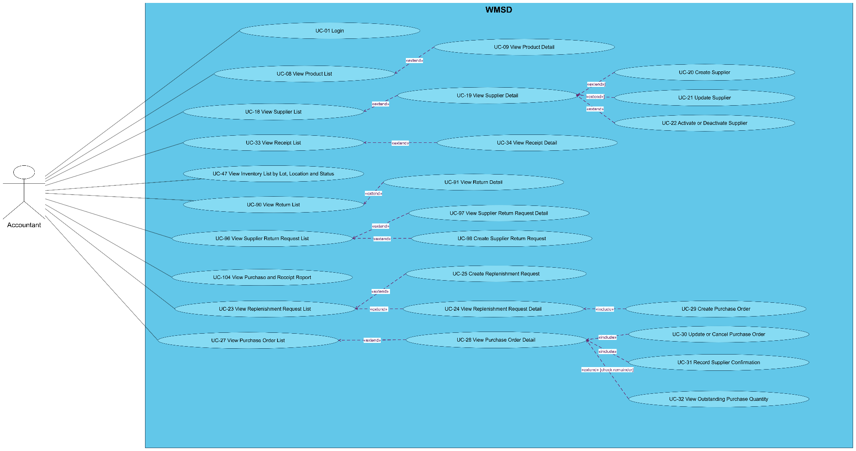

4.3.2
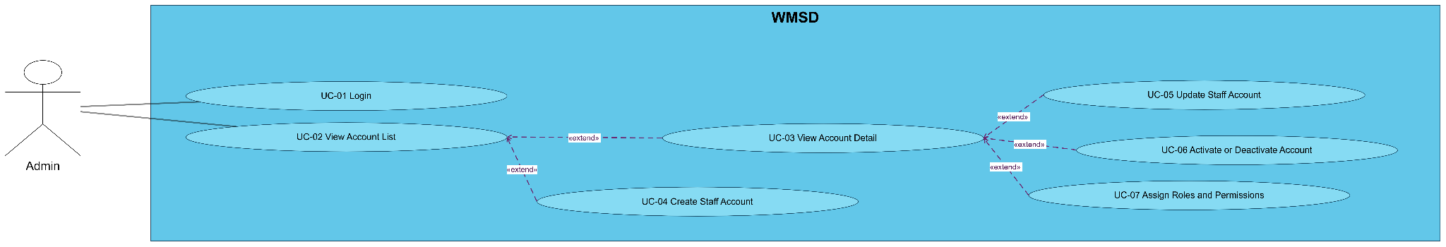

4.3.3
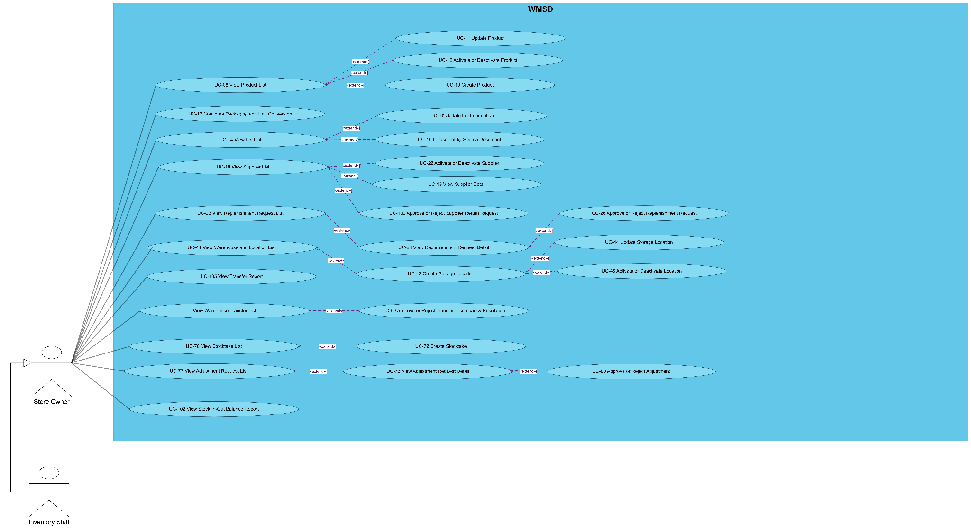

4.3.4
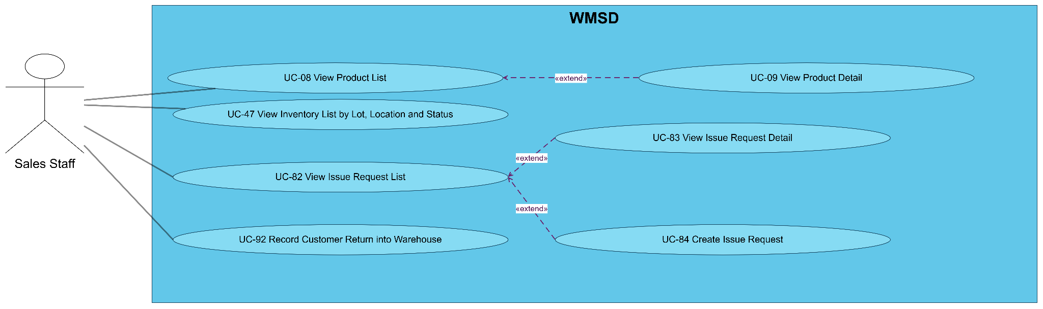

4.3.5
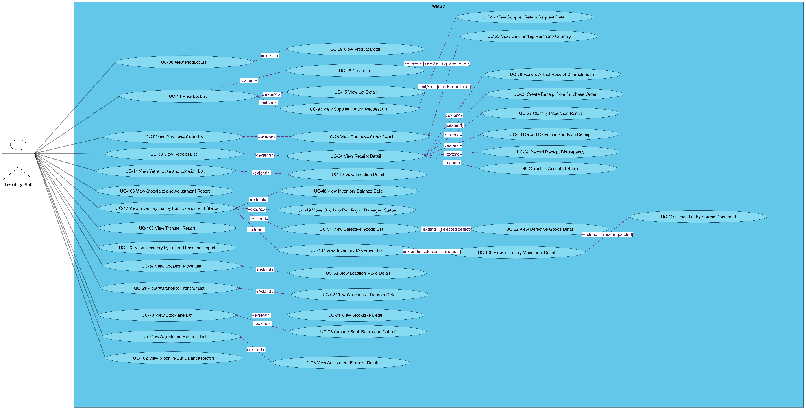

4.4 Permission Matrix

UC | Operation | Store Manager | Accountant | Warehouse Staff | Sales Staff | Administrator
UC-01 | Sign in to the system | Full | Full | Full | Full | Full
UC-02 | View account list | No | No | No | No | Full
UC-03 | View account details | No | No | No | No | Full
UC-04 | Create staff account | No | No | No | No | Full
UC-05 | Update staff account | No | No | No | No | Full
UC-06 | Activate or deactivate account | No | No | No | No | Full
UC-07 | Assign roles and operation permissions | No | No | No | No | Full
UC-08 | View product list | Full | Full | Full | Full | No
UC-09 | View product details | Full | Full | Full | Full | No
UC-10 | Create product | Full | No | No | No | No
UC-11 | Update product | Full | No | No | No | No
UC-12 | Activate or deactivate product | Full | No | No | No | No
UC-13 | Configure packaging and unit conversion | Full | No | No | No | No
UC-14 | View lot list | Full | No | Full | No | No
UC-15 | View lot details | Full | No | Full | No | No
UC-16 | Create product lot | Full | No | Full | No | No
UC-17 | Update lot information | Full | No | No | No | No
UC-18 | View supplier list | Full | Full | No | No | No
UC-19 | View supplier details | Full | Full | No | No | No
UC-20 | Create supplier | No | Full | No | No | No
UC-21 | Update supplier | No | Full | No | No | No
UC-22 | Activate or deactivate supplier | Full | Full | No | No | No
UC-23 | View replenishment request list | Full | Full | No | No | No
UC-24 | View replenishment request details | Full | Full | No | No | No
UC-25 | Create replenishment request | No | Full | No | No | No
UC-26 | Approve or reject replenishment request | Full | No | No | No | No
UC-27 | View purchase order list | Full | Full | Full | No | No
UC-28 | View purchase order details | Full | Full | Full | No | No
UC-29 | Create purchase order | No | Full | No | No | No
UC-30 | Update or cancel purchase order | No | Full | No | No | No
UC-31 | Record supplier confirmation | No | Full | No | No | No
UC-32 | View outstanding receipt quantity | Full | Full | Full | No | No
UC-33 | View goods receipt list | Full | Full | Full | No | No
UC-34 | View goods receipt details | Full | Full | Full | No | No
UC-35 | Create goods receipt from purchase order | No | No | Full | No | No
UC-36 | Record actual received quantity and characteristics | No | No | Full | No | No
UC-37 | Classify inspection results | No | No | Full | No | No
UC-38 | Record defects during receiving | No | No | Full | No | No
UC-39 | Record receiving discrepancies | No | No | Full | No | No
UC-40 | Complete accepted goods receipt | No | No | Full | No | No
UC-41 | View warehouse and location list | Full | No | Full | No | No
UC-42 | View storage location details | Full | No | Full | No | No
UC-43 | Create storage location | Full | No | No | No | No
UC-44 | Update storage location | Full | No | No | No | No
UC-45 | Activate or deactivate storage location | Full | No | No | No | No
UC-46 | Allocate accepted goods to a location | No | No | Full | No | No
UC-47 | View stock by lot, location, and quality status | Full | Full | Full | Full | No
UC-48 | View inventory balance details | Full | No | Full | No | No
UC-49 | Reclassify goods as pending inspection or defective | No | No | Full | No | No
UC-50 | Record disposition of quarantined goods | No | No | Full | No | No
UC-51 | View defective goods list | Full | No | Full | No | No
UC-52 | View defective goods details | Full | No | Full | No | No
UC-53 | Record defects discovered in storage | No | No | Full | No | No
UC-54 | Create defective goods disposition request | No | No | Full | No | No
UC-55 | Approve or reject defective goods disposition | Full | No | No | No | No
UC-56 | Record approved defective goods disposition | No | No | Full | No | No
UC-57 | View location movement list | Full | No | Full | No | No
UC-58 | View location movement details | Full | No | Full | No | No
UC-59 | Create location movement | No | No | Full | No | No
UC-60 | Confirm actual location movement | No | No | Full | No | No
UC-61 | View warehouse transfer list | Full | No | Full | No | No
UC-62 | View warehouse transfer details | Full | No | Full | No | No
UC-63 | Create warehouse transfer | No | No | Full | No | No
UC-64 | Record transfer dispatch | No | No | Full | No | No
UC-65 | Record transfer handover | No | No | Full | No | No
UC-66 | Record receipt at destination warehouse | No | No | Full | No | No
UC-67 | Record transfer discrepancy | No | No | Full | No | No
UC-68 | Request transfer discrepancy resolution | No | No | Full | No | No
UC-69 | Approve or reject transfer discrepancy resolution | Full | No | No | No | No
UC-70 | View stocktake list | Full | No | Full | No | No
UC-71 | View stocktake details | Full | No | Full | No | No
UC-72 | Create stocktake | Full | No | No | No | No
UC-73 | Capture system balance at stocktake cutoff | Full | No | Full | No | No
UC-74 | Enter actual counted quantities | No | No | Full | No | No
UC-75 | Record recount result | No | No | Full | No | No
UC-76 | Record variance reason | No | No | Full | No | No
UC-77 | View inventory adjustment request list | Full | No | Full | No | No
UC-78 | View inventory adjustment request details | Full | No | Full | No | No
UC-79 | Create inventory adjustment request | No | No | Full | No | No
UC-80 | Approve or reject inventory adjustment | Full | No | No | No | No
UC-81 | Post approved inventory adjustment | No | No | Full | No | No
UC-82 | View goods issue request list | Full | No | Full | Full | No
UC-83 | View goods issue request details | Full | No | Full | Full | No
UC-84 | Create goods issue request | No | No | No | Full | No
UC-85 | View goods issue list | Full | No | Full | No | No
UC-86 | View goods issue details | Full | No | Full | No | No
UC-87 | Create goods issue | No | No | Full | No | No
UC-88 | Select issue lots and locations | No | No | Full | No | No
UC-89 | Confirm actual goods issue quantity | No | No | Full | No | No
UC-90 | View customer return list | Full | Full | Full | No | No
UC-91 | View customer return details | Full | Full | Full | No | No
UC-92 | Record customer goods return | No | No | Full | Full | No
UC-93 | Inspect returned goods | No | No | Full | No | No
UC-94 | Classify returned goods disposition | No | No | Full | No | No
UC-95 | Approve or reject customer return disposition | Full | No | No | No | No
UC-96 | View supplier return request list | Full | Full | Full | No | No
UC-97 | View supplier return request details | Full | Full | Full | No | No
UC-98 | Create supplier return request | No | Full | Full | No | No
UC-99 | Quarantine goods pending supplier return | No | No | Full | No | No
UC-100 | Approve or reject supplier return request | Full | No | No | No | No
UC-101 | Record actual supplier return dispatch | No | No | Full | No | No
UC-102 | View inventory movement summary report | Full | No | Full | No | No
UC-103 | View stock by lot and location report | Full | No | Full | No | No
UC-104 | View purchase order and receipt report | Full | Full | No | No | No
UC-105 | View warehouse transfer report | Full | No | Full | No | No
UC-106 | View stocktake and adjustment report | Full | No | Full | No | No
UC-107 | View stock movement log | Full | No | Full | No | No
UC-108 | View stock movement details | Full | No | Full | No | No
UC-109 | Trace a product lot through source documents | Full | No | Full | No | No

5. System Functionalities

5.1 Screen Inventory

a. Screen Flow
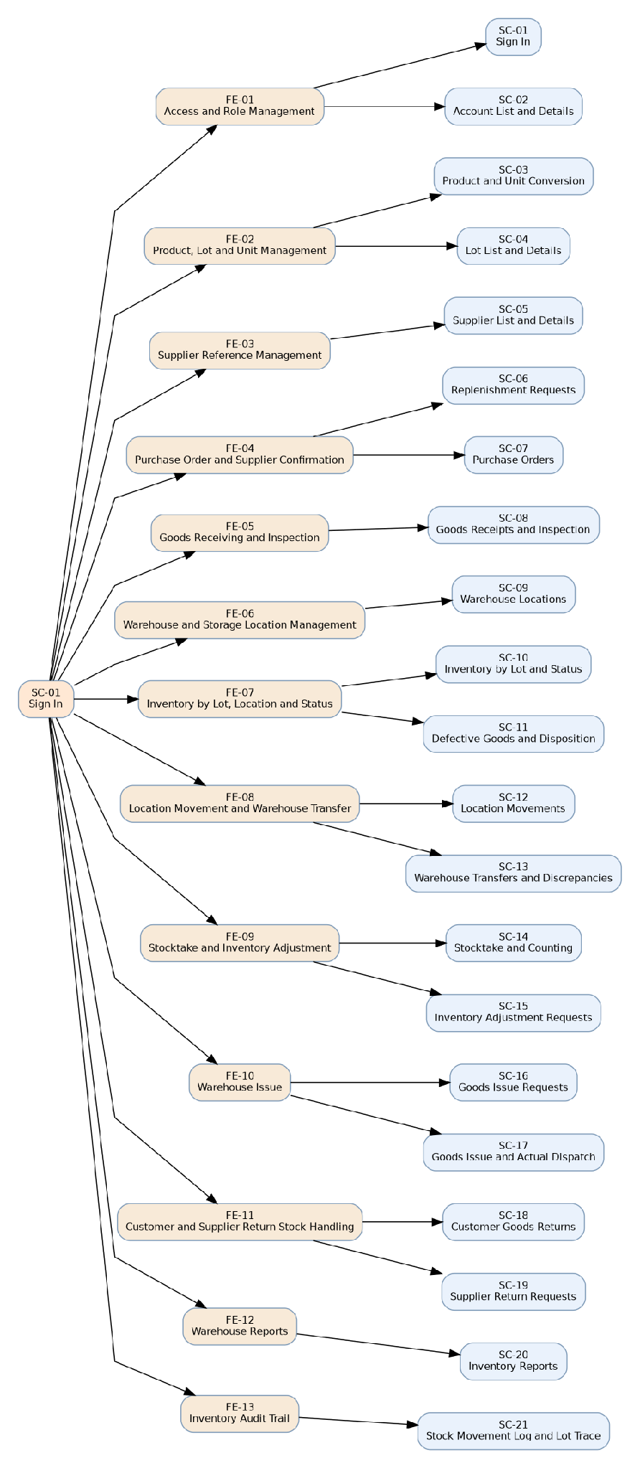
Figure 23. Screen flow by feature and related screens

b. Screen List
# | Screen Name | Feature | Description
SC-01 | Sign In | FE-01 | Sign in to the system
SC-02 | Account List and Details | FE-01 | View account list; View account details; Create staff account; Update staff account; Activate or deactivate account; Assign roles and operation permissions
SC-03 | Product and Unit Conversion | FE-02 | View product list; View product details; Create product; Update product; Activate or deactivate product; Configure packaging and unit conversion
SC-04 | Lot List and Details | FE-02 | View lot list; View lot details; Create product lot; Update lot information
SC-05 | Supplier List and Details | FE-03 | View supplier list; View supplier details; Create supplier; Update supplier; Activate or deactivate supplier
SC-06 | Replenishment Requests | FE-04 | View replenishment request list; View replenishment request details; Create replenishment request; Approve or reject replenishment request
SC-07 | Purchase Orders | FE-04 | View purchase order list; View purchase order details; Create purchase order; Update or cancel purchase order; Record supplier confirmation; View outstanding receipt quantity
SC-08 | Goods Receipts and Inspection | FE-05 | View goods receipt list; View goods receipt details; Create goods receipt from purchase order; Record actual received quantity and characteristics; Classify inspection results; Record defects during receiving; Record receiving discrepancies; Complete accepted goods receipt
SC-09 | Warehouse Locations | FE-06 | View warehouse and location list; View storage location details; Create storage location; Update storage location; Activate or deactivate storage location; Allocate accepted goods to a location
SC-10 | Inventory by Lot and Status | FE-07 | View stock by lot, location, and quality status; View inventory balance details; Reclassify goods as pending inspection or defective; Record disposition of quarantined goods
SC-11 | Defective Goods and Disposition | FE-07 | View defective goods list; View defective goods details; Record defects discovered in storage; Create defective goods disposition request; Approve or reject defective goods disposition; Record approved defective goods disposition
SC-12 | Location Movements | FE-08 | View location movement list; View location movement details; Create location movement; Confirm actual location movement
SC-13 | Warehouse Transfers and Discrepancies | FE-08 | View warehouse transfer list; View warehouse transfer details; Create warehouse transfer; Record transfer dispatch; Record transfer handover; Record receipt at destination warehouse; Record transfer discrepancy; Request transfer discrepancy resolution; Approve or reject transfer discrepancy resolution
SC-14 | Stocktake and Counting | FE-09 | View stocktake list; View stocktake details; Create stocktake; Capture system balance at stocktake cutoff; Enter actual counted quantities; Record recount result; Record variance reason
SC-15 | Inventory Adjustment Requests | FE-09 | View inventory adjustment request list; View inventory adjustment request details; Create inventory adjustment request; Approve or reject inventory adjustment; Post approved inventory adjustment
SC-16 | Goods Issue Requests | FE-10 | View goods issue request list; View goods issue request details; Create goods issue request
SC-17 | Goods Issue and Actual Dispatch | FE-10 | View goods issue list; View goods issue details; Create goods issue; Select issue lots and locations; Confirm actual goods issue quantity
SC-18 | Customer Goods Returns | FE-11 | View customer return list; View customer return details; Record customer goods return; Inspect returned goods; Classify returned goods disposition; Approve or reject customer return disposition
SC-19 | Supplier Return Requests | FE-11 | View supplier return request list; View supplier return request details; Create supplier return request; Quarantine goods pending supplier return; Approve or reject supplier return request; Record actual supplier return dispatch
SC-20 | Inventory Reports | FE-12 | View inventory movement summary report; View stock by lot and location report; View purchase order and receipt report; View warehouse transfer report; View stocktake and adjustment report
SC-21 | Stock Movement Log and Lot Trace | FE-13 | View stock movement log; View stock movement details; Trace a product lot through source documents

5.2 External API Inventory
# | API Name | Calling Path | Description
— | Not specified

5.3 Background Job Inventory
# | Job Name | Group | Description

II. Use Case Specifications

1. Access and Role Management (FE-01)

1.1 UC-01: Sign in to the system
Primary Actors | Store Manager, Accountant, Warehouse Staff, Sales Staff, Administrator | Secondary Actors | None specified by the UC source
Description | As an authorized Store Manager/Accountant/Warehouse Staff/Sales Staff/Administrator user, I want to sign in to the system so that access authorized functions according to the assigned account and role.  Related feature/screen: FE-01 — Access and Role Management / SC-01.
Preconditions | Access & identity: An account exists; authentication is initiated by the entered credentials.  Source records / workflow state: The account exists and has permission to use the system.  Required inputs (business minimum): Username; password.  Optional or source-undefined inputs: None.  Validation and uniqueness: Credentials match an active account; role rights checked.  Technical field specification: Apply the SQL Server field definitions, precision, field entry requirements and validations in Part III for the linked screen. These are technical design defaults; additional business rules require a separately approved change.
Normal Flow | 1. An authorized store manager/accountant/warehouse staff/sales staff/administrator user opens SC-01 and selects “Sign in to the system”.  2. The system checks permission, displays the relevant form and current source values.  3. Enter username and password on the Sign In screen  4. System verifies the credentials and checks account activation  5. System determines permissions assigned to the authenticated role  6. System starts the authorized user session and opens the permitted work area.  7. The system validates all mandatory input fields, cross-document quantities, actor authorization and referenced record state before accepting confirmation.  8. On success the system saves the specific business outcome and updates related documents or eligible stock only if this UC explicitly performs a stock-posting operation.  9. The system displays the resulting record/status and source references; inventory-affecting operations retain the before/after movement details.
Alternative Flows | A1 — At step 2, access/role check fails: show MSG-08 and reveal no protected record; no data are changed.  A2 — At step 3–6, a required input is absent: identify the specific missing field (MSG-02); retain entered information without committing.  A3 — At the validation step 7, a reference is inactive, duplicate, outside the current workflow stage or violates the business rule: explain the specific field/record; do not partially post.  A4 — Business-specific exception: Invalid login, inactive user or denied account returns no session.  A5 — At source-defined 3: Missing or incorrect credentials: reject sign-in with a non-disclosing error message.  A5 — At source-defined 3: The account is inactive or unauthorized: prevent access without changing business data.
Postconditions | Successful outcome: An authorized session is established with the assigned role only.  No inventory balance is changed unless the described UC expressly authorizes a stock movement.  Failure outcome: Missing inputs, a rejected action or a failed validation leave existing posted transactions and inventory unchanged.  Traceability: Existing source references, responsible actor and action time are retained where this UC creates or updates a business record.

1.2 UC-02: View account list
Primary Actors | Administrator | Secondary Actors | None specified by the UC source
Description | As a Administrator, I want to view account list so that search and filter accounts by name, role, and active status.  Related feature/screen: FE-01 — Access and Role Management / SC-02.
Preconditions | Access: The actor is signed in and authorized to view Account list under UC-02.  Reference data: Account records and role descriptions.  Optional search/filter inputs: Name, role, active/inactive status. No filters are mandatory; the actor may run an unfiltered list/report within permission scope.  Display fields: Account identifier, staff name, role, status. Values are retrieved from saved records; any displayed quantity is reconciled from the corresponding business transactions.  Result scope: Access rights and existing document/quality states determine which records can be opened.
Normal Flow | 1. The actor navigates to SC-02 and selects “View account list”.  2. The system checks role authorization and presents the permitted scope of records.  3. The actor optionally enters filters: Name, role, active/inactive status.  4. The system validates referenced record identity, supplied filter values and date-range order where applicable.  5. The system retrieves matching records using their current persisted links and permissions.  6. The system displays Account identifier, staff name, role, status with the relevant linked source references and recorded statuses.  7. The actor may inspect a result or adjust filters; this read-only action does not create, update or post inventory.
Alternative Flows | A1 — Step 2: Actor lacks view permission; show MSG-08 and reveal no protected data.  A2 — Step 3/4: A selected record identifier does not exist or is outside authorized scope; show a non-disclosing not-found/permission result.  A3 — Step 3/5: No record matches the filters; show MSG-01 and an empty list rather than sample or fabricated rows.  A4 — Step 4: Filters conflict (for example, From Date after To Date) or have an invalid value; highlight the filter, leave the stored data unchanged.  A5 — Step 5/6: A linked document is unavailable or historical/inactive; preserve the original reference and present only data for which the actor has access.
Postconditions | Successful outcome: The actor has seen the Account list and its relevant Account identifier, staff name, role, status.  Persisted business data: No creation, status transition, inventory change or approval occurs from viewing or filtering.  Empty/error outcome: No record is modified; the user can revise filters or return to the list.

1.3 UC-03: View account details
Primary Actors | Administrator | Secondary Actors | None specified by the UC source
Description | As a Administrator, I want to view account details so that display the selected account's information, assigned role, and status.  Related feature/screen: FE-01 — Access and Role Management / SC-02.
Preconditions | Access: The actor is signed in and authorized to view Selected account under UC-03.  Reference data: Account exists.  Required navigation input: Account identifier. A specific record must be selected before its details can be displayed.  Display fields: Staff name, role, account status, permitted operations. Values are retrieved from saved records; any displayed quantity is reconciled from the corresponding business transactions.  Result scope: Access rights and existing document/quality states determine which records can be opened.
Normal Flow | 1. The actor navigates to SC-02 and selects “View account details”.  2. The system checks role authorization and presents the permitted scope of records.  3. The actor selects the target Selected account by Account identifier.  4. The system validates referenced record identity, supplied filter values and date-range order where applicable.  5. The system retrieves matching records using their current persisted links and permissions.  6. The system displays Staff name, role, account status, permitted operations with the relevant linked source references and recorded statuses.  7. The actor may inspect a result or adjust filters; this read-only action does not create, update or post inventory.
Alternative Flows | A1 — Step 2: Actor lacks view permission; show MSG-08 and reveal no protected data.  A2 — Step 3/4: A selected record identifier does not exist or is outside authorized scope; show a non-disclosing not-found/permission result.  A3 — Step 3/5: No record matches the filters; show MSG-01 and an empty list rather than sample or fabricated rows.  A4 — Step 4: Filters conflict (for example, From Date after To Date) or have an invalid value; highlight the filter, leave the stored data unchanged.  A5 — Step 5/6: A linked document is unavailable or historical/inactive; preserve the original reference and present only data for which the actor has access.
Postconditions | Successful outcome: The actor has seen the Selected account and its relevant Staff name, role, account status, permitted operations.  Persisted business data: No creation, status transition, inventory change or approval occurs from viewing or filtering.  Empty/error outcome: No record is modified; the user can revise filters or return to the list.

1.4 UC-04: Create staff account
Primary Actors | Administrator | Secondary Actors | None specified by the UC source
Description | As a Administrator, I want to create staff account so that register an internal user account and select an appropriate role.  Related feature/screen: FE-01 — Access and Role Management / SC-02.
Preconditions | Access & identity: Actor is signed in and explicitly authorized for UC-04.  Source records / workflow state: Administrator has access to account management and defined role list.  Required inputs (business minimum): Username / account ID; staff name; assigned internal role.  Optional or source-undefined inputs: Contact data where maintained; credential initiation method to confirm.  Validation and uniqueness: Account identifier is not duplicated; role belongs to the five defined actors.  Technical field specification: Apply the SQL Server field definitions, precision, field entry requirements and validations in Part III for the linked screen. These are technical design defaults; additional business rules require a separately approved change.
Normal Flow | 1. A administrator opens SC-02 and selects “Create staff account”.  2. The system checks permission, displays the relevant form and current source values.  3. The actor selects the appropriate create/update/activation operation in SC-02.  4. The system displays permitted existing values and the corresponding input form.  5. The actor enters required business fields and any applicable optional values.  6. The system validates field completeness, references, workflow status and record identity.  7. The system validates all mandatory input fields, cross-document quantities, actor authorization and referenced record state before accepting confirmation.  8. On success the system saves the specific business outcome and updates related documents or eligible stock only if this UC explicitly performs a stock-posting operation.  9. The system displays the resulting record/status and source references; inventory-affecting operations retain the before/after movement details.
Alternative Flows | A1 — At step 2, access/role check fails: show MSG-08 and reveal no protected record; no data are changed.  A2 — At step 3–6, a required input is absent: identify the specific missing field (MSG-02); retain entered information without committing.  A3 — At the validation step 7, a reference is inactive, duplicate, outside the current workflow stage or violates the business rule: explain the specific field/record; do not partially post.  A4 — Business-specific exception: Duplicate account or invalid role blocks creation.
Postconditions | Successful outcome: A distinct account exists with initial access state and assigned role; no warehouse document changed.  No inventory balance is changed unless the described UC expressly authorizes a stock movement.  Failure outcome: Missing inputs, a rejected action or a failed validation leave existing posted transactions and inventory unchanged.  Traceability: Existing source references, responsible actor and action time are retained where this UC creates or updates a business record.

1.5 UC-05: Update staff account
Primary Actors | Administrator | Secondary Actors | None specified by the UC source
Description | As a Administrator, I want to update staff account so that edit allowed account information without losing its action history.  Related feature/screen: FE-01 — Access and Role Management / SC-02.
Preconditions | Access & identity: Actor is signed in and explicitly authorized for UC-05.  Source records / workflow state: The account exists, and its prior document references must remain.  Required inputs (business minimum): Account to modify; changed allowed field(s).  Optional or source-undefined inputs: Contact detail changes.  Validation and uniqueness: Identity/history links may not be broken; other user's rights cannot be escalated without authorized role assignment.  Technical field specification: Apply the SQL Server field definitions, precision, field entry requirements and validations in Part III for the linked screen. These are technical design defaults; additional business rules require a separately approved change.
Normal Flow | 1. A administrator opens SC-02 and selects “Update staff account”.  2. The system checks permission, displays the relevant form and current source values.  3. The actor selects the appropriate create/update/activation operation in SC-02.  4. The system displays permitted existing values and the corresponding input form.  5. The actor enters required business fields and any applicable optional values.  6. The system validates field completeness, references, workflow status and record identity.  7. The system validates all mandatory input fields, cross-document quantities, actor authorization and referenced record state before accepting confirmation.  8. On success the system saves the specific business outcome and updates related documents or eligible stock only if this UC explicitly performs a stock-posting operation.  9. The system displays the resulting record/status and source references; inventory-affecting operations retain the before/after movement details.
Alternative Flows | A1 — At step 2, access/role check fails: show MSG-08 and reveal no protected record; no data are changed.  A2 — At step 3–6, a required input is absent: identify the specific missing field (MSG-02); retain entered information without committing.  A3 — At the validation step 7, a reference is inactive, duplicate, outside the current workflow stage or violates the business rule: explain the specific field/record; do not partially post.  A4 — Business-specific exception: Attempted changes to historical operator identity are refused.
Postconditions | Successful outcome: Allowed account fields change; historic activity and document ownership remain readable.  No inventory balance is changed unless the described UC expressly authorizes a stock movement.  Failure outcome: Missing inputs, a rejected action or a failed validation leave existing posted transactions and inventory unchanged.  Traceability: Existing source references, responsible actor and action time are retained where this UC creates or updates a business record.

1.6 UC-06: Activate or deactivate account
Primary Actors | Administrator | Secondary Actors | None specified by the UC source
Description | As a Administrator, I want to activate or deactivate account so that enable or prevent account sign-in while preserving historical documents.  Related feature/screen: FE-01 — Access and Role Management / SC-02.
Preconditions | Access & identity: Actor is signed in and explicitly authorized for UC-06.  Source records / workflow state: Administrator can select existing account, including inactive accounts.  Required inputs (business minimum): Target account; desired active/inactive action.  Optional or source-undefined inputs: Reason, if operational policy defines it.  Validation and uniqueness: An inactive account cannot authenticate; historical transactions are preserved.  Technical field specification: Apply the SQL Server field definitions, precision, field entry requirements and validations in Part III for the linked screen. These are technical design defaults; additional business rules require a separately approved change.
Normal Flow | 1. A administrator opens SC-02 and selects “Activate or deactivate account”.  2. The system checks permission, displays the relevant form and current source values.  3. The actor selects the appropriate create/update/activation operation in SC-02.  4. The system displays permitted existing values and the corresponding input form.  5. The actor enters required business fields and any applicable optional values.  6. The system validates field completeness, references, workflow status and record identity.  7. The system validates all mandatory input fields, cross-document quantities, actor authorization and referenced record state before accepting confirmation.  8. On success the system saves the specific business outcome and updates related documents or eligible stock only if this UC explicitly performs a stock-posting operation.  9. The system displays the resulting record/status and source references; inventory-affecting operations retain the before/after movement details.
Alternative Flows | A1 — At step 2, access/role check fails: show MSG-08 and reveal no protected record; no data are changed.  A2 — At step 3–6, a required input is absent: identify the specific missing field (MSG-02); retain entered information without committing.  A3 — At the validation step 7, a reference is inactive, duplicate, outside the current workflow stage or violates the business rule: explain the specific field/record; do not partially post.  A4 — Business-specific exception: Unknown account or repeated action has no unintended impact.
Postconditions | Successful outcome: New sign-ins obey the updated access state; existing linked records are retained.  No inventory balance is changed unless the described UC expressly authorizes a stock movement.  Failure outcome: Missing inputs, a rejected action or a failed validation leave existing posted transactions and inventory unchanged.  Traceability: Existing source references, responsible actor and action time are retained where this UC creates or updates a business record.

1.7 UC-07: Assign roles and operation permissions
Primary Actors | Administrator | Secondary Actors | None specified by the UC source
Description | As a Administrator, I want to assign roles and operation permissions so that configure view, create, edit, and transaction-recording permissions by role.  Related feature/screen: FE-01 — Access and Role Management / SC-02.
Preconditions | Access & identity: Actor is signed in and explicitly authorized for UC-07.  Source records / workflow state: Administrator can access known role and UC operation definitions.  Required inputs (business minimum): Role; one or more operation permissions.  Optional or source-undefined inputs: Permission removal/addition reason.  Validation and uniqueness: Cannot assign a role or business operation absent from approved actor/UC catalogue.  Technical field specification: Apply the SQL Server field definitions, precision, field entry requirements and validations in Part III for the linked screen. These are technical design defaults; additional business rules require a separately approved change.
Normal Flow | 1. A administrator opens SC-02 and selects “Assign roles and operation permissions”.  2. The system checks permission, displays the relevant form and current source values.  3. Administrator opens an internal account or role-permissions configuration  4. System displays available business operations and current role assignments  5. Administrator selects the role and its permitted view/create/update/post actions  6. System validates and saves the permission configuration used by subsequent operations.  7. The system validates all mandatory input fields, cross-document quantities, actor authorization and referenced record state before accepting confirmation.  8. On success the system saves the specific business outcome and updates related documents or eligible stock only if this UC explicitly performs a stock-posting operation.  9. The system displays the resulting record/status and source references; inventory-affecting operations retain the before/after movement details.
Alternative Flows | A1 — At step 2, access/role check fails: show MSG-08 and reveal no protected record; no data are changed.  A2 — At step 3–6, a required input is absent: identify the specific missing field (MSG-02); retain entered information without committing.  A3 — At the validation step 7, a reference is inactive, duplicate, outside the current workflow stage or violates the business rule: explain the specific field/record; do not partially post.  A4 — Business-specific exception: Invalid or unknown operations and insufficient privilege are rejected.
Postconditions | Successful outcome: Subsequent authorization checks use saved operation-level permissions.  No inventory balance is changed unless the described UC expressly authorizes a stock movement.  Failure outcome: Missing inputs, a rejected action or a failed validation leave existing posted transactions and inventory unchanged.  Traceability: Existing source references, responsible actor and action time are retained where this UC creates or updates a business record.

2. Product, Lot and Unit Management (FE-02)

2.1 UC-08: View product list
Primary Actors | Store Manager, Accountant, Warehouse Staff, Sales Staff | Secondary Actors | None specified by the UC source
Description | As an authorized Store Manager/Accountant/Warehouse Staff/Sales Staff user, I want to view product list so that search products by item code, name, size, and status.  Related feature/screen: FE-02 — Product, Lot and Unit Management / SC-03.
Preconditions | Access: The actor is signed in and authorized to view Product list under UC-08.  Reference data: Product master is readable.  Optional search/filter inputs: Product code, name, nominal size, status. No filters are mandatory; the actor may run an unfiltered list/report within permission scope.  Display fields: Product code, category, size, product status. Values are retrieved from saved records; any displayed quantity is reconciled from the corresponding business transactions.  Result scope: Access rights and existing document/quality states determine which records can be opened.
Normal Flow | 1. The actor navigates to SC-03 and selects “View product list”.  2. The system checks role authorization and presents the permitted scope of records.  3. The actor optionally enters filters: Product code, name, nominal size, status.  4. The system validates referenced record identity, supplied filter values and date-range order where applicable.  5. The system retrieves matching records using their current persisted links and permissions.  6. The system displays Product code, category, size, product status with the relevant linked source references and recorded statuses.  7. The actor may inspect a result or adjust filters; this read-only action does not create, update or post inventory.
Alternative Flows | A1 — Step 2: Actor lacks view permission; show MSG-08 and reveal no protected data.  A2 — Step 3/4: A selected record identifier does not exist or is outside authorized scope; show a non-disclosing not-found/permission result.  A3 — Step 3/5: No record matches the filters; show MSG-01 and an empty list rather than sample or fabricated rows.  A4 — Step 4: Filters conflict (for example, From Date after To Date) or have an invalid value; highlight the filter, leave the stored data unchanged.  A5 — Step 5/6: A linked document is unavailable or historical/inactive; preserve the original reference and present only data for which the actor has access.
Postconditions | Successful outcome: The actor has seen the Product list and its relevant Product code, category, size, product status.  Persisted business data: No creation, status transition, inventory change or approval occurs from viewing or filtering.  Empty/error outcome: No record is modified; the user can revise filters or return to the list.

2.2 UC-09: View product details
Primary Actors | Store Manager, Accountant, Warehouse Staff, Sales Staff | Secondary Actors | None specified by the UC source
Description | As an authorized Store Manager/Accountant/Warehouse Staff/Sales Staff user, I want to view product details so that display tile attributes, packaging specifications, and units of measure.  Related feature/screen: FE-02 — Product, Lot and Unit Management / SC-03.
Preconditions | Access: The actor is signed in and authorized to view Selected product under UC-09.  Reference data: Product exists.  Required navigation input: Product code. A specific record must be selected before its details can be displayed.  Display fields: Product identifiers, tile attributes, unit conversion. Values are retrieved from saved records; any displayed quantity is reconciled from the corresponding business transactions.  Result scope: Access rights and existing document/quality states determine which records can be opened.
Normal Flow | 1. The actor navigates to SC-03 and selects “View product details”.  2. The system checks role authorization and presents the permitted scope of records.  3. The actor selects the target Selected product by Product code.  4. The system validates referenced record identity, supplied filter values and date-range order where applicable.  5. The system retrieves matching records using their current persisted links and permissions.  6. The system displays Product identifiers, tile attributes, unit conversion with the relevant linked source references and recorded statuses.  7. The actor may inspect a result or adjust filters; this read-only action does not create, update or post inventory.
Alternative Flows | A1 — Step 2: Actor lacks view permission; show MSG-08 and reveal no protected data.  A2 — Step 3/4: A selected record identifier does not exist or is outside authorized scope; show a non-disclosing not-found/permission result.  A3 — Step 3/5: No record matches the filters; show MSG-01 and an empty list rather than sample or fabricated rows.  A4 — Step 4: Filters conflict (for example, From Date after To Date) or have an invalid value; highlight the filter, leave the stored data unchanged.  A5 — Step 5/6: A linked document is unavailable or historical/inactive; preserve the original reference and present only data for which the actor has access.
Postconditions | Successful outcome: The actor has seen the Selected product and its relevant Product identifiers, tile attributes, unit conversion.  Persisted business data: No creation, status transition, inventory change or approval occurs from viewing or filtering.  Empty/error outcome: No record is modified; the user can revise filters or return to the list.

2.3 UC-10: Create product
Primary Actors | Store Manager | Secondary Actors | None specified by the UC source
Description | As a Store Manager, I want to create product so that record product code, category, brand, material, nominal size, and identifying characteristics.  Related feature/screen: FE-02 — Product, Lot and Unit Management / SC-03.
Preconditions | Access & identity: Actor is signed in and explicitly authorized for UC-10.  Source records / workflow state: Store Manager accesses product catalogue.  Required inputs (business minimum): Product code; product name; tile classification; material; nominal size.  Optional or source-undefined inputs: Brand; description; intended use; packaging factors (configured under UC-13).  Validation and uniqueness: Product code unique; dimensional and category data in recognized format (technical constraints to confirm).  Technical field specification: Apply the SQL Server field definitions, precision, field entry requirements and validations in Part III for the linked screen. These are technical design defaults; additional business rules require a separately approved change.
Normal Flow | 1. A store manager opens SC-03 and selects “Create product”.  2. The system checks permission, displays the relevant form and current source values.  3. The actor selects the appropriate create/update/activation operation in SC-03.  4. The system displays permitted existing values and the corresponding input form.  5. The actor enters required business fields and any applicable optional values.  6. The system validates field completeness, references, workflow status and record identity.  7. The system validates all mandatory input fields, cross-document quantities, actor authorization and referenced record state before accepting confirmation.  8. On success the system saves the specific business outcome and updates related documents or eligible stock only if this UC explicitly performs a stock-posting operation.  9. The system displays the resulting record/status and source references; inventory-affecting operations retain the before/after movement details.
Alternative Flows | A1 — At step 2, access/role check fails: show MSG-08 and reveal no protected record; no data are changed.  A2 — At step 3–6, a required input is absent: identify the specific missing field (MSG-02); retain entered information without committing.  A3 — At the validation step 7, a reference is inactive, duplicate, outside the current workflow stage or violates the business rule: explain the specific field/record; do not partially post.  A4 — Business-specific exception: Missing identifier or duplicate product code prevents creation.
Postconditions | Successful outcome: An identifiable, selectable product master exists without inventory.  No inventory balance is changed unless the described UC expressly authorizes a stock movement.  Failure outcome: Missing inputs, a rejected action or a failed validation leave existing posted transactions and inventory unchanged.  Traceability: Existing source references, responsible actor and action time are retained where this UC creates or updates a business record.

2.4 UC-11: Update product
Primary Actors | Store Manager | Secondary Actors | None specified by the UC source
Description | As a Store Manager, I want to update product so that edit allowed attributes without corrupting existing documents or inventory history.  Related feature/screen: FE-02 — Product, Lot and Unit Management / SC-03.
Preconditions | Access & identity: Actor is signed in and explicitly authorized for UC-11.  Source records / workflow state: Product exists with possible linked lots or stock documents.  Required inputs (business minimum): Existing product; changed allowed field(s).  Optional or source-undefined inputs: Description; brand; classification.  Validation and uniqueness: Do not rewrite past transactions or alter existing lot identities through a master edit.  Technical field specification: Apply the SQL Server field definitions, precision, field entry requirements and validations in Part III for the linked screen. These are technical design defaults; additional business rules require a separately approved change.
Normal Flow | 1. A store manager opens SC-03 and selects “Update product”.  2. The system checks permission, displays the relevant form and current source values.  3. The actor selects the appropriate create/update/activation operation in SC-03.  4. The system displays permitted existing values and the corresponding input form.  5. The actor enters required business fields and any applicable optional values.  6. The system validates field completeness, references, workflow status and record identity.  7. The system validates all mandatory input fields, cross-document quantities, actor authorization and referenced record state before accepting confirmation.  8. On success the system saves the specific business outcome and updates related documents or eligible stock only if this UC explicitly performs a stock-posting operation.  9. The system displays the resulting record/status and source references; inventory-affecting operations retain the before/after movement details.
Alternative Flows | A1 — At step 2, access/role check fails: show MSG-08 and reveal no protected record; no data are changed.  A2 — At step 3–6, a required input is absent: identify the specific missing field (MSG-02); retain entered information without committing.  A3 — At the validation step 7, a reference is inactive, duplicate, outside the current workflow stage or violates the business rule: explain the specific field/record; do not partially post.  A4 — Business-specific exception: Conflicting identifier/conversion changes affecting posted quantities are blocked.
Postconditions | Successful outcome: Future use reflects the updated product while historical document snapshots remain consistent.  No inventory balance is changed unless the described UC expressly authorizes a stock movement.  Failure outcome: Missing inputs, a rejected action or a failed validation leave existing posted transactions and inventory unchanged.  Traceability: Existing source references, responsible actor and action time are retained where this UC creates or updates a business record.

2.5 UC-12: Activate or deactivate product
Primary Actors | Store Manager | Secondary Actors | None specified by the UC source
Description | As a Store Manager, I want to activate or deactivate product so that prevent selection on new documents while retaining inventory and history.  Related feature/screen: FE-02 — Product, Lot and Unit Management / SC-03.
Preconditions | Access & identity: Actor is signed in and explicitly authorized for UC-12.  Source records / workflow state: Store Manager sees master product and any associated balances.  Required inputs (business minimum): Existing product; active/inactive selection.  Optional or source-undefined inputs: Reason if supplied.  Validation and uniqueness: Inactive product cannot be selected for new operational documents; historical data remain.  Technical field specification: Apply the SQL Server field definitions, precision, field entry requirements and validations in Part III for the linked screen. These are technical design defaults; additional business rules require a separately approved change.
Normal Flow | 1. A store manager opens SC-03 and selects “Activate or deactivate product”.  2. The system checks permission, displays the relevant form and current source values.  3. The actor selects the appropriate create/update/activation operation in SC-03.  4. The system displays permitted existing values and the corresponding input form.  5. The actor enters required business fields and any applicable optional values.  6. The system validates field completeness, references, workflow status and record identity.  7. The system validates all mandatory input fields, cross-document quantities, actor authorization and referenced record state before accepting confirmation.  8. On success the system saves the specific business outcome and updates related documents or eligible stock only if this UC explicitly performs a stock-posting operation.  9. The system displays the resulting record/status and source references; inventory-affecting operations retain the before/after movement details.
Alternative Flows | A1 — At step 2, access/role check fails: show MSG-08 and reveal no protected record; no data are changed.  A2 — At step 3–6, a required input is absent: identify the specific missing field (MSG-02); retain entered information without committing.  A3 — At the validation step 7, a reference is inactive, duplicate, outside the current workflow stage or violates the business rule: explain the specific field/record; do not partially post.  A4 — Business-specific exception: Deactivate attempt cannot erase or invalidate stock history.
Postconditions | Successful outcome: Product's selectable status changes without deleting linked inventory or movements.  No inventory balance is changed unless the described UC expressly authorizes a stock movement.  Failure outcome: Missing inputs, a rejected action or a failed validation leave existing posted transactions and inventory unchanged.  Traceability: Existing source references, responsible actor and action time are retained where this UC creates or updates a business record.

2.6 UC-13: Configure packaging and unit conversion
Primary Actors | Store Manager | Secondary Actors | None specified by the UC source
Description | As a Store Manager, I want to configure packaging and unit conversion so that define pieces per box and area per piece for box, piece, and square-meter conversion by product.  Related feature/screen: FE-02 — Product, Lot and Unit Management / SC-03.
Preconditions | Access & identity: Actor is signed in and explicitly authorized for UC-13.  Source records / workflow state: Product master exists; product conversion must be identifiable.  Required inputs (business minimum): Product; pieces per box; square meters per piece.  Optional or source-undefined inputs: Effective business date if versioning later agreed.  Validation and uniqueness: Factors strictly positive; consistent box/piece/m² conversion; no retroactive changes to posted quantities.  Technical field specification: Apply the SQL Server field definitions, precision, field entry requirements and validations in Part III for the linked screen. These are technical design defaults; additional business rules require a separately approved change.
Normal Flow | 1. A store manager opens SC-03 and selects “Configure packaging and unit conversion”.  2. The system checks permission, displays the relevant form and current source values.  3. Store Manager selects an existing product  4. Enter pieces per box and square meters per piece  5. System rejects missing or nonpositive conversion factors  6. System saves conversion settings for receipt, issue and stocktake operations by product.  7. The system validates all mandatory input fields, cross-document quantities, actor authorization and referenced record state before accepting confirmation.  8. On success the system saves the specific business outcome and updates related documents or eligible stock only if this UC explicitly performs a stock-posting operation.  9. The system displays the resulting record/status and source references; inventory-affecting operations retain the before/after movement details.
Alternative Flows | A1 — At step 2, access/role check fails: show MSG-08 and reveal no protected record; no data are changed.  A2 — At step 3–6, a required input is absent: identify the specific missing field (MSG-02); retain entered information without committing.  A3 — At the validation step 7, a reference is inactive, duplicate, outside the current workflow stage or violates the business rule: explain the specific field/record; do not partially post.  A4 — Business-specific exception: Zero, negative, missing factor or retroactive modification is refused.  A5 — At source-defined 4: A conversion factor is zero, negative or missing: refuse to save and identify the invalid factor.  A5 — At source-defined 4: Existing posted transactions are present: preserve their historical quantities and conversions.
Postconditions | Successful outcome: Valid unit-conversion configuration is stored for future warehouse transactions.  No inventory balance is changed unless the described UC expressly authorizes a stock movement.  Failure outcome: Missing inputs, a rejected action or a failed validation leave existing posted transactions and inventory unchanged.  Traceability: Existing source references, responsible actor and action time are retained where this UC creates or updates a business record.

2.7 UC-14: View lot list
Primary Actors | Store Manager, Warehouse Staff | Secondary Actors | None specified by the UC source
Description | As an authorized Store Manager/Warehouse Staff user, I want to view lot list so that search lots by product, lot number, tone, and actual calibre.  Related feature/screen: FE-02 — Product, Lot and Unit Management / SC-04.
Preconditions | Access: The actor is signed in and authorized to view Lot list under UC-14.  Reference data: Product lots are recorded.  Optional search/filter inputs: Product, lot number, tone, actual calibre. No filters are mandatory; the actor may run an unfiltered list/report within permission scope.  Display fields: Product, lot, tone, calibre, quantity presence. Values are retrieved from saved records; any displayed quantity is reconciled from the corresponding business transactions.  Result scope: Access rights and existing document/quality states determine which records can be opened.
Normal Flow | 1. The actor navigates to SC-04 and selects “View lot list”.  2. The system checks role authorization and presents the permitted scope of records.  3. The actor optionally enters filters: Product, lot number, tone, actual calibre.  4. The system validates referenced record identity, supplied filter values and date-range order where applicable.  5. The system retrieves matching records using their current persisted links and permissions.  6. The system displays Product, lot, tone, calibre, quantity presence with the relevant linked source references and recorded statuses.  7. The actor may inspect a result or adjust filters; this read-only action does not create, update or post inventory.
Alternative Flows | A1 — Step 2: Actor lacks view permission; show MSG-08 and reveal no protected data.  A2 — Step 3/4: A selected record identifier does not exist or is outside authorized scope; show a non-disclosing not-found/permission result.  A3 — Step 3/5: No record matches the filters; show MSG-01 and an empty list rather than sample or fabricated rows.  A4 — Step 4: Filters conflict (for example, From Date after To Date) or have an invalid value; highlight the filter, leave the stored data unchanged.  A5 — Step 5/6: A linked document is unavailable or historical/inactive; preserve the original reference and present only data for which the actor has access.
Postconditions | Successful outcome: The actor has seen the Lot list and its relevant Product, lot, tone, calibre, quantity presence.  Persisted business data: No creation, status transition, inventory change or approval occurs from viewing or filtering.  Empty/error outcome: No record is modified; the user can revise filters or return to the list.

2.8 UC-15: View lot details
Primary Actors | Store Manager, Warehouse Staff | Secondary Actors | None specified by the UC source
Description | As an authorized Store Manager/Warehouse Staff user, I want to view lot details so that display production date, tone, actual calibre, and related transaction history.  Related feature/screen: FE-02 — Product, Lot and Unit Management / SC-04.
Preconditions | Access: The actor is signed in and authorized to view Selected lot under UC-15.  Reference data: Lot exists.  Required navigation input: Product, lot number. A specific record must be selected before its details can be displayed.  Display fields: Lot attributes, production date, stock history. Values are retrieved from saved records; any displayed quantity is reconciled from the corresponding business transactions.  Result scope: Access rights and existing document/quality states determine which records can be opened.
Normal Flow | 1. The actor navigates to SC-04 and selects “View lot details”.  2. The system checks role authorization and presents the permitted scope of records.  3. The actor selects the target Selected lot by Product, lot number.  4. The system validates referenced record identity, supplied filter values and date-range order where applicable.  5. The system retrieves matching records using their current persisted links and permissions.  6. The system displays Lot attributes, production date, stock history with the relevant linked source references and recorded statuses.  7. The actor may inspect a result or adjust filters; this read-only action does not create, update or post inventory.
Alternative Flows | A1 — Step 2: Actor lacks view permission; show MSG-08 and reveal no protected data.  A2 — Step 3/4: A selected record identifier does not exist or is outside authorized scope; show a non-disclosing not-found/permission result.  A3 — Step 3/5: No record matches the filters; show MSG-01 and an empty list rather than sample or fabricated rows.  A4 — Step 4: Filters conflict (for example, From Date after To Date) or have an invalid value; highlight the filter, leave the stored data unchanged.  A5 — Step 5/6: A linked document is unavailable or historical/inactive; preserve the original reference and present only data for which the actor has access.
Postconditions | Successful outcome: The actor has seen the Selected lot and its relevant Lot attributes, production date, stock history.  Persisted business data: No creation, status transition, inventory change or approval occurs from viewing or filtering.  Empty/error outcome: No record is modified; the user can revise filters or return to the list.

2.9 UC-16: Create product lot
Primary Actors | Store Manager, Warehouse Staff | Secondary Actors | None specified by the UC source
Description | As an authorized Store Manager/Warehouse Staff user, I want to create product lot so that record lot number and physical tile characteristics on arrival, checking duplicate identity.  Related feature/screen: FE-02 — Product, Lot and Unit Management / SC-04.
Preconditions | Access & identity: Actor is signed in and explicitly authorized for UC-16.  Source records / workflow state: Product exists and is eligible for new lot creation.  Required inputs (business minimum): Product; lot number; tone; actual calibre.  Optional or source-undefined inputs: Production date (only if supplied).  Validation and uniqueness: Product+lot+tone+actual calibre may not duplicate an existing business identity.  Technical field specification: Apply the SQL Server field definitions, precision, field entry requirements and validations in Part III for the linked screen. These are technical design defaults; additional business rules require a separately approved change.
Normal Flow | 1. An authorized store manager/warehouse staff user opens SC-04 and selects “Create product lot”.  2. The system checks permission, displays the relevant form and current source values.  3. Authorized user selects a product and supplies lot number, tone and actual calibre  4. Optionally record the production date when available  5. System checks for an existing lot with the same business identity  6. System creates the lot and makes it available for receiving and stock management.  7. The system validates all mandatory input fields, cross-document quantities, actor authorization and referenced record state before accepting confirmation.  8. On success the system saves the specific business outcome and updates related documents or eligible stock only if this UC explicitly performs a stock-posting operation.  9. The system displays the resulting record/status and source references; inventory-affecting operations retain the before/after movement details.
Alternative Flows | A1 — At step 2, access/role check fails: show MSG-08 and reveal no protected record; no data are changed.  A2 — At step 3–6, a required input is absent: identify the specific missing field (MSG-02); retain entered information without committing.  A3 — At the validation step 7, a reference is inactive, duplicate, outside the current workflow stage or violates the business rule: explain the specific field/record; do not partially post.  A4 — Business-specific exception: Duplicate identity or missing physical characteristic blocks saving.  A5 — At source-defined 4: The same lot identity already exists: reject duplicate creation and direct the user to the existing lot.
Postconditions | Successful outcome: Lot is created and selectable for receipts; no stock exists solely because of lot creation.  No inventory balance is changed unless the described UC expressly authorizes a stock movement.  Failure outcome: Missing inputs, a rejected action or a failed validation leave existing posted transactions and inventory unchanged.  Traceability: Existing source references, responsible actor and action time are retained where this UC creates or updates a business record.

2.10 UC-17: Update lot information
Primary Actors | Store Manager | Secondary Actors | None specified by the UC source
Description | As a Store Manager, I want to update lot information so that edit permitted lot attributes while preserving warehouse transactions already recorded.  Related feature/screen: FE-02 — Product, Lot and Unit Management / SC-04.
Preconditions | Access & identity: Actor is signed in and explicitly authorized for UC-17.  Source records / workflow state: Lot exists and its receiving/movement history is available.  Required inputs (business minimum): Existing lot; changed allowed attribute(s).  Optional or source-undefined inputs: Production date; correction explanation.  Validation and uniqueness: Lot identity cannot be silently rewritten where stock movements already reference it.  Technical field specification: Apply the SQL Server field definitions, precision, field entry requirements and validations in Part III for the linked screen. These are technical design defaults; additional business rules require a separately approved change.
Normal Flow | 1. A store manager opens SC-04 and selects “Update lot information”.  2. The system checks permission, displays the relevant form and current source values.  3. Store Manager opens the existing lot  4. System displays lot attributes and any recorded warehouse transactions  5. Store Manager edits fields allowed by the existing transaction history  6. System preserves transaction references and saves permitted changes only.  7. The system validates all mandatory input fields, cross-document quantities, actor authorization and referenced record state before accepting confirmation.  8. On success the system saves the specific business outcome and updates related documents or eligible stock only if this UC explicitly performs a stock-posting operation.  9. The system displays the resulting record/status and source references; inventory-affecting operations retain the before/after movement details.
Alternative Flows | A1 — At step 2, access/role check fails: show MSG-08 and reveal no protected record; no data are changed.  A2 — At step 3–6, a required input is absent: identify the specific missing field (MSG-02); retain entered information without committing.  A3 — At the validation step 7, a reference is inactive, duplicate, outside the current workflow stage or violates the business rule: explain the specific field/record; do not partially post.  A4 — Business-specific exception: Editing a referenced identifying characteristic is refused pending controlled correction.
Postconditions | Successful outcome: Only permitted changes persist with original source documents unchanged.  No inventory balance is changed unless the described UC expressly authorizes a stock movement.  Failure outcome: Missing inputs, a rejected action or a failed validation leave existing posted transactions and inventory unchanged.  Traceability: Existing source references, responsible actor and action time are retained where this UC creates or updates a business record.

3. Supplier Reference Management (FE-03)

3.1 UC-18: View supplier list
Primary Actors | Store Manager, Accountant | Secondary Actors | None specified by the UC source
Description | As an authorized Store Manager/Accountant user, I want to view supplier list so that search suppliers by code, name, and cooperation status.  Related feature/screen: FE-03 — Supplier Reference Management / SC-05.
Preconditions | Access: The actor is signed in and authorized to view Supplier list under UC-18.  Reference data: Supplier directory exists.  Optional search/filter inputs: Supplier code, name, cooperation status. No filters are mandatory; the actor may run an unfiltered list/report within permission scope.  Display fields: Supplier identity, contact summary, active status. Values are retrieved from saved records; any displayed quantity is reconciled from the corresponding business transactions.  Result scope: Access rights and existing document/quality states determine which records can be opened.
Normal Flow | 1. The actor navigates to SC-05 and selects “View supplier list”.  2. The system checks role authorization and presents the permitted scope of records.  3. The actor optionally enters filters: Supplier code, name, cooperation status.  4. The system validates referenced record identity, supplied filter values and date-range order where applicable.  5. The system retrieves matching records using their current persisted links and permissions.  6. The system displays Supplier identity, contact summary, active status with the relevant linked source references and recorded statuses.  7. The actor may inspect a result or adjust filters; this read-only action does not create, update or post inventory.
Alternative Flows | A1 — Step 2: Actor lacks view permission; show MSG-08 and reveal no protected data.  A2 — Step 3/4: A selected record identifier does not exist or is outside authorized scope; show a non-disclosing not-found/permission result.  A3 — Step 3/5: No record matches the filters; show MSG-01 and an empty list rather than sample or fabricated rows.  A4 — Step 4: Filters conflict (for example, From Date after To Date) or have an invalid value; highlight the filter, leave the stored data unchanged.  A5 — Step 5/6: A linked document is unavailable or historical/inactive; preserve the original reference and present only data for which the actor has access.
Postconditions | Successful outcome: The actor has seen the Supplier list and its relevant Supplier identity, contact summary, active status.  Persisted business data: No creation, status transition, inventory change or approval occurs from viewing or filtering.  Empty/error outcome: No record is modified; the user can revise filters or return to the list.

3.2 UC-19: View supplier details
Primary Actors | Store Manager, Accountant | Secondary Actors | None specified by the UC source
Description | As an authorized Store Manager/Accountant user, I want to view supplier details so that display contact information and related purchases, receipts, and returns.  Related feature/screen: FE-03 — Supplier Reference Management / SC-05.
Preconditions | Access: The actor is signed in and authorized to view Selected supplier under UC-19.  Reference data: Supplier exists.  Required navigation input: Supplier code. A specific record must be selected before its details can be displayed.  Display fields: Contact fields, related purchases, receipts, returns. Values are retrieved from saved records; any displayed quantity is reconciled from the corresponding business transactions.  Result scope: Access rights and existing document/quality states determine which records can be opened.
Normal Flow | 1. The actor navigates to SC-05 and selects “View supplier details”.  2. The system checks role authorization and presents the permitted scope of records.  3. The actor selects the target Selected supplier by Supplier code.  4. The system validates referenced record identity, supplied filter values and date-range order where applicable.  5. The system retrieves matching records using their current persisted links and permissions.  6. The system displays Contact fields, related purchases, receipts, returns with the relevant linked source references and recorded statuses.  7. The actor may inspect a result or adjust filters; this read-only action does not create, update or post inventory.
Alternative Flows | A1 — Step 2: Actor lacks view permission; show MSG-08 and reveal no protected data.  A2 — Step 3/4: A selected record identifier does not exist or is outside authorized scope; show a non-disclosing not-found/permission result.  A3 — Step 3/5: No record matches the filters; show MSG-01 and an empty list rather than sample or fabricated rows.  A4 — Step 4: Filters conflict (for example, From Date after To Date) or have an invalid value; highlight the filter, leave the stored data unchanged.  A5 — Step 5/6: A linked document is unavailable or historical/inactive; preserve the original reference and present only data for which the actor has access.
Postconditions | Successful outcome: The actor has seen the Selected supplier and its relevant Contact fields, related purchases, receipts, returns.  Persisted business data: No creation, status transition, inventory change or approval occurs from viewing or filtering.  Empty/error outcome: No record is modified; the user can revise filters or return to the list.

3.3 UC-20: Create supplier
Primary Actors | Accountant | Secondary Actors | None specified by the UC source
Description | As a Accountant, I want to create supplier so that record supplier code, name, address, telephone number, and contact person.  Related feature/screen: FE-03 — Supplier Reference Management / SC-05.
Preconditions | Access & identity: Actor is signed in and explicitly authorized for UC-20.  Source records / workflow state: Accountant is authorized to maintain supplier reference records.  Required inputs (business minimum): Supplier code; supplier name.  Optional or source-undefined inputs: Contact person; phone; address.  Validation and uniqueness: Supplier code not duplicated; basic contact fields must be coherent if entered.  Technical field specification: Apply the SQL Server field definitions, precision, field entry requirements and validations in Part III for the linked screen. These are technical design defaults; additional business rules require a separately approved change.
Normal Flow | 1. A accountant opens SC-05 and selects “Create supplier”.  2. The system checks permission, displays the relevant form and current source values.  3. The actor selects the appropriate create/update/activation operation in SC-05.  4. The system displays permitted existing values and the corresponding input form.  5. The actor enters required business fields and any applicable optional values.  6. The system validates field completeness, references, workflow status and record identity.  7. The system validates all mandatory input fields, cross-document quantities, actor authorization and referenced record state before accepting confirmation.  8. On success the system saves the specific business outcome and updates related documents or eligible stock only if this UC explicitly performs a stock-posting operation.  9. The system displays the resulting record/status and source references; inventory-affecting operations retain the before/after movement details.
Alternative Flows | A1 — At step 2, access/role check fails: show MSG-08 and reveal no protected record; no data are changed.  A2 — At step 3–6, a required input is absent: identify the specific missing field (MSG-02); retain entered information without committing.  A3 — At the validation step 7, a reference is inactive, duplicate, outside the current workflow stage or violates the business rule: explain the specific field/record; do not partially post.  A4 — Business-specific exception: Duplicate code and missing supplier identity are identified before saving.
Postconditions | Successful outcome: Supplier master becomes available for new purchase orders, subject to active status.  No inventory balance is changed unless the described UC expressly authorizes a stock movement.  Failure outcome: Missing inputs, a rejected action or a failed validation leave existing posted transactions and inventory unchanged.  Traceability: Existing source references, responsible actor and action time are retained where this UC creates or updates a business record.

3.4 UC-21: Update supplier
Primary Actors | Accountant | Secondary Actors | None specified by the UC source
Description | As a Accountant, I want to update supplier so that edit supplier contact details and reference information.  Related feature/screen: FE-03 — Supplier Reference Management / SC-05.
Preconditions | Access & identity: Actor is signed in and explicitly authorized for UC-21.  Source records / workflow state: Supplier record exists even if historical orders reference it.  Required inputs (business minimum): Existing supplier; changed supplier field(s).  Optional or source-undefined inputs: Contact person; phone; address.  Validation and uniqueness: Past PO and receipts retain their referenced supplier.  Technical field specification: Apply the SQL Server field definitions, precision, field entry requirements and validations in Part III for the linked screen. These are technical design defaults; additional business rules require a separately approved change.
Normal Flow | 1. A accountant opens SC-05 and selects “Update supplier”.  2. The system checks permission, displays the relevant form and current source values.  3. The actor selects the appropriate create/update/activation operation in SC-05.  4. The system displays permitted existing values and the corresponding input form.  5. The actor enters required business fields and any applicable optional values.  6. The system validates field completeness, references, workflow status and record identity.  7. The system validates all mandatory input fields, cross-document quantities, actor authorization and referenced record state before accepting confirmation.  8. On success the system saves the specific business outcome and updates related documents or eligible stock only if this UC explicitly performs a stock-posting operation.  9. The system displays the resulting record/status and source references; inventory-affecting operations retain the before/after movement details.
Alternative Flows | A1 — At step 2, access/role check fails: show MSG-08 and reveal no protected record; no data are changed.  A2 — At step 3–6, a required input is absent: identify the specific missing field (MSG-02); retain entered information without committing.  A3 — At the validation step 7, a reference is inactive, duplicate, outside the current workflow stage or violates the business rule: explain the specific field/record; do not partially post.  A4 — Business-specific exception: Changes that delete a supplier with referenced POs are not accepted.
Postconditions | Successful outcome: Contact/reference information changes while previous purchasing history remains intact.  No inventory balance is changed unless the described UC expressly authorizes a stock movement.  Failure outcome: Missing inputs, a rejected action or a failed validation leave existing posted transactions and inventory unchanged.  Traceability: Existing source references, responsible actor and action time are retained where this UC creates or updates a business record.

3.5 UC-22: Activate or deactivate supplier
Primary Actors | Store Manager, Accountant | Secondary Actors | None specified by the UC source
Description | As an authorized Store Manager/Accountant user, I want to activate or deactivate supplier so that prevent inactive suppliers from being selected on new purchase orders while retaining old records.  Related feature/screen: FE-03 — Supplier Reference Management / SC-05.
Preconditions | Access & identity: Actor is signed in and explicitly authorized for UC-22.  Source records / workflow state: Supplier exists and existing PO/receipt/return history is accessible.  Required inputs (business minimum): Supplier; active/inactive action.  Optional or source-undefined inputs: Reason if defined.  Validation and uniqueness: Inactive supplier cannot be newly selected in purchase order, but old documents remain.  Technical field specification: Apply the SQL Server field definitions, precision, field entry requirements and validations in Part III for the linked screen. These are technical design defaults; additional business rules require a separately approved change.
Normal Flow | 1. An authorized store manager/accountant user opens SC-05 and selects “Activate or deactivate supplier”.  2. The system checks permission, displays the relevant form and current source values.  3. The actor selects the appropriate create/update/activation operation in SC-05.  4. The system displays permitted existing values and the corresponding input form.  5. The actor enters required business fields and any applicable optional values.  6. The system validates field completeness, references, workflow status and record identity.  7. The system validates all mandatory input fields, cross-document quantities, actor authorization and referenced record state before accepting confirmation.  8. On success the system saves the specific business outcome and updates related documents or eligible stock only if this UC explicitly performs a stock-posting operation.  9. The system displays the resulting record/status and source references; inventory-affecting operations retain the before/after movement details.
Alternative Flows | A1 — At step 2, access/role check fails: show MSG-08 and reveal no protected record; no data are changed.  A2 — At step 3–6, a required input is absent: identify the specific missing field (MSG-02); retain entered information without committing.  A3 — At the validation step 7, a reference is inactive, duplicate, outside the current workflow stage or violates the business rule: explain the specific field/record; do not partially post.  A4 — Business-specific exception: Creating a new PO with inactive supplier is rejected.
Postconditions | Successful outcome: Supplier selectability changes and historical links remain valid.  No inventory balance is changed unless the described UC expressly authorizes a stock movement.  Failure outcome: Missing inputs, a rejected action or a failed validation leave existing posted transactions and inventory unchanged.  Traceability: Existing source references, responsible actor and action time are retained where this UC creates or updates a business record.

4. Purchase Order and Supplier Confirmation (FE-04)

4.1 UC-23: View replenishment request list
Primary Actors | Store Manager, Accountant | Secondary Actors | None specified by the UC source
Description | As an authorized Store Manager/Accountant user, I want to view replenishment request list so that search requests by status, date, creator, and approval decision.  Related feature/screen: FE-04 — Purchase Order and Supplier Confirmation / SC-06.
Preconditions | Access: The actor is signed in and authorized to view Replenishment list under UC-23.  Reference data: Replenishment requests exist.  Optional search/filter inputs: Creation date, creator, status, approval decision. No filters are mandatory; the actor may run an unfiltered list/report within permission scope.  Display fields: Request number, products, quantity, decision. Values are retrieved from saved records; any displayed quantity is reconciled from the corresponding business transactions.  Result scope: Access rights and existing document/quality states determine which records can be opened.
Normal Flow | 1. The actor navigates to SC-06 and selects “View replenishment request list”.  2. The system checks role authorization and presents the permitted scope of records.  3. The actor optionally enters filters: Creation date, creator, status, approval decision.  4. The system validates referenced record identity, supplied filter values and date-range order where applicable.  5. The system retrieves matching records using their current persisted links and permissions.  6. The system displays Request number, products, quantity, decision with the relevant linked source references and recorded statuses.  7. The actor may inspect a result or adjust filters; this read-only action does not create, update or post inventory.
Alternative Flows | A1 — Step 2: Actor lacks view permission; show MSG-08 and reveal no protected data.  A2 — Step 3/4: A selected record identifier does not exist or is outside authorized scope; show a non-disclosing not-found/permission result.  A3 — Step 3/5: No record matches the filters; show MSG-01 and an empty list rather than sample or fabricated rows.  A4 — Step 4: Filters conflict (for example, From Date after To Date) or have an invalid value; highlight the filter, leave the stored data unchanged.  A5 — Step 5/6: A linked document is unavailable or historical/inactive; preserve the original reference and present only data for which the actor has access.
Postconditions | Successful outcome: The actor has seen the Replenishment list and its relevant Request number, products, quantity, decision.  Persisted business data: No creation, status transition, inventory change or approval occurs from viewing or filtering.  Empty/error outcome: No record is modified; the user can revise filters or return to the list.

4.2 UC-24: View replenishment request details
Primary Actors | Store Manager, Accountant | Secondary Actors | None specified by the UC source
Description | As an authorized Store Manager/Accountant user, I want to view replenishment request details so that display required products, reference stock, requested quantities, and approval history.  Related feature/screen: FE-04 — Purchase Order and Supplier Confirmation / SC-06.
Preconditions | Access: The actor is signed in and authorized to view Selected replenishment request under UC-24.  Reference data: Request exists.  Required navigation input: Request number. A specific record must be selected before its details can be displayed.  Display fields: Product lines, available stock reference, approval history. Values are retrieved from saved records; any displayed quantity is reconciled from the corresponding business transactions.  Result scope: Access rights and existing document/quality states determine which records can be opened.
Normal Flow | 1. The actor navigates to SC-06 and selects “View replenishment request details”.  2. The system checks role authorization and presents the permitted scope of records.  3. The actor selects the target Selected replenishment request by Request number.  4. The system validates referenced record identity, supplied filter values and date-range order where applicable.  5. The system retrieves matching records using their current persisted links and permissions.  6. The system displays Product lines, available stock reference, approval history with the relevant linked source references and recorded statuses.  7. The actor may inspect a result or adjust filters; this read-only action does not create, update or post inventory.
Alternative Flows | A1 — Step 2: Actor lacks view permission; show MSG-08 and reveal no protected data.  A2 — Step 3/4: A selected record identifier does not exist or is outside authorized scope; show a non-disclosing not-found/permission result.  A3 — Step 3/5: No record matches the filters; show MSG-01 and an empty list rather than sample or fabricated rows.  A4 — Step 4: Filters conflict (for example, From Date after To Date) or have an invalid value; highlight the filter, leave the stored data unchanged.  A5 — Step 5/6: A linked document is unavailable or historical/inactive; preserve the original reference and present only data for which the actor has access.
Postconditions | Successful outcome: The actor has seen the Selected replenishment request and its relevant Product lines, available stock reference, approval history.  Persisted business data: No creation, status transition, inventory change or approval occurs from viewing or filtering.  Empty/error outcome: No record is modified; the user can revise filters or return to the list.

4.3 UC-25: Create replenishment request
Primary Actors | Accountant | Secondary Actors | None specified by the UC source
Description | As a Accountant, I want to create replenishment request so that propose replenishment after checking stock and recording products, quantities, and reasons.  Related feature/screen: FE-04 — Purchase Order and Supplier Confirmation / SC-06.
Preconditions | Access & identity: Actor is signed in and explicitly authorized for UC-25.  Source records / workflow state: Accountant can view product catalogue and reference stock.  Required inputs (business minimum): Product line(s); requested quantity for each line; replenishment reason.  Optional or source-undefined inputs: Reference on-hand quantity; supporting source document.  Validation and uniqueness: At least one line; positive quantities; eligible products; no forced automatic purchase.  Technical field specification: Apply the SQL Server field definitions, precision, field entry requirements and validations in Part III for the linked screen. These are technical design defaults; additional business rules require a separately approved change.
Normal Flow | 1. A accountant opens SC-06 and selects “Create replenishment request”.  2. The system checks permission, displays the relevant form and current source values.  3. Accountant reviews available stock and identifies replenishment demand  4. Select product lines, requested quantities and reasons  5. System records reference stock and the creator  6. Accountant submits the request for Store Manager approval.  7. The system validates all mandatory input fields, cross-document quantities, actor authorization and referenced record state before accepting confirmation.  8. On success the system saves the specific business outcome and updates related documents or eligible stock only if this UC explicitly performs a stock-posting operation.  9. The system displays the resulting record/status and source references; inventory-affecting operations retain the before/after movement details.
Alternative Flows | A1 — At step 2, access/role check fails: show MSG-08 and reveal no protected record; no data are changed.  A2 — At step 3–6, a required input is absent: identify the specific missing field (MSG-02); retain entered information without committing.  A3 — At the validation step 7, a reference is inactive, duplicate, outside the current workflow stage or violates the business rule: explain the specific field/record; do not partially post.  A4 — Business-specific exception: Missing line/reason or nonpositive quantity blocks submission.
Postconditions | Successful outcome: Replenishment request is stored for Store Manager decision; no PO/receipt/stock yet.  No inventory balance is changed unless the described UC expressly authorizes a stock movement.  Failure outcome: Missing inputs, a rejected action or a failed validation leave existing posted transactions and inventory unchanged.  Traceability: Existing source references, responsible actor and action time are retained where this UC creates or updates a business record.

4.4 UC-26: Approve or reject replenishment request
Primary Actors | Store Manager | Secondary Actors | None specified by the UC source
Description | As a Store Manager, I want to approve or reject replenishment request so that review the request and record decision, approver, time, and rejection reason.  Related feature/screen: FE-04 — Purchase Order and Supplier Confirmation / SC-06.
Preconditions | Access & identity: Actor is signed in and explicitly authorized for UC-26.  Source records / workflow state: Store Manager can see an undecided request and its stock basis.  Required inputs (business minimum): Pending replenishment request; approve/reject decision.  Optional or source-undefined inputs: Rejection reason (required on rejection).  Validation and uniqueness: Only pending requests can be decided; rejection contains rationale.  Technical field specification: Apply the SQL Server field definitions, precision, field entry requirements and validations in Part III for the linked screen. These are technical design defaults; additional business rules require a separately approved change.
Normal Flow | 1. A store manager opens SC-06 and selects “Approve or reject replenishment request”.  2. The system checks permission, displays the relevant form and current source values.  3. Store Manager opens a pending replenishment request  4. System displays requested lines, reference inventory and reason  5. Store Manager chooses Approve or Reject and records a reason when rejecting  6. System records decision, approver and decision time and controls purchase-order eligibility.  7. The system validates all mandatory input fields, cross-document quantities, actor authorization and referenced record state before accepting confirmation.  8. On success the system saves the specific business outcome and updates related documents or eligible stock only if this UC explicitly performs a stock-posting operation.  9. The system displays the resulting record/status and source references; inventory-affecting operations retain the before/after movement details.
Alternative Flows | A1 — At step 2, access/role check fails: show MSG-08 and reveal no protected record; no data are changed.  A2 — At step 3–6, a required input is absent: identify the specific missing field (MSG-02); retain entered information without committing.  A3 — At the validation step 7, a reference is inactive, duplicate, outside the current workflow stage or violates the business rule: explain the specific field/record; do not partially post.  A4 — Business-specific exception: Repeated or unauthorized approval is rejected.  A5 — At source-defined 4: The Manager rejects the request: record the rejection reason and do not permit purchase-order creation from that request.  A6 — Reject outcome: a rejection reason is mandatory; record rejection and keep the proposed stock operation unposted.
Postconditions | Successful outcome: Decision, approver and decision timestamp recorded; only approved request is PO-eligible.  No inventory balance is changed unless the described UC expressly authorizes a stock movement.  Failure outcome: Missing inputs, a rejected action or a failed validation leave existing posted transactions and inventory unchanged.  Traceability: Existing source references, responsible actor and action time are retained where this UC creates or updates a business record.

4.5 UC-27: View purchase order list
Primary Actors | Store Manager, Accountant, Warehouse Staff | Secondary Actors | None specified by the UC source
Description | As an authorized Store Manager/Accountant/Warehouse Staff user, I want to view purchase order list so that filter orders by supplier, date, status, and outstanding quantity.  Related feature/screen: FE-04 — Purchase Order and Supplier Confirmation / SC-07.
Preconditions | Access: The actor is signed in and authorized to view Purchase order list under UC-27.  Reference data: Orders exist.  Optional search/filter inputs: Supplier, order date, status, outstanding qty. No filters are mandatory; the actor may run an unfiltered list/report within permission scope.  Display fields: Order number, supplier, confirmed/received/outstanding. Values are retrieved from saved records; any displayed quantity is reconciled from the corresponding business transactions.  Result scope: Access rights and existing document/quality states determine which records can be opened.
Normal Flow | 1. The actor navigates to SC-07 and selects “View purchase order list”.  2. The system checks role authorization and presents the permitted scope of records.  3. The actor optionally enters filters: Supplier, order date, status, outstanding qty.  4. The system validates referenced record identity, supplied filter values and date-range order where applicable.  5. The system retrieves matching records using their current persisted links and permissions.  6. The system displays Order number, supplier, confirmed/received/outstanding with the relevant linked source references and recorded statuses.  7. The actor may inspect a result or adjust filters; this read-only action does not create, update or post inventory.
Alternative Flows | A1 — Step 2: Actor lacks view permission; show MSG-08 and reveal no protected data.  A2 — Step 3/4: A selected record identifier does not exist or is outside authorized scope; show a non-disclosing not-found/permission result.  A3 — Step 3/5: No record matches the filters; show MSG-01 and an empty list rather than sample or fabricated rows.  A4 — Step 4: Filters conflict (for example, From Date after To Date) or have an invalid value; highlight the filter, leave the stored data unchanged.  A5 — Step 5/6: A linked document is unavailable or historical/inactive; preserve the original reference and present only data for which the actor has access.
Postconditions | Successful outcome: The actor has seen the Purchase order list and its relevant Order number, supplier, confirmed/received/outstanding.  Persisted business data: No creation, status transition, inventory change or approval occurs from viewing or filtering.  Empty/error outcome: No record is modified; the user can revise filters or return to the list.

4.6 UC-28: View purchase order details
Primary Actors | Store Manager, Accountant, Warehouse Staff | Secondary Actors | None specified by the UC source
Description | As an authorized Store Manager/Accountant/Warehouse Staff user, I want to view purchase order details so that display order lines, supplier confirmations, and partial receipt history.  Related feature/screen: FE-04 — Purchase Order and Supplier Confirmation / SC-07.
Preconditions | Access: The actor is signed in and authorized to view Selected purchase order under UC-28.  Reference data: PO exists.  Required navigation input: Order number. A specific record must be selected before its details can be displayed.  Display fields: Product lines, ordered, confirmed, received, outstanding, receipt links. Values are retrieved from saved records; any displayed quantity is reconciled from the corresponding business transactions.  Result scope: Access rights and existing document/quality states determine which records can be opened.
Normal Flow | 1. The actor navigates to SC-07 and selects “View purchase order details”.  2. The system checks role authorization and presents the permitted scope of records.  3. The actor selects the target Selected purchase order by Order number.  4. The system validates referenced record identity, supplied filter values and date-range order where applicable.  5. The system retrieves matching records using their current persisted links and permissions.  6. The system displays Product lines, ordered, confirmed, received, outstanding, receipt links with the relevant linked source references and recorded statuses.  7. The actor may inspect a result or adjust filters; this read-only action does not create, update or post inventory.
Alternative Flows | A1 — Step 2: Actor lacks view permission; show MSG-08 and reveal no protected data.  A2 — Step 3/4: A selected record identifier does not exist or is outside authorized scope; show a non-disclosing not-found/permission result.  A3 — Step 3/5: No record matches the filters; show MSG-01 and an empty list rather than sample or fabricated rows.  A4 — Step 4: Filters conflict (for example, From Date after To Date) or have an invalid value; highlight the filter, leave the stored data unchanged.  A5 — Step 5/6: A linked document is unavailable or historical/inactive; preserve the original reference and present only data for which the actor has access.
Postconditions | Successful outcome: The actor has seen the Selected purchase order and its relevant Product lines, ordered, confirmed, received, outstanding, receipt links.  Persisted business data: No creation, status transition, inventory change or approval occurs from viewing or filtering.  Empty/error outcome: No record is modified; the user can revise filters or return to the list.

4.7 UC-29: Create purchase order
Primary Actors | Accountant | Secondary Actors | None specified by the UC source
Description | As a Accountant, I want to create purchase order so that create an order from an approved request, specifying supplier, products, quantities, units, and expected receipt date.  Related feature/screen: FE-04 — Purchase Order and Supplier Confirmation / SC-07.
Preconditions | Access & identity: Actor is signed in and explicitly authorized for UC-29.  Source records / workflow state: An approved request exists; corresponding products and supplier are active.  Required inputs (business minimum): Approved replenishment request; active supplier; products; quantities; unit; expected receipt date.  Optional or source-undefined inputs: Supplier order reference / notes.  Validation and uniqueness: Positive ordered quantities; correct units; reference approval; date is valid.  Technical field specification: Apply the SQL Server field definitions, precision, field entry requirements and validations in Part III for the linked screen. These are technical design defaults; additional business rules require a separately approved change.
Normal Flow | 1. A accountant opens SC-07 and selects “Create purchase order”.  2. The system checks permission, displays the relevant form and current source values.  3. Accountant selects an approved replenishment request  4. Choose an active supplier, items, quantities, units and expected receipt date  5. System validates the approved request and supplier status  6. System creates the purchase order with source-request links and outstanding quantities.  7. The system validates all mandatory input fields, cross-document quantities, actor authorization and referenced record state before accepting confirmation.  8. On success the system saves the specific business outcome and updates related documents or eligible stock only if this UC explicitly performs a stock-posting operation.  9. The system displays the resulting record/status and source references; inventory-affecting operations retain the before/after movement details.
Alternative Flows | A1 — At step 2, access/role check fails: show MSG-08 and reveal no protected record; no data are changed.  A2 — At step 3–6, a required input is absent: identify the specific missing field (MSG-02); retain entered information without committing.  A3 — At the validation step 7, a reference is inactive, duplicate, outside the current workflow stage or violates the business rule: explain the specific field/record; do not partially post.  A4 — Business-specific exception: Unapproved request, inactive supplier or invalid line blocks creation.  A5 — At source-defined 4: The replenishment request is not approved or the supplier is inactive: block order creation.
Postconditions | Successful outcome: PO is created and linked to the request with ordered/received/outstanding quantities.  No inventory balance is changed unless the described UC expressly authorizes a stock movement.  Failure outcome: Missing inputs, a rejected action or a failed validation leave existing posted transactions and inventory unchanged.  Traceability: Existing source references, responsible actor and action time are retained where this UC creates or updates a business record.

4.8 UC-30: Update or cancel purchase order
Primary Actors | Accountant | Secondary Actors | None specified by the UC source
Description | As a Accountant, I want to update or cancel purchase order so that change only the unreceived portion without deleting quantities already received.  Related feature/screen: FE-04 — Purchase Order and Supplier Confirmation / SC-07.
Preconditions | Access & identity: Actor is signed in and explicitly authorized for UC-30.  Source records / workflow state: The PO exists; current receipts and supplier confirmation are visible.  Required inputs (business minimum): PO; edit/cancel action; changed unreceived line quantity (if editing).  Optional or source-undefined inputs: Reason for revision.  Validation and uniqueness: Received quantities cannot be reduced/cancelled; all posted receipts retained.  Technical field specification: Apply the SQL Server field definitions, precision, field entry requirements and validations in Part III for the linked screen. These are technical design defaults; additional business rules require a separately approved change.
Normal Flow | 1. A accountant opens SC-07 and selects “Update or cancel purchase order”.  2. The system checks permission, displays the relevant form and current source values.  3. Accountant opens the purchase order and reviews previous receipts  4. Edit or cancel only quantities that have not been received  5. System prevents reducing ordered quantities below already received quantities  6. System saves permitted changes and preserves every recorded receipt.  7. The system validates all mandatory input fields, cross-document quantities, actor authorization and referenced record state before accepting confirmation.  8. On success the system saves the specific business outcome and updates related documents or eligible stock only if this UC explicitly performs a stock-posting operation.  9. The system displays the resulting record/status and source references; inventory-affecting operations retain the before/after movement details.
Alternative Flows | A1 — At step 2, access/role check fails: show MSG-08 and reveal no protected record; no data are changed.  A2 — At step 3–6, a required input is absent: identify the specific missing field (MSG-02); retain entered information without committing.  A3 — At the validation step 7, a reference is inactive, duplicate, outside the current workflow stage or violates the business rule: explain the specific field/record; do not partially post.  A4 — Business-specific exception: Entire PO cannot be erased when linked receipts already exist.  A5 — At source-defined 4: A partially received order is changed or canceled: affect only the unreceived portion.
Postconditions | Successful outcome: Only permitted outstanding quantities/status change; prior goods receipts remain unchanged.  No inventory balance is changed unless the described UC expressly authorizes a stock movement.  Failure outcome: Missing inputs, a rejected action or a failed validation leave existing posted transactions and inventory unchanged.  Traceability: Existing source references, responsible actor and action time are retained where this UC creates or updates a business record.

4.9 UC-31: Record supplier confirmation
Primary Actors | Accountant | Secondary Actors | None specified by the UC source
Description | As a Accountant, I want to record supplier confirmation so that record confirmed quantities and anticipated delivery schedule, including partial confirmation.  Related feature/screen: FE-04 — Purchase Order and Supplier Confirmation / SC-07.
Preconditions | Access & identity: Actor is signed in and explicitly authorized for UC-31.  Source records / workflow state: PO exists and its lines are available to Accountant.  Required inputs (business minimum): PO; affected order line(s); confirmed quantities.  Optional or source-undefined inputs: Expected delivery date/notes supplied by supplier.  Validation and uniqueness: Confirmed quantity nonnegative and cannot exceed applicable ordered remainder without documented change.  Technical field specification: Apply the SQL Server field definitions, precision, field entry requirements and validations in Part III for the linked screen. These are technical design defaults; additional business rules require a separately approved change.
Normal Flow | 1. A accountant opens SC-07 and selects “Record supplier confirmation”.  2. The system checks permission, displays the relevant form and current source values.  3. Accountant opens the purchase order and selects its lines  4. Record confirmed quantity and expected delivery information supplied by the supplier  5. System supports partial confirmation without changing historical receipts  6. System updates ordered, confirmed, received and outstanding quantities.  7. The system validates all mandatory input fields, cross-document quantities, actor authorization and referenced record state before accepting confirmation.  8. On success the system saves the specific business outcome and updates related documents or eligible stock only if this UC explicitly performs a stock-posting operation.  9. The system displays the resulting record/status and source references; inventory-affecting operations retain the before/after movement details.
Alternative Flows | A1 — At step 2, access/role check fails: show MSG-08 and reveal no protected record; no data are changed.  A2 — At step 3–6, a required input is absent: identify the specific missing field (MSG-02); retain entered information without committing.  A3 — At the validation step 7, a reference is inactive, duplicate, outside the current workflow stage or violates the business rule: explain the specific field/record; do not partially post.  A4 — Business-specific exception: Partial confirmation is supported; over-confirmation requires correction.  A5 — At source-defined 4: The supplier confirms less than ordered: keep the unconfirmed portion outstanding.
Postconditions | Successful outcome: Supplier confirmation stored; confirmed/ordered/received/outstanding values reconciled.  No inventory balance is changed unless the described UC expressly authorizes a stock movement.  Failure outcome: Missing inputs, a rejected action or a failed validation leave existing posted transactions and inventory unchanged.  Traceability: Existing source references, responsible actor and action time are retained where this UC creates or updates a business record.

4.10 UC-32: View outstanding receipt quantity
Primary Actors | Store Manager, Accountant, Warehouse Staff | Secondary Actors | None specified by the UC source
Description | As an authorized Store Manager/Accountant/Warehouse Staff user, I want to view outstanding receipt quantity so that compare ordered, supplier-confirmed, delivered/received, and outstanding quantities by order line.  Related feature/screen: FE-04 — Purchase Order and Supplier Confirmation / SC-07.
Preconditions | Access: The actor is signed in and authorized to view Purchase order / product line under UC-32.  Reference data: PO exists.  Optional search/filter inputs: Supplier, PO no., product. No filters are mandatory; the actor may run an unfiltered list/report within permission scope.  Display fields: Ordered, confirmed, received, outstanding by line. Values are retrieved from saved records; any displayed quantity is reconciled from the corresponding business transactions.  Result scope: Access rights and existing document/quality states determine which records can be opened.
Normal Flow | 1. The actor navigates to SC-07 and selects “View outstanding receipt quantity”.  2. The system checks role authorization and presents the permitted scope of records.  3. The actor optionally enters filters: Supplier, PO no., product.  4. The system validates referenced record identity, supplied filter values and date-range order where applicable.  5. The system retrieves matching records using their current persisted links and permissions.  6. The system displays Ordered, confirmed, received, outstanding by line with the relevant linked source references and recorded statuses.  7. The actor may inspect a result or adjust filters; this read-only action does not create, update or post inventory.
Alternative Flows | A1 — Step 2: Actor lacks view permission; show MSG-08 and reveal no protected data.  A2 — Step 3/4: A selected record identifier does not exist or is outside authorized scope; show a non-disclosing not-found/permission result.  A3 — Step 3/5: No record matches the filters; show MSG-01 and an empty list rather than sample or fabricated rows.  A4 — Step 4: Filters conflict (for example, From Date after To Date) or have an invalid value; highlight the filter, leave the stored data unchanged.  A5 — Step 5/6: A linked document is unavailable or historical/inactive; preserve the original reference and present only data for which the actor has access.
Postconditions | Successful outcome: The actor has seen the Purchase order / product line and its relevant Ordered, confirmed, received, outstanding by line.  Persisted business data: No creation, status transition, inventory change or approval occurs from viewing or filtering.  Empty/error outcome: No record is modified; the user can revise filters or return to the list.

5. Goods Receiving and Inspection (FE-05)

5.1 UC-33: View goods receipt list
Primary Actors | Store Manager, Accountant, Warehouse Staff | Secondary Actors | None specified by the UC source
Description | As an authorized Store Manager/Accountant/Warehouse Staff user, I want to view goods receipt list so that search deliveries associated with purchase orders and their processing status.  Related feature/screen: FE-05 — Goods Receiving and Inspection / SC-08.
Preconditions | Access: The actor is signed in and authorized to view Goods receipt list under UC-33.  Reference data: Receipts exist.  Optional search/filter inputs: PO, receipt reference, status, date. No filters are mandatory; the actor may run an unfiltered list/report within permission scope.  Display fields: Receipt number, PO, delivered/inspected state. Values are retrieved from saved records; any displayed quantity is reconciled from the corresponding business transactions.  Result scope: Access rights and existing document/quality states determine which records can be opened.
Normal Flow | 1. The actor navigates to SC-08 and selects “View goods receipt list”.  2. The system checks role authorization and presents the permitted scope of records.  3. The actor optionally enters filters: PO, receipt reference, status, date.  4. The system validates referenced record identity, supplied filter values and date-range order where applicable.  5. The system retrieves matching records using their current persisted links and permissions.  6. The system displays Receipt number, PO, delivered/inspected state with the relevant linked source references and recorded statuses.  7. The actor may inspect a result or adjust filters; this read-only action does not create, update or post inventory.
Alternative Flows | A1 — Step 2: Actor lacks view permission; show MSG-08 and reveal no protected data.  A2 — Step 3/4: A selected record identifier does not exist or is outside authorized scope; show a non-disclosing not-found/permission result.  A3 — Step 3/5: No record matches the filters; show MSG-01 and an empty list rather than sample or fabricated rows.  A4 — Step 4: Filters conflict (for example, From Date after To Date) or have an invalid value; highlight the filter, leave the stored data unchanged.  A5 — Step 5/6: A linked document is unavailable or historical/inactive; preserve the original reference and present only data for which the actor has access.
Postconditions | Successful outcome: The actor has seen the Goods receipt list and its relevant Receipt number, PO, delivered/inspected state.  Persisted business data: No creation, status transition, inventory change or approval occurs from viewing or filtering.  Empty/error outcome: No record is modified; the user can revise filters or return to the list.

5.2 UC-34: View goods receipt details
Primary Actors | Store Manager, Accountant, Warehouse Staff | Secondary Actors | None specified by the UC source
Description | As an authorized Store Manager/Accountant/Warehouse Staff user, I want to view goods receipt details so that display delivered, accepted, pending inspection, defective, and rejected quantities.  Related feature/screen: FE-05 — Goods Receiving and Inspection / SC-08.
Preconditions | Access: The actor is signed in and authorized to view Selected goods receipt under UC-34.  Reference data: Receipt exists.  Required navigation input: Receipt number. A specific record must be selected before its details can be displayed.  Display fields: Physical quantities and accepted/pending/defective/rejected parts. Values are retrieved from saved records; any displayed quantity is reconciled from the corresponding business transactions.  Result scope: Access rights and existing document/quality states determine which records can be opened.
Normal Flow | 1. The actor navigates to SC-08 and selects “View goods receipt details”.  2. The system checks role authorization and presents the permitted scope of records.  3. The actor selects the target Selected goods receipt by Receipt number.  4. The system validates referenced record identity, supplied filter values and date-range order where applicable.  5. The system retrieves matching records using their current persisted links and permissions.  6. The system displays Physical quantities and accepted/pending/defective/rejected parts with the relevant linked source references and recorded statuses.  7. The actor may inspect a result or adjust filters; this read-only action does not create, update or post inventory.
Alternative Flows | A1 — Step 2: Actor lacks view permission; show MSG-08 and reveal no protected data.  A2 — Step 3/4: A selected record identifier does not exist or is outside authorized scope; show a non-disclosing not-found/permission result.  A3 — Step 3/5: No record matches the filters; show MSG-01 and an empty list rather than sample or fabricated rows.  A4 — Step 4: Filters conflict (for example, From Date after To Date) or have an invalid value; highlight the filter, leave the stored data unchanged.  A5 — Step 5/6: A linked document is unavailable or historical/inactive; preserve the original reference and present only data for which the actor has access.
Postconditions | Successful outcome: The actor has seen the Selected goods receipt and its relevant Physical quantities and accepted/pending/defective/rejected parts.  Persisted business data: No creation, status transition, inventory change or approval occurs from viewing or filtering.  Empty/error outcome: No record is modified; the user can revise filters or return to the list.

5.3 UC-35: Create goods receipt from purchase order
Primary Actors | Warehouse Staff | Secondary Actors | None specified by the UC source
Description | As a Warehouse Staff, I want to create goods receipt from purchase order so that record each supplier delivery separately and link it to its purchase order.  Related feature/screen: FE-05 — Goods Receiving and Inspection / SC-08.
Preconditions | Access & identity: Actor is signed in and explicitly authorized for UC-35.  Source records / workflow state: Purchase order exists and delivery is physically presented for receipt.  Required inputs (business minimum): Source PO; delivery identifier / receipt reference; delivered line(s).  Optional or source-undefined inputs: Carrier note / external document reference.  Validation and uniqueness: The delivery is captured independently; no automatic accepted stock increase.  Technical field specification: Apply the SQL Server field definitions, precision, field entry requirements and validations in Part III for the linked screen. These are technical design defaults; additional business rules require a separately approved change.
Normal Flow | 1. A warehouse staff opens SC-08 and selects “Create goods receipt from purchase order”.  2. The system checks permission, displays the relevant form and current source values.  3. Warehouse Staff selects a purchase order and identifies the current delivery  4. System displays relevant order lines and quantity outstanding  5. Staff creates a distinct goods receipt for the delivery  6. System links the new receipt to its purchase order without posting accepted stock yet.  7. The system validates all mandatory input fields, cross-document quantities, actor authorization and referenced record state before accepting confirmation.  8. On success the system saves the specific business outcome and updates related documents or eligible stock only if this UC explicitly performs a stock-posting operation.  9. The system displays the resulting record/status and source references; inventory-affecting operations retain the before/after movement details.
Alternative Flows | A1 — At step 2, access/role check fails: show MSG-08 and reveal no protected record; no data are changed.  A2 — At step 3–6, a required input is absent: identify the specific missing field (MSG-02); retain entered information without committing.  A3 — At the validation step 7, a reference is inactive, duplicate, outside the current workflow stage or violates the business rule: explain the specific field/record; do not partially post.  A4 — Business-specific exception: Duplicate delivery reference is flagged for checking rather than double recording.
Postconditions | Successful outcome: A receipt document is linked to the PO and awaits physical count and inspection.  No inventory balance is changed unless the described UC expressly authorizes a stock movement.  Failure outcome: Missing inputs, a rejected action or a failed validation leave existing posted transactions and inventory unchanged.  Traceability: Existing source references, responsible actor and action time are retained where this UC creates or updates a business record.

5.4 UC-36: Record actual received quantity and characteristics
Primary Actors | Warehouse Staff | Secondary Actors | None specified by the UC source
Description | As a Warehouse Staff, I want to record actual received quantity and characteristics so that enter boxes, pieces, square meters, lot, tone, calibre, location, and package condition.  Related feature/screen: FE-05 — Goods Receiving and Inspection / SC-08.
Preconditions | Access & identity: Actor is signed in and explicitly authorized for UC-36.  Source records / workflow state: Receipt exists and item has a valid conversion configuration.  Required inputs (business minimum): Goods receipt line; lot number; tone; actual calibre; physically received quantity; unit.  Optional or source-undefined inputs: Boxes / pieces / m² alternative input; packaging condition.  Validation and uniqueness: Quantity positive and convertible using selected product's own UoM rule.  Technical field specification: Apply the SQL Server field definitions, precision, field entry requirements and validations in Part III for the linked screen. These are technical design defaults; additional business rules require a separately approved change.
Normal Flow | 1. A warehouse staff opens SC-08 and selects “Record actual received quantity and characteristics”.  2. The system checks permission, displays the relevant form and current source values.  3. Warehouse Staff opens a goods receipt line  4. Record boxes, pieces or square meters and identify lot, tone and actual calibre  5. Record intended location and package condition  6. System applies product-specific conversion and saves the actual received quantities.  7. The system validates all mandatory input fields, cross-document quantities, actor authorization and referenced record state before accepting confirmation.  8. On success the system saves the specific business outcome and updates related documents or eligible stock only if this UC explicitly performs a stock-posting operation.  9. The system displays the resulting record/status and source references; inventory-affecting operations retain the before/after movement details.
Alternative Flows | A1 — At step 2, access/role check fails: show MSG-08 and reveal no protected record; no data are changed.  A2 — At step 3–6, a required input is absent: identify the specific missing field (MSG-02); retain entered information without committing.  A3 — At the validation step 7, a reference is inactive, duplicate, outside the current workflow stage or violates the business rule: explain the specific field/record; do not partially post.  A4 — Business-specific exception: Invalid lot/units or contradictory unit quantities are rejected.
Postconditions | Successful outcome: Actual quantity and lot characteristics are recorded, pending inspection classification.  No inventory balance is changed unless the described UC expressly authorizes a stock movement.  Failure outcome: Missing inputs, a rejected action or a failed validation leave existing posted transactions and inventory unchanged.  Traceability: Existing source references, responsible actor and action time are retained where this UC creates or updates a business record.

5.5 UC-37: Classify inspection results
Primary Actors | Warehouse Staff | Secondary Actors | None specified by the UC source
Description | As a Warehouse Staff, I want to classify inspection results so that split received goods into accepted, pending inspection, defective, and rejected categories.  Related feature/screen: FE-05 — Goods Receiving and Inspection / SC-08.
Preconditions | Access & identity: Actor is signed in and explicitly authorized for UC-37.  Source records / workflow state: Physical receipt count exists for the specified line.  Required inputs (business minimum): Receipt line; accepted qty; pending-inspection qty; defective qty; rejected qty.  Optional or source-undefined inputs: Inspection remarks.  Validation and uniqueness: All categories >=0 and sum exactly to actual received quantity.  Technical field specification: Apply the SQL Server field definitions, precision, field entry requirements and validations in Part III for the linked screen. These are technical design defaults; additional business rules require a separately approved change.
Normal Flow | 1. A warehouse staff opens SC-08 and selects “Classify inspection results”.  2. The system checks permission, displays the relevant form and current source values.  3. Warehouse Staff inspects the received product lines  4. Enter accepted, pending inspection, defective and rejected quantities  5. System verifies that the categories reconcile to total actual received quantity  6. System retains each category separately for subsequent posting and handling.  7. The system validates all mandatory input fields, cross-document quantities, actor authorization and referenced record state before accepting confirmation.  8. On success the system saves the specific business outcome and updates related documents or eligible stock only if this UC explicitly performs a stock-posting operation.  9. The system displays the resulting record/status and source references; inventory-affecting operations retain the before/after movement details.
Alternative Flows | A1 — At step 2, access/role check fails: show MSG-08 and reveal no protected record; no data are changed.  A2 — At step 3–6, a required input is absent: identify the specific missing field (MSG-02); retain entered information without committing.  A3 — At the validation step 7, a reference is inactive, duplicate, outside the current workflow stage or violates the business rule: explain the specific field/record; do not partially post.  A4 — Business-specific exception: Unbalanced classification or negative quantity prevents completion.  A5 — At source-defined 4: Classified quantities do not equal the actual received quantity: prevent completion until corrected.
Postconditions | Successful outcome: Each quality category recorded separately; only accepted part may later become usable.  No inventory balance is changed unless the described UC expressly authorizes a stock movement.  Failure outcome: Missing inputs, a rejected action or a failed validation leave existing posted transactions and inventory unchanged.  Traceability: Existing source references, responsible actor and action time are retained where this UC creates or updates a business record.

5.6 UC-38: Record defects during receiving
Primary Actors | Warehouse Staff | Secondary Actors | None specified by the UC source
Description | As a Warehouse Staff, I want to record defects during receiving so that capture lot, defective quantity, defect type, and evidence separately from accepted stock.  Related feature/screen: FE-05 — Goods Receiving and Inspection / SC-08.
Preconditions | Access & identity: Actor is signed in and explicitly authorized for UC-38.  Source records / workflow state: The receipt has inspected defective stock identified.  Required inputs (business minimum): Receipt line; defective quantity; defect classification; lot identity.  Optional or source-undefined inputs: Damage photo/document where available; narrative.  Validation and uniqueness: Defective quantity cannot exceed inspected/affected quantity or also be classified as accepted.  Technical field specification: Apply the SQL Server field definitions, precision, field entry requirements and validations in Part III for the linked screen. These are technical design defaults; additional business rules require a separately approved change.
Normal Flow | 1. A warehouse staff opens SC-08 and selects “Record defects during receiving”.  2. The system checks permission, displays the relevant form and current source values.  3. Warehouse Staff selects a defective quantity on a goods receipt  4. Specify defect type, affected lot and quantity and attach available evidence  5. System associates the defect with the receipt line  6. System ensures this quantity cannot be posted as accepted stock.  7. The system validates all mandatory input fields, cross-document quantities, actor authorization and referenced record state before accepting confirmation.  8. On success the system saves the specific business outcome and updates related documents or eligible stock only if this UC explicitly performs a stock-posting operation.  9. The system displays the resulting record/status and source references; inventory-affecting operations retain the before/after movement details.
Alternative Flows | A1 — At step 2, access/role check fails: show MSG-08 and reveal no protected record; no data are changed.  A2 — At step 3–6, a required input is absent: identify the specific missing field (MSG-02); retain entered information without committing.  A3 — At the validation step 7, a reference is inactive, duplicate, outside the current workflow stage or violates the business rule: explain the specific field/record; do not partially post.  A4 — Business-specific exception: Excess defect quantity and contradictory categories rejected.
Postconditions | Successful outcome: Defect evidence and affected quantity associated to receipt without increasing usable stock.  No inventory balance is changed unless the described UC expressly authorizes a stock movement.  Failure outcome: Missing inputs, a rejected action or a failed validation leave existing posted transactions and inventory unchanged.  Traceability: Existing source references, responsible actor and action time are retained where this UC creates or updates a business record.

5.7 UC-39: Record receiving discrepancies
Primary Actors | Warehouse Staff | Secondary Actors | None specified by the UC source
Description | As a Warehouse Staff, I want to record receiving discrepancies so that record shortages, excesses, mismatched characteristics, damage, and supporting documents.  Related feature/screen: FE-05 — Goods Receiving and Inspection / SC-08.
Preconditions | Access & identity: Actor is signed in and explicitly authorized for UC-39.  Source records / workflow state: Ordered/delivered/actually received quantities are available.  Required inputs (business minimum): Receipt; affected PO/receipt line; discrepancy type; difference quantity; explanation.  Optional or source-undefined inputs: Evidence / delivery note.  Validation and uniqueness: Variance follows source comparison and is retained even if unresolved.  Technical field specification: Apply the SQL Server field definitions, precision, field entry requirements and validations in Part III for the linked screen. These are technical design defaults; additional business rules require a separately approved change.
Normal Flow | 1. A warehouse staff opens SC-08 and selects “Record receiving discrepancies”.  2. The system checks permission, displays the relevant form and current source values.  3. Warehouse Staff compares delivery details with the order and actual receipt  4. Identify shortages, excesses, wrong characteristics or damaged goods  5. Record variance and supporting evidence  6. System saves the discrepancy against the original goods receipt.  7. The system validates all mandatory input fields, cross-document quantities, actor authorization and referenced record state before accepting confirmation.  8. On success the system saves the specific business outcome and updates related documents or eligible stock only if this UC explicitly performs a stock-posting operation.  9. The system displays the resulting record/status and source references; inventory-affecting operations retain the before/after movement details.
Alternative Flows | A1 — At step 2, access/role check fails: show MSG-08 and reveal no protected record; no data are changed.  A2 — At step 3–6, a required input is absent: identify the specific missing field (MSG-02); retain entered information without committing.  A3 — At the validation step 7, a reference is inactive, duplicate, outside the current workflow stage or violates the business rule: explain the specific field/record; do not partially post.  A4 — Business-specific exception: Difference of zero or missing discrepancy reason triggers clarification.
Postconditions | Successful outcome: Linked discrepancy record exists with quantity and evidence where supplied.  No inventory balance is changed unless the described UC expressly authorizes a stock movement.  Failure outcome: Missing inputs, a rejected action or a failed validation leave existing posted transactions and inventory unchanged.  Traceability: Existing source references, responsible actor and action time are retained where this UC creates or updates a business record.

5.8 UC-40: Complete accepted goods receipt
Primary Actors | Warehouse Staff | Secondary Actors | None specified by the UC source
Description | As a Warehouse Staff, I want to complete accepted goods receipt so that post accepted quantities to appropriate inventory; maintain separate non-accepted categories.  Related feature/screen: FE-05 — Goods Receiving and Inspection / SC-08.
Preconditions | Access & identity: Actor is signed in and explicitly authorized for UC-40.  Source records / workflow state: Inspection categories reconcile and accepted quantity is known.  Required inputs (business minimum): Inspected goods receipt; accepted lines/quantities; warehouse; active put-away location.  Optional or source-undefined inputs: Receipt completion note.  Validation and uniqueness: Only accepted qty may post; warehouse/location and lot must be valid; no duplicate post.  Technical field specification: Apply the SQL Server field definitions, precision, field entry requirements and validations in Part III for the linked screen. These are technical design defaults; additional business rules require a separately approved change.
Normal Flow | 1. A warehouse staff opens SC-08 and selects “Complete accepted goods receipt”.  2. The system checks permission, displays the relevant form and current source values.  3. Warehouse Staff reviews the inspected receipt and accepted lot lines  4. Assign valid warehouse and location information  5. System verifies quality classification and prevents non-accepted quantities from entering usable stock  6. System posts only accept quantities and create stock movement history.  7. The system validates all mandatory input fields, cross-document quantities, actor authorization and referenced record state before accepting confirmation.  8. On success the system saves the specific business outcome and updates related documents or eligible stock only if this UC explicitly performs a stock-posting operation.  9. The system displays the resulting record/status and source references; inventory-affecting operations retain the before/after movement details.
Alternative Flows | A1 — At step 2, access/role check fails: show MSG-08 and reveal no protected record; no data are changed.  A2 — At step 3–6, a required input is absent: identify the specific missing field (MSG-02); retain entered information without committing.  A3 — At the validation step 7, a reference is inactive, duplicate, outside the current workflow stage or violates the business rule: explain the specific field/record; do not partially post.  A4 — Business-specific exception: Pending/defective/rejected qty never increases usable stock.  A5 — At source-defined 4: Any quantity is still pending, defective or rejected: exclude it from usable stock and retain its separate status.  A6 — Duplicate or interrupted posting: do not repeat the quantity change; retain or report the existing posted result.
Postconditions | Successful outcome: Accepted balance rises at exact lot/location; quality exceptions stay isolated; movement log records post.  Data integrity: The exact linked lot/location and quantity/status change is reflected in stock and UC-107–109 audit history.  Failure outcome: Missing inputs, a rejected action or a failed validation leave existing posted transactions and inventory unchanged.  Traceability: Existing source references, responsible actor and action time are retained where this UC creates or updates a business record.

6. Warehouse and Storage Location Management (FE-06)

6.1 UC-41: View warehouse and location list
Primary Actors | Store Manager, Warehouse Staff | Secondary Actors | None specified by the UC source
Description | As an authorized Store Manager/Warehouse Staff user, I want to view warehouse and location list so that search by warehouse, area, aisle, rack, and location code.  Related feature/screen: FE-06 — Warehouse and Storage Location Management / SC-09.
Preconditions | Access: The actor is signed in and authorized to view Warehouse/location list under UC-41.  Reference data: Warehouse/location records exist.  Optional search/filter inputs: Warehouse, area, location code, status. No filters are mandatory; the actor may run an unfiltered list/report within permission scope.  Display fields: Warehouse, location code, rack, current status. Values are retrieved from saved records; any displayed quantity is reconciled from the corresponding business transactions.  Result scope: Access rights and existing document/quality states determine which records can be opened.
Normal Flow | 1. The actor navigates to SC-09 and selects “View warehouse and location list”.  2. The system checks role authorization and presents the permitted scope of records.  3. The actor optionally enters filters: Warehouse, area, location code, status.  4. The system validates referenced record identity, supplied filter values and date-range order where applicable.  5. The system retrieves matching records using their current persisted links and permissions.  6. The system displays Warehouse, location code, rack, current status with the relevant linked source references and recorded statuses.  7. The actor may inspect a result or adjust filters; this read-only action does not create, update or post inventory.
Alternative Flows | A1 — Step 2: Actor lacks view permission; show MSG-08 and reveal no protected data.  A2 — Step 3/4: A selected record identifier does not exist or is outside authorized scope; show a non-disclosing not-found/permission result.  A3 — Step 3/5: No record matches the filters; show MSG-01 and an empty list rather than sample or fabricated rows.  A4 — Step 4: Filters conflict (for example, From Date after To Date) or have an invalid value; highlight the filter, leave the stored data unchanged.  A5 — Step 5/6: A linked document is unavailable or historical/inactive; preserve the original reference and present only data for which the actor has access.
Postconditions | Successful outcome: The actor has seen the Warehouse/location list and its relevant Warehouse, location code, rack, current status.  Persisted business data: No creation, status transition, inventory change or approval occurs from viewing or filtering.  Empty/error outcome: No record is modified; the user can revise filters or return to the list.

6.2 UC-42: View storage location details
Primary Actors | Store Manager, Warehouse Staff | Secondary Actors | None specified by the UC source
Description | As an authorized Store Manager/Warehouse Staff user, I want to view storage location details so that display capacity, status, and lot-level quantities at a location.  Related feature/screen: FE-06 — Warehouse and Storage Location Management / SC-09.
Preconditions | Access: The actor is signed in and authorized to view Selected location under UC-42.  Reference data: Location exists.  Required navigation input: Warehouse + location code. A specific record must be selected before its details can be displayed.  Display fields: Area, aisle, rack, status, stock by lot/quality. Values are retrieved from saved records; any displayed quantity is reconciled from the corresponding business transactions.  Result scope: Access rights and existing document/quality states determine which records can be opened.
Normal Flow | 1. The actor navigates to SC-09 and selects “View storage location details”.  2. The system checks role authorization and presents the permitted scope of records.  3. The actor selects the target Selected location by Warehouse + location code.  4. The system validates referenced record identity, supplied filter values and date-range order where applicable.  5. The system retrieves matching records using their current persisted links and permissions.  6. The system displays Area, aisle, rack, status, stock by lot/quality with the relevant linked source references and recorded statuses.  7. The actor may inspect a result or adjust filters; this read-only action does not create, update or post inventory.
Alternative Flows | A1 — Step 2: Actor lacks view permission; show MSG-08 and reveal no protected data.  A2 — Step 3/4: A selected record identifier does not exist or is outside authorized scope; show a non-disclosing not-found/permission result.  A3 — Step 3/5: No record matches the filters; show MSG-01 and an empty list rather than sample or fabricated rows.  A4 — Step 4: Filters conflict (for example, From Date after To Date) or have an invalid value; highlight the filter, leave the stored data unchanged.  A5 — Step 5/6: A linked document is unavailable or historical/inactive; preserve the original reference and present only data for which the actor has access.
Postconditions | Successful outcome: The actor has seen the Selected location and its relevant Area, aisle, rack, status, stock by lot/quality.  Persisted business data: No creation, status transition, inventory change or approval occurs from viewing or filtering.  Empty/error outcome: No record is modified; the user can revise filters or return to the list.

6.3 UC-43: Create storage location
Primary Actors | Store Manager | Secondary Actors | None specified by the UC source
Description | As a Store Manager, I want to create storage location so that define area, aisle, rack, location code, and storage capacity.  Related feature/screen: FE-06 — Warehouse and Storage Location Management / SC-09.
Preconditions | Access & identity: Actor is signed in and explicitly authorized for UC-43.  Source records / workflow state: Warehouse exists and is eligible for operational location setup.  Required inputs (business minimum): Warehouse; area; location code; storage position information.  Optional or source-undefined inputs: Aisle; rack; capacity (if used).  Validation and uniqueness: Location code unique within warehouse; valid parent warehouse.  Technical field specification: Apply the SQL Server field definitions, precision, field entry requirements and validations in Part III for the linked screen. These are technical design defaults; additional business rules require a separately approved change.
Normal Flow | 1. A store manager opens SC-09 and selects “Create storage location”.  2. The system checks permission, displays the relevant form and current source values.  3. The actor selects the appropriate create/update/activation operation in SC-09.  4. The system displays permitted existing values and the corresponding input form.  5. The actor enters required business fields and any applicable optional values.  6. The system validates field completeness, references, workflow status and record identity.  7. The system validates all mandatory input fields, cross-document quantities, actor authorization and referenced record state before accepting confirmation.  8. On success the system saves the specific business outcome and updates related documents or eligible stock only if this UC explicitly performs a stock-posting operation.  9. The system displays the resulting record/status and source references; inventory-affecting operations retain the before/after movement details.
Alternative Flows | A1 — At step 2, access/role check fails: show MSG-08 and reveal no protected record; no data are changed.  A2 — At step 3–6, a required input is absent: identify the specific missing field (MSG-02); retain entered information without committing.  A3 — At the validation step 7, a reference is inactive, duplicate, outside the current workflow stage or violates the business rule: explain the specific field/record; do not partially post.  A4 — Business-specific exception: Duplicate location code or invalid warehouse blocks creation.
Postconditions | Successful outcome: New selectable storage location exists with no prefilled stock.  No inventory balance is changed unless the described UC expressly authorizes a stock movement.  Failure outcome: Missing inputs, a rejected action or a failed validation leave existing posted transactions and inventory unchanged.  Traceability: Existing source references, responsible actor and action time are retained where this UC creates or updates a business record.

6.4 UC-44: Update storage location
Primary Actors | Store Manager | Secondary Actors | None specified by the UC source
Description | As a Store Manager, I want to update storage location so that edit permitted attributes without altering historical stock movement records.  Related feature/screen: FE-06 — Warehouse and Storage Location Management / SC-09.
Preconditions | Access & identity: Actor is signed in and explicitly authorized for UC-44.  Source records / workflow state: Location exists and current stock is visible.  Required inputs (business minimum): Existing location; changes to allowed attributes.  Optional or source-undefined inputs: Rack/area/capacity.  Validation and uniqueness: Current holdings must remain addressable; warehouse identity not arbitrarily changed.  Technical field specification: Apply the SQL Server field definitions, precision, field entry requirements and validations in Part III for the linked screen. These are technical design defaults; additional business rules require a separately approved change.
Normal Flow | 1. A store manager opens SC-09 and selects “Update storage location”.  2. The system checks permission, displays the relevant form and current source values.  3. The actor selects the appropriate create/update/activation operation in SC-09.  4. The system displays permitted existing values and the corresponding input form.  5. The actor enters required business fields and any applicable optional values.  6. The system validates field completeness, references, workflow status and record identity.  7. The system validates all mandatory input fields, cross-document quantities, actor authorization and referenced record state before accepting confirmation.  8. On success the system saves the specific business outcome and updates related documents or eligible stock only if this UC explicitly performs a stock-posting operation.  9. The system displays the resulting record/status and source references; inventory-affecting operations retain the before/after movement details.
Alternative Flows | A1 — At step 2, access/role check fails: show MSG-08 and reveal no protected record; no data are changed.  A2 — At step 3–6, a required input is absent: identify the specific missing field (MSG-02); retain entered information without committing.  A3 — At the validation step 7, a reference is inactive, duplicate, outside the current workflow stage or violates the business rule: explain the specific field/record; do not partially post.  A4 — Business-specific exception: Move/rename contradicting referenced stock placement is denied.
Postconditions | Successful outcome: Allowed location attributes updated without changing stock history.  No inventory balance is changed unless the described UC expressly authorizes a stock movement.  Failure outcome: Missing inputs, a rejected action or a failed validation leave existing posted transactions and inventory unchanged.  Traceability: Existing source references, responsible actor and action time are retained where this UC creates or updates a business record.

6.5 UC-45: Activate or deactivate storage location
Primary Actors | Store Manager | Secondary Actors | None specified by the UC source
Description | As a Store Manager, I want to activate or deactivate storage location so that deactivate only after stock is cleared; retain history and prevent future new transactions.  Related feature/screen: FE-06 — Warehouse and Storage Location Management / SC-09.
Preconditions | Access & identity: Actor is signed in and explicitly authorized for UC-45.  Source records / workflow state: Location exists and has full stock breakdown by quality state.  Required inputs (business minimum): Existing location; active/inactive action.  Optional or source-undefined inputs: Explanatory note.  Validation and uniqueness: Cannot deactivate while any stock quality category remains at location.  Technical field specification: Apply the SQL Server field definitions, precision, field entry requirements and validations in Part III for the linked screen. These are technical design defaults; additional business rules require a separately approved change.
Normal Flow | 1. A store manager opens SC-09 and selects “Activate or deactivate storage location”.  2. The system checks permission, displays the relevant form and current source values.  3. Store Manager opens a storage location and selects a status change  4. System checks physical stock in all quality statuses at this location  5. Only empty locations may be deactivated  6. System retains the location's history and blocks it from new transactions.  7. The system validates all mandatory input fields, cross-document quantities, actor authorization and referenced record state before accepting confirmation.  8. On success the system saves the specific business outcome and updates related documents or eligible stock only if this UC explicitly performs a stock-posting operation.  9. The system displays the resulting record/status and source references; inventory-affecting operations retain the before/after movement details.
Alternative Flows | A1 — At step 2, access/role check fails: show MSG-08 and reveal no protected record; no data are changed.  A2 — At step 3–6, a required input is absent: identify the specific missing field (MSG-02); retain entered information without committing.  A3 — At the validation step 7, a reference is inactive, duplicate, outside the current workflow stage or violates the business rule: explain the specific field/record; do not partially post.  A4 — Business-specific exception: Any nonzero stock blocks inactivation.  A5 — At source-defined 3: Stock remains in any quality state: reject the deactivation.
Postconditions | Successful outcome: Availability for new placement changes without removing previous movements.  No inventory balance is changed unless the described UC expressly authorizes a stock movement.  Failure outcome: Missing inputs, a rejected action or a failed validation leave existing posted transactions and inventory unchanged.  Traceability: Existing source references, responsible actor and action time are retained where this UC creates or updates a business record.

6.6 UC-46: Allocate accepted goods to a location
Primary Actors | Warehouse Staff | Secondary Actors | None specified by the UC source
Description | As a Warehouse Staff, I want to allocate accepted goods to a location so that assign accepted quantities to their actual warehouse and storage location.  Related feature/screen: FE-06 — Warehouse and Storage Location Management / SC-09.
Preconditions | Access & identity: Actor is signed in and explicitly authorized for UC-46.  Source records / workflow state: Accepted goods exist and have not yet been fully allocated to storage.  Required inputs (business minimum): Accepted receipt/lot line; target active warehouse/location; put-away actual quantity.  Optional or source-undefined inputs: Handling note.  Validation and uniqueness: Quantity within unallocated accepted remainder; active destination location.  Technical field specification: Apply the SQL Server field definitions, precision, field entry requirements and validations in Part III for the linked screen. These are technical design defaults; additional business rules require a separately approved change.
Normal Flow | 1. A warehouse staff opens SC-09 and selects “Allocate accepted goods to a location”.  2. The system checks permission, displays the relevant form and current source values.  3. Warehouse Staff selects accepted goods available for put-away  4. Identify the intended warehouse and active storage location  5. Record the quantity physically stored at that location  6. System saves the lot/location balance and its receipt linkage.  7. The system validates all mandatory input fields, cross-document quantities, actor authorization and referenced record state before accepting confirmation.  8. On success the system saves the specific business outcome and updates related documents or eligible stock only if this UC explicitly performs a stock-posting operation.  9. The system displays the resulting record/status and source references; inventory-affecting operations retain the before/after movement details.
Alternative Flows | A1 — At step 2, access/role check fails: show MSG-08 and reveal no protected record; no data are changed.  A2 — At step 3–6, a required input is absent: identify the specific missing field (MSG-02); retain entered information without committing.  A3 — At the validation step 7, a reference is inactive, duplicate, outside the current workflow stage or violates the business rule: explain the specific field/record; do not partially post.  A4 — Business-specific exception: Over-allocation or inactive location blocks put-away.  A6 — Duplicate or interrupted posting: do not repeat the quantity change; retain or report the existing posted result.
Postconditions | Successful outcome: Lot/location accepted balance updated and source receipt linked.  Data integrity: The exact linked lot/location and quantity/status change is reflected in stock and UC-107–109 audit history.  Failure outcome: Missing inputs, a rejected action or a failed validation leave existing posted transactions and inventory unchanged.  Traceability: Existing source references, responsible actor and action time are retained where this UC creates or updates a business record.

7. Inventory by Lot, Location and Status (FE-07)

7.1 UC-47: View stock by lot, location, and quality status
Primary Actors | Store Manager, Accountant, Warehouse Staff, Sales Staff | Secondary Actors | None specified by the UC source
Description | As an authorized Store Manager/Accountant/Warehouse Staff/Sales Staff user, I want to view stock by lot, location, and quality status so that filter inventory by product, warehouse, lot, tone, calibre, and quality status.  Related feature/screen: FE-07 — Inventory by Lot, Location and Status / SC-10.
Preconditions | Access: The actor is signed in and authorized to view Inventory balance list under UC-47.  Reference data: Inventory balances exist.  Optional search/filter inputs: Warehouse, product, lot, location, quality status. No filters are mandatory; the actor may run an unfiltered list/report within permission scope.  Display fields: Lot, location, actual/usable qty, status. Values are retrieved from saved records; any displayed quantity is reconciled from the corresponding business transactions.  Result scope: Access rights and existing document/quality states determine which records can be opened.
Normal Flow | 1. The actor navigates to SC-10 and selects “View stock by lot, location, and quality status”.  2. The system checks role authorization and presents the permitted scope of records.  3. The actor optionally enters filters: Warehouse, product, lot, location, quality status.  4. The system validates referenced record identity, supplied filter values and date-range order where applicable.  5. The system retrieves matching records using their current persisted links and permissions.  6. The system displays Lot, location, actual/usable qty, status with the relevant linked source references and recorded statuses.  7. The actor may inspect a result or adjust filters; this read-only action does not create, update or post inventory.
Alternative Flows | A1 — Step 2: Actor lacks view permission; show MSG-08 and reveal no protected data.  A2 — Step 3/4: A selected record identifier does not exist or is outside authorized scope; show a non-disclosing not-found/permission result.  A3 — Step 3/5: No record matches the filters; show MSG-01 and an empty list rather than sample or fabricated rows.  A4 — Step 4: Filters conflict (for example, From Date after To Date) or have an invalid value; highlight the filter, leave the stored data unchanged.  A5 — Step 5/6: A linked document is unavailable or historical/inactive; preserve the original reference and present only data for which the actor has access.
Postconditions | Successful outcome: The actor has seen the Inventory balance list and its relevant Lot, location, actual/usable qty, status.  Persisted business data: No creation, status transition, inventory change or approval occurs from viewing or filtering.  Empty/error outcome: No record is modified; the user can revise filters or return to the list.

7.2 UC-48: View inventory balance details
Primary Actors | Store Manager, Warehouse Staff | Secondary Actors | None specified by the UC source
Description | As an authorized Store Manager/Warehouse Staff user, I want to view inventory balance details so that display physical quantity, usable quantity, and source movement documents.  Related feature/screen: FE-07 — Inventory by Lot, Location and Status / SC-10.
Preconditions | Access: The actor is signed in and authorized to view Selected inventory line under UC-48.  Reference data: Balance line exists.  Required navigation input: Product, lot, location, quality status. A specific record must be selected before its details can be displayed.  Display fields: Qty and UoM, source documents, last movement. Values are retrieved from saved records; any displayed quantity is reconciled from the corresponding business transactions.  Result scope: Access rights and existing document/quality states determine which records can be opened.
Normal Flow | 1. The actor navigates to SC-10 and selects “View inventory balance details”.  2. The system checks role authorization and presents the permitted scope of records.  3. The actor selects the target Selected inventory line by Product, lot, location, quality status.  4. The system validates referenced record identity, supplied filter values and date-range order where applicable.  5. The system retrieves matching records using their current persisted links and permissions.  6. The system displays Qty and UoM, source documents, last movement with the relevant linked source references and recorded statuses.  7. The actor may inspect a result or adjust filters; this read-only action does not create, update or post inventory.
Alternative Flows | A1 — Step 2: Actor lacks view permission; show MSG-08 and reveal no protected data.  A2 — Step 3/4: A selected record identifier does not exist or is outside authorized scope; show a non-disclosing not-found/permission result.  A3 — Step 3/5: No record matches the filters; show MSG-01 and an empty list rather than sample or fabricated rows.  A4 — Step 4: Filters conflict (for example, From Date after To Date) or have an invalid value; highlight the filter, leave the stored data unchanged.  A5 — Step 5/6: A linked document is unavailable or historical/inactive; preserve the original reference and present only data for which the actor has access.
Postconditions | Successful outcome: The actor has seen the Selected inventory line and its relevant Qty and UoM, source documents, last movement.  Persisted business data: No creation, status transition, inventory change or approval occurs from viewing or filtering.  Empty/error outcome: No record is modified; the user can revise filters or return to the list.

7.3 UC-49: Reclassify goods as pending inspection or defective
Primary Actors | Warehouse Staff | Secondary Actors | None specified by the UC source
Description | As a Warehouse Staff, I want to reclassify goods as pending inspection or defective so that separate non-usable quantities from available stock.  Related feature/screen: FE-07 — Inventory by Lot, Location and Status / SC-10.
Preconditions | Access & identity: Actor is signed in and explicitly authorized for UC-49.  Source records / workflow state: Selected product/lot/location has eligible source-state balance.  Required inputs (business minimum): Existing inventory line; quantity to segregate; target quality state; reason.  Optional or source-undefined inputs: Evidence / observations.  Validation and uniqueness: Quantity >0 and <= source-state balance; target quality is pending/defective.  Technical field specification: Apply the SQL Server field definitions, precision, field entry requirements and validations in Part III for the linked screen. These are technical design defaults; additional business rules require a separately approved change.
Normal Flow | 1. A warehouse staff opens SC-10 and selects “Reclassify goods as pending inspection or defective”.  2. The system checks permission, displays the relevant form and current source values.  3. Warehouse Staff chooses a lot and stock line requiring segregation  4. Enter the quantity and reason for Pending Inspection or Defective status  5. System checks available quantity under the source quality state  6. System reclassifies stock while preventing use of the segregated quantity.  7. The system validates all mandatory input fields, cross-document quantities, actor authorization and referenced record state before accepting confirmation.  8. On success the system saves the specific business outcome and updates related documents or eligible stock only if this UC explicitly performs a stock-posting operation.  9. The system displays the resulting record/status and source references; inventory-affecting operations retain the before/after movement details.
Alternative Flows | A1 — At step 2, access/role check fails: show MSG-08 and reveal no protected record; no data are changed.  A2 — At step 3–6, a required input is absent: identify the specific missing field (MSG-02); retain entered information without committing.  A3 — At the validation step 7, a reference is inactive, duplicate, outside the current workflow stage or violates the business rule: explain the specific field/record; do not partially post.  A4 — Business-specific exception: Lack of eligible source stock blocks segregation.  A5 — At source-defined 3: Requested segregation exceeds stock eligible for reclassification: reject the transaction.  A6 — Duplicate or interrupted posting: do not repeat the quantity change; retain or report the existing posted result.
Postconditions | Successful outcome: Quantity is reclassified without increasing overall physical stock; usable share decreases.  Data integrity: The exact linked lot/location and quantity/status change is reflected in stock and UC-107–109 audit history.  Failure outcome: Missing inputs, a rejected action or a failed validation leave existing posted transactions and inventory unchanged.  Traceability: Existing source references, responsible actor and action time are retained where this UC creates or updates a business record.

7.4 UC-50: Record disposition of quarantined goods
Primary Actors | Warehouse Staff | Secondary Actors | None specified by the UC source
Description | As a Warehouse Staff, I want to record disposition of quarantined goods so that classify inspected goods as accepted, conditionally usable, supplier-returned, or written off.  Related feature/screen: FE-07 — Inventory by Lot, Location and Status / SC-10.
Preconditions | Access & identity: Actor is signed in and explicitly authorized for UC-50.  Source records / workflow state: Goods are quarantined; decision/approval exists if needed for requested disposition.  Required inputs (business minimum): Quarantined goods case/lot; handling decision; affected quantity.  Optional or source-undefined inputs: Reason and evidence.  Validation and uniqueness: Disposition is authorized; cannot return more to usable than inspected/approved.  Technical field specification: Apply the SQL Server field definitions, precision, field entry requirements and validations in Part III for the linked screen. These are technical design defaults; additional business rules require a separately approved change.
Normal Flow | 1. A warehouse staff opens SC-10 and selects “Record disposition of quarantined goods”.  2. The system checks permission, displays the relevant form and current source values.  3. Warehouse Staff opens a quarantined lot whose disposition has been determined  4. Select accepted, conditionally usable, supplier return or loss as applicable  5. System checks the corresponding handling decision and affected quantity  6. System records the status/quantity impact with a traceable movement.  7. The system validates all mandatory input fields, cross-document quantities, actor authorization and referenced record state before accepting confirmation.  8. On success the system saves the specific business outcome and updates related documents or eligible stock only if this UC explicitly performs a stock-posting operation.  9. The system displays the resulting record/status and source references; inventory-affecting operations retain the before/after movement details.
Alternative Flows | A1 — At step 2, access/role check fails: show MSG-08 and reveal no protected record; no data are changed.  A2 — At step 3–6, a required input is absent: identify the specific missing field (MSG-02); retain entered information without committing.  A3 — At the validation step 7, a reference is inactive, duplicate, outside the current workflow stage or violates the business rule: explain the specific field/record; do not partially post.  A4 — Business-specific exception: Unapproved disposition or exceeding quarantined quantity is rejected.  A6 — Duplicate or interrupted posting: do not repeat the quantity change; retain or report the existing posted result.
Postconditions | Successful outcome: Quality state/quantity updated exactly once with traceable movement.  Data integrity: The exact linked lot/location and quantity/status change is reflected in stock and UC-107–109 audit history.  Failure outcome: Missing inputs, a rejected action or a failed validation leave existing posted transactions and inventory unchanged.  Traceability: Existing source references, responsible actor and action time are retained where this UC creates or updates a business record.

7.5 UC-51: View defective goods list
Primary Actors | Store Manager, Warehouse Staff | Secondary Actors | None specified by the UC source
Description | As an authorized Store Manager/Warehouse Staff user, I want to view defective goods list so that filter defective goods by product, lot, location, cause, status, and proposed disposition.  Related feature/screen: FE-07 — Inventory by Lot, Location and Status / SC-11.
Preconditions | Access: The actor is signed in and authorized to view Defective case list under UC-51.  Reference data: Defective cases exist.  Optional search/filter inputs: Warehouse, lot, status, reason. No filters are mandatory; the actor may run an unfiltered list/report within permission scope.  Display fields: Case no., lot, defect qty, disposition status. Values are retrieved from saved records; any displayed quantity is reconciled from the corresponding business transactions.  Result scope: Access rights and existing document/quality states determine which records can be opened.
Normal Flow | 1. The actor navigates to SC-11 and selects “View defective goods list”.  2. The system checks role authorization and presents the permitted scope of records.  3. The actor optionally enters filters: Warehouse, lot, status, reason.  4. The system validates referenced record identity, supplied filter values and date-range order where applicable.  5. The system retrieves matching records using their current persisted links and permissions.  6. The system displays Case no., lot, defect qty, disposition status with the relevant linked source references and recorded statuses.  7. The actor may inspect a result or adjust filters; this read-only action does not create, update or post inventory.
Alternative Flows | A1 — Step 2: Actor lacks view permission; show MSG-08 and reveal no protected data.  A2 — Step 3/4: A selected record identifier does not exist or is outside authorized scope; show a non-disclosing not-found/permission result.  A3 — Step 3/5: No record matches the filters; show MSG-01 and an empty list rather than sample or fabricated rows.  A4 — Step 4: Filters conflict (for example, From Date after To Date) or have an invalid value; highlight the filter, leave the stored data unchanged.  A5 — Step 5/6: A linked document is unavailable or historical/inactive; preserve the original reference and present only data for which the actor has access.
Postconditions | Successful outcome: The actor has seen the Defective case list and its relevant Case no., lot, defect qty, disposition status.  Persisted business data: No creation, status transition, inventory change or approval occurs from viewing or filtering.  Empty/error outcome: No record is modified; the user can revise filters or return to the list.

7.6 UC-52: View defective goods details
Primary Actors | Store Manager, Warehouse Staff | Secondary Actors | None specified by the UC source
Description | As an authorized Store Manager/Warehouse Staff user, I want to view defective goods details so that display affected quantity, evidence, recorder, and related handling actions.  Related feature/screen: FE-07 — Inventory by Lot, Location and Status / SC-11.
Preconditions | Access: The actor is signed in and authorized to view Selected defective goods case under UC-52.  Reference data: Case exists.  Required navigation input: Case ID. A specific record must be selected before its details can be displayed.  Display fields: Lot/location, cause, qty, proposal and decision. Values are retrieved from saved records; any displayed quantity is reconciled from the corresponding business transactions.  Result scope: Access rights and existing document/quality states determine which records can be opened.
Normal Flow | 1. The actor navigates to SC-11 and selects “View defective goods details”.  2. The system checks role authorization and presents the permitted scope of records.  3. The actor selects the target Selected defective goods case by Case ID.  4. The system validates referenced record identity, supplied filter values and date-range order where applicable.  5. The system retrieves matching records using their current persisted links and permissions.  6. The system displays Lot/location, cause, qty, proposal and decision with the relevant linked source references and recorded statuses.  7. The actor may inspect a result or adjust filters; this read-only action does not create, update or post inventory.
Alternative Flows | A1 — Step 2: Actor lacks view permission; show MSG-08 and reveal no protected data.  A2 — Step 3/4: A selected record identifier does not exist or is outside authorized scope; show a non-disclosing not-found/permission result.  A3 — Step 3/5: No record matches the filters; show MSG-01 and an empty list rather than sample or fabricated rows.  A4 — Step 4: Filters conflict (for example, From Date after To Date) or have an invalid value; highlight the filter, leave the stored data unchanged.  A5 — Step 5/6: A linked document is unavailable or historical/inactive; preserve the original reference and present only data for which the actor has access.
Postconditions | Successful outcome: The actor has seen the Selected defective goods case and its relevant Lot/location, cause, qty, proposal and decision.  Persisted business data: No creation, status transition, inventory change or approval occurs from viewing or filtering.  Empty/error outcome: No record is modified; the user can revise filters or return to the list.

7.7 UC-53: Record defects discovered in storage
Primary Actors | Warehouse Staff | Secondary Actors | None specified by the UC source
Description | As a Warehouse Staff, I want to record defects discovered in storage so that capture lot, location, quantity, cause, and removal from usable inventory.  Related feature/screen: FE-07 — Inventory by Lot, Location and Status / SC-11.
Preconditions | Access & identity: Actor is signed in and explicitly authorized for UC-53.  Source records / workflow state: Stock exists at specified lot/location and is not previously segregated as defective.  Required inputs (business minimum): Warehouse; lot; location; defective quantity; cause.  Optional or source-undefined inputs: Evidence/reference.  Validation and uniqueness: Defect quantity >0 and <= eligible source balance.  Technical field specification: Apply the SQL Server field definitions, precision, field entry requirements and validations in Part III for the linked screen. These are technical design defaults; additional business rules require a separately approved change.
Normal Flow | 1. A warehouse staff opens SC-11 and selects “Record defects discovered in storage”.  2. The system checks permission, displays the relevant form and current source values.  3. Warehouse Staff discovers damage during storage  4. Identify the warehouse, lot, location and defective quantity  5. Enter cause and supporting details  6. System creates a defective goods case and excludes that quantity from usable balance.  7. The system validates all mandatory input fields, cross-document quantities, actor authorization and referenced record state before accepting confirmation.  8. On success the system saves the specific business outcome and updates related documents or eligible stock only if this UC explicitly performs a stock-posting operation.  9. The system displays the resulting record/status and source references; inventory-affecting operations retain the before/after movement details.
Alternative Flows | A1 — At step 2, access/role check fails: show MSG-08 and reveal no protected record; no data are changed.  A2 — At step 3–6, a required input is absent: identify the specific missing field (MSG-02); retain entered information without committing.  A3 — At the validation step 7, a reference is inactive, duplicate, outside the current workflow stage or violates the business rule: explain the specific field/record; do not partially post.  A4 — Business-specific exception: Same damaged goods may not be counted twice.  A6 — Duplicate or interrupted posting: do not repeat the quantity change; retain or report the existing posted result.
Postconditions | Successful outcome: Defective case and segregated quantity recorded; usable decreases.  Data integrity: The exact linked lot/location and quantity/status change is reflected in stock and UC-107–109 audit history.  Failure outcome: Missing inputs, a rejected action or a failed validation leave existing posted transactions and inventory unchanged.  Traceability: Existing source references, responsible actor and action time are retained where this UC creates or updates a business record.

7.8 UC-54: Create defective goods disposition request
Primary Actors | Warehouse Staff | Secondary Actors | None specified by the UC source
Description | As a Warehouse Staff, I want to create defective goods disposition request so that propose supplier return, conditional use, or stock loss for quarantined goods.  Related feature/screen: FE-07 — Inventory by Lot, Location and Status / SC-11.
Preconditions | Access & identity: Actor is signed in and explicitly authorized for UC-54.  Source records / workflow state: Defective case is pending handling and its quarantined balance is visible.  Required inputs (business minimum): Defective case; requested disposition; affected quantity; reason.  Optional or source-undefined inputs: Evidence references.  Validation and uniqueness: Proposal must not exceed quarantined quantity.  Technical field specification: Apply the SQL Server field definitions, precision, field entry requirements and validations in Part III for the linked screen. These are technical design defaults; additional business rules require a separately approved change.
Normal Flow | 1. A warehouse staff opens SC-11 and selects “Create defective goods disposition request”.  2. The system checks permission, displays the relevant form and current source values.  3. Warehouse Staff selects a quarantined defective goods case  4. Review recorded quantity, defect reason and evidence  5. Propose supplier return, conditional use or write-off as applicable  6. System saves the proposal pending Store Manager approval.  7. The system validates all mandatory input fields, cross-document quantities, actor authorization and referenced record state before accepting confirmation.  8. On success the system saves the specific business outcome and updates related documents or eligible stock only if this UC explicitly performs a stock-posting operation.  9. The system displays the resulting record/status and source references; inventory-affecting operations retain the before/after movement details.
Alternative Flows | A1 — At step 2, access/role check fails: show MSG-08 and reveal no protected record; no data are changed.  A2 — At step 3–6, a required input is absent: identify the specific missing field (MSG-02); retain entered information without committing.  A3 — At the validation step 7, a reference is inactive, duplicate, outside the current workflow stage or violates the business rule: explain the specific field/record; do not partially post.  A4 — Business-specific exception: Unquarantined case or incomplete proposal is rejected.
Postconditions | Successful outcome: Decision request created; no stock posting until Manager approves.  No inventory balance is changed unless the described UC expressly authorizes a stock movement.  Failure outcome: Missing inputs, a rejected action or a failed validation leave existing posted transactions and inventory unchanged.  Traceability: Existing source references, responsible actor and action time are retained where this UC creates or updates a business record.

7.9 UC-55: Approve or reject defective goods disposition
Primary Actors | Store Manager | Secondary Actors | None specified by the UC source
Description | As a Store Manager, I want to approve or reject defective goods disposition so that review cause and evidence and approve or reject the proposed handling.  Related feature/screen: FE-07 — Inventory by Lot, Location and Status / SC-11.
Preconditions | Access & identity: Actor is signed in and explicitly authorized for UC-55.  Source records / workflow state: Manager sees defect, quantity and evidence.  Required inputs (business minimum): Pending defect disposition; decision.  Optional or source-undefined inputs: Reason (required for rejection).  Validation and uniqueness: Only pending proposal can be decided; no quantity change on rejection.  Technical field specification: Apply the SQL Server field definitions, precision, field entry requirements and validations in Part III for the linked screen. These are technical design defaults; additional business rules require a separately approved change.
Normal Flow | 1. A store manager opens SC-11 and selects “Approve or reject defective goods disposition”.  2. The system checks permission, displays the relevant form and current source values.  3. Store Manager opens a pending defective goods disposition proposal  4. Review lot, quantity, cause and supporting evidence  5. Choose Approve or Reject and document the rejection rationale  6. System records the decision and enables posting only for approved proposals.  7. The system validates all mandatory input fields, cross-document quantities, actor authorization and referenced record state before accepting confirmation.  8. On success the system saves the specific business outcome and updates related documents or eligible stock only if this UC explicitly performs a stock-posting operation.  9. The system displays the resulting record/status and source references; inventory-affecting operations retain the before/after movement details.
Alternative Flows | A1 — At step 2, access/role check fails: show MSG-08 and reveal no protected record; no data are changed.  A2 — At step 3–6, a required input is absent: identify the specific missing field (MSG-02); retain entered information without committing.  A3 — At the validation step 7, a reference is inactive, duplicate, outside the current workflow stage or violates the business rule: explain the specific field/record; do not partially post.  A4 — Business-specific exception: Unapproved/duplicate decision is blocked.  A5 — At source-defined 4: The proposal is rejected: retain quarantine and prevent disposition posting.  A6 — Reject outcome: a rejection reason is mandatory; record rejection and keep the proposed stock operation unposted.
Postconditions | Successful outcome: Approval decision stored; approved proposal enabled for UC-56 only.  No inventory balance is changed unless the described UC expressly authorizes a stock movement.  Failure outcome: Missing inputs, a rejected action or a failed validation leave existing posted transactions and inventory unchanged.  Traceability: Existing source references, responsible actor and action time are retained where this UC creates or updates a business record.

7.10 UC-56: Record approved defective goods disposition
Primary Actors | Warehouse Staff | Secondary Actors | None specified by the UC source
Description | As a Warehouse Staff, I want to record approved defective goods disposition so that update quantities and quality status according to the approved resolution.  Related feature/screen: FE-07 — Inventory by Lot, Location and Status / SC-11.
Preconditions | Access & identity: Actor is signed in and explicitly authorized for UC-56.  Source records / workflow state: Approval exists for referenced defect case.  Required inputs (business minimum): Approved defect resolution; actual handled quantity; final quality/disposition.  Optional or source-undefined inputs: Supporting execution note.  Validation and uniqueness: Handled quantity <= approved/quarantined; cannot post twice.  Technical field specification: Apply the SQL Server field definitions, precision, field entry requirements and validations in Part III for the linked screen. These are technical design defaults; additional business rules require a separately approved change.
Normal Flow | 1. A warehouse staff opens SC-11 and selects “Record approved defective goods disposition”.  2. The system checks permission, displays the relevant form and current source values.  3. Warehouse Staff selects an approved defective goods disposition  4. Review authorized resolution and identify actual quantity affected  5. System rejects posting that exceeds the approved or eligible quantity  6. System updates quantity/status once and links the movement to the approved case.  7. The system validates all mandatory input fields, cross-document quantities, actor authorization and referenced record state before accepting confirmation.  8. On success the system saves the specific business outcome and updates related documents or eligible stock only if this UC explicitly performs a stock-posting operation.  9. The system displays the resulting record/status and source references; inventory-affecting operations retain the before/after movement details.
Alternative Flows | A1 — At step 2, access/role check fails: show MSG-08 and reveal no protected record; no data are changed.  A2 — At step 3–6, a required input is absent: identify the specific missing field (MSG-02); retain entered information without committing.  A3 — At the validation step 7, a reference is inactive, duplicate, outside the current workflow stage or violates the business rule: explain the specific field/record; do not partially post.  A4 — Business-specific exception: Incorrect authorization, over-handling or repeated posting blocked.  A6 — Duplicate or interrupted posting: do not repeat the quantity change; retain or report the existing posted result.
Postconditions | Successful outcome: Exact approved stock effect and linked audit movement recorded.  Data integrity: The exact linked lot/location and quantity/status change is reflected in stock and UC-107–109 audit history.  Failure outcome: Missing inputs, a rejected action or a failed validation leave existing posted transactions and inventory unchanged.  Traceability: Existing source references, responsible actor and action time are retained where this UC creates or updates a business record.

8. Location Movement and Warehouse Transfer (FE-08)

8.1 UC-57: View location movement list
Primary Actors | Store Manager, Warehouse Staff | Secondary Actors | None specified by the UC source
Description | As an authorized Store Manager/Warehouse Staff user, I want to view location movement list so that search same-warehouse movements by lot and status.  Related feature/screen: FE-08 — Location Movement and Warehouse Transfer / SC-12.
Preconditions | Access: The actor is signed in and authorized to view Location movement list under UC-57.  Reference data: Movements exist.  Optional search/filter inputs: Warehouse, movement reference, date/status. No filters are mandatory; the actor may run an unfiltered list/report within permission scope.  Display fields: Source/destination locations, planned/actual qty. Values are retrieved from saved records; any displayed quantity is reconciled from the corresponding business transactions.  Result scope: Access rights and existing document/quality states determine which records can be opened.
Normal Flow | 1. The actor navigates to SC-12 and selects “View location movement list”.  2. The system checks role authorization and presents the permitted scope of records.  3. The actor optionally enters filters: Warehouse, movement reference, date/status.  4. The system validates referenced record identity, supplied filter values and date-range order where applicable.  5. The system retrieves matching records using their current persisted links and permissions.  6. The system displays Source/destination locations, planned/actual qty with the relevant linked source references and recorded statuses.  7. The actor may inspect a result or adjust filters; this read-only action does not create, update or post inventory.
Alternative Flows | A1 — Step 2: Actor lacks view permission; show MSG-08 and reveal no protected data.  A2 — Step 3/4: A selected record identifier does not exist or is outside authorized scope; show a non-disclosing not-found/permission result.  A3 — Step 3/5: No record matches the filters; show MSG-01 and an empty list rather than sample or fabricated rows.  A4 — Step 4: Filters conflict (for example, From Date after To Date) or have an invalid value; highlight the filter, leave the stored data unchanged.  A5 — Step 5/6: A linked document is unavailable or historical/inactive; preserve the original reference and present only data for which the actor has access.
Postconditions | Successful outcome: The actor has seen the Location movement list and its relevant Source/destination locations, planned/actual qty.  Persisted business data: No creation, status transition, inventory change or approval occurs from viewing or filtering.  Empty/error outcome: No record is modified; the user can revise filters or return to the list.

8.2 UC-58: View location movement details
Primary Actors | Store Manager, Warehouse Staff | Secondary Actors | None specified by the UC source
Description | As an authorized Store Manager/Warehouse Staff user, I want to view location movement details so that display source, destination, and actual transferred quantities.  Related feature/screen: FE-08 — Location Movement and Warehouse Transfer / SC-12.
Preconditions | Access: The actor is signed in and authorized to view Selected location movement under UC-58.  Reference data: Movement exists.  Required navigation input: Movement no.. A specific record must be selected before its details can be displayed.  Display fields: Lot, source/destination, planned/actual qty, postings. Values are retrieved from saved records; any displayed quantity is reconciled from the corresponding business transactions.  Result scope: Access rights and existing document/quality states determine which records can be opened.
Normal Flow | 1. The actor navigates to SC-12 and selects “View location movement details”.  2. The system checks role authorization and presents the permitted scope of records.  3. The actor selects the target Selected location movement by Movement no..  4. The system validates referenced record identity, supplied filter values and date-range order where applicable.  5. The system retrieves matching records using their current persisted links and permissions.  6. The system displays Lot, source/destination, planned/actual qty, postings with the relevant linked source references and recorded statuses.  7. The actor may inspect a result or adjust filters; this read-only action does not create, update or post inventory.
Alternative Flows | A1 — Step 2: Actor lacks view permission; show MSG-08 and reveal no protected data.  A2 — Step 3/4: A selected record identifier does not exist or is outside authorized scope; show a non-disclosing not-found/permission result.  A3 — Step 3/5: No record matches the filters; show MSG-01 and an empty list rather than sample or fabricated rows.  A4 — Step 4: Filters conflict (for example, From Date after To Date) or have an invalid value; highlight the filter, leave the stored data unchanged.  A5 — Step 5/6: A linked document is unavailable or historical/inactive; preserve the original reference and present only data for which the actor has access.
Postconditions | Successful outcome: The actor has seen the Selected location movement and its relevant Lot, source/destination, planned/actual qty, postings.  Persisted business data: No creation, status transition, inventory change or approval occurs from viewing or filtering.  Empty/error outcome: No record is modified; the user can revise filters or return to the list.

8.3 UC-59: Create location movement
Primary Actors | Warehouse Staff | Secondary Actors | None specified by the UC source
Description | As a Warehouse Staff, I want to create location movement so that specify lot, quantity, source and destination locations within the same warehouse.  Related feature/screen: FE-08 — Location Movement and Warehouse Transfer / SC-12.
Preconditions | Access & identity: Actor is signed in and explicitly authorized for UC-59.  Source records / workflow state: Both active locations are in the same warehouse and source contains lot.  Required inputs (business minimum): Warehouse; lot; source location; destination location; planned qty.  Optional or source-undefined inputs: Movement note.  Validation and uniqueness: Different source/destination; planned qty >0 and within eligible source.  Technical field specification: Apply the SQL Server field definitions, precision, field entry requirements and validations in Part III for the linked screen. These are technical design defaults; additional business rules require a separately approved change.
Normal Flow | 1. A warehouse staff opens SC-12 and selects “Create location movement”.  2. The system checks permission, displays the relevant form and current source values.  3. Warehouse Staff identifies a lot, source location and destination location  4. Verify that both locations belong to the same warehouse  5. Record intended movement quantity  6. System validates eligible source stock and creates the movement record.  7. The system validates all mandatory input fields, cross-document quantities, actor authorization and referenced record state before accepting confirmation.  8. On success the system saves the specific business outcome and updates related documents or eligible stock only if this UC explicitly performs a stock-posting operation.  9. The system displays the resulting record/status and source references; inventory-affecting operations retain the before/after movement details.
Alternative Flows | A1 — At step 2, access/role check fails: show MSG-08 and reveal no protected record; no data are changed.  A2 — At step 3–6, a required input is absent: identify the specific missing field (MSG-02); retain entered information without committing.  A3 — At the validation step 7, a reference is inactive, duplicate, outside the current workflow stage or violates the business rule: explain the specific field/record; do not partially post.  A4 — Business-specific exception: Cross-warehouse destination requires transfer UC-63.
Postconditions | Successful outcome: Location movement document created, not yet final stock effect.  No inventory balance is changed unless the described UC expressly authorizes a stock movement.  Failure outcome: Missing inputs, a rejected action or a failed validation leave existing posted transactions and inventory unchanged.  Traceability: Existing source references, responsible actor and action time are retained where this UC creates or updates a business record.

8.4 UC-60: Confirm actual location movement
Primary Actors | Warehouse Staff | Secondary Actors | None specified by the UC source
Description | As a Warehouse Staff, I want to confirm actual location movement so that decrease source-location quantity and increase destination-location quantity without changing warehouse total.  Related feature/screen: FE-08 — Location Movement and Warehouse Transfer / SC-12.
Preconditions | Access & identity: Actor is signed in and explicitly authorized for UC-60.  Source records / workflow state: Movement exists; physical operation has taken place.  Required inputs (business minimum): Prepared location movement; actual moved quantity.  Optional or source-undefined inputs: Execution note.  Validation and uniqueness: Actual qty >0 and <= source usable stock; active destination same warehouse.  Technical field specification: Apply the SQL Server field definitions, precision, field entry requirements and validations in Part III for the linked screen. These are technical design defaults; additional business rules require a separately approved change.
Normal Flow | 1. A warehouse staff opens SC-12 and selects “Confirm actual location movement”.  2. The system checks permission, displays the relevant form and current source values.  3. Warehouse Staff opens a pending location movement  4. Enter actual moved quantity by lot  5. System checks source available balance and active destination  6. System subtracts from source and adds to destination atomically without changing warehouse total.  7. The system validates all mandatory input fields, cross-document quantities, actor authorization and referenced record state before accepting confirmation.  8. On success the system saves the specific business outcome and updates related documents or eligible stock only if this UC explicitly performs a stock-posting operation.  9. The system displays the resulting record/status and source references; inventory-affecting operations retain the before/after movement details.
Alternative Flows | A1 — At step 2, access/role check fails: show MSG-08 and reveal no protected record; no data are changed.  A2 — At step 3–6, a required input is absent: identify the specific missing field (MSG-02); retain entered information without committing.  A3 — At the validation step 7, a reference is inactive, duplicate, outside the current workflow stage or violates the business rule: explain the specific field/record; do not partially post.  A4 — Business-specific exception: Insufficient stock / repeated confirmation prevents posting.  A5 — At source-defined 3: Destination belongs to another warehouse: require the warehouse-transfer flow instead.  A5 — At source-defined 3: Source balance is insufficient: reject confirmation.  A6 — Duplicate or interrupted posting: do not repeat the quantity change; retain or report the existing posted result.
Postconditions | Successful outcome: Equal source reduction and destination increase; total warehouse unchanged.  Data integrity: The exact linked lot/location and quantity/status change is reflected in stock and UC-107–109 audit history.  Failure outcome: Missing inputs, a rejected action or a failed validation leave existing posted transactions and inventory unchanged.  Traceability: Existing source references, responsible actor and action time are retained where this UC creates or updates a business record.

8.5 UC-61: View warehouse transfer list
Primary Actors | Store Manager, Warehouse Staff | Secondary Actors | None specified by the UC source
Description | As an authorized Store Manager/Warehouse Staff user, I want to view warehouse transfer list so that search transfers by source/destination warehouse and in-transit/received status.  Related feature/screen: FE-08 — Location Movement and Warehouse Transfer / SC-13.
Preconditions | Access: The actor is signed in and authorized to view Warehouse transfer list under UC-61.  Reference data: Transfers exist.  Optional search/filter inputs: Source/destination warehouse, status. No filters are mandatory; the actor may run an unfiltered list/report within permission scope.  Display fields: Transfer no., dispatched/received qty, status. Values are retrieved from saved records; any displayed quantity is reconciled from the corresponding business transactions.  Result scope: Access rights and existing document/quality states determine which records can be opened.
Normal Flow | 1. The actor navigates to SC-13 and selects “View warehouse transfer list”.  2. The system checks role authorization and presents the permitted scope of records.  3. The actor optionally enters filters: Source/destination warehouse, status.  4. The system validates referenced record identity, supplied filter values and date-range order where applicable.  5. The system retrieves matching records using their current persisted links and permissions.  6. The system displays Transfer no., dispatched/received qty, status with the relevant linked source references and recorded statuses.  7. The actor may inspect a result or adjust filters; this read-only action does not create, update or post inventory.
Alternative Flows | A1 — Step 2: Actor lacks view permission; show MSG-08 and reveal no protected data.  A2 — Step 3/4: A selected record identifier does not exist or is outside authorized scope; show a non-disclosing not-found/permission result.  A3 — Step 3/5: No record matches the filters; show MSG-01 and an empty list rather than sample or fabricated rows.  A4 — Step 4: Filters conflict (for example, From Date after To Date) or have an invalid value; highlight the filter, leave the stored data unchanged.  A5 — Step 5/6: A linked document is unavailable or historical/inactive; preserve the original reference and present only data for which the actor has access.
Postconditions | Successful outcome: The actor has seen the Warehouse transfer list and its relevant Transfer no., dispatched/received qty, status.  Persisted business data: No creation, status transition, inventory change or approval occurs from viewing or filtering.  Empty/error outcome: No record is modified; the user can revise filters or return to the list.

8.6 UC-62: View warehouse transfer details
Primary Actors | Store Manager, Warehouse Staff | Secondary Actors | None specified by the UC source
Description | As an authorized Store Manager/Warehouse Staff user, I want to view warehouse transfer details so that display dispatched, handed-over, and received quantities and discrepancies by lot.  Related feature/screen: FE-08 — Location Movement and Warehouse Transfer / SC-13.
Preconditions | Access: The actor is signed in and authorized to view Selected warehouse transfer under UC-62.  Reference data: Transfer exists.  Required navigation input: Transfer no.. A specific record must be selected before its details can be displayed.  Display fields: Source/destination, dispatch/handover/receipt, differences. Values are retrieved from saved records; any displayed quantity is reconciled from the corresponding business transactions.  Result scope: Access rights and existing document/quality states determine which records can be opened.
Normal Flow | 1. The actor navigates to SC-13 and selects “View warehouse transfer details”.  2. The system checks role authorization and presents the permitted scope of records.  3. The actor selects the target Selected warehouse transfer by Transfer no..  4. The system validates referenced record identity, supplied filter values and date-range order where applicable.  5. The system retrieves matching records using their current persisted links and permissions.  6. The system displays Source/destination, dispatch/handover/receipt, differences with the relevant linked source references and recorded statuses.  7. The actor may inspect a result or adjust filters; this read-only action does not create, update or post inventory.
Alternative Flows | A1 — Step 2: Actor lacks view permission; show MSG-08 and reveal no protected data.  A2 — Step 3/4: A selected record identifier does not exist or is outside authorized scope; show a non-disclosing not-found/permission result.  A3 — Step 3/5: No record matches the filters; show MSG-01 and an empty list rather than sample or fabricated rows.  A4 — Step 4: Filters conflict (for example, From Date after To Date) or have an invalid value; highlight the filter, leave the stored data unchanged.  A5 — Step 5/6: A linked document is unavailable or historical/inactive; preserve the original reference and present only data for which the actor has access.
Postconditions | Successful outcome: The actor has seen the Selected warehouse transfer and its relevant Source/destination, dispatch/handover/receipt, differences.  Persisted business data: No creation, status transition, inventory change or approval occurs from viewing or filtering.  Empty/error outcome: No record is modified; the user can revise filters or return to the list.

8.7 UC-63: Create warehouse transfer
Primary Actors | Warehouse Staff | Secondary Actors | None specified by the UC source
Description | As a Warehouse Staff, I want to create warehouse transfer so that record source/destination warehouses, lot, planned quantity, and responsible personnel.  Related feature/screen: FE-08 — Location Movement and Warehouse Transfer / SC-13.
Preconditions | Access & identity: Actor is signed in and explicitly authorized for UC-63.  Source records / workflow state: Warehouses exist and transfer operation is in source scope.  Required inputs (business minimum): Source warehouse; destination warehouse; lot; planned qty; responsible staff.  Optional or source-undefined inputs: Transport reference.  Validation and uniqueness: Source and destination different; source stock/lot eligible; qty >0.  Technical field specification: Apply the SQL Server field definitions, precision, field entry requirements and validations in Part III for the linked screen. These are technical design defaults; additional business rules require a separately approved change.
Normal Flow | 1. A warehouse staff opens SC-13 and selects “Create warehouse transfer”.  2. The system checks permission, displays the relevant form and current source values.  3. Warehouse Staff chooses distinct source and destination warehouses  4. Identify lot, planned quantity and responsible personnel  5. System checks source eligible stock and warehouse reference data  6. System creates a transfer for dispatch, handover and destination receipt stages.  7. The system validates all mandatory input fields, cross-document quantities, actor authorization and referenced record state before accepting confirmation.  8. On success the system saves the specific business outcome and updates related documents or eligible stock only if this UC explicitly performs a stock-posting operation.  9. The system displays the resulting record/status and source references; inventory-affecting operations retain the before/after movement details.
Alternative Flows | A1 — At step 2, access/role check fails: show MSG-08 and reveal no protected record; no data are changed.  A2 — At step 3–6, a required input is absent: identify the specific missing field (MSG-02); retain entered information without committing.  A3 — At the validation step 7, a reference is inactive, duplicate, outside the current workflow stage or violates the business rule: explain the specific field/record; do not partially post.  A4 — Business-specific exception: Same warehouse uses location movement, not transfer.
Postconditions | Successful outcome: Transfer created with planned quantity and unprocessed checkpoints.  No inventory balance is changed unless the described UC expressly authorizes a stock movement.  Failure outcome: Missing inputs, a rejected action or a failed validation leave existing posted transactions and inventory unchanged.  Traceability: Existing source references, responsible actor and action time are retained where this UC creates or updates a business record.

8.8 UC-64: Record transfer dispatch
Primary Actors | Warehouse Staff | Secondary Actors | None specified by the UC source
Description | As a Warehouse Staff, I want to record transfer dispatch so that decrease usable stock at the source and record dispatched quantity as in transit.  Related feature/screen: FE-08 — Location Movement and Warehouse Transfer / SC-13.
Preconditions | Access & identity: Actor is signed in and explicitly authorized for UC-64.  Source records / workflow state: Transfer exists and is eligible to dispatch; source usable qty known.  Required inputs (business minimum): Transfer; source lot/location; actual dispatched qty.  Optional or source-undefined inputs: Dispatch reference/time.  Validation and uniqueness: Actual dispatched <= source stock and permitted transfer quantity.  Technical field specification: Apply the SQL Server field definitions, precision, field entry requirements and validations in Part III for the linked screen. These are technical design defaults; additional business rules require a separately approved change.
Normal Flow | 1. A warehouse staff opens SC-13 and selects “Record transfer dispatch”.  2. The system checks permission, displays the relevant form and current source values.  3. Warehouse Staff opens an eligible warehouse transfer  4. Enter actual dispatched quantity by lot and source location  5. System validates available source quantity  6. System deducts dispatched stock from source availability and tracks it as in transit.  7. The system validates all mandatory input fields, cross-document quantities, actor authorization and referenced record state before accepting confirmation.  8. On success the system saves the specific business outcome and updates related documents or eligible stock only if this UC explicitly performs a stock-posting operation.  9. The system displays the resulting record/status and source references; inventory-affecting operations retain the before/after movement details.
Alternative Flows | A1 — At step 2, access/role check fails: show MSG-08 and reveal no protected record; no data are changed.  A2 — At step 3–6, a required input is absent: identify the specific missing field (MSG-02); retain entered information without committing.  A3 — At the validation step 7, a reference is inactive, duplicate, outside the current workflow stage or violates the business rule: explain the specific field/record; do not partially post.  A4 — Business-specific exception: Insufficient stock or duplicate dispatch rejected.  A6 — Duplicate or interrupted posting: do not repeat the quantity change; retain or report the existing posted result.
Postconditions | Successful outcome: Source usable stock reduces; stock becomes in transit; dispatch checkpoint retained.  Data integrity: The exact linked lot/location and quantity/status change is reflected in stock and UC-107–109 audit history.  Failure outcome: Missing inputs, a rejected action or a failed validation leave existing posted transactions and inventory unchanged.  Traceability: Existing source references, responsible actor and action time are retained where this UC creates or updates a business record.

8.9 UC-65: Record transfer handover
Primary Actors | Warehouse Staff | Secondary Actors | None specified by the UC source
Description | As a Warehouse Staff, I want to record transfer handover so that capture handed-over quantity, handler, time, and supporting evidence.  Related feature/screen: FE-08 — Location Movement and Warehouse Transfer / SC-13.
Preconditions | Access & identity: Actor is signed in and explicitly authorized for UC-65.  Source records / workflow state: Dispatch checkpoint exists with known quantity.  Required inputs (business minimum): Dispatched transfer; handed-over qty; handler; handover time.  Optional or source-undefined inputs: Delivery/handover evidence.  Validation and uniqueness: Handover must reference same transfer and lot; any variance separately recorded.  Technical field specification: Apply the SQL Server field definitions, precision, field entry requirements and validations in Part III for the linked screen. These are technical design defaults; additional business rules require a separately approved change.
Normal Flow | 1. A warehouse staff opens SC-13 and selects “Record transfer handover”.  2. The system checks permission, displays the relevant form and current source values.  3. Warehouse Staff opens a dispatched transfer  4. Enter handed-over quantity, responsible handover party, time and evidence  5. System compares handover figures with recorded dispatch  6. System records the handover checkpoint for destination reconciliation.  7. The system validates all mandatory input fields, cross-document quantities, actor authorization and referenced record state before accepting confirmation.  8. On success the system saves the specific business outcome and updates related documents or eligible stock only if this UC explicitly performs a stock-posting operation.  9. The system displays the resulting record/status and source references; inventory-affecting operations retain the before/after movement details.
Alternative Flows | A1 — At step 2, access/role check fails: show MSG-08 and reveal no protected record; no data are changed.  A2 — At step 3–6, a required input is absent: identify the specific missing field (MSG-02); retain entered information without committing.  A3 — At the validation step 7, a reference is inactive, duplicate, outside the current workflow stage or violates the business rule: explain the specific field/record; do not partially post.  A4 — Business-specific exception: If handed-over differs, record discrepancy rather than silently reconcile.
Postconditions | Successful outcome: Handover checkpoint stored without losing dispatched values.  No inventory balance is changed unless the described UC expressly authorizes a stock movement.  Failure outcome: Missing inputs, a rejected action or a failed validation leave existing posted transactions and inventory unchanged.  Traceability: Existing source references, responsible actor and action time are retained where this UC creates or updates a business record.

8.10 UC-66: Record receipt at destination warehouse
Primary Actors | Warehouse Staff | Secondary Actors | None specified by the UC source
Description | As a Warehouse Staff, I want to record receipt at destination warehouse so that record actual received quantity and condition at the destination warehouse/location.  Related feature/screen: FE-08 — Location Movement and Warehouse Transfer / SC-13.
Preconditions | Access & identity: Actor is signed in and explicitly authorized for UC-66.  Source records / workflow state: Dispatch and handover checkpoints exist and destination can receive.  Required inputs (business minimum): Transferred lot; destination warehouse/location; actual received qty; condition.  Optional or source-undefined inputs: Receipt evidence/note.  Validation and uniqueness: Actual received qty cannot silently exceed transfer; any mismatch creates discrepancy.  Technical field specification: Apply the SQL Server field definitions, precision, field entry requirements and validations in Part III for the linked screen. These are technical design defaults; additional business rules require a separately approved change.
Normal Flow | 1. A warehouse staff opens SC-13 and selects “Record receipt at destination warehouse”.  2. The system checks permission, displays the relevant form and current source values.  3. Warehouse Staff at destination opens the transfer  4. Record actual received quantity, inspected condition and target storage location  5. System reconciles dispatch, handover and destination receipt quantities  6. System updates destination balance by quality status and flags any discrepancy.  7. The system validates all mandatory input fields, cross-document quantities, actor authorization and referenced record state before accepting confirmation.  8. On success the system saves the specific business outcome and updates related documents or eligible stock only if this UC explicitly performs a stock-posting operation.  9. The system displays the resulting record/status and source references; inventory-affecting operations retain the before/after movement details.
Alternative Flows | A1 — At step 2, access/role check fails: show MSG-08 and reveal no protected record; no data are changed.  A2 — At step 3–6, a required input is absent: identify the specific missing field (MSG-02); retain entered information without committing.  A3 — At the validation step 7, a reference is inactive, duplicate, outside the current workflow stage or violates the business rule: explain the specific field/record; do not partially post.  A4 — Business-specific exception: Missing source stages or damaged/missing units require separate discrepancy.  A5 — At source-defined 4: Short, excess or damaged goods are identified: create a linked transfer discrepancy for review.  A6 — Duplicate or interrupted posting: do not repeat the quantity change; retain or report the existing posted result.
Postconditions | Successful outcome: Destination stock records actual receipt in quality status; in-transit balance reconciled.  Data integrity: The exact linked lot/location and quantity/status change is reflected in stock and UC-107–109 audit history.  Failure outcome: Missing inputs, a rejected action or a failed validation leave existing posted transactions and inventory unchanged.  Traceability: Existing source references, responsible actor and action time are retained where this UC creates or updates a business record.

8.11 UC-67: Record transfer discrepancy
Primary Actors | Warehouse Staff | Secondary Actors | None specified by the UC source
Description | As a Warehouse Staff, I want to record transfer discrepancy so that reconcile dispatched, handed-over, and received quantities, including shortage, excess, and damage.  Related feature/screen: FE-08 — Location Movement and Warehouse Transfer / SC-13.
Preconditions | Access & identity: Actor is signed in and explicitly authorized for UC-67.  Source records / workflow state: One or more checkpoints disagree or show damage.  Required inputs (business minimum): Transfer; dispatched qty; handed-over qty; received qty; discrepancy reason.  Optional or source-undefined inputs: Evidence/document references.  Validation and uniqueness: Actual checkpoint values retained, no automatic overwriting.  Technical field specification: Apply the SQL Server field definitions, precision, field entry requirements and validations in Part III for the linked screen. These are technical design defaults; additional business rules require a separately approved change.
Normal Flow | 1. A warehouse staff opens SC-13 and selects “Record transfer discrepancy”.  2. The system checks permission, displays the relevant form and current source values.  3. Warehouse Staff identifies a transfer with inconsistent quantity checkpoints  4. Compare dispatched, handed-over and received values  5. Record missing, excess or damaged quantity and available evidence  6. System retains the variance against the relevant transfer stages.  7. The system validates all mandatory input fields, cross-document quantities, actor authorization and referenced record state before accepting confirmation.  8. On success the system saves the specific business outcome and updates related documents or eligible stock only if this UC explicitly performs a stock-posting operation.  9. The system displays the resulting record/status and source references; inventory-affecting operations retain the before/after movement details.
Alternative Flows | A1 — At step 2, access/role check fails: show MSG-08 and reveal no protected record; no data are changed.  A2 — At step 3–6, a required input is absent: identify the specific missing field (MSG-02); retain entered information without committing.  A3 — At the validation step 7, a reference is inactive, duplicate, outside the current workflow stage or violates the business rule: explain the specific field/record; do not partially post.  A4 — Business-specific exception: Attempt to erase checkpoint value instead of recording difference denied.
Postconditions | Successful outcome: Variance document records shortage/excess/damage and source quantities.  No inventory balance is changed unless the described UC expressly authorizes a stock movement.  Failure outcome: Missing inputs, a rejected action or a failed validation leave existing posted transactions and inventory unchanged.  Traceability: Existing source references, responsible actor and action time are retained where this UC creates or updates a business record.

8.12 UC-68: Request transfer discrepancy resolution
Primary Actors | Warehouse Staff | Secondary Actors | None specified by the UC source
Description | As a Warehouse Staff, I want to request transfer discrepancy resolution so that propose corrective handling with a discrepancy report before closing the case.  Related feature/screen: FE-08 — Location Movement and Warehouse Transfer / SC-13.
Preconditions | Access & identity: Actor is signed in and explicitly authorized for UC-68.  Source records / workflow state: Transfer discrepancy exists and is not already resolved.  Required inputs (business minimum): Existing transfer discrepancy; proposed resolution; reason.  Optional or source-undefined inputs: Evidence/quantity proposal.  Validation and uniqueness: Resolution references specific mismatch and intended quantity impact.  Technical field specification: Apply the SQL Server field definitions, precision, field entry requirements and validations in Part III for the linked screen. These are technical design defaults; additional business rules require a separately approved change.
Normal Flow | 1. A warehouse staff opens SC-13 and selects “Request transfer discrepancy resolution”.  2. The system checks permission, displays the relevant form and current source values.  3. Warehouse Staff opens a recorded transfer discrepancy  4. Review the variance, cause and reconciliation report  5. Propose a corrective disposition with supporting evidence  6. System submits the resolution request for Store Manager decision.  7. The system validates all mandatory input fields, cross-document quantities, actor authorization and referenced record state before accepting confirmation.  8. On success the system saves the specific business outcome and updates related documents or eligible stock only if this UC explicitly performs a stock-posting operation.  9. The system displays the resulting record/status and source references; inventory-affecting operations retain the before/after movement details.
Alternative Flows | A1 — At step 2, access/role check fails: show MSG-08 and reveal no protected record; no data are changed.  A2 — At step 3–6, a required input is absent: identify the specific missing field (MSG-02); retain entered information without committing.  A3 — At the validation step 7, a reference is inactive, duplicate, outside the current workflow stage or violates the business rule: explain the specific field/record; do not partially post.  A4 — Business-specific exception: Incomplete proposed handling blocks submission.
Postconditions | Successful outcome: Resolution request awaits Manager decision; no premature posting.  No inventory balance is changed unless the described UC expressly authorizes a stock movement.  Failure outcome: Missing inputs, a rejected action or a failed validation leave existing posted transactions and inventory unchanged.  Traceability: Existing source references, responsible actor and action time are retained where this UC creates or updates a business record.

8.13 UC-69: Approve or reject transfer discrepancy resolution
Primary Actors | Store Manager | Secondary Actors | None specified by the UC source
Description | As a Store Manager, I want to approve or reject transfer discrepancy resolution so that review three quantity checkpoints and supporting evidence before deciding.  Related feature/screen: FE-08 — Location Movement and Warehouse Transfer / SC-13.
Preconditions | Access & identity: Actor is signed in and explicitly authorized for UC-69.  Source records / workflow state: Store Manager reviews three checkpoint quantities and evidence.  Required inputs (business minimum): Pending discrepancy resolution; approve/reject decision.  Optional or source-undefined inputs: Reason (required on rejection).  Validation and uniqueness: Decision only on pending case; accepted resolution still bounded by recorded discrepancy.  Technical field specification: Apply the SQL Server field definitions, precision, field entry requirements and validations in Part III for the linked screen. These are technical design defaults; additional business rules require a separately approved change.
Normal Flow | 1. A store manager opens SC-13 and selects “Approve or reject transfer discrepancy resolution”.  2. The system checks permission, displays the relevant form and current source values.  3. Store Manager opens a pending transfer discrepancy resolution  4. Review dispatched, handed-over and received values and attached evidence  5. Approve or reject the proposed resolution  6. System records the decision and permits stock posting only for an approved resolution.  7. The system validates all mandatory input fields, cross-document quantities, actor authorization and referenced record state before accepting confirmation.  8. On success the system saves the specific business outcome and updates related documents or eligible stock only if this UC explicitly performs a stock-posting operation.  9. The system displays the resulting record/status and source references; inventory-affecting operations retain the before/after movement details.
Alternative Flows | A1 — At step 2, access/role check fails: show MSG-08 and reveal no protected record; no data are changed.  A2 — At step 3–6, a required input is absent: identify the specific missing field (MSG-02); retain entered information without committing.  A3 — At the validation step 7, a reference is inactive, duplicate, outside the current workflow stage or violates the business rule: explain the specific field/record; do not partially post.  A4 — Business-specific exception: Missing evidence/reason where material or repeated decision rejected.  A5 — At source-defined 4: The resolution is rejected: retain the unresolved discrepancy without applying its stock impact.  A6 — Reject outcome: a rejection reason is mandatory; record rejection and keep the proposed stock operation unposted.
Postconditions | Successful outcome: Decision, approver/time recorded; approved only can affect inventory.  No inventory balance is changed unless the described UC expressly authorizes a stock movement.  Failure outcome: Missing inputs, a rejected action or a failed validation leave existing posted transactions and inventory unchanged.  Traceability: Existing source references, responsible actor and action time are retained where this UC creates or updates a business record.

9. Stocktake and Inventory Adjustment (FE-09)

9.1 UC-70: View stocktake list
Primary Actors | Store Manager, Warehouse Staff | Secondary Actors | None specified by the UC source
Description | As an authorized Store Manager/Warehouse Staff user, I want to view stocktake list so that search stocktakes by warehouse, scope, cutoff time, and status.  Related feature/screen: FE-09 — Stocktake and Inventory Adjustment / SC-14.
Preconditions | Access: The actor is signed in and authorized to view Stocktake list under UC-70.  Reference data: Stocktakes exist.  Optional search/filter inputs: Warehouse, scope, cutoff date/time, status. No filters are mandatory; the actor may run an unfiltered list/report within permission scope.  Display fields: Stocktake reference, scope, cutoff, status. Values are retrieved from saved records; any displayed quantity is reconciled from the corresponding business transactions.  Result scope: Access rights and existing document/quality states determine which records can be opened.
Normal Flow | 1. The actor navigates to SC-14 and selects “View stocktake list”.  2. The system checks role authorization and presents the permitted scope of records.  3. The actor optionally enters filters: Warehouse, scope, cutoff date/time, status.  4. The system validates referenced record identity, supplied filter values and date-range order where applicable.  5. The system retrieves matching records using their current persisted links and permissions.  6. The system displays Stocktake reference, scope, cutoff, status with the relevant linked source references and recorded statuses.  7. The actor may inspect a result or adjust filters; this read-only action does not create, update or post inventory.
Alternative Flows | A1 — Step 2: Actor lacks view permission; show MSG-08 and reveal no protected data.  A2 — Step 3/4: A selected record identifier does not exist or is outside authorized scope; show a non-disclosing not-found/permission result.  A3 — Step 3/5: No record matches the filters; show MSG-01 and an empty list rather than sample or fabricated rows.  A4 — Step 4: Filters conflict (for example, From Date after To Date) or have an invalid value; highlight the filter, leave the stored data unchanged.  A5 — Step 5/6: A linked document is unavailable or historical/inactive; preserve the original reference and present only data for which the actor has access.
Postconditions | Successful outcome: The actor has seen the Stocktake list and its relevant Stocktake reference, scope, cutoff, status.  Persisted business data: No creation, status transition, inventory change or approval occurs from viewing or filtering.  Empty/error outcome: No record is modified; the user can revise filters or return to the list.

9.2 UC-71: View stocktake details
Primary Actors | Store Manager, Warehouse Staff | Secondary Actors | None specified by the UC source
Description | As an authorized Store Manager/Warehouse Staff user, I want to view stocktake details so that view included lots/locations, system snapshot, counted quantities, and variances.  Related feature/screen: FE-09 — Stocktake and Inventory Adjustment / SC-14.
Preconditions | Access: The actor is signed in and authorized to view Selected stocktake under UC-71.  Reference data: Stocktake exists.  Required navigation input: Stocktake no.. A specific record must be selected before its details can be displayed.  Display fields: Snapshot, count, recount, variance by lot/location. Values are retrieved from saved records; any displayed quantity is reconciled from the corresponding business transactions.  Result scope: Access rights and existing document/quality states determine which records can be opened.
Normal Flow | 1. The actor navigates to SC-14 and selects “View stocktake details”.  2. The system checks role authorization and presents the permitted scope of records.  3. The actor selects the target Selected stocktake by Stocktake no..  4. The system validates referenced record identity, supplied filter values and date-range order where applicable.  5. The system retrieves matching records using their current persisted links and permissions.  6. The system displays Snapshot, count, recount, variance by lot/location with the relevant linked source references and recorded statuses.  7. The actor may inspect a result or adjust filters; this read-only action does not create, update or post inventory.
Alternative Flows | A1 — Step 2: Actor lacks view permission; show MSG-08 and reveal no protected data.  A2 — Step 3/4: A selected record identifier does not exist or is outside authorized scope; show a non-disclosing not-found/permission result.  A3 — Step 3/5: No record matches the filters; show MSG-01 and an empty list rather than sample or fabricated rows.  A4 — Step 4: Filters conflict (for example, From Date after To Date) or have an invalid value; highlight the filter, leave the stored data unchanged.  A5 — Step 5/6: A linked document is unavailable or historical/inactive; preserve the original reference and present only data for which the actor has access.
Postconditions | Successful outcome: The actor has seen the Selected stocktake and its relevant Snapshot, count, recount, variance by lot/location.  Persisted business data: No creation, status transition, inventory change or approval occurs from viewing or filtering.  Empty/error outcome: No record is modified; the user can revise filters or return to the list.

9.3 UC-72: Create stocktake
Primary Actors | Store Manager | Secondary Actors | None specified by the UC source
Description | As a Store Manager, I want to create stocktake so that specify warehouse, area, location, lot scope, and counting cutoff time.  Related feature/screen: FE-09 — Stocktake and Inventory Adjustment / SC-14.
Preconditions | Access & identity: Actor is signed in and explicitly authorized for UC-72.  Source records / workflow state: Warehouse and locations exist; Manager may initiate stocktake.  Required inputs (business minimum): Warehouse; included area/location/lot scope; cut-off time.  Optional or source-undefined inputs: Stocktake note; assigned counter if available.  Validation and uniqueness: Scope nonempty; time valid; each line belongs to selected warehouse.  Technical field specification: Apply the SQL Server field definitions, precision, field entry requirements and validations in Part III for the linked screen. These are technical design defaults; additional business rules require a separately approved change.
Normal Flow | 1. A store manager opens SC-14 and selects “Create stocktake”.  2. The system checks permission, displays the relevant form and current source values.  3. Store Manager selects warehouse, locations, lots and scope to be counted  4. Specify the business cutoff time for the count  5. System creates the stocktake and its included counting lines  6. System prepares the defined scope for snapshot capture and counting.  7. The system validates all mandatory input fields, cross-document quantities, actor authorization and referenced record state before accepting confirmation.  8. On success the system saves the specific business outcome and updates related documents or eligible stock only if this UC explicitly performs a stock-posting operation.  9. The system displays the resulting record/status and source references; inventory-affecting operations retain the before/after movement details.
Alternative Flows | A1 — At step 2, access/role check fails: show MSG-08 and reveal no protected record; no data are changed.  A2 — At step 3–6, a required input is absent: identify the specific missing field (MSG-02); retain entered information without committing.  A3 — At the validation step 7, a reference is inactive, duplicate, outside the current workflow stage or violates the business rule: explain the specific field/record; do not partially post.  A4 — Business-specific exception: Missing count scope or invalid cutoff blocks creation.
Postconditions | Successful outcome: Stocktake created with count scope; snapshot yet to be captured.  No inventory balance is changed unless the described UC expressly authorizes a stock movement.  Failure outcome: Missing inputs, a rejected action or a failed validation leave existing posted transactions and inventory unchanged.  Traceability: Existing source references, responsible actor and action time are retained where this UC creates or updates a business record.

9.4 UC-73: Capture system balance at stocktake cutoff
Primary Actors | Store Manager, Warehouse Staff | Secondary Actors | None specified by the UC source
Description | As an authorized Store Manager/Warehouse Staff user, I want to capture system balance at stocktake cutoff so that save a stock snapshot and identify transactions recorded after the cutoff.  Related feature/screen: FE-09 — Stocktake and Inventory Adjustment / SC-14.
Preconditions | Access & identity: Actor is signed in and explicitly authorized for UC-73.  Source records / workflow state: Stocktake defined and has unclosed scope.  Required inputs (business minimum): Stocktake; cut-off instant.  Optional or source-undefined inputs: None.  Validation and uniqueness: Snapshot contains balance by lot/location/quality state and is immutable after capture.  Technical field specification: Apply the SQL Server field definitions, precision, field entry requirements and validations in Part III for the linked screen. These are technical design defaults; additional business rules require a separately approved change.
Normal Flow | 1. An authorized store manager/warehouse staff user opens SC-14 and selects “Capture system balance at stocktake cutoff”.  2. The system checks permission, displays the relevant form and current source values.  3. Authorized Store Manager opens the stocktake for cutoff capture  4. System snapshots balances by lot, location and quality status at the cutoff  5. System separately identifies transactions after the cutoff  6. System preserves the cutoff values for subsequent count reconciliation.  7. The system validates all mandatory input fields, cross-document quantities, actor authorization and referenced record state before accepting confirmation.  8. On success the system saves the specific business outcome and updates related documents or eligible stock only if this UC explicitly performs a stock-posting operation.  9. The system displays the resulting record/status and source references; inventory-affecting operations retain the before/after movement details.
Alternative Flows | A1 — At step 2, access/role check fails: show MSG-08 and reveal no protected record; no data are changed.  A2 — At step 3–6, a required input is absent: identify the specific missing field (MSG-02); retain entered information without committing.  A3 — At the validation step 7, a reference is inactive, duplicate, outside the current workflow stage or violates the business rule: explain the specific field/record; do not partially post.  A4 — Business-specific exception: Repeated capture cannot silently overwrite existing snapshot.  A5 — At source-defined 3: Transactions occur after cutoff: list them separately without modifying the saved snapshot.  A6 — Duplicate or interrupted posting: do not repeat the quantity change; retain or report the existing posted result.
Postconditions | Successful outcome: System balances preserved; later movements identified separately.  No inventory balance is changed unless the described UC expressly authorizes a stock movement.  Failure outcome: Missing inputs, a rejected action or a failed validation leave existing posted transactions and inventory unchanged.  Traceability: Existing source references, responsible actor and action time are retained where this UC creates or updates a business record.

9.5 UC-74: Enter actual counted quantities
Primary Actors | Warehouse Staff | Secondary Actors | None specified by the UC source
Description | As a Warehouse Staff, I want to enter actual counted quantities so that record boxes, pieces, and square meters by location, lot, and status.  Related feature/screen: FE-09 — Stocktake and Inventory Adjustment / SC-14.
Preconditions | Access & identity: Actor is signed in and explicitly authorized for UC-74.  Source records / workflow state: Snapshot exists for relevant lot/location/status and counter may access it.  Required inputs (business minimum): Stocktake line; actual counted qty; unit.  Optional or source-undefined inputs: Count note.  Validation and uniqueness: Count qty >=0; conversion according to product; only included lines count.  Technical field specification: Apply the SQL Server field definitions, precision, field entry requirements and validations in Part III for the linked screen. These are technical design defaults; additional business rules require a separately approved change.
Normal Flow | 1. A warehouse staff opens SC-14 and selects “Enter actual counted quantities”.  2. The system checks permission, displays the relevant form and current source values.  3. Warehouse Staff opens the stocktake lines  4. Enter physically counted boxes, pieces or square meters for each lot/location  5. System applies the product-specific unit conversion  6. System calculates the variance against the cutoff snapshot.  7. The system validates all mandatory input fields, cross-document quantities, actor authorization and referenced record state before accepting confirmation.  8. On success the system saves the specific business outcome and updates related documents or eligible stock only if this UC explicitly performs a stock-posting operation.  9. The system displays the resulting record/status and source references; inventory-affecting operations retain the before/after movement details.
Alternative Flows | A1 — At step 2, access/role check fails: show MSG-08 and reveal no protected record; no data are changed.  A2 — At step 3–6, a required input is absent: identify the specific missing field (MSG-02); retain entered information without committing.  A3 — At the validation step 7, a reference is inactive, duplicate, outside the current workflow stage or violates the business rule: explain the specific field/record; do not partially post.  A4 — Business-specific exception: Invalid unit/negative count/out-of-scope line rejected.
Postconditions | Successful outcome: Actual count and calculated variance are saved, without changing stock balance.  No inventory balance is changed unless the described UC expressly authorizes a stock movement.  Failure outcome: Missing inputs, a rejected action or a failed validation leave existing posted transactions and inventory unchanged.  Traceability: Existing source references, responsible actor and action time are retained where this UC creates or updates a business record.

9.6 UC-75: Record recount result
Primary Actors | Warehouse Staff | Secondary Actors | None specified by the UC source
Description | As a Warehouse Staff, I want to record recount result so that record follow-up counts when variances require verification.  Related feature/screen: FE-09 — Stocktake and Inventory Adjustment / SC-14.
Preconditions | Access & identity: Actor is signed in and explicitly authorized for UC-75.  Source records / workflow state: Initial count exists for this stocktake line.  Required inputs (business minimum): Existing counted line; recount qty; recorder.  Optional or source-undefined inputs: Reason for recount; counting time if captured automatically.  Validation and uniqueness: Recount remains distinct from initial count and uses same unit basis.  Technical field specification: Apply the SQL Server field definitions, precision, field entry requirements and validations in Part III for the linked screen. These are technical design defaults; additional business rules require a separately approved change.
Normal Flow | 1. A warehouse staff opens SC-14 and selects “Record recount result”.  2. The system checks permission, displays the relevant form and current source values.  3. Warehouse Staff identifies a counted line requiring verification  4. Record the recount quantity, recorder and time  5. System preserves the initial count instead of overwriting it  6. System displays initial count, recount and corresponding variance.  7. The system validates all mandatory input fields, cross-document quantities, actor authorization and referenced record state before accepting confirmation.  8. On success the system saves the specific business outcome and updates related documents or eligible stock only if this UC explicitly performs a stock-posting operation.  9. The system displays the resulting record/status and source references; inventory-affecting operations retain the before/after movement details.
Alternative Flows | A1 — At step 2, access/role check fails: show MSG-08 and reveal no protected record; no data are changed.  A2 — At step 3–6, a required input is absent: identify the specific missing field (MSG-02); retain entered information without committing.  A3 — At the validation step 7, a reference is inactive, duplicate, outside the current workflow stage or violates the business rule: explain the specific field/record; do not partially post.  A4 — Business-specific exception: Missing count or out-of-scope recount blocked.
Postconditions | Successful outcome: Recount history persisted, variance refreshed without erasing first count.  No inventory balance is changed unless the described UC expressly authorizes a stock movement.  Failure outcome: Missing inputs, a rejected action or a failed validation leave existing posted transactions and inventory unchanged.  Traceability: Existing source references, responsible actor and action time are retained where this UC creates or updates a business record.

9.7 UC-76: Record variance reason
Primary Actors | Warehouse Staff | Secondary Actors | None specified by the UC source
Description | As a Warehouse Staff, I want to record variance reason so that explain discrepancies with before/after quantities and the responsible recorder.  Related feature/screen: FE-09 — Stocktake and Inventory Adjustment / SC-14.
Preconditions | Access & identity: Actor is signed in and explicitly authorized for UC-76.  Source records / workflow state: Stocktake has snapshot and actual count with a difference.  Required inputs (business minimum): Variance line; discrepancy cause.  Optional or source-undefined inputs: Supporting evidence.  Validation and uniqueness: Cause must link to exact lot/location and unchanged snapshot.  Technical field specification: Apply the SQL Server field definitions, precision, field entry requirements and validations in Part III for the linked screen. These are technical design defaults; additional business rules require a separately approved change.
Normal Flow | 1. A warehouse staff opens SC-14 and selects “Record variance reason”.  2. The system checks permission, displays the relevant form and current source values.  3. Warehouse Staff opens a stocktake variance line  4. Record variance reason and its relevant evidence or explanation  5. System preserves stock snapshot and counted values  6. System makes the documented variance available for an adjustment request without changing stock.  7. The system validates all mandatory input fields, cross-document quantities, actor authorization and referenced record state before accepting confirmation.  8. On success the system saves the specific business outcome and updates related documents or eligible stock only if this UC explicitly performs a stock-posting operation.  9. The system displays the resulting record/status and source references; inventory-affecting operations retain the before/after movement details.
Alternative Flows | A1 — At step 2, access/role check fails: show MSG-08 and reveal no protected record; no data are changed.  A2 — At step 3–6, a required input is absent: identify the specific missing field (MSG-02); retain entered information without committing.  A3 — At the validation step 7, a reference is inactive, duplicate, outside the current workflow stage or violates the business rule: explain the specific field/record; do not partially post.  A4 — Business-specific exception: Cannot submit reason without a count variance line.
Postconditions | Successful outcome: Variance reason saved to inform adjustment proposal; physical stock unchanged.  No inventory balance is changed unless the described UC expressly authorizes a stock movement.  Failure outcome: Missing inputs, a rejected action or a failed validation leave existing posted transactions and inventory unchanged.  Traceability: Existing source references, responsible actor and action time are retained where this UC creates or updates a business record.

9.8 UC-77: View inventory adjustment request list
Primary Actors | Store Manager, Warehouse Staff | Secondary Actors | None specified by the UC source
Description | As an authorized Store Manager/Warehouse Staff user, I want to view inventory adjustment request list so that search by stocktake, lot, location, variance reason, and approval status.  Related feature/screen: FE-09 — Stocktake and Inventory Adjustment / SC-15.
Preconditions | Access: The actor is signed in and authorized to view Adjustment request list under UC-77.  Reference data: Adjustment requests exist.  Optional search/filter inputs: Stocktake, lot, location, approval status. No filters are mandatory; the actor may run an unfiltered list/report within permission scope.  Display fields: Adjustment id, difference, cause, approval state. Values are retrieved from saved records; any displayed quantity is reconciled from the corresponding business transactions.  Result scope: Access rights and existing document/quality states determine which records can be opened.
Normal Flow | 1. The actor navigates to SC-15 and selects “View inventory adjustment request list”.  2. The system checks role authorization and presents the permitted scope of records.  3. The actor optionally enters filters: Stocktake, lot, location, approval status.  4. The system validates referenced record identity, supplied filter values and date-range order where applicable.  5. The system retrieves matching records using their current persisted links and permissions.  6. The system displays Adjustment id, difference, cause, approval state with the relevant linked source references and recorded statuses.  7. The actor may inspect a result or adjust filters; this read-only action does not create, update or post inventory.
Alternative Flows | A1 — Step 2: Actor lacks view permission; show MSG-08 and reveal no protected data.  A2 — Step 3/4: A selected record identifier does not exist or is outside authorized scope; show a non-disclosing not-found/permission result.  A3 — Step 3/5: No record matches the filters; show MSG-01 and an empty list rather than sample or fabricated rows.  A4 — Step 4: Filters conflict (for example, From Date after To Date) or have an invalid value; highlight the filter, leave the stored data unchanged.  A5 — Step 5/6: A linked document is unavailable or historical/inactive; preserve the original reference and present only data for which the actor has access.
Postconditions | Successful outcome: The actor has seen the Adjustment request list and its relevant Adjustment id, difference, cause, approval state.  Persisted business data: No creation, status transition, inventory change or approval occurs from viewing or filtering.  Empty/error outcome: No record is modified; the user can revise filters or return to the list.

9.9 UC-78: View inventory adjustment request details
Primary Actors | Store Manager, Warehouse Staff | Secondary Actors | None specified by the UC source
Description | As an authorized Store Manager/Warehouse Staff user, I want to view inventory adjustment request details so that display before/after quantities, cause, creator, evidence, and approval decision.  Related feature/screen: FE-09 — Stocktake and Inventory Adjustment / SC-15.
Preconditions | Access: The actor is signed in and authorized to view Selected adjustment request under UC-78.  Reference data: Adjustment request exists.  Required navigation input: Adjustment id. A specific record must be selected before its details can be displayed.  Display fields: Snapshot/count, before/after, evidence, decision. Values are retrieved from saved records; any displayed quantity is reconciled from the corresponding business transactions.  Result scope: Access rights and existing document/quality states determine which records can be opened.
Normal Flow | 1. The actor navigates to SC-15 and selects “View inventory adjustment request details”.  2. The system checks role authorization and presents the permitted scope of records.  3. The actor selects the target Selected adjustment request by Adjustment id.  4. The system validates referenced record identity, supplied filter values and date-range order where applicable.  5. The system retrieves matching records using their current persisted links and permissions.  6. The system displays Snapshot/count, before/after, evidence, decision with the relevant linked source references and recorded statuses.  7. The actor may inspect a result or adjust filters; this read-only action does not create, update or post inventory.
Alternative Flows | A1 — Step 2: Actor lacks view permission; show MSG-08 and reveal no protected data.  A2 — Step 3/4: A selected record identifier does not exist or is outside authorized scope; show a non-disclosing not-found/permission result.  A3 — Step 3/5: No record matches the filters; show MSG-01 and an empty list rather than sample or fabricated rows.  A4 — Step 4: Filters conflict (for example, From Date after To Date) or have an invalid value; highlight the filter, leave the stored data unchanged.  A5 — Step 5/6: A linked document is unavailable or historical/inactive; preserve the original reference and present only data for which the actor has access.
Postconditions | Successful outcome: The actor has seen the Selected adjustment request and its relevant Snapshot/count, before/after, evidence, decision.  Persisted business data: No creation, status transition, inventory change or approval occurs from viewing or filtering.  Empty/error outcome: No record is modified; the user can revise filters or return to the list.

9.10 UC-79: Create inventory adjustment request
Primary Actors | Warehouse Staff | Secondary Actors | None specified by the UC source
Description | As a Warehouse Staff, I want to create inventory adjustment request so that request stock adjustment against a stocktake variance with cause and supporting quantities.  Related feature/screen: FE-09 — Stocktake and Inventory Adjustment / SC-15.
Preconditions | Access & identity: Actor is signed in and explicitly authorized for UC-79.  Source records / workflow state: Variance reviewed and eligible for adjustment; no existing posted duplicate.  Required inputs (business minimum): Stocktake variance; proposed adjustment qty; reason.  Optional or source-undefined inputs: Evidence reference.  Validation and uniqueness: Adjustment amount consistent with documented snapshot/count difference.  Technical field specification: Apply the SQL Server field definitions, precision, field entry requirements and validations in Part III for the linked screen. These are technical design defaults; additional business rules require a separately approved change.
Normal Flow | 1. A warehouse staff opens SC-15 and selects “Create inventory adjustment request”.  2. The system checks permission, displays the relevant form and current source values.  3. Warehouse Staff selects an outstanding stocktake variance  4. Review the before/after quantities, cause and evidence  5. Create an inventory adjustment request linked to the stocktake  6. System marks the request as awaiting Store Manager approval.  7. The system validates all mandatory input fields, cross-document quantities, actor authorization and referenced record state before accepting confirmation.  8. On success the system saves the specific business outcome and updates related documents or eligible stock only if this UC explicitly performs a stock-posting operation.  9. The system displays the resulting record/status and source references; inventory-affecting operations retain the before/after movement details.
Alternative Flows | A1 — At step 2, access/role check fails: show MSG-08 and reveal no protected record; no data are changed.  A2 — At step 3–6, a required input is absent: identify the specific missing field (MSG-02); retain entered information without committing.  A3 — At the validation step 7, a reference is inactive, duplicate, outside the current workflow stage or violates the business rule: explain the specific field/record; do not partially post.  A4 — Business-specific exception: Over-adjustment or duplicate case blocked.
Postconditions | Successful outcome: Adjustment request stored awaiting Manager decision; no stock posting.  No inventory balance is changed unless the described UC expressly authorizes a stock movement.  Failure outcome: Missing inputs, a rejected action or a failed validation leave existing posted transactions and inventory unchanged.  Traceability: Existing source references, responsible actor and action time are retained where this UC creates or updates a business record.

9.11 UC-80: Approve or reject inventory adjustment
Primary Actors | Store Manager | Secondary Actors | None specified by the UC source
Description | As a Store Manager, I want to approve or reject inventory adjustment so that review counted quantities and causes; store decision, approver, and timestamp.  Related feature/screen: FE-09 — Stocktake and Inventory Adjustment / SC-15.
Preconditions | Access & identity: Actor is signed in and explicitly authorized for UC-80.  Source records / workflow state: Manager can see initial/recount, cut-off snapshot, variance and evidence.  Required inputs (business minimum): Pending adjustment; approve/reject decision.  Optional or source-undefined inputs: Reason (required for rejection).  Validation and uniqueness: Only unapproved requests; decision must not itself update stock.  Technical field specification: Apply the SQL Server field definitions, precision, field entry requirements and validations in Part III for the linked screen. These are technical design defaults; additional business rules require a separately approved change.
Normal Flow | 1. A store manager opens SC-15 and selects “Approve or reject inventory adjustment”.  2. The system checks permission, displays the relevant form and current source values.  3. Store Manager opens an inventory adjustment request  4. Review original count, recount, variance, cause and evidence  5. Approve or reject the adjustment and record the decision  6. System stores approver/time and allows posting only when approved.  7. The system validates all mandatory input fields, cross-document quantities, actor authorization and referenced record state before accepting confirmation.  8. On success the system saves the specific business outcome and updates related documents or eligible stock only if this UC explicitly performs a stock-posting operation.  9. The system displays the resulting record/status and source references; inventory-affecting operations retain the before/after movement details.
Alternative Flows | A1 — At step 2, access/role check fails: show MSG-08 and reveal no protected record; no data are changed.  A2 — At step 3–6, a required input is absent: identify the specific missing field (MSG-02); retain entered information without committing.  A3 — At the validation step 7, a reference is inactive, duplicate, outside the current workflow stage or violates the business rule: explain the specific field/record; do not partially post.  A4 — Business-specific exception: Duplicate approval or invalid state denied.  A5 — At source-defined 4: Adjustment approval is refused: record the decision and block posting.  A6 — Reject outcome: a rejection reason is mandatory; record rejection and keep the proposed stock operation unposted.
Postconditions | Successful outcome: Decision/approver/time stored; posted only through UC-81 when approved.  No inventory balance is changed unless the described UC expressly authorizes a stock movement.  Failure outcome: Missing inputs, a rejected action or a failed validation leave existing posted transactions and inventory unchanged.  Traceability: Existing source references, responsible actor and action time are retained where this UC creates or updates a business record.

9.12 UC-81: Post approved inventory adjustment
Primary Actors | Warehouse Staff | Secondary Actors | None specified by the UC source
Description | As a Warehouse Staff, I want to post approved inventory adjustment so that change inventory only for an approved request and create an auditable movement.  Related feature/screen: FE-09 — Stocktake and Inventory Adjustment / SC-15.
Preconditions | Access & identity: Actor is signed in and explicitly authorized for UC-81.  Source records / workflow state: Approved, unposted adjustment request exists.  Required inputs (business minimum): Approved adjustment; referenced lot/location; approved difference.  Optional or source-undefined inputs: Post note.  Validation and uniqueness: One post only; exact difference on referenced stock scope.  Technical field specification: Apply the SQL Server field definitions, precision, field entry requirements and validations in Part III for the linked screen. These are technical design defaults; additional business rules require a separately approved change.
Normal Flow | 1. A warehouse staff opens SC-15 and selects “Post approved inventory adjustment”.  2. The system checks permission, displays the relevant form and current source values.  3. Warehouse Staff opens an approved adjustment request  4. System checks approved status and ensures it has not already been posted  5. System applies the documented quantity change to the correct lot/location  6. System creates one adjustment movement with before/after balances.  7. The system validates all mandatory input fields, cross-document quantities, actor authorization and referenced record state before accepting confirmation.  8. On success the system saves the specific business outcome and updates related documents or eligible stock only if this UC explicitly performs a stock-posting operation.  9. The system displays the resulting record/status and source references; inventory-affecting operations retain the before/after movement details.
Alternative Flows | A1 — At step 2, access/role check fails: show MSG-08 and reveal no protected record; no data are changed.  A2 — At step 3–6, a required input is absent: identify the specific missing field (MSG-02); retain entered information without committing.  A3 — At the validation step 7, a reference is inactive, duplicate, outside the current workflow stage or violates the business rule: explain the specific field/record; do not partially post.  A4 — Business-specific exception: Rejected/pending/already-posted adjustment is refused.  A5 — At source-defined 2: Approval is missing or the request was already posted: refuse a second stock change.  A6 — Duplicate or interrupted posting: do not repeat the quantity change; retain or report the existing posted result.
Postconditions | Successful outcome: Inventory and movement log updated exactly once with before/after.  Data integrity: The exact linked lot/location and quantity/status change is reflected in stock and UC-107–109 audit history.  Failure outcome: Missing inputs, a rejected action or a failed validation leave existing posted transactions and inventory unchanged.  Traceability: Existing source references, responsible actor and action time are retained where this UC creates or updates a business record.

10. Warehouse Issue (FE-10)

10.1 UC-82: View goods issue request list
Primary Actors | Sales Staff, Warehouse Staff, Store Manager | Secondary Actors | None specified by the UC source
Description | As an authorized Sales Staff/Warehouse Staff/Store Manager user, I want to view goods issue request list so that search issues requested against source documents and processing status.  Related feature/screen: FE-10 — Warehouse Issue / SC-16.
Preconditions | Access: The actor is signed in and authorized to view Goods issue request list under UC-82.  Reference data: Issue requests exist.  Optional search/filter inputs: Source document, request date, status. No filters are mandatory; the actor may run an unfiltered list/report within permission scope.  Display fields: Request, source ref, quantities requested/issued. Values are retrieved from saved records; any displayed quantity is reconciled from the corresponding business transactions.  Result scope: Access rights and existing document/quality states determine which records can be opened.
Normal Flow | 1. The actor navigates to SC-16 and selects “View goods issue request list”.  2. The system checks role authorization and presents the permitted scope of records.  3. The actor optionally enters filters: Source document, request date, status.  4. The system validates referenced record identity, supplied filter values and date-range order where applicable.  5. The system retrieves matching records using their current persisted links and permissions.  6. The system displays Request, source ref, quantities requested/issued with the relevant linked source references and recorded statuses.  7. The actor may inspect a result or adjust filters; this read-only action does not create, update or post inventory.
Alternative Flows | A1 — Step 2: Actor lacks view permission; show MSG-08 and reveal no protected data.  A2 — Step 3/4: A selected record identifier does not exist or is outside authorized scope; show a non-disclosing not-found/permission result.  A3 — Step 3/5: No record matches the filters; show MSG-01 and an empty list rather than sample or fabricated rows.  A4 — Step 4: Filters conflict (for example, From Date after To Date) or have an invalid value; highlight the filter, leave the stored data unchanged.  A5 — Step 5/6: A linked document is unavailable or historical/inactive; preserve the original reference and present only data for which the actor has access.
Postconditions | Successful outcome: The actor has seen the Goods issue request list and its relevant Request, source ref, quantities requested/issued.  Persisted business data: No creation, status transition, inventory change or approval occurs from viewing or filtering.  Empty/error outcome: No record is modified; the user can revise filters or return to the list.

10.2 UC-83: View goods issue request details
Primary Actors | Sales Staff, Warehouse Staff, Store Manager | Secondary Actors | None specified by the UC source
Description | As an authorized Sales Staff/Warehouse Staff/Store Manager user, I want to view goods issue request details so that display products, requested quantities, and quantities already issued.  Related feature/screen: FE-10 — Warehouse Issue / SC-16.
Preconditions | Access: The actor is signed in and authorized to view Selected goods issue request under UC-83.  Reference data: Issue request exists.  Required navigation input: Issue request ref. A specific record must be selected before its details can be displayed.  Display fields: Product lines, quantities requested/already issued/outstanding. Values are retrieved from saved records; any displayed quantity is reconciled from the corresponding business transactions.  Result scope: Access rights and existing document/quality states determine which records can be opened.
Normal Flow | 1. The actor navigates to SC-16 and selects “View goods issue request details”.  2. The system checks role authorization and presents the permitted scope of records.  3. The actor selects the target Selected goods issue request by Issue request ref.  4. The system validates referenced record identity, supplied filter values and date-range order where applicable.  5. The system retrieves matching records using their current persisted links and permissions.  6. The system displays Product lines, quantities requested/already issued/outstanding with the relevant linked source references and recorded statuses.  7. The actor may inspect a result or adjust filters; this read-only action does not create, update or post inventory.
Alternative Flows | A1 — Step 2: Actor lacks view permission; show MSG-08 and reveal no protected data.  A2 — Step 3/4: A selected record identifier does not exist or is outside authorized scope; show a non-disclosing not-found/permission result.  A3 — Step 3/5: No record matches the filters; show MSG-01 and an empty list rather than sample or fabricated rows.  A4 — Step 4: Filters conflict (for example, From Date after To Date) or have an invalid value; highlight the filter, leave the stored data unchanged.  A5 — Step 5/6: A linked document is unavailable or historical/inactive; preserve the original reference and present only data for which the actor has access.
Postconditions | Successful outcome: The actor has seen the Selected goods issue request and its relevant Product lines, quantities requested/already issued/outstanding.  Persisted business data: No creation, status transition, inventory change or approval occurs from viewing or filtering.  Empty/error outcome: No record is modified; the user can revise filters or return to the list.

10.3 UC-84: Create goods issue request
Primary Actors | Sales Staff | Secondary Actors | None specified by the UC source
Description | As a Sales Staff, I want to create goods issue request so that specify source document, products, and required quantities without processing sales payment.  Related feature/screen: FE-10 — Warehouse Issue / SC-16.
Preconditions | Access & identity: Actor is signed in and explicitly authorized for UC-84.  Source records / workflow state: Sales Staff has a valid source document reference.  Required inputs (business minimum): Source business document; product line(s); requested qty.  Optional or source-undefined inputs: Request note.  Validation and uniqueness: Positive lines; no payment processing implied.  Technical field specification: Apply the SQL Server field definitions, precision, field entry requirements and validations in Part III for the linked screen. These are technical design defaults; additional business rules require a separately approved change.
Normal Flow | 1. A sales staff opens SC-16 and selects “Create goods issue request”.  2. The system checks permission, displays the relevant form and current source values.  3. Sales Staff identifies the source transaction requiring dispatch  4. Enter source document reference, products and quantities requested  5. System validates actor permissions and source data  6. System creates the goods issue request for Warehouse Staff without processing sales payments.  7. The system validates all mandatory input fields, cross-document quantities, actor authorization and referenced record state before accepting confirmation.  8. On success the system saves the specific business outcome and updates related documents or eligible stock only if this UC explicitly performs a stock-posting operation.  9. The system displays the resulting record/status and source references; inventory-affecting operations retain the before/after movement details.
Alternative Flows | A1 — At step 2, access/role check fails: show MSG-08 and reveal no protected record; no data are changed.  A2 — At step 3–6, a required input is absent: identify the specific missing field (MSG-02); retain entered information without committing.  A3 — At the validation step 7, a reference is inactive, duplicate, outside the current workflow stage or violates the business rule: explain the specific field/record; do not partially post.  A4 — Business-specific exception: Invalid source or zero quantities prevent request.
Postconditions | Successful outcome: Goods issue request created with outstanding requested quantities.  No inventory balance is changed unless the described UC expressly authorizes a stock movement.  Failure outcome: Missing inputs, a rejected action or a failed validation leave existing posted transactions and inventory unchanged.  Traceability: Existing source references, responsible actor and action time are retained where this UC creates or updates a business record.

10.4 UC-85: View goods issue list
Primary Actors | Store Manager, Warehouse Staff | Secondary Actors | None specified by the UC source
Description | As an authorized Store Manager/Warehouse Staff user, I want to view goods issue list so that search by source request, issue date, and status.  Related feature/screen: FE-10 — Warehouse Issue / SC-17.
Preconditions | Access: The actor is signed in and authorized to view Goods issue list under UC-85.  Reference data: Issue records exist.  Optional search/filter inputs: Source request, issue date, status. No filters are mandatory; the actor may run an unfiltered list/report within permission scope.  Display fields: Issue no., source request, actual qty, status. Values are retrieved from saved records; any displayed quantity is reconciled from the corresponding business transactions.  Result scope: Access rights and existing document/quality states determine which records can be opened.
Normal Flow | 1. The actor navigates to SC-17 and selects “View goods issue list”.  2. The system checks role authorization and presents the permitted scope of records.  3. The actor optionally enters filters: Source request, issue date, status.  4. The system validates referenced record identity, supplied filter values and date-range order where applicable.  5. The system retrieves matching records using their current persisted links and permissions.  6. The system displays Issue no., source request, actual qty, status with the relevant linked source references and recorded statuses.  7. The actor may inspect a result or adjust filters; this read-only action does not create, update or post inventory.
Alternative Flows | A1 — Step 2: Actor lacks view permission; show MSG-08 and reveal no protected data.  A2 — Step 3/4: A selected record identifier does not exist or is outside authorized scope; show a non-disclosing not-found/permission result.  A3 — Step 3/5: No record matches the filters; show MSG-01 and an empty list rather than sample or fabricated rows.  A4 — Step 4: Filters conflict (for example, From Date after To Date) or have an invalid value; highlight the filter, leave the stored data unchanged.  A5 — Step 5/6: A linked document is unavailable or historical/inactive; preserve the original reference and present only data for which the actor has access.
Postconditions | Successful outcome: The actor has seen the Goods issue list and its relevant Issue no., source request, actual qty, status.  Persisted business data: No creation, status transition, inventory change or approval occurs from viewing or filtering.  Empty/error outcome: No record is modified; the user can revise filters or return to the list.

10.5 UC-86: View goods issue details
Primary Actors | Store Manager, Warehouse Staff | Secondary Actors | None specified by the UC source
Description | As an authorized Store Manager/Warehouse Staff user, I want to view goods issue details so that display lot, location, prepared quantity, and actual issued quantity by line.  Related feature/screen: FE-10 — Warehouse Issue / SC-17.
Preconditions | Access: The actor is signed in and authorized to view Selected goods issue under UC-86.  Reference data: Issue exists.  Required navigation input: Issue number. A specific record must be selected before its details can be displayed.  Display fields: Lot, location, prepared/actual issued quantities. Values are retrieved from saved records; any displayed quantity is reconciled from the corresponding business transactions.  Result scope: Access rights and existing document/quality states determine which records can be opened.
Normal Flow | 1. The actor navigates to SC-17 and selects “View goods issue details”.  2. The system checks role authorization and presents the permitted scope of records.  3. The actor selects the target Selected goods issue by Issue number.  4. The system validates referenced record identity, supplied filter values and date-range order where applicable.  5. The system retrieves matching records using their current persisted links and permissions.  6. The system displays Lot, location, prepared/actual issued quantities with the relevant linked source references and recorded statuses.  7. The actor may inspect a result or adjust filters; this read-only action does not create, update or post inventory.
Alternative Flows | A1 — Step 2: Actor lacks view permission; show MSG-08 and reveal no protected data.  A2 — Step 3/4: A selected record identifier does not exist or is outside authorized scope; show a non-disclosing not-found/permission result.  A3 — Step 3/5: No record matches the filters; show MSG-01 and an empty list rather than sample or fabricated rows.  A4 — Step 4: Filters conflict (for example, From Date after To Date) or have an invalid value; highlight the filter, leave the stored data unchanged.  A5 — Step 5/6: A linked document is unavailable or historical/inactive; preserve the original reference and present only data for which the actor has access.
Postconditions | Successful outcome: The actor has seen the Selected goods issue and its relevant Lot, location, prepared/actual issued quantities.  Persisted business data: No creation, status transition, inventory change or approval occurs from viewing or filtering.  Empty/error outcome: No record is modified; the user can revise filters or return to the list.

10.6 UC-87: Create goods issue
Primary Actors | Warehouse Staff | Secondary Actors | None specified by the UC source
Description | As a Warehouse Staff, I want to create goods issue so that generate an issue against a request and identify quantities to prepare.  Related feature/screen: FE-10 — Warehouse Issue / SC-17.
Preconditions | Access & identity: Actor is signed in and explicitly authorized for UC-87.  Source records / workflow state: Goods issue request exists with quantity not yet issued.  Required inputs (business minimum): Eligible goods issue request; prepared product/quantity lines.  Optional or source-undefined inputs: Picking note.  Validation and uniqueness: Prepared <= requested outstanding and assigned line matches request.  Technical field specification: Apply the SQL Server field definitions, precision, field entry requirements and validations in Part III for the linked screen. These are technical design defaults; additional business rules require a separately approved change.
Normal Flow | 1. A warehouse staff opens SC-17 and selects “Create goods issue”.  2. The system checks permission, displays the relevant form and current source values.  3. Warehouse Staff selects a goods issue request with quantity outstanding  4. System displays requested lines and already issued quantities  5. Staff creates an issue document and records planned preparation quantities  6. System links the issue document to its originating request.  7. The system validates all mandatory input fields, cross-document quantities, actor authorization and referenced record state before accepting confirmation.  8. On success the system saves the specific business outcome and updates related documents or eligible stock only if this UC explicitly performs a stock-posting operation.  9. The system displays the resulting record/status and source references; inventory-affecting operations retain the before/after movement details.
Alternative Flows | A1 — At step 2, access/role check fails: show MSG-08 and reveal no protected record; no data are changed.  A2 — At step 3–6, a required input is absent: identify the specific missing field (MSG-02); retain entered information without committing.  A3 — At the validation step 7, a reference is inactive, duplicate, outside the current workflow stage or violates the business rule: explain the specific field/record; do not partially post.  A4 — Business-specific exception: Already fully fulfilled source request cannot create duplicate issue.
Postconditions | Successful outcome: Goods issue prepared and linked to source request, no stock deduction until actual issue.  No inventory balance is changed unless the described UC expressly authorizes a stock movement.  Failure outcome: Missing inputs, a rejected action or a failed validation leave existing posted transactions and inventory unchanged.  Traceability: Existing source references, responsible actor and action time are retained where this UC creates or updates a business record.

10.7 UC-88: Select issue lots and locations
Primary Actors | Warehouse Staff | Secondary Actors | None specified by the UC source
Description | As a Warehouse Staff, I want to select issue lots and locations so that pick eligible inventory and handle insufficiency in a single lot.  Related feature/screen: FE-10 — Warehouse Issue / SC-17.
Preconditions | Access & identity: Actor is signed in and explicitly authorized for UC-88.  Source records / workflow state: Issue document exists and selected eligible stock is visible.  Required inputs (business minimum): Issue line; selected lot; warehouse/location; allocated qty.  Optional or source-undefined inputs: Additional lot/location selections if one insufficient.  Validation and uniqueness: For each lot/location allocated qty >0 and <= usable and remaining requested.  Technical field specification: Apply the SQL Server field definitions, precision, field entry requirements and validations in Part III for the linked screen. These are technical design defaults; additional business rules require a separately approved change.
Normal Flow | 1. A warehouse staff opens SC-17 and selects “Select issue lots and locations”.  2. The system checks permission, displays the relevant form and current source values.  3. Warehouse Staff opens an issue line needing stock allocation  4. Select eligible lot(s), warehouse location(s) and prepared quantities  5. System checks usable stock separately for each chosen lot/location  6. System records allocations and highlights remaining quantity when one lot is insufficient.  7. The system validates all mandatory input fields, cross-document quantities, actor authorization and referenced record state before accepting confirmation.  8. On success the system saves the specific business outcome and updates related documents or eligible stock only if this UC explicitly performs a stock-posting operation.  9. The system displays the resulting record/status and source references; inventory-affecting operations retain the before/after movement details.
Alternative Flows | A1 — At step 2, access/role check fails: show MSG-08 and reveal no protected record; no data are changed.  A2 — At step 3–6, a required input is absent: identify the specific missing field (MSG-02); retain entered information without committing.  A3 — At the validation step 7, a reference is inactive, duplicate, outside the current workflow stage or violates the business rule: explain the specific field/record; do not partially post.  A4 — Business-specific exception: Defective/pending lot or insufficient single location cannot be allocated.  A5 — At source-defined 3: One lot has insufficient usable stock: allow another eligible lot/location to be selected.
Postconditions | Successful outcome: Stock allocations recorded by lot/location; not yet final actual issue.  No inventory balance is changed unless the described UC expressly authorizes a stock movement.  Failure outcome: Missing inputs, a rejected action or a failed validation leave existing posted transactions and inventory unchanged.  Traceability: Existing source references, responsible actor and action time are retained where this UC creates or updates a business record.

10.8 UC-89: Confirm actual goods issue quantity
Primary Actors | Warehouse Staff | Secondary Actors | None specified by the UC source
Description | As a Warehouse Staff, I want to confirm actual goods issue quantity so that deduct stock from the exact lot/location based on actual quantity and record the related request.  Related feature/screen: FE-10 — Warehouse Issue / SC-17.
Preconditions | Access & identity: Actor is signed in and explicitly authorized for UC-89.  Source records / workflow state: Stock allocated and goods physically dispatched.  Required inputs (business minimum): Issue; actual qty per selected lot/location.  Optional or source-undefined inputs: Dispatch note / handover reference.  Validation and uniqueness: Actual <= allocated/usable/remaining request; one-time posting.  Technical field specification: Apply the SQL Server field definitions, precision, field entry requirements and validations in Part III for the linked screen. These are technical design defaults; additional business rules require a separately approved change.
Normal Flow | 1. A warehouse staff opens SC-17 and selects “Confirm actual goods issue quantity”.  2. The system checks permission, displays the relevant form and current source values.  3. Warehouse Staff confirms the quantity physically dispatched from each lot/location  4. System checks usable balance and remaining requested quantity  5. System deducts only the actual issued quantity from the selected stock lines  6. System stores issued and still-outstanding quantities and corresponding stock movements.  7. The system validates all mandatory input fields, cross-document quantities, actor authorization and referenced record state before accepting confirmation.  8. On success the system saves the specific business outcome and updates related documents or eligible stock only if this UC explicitly performs a stock-posting operation.  9. The system displays the resulting record/status and source references; inventory-affecting operations retain the before/after movement details.
Alternative Flows | A1 — At step 2, access/role check fails: show MSG-08 and reveal no protected record; no data are changed.  A2 — At step 3–6, a required input is absent: identify the specific missing field (MSG-02); retain entered information without committing.  A3 — At the validation step 7, a reference is inactive, duplicate, outside the current workflow stage or violates the business rule: explain the specific field/record; do not partially post.  A4 — Business-specific exception: Short dispatch is valid, but posting repeated actual quantity is not.  A5 — At source-defined 3: Actual dispatch is less than requested: post only actual quantity and retain the unissued remainder.  A6 — Duplicate or interrupted posting: do not repeat the quantity change; retain or report the existing posted result.
Postconditions | Successful outcome: Exact actual quantities deducted; pending remainder retained; movement records linked.  Data integrity: The exact linked lot/location and quantity/status change is reflected in stock and UC-107–109 audit history.  Failure outcome: Missing inputs, a rejected action or a failed validation leave existing posted transactions and inventory unchanged.  Traceability: Existing source references, responsible actor and action time are retained where this UC creates or updates a business record.

11. Customer and Supplier Return Stock Handling (FE-11)

11.1 UC-90: View customer return list
Primary Actors | Store Manager, Accountant, Warehouse Staff | Secondary Actors | None specified by the UC source
Description | As an authorized Store Manager/Accountant/Warehouse Staff user, I want to view customer return list so that search returns by source, reason, and inspection status.  Related feature/screen: FE-11 — Customer and Supplier Return Stock Handling / SC-18.
Preconditions | Access: The actor is signed in and authorized to view Customer return list under UC-90.  Reference data: Customer returns exist.  Optional search/filter inputs: Source document, return reason, inspection status. No filters are mandatory; the actor may run an unfiltered list/report within permission scope.  Display fields: Return no., lot, quantity, decision state. Values are retrieved from saved records; any displayed quantity is reconciled from the corresponding business transactions.  Result scope: Access rights and existing document/quality states determine which records can be opened.
Normal Flow | 1. The actor navigates to SC-18 and selects “View customer return list”.  2. The system checks role authorization and presents the permitted scope of records.  3. The actor optionally enters filters: Source document, return reason, inspection status.  4. The system validates referenced record identity, supplied filter values and date-range order where applicable.  5. The system retrieves matching records using their current persisted links and permissions.  6. The system displays Return no., lot, quantity, decision state with the relevant linked source references and recorded statuses.  7. The actor may inspect a result or adjust filters; this read-only action does not create, update or post inventory.
Alternative Flows | A1 — Step 2: Actor lacks view permission; show MSG-08 and reveal no protected data.  A2 — Step 3/4: A selected record identifier does not exist or is outside authorized scope; show a non-disclosing not-found/permission result.  A3 — Step 3/5: No record matches the filters; show MSG-01 and an empty list rather than sample or fabricated rows.  A4 — Step 4: Filters conflict (for example, From Date after To Date) or have an invalid value; highlight the filter, leave the stored data unchanged.  A5 — Step 5/6: A linked document is unavailable or historical/inactive; preserve the original reference and present only data for which the actor has access.
Postconditions | Successful outcome: The actor has seen the Customer return list and its relevant Return no., lot, quantity, decision state.  Persisted business data: No creation, status transition, inventory change or approval occurs from viewing or filtering.  Empty/error outcome: No record is modified; the user can revise filters or return to the list.

11.2 UC-91: View customer return details
Primary Actors | Store Manager, Accountant, Warehouse Staff | Secondary Actors | None specified by the UC source
Description | As an authorized Store Manager/Accountant/Warehouse Staff user, I want to view customer return details so that display lot, quantity, condition, and proposed resolution.  Related feature/screen: FE-11 — Customer and Supplier Return Stock Handling / SC-18.
Preconditions | Access: The actor is signed in and authorized to view Selected customer return under UC-91.  Reference data: Customer return exists.  Required navigation input: Return no.. A specific record must be selected before its details can be displayed.  Display fields: Source, lot, qty, condition, proposed disposition. Values are retrieved from saved records; any displayed quantity is reconciled from the corresponding business transactions.  Result scope: Access rights and existing document/quality states determine which records can be opened.
Normal Flow | 1. The actor navigates to SC-18 and selects “View customer return details”.  2. The system checks role authorization and presents the permitted scope of records.  3. The actor selects the target Selected customer return by Return no..  4. The system validates referenced record identity, supplied filter values and date-range order where applicable.  5. The system retrieves matching records using their current persisted links and permissions.  6. The system displays Source, lot, qty, condition, proposed disposition with the relevant linked source references and recorded statuses.  7. The actor may inspect a result or adjust filters; this read-only action does not create, update or post inventory.
Alternative Flows | A1 — Step 2: Actor lacks view permission; show MSG-08 and reveal no protected data.  A2 — Step 3/4: A selected record identifier does not exist or is outside authorized scope; show a non-disclosing not-found/permission result.  A3 — Step 3/5: No record matches the filters; show MSG-01 and an empty list rather than sample or fabricated rows.  A4 — Step 4: Filters conflict (for example, From Date after To Date) or have an invalid value; highlight the filter, leave the stored data unchanged.  A5 — Step 5/6: A linked document is unavailable or historical/inactive; preserve the original reference and present only data for which the actor has access.
Postconditions | Successful outcome: The actor has seen the Selected customer return and its relevant Source, lot, qty, condition, proposed disposition.  Persisted business data: No creation, status transition, inventory change or approval occurs from viewing or filtering.  Empty/error outcome: No record is modified; the user can revise filters or return to the list.

11.3 UC-92: Record customer goods return
Primary Actors | Sales Staff, Warehouse Staff | Secondary Actors | None specified by the UC source
Description | As an authorized Sales Staff/Warehouse Staff user, I want to record customer goods return so that record source document, products, lot, returned quantity, and reason.  Related feature/screen: FE-11 — Customer and Supplier Return Stock Handling / SC-18.
Preconditions | Access & identity: Actor is signed in and explicitly authorized for UC-92.  Source records / workflow state: Returned goods physically presented; source can be referenced.  Required inputs (business minimum): Customer source document; product; lot; returned qty; return reason.  Optional or source-undefined inputs: Visible condition / packaging note.  Validation and uniqueness: Return qty >0; does not automatically restock.  Technical field specification: Apply the SQL Server field definitions, precision, field entry requirements and validations in Part III for the linked screen. These are technical design defaults; additional business rules require a separately approved change.
Normal Flow | 1. An authorized sales staff/warehouse staff user opens SC-18 and selects “Record customer goods return”.  2. The system checks permission, displays the relevant form and current source values.  3. Sales Staff or Warehouse Staff records a customer return against a source document  4. Enter product, lot, returned quantity, reason and apparent condition  5. System creates a return record awaiting warehouse inspection  6. System does not yet increase usable inventory.  7. The system validates all mandatory input fields, cross-document quantities, actor authorization and referenced record state before accepting confirmation.  8. On success the system saves the specific business outcome and updates related documents or eligible stock only if this UC explicitly performs a stock-posting operation.  9. The system displays the resulting record/status and source references; inventory-affecting operations retain the before/after movement details.
Alternative Flows | A1 — At step 2, access/role check fails: show MSG-08 and reveal no protected record; no data are changed.  A2 — At step 3–6, a required input is absent: identify the specific missing field (MSG-02); retain entered information without committing.  A3 — At the validation step 7, a reference is inactive, duplicate, outside the current workflow stage or violates the business rule: explain the specific field/record; do not partially post.  A4 — Business-specific exception: Missing source or invalid quantity prevents receiving the return.
Postconditions | Successful outcome: Return document created pending inspection, no usable inventory gain.  No inventory balance is changed unless the described UC expressly authorizes a stock movement.  Failure outcome: Missing inputs, a rejected action or a failed validation leave existing posted transactions and inventory unchanged.  Traceability: Existing source references, responsible actor and action time are retained where this UC creates or updates a business record.

11.4 UC-93: Inspect returned goods
Primary Actors | Warehouse Staff | Secondary Actors | None specified by the UC source
Description | As a Warehouse Staff, I want to inspect returned goods so that count and assess unopened packaging, opened packaging, tone mismatch, or damage.  Related feature/screen: FE-11 — Customer and Supplier Return Stock Handling / SC-18.
Preconditions | Access & identity: Actor is signed in and explicitly authorized for UC-93.  Source records / workflow state: Customer return exists and has not been fully inspected.  Required inputs (business minimum): Return document; inspected qty; condition findings.  Optional or source-undefined inputs: Packaging/tone/damage remarks.  Validation and uniqueness: Inspected qty matches observed return; record distinct damaged/open quantities.  Technical field specification: Apply the SQL Server field definitions, precision, field entry requirements and validations in Part III for the linked screen. These are technical design defaults; additional business rules require a separately approved change.
Normal Flow | 1. A warehouse staff opens SC-18 and selects “Inspect returned goods”.  2. The system checks permission, displays the relevant form and current source values.  3. Warehouse Staff opens a customer return for inspection  4. Count actual returns and assess intact/opened packaging, tone mismatch and damage  5. Record inspected quantity and observed condition by lot  6. System saves findings for disposition classification.  7. The system validates all mandatory input fields, cross-document quantities, actor authorization and referenced record state before accepting confirmation.  8. On success the system saves the specific business outcome and updates related documents or eligible stock only if this UC explicitly performs a stock-posting operation.  9. The system displays the resulting record/status and source references; inventory-affecting operations retain the before/after movement details.
Alternative Flows | A1 — At step 2, access/role check fails: show MSG-08 and reveal no protected record; no data are changed.  A2 — At step 3–6, a required input is absent: identify the specific missing field (MSG-02); retain entered information without committing.  A3 — At the validation step 7, a reference is inactive, duplicate, outside the current workflow stage or violates the business rule: explain the specific field/record; do not partially post.  A4 — Business-specific exception: Excess inspection quantity or missing condition requires correction.
Postconditions | Successful outcome: Inspection outcome saved pending disposition; usable unchanged.  No inventory balance is changed unless the described UC expressly authorizes a stock movement.  Failure outcome: Missing inputs, a rejected action or a failed validation leave existing posted transactions and inventory unchanged.  Traceability: Existing source references, responsible actor and action time are retained where this UC creates or updates a business record.

11.5 UC-94: Classify returned goods disposition
Primary Actors | Warehouse Staff | Secondary Actors | None specified by the UC source
Description | As a Warehouse Staff, I want to classify returned goods disposition so that record accepted, conditionally accepted, defective, or awaiting supplier return before posting inventory.  Related feature/screen: FE-11 — Customer and Supplier Return Stock Handling / SC-18.
Preconditions | Access & identity: Actor is signed in and explicitly authorized for UC-94.  Source records / workflow state: Return inspection quantities are available.  Required inputs (business minimum): Inspected return; accepted qty; conditionally usable qty; defective qty; supplier-return-pending qty.  Optional or source-undefined inputs: Disposition note.  Validation and uniqueness: Disposition categories sum to inspected qty; each >=0.  Technical field specification: Apply the SQL Server field definitions, precision, field entry requirements and validations in Part III for the linked screen. These are technical design defaults; additional business rules require a separately approved change.
Normal Flow | 1. A warehouse staff opens SC-18 and selects “Classify returned goods disposition”.  2. The system checks permission, displays the relevant form and current source values.  3. Warehouse Staff classifies the inspected returned quantity  4. Split quantities into accepted, conditional, defective and pending supplier return  5. System validates that classifications reconcile to the inspected quantity  6. System forwards the proposed classification for approval without increasing usable balance.  7. The system validates all mandatory input fields, cross-document quantities, actor authorization and referenced record state before accepting confirmation.  8. On success the system saves the specific business outcome and updates related documents or eligible stock only if this UC explicitly performs a stock-posting operation.  9. The system displays the resulting record/status and source references; inventory-affecting operations retain the before/after movement details.
Alternative Flows | A1 — At step 2, access/role check fails: show MSG-08 and reveal no protected record; no data are changed.  A2 — At step 3–6, a required input is absent: identify the specific missing field (MSG-02); retain entered information without committing.  A3 — At the validation step 7, a reference is inactive, duplicate, outside the current workflow stage or violates the business rule: explain the specific field/record; do not partially post.  A4 — Business-specific exception: Unbalanced or contradictory classification blocks submission.
Postconditions | Successful outcome: Classification/proposal recorded; usable stock unchanged until approval.  No inventory balance is changed unless the described UC expressly authorizes a stock movement.  Failure outcome: Missing inputs, a rejected action or a failed validation leave existing posted transactions and inventory unchanged.  Traceability: Existing source references, responsible actor and action time are retained where this UC creates or updates a business record.

11.6 UC-95: Approve or reject customer return disposition
Primary Actors | Store Manager | Secondary Actors | None specified by the UC source
Description | As a Store Manager, I want to approve or reject customer return disposition so that approve/reject restocking, quarantine, or loss based on inspected results.  Related feature/screen: FE-11 — Customer and Supplier Return Stock Handling / SC-18.
Preconditions | Access & identity: Actor is signed in and explicitly authorized for UC-95.  Source records / workflow state: Manager sees inspection results and proposed restock/quarantine/loss.  Required inputs (business minimum): Pending customer-return disposition; approve/reject decision.  Optional or source-undefined inputs: Reason (required for rejection).  Validation and uniqueness: Only decided approved quantities may be posted under selected quality category.  Technical field specification: Apply the SQL Server field definitions, precision, field entry requirements and validations in Part III for the linked screen. These are technical design defaults; additional business rules require a separately approved change.
Normal Flow | 1. A store manager opens SC-18 and selects “Approve or reject customer return disposition”.  2. The system checks permission, displays the relevant form and current source values.  3. Store Manager reviews a customer return inspection and proposed disposition  4. Approve or reject restocking, quarantine or stock loss  5. System records decision, actor and timestamp  6. Only the approved disposition may change inventory quantity/status.  7. The system validates all mandatory input fields, cross-document quantities, actor authorization and referenced record state before accepting confirmation.  8. On success the system saves the specific business outcome and updates related documents or eligible stock only if this UC explicitly performs a stock-posting operation.  9. The system displays the resulting record/status and source references; inventory-affecting operations retain the before/after movement details.
Alternative Flows | A1 — At step 2, access/role check fails: show MSG-08 and reveal no protected record; no data are changed.  A2 — At step 3–6, a required input is absent: identify the specific missing field (MSG-02); retain entered information without committing.  A3 — At the validation step 7, a reference is inactive, duplicate, outside the current workflow stage or violates the business rule: explain the specific field/record; do not partially post.  A4 — Business-specific exception: Premature restock or approval of more than inspected refused.  A5 — At source-defined 4: The disposition is rejected: leave returned goods awaiting resolution rather than increasing usable stock.  A6 — Reject outcome: a rejection reason is mandatory; record rejection and keep the proposed stock operation unposted.
Postconditions | Successful outcome: Decision/approver/time recorded and authorized stock handling enabled.  No inventory balance is changed unless the described UC expressly authorizes a stock movement.  Failure outcome: Missing inputs, a rejected action or a failed validation leave existing posted transactions and inventory unchanged.  Traceability: Existing source references, responsible actor and action time are retained where this UC creates or updates a business record.

11.7 UC-96: View supplier return request list
Primary Actors | Store Manager, Accountant, Warehouse Staff | Secondary Actors | None specified by the UC source
Description | As an authorized Store Manager/Accountant/Warehouse Staff user, I want to view supplier return request list so that search by supplier, lot, reason, and approval status.  Related feature/screen: FE-11 — Customer and Supplier Return Stock Handling / SC-19.
Preconditions | Access: The actor is signed in and authorized to view Supplier return list under UC-96.  Reference data: Supplier returns exist.  Optional search/filter inputs: Supplier, lot, reason, approval status. No filters are mandatory; the actor may run an unfiltered list/report within permission scope.  Display fields: Return request, original receipt, qty, status. Values are retrieved from saved records; any displayed quantity is reconciled from the corresponding business transactions.  Result scope: Access rights and existing document/quality states determine which records can be opened.
Normal Flow | 1. The actor navigates to SC-19 and selects “View supplier return request list”.  2. The system checks role authorization and presents the permitted scope of records.  3. The actor optionally enters filters: Supplier, lot, reason, approval status.  4. The system validates referenced record identity, supplied filter values and date-range order where applicable.  5. The system retrieves matching records using their current persisted links and permissions.  6. The system displays Return request, original receipt, qty, status with the relevant linked source references and recorded statuses.  7. The actor may inspect a result or adjust filters; this read-only action does not create, update or post inventory.
Alternative Flows | A1 — Step 2: Actor lacks view permission; show MSG-08 and reveal no protected data.  A2 — Step 3/4: A selected record identifier does not exist or is outside authorized scope; show a non-disclosing not-found/permission result.  A3 — Step 3/5: No record matches the filters; show MSG-01 and an empty list rather than sample or fabricated rows.  A4 — Step 4: Filters conflict (for example, From Date after To Date) or have an invalid value; highlight the filter, leave the stored data unchanged.  A5 — Step 5/6: A linked document is unavailable or historical/inactive; preserve the original reference and present only data for which the actor has access.
Postconditions | Successful outcome: The actor has seen the Supplier return list and its relevant Return request, original receipt, qty, status.  Persisted business data: No creation, status transition, inventory change or approval occurs from viewing or filtering.  Empty/error outcome: No record is modified; the user can revise filters or return to the list.

11.8 UC-97: View supplier return request details
Primary Actors | Store Manager, Accountant, Warehouse Staff | Secondary Actors | None specified by the UC source
Description | As an authorized Store Manager/Accountant/Warehouse Staff user, I want to view supplier return request details so that display lot, location, quantity, source receipt, evidence, and approval decision.  Related feature/screen: FE-11 — Customer and Supplier Return Stock Handling / SC-19.
Preconditions | Access: The actor is signed in and authorized to view Selected supplier return request under UC-97.  Reference data: Supplier return exists.  Required navigation input: Return request no.. A specific record must be selected before its details can be displayed.  Display fields: Lot/location, original receipt, evidence, decision. Values are retrieved from saved records; any displayed quantity is reconciled from the corresponding business transactions.  Result scope: Access rights and existing document/quality states determine which records can be opened.
Normal Flow | 1. The actor navigates to SC-19 and selects “View supplier return request details”.  2. The system checks role authorization and presents the permitted scope of records.  3. The actor selects the target Selected supplier return request by Return request no..  4. The system validates referenced record identity, supplied filter values and date-range order where applicable.  5. The system retrieves matching records using their current persisted links and permissions.  6. The system displays Lot/location, original receipt, evidence, decision with the relevant linked source references and recorded statuses.  7. The actor may inspect a result or adjust filters; this read-only action does not create, update or post inventory.
Alternative Flows | A1 — Step 2: Actor lacks view permission; show MSG-08 and reveal no protected data.  A2 — Step 3/4: A selected record identifier does not exist or is outside authorized scope; show a non-disclosing not-found/permission result.  A3 — Step 3/5: No record matches the filters; show MSG-01 and an empty list rather than sample or fabricated rows.  A4 — Step 4: Filters conflict (for example, From Date after To Date) or have an invalid value; highlight the filter, leave the stored data unchanged.  A5 — Step 5/6: A linked document is unavailable or historical/inactive; preserve the original reference and present only data for which the actor has access.
Postconditions | Successful outcome: The actor has seen the Selected supplier return request and its relevant Lot/location, original receipt, evidence, decision.  Persisted business data: No creation, status transition, inventory change or approval occurs from viewing or filtering.  Empty/error outcome: No record is modified; the user can revise filters or return to the list.

11.9 UC-98: Create supplier return request
Primary Actors | Accountant, Warehouse Staff | Secondary Actors | None specified by the UC source
Description | As an authorized Accountant/Warehouse Staff user, I want to create supplier return request so that record lot, location, quantity, reason, and original receipt document.  Related feature/screen: FE-11 — Customer and Supplier Return Stock Handling / SC-19.
Preconditions | Access & identity: Actor is signed in and explicitly authorized for UC-98.  Source records / workflow state: Supplier and original receipt exist; physical quantity identifiable.  Required inputs (business minimum): Supplier; original receipt; lot; location; return qty; reason.  Optional or source-undefined inputs: Evidence / supporting record.  Validation and uniqueness: Source lot/receipt linked; qty >0 and does not exceed eligible returnable amount.  Technical field specification: Apply the SQL Server field definitions, precision, field entry requirements and validations in Part III for the linked screen. These are technical design defaults; additional business rules require a separately approved change.
Normal Flow | 1. An authorized accountant/warehouse staff user opens SC-19 and selects “Create supplier return request”.  2. The system checks permission, displays the relevant form and current source values.  3. Accountant or Warehouse Staff selects a supplier and original receipt  4. Identify the product lot/location, return quantity, reason and evidence  5. System records a supplier return request linked to the original receipt  6. System retains the request for quarantine and approval.  7. The system validates all mandatory input fields, cross-document quantities, actor authorization and referenced record state before accepting confirmation.  8. On success the system saves the specific business outcome and updates related documents or eligible stock only if this UC explicitly performs a stock-posting operation.  9. The system displays the resulting record/status and source references; inventory-affecting operations retain the before/after movement details.
Alternative Flows | A1 — At step 2, access/role check fails: show MSG-08 and reveal no protected record; no data are changed.  A2 — At step 3–6, a required input is absent: identify the specific missing field (MSG-02); retain entered information without committing.  A3 — At the validation step 7, a reference is inactive, duplicate, outside the current workflow stage or violates the business rule: explain the specific field/record; do not partially post.  A4 — Business-specific exception: No original receipt or duplicate return qty triggers correction.
Postconditions | Successful outcome: Return request exists with source receipt traceable.  No inventory balance is changed unless the described UC expressly authorizes a stock movement.  Failure outcome: Missing inputs, a rejected action or a failed validation leave existing posted transactions and inventory unchanged.  Traceability: Existing source references, responsible actor and action time are retained where this UC creates or updates a business record.

11.10 UC-99: Quarantine goods pending supplier return
Primary Actors | Warehouse Staff | Secondary Actors | None specified by the UC source
Description | As a Warehouse Staff, I want to quarantine goods pending supplier return so that reserve the specified lot/location quantity outside available stock until shipment.  Related feature/screen: FE-11 — Customer and Supplier Return Stock Handling / SC-19.
Preconditions | Access & identity: Actor is signed in and explicitly authorized for UC-99.  Source records / workflow state: Return request exists, material is at source lot/location.  Required inputs (business minimum): Supplier return request; lot/location; quarantine qty.  Optional or source-undefined inputs: Quarantine note.  Validation and uniqueness: Quantity <= eligible lot balance, one segregation only.  Technical field specification: Apply the SQL Server field definitions, precision, field entry requirements and validations in Part III for the linked screen. These are technical design defaults; additional business rules require a separately approved change.
Normal Flow | 1. A warehouse staff opens SC-19 and selects “Quarantine goods pending supplier return”.  2. The system checks permission, displays the relevant form and current source values.  3. Warehouse Staff opens a supplier return request  4. Identify eligible lot/location quantities awaiting return  5. System separates reserved return quantity from usable stock  6. System retains quarantine status until authorized return dispatch.  7. The system validates all mandatory input fields, cross-document quantities, actor authorization and referenced record state before accepting confirmation.  8. On success the system saves the specific business outcome and updates related documents or eligible stock only if this UC explicitly performs a stock-posting operation.  9. The system displays the resulting record/status and source references; inventory-affecting operations retain the before/after movement details.
Alternative Flows | A1 — At step 2, access/role check fails: show MSG-08 and reveal no protected record; no data are changed.  A2 — At step 3–6, a required input is absent: identify the specific missing field (MSG-02); retain entered information without committing.  A3 — At the validation step 7, a reference is inactive, duplicate, outside the current workflow stage or violates the business rule: explain the specific field/record; do not partially post.  A4 — Business-specific exception: Existing segregation cannot be deducted again.  A6 — Duplicate or interrupted posting: do not repeat the quantity change; retain or report the existing posted result.
Postconditions | Successful outcome: Amount awaiting supplier return excluded from available issue stock.  Data integrity: The exact linked lot/location and quantity/status change is reflected in stock and UC-107–109 audit history.  Failure outcome: Missing inputs, a rejected action or a failed validation leave existing posted transactions and inventory unchanged.  Traceability: Existing source references, responsible actor and action time are retained where this UC creates or updates a business record.

11.11 UC-100: Approve or reject supplier return request
Primary Actors | Store Manager | Secondary Actors | None specified by the UC source
Description | As a Store Manager, I want to approve or reject supplier return request so that record decision and reason before authorizing the return shipment.  Related feature/screen: FE-11 — Customer and Supplier Return Stock Handling / SC-19.
Preconditions | Access & identity: Actor is signed in and explicitly authorized for UC-100.  Source records / workflow state: Manager can review supplier, lot, original receipt and evidence.  Required inputs (business minimum): Pending supplier return request; approve/reject decision.  Optional or source-undefined inputs: Reason (required for rejection).  Validation and uniqueness: Only pending request may be decided; no dispatch until approved.  Technical field specification: Apply the SQL Server field definitions, precision, field entry requirements and validations in Part III for the linked screen. These are technical design defaults; additional business rules require a separately approved change.
Normal Flow | 1. A store manager opens SC-19 and selects “Approve or reject supplier return request”.  2. The system checks permission, displays the relevant form and current source values.  3. Store Manager reviews the supplier return request and source receipt  4. Inspect lot, quantity, reason and evidence  5. Approve or reject the requested return, recording decision and rationale  6. System permits actual return dispatch only after approval.  7. The system validates all mandatory input fields, cross-document quantities, actor authorization and referenced record state before accepting confirmation.  8. On success the system saves the specific business outcome and updates related documents or eligible stock only if this UC explicitly performs a stock-posting operation.  9. The system displays the resulting record/status and source references; inventory-affecting operations retain the before/after movement details.
Alternative Flows | A1 — At step 2, access/role check fails: show MSG-08 and reveal no protected record; no data are changed.  A2 — At step 3–6, a required input is absent: identify the specific missing field (MSG-02); retain entered information without committing.  A3 — At the validation step 7, a reference is inactive, duplicate, outside the current workflow stage or violates the business rule: explain the specific field/record; do not partially post.  A4 — Business-specific exception: Unapproved/rejected request cannot be shipped through UC-101.  A6 — Reject outcome: a rejection reason is mandatory; record rejection and keep the proposed stock operation unposted.
Postconditions | Successful outcome: Approval decision stored; approved request dispatch-eligible.  No inventory balance is changed unless the described UC expressly authorizes a stock movement.  Failure outcome: Missing inputs, a rejected action or a failed validation leave existing posted transactions and inventory unchanged.  Traceability: Existing source references, responsible actor and action time are retained where this UC creates or updates a business record.

11.12 UC-101: Record actual supplier return dispatch
Primary Actors | Warehouse Staff | Secondary Actors | None specified by the UC source
Description | As a Warehouse Staff, I want to record actual supplier return dispatch so that record actual goods returned without double-deducting goods previously rejected at receipt.  Related feature/screen: FE-11 — Customer and Supplier Return Stock Handling / SC-19.
Preconditions | Access & identity: Actor is signed in and explicitly authorized for UC-101.  Source records / workflow state: Return approved and physically segregated or originally rejected goods identifiable.  Required inputs (business minimum): Approved supplier return; actual dispatched qty; related lot/location.  Optional or source-undefined inputs: Dispatch note or proof.  Validation and uniqueness: Actual <= approved/eligible; check original receipt stock effect; no double deduction.  Technical field specification: Apply the SQL Server field definitions, precision, field entry requirements and validations in Part III for the linked screen. These are technical design defaults; additional business rules require a separately approved change.
Normal Flow | 1. A warehouse staff opens SC-19 and selects “Record actual supplier return dispatch”.  2. The system checks permission, displays the relevant form and current source values.  3. Warehouse Staff opens an approved supplier return request  4. Record actual quantities handed back to the supplier  5. System checks quarantined balance and whether the source items had already been rejected before stock acceptance  6. System posts the return without deducting the same quantity twice.  7. The system validates all mandatory input fields, cross-document quantities, actor authorization and referenced record state before accepting confirmation.  8. On success the system saves the specific business outcome and updates related documents or eligible stock only if this UC explicitly performs a stock-posting operation.  9. The system displays the resulting record/status and source references; inventory-affecting operations retain the before/after movement details.
Alternative Flows | A1 — At step 2, access/role check fails: show MSG-08 and reveal no protected record; no data are changed.  A2 — At step 3–6, a required input is absent: identify the specific missing field (MSG-02); retain entered information without committing.  A3 — At the validation step 7, a reference is inactive, duplicate, outside the current workflow stage or violates the business rule: explain the specific field/record; do not partially post.  A4 — Business-specific exception: Double deduction of rejected-before-acceptance stock is blocked.  A5 — At source-defined 3: Source items were previously rejected before stock acceptance: record physical return but do not deduct available stock a second time.  A6 — Duplicate or interrupted posting: do not repeat the quantity change; retain or report the existing posted result.
Postconditions | Successful outcome: Return dispatch logged; physically returned qty reconciled and auditable.  Data integrity: The exact linked lot/location and quantity/status change is reflected in stock and UC-107–109 audit history.  Failure outcome: Missing inputs, a rejected action or a failed validation leave existing posted transactions and inventory unchanged.  Traceability: Existing source references, responsible actor and action time are retained where this UC creates or updates a business record.

12. Warehouse Reports (FE-12)

12.1 UC-102: View inventory movement summary report
Primary Actors | Store Manager, Warehouse Staff | Secondary Actors | None specified by the UC source
Description | As an authorized Store Manager/Warehouse Staff user, I want to view inventory movement summary report so that show opening, inbound, outbound, adjustment, and closing balances for a selected period.  Related feature/screen: FE-12 — Warehouse Reports / SC-20.
Preconditions | Access: The actor is signed in and authorized to view Inventory movement summary report under UC-102.  Reference data: Movement ledger exists.  Optional search/filter inputs: Reporting period, warehouse. No filters are mandatory; the actor may run an unfiltered list/report within permission scope.  Display fields: Opening, inbound, outbound, adjustments, closing. Values are retrieved from saved records; any displayed quantity is reconciled from the corresponding business transactions.  Result scope: Access rights and existing document/quality states determine which records can be opened.
Normal Flow | 1. The actor navigates to SC-20 and selects “View inventory movement summary report”.  2. The system checks role authorization and presents the permitted scope of records.  3. The actor optionally enters filters: Reporting period, warehouse.  4. The system validates referenced record identity, supplied filter values and date-range order where applicable.  5. The system retrieves matching records using their current persisted links and permissions.  6. The system displays Opening, inbound, outbound, adjustments, closing with the relevant linked source references and recorded statuses.  7. The actor may inspect a result or adjust filters; this read-only action does not create, update or post inventory.
Alternative Flows | A1 — Step 2: Actor lacks view permission; show MSG-08 and reveal no protected data.  A2 — Step 3/4: A selected record identifier does not exist or is outside authorized scope; show a non-disclosing not-found/permission result.  A3 — Step 3/5: No record matches the filters; show MSG-01 and an empty list rather than sample or fabricated rows.  A4 — Step 4: Filters conflict (for example, From Date after To Date) or have an invalid value; highlight the filter, leave the stored data unchanged.  A5 — Step 5/6: A linked document is unavailable or historical/inactive; preserve the original reference and present only data for which the actor has access.
Postconditions | Successful outcome: The actor has seen the Inventory movement summary report and its relevant Opening, inbound, outbound, adjustments, closing.  Persisted business data: No creation, status transition, inventory change or approval occurs from viewing or filtering.  Empty/error outcome: No record is modified; the user can revise filters or return to the list.

12.2 UC-103: View stock by lot and location report
Primary Actors | Store Manager, Warehouse Staff | Secondary Actors | None specified by the UC source
Description | As an authorized Store Manager/Warehouse Staff user, I want to view stock by lot and location report so that show quantities by warehouse, location, lot, tone, and quality status.  Related feature/screen: FE-12 — Warehouse Reports / SC-20.
Preconditions | Access: The actor is signed in and authorized to view Stock by lot/location report under UC-103.  Reference data: Stock balances exist.  Optional search/filter inputs: Warehouse, product, lot, quality status. No filters are mandatory; the actor may run an unfiltered list/report within permission scope.  Display fields: Warehouse, location, lot, tone, status, qty. Values are retrieved from saved records; any displayed quantity is reconciled from the corresponding business transactions.  Result scope: Access rights and existing document/quality states determine which records can be opened.
Normal Flow | 1. The actor navigates to SC-20 and selects “View stock by lot and location report”.  2. The system checks role authorization and presents the permitted scope of records.  3. The actor optionally enters filters: Warehouse, product, lot, quality status.  4. The system validates referenced record identity, supplied filter values and date-range order where applicable.  5. The system retrieves matching records using their current persisted links and permissions.  6. The system displays Warehouse, location, lot, tone, status, qty with the relevant linked source references and recorded statuses.  7. The actor may inspect a result or adjust filters; this read-only action does not create, update or post inventory.
Alternative Flows | A1 — Step 2: Actor lacks view permission; show MSG-08 and reveal no protected data.  A2 — Step 3/4: A selected record identifier does not exist or is outside authorized scope; show a non-disclosing not-found/permission result.  A3 — Step 3/5: No record matches the filters; show MSG-01 and an empty list rather than sample or fabricated rows.  A4 — Step 4: Filters conflict (for example, From Date after To Date) or have an invalid value; highlight the filter, leave the stored data unchanged.  A5 — Step 5/6: A linked document is unavailable or historical/inactive; preserve the original reference and present only data for which the actor has access.
Postconditions | Successful outcome: The actor has seen the Stock by lot/location report and its relevant Warehouse, location, lot, tone, status, qty.  Persisted business data: No creation, status transition, inventory change or approval occurs from viewing or filtering.  Empty/error outcome: No record is modified; the user can revise filters or return to the list.

12.3 UC-104: View purchase order and receipt report
Primary Actors | Store Manager, Accountant | Secondary Actors | None specified by the UC source
Description | As an authorized Store Manager/Accountant user, I want to view purchase order and receipt report so that compare ordered, confirmed, received, and outstanding quantities.  Related feature/screen: FE-12 — Warehouse Reports / SC-20.
Preconditions | Access: The actor is signed in and authorized to view PO and receiving report under UC-104.  Reference data: Purchases and receipts exist.  Optional search/filter inputs: Date range, supplier, PO. No filters are mandatory; the actor may run an unfiltered list/report within permission scope.  Display fields: Ordered, confirmed, received, outstanding. Values are retrieved from saved records; any displayed quantity is reconciled from the corresponding business transactions.  Result scope: Access rights and existing document/quality states determine which records can be opened.
Normal Flow | 1. The actor navigates to SC-20 and selects “View purchase order and receipt report”.  2. The system checks role authorization and presents the permitted scope of records.  3. The actor optionally enters filters: Date range, supplier, PO.  4. The system validates referenced record identity, supplied filter values and date-range order where applicable.  5. The system retrieves matching records using their current persisted links and permissions.  6. The system displays Ordered, confirmed, received, outstanding with the relevant linked source references and recorded statuses.  7. The actor may inspect a result or adjust filters; this read-only action does not create, update or post inventory.
Alternative Flows | A1 — Step 2: Actor lacks view permission; show MSG-08 and reveal no protected data.  A2 — Step 3/4: A selected record identifier does not exist or is outside authorized scope; show a non-disclosing not-found/permission result.  A3 — Step 3/5: No record matches the filters; show MSG-01 and an empty list rather than sample or fabricated rows.  A4 — Step 4: Filters conflict (for example, From Date after To Date) or have an invalid value; highlight the filter, leave the stored data unchanged.  A5 — Step 5/6: A linked document is unavailable or historical/inactive; preserve the original reference and present only data for which the actor has access.
Postconditions | Successful outcome: The actor has seen the PO and receiving report and its relevant Ordered, confirmed, received, outstanding.  Persisted business data: No creation, status transition, inventory change or approval occurs from viewing or filtering.  Empty/error outcome: No record is modified; the user can revise filters or return to the list.

12.4 UC-105: View warehouse transfer report
Primary Actors | Store Manager, Warehouse Staff | Secondary Actors | None specified by the UC source
Description | As an authorized Store Manager/Warehouse Staff user, I want to view warehouse transfer report so that track dispatched, in-transit, received, and discrepancy quantities.  Related feature/screen: FE-12 — Warehouse Reports / SC-20.
Preconditions | Access: The actor is signed in and authorized to view Warehouse transfer report under UC-105.  Reference data: Transfer records exist.  Optional search/filter inputs: Date range, source/destination warehouse. No filters are mandatory; the actor may run an unfiltered list/report within permission scope.  Display fields: Dispatched, in transit, received, discrepancy. Values are retrieved from saved records; any displayed quantity is reconciled from the corresponding business transactions.  Result scope: Access rights and existing document/quality states determine which records can be opened.
Normal Flow | 1. The actor navigates to SC-20 and selects “View warehouse transfer report”.  2. The system checks role authorization and presents the permitted scope of records.  3. The actor optionally enters filters: Date range, source/destination warehouse.  4. The system validates referenced record identity, supplied filter values and date-range order where applicable.  5. The system retrieves matching records using their current persisted links and permissions.  6. The system displays Dispatched, in transit, received, discrepancy with the relevant linked source references and recorded statuses.  7. The actor may inspect a result or adjust filters; this read-only action does not create, update or post inventory.
Alternative Flows | A1 — Step 2: Actor lacks view permission; show MSG-08 and reveal no protected data.  A2 — Step 3/4: A selected record identifier does not exist or is outside authorized scope; show a non-disclosing not-found/permission result.  A3 — Step 3/5: No record matches the filters; show MSG-01 and an empty list rather than sample or fabricated rows.  A4 — Step 4: Filters conflict (for example, From Date after To Date) or have an invalid value; highlight the filter, leave the stored data unchanged.  A5 — Step 5/6: A linked document is unavailable or historical/inactive; preserve the original reference and present only data for which the actor has access.
Postconditions | Successful outcome: The actor has seen the Warehouse transfer report and its relevant Dispatched, in transit, received, discrepancy.  Persisted business data: No creation, status transition, inventory change or approval occurs from viewing or filtering.  Empty/error outcome: No record is modified; the user can revise filters or return to the list.

12.5 UC-106: View stocktake and adjustment report
Primary Actors | Store Manager, Warehouse Staff | Secondary Actors | None specified by the UC source
Description | As an authorized Store Manager/Warehouse Staff user, I want to view stocktake and adjustment report so that show counts, variance reasons, and recorded adjustments.  Related feature/screen: FE-12 — Warehouse Reports / SC-20.
Preconditions | Access: The actor is signed in and authorized to view Stocktake and adjustment report under UC-106.  Reference data: Stocktake/adjustments exist.  Optional search/filter inputs: Period, warehouse, stocktake. No filters are mandatory; the actor may run an unfiltered list/report within permission scope.  Display fields: Snapshot, counts, variance, adjustment decision. Values are retrieved from saved records; any displayed quantity is reconciled from the corresponding business transactions.  Result scope: Access rights and existing document/quality states determine which records can be opened.
Normal Flow | 1. The actor navigates to SC-20 and selects “View stocktake and adjustment report”.  2. The system checks role authorization and presents the permitted scope of records.  3. The actor optionally enters filters: Period, warehouse, stocktake.  4. The system validates referenced record identity, supplied filter values and date-range order where applicable.  5. The system retrieves matching records using their current persisted links and permissions.  6. The system displays Snapshot, counts, variance, adjustment decision with the relevant linked source references and recorded statuses.  7. The actor may inspect a result or adjust filters; this read-only action does not create, update or post inventory.
Alternative Flows | A1 — Step 2: Actor lacks view permission; show MSG-08 and reveal no protected data.  A2 — Step 3/4: A selected record identifier does not exist or is outside authorized scope; show a non-disclosing not-found/permission result.  A3 — Step 3/5: No record matches the filters; show MSG-01 and an empty list rather than sample or fabricated rows.  A4 — Step 4: Filters conflict (for example, From Date after To Date) or have an invalid value; highlight the filter, leave the stored data unchanged.  A5 — Step 5/6: A linked document is unavailable or historical/inactive; preserve the original reference and present only data for which the actor has access.
Postconditions | Successful outcome: The actor has seen the Stocktake and adjustment report and its relevant Snapshot, counts, variance, adjustment decision.  Persisted business data: No creation, status transition, inventory change or approval occurs from viewing or filtering.  Empty/error outcome: No record is modified; the user can revise filters or return to the list.

13. Inventory Audit Trail (FE-13)

13.1 UC-107: View stock movement log
Primary Actors | Store Manager, Warehouse Staff | Secondary Actors | None specified by the UC source
Description | As an authorized Store Manager/Warehouse Staff user, I want to view stock movement log so that filter movements by product, lot, location, transaction type, and time.  Related feature/screen: FE-13 — Inventory Audit Trail / SC-21.
Preconditions | Access: The actor is signed in and authorized to view Stock movement log under UC-107.  Reference data: Movements exist.  Optional search/filter inputs: Product, lot, warehouse, location, type, time. No filters are mandatory; the actor may run an unfiltered list/report within permission scope.  Display fields: Movement no., source doc, before/after, operator. Values are retrieved from saved records; any displayed quantity is reconciled from the corresponding business transactions.  Result scope: Access rights and existing document/quality states determine which records can be opened.
Normal Flow | 1. The actor navigates to SC-21 and selects “View stock movement log”.  2. The system checks role authorization and presents the permitted scope of records.  3. The actor optionally enters filters: Product, lot, warehouse, location, type, time.  4. The system validates referenced record identity, supplied filter values and date-range order where applicable.  5. The system retrieves matching records using their current persisted links and permissions.  6. The system displays Movement no., source doc, before/after, operator with the relevant linked source references and recorded statuses.  7. The actor may inspect a result or adjust filters; this read-only action does not create, update or post inventory.
Alternative Flows | A1 — Step 2: Actor lacks view permission; show MSG-08 and reveal no protected data.  A2 — Step 3/4: A selected record identifier does not exist or is outside authorized scope; show a non-disclosing not-found/permission result.  A3 — Step 3/5: No record matches the filters; show MSG-01 and an empty list rather than sample or fabricated rows.  A4 — Step 4: Filters conflict (for example, From Date after To Date) or have an invalid value; highlight the filter, leave the stored data unchanged.  A5 — Step 5/6: A linked document is unavailable or historical/inactive; preserve the original reference and present only data for which the actor has access.
Postconditions | Successful outcome: The actor has seen the Stock movement log and its relevant Movement no., source doc, before/after, operator.  Persisted business data: No creation, status transition, inventory change or approval occurs from viewing or filtering.  Empty/error outcome: No record is modified; the user can revise filters or return to the list.

13.2 UC-108: View stock movement details
Primary Actors | Store Manager, Warehouse Staff | Secondary Actors | None specified by the UC source
Description | As an authorized Store Manager/Warehouse Staff user, I want to view stock movement details so that display source document, before/after quantity, operator, time, and reason.  Related feature/screen: FE-13 — Inventory Audit Trail / SC-21.
Preconditions | Access: The actor is signed in and authorized to view Selected stock movement under UC-108.  Reference data: Movement exists.  Required navigation input: Movement id. A specific record must be selected before its details can be displayed.  Display fields: Source doc, product, lot/location, before/after, user/time. Values are retrieved from saved records; any displayed quantity is reconciled from the corresponding business transactions.  Result scope: Access rights and existing document/quality states determine which records can be opened.
Normal Flow | 1. The actor navigates to SC-21 and selects “View stock movement details”.  2. The system checks role authorization and presents the permitted scope of records.  3. The actor selects the target Selected stock movement by Movement id.  4. The system validates referenced record identity, supplied filter values and date-range order where applicable.  5. The system retrieves matching records using their current persisted links and permissions.  6. The system displays Source doc, product, lot/location, before/after, user/time with the relevant linked source references and recorded statuses.  7. The actor may inspect a result or adjust filters; this read-only action does not create, update or post inventory.
Alternative Flows | A1 — Step 2: Actor lacks view permission; show MSG-08 and reveal no protected data.  A2 — Step 3/4: A selected record identifier does not exist or is outside authorized scope; show a non-disclosing not-found/permission result.  A3 — Step 3/5: No record matches the filters; show MSG-01 and an empty list rather than sample or fabricated rows.  A4 — Step 4: Filters conflict (for example, From Date after To Date) or have an invalid value; highlight the filter, leave the stored data unchanged.  A5 — Step 5/6: A linked document is unavailable or historical/inactive; preserve the original reference and present only data for which the actor has access.
Postconditions | Successful outcome: The actor has seen the Selected stock movement and its relevant Source doc, product, lot/location, before/after, user/time.  Persisted business data: No creation, status transition, inventory change or approval occurs from viewing or filtering.  Empty/error outcome: No record is modified; the user can revise filters or return to the list.

13.3 UC-109: Trace a product lot through source documents
Primary Actors | Store Manager, Warehouse Staff | Secondary Actors | None specified by the UC source
Description | As an authorized Store Manager/Warehouse Staff user, I want to trace a product lot through source documents so that link a lot's receipts, movements, issues, returns, and inventory adjustments.  Related feature/screen: FE-13 — Inventory Audit Trail / SC-21.
Preconditions | Access: The actor is signed in and authorized to view Selected product lot under UC-109.  Reference data: Lot and linked documents exist.  Optional search/filter inputs: Product, lot, time range. No filters are mandatory; the actor may run an unfiltered list/report within permission scope.  Display fields: Linked receipts, transfers, issues, returns, adjustments in sequence. Values are retrieved from saved records; any displayed quantity is reconciled from the corresponding business transactions.  Result scope: Access rights and existing document/quality states determine which records can be opened.
Normal Flow | 1. The actor navigates to SC-21 and selects “Trace a product lot through source documents”.  2. The system checks role authorization and presents the permitted scope of records.  3. The actor optionally enters filters: Product, lot, time range.  4. The system validates referenced record identity, supplied filter values and date-range order where applicable.  5. The system retrieves matching records using their current persisted links and permissions.  6. The system displays Linked receipts, transfers, issues, returns, adjustments in sequence with the relevant linked source references and recorded statuses.  7. The actor may inspect a result or adjust filters; this read-only action does not create, update or post inventory.
Alternative Flows | A1 — Step 2: Actor lacks view permission; show MSG-08 and reveal no protected data.  A2 — Step 3/4: A selected record identifier does not exist or is outside authorized scope; show a non-disclosing not-found/permission result.  A3 — Step 3/5: No record matches the filters; show MSG-01 and an empty list rather than sample or fabricated rows.  A4 — Step 4: Filters conflict (for example, From Date after To Date) or have an invalid value; highlight the filter, leave the stored data unchanged.  A5 — Step 5/6: A linked document is unavailable or historical/inactive; preserve the original reference and present only data for which the actor has access.
Postconditions | Successful outcome: The actor has seen the Selected product lot and its relevant Linked receipts, transfers, issues, returns, adjustments in sequence.  Persisted business data: No creation, status transition, inventory change or approval occurs from viewing or filtering.  Empty/error outcome: No record is modified; the user can revise filters or return to the list.

III. Functional Requirements
Every list mockup displays illustrative records in its on-screen results table. Mockup data do not represent customer operational records. The Field Name / Description table below each screen specifies recommended Microsoft SQL Server types, lengths/precision, entry requirements, defaults and validations. A required field must be populated in the stated workflow step; an Optional filter does not persist to a transaction; a Read-only field is populated from existing records or calculations. Technical data type recommendations do not introduce unapproved workflows or approval rules.

1. Access and Role Management (FE-01)

1.1 Sign In

1.1.1 SC-01: Sign In
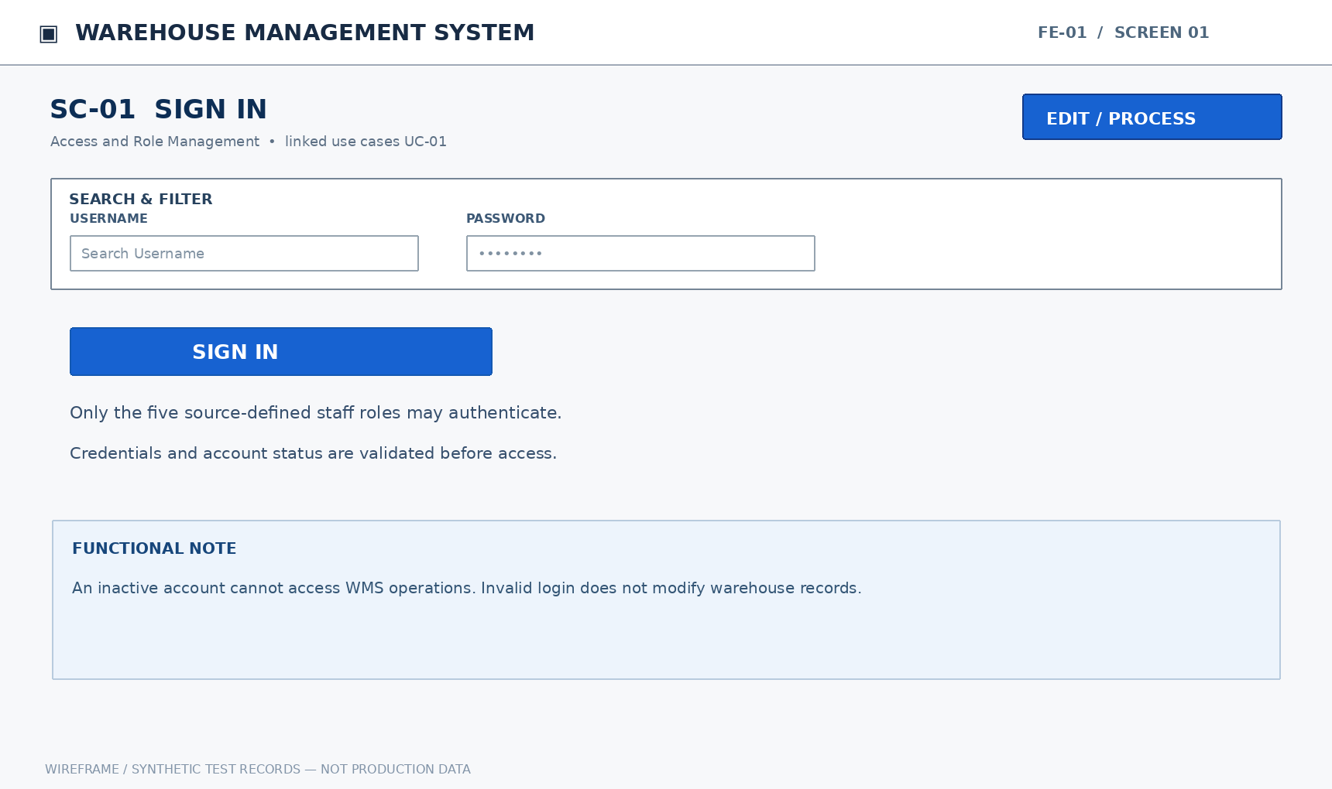
Mockup SC-01. Sign In — illustrative functional layout
Purpose: Access authorized functions according to the assigned account and role.
Mapped Use Cases: UC-01 (Sign in to the system)
This screen allows only the relevant authorized roles to perform the mapped actions. Each write operation checks current document state, item/lot/location scope and approval/eligible-stock rules.
UC | Authorized Actor(s) | Functional Behavior / Expected Outcome
UC-01 | Store Manager, Accountant, Warehouse Staff, Sales Staff, Administrator | Access authorized functions according to the assigned account and role.

Field Description
Field Name | Description
Username | NVARCHAR(50). Entry: Required. Default: No SQL DEFAULT; supply or select a value.  Validation: Account login identifier; trim surrounding whitespace and compare against existing usernames without creating duplicates.
Password | NVARCHAR(128) (input only; hash persisted). Entry: Required. Default: No SQL DEFAULT; supply or select a value.  Validation: Required masked credential; verify against a salted one-way hash. Never store plaintext or display it in activity logs.

1.2 Account List and Details

1.2.1 SC-02: Account List and Details
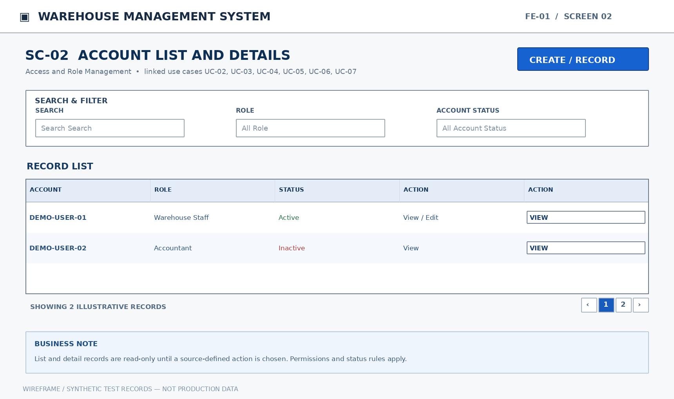
Mockup SC-02. Account List and Details — illustrative functional layout
Purpose: Search and filter accounts by name, role, and active status. Display the selected account's information, assigned role, and status. Register an internal user account and select an appropriate role. Edit allowed account information without losing its action history. Enable or prevent account sign-in while preserving historical documents. Configure view, create, edit, and transaction-recording permissions by role.
Mapped Use Cases: UC-02 (View account list), UC-03 (View account details), UC-04 (Create staff account), UC-05 (Update staff account), UC-06 (Activate or deactivate account), UC-07 (Assign roles and operation permissions)
This screen allows only the relevant authorized roles to perform the mapped actions. Each write operation checks current document state, item/lot/location scope and approval/eligible-stock rules.
UC | Authorized Actor(s) | Functional Behavior / Expected Outcome
UC-02 | Administrator | Search and filter accounts by name, role, and active status.
UC-03 | Administrator | Display the selected account's information, assigned role, and status.
UC-04 | Administrator | Register an internal user account and select an appropriate role.
UC-05 | Administrator | Edit allowed account information without losing its action history.
UC-06 | Administrator | Enable or prevent account sign-in while preserving historical documents.
UC-07 | Administrator | Configure view, create, edit, and transaction-recording permissions by role.

Field Description
Field Name | Description
Search | NVARCHAR(150) (filter only). Entry: Optional filter. Default: NULL (blank filter is ignored).  Validation: Optional keyword matched to the authorized list; no value is saved to a business record.
Role | BIGINT (reference ID). Entry: Required on account create / optional filter. Default: NULL (blank filter is ignored).  Validation: Choose an existing authorized internal role; store its reference ID, not free text.
Account Status | BIT (0=inactive; 1=active). Entry: System-controlled. Default: Assigned by the workflow (no fixed SQL DEFAULT).  Validation: System-maintained activation flag; inactive accounts cannot authenticate and existing audit references remain.
Username | NVARCHAR(50). Entry: Required on account create. Default: No SQL DEFAULT; supply or select a value.  Validation: Account login identifier; trim surrounding whitespace and compare against existing usernames without creating duplicates.
Permissions | BIT per permission (role-operation junction). Entry: Required when assigning role rights. Default: No SQL DEFAULT; supply or select a value.  Validation: Store the permitted role-to-operation flags; only the administrator may modify operation assignments.

2. Product, Lot and Unit Management (FE-02)

2.1 Product and Unit Conversion

2.1.1 SC-03: Product and Unit Conversion
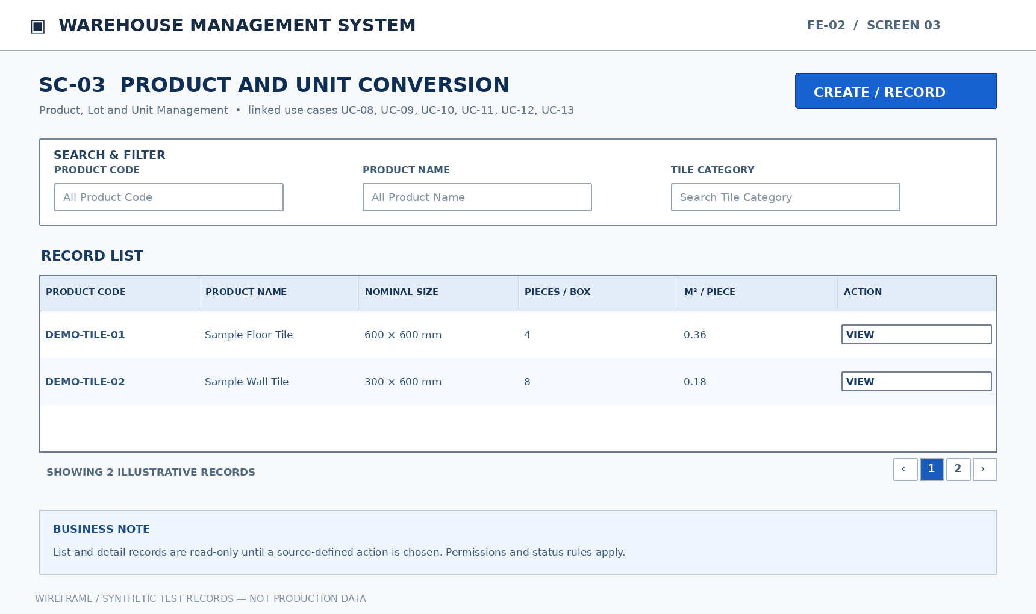
Mockup SC-03. Product and Unit Conversion — illustrative functional layout
Purpose: Search products by item code, name, size, and status. Display tile attributes, packaging specifications, and units of measure. Record product code, category, brand, material, nominal size, and identifying characteristics. Edit allowed attributes without corrupting existing documents or inventory history. Prevent selection on new documents while retaining inventory and history. Define pieces per box and area per piece for box, piece, and square-meter conversion by product.
Mapped Use Cases: UC-08 (View product list), UC-09 (View product details), UC-10 (Create product), UC-11 (Update product), UC-12 (Activate or deactivate product), UC-13 (Configure packaging and unit conversion)
This screen allows only the relevant authorized roles to perform the mapped actions. Each write operation checks current document state, item/lot/location scope and approval/eligible-stock rules.
UC | Authorized Actor(s) | Functional Behavior / Expected Outcome
UC-08 | Store Manager, Accountant, Warehouse Staff, Sales Staff | Search products by item code, name, size, and status.
UC-09 | Store Manager, Accountant, Warehouse Staff, Sales Staff | Display tile attributes, packaging specifications, and units of measure.
UC-10 | Store Manager | Record product code, category, brand, material, nominal size, and identifying characteristics.
UC-11 | Store Manager | Edit allowed attributes without corrupting existing documents or inventory history.
UC-12 | Store Manager | Prevent selection on new documents while retaining inventory and history.
UC-13 | Store Manager | Define pieces per box and area per piece for box, piece, and square-meter conversion by product.

Field Description
Field Name | Description
Product Code | NVARCHAR(50). Entry: Required. Default: No SQL DEFAULT; supply or select a value.  Validation: Business product identifier; required on product creation and unique across the product catalog.
Product Name | NVARCHAR(150). Entry: Required. Default: No SQL DEFAULT; supply or select a value.  Validation: Descriptive tile name; required on product creation; trim whitespace and reject an empty value.
Tile Category | NVARCHAR(100). Entry: Required. Default: No SQL DEFAULT; supply or select a value.  Validation: Select the tile functional category from the configured reference list.
Brand | NVARCHAR(100). Entry: Optional. Default: NULL.  Validation: Optional brand name/reference associated with the product.
Material | NVARCHAR(100). Entry: Required. Default: No SQL DEFAULT; supply or select a value.  Validation: Select the material classification for the tile product.
Nominal Size | NVARCHAR(100). Entry: Required. Default: No SQL DEFAULT; supply or select a value.  Validation: Nominal tile dimension label, such as 600×600 mm; preserve it separately from lot actual calibre.
Pieces / Box | INT. Entry: Required when configuring conversion. Default: No SQL DEFAULT; supply or select a value.  Validation: Whole pieces per package; must be greater than zero when configuring conversion.
m² / Piece | DECIMAL(18,6). Entry: Required when configuring conversion. Default: No SQL DEFAULT; supply or select a value.  Validation: Square-meter conversion factor per piece; must be greater than zero and used consistently in stock movements.
Status | VARCHAR(30). Entry: System-controlled. Default: Assigned by the workflow (no fixed SQL DEFAULT).  Validation: Workflow-dependent state; display the current status and accept only transitions authorized by the relevant UC.

Input and validation notes: SQL Server types and maximum lengths are the proposed implementation baseline. Reference inputs must resolve to existing eligible master/source records; quantities must respect the product unit conversion and current lot/location quality state. Read-only balances, audit details and approval actor/timestamps are system-populated. Failed validation must not partially post any inventory movement.

2.2 Lot List and Details

2.2.1 SC-04: Lot List and Details
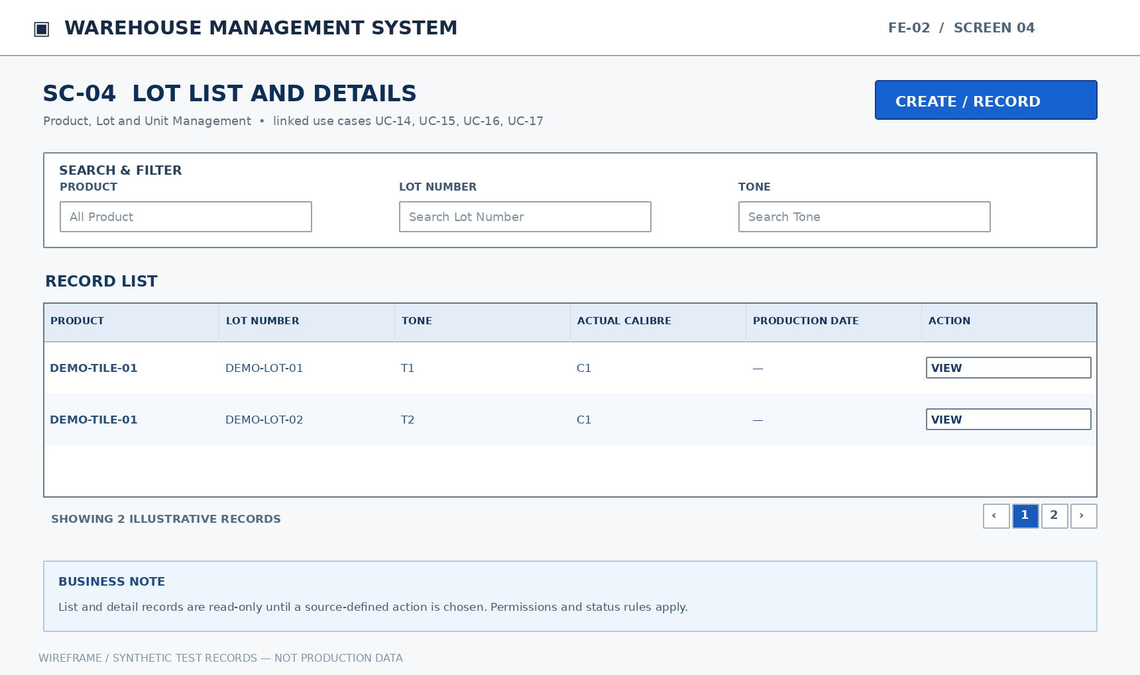
Mockup SC-04. Lot List and Details — illustrative functional layout
Purpose: Search lots by product, lot number, tone, and actual calibre. Display production date, tone, actual calibre, and related transaction history. Record lot number and physical tile characteristics on arrival, checking duplicate identity. Edit permitted lot attributes while preserving warehouse transactions already recorded.
Mapped Use Cases: UC-14 (View lot list), UC-15 (View lot details), UC-16 (Create product lot), UC-17 (Update lot information)
This screen allows only the relevant authorized roles to perform the mapped actions. Each write operation checks current document state, item/lot/location scope and approval/eligible-stock rules.
UC | Authorized Actor(s) | Functional Behavior / Expected Outcome
UC-14 | Store Manager, Warehouse Staff | Search lots by product, lot number, tone, and actual calibre.
UC-15 | Store Manager, Warehouse Staff | Display production date, tone, actual calibre, and related transaction history.
UC-16 | Store Manager, Warehouse Staff | Record lot number and physical tile characteristics on arrival, checking duplicate identity.
UC-17 | Store Manager | Edit permitted lot attributes while preserving warehouse transactions already recorded.

Field Description
Field Name | Description
Product | BIGINT (reference ID). Entry: Required. Default: No SQL DEFAULT; supply or select a value.  Validation: Existing product reference; selection must respect product activation and the current workflow.
Lot Number | NVARCHAR(50). Entry: Required. Default: No SQL DEFAULT; supply or select a value.  Validation: Lot identifier; validate the source-defined product/lot/tone/calibre identity before creating a duplicate.
Tone | NVARCHAR(100). Entry: Required. Default: No SQL DEFAULT; supply or select a value.  Validation: Actual lot shade/tone; required when registering a lot and used to distinguish physical stock.
Actual Calibre | NVARCHAR(100). Entry: Required. Default: No SQL DEFAULT; supply or select a value.  Validation: Actual lot dimension/calibre value, independent of the product nominal size.
Production Date | DATE. Entry: Optional. Default: NULL.  Validation: Optional actual manufacturing date; reject invalid calendar dates and never substitute a guessed date.
Transaction History | Derived result set (no standalone SQL column). Entry: Read-only. Default: Derived from persisted data; not user-entered.  Validation: Read-only list of posted documents and movements relating to the selected lot; generated from audit records.

3. Supplier Reference Management (FE-03)

3.1 Supplier List and Details

3.1.1 SC-05: Supplier List and Details
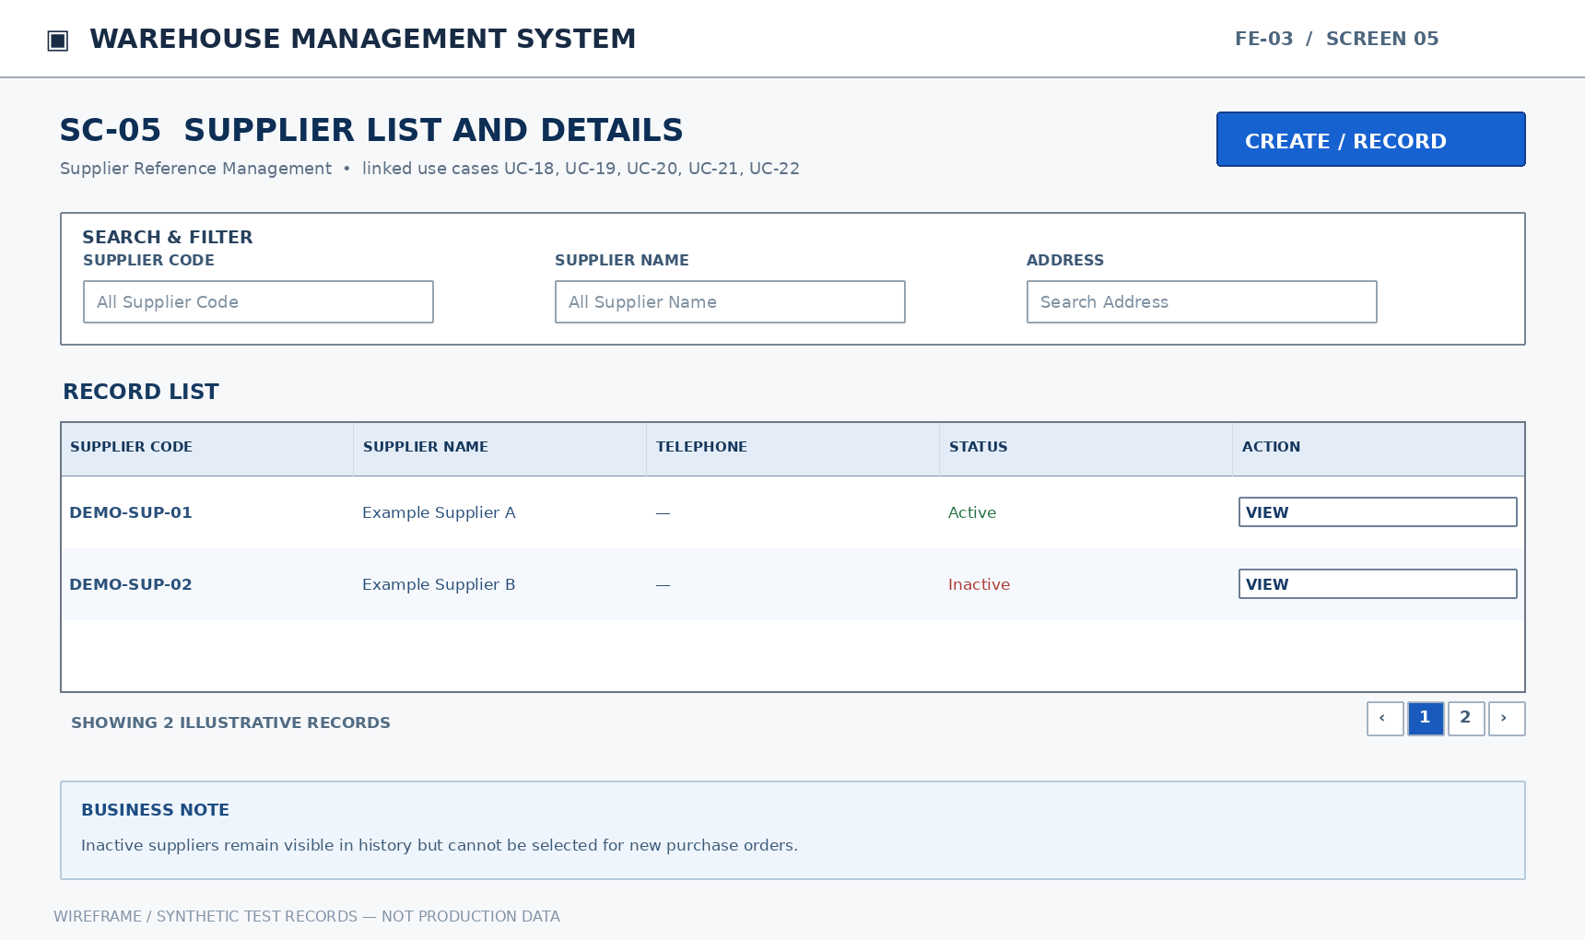
Mockup SC-05. Supplier List and Details — illustrative functional layout
Purpose: Search suppliers by code, name, and cooperation status. Display contact information and related purchases, receipts, and returns. Record supplier code, name, address, telephone number, and contact person. Edit supplier contact details and reference information. Prevent inactive suppliers from being selected on new purchase orders while retaining old records.
Mapped Use Cases: UC-18 (View supplier list), UC-19 (View supplier details), UC-20 (Create supplier), UC-21 (Update supplier), UC-22 (Activate or deactivate supplier)
This screen allows only the relevant authorized roles to perform the mapped actions. Each write operation checks current document state, item/lot/location scope and approval/eligible-stock rules.
UC | Authorized Actor(s) | Functional Behavior / Expected Outcome
UC-18 | Store Manager, Accountant | Search suppliers by code, name, and cooperation status.
UC-19 | Store Manager, Accountant | Display contact information and related purchases, receipts, and returns.
UC-20 | Accountant | Record supplier code, name, address, telephone number, and contact person.
UC-21 | Accountant | Edit supplier contact details and reference information.
UC-22 | Store Manager, Accountant | Prevent inactive suppliers from being selected on new purchase orders while retaining old records.

Field Description
Field Name | Description
Supplier Code | NVARCHAR(50). Entry: Required. Default: No SQL DEFAULT; supply or select a value.  Validation: Required supplier identifier; enforce uniqueness in the supplier reference table.
Supplier Name | NVARCHAR(150). Entry: Required. Default: No SQL DEFAULT; supply or select a value.  Validation: Required supplier business name; trim leading/trailing whitespace and reject blank names.
Address | NVARCHAR(255). Entry: Optional. Default: NULL.  Validation: Optional supplier correspondence address; preserve Vietnamese/Unicode characters.
Telephone | VARCHAR(20). Entry: Optional. Default: NULL.  Validation: Optional contact phone; preserve leading zero and + sign; store as text, not a number.
Contact Person | NVARCHAR(100). Entry: Optional. Default: NULL.  Validation: Optional representative/contact name for supplier communications.
Status | VARCHAR(30). Entry: System-controlled. Default: Assigned by the workflow (no fixed SQL DEFAULT).  Validation: Workflow-dependent state; display the current status and accept only transitions authorized by the relevant UC.

4. Purchase Order and Supplier Confirmation (FE-04)

4.1 Replenishment Requests

4.1.1 SC-06: Replenishment Requests
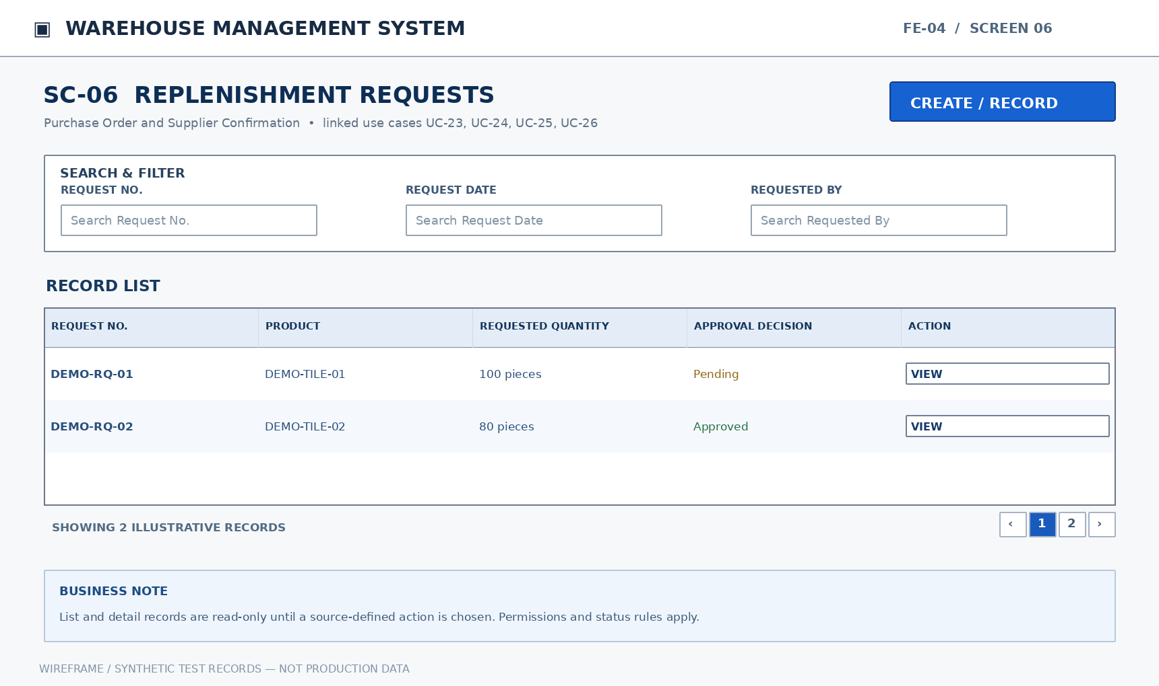
Mockup SC-06. Replenishment Requests — illustrative functional layout
Purpose: Search requests by status, date, creator, and approval decision. Display required products, reference stock, requested quantities, and approval history. Propose replenishment after checking stock and recording products, quantities, and reasons. Review the request and record decision, approver, time, and rejection reason.
Mapped Use Cases: UC-23 (View replenishment request list), UC-24 (View replenishment request details), UC-25 (Create replenishment request), UC-26 (Approve or reject replenishment request)
This screen allows only the relevant authorized roles to perform the mapped actions. Each write operation checks current document state, item/lot/location scope and approval/eligible-stock rules.
UC | Authorized Actor(s) | Functional Behavior / Expected Outcome
UC-23 | Store Manager, Accountant | Search requests by status, date, creator, and approval decision.
UC-24 | Store Manager, Accountant | Display required products, reference stock, requested quantities, and approval history.
UC-25 | Accountant | Propose replenishment after checking stock and recording products, quantities, and reasons.
UC-26 | Store Manager | Review the request and record decision, approver, time, and rejection reason.

Field Description
Field Name | Description
Request No. | NVARCHAR(50). Entry: System-generated. Default: Assigned by the workflow (no fixed SQL DEFAULT).  Validation: System-assigned replenishment request code; unique among replenishment documents and read-only after creation.
Request Date | DATE. Entry: System-generated. Default: Assigned by the workflow (no fixed SQL DEFAULT).  Validation: Creation date of the request; system-populated and read-only.
Requested By | BIGINT (reference ID). Entry: System-generated. Default: Assigned by the workflow (no fixed SQL DEFAULT).  Validation: Reference to the authenticated employee/account that submitted the document; system-populated.
Reference Stock | DECIMAL(18,3). Entry: Read-only. Default: Derived from persisted data; not user-entered.  Validation: Read-only on-hand quantity for the relevant product/warehouse at request creation; never treated as an editable stock movement.
Product | BIGINT (reference ID). Entry: Required. Default: No SQL DEFAULT; supply or select a value.  Validation: Existing product reference; selection must respect product activation and the current workflow.
Requested Quantity | DECIMAL(18,3). Entry: Required. Default: No SQL DEFAULT; supply or select a value.  Validation: Quantity requested on a replenishment or issue line; greater than zero on submission.
Reason | NVARCHAR(500). Entry: Required. Default: No SQL DEFAULT; supply or select a value.  Validation: Business justification; required on requests and variance/return actions that explicitly require a reason.
Approval Decision | VARCHAR(30). Entry: Required when deciding. Default: No SQL DEFAULT; supply or select a value.  Validation: Approve or reject an eligible pending request; capture approver and decision time; rejection requires a reason.

4.2 Purchase Orders

4.2.1 SC-07: Purchase Orders
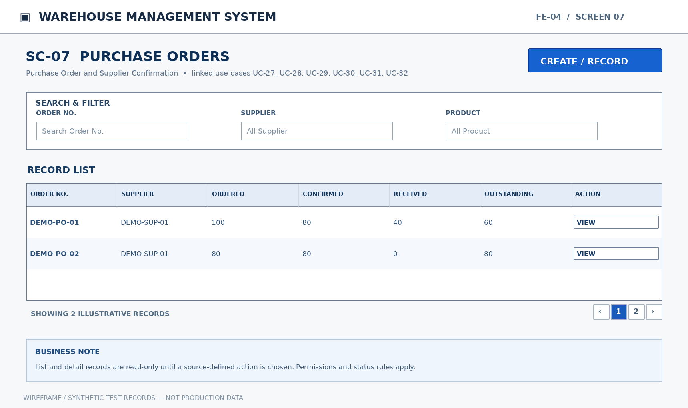
Mockup SC-07. Purchase Orders — illustrative functional layout
Purpose: Filter orders by supplier, date, status, and outstanding quantity. Display order lines, supplier confirmations, and partial receipt history. Create an order from an approved request, specifying supplier, products, quantities, units, and expected receipt date. Change only the unreceived portion without deleting quantities already received. Record confirmed quantities and anticipated delivery schedule, including partial confirmation. Compare ordered, supplier-confirmed, delivered/received, and outstanding quantities by order line.
Mapped Use Cases: UC-27 (View purchase order list), UC-28 (View purchase order details), UC-29 (Create purchase order), UC-30 (Update or cancel purchase order), UC-31 (Record supplier confirmation), UC-32 (View outstanding receipt quantity)
This screen allows only the relevant authorized roles to perform the mapped actions. Each write operation checks current document state, item/lot/location scope and approval/eligible-stock rules.
UC | Authorized Actor(s) | Functional Behavior / Expected Outcome
UC-27 | Store Manager, Accountant, Warehouse Staff | Filter orders by supplier, date, status, and outstanding quantity.
UC-28 | Store Manager, Accountant, Warehouse Staff | Display order lines, supplier confirmations, and partial receipt history.
UC-29 | Accountant | Create an order from an approved request, specifying supplier, products, quantities, units, and expected receipt date.
UC-30 | Accountant | Change only the unreceived portion without deleting quantities already received.
UC-31 | Accountant | Record confirmed quantities and anticipated delivery schedule, including partial confirmation.
UC-32 | Store Manager, Accountant, Warehouse Staff | Compare ordered, supplier-confirmed, delivered/received, and outstanding quantities by order line.

Field Description
Field Name | Description
Order No. | NVARCHAR(50). Entry: System-generated. Default: Assigned by the workflow (no fixed SQL DEFAULT).  Validation: Unique purchase order document number, generated or assigned at PO creation and displayed read-only thereafter.
Supplier | BIGINT (reference ID). Entry: Required. Default: No SQL DEFAULT; supply or select a value.  Validation: Existing supplier reference; a new purchase order may use only an active supplier.
Product | BIGINT (reference ID). Entry: Required. Default: No SQL DEFAULT; supply or select a value.  Validation: Existing product reference; selection must respect product activation and the current workflow.
Ordered Quantity | DECIMAL(18,3). Entry: Required. Default: No SQL DEFAULT; supply or select a value.  Validation: Positive purchase order line quantity; not lower than quantity already received when edited.
Unit | VARCHAR(10). Entry: Required. Default: No SQL DEFAULT; supply or select a value.  Validation: Selected product unit of measure: piece, box, or m²; use the product-specific conversion factor.
Expected Receipt | DATE. Entry: Required. Default: No SQL DEFAULT; supply or select a value.  Validation: Expected goods arrival date recorded on a purchase order; calendar date only.
Confirmed Quantity | DECIMAL(18,3). Entry: Required at confirmation. Default: No SQL DEFAULT; supply or select a value.  Validation: Supplier-confirmed line quantity; nonnegative and reconciled against the applicable ordered quantity.
Received Quantity | DECIMAL(18,3). Entry: Read-only. Default: Derived from persisted data; not user-entered.  Validation: Actual quantity captured at a receiving checkpoint; nonnegative and linked to the source order.
Outstanding Quantity | DECIMAL(18,3). Entry: Read-only. Default: Derived from persisted data; not user-entered.  Validation: Read-only remaining purchase quantity calculated from ordered and received quantities with relevant confirmation state.

5. Goods Receiving and Inspection (FE-05)

5.1 Goods Receipts and Inspection

5.1.1 SC-08: Goods Receipts and Inspection
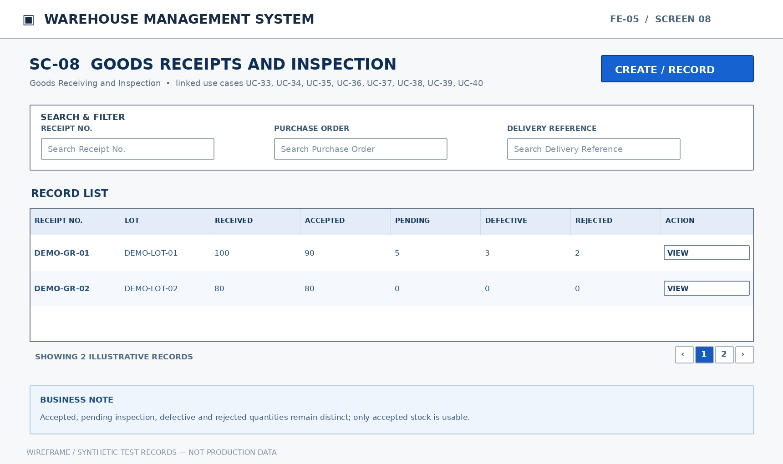
Mockup SC-08. Goods Receipts and Inspection — illustrative functional layout
Purpose: Search deliveries associated with purchase orders and their processing status. Display delivered, accepted, pending inspection, defective, and rejected quantities. Record each supplier delivery separately and link it to its purchase order. Enter boxes, pieces, square meters, lot, tone, calibre, location, and package condition. Split received goods into accepted, pending inspection, defective, and rejected categories. Capture lot, defective quantity, defect type, and evidence separately from accepted stock. Record shortages, excesses, mismatched characteristics, damage, and supporting documents. Post accepted quantities to appropriate inventory; maintain separate non-accepted categories.
Mapped Use Cases: UC-33 (View goods receipt list), UC-34 (View goods receipt details), UC-35 (Create goods receipt from purchase order), UC-36 (Record actual received quantity and characteristics), UC-37 (Classify inspection results), UC-38 (Record defects during receiving), UC-39 (Record receiving discrepancies), UC-40 (Complete accepted goods receipt)
This screen allows only the relevant authorized roles to perform the mapped actions. Each write operation checks current document state, item/lot/location scope and approval/eligible-stock rules.
UC | Authorized Actor(s) | Functional Behavior / Expected Outcome
UC-33 | Store Manager, Accountant, Warehouse Staff | Search deliveries associated with purchase orders and their processing status.
UC-34 | Store Manager, Accountant, Warehouse Staff | Display delivered, accepted, pending inspection, defective, and rejected quantities.
UC-35 | Warehouse Staff | Record each supplier delivery separately and link it to its purchase order.
UC-36 | Warehouse Staff | Enter boxes, pieces, square meters, lot, tone, calibre, location, and package condition.
UC-37 | Warehouse Staff | Split received goods into accepted, pending inspection, defective, and rejected categories.
UC-38 | Warehouse Staff | Capture lot, defective quantity, defect type, and evidence separately from accepted stock.
UC-39 | Warehouse Staff | Record shortages, excesses, mismatched characteristics, damage, and supporting documents.
UC-40 | Warehouse Staff | Post accepted quantities to appropriate inventory; maintain separate non-accepted categories.

Field Description
Field Name | Description
Receipt No. | NVARCHAR(50). Entry: System-generated. Default: Assigned by the workflow (no fixed SQL DEFAULT).  Validation: Unique goods receipt document code; associates inspected goods with the source purchase order.
Purchase Order | BIGINT (reference ID). Entry: Required. Default: No SQL DEFAULT; supply or select a value.  Validation: Source purchase order reference; must exist and remain linked to the receipt.
Delivery Reference | NVARCHAR(50). Entry: Required for external delivery identification. Default: No SQL DEFAULT; supply or select a value.  Validation: External delivery note/reference for the shipment; check repeated reference against the relevant supplier and PO.
Product | BIGINT (reference ID). Entry: Required. Default: No SQL DEFAULT; supply or select a value.  Validation: Existing product reference; selection must respect product activation and the current workflow.
Lot | BIGINT (reference ID). Entry: Required. Default: No SQL DEFAULT; supply or select a value.  Validation: Existing lot record reference; lot/tone/calibre must match the selected product.
Tone | NVARCHAR(100). Entry: Required. Default: No SQL DEFAULT; supply or select a value.  Validation: Actual lot shade/tone; required when registering a lot and used to distinguish physical stock.
Actual Calibre | NVARCHAR(100). Entry: Required. Default: No SQL DEFAULT; supply or select a value.  Validation: Actual lot dimension/calibre value, independent of the product nominal size.
Boxes | INT. Entry: Conditional: quantity may be entered in boxes/pieces/m². Default: No SQL DEFAULT; supply or select a value.  Validation: Nonnegative integer number of cartons/boxes physically received; converted using pieces per box.
Pieces | INT. Entry: Conditional: quantity may be entered in boxes/pieces/m². Default: No SQL DEFAULT; supply or select a value.  Validation: Nonnegative integer quantity of individual pieces physically received; do not use floating-point units.
m² | DECIMAL(18,3). Entry: Conditional: quantity may be entered in boxes/pieces/m². Default: No SQL DEFAULT; supply or select a value.  Validation: Nonnegative measured square-meter quantity converted by the selected product conversion factors.
Accepted | DECIMAL(18,3). Entry: Required at inspection. Default: No SQL DEFAULT; supply or select a value.  Validation: Accepted goods quantity at inspection; must be nonnegative and included in the total received reconciliation.
Pending Inspection | DECIMAL(18,3). Entry: Required at inspection. Default: No SQL DEFAULT; supply or select a value.  Validation: Quantity awaiting inspection; cannot count toward usable stock.
Defective | DECIMAL(18,3). Entry: Required at inspection. Default: No SQL DEFAULT; supply or select a value.  Validation: Quantity determined defective during receipt inspection; cannot be included as accepted/usable stock.
Rejected | DECIMAL(18,3). Entry: Required at inspection. Default: No SQL DEFAULT; supply or select a value.  Validation: Quantity rejected on arrival; remain segregated from accepted inventory.
Location | BIGINT (reference ID). Entry: Required when posting accepted stock. Default: No SQL DEFAULT; supply or select a value.  Validation: Existing location reference within the chosen warehouse; must be active/eligible for a new stock posting.

6. Warehouse and Storage Location Management (FE-06)

6.1 Warehouse Locations

6.1.1 SC-09: Warehouse Locations
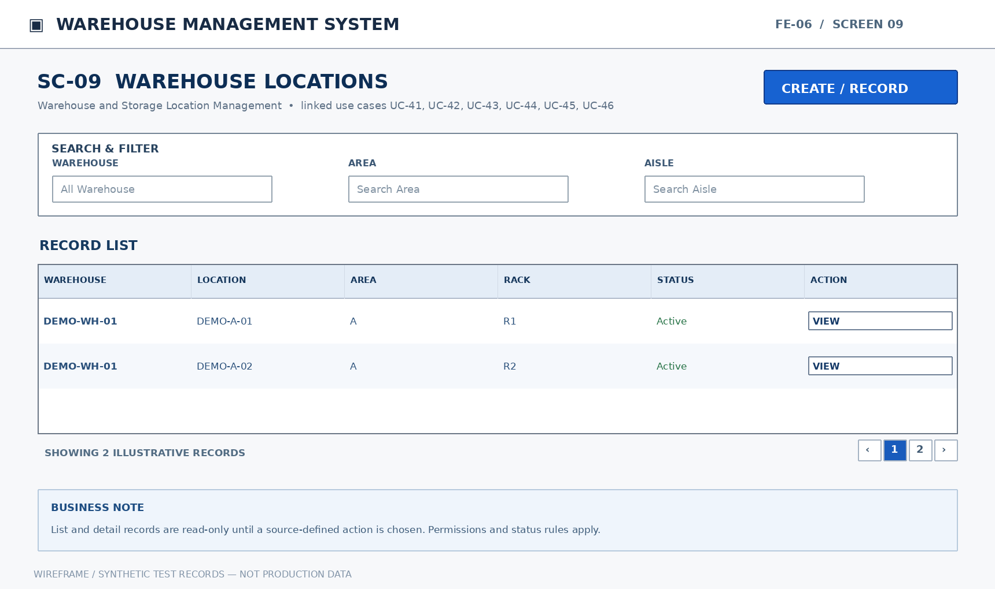
Mockup SC-09. Warehouse Locations — illustrative functional layout
Purpose: Search by warehouse, area, aisle, rack, and location code. Display capacity, status, and lot-level quantities at a location. Define area, aisle, rack, location code, and storage capacity. Edit permitted attributes without altering historical stock movement records. Deactivate only after stock is cleared; retain history and prevent future new transactions. Assign accepted quantities to their actual warehouse and storage location.
Mapped Use Cases: UC-41 (View warehouse and location list), UC-42 (View storage location details), UC-43 (Create storage location), UC-44 (Update storage location), UC-45 (Activate or deactivate storage location), UC-46 (Allocate accepted goods to a location)
This screen allows only the relevant authorized roles to perform the mapped actions. Each write operation checks current document state, item/lot/location scope and approval/eligible-stock rules.
UC | Authorized Actor(s) | Functional Behavior / Expected Outcome
UC-41 | Store Manager, Warehouse Staff | Search by warehouse, area, aisle, rack, and location code.
UC-42 | Store Manager, Warehouse Staff | Display capacity, status, and lot-level quantities at a location.
UC-43 | Store Manager | Define area, aisle, rack, location code, and storage capacity.
UC-44 | Store Manager | Edit permitted attributes without altering historical stock movement records.
UC-45 | Store Manager | Deactivate only after stock is cleared; retain history and prevent future new transactions.
UC-46 | Warehouse Staff | Assign accepted quantities to their actual warehouse and storage location.

Field Description
Field Name | Description
Warehouse | BIGINT (reference ID). Entry: Required. Default: No SQL DEFAULT; supply or select a value.  Validation: Authorized warehouse reference; restrict the lookup to locations and operations permitted to the user.
Area | NVARCHAR(100). Entry: Optional. Default: NULL.  Validation: Optional storage zone/area designation within the parent warehouse.
Aisle | NVARCHAR(100). Entry: Optional. Default: NULL.  Validation: Optional aisle identifier within a warehouse area.
Rack | NVARCHAR(100). Entry: Optional. Default: NULL.  Validation: Optional rack identifier within the storage area/aisle.
Location Code | NVARCHAR(50). Entry: Required. Default: No SQL DEFAULT; supply or select a value.  Validation: Required unique location code within its parent warehouse.
Capacity | DECIMAL(18,3). Entry: Optional. Default: NULL.  Validation: Optional storage capacity; must be positive if configured and interpreted using the location capacity unit.
Status | VARCHAR(30). Entry: System-controlled. Default: Assigned by the workflow (no fixed SQL DEFAULT).  Validation: Workflow-dependent state; display the current status and accept only transitions authorized by the relevant UC.
Stock at Location | DECIMAL(18,3). Entry: Read-only. Default: Derived from persisted data; not user-entered.  Validation: Read-only total balance in the selected location; calculated from posted lot/location movements.

7. Inventory by Lot, Location and Status (FE-07)

7.1 Inventory by Lot and Status

7.1.1 SC-10: Inventory by Lot and Status
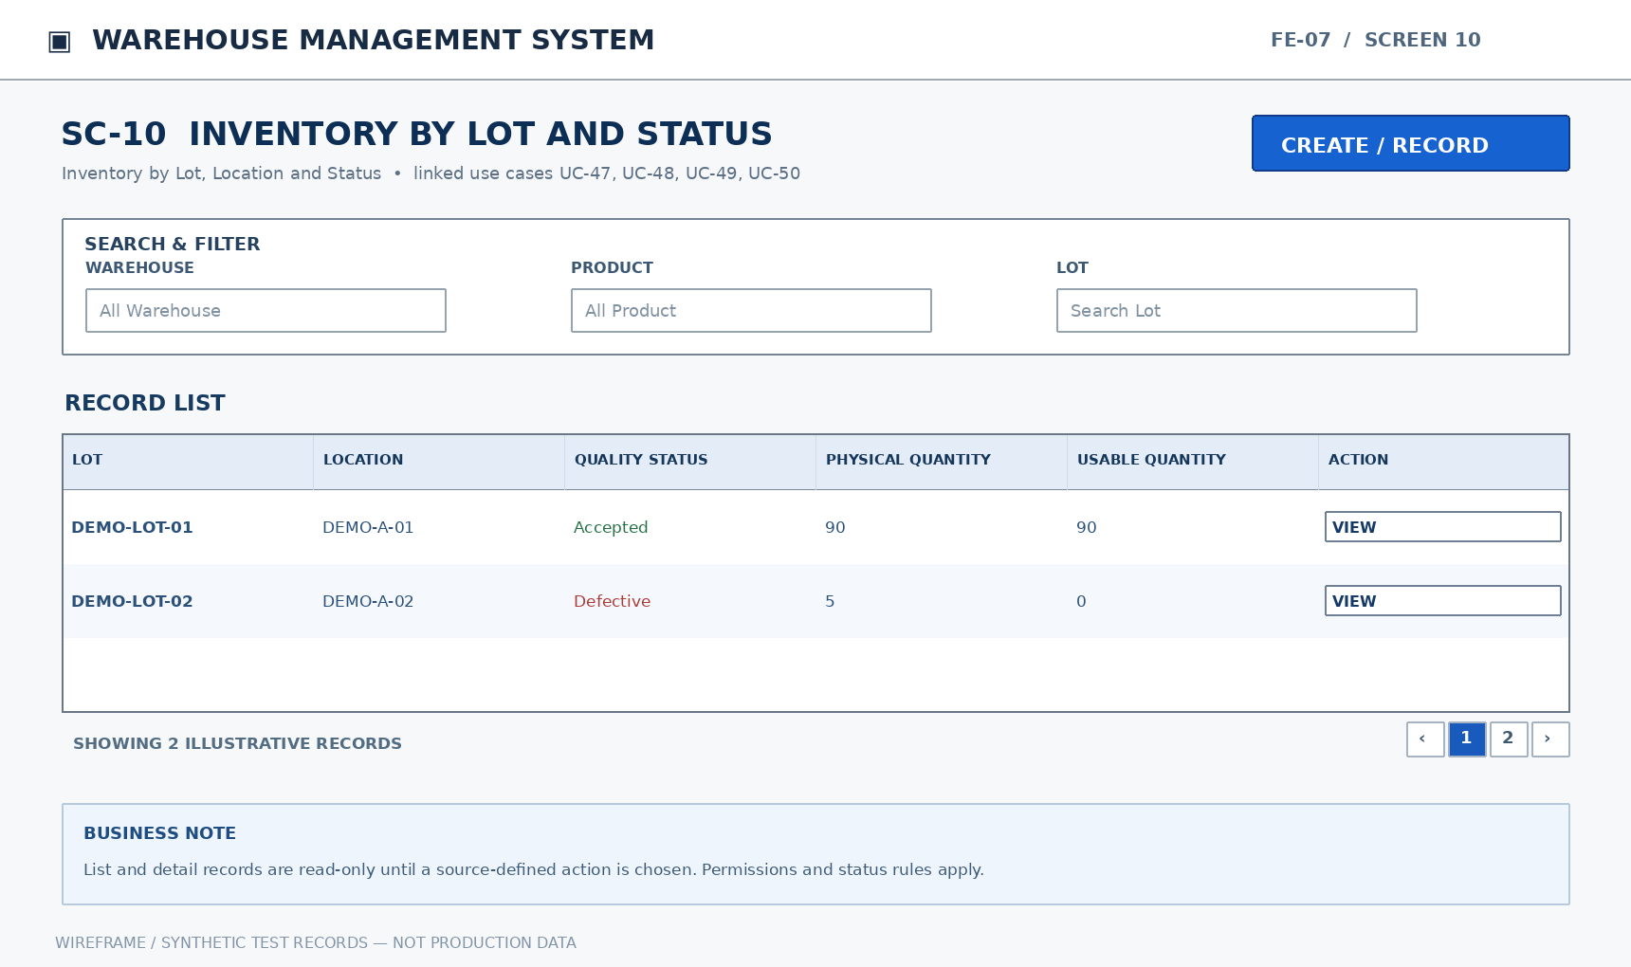
Mockup SC-10. Inventory by Lot and Status — illustrative functional layout
Purpose: Filter inventory by product, warehouse, lot, tone, calibre, and quality status. Display physical quantity, usable quantity, and source movement documents. Separate non-usable quantities from available stock. Classify inspected goods as accepted, conditionally usable, supplier-returned, or written off.
Mapped Use Cases: UC-47 (View stock by lot, location, and quality status), UC-48 (View inventory balance details), UC-49 (Reclassify goods as pending inspection or defective), UC-50 (Record disposition of quarantined goods)
This screen allows only the relevant authorized roles to perform the mapped actions. Each write operation checks current document state, item/lot/location scope and approval/eligible-stock rules.
UC | Authorized Actor(s) | Functional Behavior / Expected Outcome
UC-47 | Store Manager, Accountant, Warehouse Staff, Sales Staff | Filter inventory by product, warehouse, lot, tone, calibre, and quality status.
UC-48 | Store Manager, Warehouse Staff | Display physical quantity, usable quantity, and source movement documents.
UC-49 | Warehouse Staff | Separate non-usable quantities from available stock.
UC-50 | Warehouse Staff | Classify inspected goods as accepted, conditionally usable, supplier-returned, or written off.

Field Description
Field Name | Description
Warehouse | BIGINT (reference ID). Entry: Read-only / optional filter. Default: NULL (blank filter is ignored).  Validation: Authorized warehouse reference; restrict the lookup to locations and operations permitted to the user. Historical/inactive master records remain searchable where linked to authorized posted transactions.
Product | BIGINT (reference ID). Entry: Read-only / optional filter. Default: NULL (blank filter is ignored).  Validation: Existing product reference; selection must respect product activation and the current workflow. Historical/inactive master records remain searchable where linked to authorized posted transactions.
Lot | BIGINT (reference ID). Entry: Read-only / optional filter. Default: NULL (blank filter is ignored).  Validation: Existing lot record reference; lot/tone/calibre must match the selected product. Historical/inactive master records remain searchable where linked to authorized posted transactions.
Tone | NVARCHAR(100). Entry: Read-only / optional filter. Default: NULL (blank filter is ignored).  Validation: Actual lot shade/tone; required when registering a lot and used to distinguish physical stock.
Actual Calibre | NVARCHAR(100). Entry: Read-only / optional filter. Default: NULL (blank filter is ignored).  Validation: Actual lot dimension/calibre value, independent of the product nominal size.
Location | BIGINT (reference ID). Entry: Read-only / optional filter. Default: NULL (blank filter is ignored).  Validation: Existing location reference within the chosen warehouse; must be active/eligible for a new stock posting. Historical/inactive master records remain searchable where linked to authorized posted transactions.
Quality Status | VARCHAR(30). Entry: Read-only / optional filter. Default: NULL (blank filter is ignored).  Validation: Stock quality category; only eligible accepted quantities are included in usable stock.
Physical Quantity | DECIMAL(18,3). Entry: Read-only / optional filter. Default: NULL (blank filter is ignored).  Validation: Read-only physical quantity held at the specified lot/location across its quality categories.
Usable Quantity | DECIMAL(18,3). Entry: Read-only / optional filter. Default: NULL (blank filter is ignored).  Validation: Read-only available-for-issue quantity; excludes pending, defective and quarantined amounts.

7.2 Defective Goods and Disposition

7.2.1 SC-11: Defective Goods and Disposition
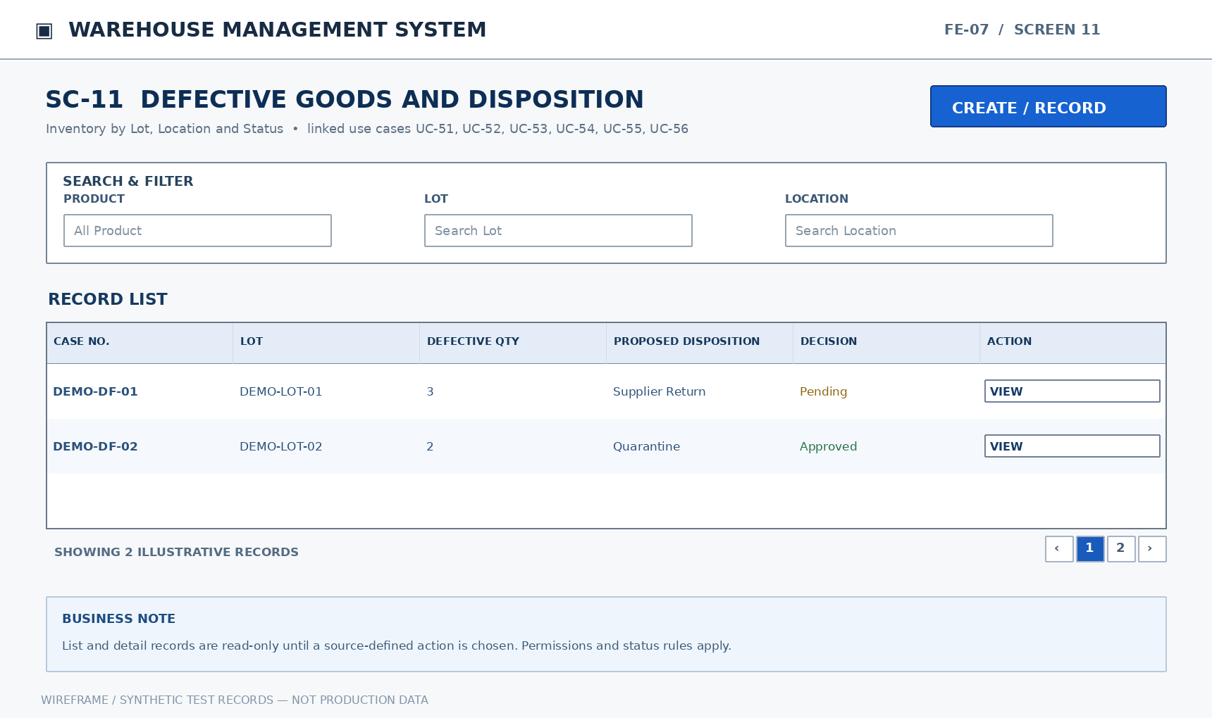
Mockup SC-11. Defective Goods and Disposition — illustrative functional layout
Purpose: Filter defective goods by product, lot, location, cause, status, and proposed disposition. Display affected quantity, evidence, recorder, and related handling actions. Capture lot, location, quantity, cause, and removal from usable inventory. Propose supplier return, conditional use, or stock loss for quarantined goods. Review cause and evidence and approve or reject the proposed handling. Update quantities and quality status according to the approved resolution.
Mapped Use Cases: UC-51 (View defective goods list), UC-52 (View defective goods details), UC-53 (Record defects discovered in storage), UC-54 (Create defective goods disposition request), UC-55 (Approve or reject defective goods disposition), UC-56 (Record approved defective goods disposition)
This screen allows only the relevant authorized roles to perform the mapped actions. Each write operation checks current document state, item/lot/location scope and approval/eligible-stock rules.
UC | Authorized Actor(s) | Functional Behavior / Expected Outcome
UC-51 | Store Manager, Warehouse Staff | Filter defective goods by product, lot, location, cause, status, and proposed disposition.
UC-52 | Store Manager, Warehouse Staff | Display affected quantity, evidence, recorder, and related handling actions.
UC-53 | Warehouse Staff | Capture lot, location, quantity, cause, and removal from usable inventory.
UC-54 | Warehouse Staff | Propose supplier return, conditional use, or stock loss for quarantined goods.
UC-55 | Store Manager | Review cause and evidence and approve or reject the proposed handling.
UC-56 | Warehouse Staff | Update quantities and quality status according to the approved resolution.

Field Description
Field Name | Description
Product | BIGINT (reference ID). Entry: Required. Default: No SQL DEFAULT; supply or select a value.  Validation: Existing product reference; selection must respect product activation and the current workflow.
Lot | BIGINT (reference ID). Entry: Required. Default: No SQL DEFAULT; supply or select a value.  Validation: Existing lot record reference; lot/tone/calibre must match the selected product.
Location | BIGINT (reference ID). Entry: Required. Default: No SQL DEFAULT; supply or select a value.  Validation: Existing location reference within the chosen warehouse; must be active/eligible for a new stock posting.
Defective Quantity | DECIMAL(18,3). Entry: Required for new case. Default: No SQL DEFAULT; supply or select a value.  Validation: Positive affected quantity when a new defective-goods case is recorded; cannot exceed eligible source quantity.
Cause | NVARCHAR(500). Entry: Required for new case. Default: No SQL DEFAULT; supply or select a value.  Validation: Explain the discrepancy or damage cause; required for recorded defect/variance resolution where specified.
Evidence | NVARCHAR(500) (storage object key). Entry: Optional. Default: NULL.  Validation: Optional secure document or image reference attached to an incident/return; validate that the storage object belongs to the record.
Proposed Disposition | VARCHAR(30). Entry: Required when submitting proposal. Default: No SQL DEFAULT; supply or select a value.  Validation: Select the documented handling proposal for a defective case; save proposal separately from approval.
Approval Decision | VARCHAR(30). Entry: Required when deciding. Default: No SQL DEFAULT; supply or select a value.  Validation: Approve or reject an eligible pending request; capture approver and decision time; rejection requires a reason.

8. Location Movement and Warehouse Transfer (FE-08)

8.1 Location Movements

8.1.1 SC-12: Location Movements
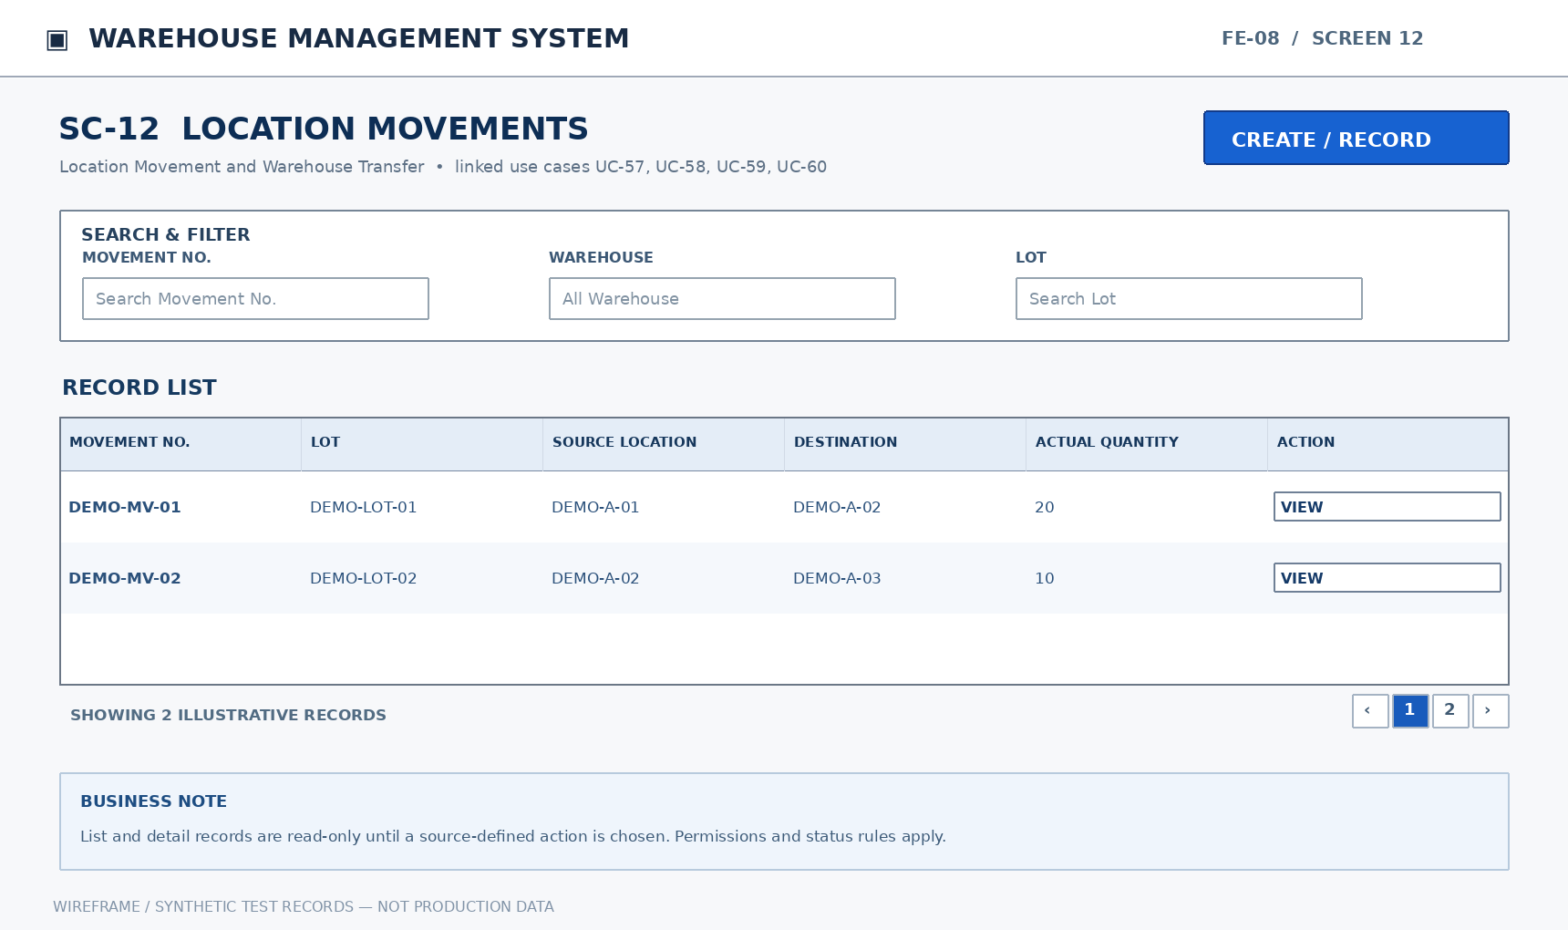
Mockup SC-12. Location Movements — illustrative functional layout
Purpose: Search same-warehouse movements by lot and status. Display source, destination, and actual transferred quantities. Specify lot, quantity, source and destination locations within the same warehouse. Decrease source-location quantity and increase destination-location quantity without changing warehouse total.
Mapped Use Cases: UC-57 (View location movement list), UC-58 (View location movement details), UC-59 (Create location movement), UC-60 (Confirm actual location movement)
This screen allows only the relevant authorized roles to perform the mapped actions. Each write operation checks current document state, item/lot/location scope and approval/eligible-stock rules.
UC | Authorized Actor(s) | Functional Behavior / Expected Outcome
UC-57 | Store Manager, Warehouse Staff | Search same-warehouse movements by lot and status.
UC-58 | Store Manager, Warehouse Staff | Display source, destination, and actual transferred quantities.
UC-59 | Warehouse Staff | Specify lot, quantity, source and destination locations within the same warehouse.
UC-60 | Warehouse Staff | Decrease source-location quantity and increase destination-location quantity without changing warehouse total.

Field Description
Field Name | Description
Movement No. | NVARCHAR(50). Entry: System-generated. Default: Assigned by the workflow (no fixed SQL DEFAULT).  Validation: Unique movement reference for a location transfer; generated when a movement record is created.
Warehouse | BIGINT (reference ID). Entry: Required. Default: No SQL DEFAULT; supply or select a value.  Validation: Authorized warehouse reference; restrict the lookup to locations and operations permitted to the user.
Lot | BIGINT (reference ID). Entry: Required. Default: No SQL DEFAULT; supply or select a value.  Validation: Existing lot record reference; lot/tone/calibre must match the selected product.
Source Location | BIGINT (reference ID). Entry: Required. Default: No SQL DEFAULT; supply or select a value.  Validation: Existing origin location reference; must contain enough eligible stock for the movement.
Destination Location | BIGINT (reference ID). Entry: Required. Default: No SQL DEFAULT; supply or select a value.  Validation: Existing destination location reference; must differ from source and belong to the selected transfer scope.
Planned Quantity | DECIMAL(18,3). Entry: Required. Default: No SQL DEFAULT; supply or select a value.  Validation: Requested movement quantity; must be greater than zero and not exceed eligible source stock.
Actual Moved Quantity | DECIMAL(18,3). Entry: Required when confirming movement. Default: No SQL DEFAULT; supply or select a value.  Validation: Positive actual moved quantity; reduces source balance and increases destination balance by the same amount.

8.2 Warehouse Transfers and Discrepancies

8.2.1 SC-13: Warehouse Transfers and Discrepancies
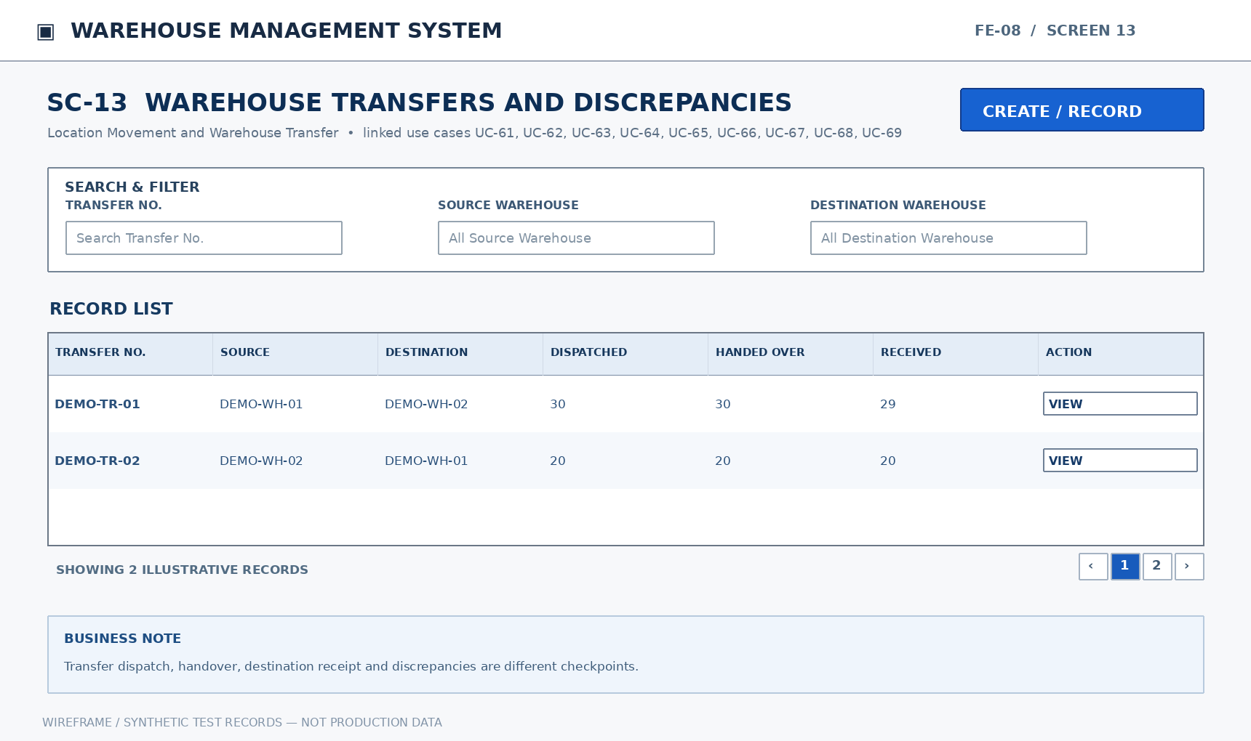
Mockup SC-13. Warehouse Transfers and Discrepancies — illustrative functional layout
Purpose: Search transfers by source/destination warehouse and in-transit/received status. Display dispatched, handed-over, and received quantities and discrepancies by lot. Record source/destination warehouses, lot, planned quantity, and responsible personnel. Decrease usable stock at the source and record dispatched quantity as in transit. Capture handed-over quantity, handler, time, and supporting evidence. Record actual received quantity and condition at the destination warehouse/location. Reconcile dispatched, handed-over, and received quantities, including shortage, excess, and damage. Propose corrective handling with a discrepancy report before closing the case. Review three quantity checkpoints and supporting evidence before deciding.
Mapped Use Cases: UC-61 (View warehouse transfer list), UC-62 (View warehouse transfer details), UC-63 (Create warehouse transfer), UC-64 (Record transfer dispatch), UC-65 (Record transfer handover), UC-66 (Record receipt at destination warehouse), UC-67 (Record transfer discrepancy), UC-68 (Request transfer discrepancy resolution), UC-69 (Approve or reject transfer discrepancy resolution)
This screen allows only the relevant authorized roles to perform the mapped actions. Each write operation checks current document state, item/lot/location scope and approval/eligible-stock rules.
UC | Authorized Actor(s) | Functional Behavior / Expected Outcome
UC-61 | Store Manager, Warehouse Staff | Search transfers by source/destination warehouse and in-transit/received status.
UC-62 | Store Manager, Warehouse Staff | Display dispatched, handed-over, and received quantities and discrepancies by lot.
UC-63 | Warehouse Staff | Record source/destination warehouses, lot, planned quantity, and responsible personnel.
UC-64 | Warehouse Staff | Decrease usable stock at the source and record dispatched quantity as in transit.
UC-65 | Warehouse Staff | Capture handed-over quantity, handler, time, and supporting evidence.
UC-66 | Warehouse Staff | Record actual received quantity and condition at the destination warehouse/location.
UC-67 | Warehouse Staff | Reconcile dispatched, handed-over, and received quantities, including shortage, excess, and damage.
UC-68 | Warehouse Staff | Propose corrective handling with a discrepancy report before closing the case.
UC-69 | Store Manager | Review three quantity checkpoints and supporting evidence before deciding.

Field Description
Field Name | Description
Transfer No. | NVARCHAR(50). Entry: System-generated. Default: Assigned by the workflow (no fixed SQL DEFAULT).  Validation: Unique warehouse transfer document reference.
Source Warehouse | BIGINT (reference ID). Entry: Required. Default: No SQL DEFAULT; supply or select a value.  Validation: Source warehouse reference; cannot be the same as the destination for an inter-warehouse transfer.
Destination Warehouse | BIGINT (reference ID). Entry: Required. Default: No SQL DEFAULT; supply or select a value.  Validation: Destination warehouse reference for the inter-warehouse transfer.
Lot | BIGINT (reference ID). Entry: Required. Default: No SQL DEFAULT; supply or select a value.  Validation: Existing lot record reference; lot/tone/calibre must match the selected product.
Dispatched Quantity | DECIMAL(18,3). Entry: Required at dispatch. Default: No SQL DEFAULT; supply or select a value.  Validation: Quantity actually dispatched from source warehouse; greater than zero when dispatching.
Handed-over Quantity | DECIMAL(18,3). Entry: Required at handover. Default: No SQL DEFAULT; supply or select a value.  Validation: Physical quantity handed over in transit; must reconcile with transfer dispatch and evidence.
Received Quantity | DECIMAL(18,3). Entry: Required at receipt. Default: No SQL DEFAULT; supply or select a value.  Validation: Actual quantity captured at a receiving checkpoint; nonnegative and linked to the source order.
Discrepancy | DECIMAL(18,3). Entry: System-calculated. Default: Assigned by the workflow (no fixed SQL DEFAULT).  Validation: Calculated signed difference between expected/handover and actual received transfer quantities.
Evidence | NVARCHAR(500) (storage object key). Entry: Optional. Default: NULL.  Validation: Optional secure document or image reference attached to an incident/return; validate that the storage object belongs to the record.
Decision | VARCHAR(30). Entry: Required when deciding resolution. Default: No SQL DEFAULT; supply or select a value.  Validation: Approve/reject or documented workflow decision; capture authorizing user and action time.

9. Stocktake and Inventory Adjustment (FE-09)

9.1 Stocktake and Counting

9.1.1 SC-14: Stocktake and Counting
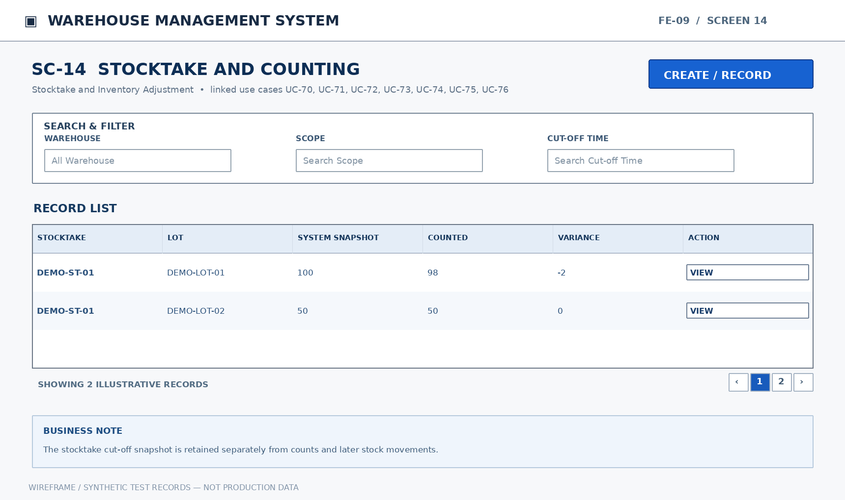
Mockup SC-14. Stocktake and Counting — illustrative functional layout
Purpose: Search stocktakes by warehouse, scope, cutoff time, and status. View included lots/locations, system snapshot, counted quantities, and variances. Specify warehouse, area, location, lot scope, and counting cutoff time. Save a stock snapshot and identify transactions recorded after the cutoff. Record boxes, pieces, and square meters by location, lot, and status. Record follow-up counts when variances require verification. Explain discrepancies with before/after quantities and the responsible recorder.
Mapped Use Cases: UC-70 (View stocktake list), UC-71 (View stocktake details), UC-72 (Create stocktake), UC-73 (Capture system balance at stocktake cutoff), UC-74 (Enter actual counted quantities), UC-75 (Record recount result), UC-76 (Record variance reason)
This screen allows only the relevant authorized roles to perform the mapped actions. Each write operation checks current document state, item/lot/location scope and approval/eligible-stock rules.
UC | Authorized Actor(s) | Functional Behavior / Expected Outcome
UC-70 | Store Manager, Warehouse Staff | Search stocktakes by warehouse, scope, cutoff time, and status.
UC-71 | Store Manager, Warehouse Staff | View included lots/locations, system snapshot, counted quantities, and variances.
UC-72 | Store Manager | Specify warehouse, area, location, lot scope, and counting cutoff time.
UC-73 | Store Manager, Warehouse Staff | Save a stock snapshot and identify transactions recorded after the cutoff.
UC-74 | Warehouse Staff | Record boxes, pieces, and square meters by location, lot, and status.
UC-75 | Warehouse Staff | Record follow-up counts when variances require verification.
UC-76 | Warehouse Staff | Explain discrepancies with before/after quantities and the responsible recorder.

Field Description
Field Name | Description
Warehouse | BIGINT (reference ID). Entry: Required for stocktake. Default: No SQL DEFAULT; supply or select a value.  Validation: Authorized warehouse reference; restrict the lookup to locations and operations permitted to the user.
Scope | NVARCHAR(100). Entry: Required for stocktake. Default: No SQL DEFAULT; supply or select a value.  Validation: Selected stocktake scope (warehouse, applicable products/lots/locations); stored with the stocktake record.
Cut-off Time | DATETIME2(0). Entry: System-captured. Default: Assigned by the workflow (no fixed SQL DEFAULT).  Validation: Snapshot timestamp for a stocktake; frozen balances use this precise point in time.
Lot | BIGINT (reference ID). Entry: Required on count line. Default: No SQL DEFAULT; supply or select a value.  Validation: Existing lot record reference; lot/tone/calibre must match the selected product.
Location | BIGINT (reference ID). Entry: Required on count line. Default: No SQL DEFAULT; supply or select a value.  Validation: Existing location reference within the chosen warehouse; must be active/eligible for a new stock posting.
System Snapshot | DECIMAL(18,3). Entry: Read-only. Default: Derived from persisted data; not user-entered.  Validation: Read-only inventory quantity captured at the frozen stocktake cut-off.
Counted Quantity | DECIMAL(18,3). Entry: Required for count line. Default: No SQL DEFAULT; supply or select a value.  Validation: Actual physical count; zero is permitted and must be distinguished from no count submitted.
Recount Quantity | DECIMAL(18,3). Entry: Optional recount. Default: NULL.  Validation: Optional physical recount; retain original count and user/time rather than overwriting it.
Variance | DECIMAL(18,3). Entry: System-calculated. Default: Assigned by the workflow (no fixed SQL DEFAULT).  Validation: Signed difference between a physical amount and its comparison baseline; can be positive, zero or negative.
Cause | NVARCHAR(500). Entry: Required when documenting a variance. Default: No SQL DEFAULT; supply or select a value.  Validation: Explain the discrepancy or damage cause; required for recorded defect/variance resolution where specified.

9.2 Inventory Adjustment Requests

9.2.1 SC-15: Inventory Adjustment Requests
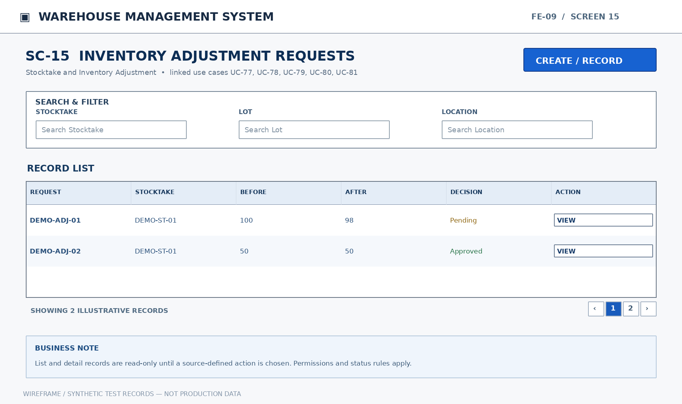
Mockup SC-15. Inventory Adjustment Requests — illustrative functional layout
Purpose: Search by stocktake, lot, location, variance reason, and approval status. Display before/after quantities, cause, creator, evidence, and approval decision. Request stock adjustment against a stocktake variance with cause and supporting quantities. Review counted quantities and causes; store decision, approver, and timestamp. Change inventory only for an approved request and create an auditable movement.
Mapped Use Cases: UC-77 (View inventory adjustment request list), UC-78 (View inventory adjustment request details), UC-79 (Create inventory adjustment request), UC-80 (Approve or reject inventory adjustment), UC-81 (Post approved inventory adjustment)
This screen allows only the relevant authorized roles to perform the mapped actions. Each write operation checks current document state, item/lot/location scope and approval/eligible-stock rules.
UC | Authorized Actor(s) | Functional Behavior / Expected Outcome
UC-77 | Store Manager, Warehouse Staff | Search by stocktake, lot, location, variance reason, and approval status.
UC-78 | Store Manager, Warehouse Staff | Display before/after quantities, cause, creator, evidence, and approval decision.
UC-79 | Warehouse Staff | Request stock adjustment against a stocktake variance with cause and supporting quantities.
UC-80 | Store Manager | Review counted quantities and causes; store decision, approver, and timestamp.
UC-81 | Warehouse Staff | Change inventory only for an approved request and create an auditable movement.

Field Description
Field Name | Description
Stocktake | BIGINT (reference ID). Entry: Required. Default: No SQL DEFAULT; supply or select a value.  Validation: Reference to an existing stocktake/snapshot; adjustments must link to a recorded stocktake.
Lot | BIGINT (reference ID). Entry: Required. Default: No SQL DEFAULT; supply or select a value.  Validation: Existing lot record reference; lot/tone/calibre must match the selected product.
Location | BIGINT (reference ID). Entry: Required. Default: No SQL DEFAULT; supply or select a value.  Validation: Existing location reference within the chosen warehouse; must be active/eligible for a new stock posting.
Before Quantity | DECIMAL(18,3). Entry: Read-only. Default: Derived from persisted data; not user-entered.  Validation: Read-only balance prior to the relevant posted transaction; preserved in movement history.
After Quantity | DECIMAL(18,3). Entry: Read-only. Default: Derived from persisted data; not user-entered.  Validation: Read-only balance after the transaction is posted; reconciled to the change amount.
Reason | NVARCHAR(500). Entry: Required. Default: No SQL DEFAULT; supply or select a value.  Validation: Business justification; required on requests and variance/return actions that explicitly require a reason.
Evidence | NVARCHAR(500) (storage object key). Entry: Optional. Default: NULL.  Validation: Optional secure document or image reference attached to an incident/return; validate that the storage object belongs to the record.
Requested By | BIGINT (reference ID). Entry: System-generated. Default: Assigned by the workflow (no fixed SQL DEFAULT).  Validation: Reference to the authenticated employee/account that submitted the document; system-populated.
Approved By | BIGINT (reference ID). Entry: System-generated on approval. Default: Assigned by the workflow (no fixed SQL DEFAULT).  Validation: System-populated approver account reference when an approval decision is made.

10. Warehouse Issue (FE-10)

10.1 Goods Issue Requests

10.1.1 SC-16: Goods Issue Requests
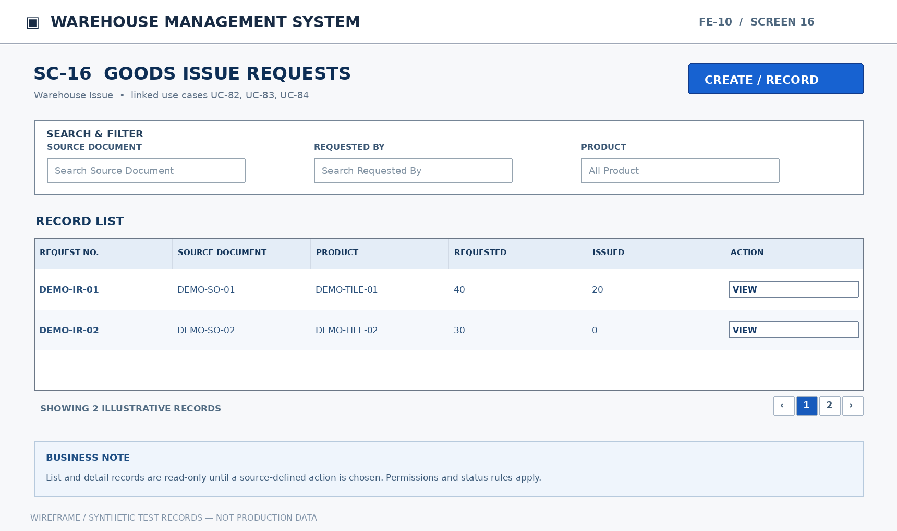
Mockup SC-16. Goods Issue Requests — illustrative functional layout
Purpose: Search issues requested against source documents and processing status. Display products, requested quantities, and quantities already issued. Specify source document, products, and required quantities without processing sales payment.
Mapped Use Cases: UC-82 (View goods issue request list), UC-83 (View goods issue request details), UC-84 (Create goods issue request)
This screen allows only the relevant authorized roles to perform the mapped actions. Each write operation checks current document state, item/lot/location scope and approval/eligible-stock rules.
UC | Authorized Actor(s) | Functional Behavior / Expected Outcome
UC-82 | Sales Staff, Warehouse Staff, Store Manager | Search issues requested against source documents and processing status.
UC-83 | Sales Staff, Warehouse Staff, Store Manager | Display products, requested quantities, and quantities already issued.
UC-84 | Sales Staff | Specify source document, products, and required quantities without processing sales payment.

Field Description
Field Name | Description
Source Document | NVARCHAR(50). Entry: Required. Default: No SQL DEFAULT; supply or select a value.  Validation: Originating business document code; no tax-invoice generation is implied by this warehouse reference.
Requested By | BIGINT (reference ID). Entry: System-generated. Default: Assigned by the workflow (no fixed SQL DEFAULT).  Validation: Reference to the authenticated employee/account that submitted the document; system-populated.
Product | BIGINT (reference ID). Entry: Required. Default: No SQL DEFAULT; supply or select a value.  Validation: Existing product reference; selection must respect product activation and the current workflow.
Requested Quantity | DECIMAL(18,3). Entry: Required. Default: No SQL DEFAULT; supply or select a value.  Validation: Quantity requested on a replenishment or issue line; greater than zero on submission.
Issued Quantity | DECIMAL(18,3). Entry: Read-only. Default: Derived from persisted data; not user-entered.  Validation: Read-only quantity already dispatched for the request, based on posted goods issues.
Status | VARCHAR(30). Entry: System-controlled. Default: Assigned by the workflow (no fixed SQL DEFAULT).  Validation: Workflow-dependent state; display the current status and accept only transitions authorized by the relevant UC.

10.2 Goods Issue and Actual Dispatch

10.2.1 SC-17: Goods Issue and Actual Dispatch
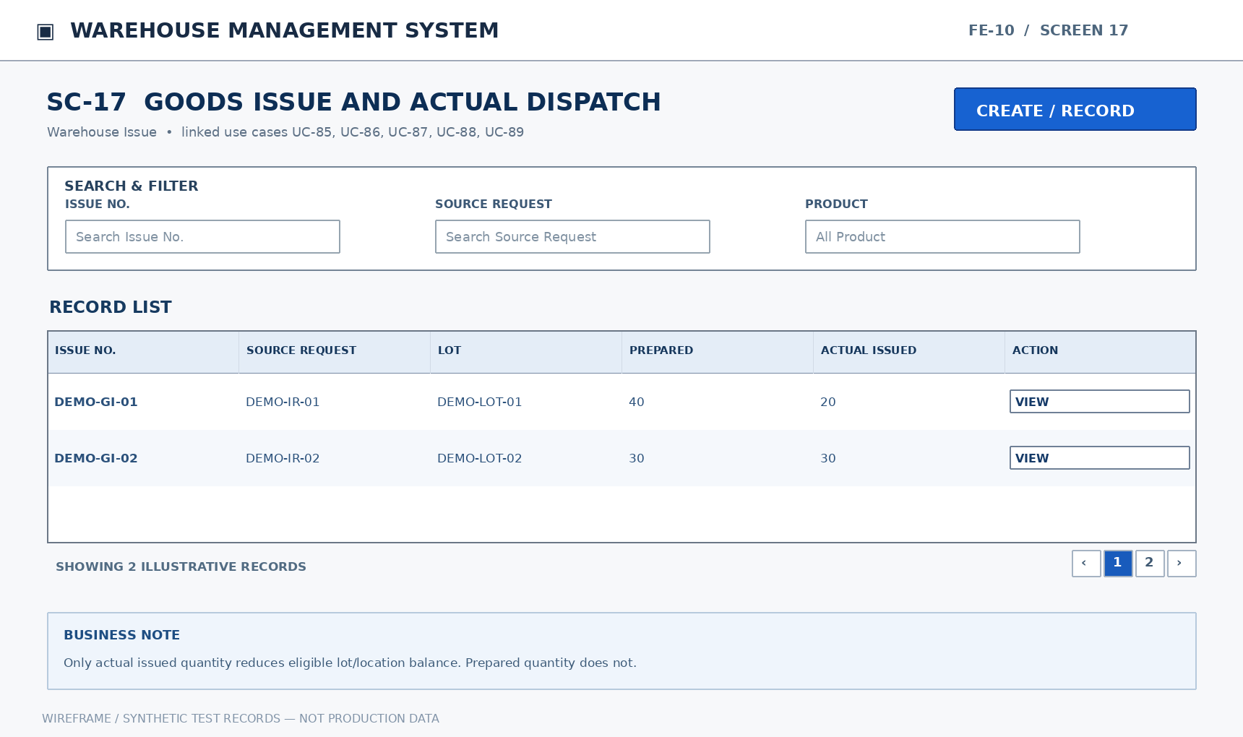
Mockup SC-17. Goods Issue and Actual Dispatch — illustrative functional layout
Purpose: Search by source request, issue date, and status. Display lot, location, prepared quantity, and actual issued quantity by line. Generate an issue against a request and identify quantities to prepare. Pick eligible inventory and handle insufficiency in a single lot. Deduct stock from the exact lot/location based on actual quantity and record the related request.
Mapped Use Cases: UC-85 (View goods issue list), UC-86 (View goods issue details), UC-87 (Create goods issue), UC-88 (Select issue lots and locations), UC-89 (Confirm actual goods issue quantity)
This screen allows only the relevant authorized roles to perform the mapped actions. Each write operation checks current document state, item/lot/location scope and approval/eligible-stock rules.
UC | Authorized Actor(s) | Functional Behavior / Expected Outcome
UC-85 | Store Manager, Warehouse Staff | Search by source request, issue date, and status.
UC-86 | Store Manager, Warehouse Staff | Display lot, location, prepared quantity, and actual issued quantity by line.
UC-87 | Warehouse Staff | Generate an issue against a request and identify quantities to prepare.
UC-88 | Warehouse Staff | Pick eligible inventory and handle insufficiency in a single lot.
UC-89 | Warehouse Staff | Deduct stock from the exact lot/location based on actual quantity and record the related request.

Field Description
Field Name | Description
Issue No. | NVARCHAR(50). Entry: System-generated. Default: Assigned by the workflow (no fixed SQL DEFAULT).  Validation: Unique goods-issue document reference; generated per issue record.
Source Request | BIGINT (reference ID). Entry: Required. Default: No SQL DEFAULT; supply or select a value.  Validation: Reference to the approved/eligible goods issue request; retains original source quantities.
Product | BIGINT (reference ID). Entry: Required. Default: No SQL DEFAULT; supply or select a value.  Validation: Existing product reference; selection must respect product activation and the current workflow.
Lot | BIGINT (reference ID). Entry: Required. Default: No SQL DEFAULT; supply or select a value.  Validation: Existing lot record reference; lot/tone/calibre must match the selected product.
Location | BIGINT (reference ID). Entry: Required. Default: No SQL DEFAULT; supply or select a value.  Validation: Existing location reference within the chosen warehouse; must be active/eligible for a new stock posting.
Prepared Quantity | DECIMAL(18,3). Entry: Optional until picking. Default: NULL.  Validation: Quantity picked/prepared for issue; not a stock deduction until the actual issue is posted.
Actual Issued Quantity | DECIMAL(18,3). Entry: Required at physical issue. Default: No SQL DEFAULT; supply or select a value.  Validation: Quantity physically handed out; must be positive and no greater than available eligible stock.
Remaining Quantity | DECIMAL(18,3). Entry: Read-only. Default: Derived from persisted data; not user-entered.  Validation: Read-only unissued quantity reconciled against requested and actual posted issue quantities.

11. Customer and Supplier Return Stock Handling (FE-11)

11.1 Customer Goods Returns

11.1.1 SC-18: Customer Goods Returns
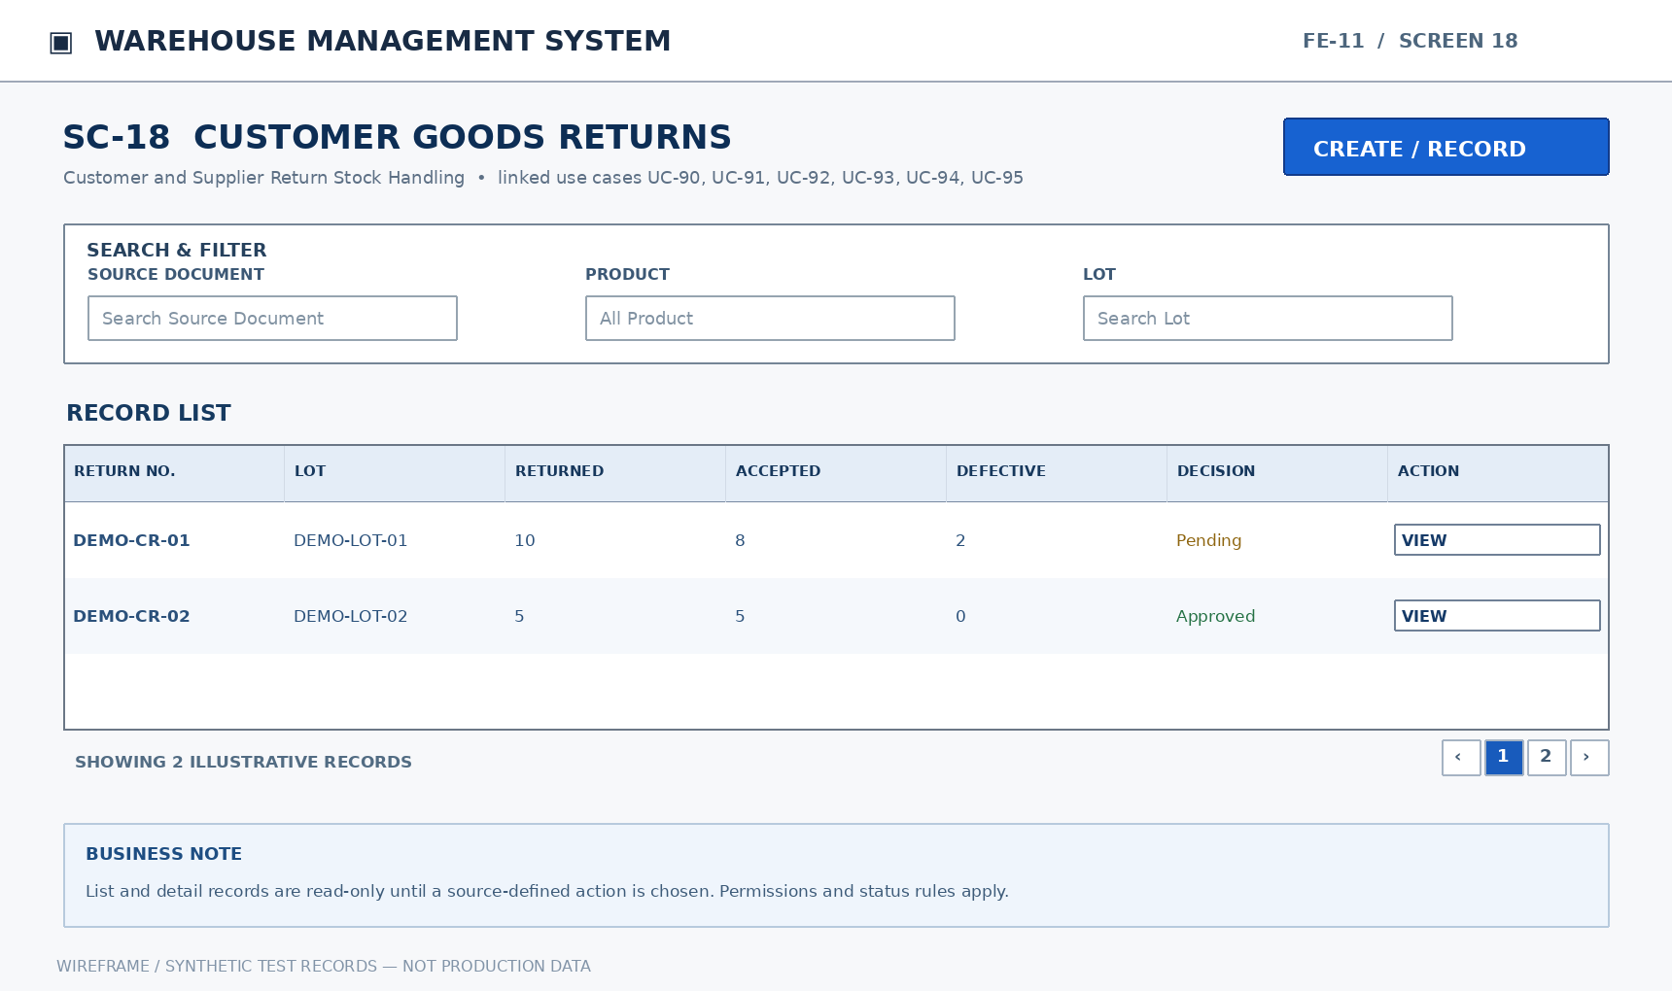
Mockup SC-18. Customer Goods Returns — illustrative functional layout
Purpose: Search returns by source, reason, and inspection status. Display lot, quantity, condition, and proposed resolution. Record source document, products, lot, returned quantity, and reason. Count and assess unopened packaging, opened packaging, tone mismatch, or damage. Record accepted, conditionally accepted, defective, or awaiting supplier return before posting inventory. Approve/reject restocking, quarantine, or loss based on inspected results.
Mapped Use Cases: UC-90 (View customer return list), UC-91 (View customer return details), UC-92 (Record customer goods return), UC-93 (Inspect returned goods), UC-94 (Classify returned goods disposition), UC-95 (Approve or reject customer return disposition)
This screen allows only the relevant authorized roles to perform the mapped actions. Each write operation checks current document state, item/lot/location scope and approval/eligible-stock rules.
UC | Authorized Actor(s) | Functional Behavior / Expected Outcome
UC-90 | Store Manager, Accountant, Warehouse Staff | Search returns by source, reason, and inspection status.
UC-91 | Store Manager, Accountant, Warehouse Staff | Display lot, quantity, condition, and proposed resolution.
UC-92 | Sales Staff, Warehouse Staff | Record source document, products, lot, returned quantity, and reason.
UC-93 | Warehouse Staff | Count and assess unopened packaging, opened packaging, tone mismatch, or damage.
UC-94 | Warehouse Staff | Record accepted, conditionally accepted, defective, or awaiting supplier return before posting inventory.
UC-95 | Store Manager | Approve/reject restocking, quarantine, or loss based on inspected results.

Field Description
Field Name | Description
Source Document | NVARCHAR(50). Entry: Required. Default: No SQL DEFAULT; supply or select a value.  Validation: Originating business document code; no tax-invoice generation is implied by this warehouse reference.
Product | BIGINT (reference ID). Entry: Required. Default: No SQL DEFAULT; supply or select a value.  Validation: Existing product reference; selection must respect product activation and the current workflow.
Lot | BIGINT (reference ID). Entry: Required. Default: No SQL DEFAULT; supply or select a value.  Validation: Existing lot record reference; lot/tone/calibre must match the selected product.
Returned Quantity | DECIMAL(18,3). Entry: Required. Default: No SQL DEFAULT; supply or select a value.  Validation: Positive physical quantity returned by customer; held for inspection before eligible restocking.
Reason | NVARCHAR(500). Entry: Required. Default: No SQL DEFAULT; supply or select a value.  Validation: Business justification; required on requests and variance/return actions that explicitly require a reason.
Condition | VARCHAR(30). Entry: Required when inspected. Default: No SQL DEFAULT; supply or select a value.  Validation: Inspection state of returned goods; recorded before proposing a disposition.
Accepted Quantity | DECIMAL(18,3). Entry: Required for disposition. Default: No SQL DEFAULT; supply or select a value.  Validation: Quantity accepted for reuse/restock after inspection and authorization; nonnegative.
Defective Quantity | DECIMAL(18,3). Entry: Required for disposition. Default: No SQL DEFAULT; supply or select a value.  Validation: Positive affected quantity when a new defective-goods case is recorded; cannot exceed eligible source quantity.
Disposition | VARCHAR(30). Entry: Required when submitting disposal proposal. Default: No SQL DEFAULT; supply or select a value.  Validation: Handling category for inspected return goods; posted only after the required approval.
Decision | VARCHAR(30). Entry: Required on manager decision. Default: No SQL DEFAULT; supply or select a value.  Validation: Approve/reject or documented workflow decision; capture authorizing user and action time.

11.2 Supplier Return Requests

11.2.1 SC-19: Supplier Return Requests
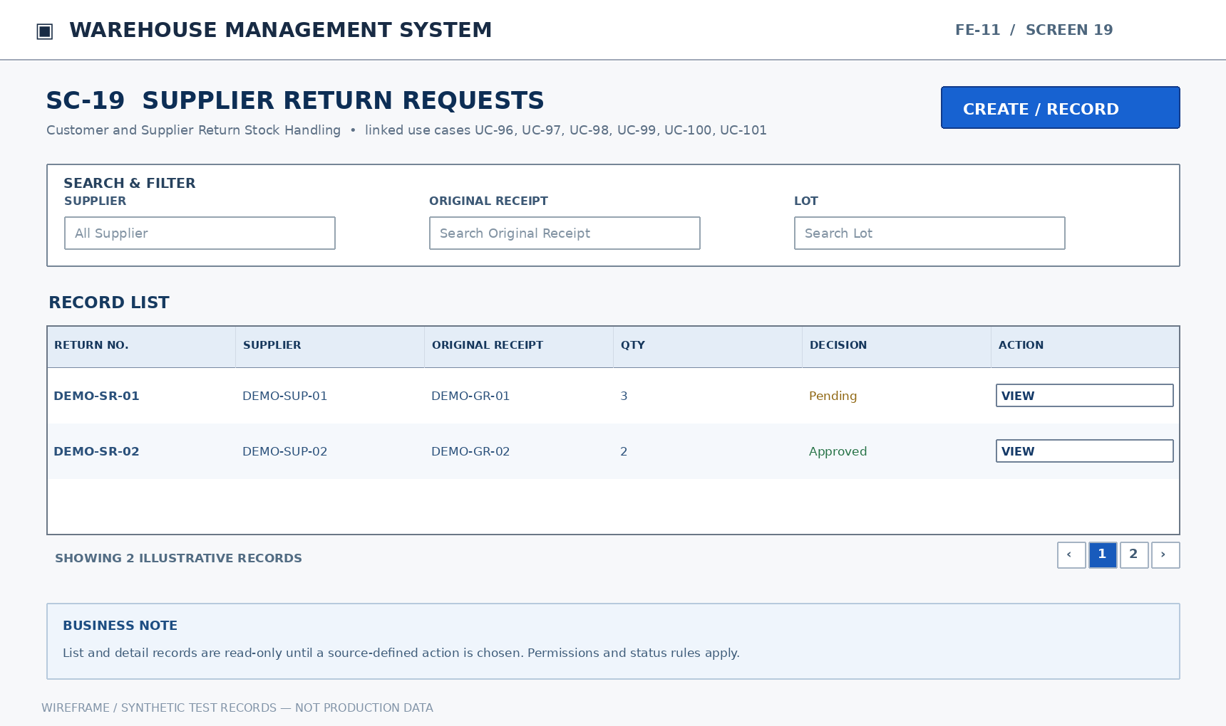
Mockup SC-19. Supplier Return Requests — illustrative functional layout
Purpose: Search by supplier, lot, reason, and approval status. Display lot, location, quantity, source receipt, evidence, and approval decision. Record lot, location, quantity, reason, and original receipt document. Reserve the specified lot/location quantity outside available stock until shipment. Record decision and reason before authorizing the return shipment. Record actual goods returned without double-deducting goods previously rejected at receipt.
Mapped Use Cases: UC-96 (View supplier return request list), UC-97 (View supplier return request details), UC-98 (Create supplier return request), UC-99 (Quarantine goods pending supplier return), UC-100 (Approve or reject supplier return request), UC-101 (Record actual supplier return dispatch)
This screen allows only the relevant authorized roles to perform the mapped actions. Each write operation checks current document state, item/lot/location scope and approval/eligible-stock rules.
UC | Authorized Actor(s) | Functional Behavior / Expected Outcome
UC-96 | Store Manager, Accountant, Warehouse Staff | Search by supplier, lot, reason, and approval status.
UC-97 | Store Manager, Accountant, Warehouse Staff | Display lot, location, quantity, source receipt, evidence, and approval decision.
UC-98 | Accountant, Warehouse Staff | Record lot, location, quantity, reason, and original receipt document.
UC-99 | Warehouse Staff | Reserve the specified lot/location quantity outside available stock until shipment.
UC-100 | Store Manager | Record decision and reason before authorizing the return shipment.
UC-101 | Warehouse Staff | Record actual goods returned without double-deducting goods previously rejected at receipt.

Field Description
Field Name | Description
Supplier | BIGINT (reference ID). Entry: Required. Default: No SQL DEFAULT; supply or select a value.  Validation: Existing supplier reference; a new purchase order may use only an active supplier.
Original Receipt | BIGINT (reference ID). Entry: Required. Default: No SQL DEFAULT; supply or select a value.  Validation: Reference to original supplier goods receipt; used to trace stock already posted or rejected.
Lot | BIGINT (reference ID). Entry: Required. Default: No SQL DEFAULT; supply or select a value.  Validation: Existing lot record reference; lot/tone/calibre must match the selected product.
Location | BIGINT (reference ID). Entry: Required. Default: No SQL DEFAULT; supply or select a value.  Validation: Existing location reference within the chosen warehouse; must be active/eligible for a new stock posting.
Return Quantity | DECIMAL(18,3). Entry: Required. Default: No SQL DEFAULT; supply or select a value.  Validation: Positive quantity proposed to return to the supplier; may not exceed eligible lot balance.
Reason | NVARCHAR(500). Entry: Required. Default: No SQL DEFAULT; supply or select a value.  Validation: Business justification; required on requests and variance/return actions that explicitly require a reason.
Evidence | NVARCHAR(500) (storage object key). Entry: Optional. Default: NULL.  Validation: Optional secure document or image reference attached to an incident/return; validate that the storage object belongs to the record.
Quarantine Status | VARCHAR(30). Entry: System-controlled. Default: Assigned by the workflow (no fixed SQL DEFAULT).  Validation: Status of supplier-return segregation; quarantined quantities excluded from usable stock.
Decision | VARCHAR(30). Entry: Required when deciding. Default: No SQL DEFAULT; supply or select a value.  Validation: Approve/reject or documented workflow decision; capture authorizing user and action time.
Actual Dispatched Quantity | DECIMAL(18,3). Entry: Required at dispatch. Default: No SQL DEFAULT; supply or select a value.  Validation: Quantity actually sent to supplier after approval; may not exceed approved eligible quantity.

12. Warehouse Reports (FE-12)

12.1 Inventory Reports

12.1.1 SC-20: Inventory Reports
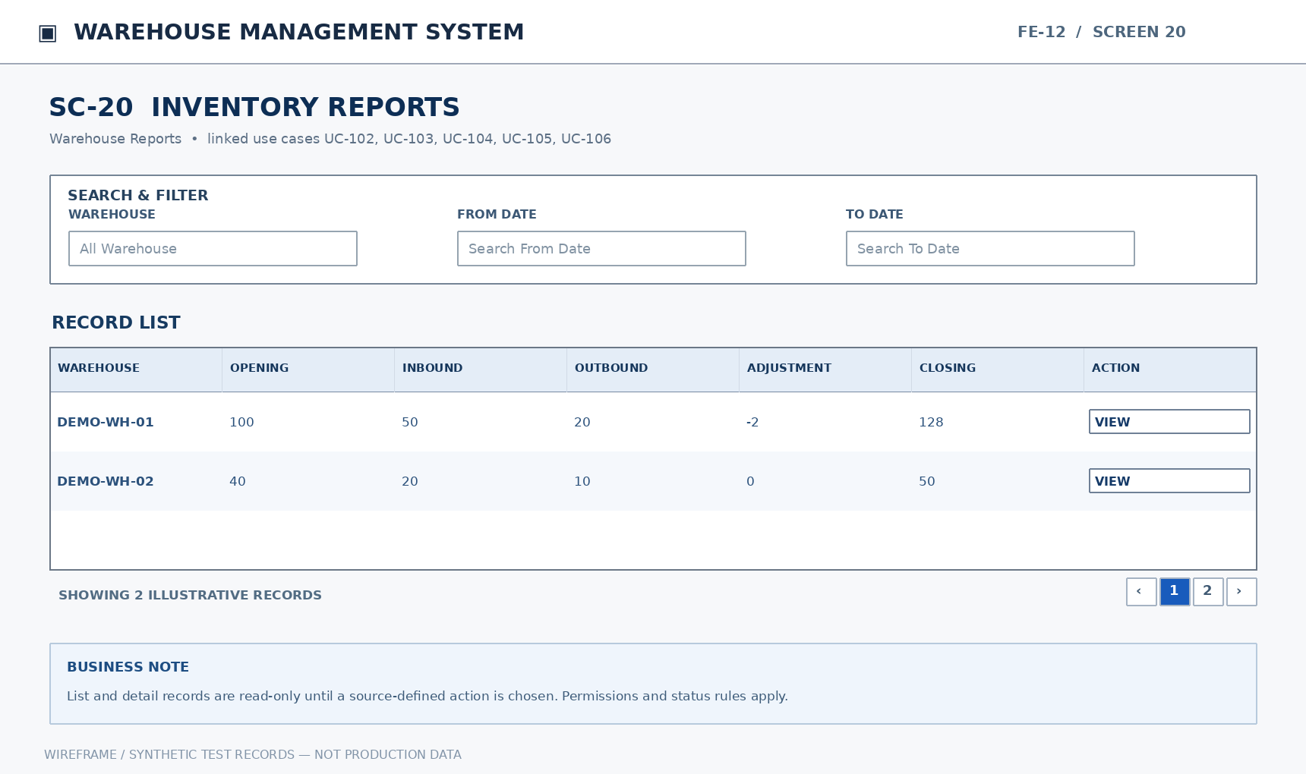
Mockup SC-20. Inventory Reports — illustrative functional layout
Purpose: Show opening, inbound, outbound, adjustment, and closing balances for a selected period. Show quantities by warehouse, location, lot, tone, and quality status. Compare ordered, confirmed, received, and outstanding quantities. Track dispatched, in-transit, received, and discrepancy quantities. Show counts, variance reasons, and recorded adjustments.
Mapped Use Cases: UC-102 (View inventory movement summary report), UC-103 (View stock by lot and location report), UC-104 (View purchase order and receipt report), UC-105 (View warehouse transfer report), UC-106 (View stocktake and adjustment report)
This screen allows only the relevant authorized roles to perform the mapped actions. Each write operation checks current document state, item/lot/location scope and approval/eligible-stock rules.
UC | Authorized Actor(s) | Functional Behavior / Expected Outcome
UC-102 | Store Manager, Warehouse Staff | Show opening, inbound, outbound, adjustment, and closing balances for a selected period.
UC-103 | Store Manager, Warehouse Staff | Show quantities by warehouse, location, lot, tone, and quality status.
UC-104 | Store Manager, Accountant | Compare ordered, confirmed, received, and outstanding quantities.
UC-105 | Store Manager, Warehouse Staff | Track dispatched, in-transit, received, and discrepancy quantities.
UC-106 | Store Manager, Warehouse Staff | Show counts, variance reasons, and recorded adjustments.

Field Description
Field Name | Description
Warehouse | BIGINT (reference ID). Entry: Optional filter. Default: NULL (blank filter is ignored).  Validation: Authorized warehouse reference; restrict the lookup to locations and operations permitted to the user. Historical/inactive master records remain searchable where linked to authorized posted transactions.
From Date | DATE. Entry: Optional filter. Default: NULL (blank filter is ignored).  Validation: Optional reporting period start; cannot be later than the end date if both provided.
To Date | DATE. Entry: Optional filter. Default: NULL (blank filter is ignored).  Validation: Optional reporting period end; cannot be earlier than start date if both provided.
Product | BIGINT (reference ID). Entry: Optional filter. Default: NULL (blank filter is ignored).  Validation: Existing product reference; selection must respect product activation and the current workflow. Historical/inactive master records remain searchable where linked to authorized posted transactions.
Lot | BIGINT (reference ID). Entry: Optional filter. Default: NULL (blank filter is ignored).  Validation: Existing lot record reference; lot/tone/calibre must match the selected product. Historical/inactive master records remain searchable where linked to authorized posted transactions.
Location | BIGINT (reference ID). Entry: Optional filter. Default: NULL (blank filter is ignored).  Validation: Existing location reference within the chosen warehouse; must be active/eligible for a new stock posting. Historical/inactive master records remain searchable where linked to authorized posted transactions.
Inbound | DECIMAL(18,3). Entry: Read-only calculated. Default: Derived from persisted data; not user-entered.  Validation: Read-only sum of received/inbound posted movements for the reporting scope.
Outbound | DECIMAL(18,3). Entry: Read-only calculated. Default: Derived from persisted data; not user-entered.  Validation: Read-only sum of issued/outbound posted movements for the reporting scope.
Opening Balance | DECIMAL(18,3). Entry: Read-only calculated. Default: Derived from persisted data; not user-entered.  Validation: Read-only stock balance at the start of the selected reporting period.
Closing Balance | DECIMAL(18,3). Entry: Read-only calculated. Default: Derived from persisted data; not user-entered.  Validation: Read-only balance at period end, reconciled with inbound/outbound/adjustment movements.
Variance | DECIMAL(18,3). Entry: Read-only calculated. Default: Derived from persisted data; not user-entered.  Validation: Signed difference between a physical amount and its comparison baseline; can be positive, zero or negative.

13. Inventory Audit Trail (FE-13)

13.1 Stock Movement Log and Lot Trace

13.1.1 SC-21: Stock Movement Log and Lot Trace
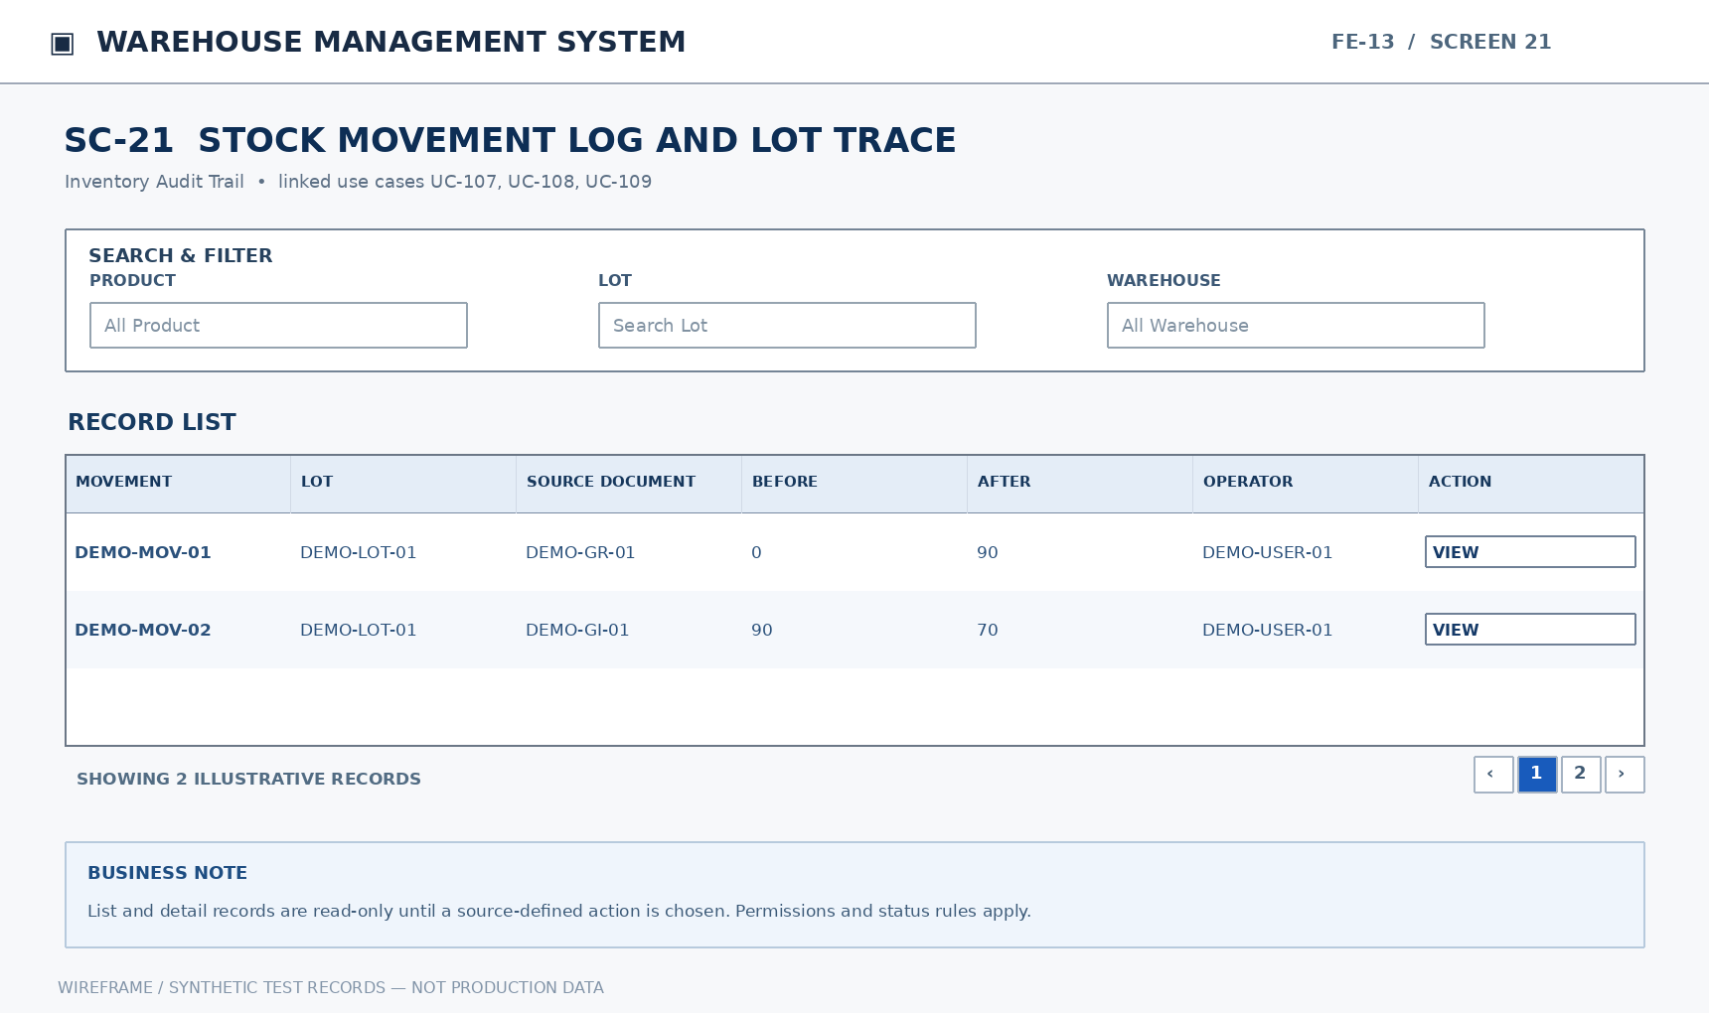
Mockup SC-21. Stock Movement Log and Lot Trace — illustrative functional layout
Purpose: Filter movements by product, lot, location, transaction type, and time. Display source document, before/after quantity, operator, time, and reason. Link a lot's receipts, movements, issues, returns, and inventory adjustments.
Mapped Use Cases: UC-107 (View stock movement log), UC-108 (View stock movement details), UC-109 (Trace a product lot through source documents)
This screen allows only the relevant authorized roles to perform the mapped actions. Each write operation checks current document state, item/lot/location scope and approval/eligible-stock rules.
UC | Authorized Actor(s) | Functional Behavior / Expected Outcome
UC-107 | Store Manager, Warehouse Staff | Filter movements by product, lot, location, transaction type, and time.
UC-108 | Store Manager, Warehouse Staff | Display source document, before/after quantity, operator, time, and reason.
UC-109 | Store Manager, Warehouse Staff | Link a lot's receipts, movements, issues, returns, and inventory adjustments.

Field Description
Field Name | Description
Product | BIGINT (reference ID). Entry: Optional filter. Default: NULL (blank filter is ignored).  Validation: Existing product reference; selection must respect product activation and the current workflow. Historical/inactive master records remain searchable where linked to authorized posted transactions.
Lot | BIGINT (reference ID). Entry: Optional filter. Default: NULL (blank filter is ignored).  Validation: Existing lot record reference; lot/tone/calibre must match the selected product. Historical/inactive master records remain searchable where linked to authorized posted transactions.
Warehouse | BIGINT (reference ID). Entry: Optional filter. Default: NULL (blank filter is ignored).  Validation: Authorized warehouse reference; restrict the lookup to locations and operations permitted to the user. Historical/inactive master records remain searchable where linked to authorized posted transactions.
Location | BIGINT (reference ID). Entry: Optional filter. Default: NULL (blank filter is ignored).  Validation: Existing location reference within the chosen warehouse; must be active/eligible for a new stock posting. Historical/inactive master records remain searchable where linked to authorized posted transactions.
Transaction Type | VARCHAR(30). Entry: Optional filter. Default: NULL (blank filter is ignored).  Validation: Recorded movement classification used for audit filters; selected from logged transaction types.
Source Document | NVARCHAR(50). Entry: Optional filter. Default: NULL (blank filter is ignored).  Validation: Originating business document code; no tax-invoice generation is implied by this warehouse reference.
Before Quantity | DECIMAL(18,3). Entry: Read-only audit field. Default: Derived from persisted data; not user-entered.  Validation: Read-only balance prior to the relevant posted transaction; preserved in movement history.
After Quantity | DECIMAL(18,3). Entry: Read-only audit field. Default: Derived from persisted data; not user-entered.  Validation: Read-only balance after the transaction is posted; reconciled to the change amount.
Operator | BIGINT (reference ID). Entry: Read-only audit field. Default: Derived from persisted data; not user-entered.  Validation: Read-only reference to the staff account that posted the movement.
Transaction Time | DATETIME2(0). Entry: Read-only audit field. Default: Derived from persisted data; not user-entered.  Validation: Read-only database timestamp of the recorded stock/audit event.

14. Background Job Inventory

14.1 Background Job Scope
No one of the 109 source UCs defines a background job trigger, execution schedule, retry strategy or retention period. Therefore, this SRS does not fabricate JOB IDs or processing details. Any later-approved job requires a separate source-driven specification.
Trigger | Purpose | Processing Steps | Failure Behavior

15. External API Inventory

15.1 External API Scope
The current UC worksheet contains no external endpoint contract, HTTP method, authorization mechanism, webhook or required external-system actor. Payment and HR integration examples from the generic report template are not applicable to this WMS.
URL | Purpose | Caller | Auth

IV. Non-Functional Requirements

1. External Interfaces
Interface | Requirement | Acceptance / Verification
Web user interface | Provide feature-specific forms, lists, filters and confirmation actions with role-appropriate access; clearly distinguish product, lot, tone, calibre, location and quality state. | Review SC-01 through SC-21 and ensure relevant fields are visible without confusing quality or quantity types.
Document and evidence links | Defect, discrepancy, inventory adjustment and return records must retain source document and supporting evidence associations. | Authorized staff can trace the record to its originating transaction and supporting documents.
External integration | No technical third-party interface is established by the current UCs. | New integrations require source documents, specified interfaces and a change request before implementation.
Printing / export | The UC list identifies report viewing but does not specify print forms, export formats or electronic signatures. | Do not treat unsupported export/printing as a signed-off system requirement.

2. Quality Attributes

2.1 Usability
Requirement | Specification | Verification
Screen consistency | Lists consistently show search, filters and results; details consistently display document references and transaction history. | Compare interactions across SC-02–SC-21.
Quality status clarity | Defective/pending goods must not appear as usable stock; ordered, confirmed, dispatched, handed-over and received quantities must have distinct headings. | Test UC-32, UC-47, UC-62 and UC-67.
Validation feedback | Unauthorized, invalid-state and excess-stock operations show a clear actionable message without committing a partial change. | Exercise the alternative paths in Part II and system messages in Appendix.
Data entry accuracy | Choose active master data rather than free-entering unrelated codes; display conversion assumptions for each product. | Test UC-13, UC-36, UC-74 and UC-88.

2.2 Performance
No source file provides a signed-off response-time SLA, simultaneous-user count, maximum inventory volume or availability percentage. Accordingly, this version specifies verifiable behavior while leaving numeric limits open for customer confirmation.
Requirement | Target / Behavior | Condition / Verification
List and filter behavior | Return correctly scoped results, report empty matches and prevent duplicate posting from repeated actions. | Test on representative customer-approved data sets when available.
Transaction consistency | Goods receipt, movement, issue, return and adjustment operations must not produce partially committed balances. | Reconcile UC-40,60,64,66,81,89,101 with movement records.
Report reconciliation | Closing quantity equals opening quantity plus applicable inbound, outbound and adjustment movements within the same reporting scope. | Cross-check UC-102 against stock movements UC-107.
Capacity and SLA | Numerical targets are not specified in supplied requirements. | Confirm measurable values during acceptance criteria review.

2.3 Security
Requirement | Description | Verification
Authentication | Only active authenticated accounts can access internal operations. | Test UC-01, UC-06 and UC-07.
Role-based authorization | Each data read and state change checks the assigned role/UC permission, not merely whether a UI button is visible. | Attempt direct requests for actions marked No in the permission matrix.
Credential protection | Credentials are not stored or logged in directly readable form. | Check stored data and event logs for plaintext passwords.
Audit integrity | Every change to stock records source document, operator, timestamp and original/resulting quantity. | Trace UC-107–109 back to affected documents.
Evidence access | Only roles assigned to the relevant business record may access discrepancy/defect evidence. | Test UC-38,39,55,67,68,98 under allowed and denied roles.
Approval protection | Pending or rejected proposals cannot trigger an unauthorized quantity adjustment. | Test UC-49,55,79–81,95,100.

2.4 Reliability and Data Integrity
Posting of accepted receipts, intra-warehouse movement, transfer dispatch/receipt, approved adjustment, actual issue and supplier return must be atomic at the document/line level. Repeated confirmation or interrupted operations must not increase or decrease the same eligible quantity more than once. This describes the required business outcome; it does not prescribe a particular database technology.

2.5 Maintainability and Traceability
Each requirement retains its FE/UC identifier and is mapped to a screen and a fully specified use case. Data-rule changes must be assessed for impacts on unit conversion, source document linkage, approval steps and movement history. A revision must never silently rewrite the meaning of an existing UC ID.

V. Requirement Appendix

1. Business Rules
GBR-ID | Rule Statement | Applies To | Rationale | Enforced By
GB-01 | Only a role explicitly authorized for a UC may read or perform its corresponding operation. | All UCs | Segregates responsibilities and protects transactions. | Enforce permissions on every request.
GB-02 | Inactive accounts, products, suppliers and locations cannot be used in new operations; history is preserved. | UC-06,12,22,45 | Historical transactions remain explainable. | Validate master-record state when creating documents.
GB-03 | Convert boxes/pieces/square meters using the selected product configuration. | UC-13,36,74,89 | Prevents conversion errors across tile products. | Use and verify the product-specific conversion factors.
GB-04 | Only inspected accepted quantities may increase usable inventory. | UC-37–40,49–50,92–95 | Prevents issue of pending or defective goods. | Reconcile accepted quality quantities before posting.
GB-05 | Partially received purchase orders can change only quantities not yet received. | UC-30–32 | Preserves source receipt history. | Check already posted receipt quantity.
GB-06 | Intra-warehouse location movement does not change total warehouse balance. | UC-59–60 | Preserves inventory totals. | Post equal and opposite changes across locations.
GB-07 | Warehouse transfers distinguish dispatch, handover and receipt; variances require approved resolution. | UC-63–69 | Keeps in-transit stock accountable. | Reconcile three checkpoints and evidence.
GB-08 | Stocktake uses an immutable balance snapshot and records subsequent movements separately. | UC-72–76 | Prevents incorrect variance calculations. | Retain stocktake cut-off timestamp and original values.
GB-09 | An inventory adjustment requires approval and can be posted at most once. | UC-79–81 | Prevents unauthorized or duplicate stock changes. | Check approval and posted flag on each attempt.
GB-10 | Goods issue deducts only actual issued stock by lot and location. | UC-87–89 | Prevents incorrect or negative inventory. | Validate usable quantity before posting.
GB-11 | Customer returns cannot increase usable stock before approved disposition. | UC-92–95 | Protects goods quality control. | Check inspection and decision state.
GB-12 | Goods rejected at original receipt cannot be deducted again when returned to supplier. | UC-37,40,101 | Prevents double deduction. | Reconcile original receipt inventory impact.
GB-13 | Every stock movement must link source document, user, time and before/after quantities. | UC-107–109 | Enables audit and lot traceability. | Store immutable posting metadata.

2. System Messages
# | Message Code | Type | Context | Content
1 | MSG-01 | Inline | No matching search results | No matching records were found.
2 | MSG-02 | Field error | A mandatory field is empty | Please enter {field_name}.
3 | MSG-03 | Field error | Quantity has an invalid value | {field_name} must be a valid non-negative amount.
4 | MSG-04 | Field error | Quantity exceeds usable stock | Requested quantity exceeds usable stock for the selected lot and location.
5 | MSG-05 | Inline | Selected reference is inactive | {entity_name} is inactive and cannot be selected on a new document.
6 | MSG-06 | Confirmation | User confirms inventory posting | Confirm the actual quantity to be posted for this document?
7 | MSG-07 | Toast | Document is saved | {document_type} has been saved.
8 | MSG-08 | Inline | Access is not authorized | You do not have permission to perform this action.
9 | MSG-09 | Inline | Required approval is missing | The document cannot be processed before the required approval.
10 | MSG-10 | Field error | Rejection / discrepancy reason is missing | Please provide a reason for rejecting or resolving the discrepancy.
11 | MSG-11 | Inline | Duplicate lot identity | A lot with these identifying attributes already exists.
12 | MSG-12 | Inline | Location still contains stock | The location cannot be deactivated while stock remains.
13 | MSG-13 | Inline | Posting has already been completed | This document has already affected stock; duplicate posting is blocked.
14 | MSG-14 | Inline | Inspection classification does not reconcile | Classification totals must equal the actual received quantity.
15 | MSG-15 | Inline | Authentication failed | Sign-in credentials are invalid.
16 | MSG-16 | Toast | Stocktake result saved | Count results and associated variances have been saved.
17 | MSG-17 | Inline | Transfer quantities differ | Dispatch, handover and receipt values do not match; record a discrepancy.
18 | MSG-18 | Toast | Approval request rejected | The rejection decision and its reason have been recorded.
19 | MSG-19 | Inline | Purchase order partly received | The received portion of a purchase order cannot be canceled or reduced.
20 | MSG-20 | Inline | Return has not been approved | Goods cannot be restocked or returned to the supplier before disposition approval.

3. Other Requirements

