

CAPSTONE PROJECT REPORT
Report 1 – Project Introduction

– Hanoi, Oct 2026 –
Table of Contents
Change Log 2
Definition and Acronyms 3
I. Project Overview 3
1. Project Information 3
2. Project Purpose 4
3. Project Stakeholders 5
II. Product Background 5
III. Existing Solutions 15
1. KiotViet 15
2. MISA eShop 16
3. Consolidated Gaps and Section Summary 16
IV. Proposed Solution 17
V. Project Scope & Limitations 27
1. Major Features 27
2. Limitations & Exclusions 28

Change Log
Date | A*M, D | In charge | Change Description
19/09/2026 | A | Project Team | Created the initial project overview and baseline scope.
19/09/2026 | A | Project Team | Documented purchasing, stock and sales workflows.
19/09/2026 | A | Project Team | Added the software comparison and proposed solution.
26/09/2026 | M | Project Team | Revised Product Background and store information.
26/09/2026 | M | Project Team | Updated the existing-solution comparison.
26/09/2026 | M | Project Team | Revised project scope, major features and scope boundaries.
29/09/2026 | M | Project Team | Rewrote Product Background for the store’s operating context.
29/09/2026 | M | Project Team | Specified warehouse pain points and mapped them to Major Features.
29/09/2026 | M | Project Team | Clarified report language and project scope.
08/10/2026 | M | Project Team | Completed stakeholder details from the client-provided list.
08/10/2026 | M | Project Team | Clarified owner-reviewed purchase proposals, transfer evidence checkpoints and return outcomes.
08/10/2026 | A | Project Team | Added Figure 3, the proposed WMSD warehouse process.
08/10/2026 | M | Project Team | Applied the official template, clarified sales and financial boundaries, removed unused acronyms, aligned contents headings and refined table pagination.
09/10/2026 | M | HieuDT | Add Diagram about Proposed Solution
09/10/26 | M | MinhTD | Modify Existing Solution
09/10/26 | M | TrungPH | Modify and revise Product Background
09/10/26 | M
*A - Added M - Modified D - Deleted

Definition and Acronyms
Acronym | Definition
WMSD | Warehouse Management System Development – project name and code.
PO | Purchase Order – supplier order for products and quantities.
GAP | Project gap – an unmet operational control in the case-store workflow relative to available retail-software functions.
FE | Feature – identifier for an in-scope function in Section V.
LI | Limitation/Exclusion – identifier for a capability outside this release.

I. Project Overview

1. Project Information
– English name: Warehouse Management System Development
– Vietnamese name: Phát Triển Ứng Dụng Quản Lý Kho
– Project code: WMSD
– Group name: SEP490_G56
– Software type: Responsive Web Application – warehouse operations for one retail store
–Baseline scope: One store with configurable warehouse areas, storage positions and warehouse-to-warehouse transfer where used

2. Project Purpose
Warehouse Management System Development (WMSD) supports the warehouse operations of Cửa hàng điện nước gạch ốp lát Tân Thương, which already uses MISA eShop for retail records. WMSD connects purchase orders, each goods receipt, inspection, put-away, stock movement, issue, return and stock count so warehouse staff can trace what physically happened to each quantity.
The project serves one retail store and its configured warehouse locations. Tile stock is identified by item, lot, tone, actual calibre, quality status and storage position, with consistent box, piece and square-metre quantities. A transfer between configured warehouses is tracked as in transit until the destination records its actual receipt.
The first release focuses on accurate warehouse operations and traceability. WMSD records purchase and sales-document references for stock movements while MISA eShop remains the retail system. WMSD records physical issues and returns only; sales orders, quotations, pricing, promotions, fulfillment, delivery, payments, refunds, receivables, accounting and statutory invoicing remain outside this release. Direct MISA integration is also excluded.
3. Project Stakeholders
Full Name | Role | Email | Mobile
Tân Thương | Client |  | 0344449888
Nguyễn Thị Hải Năng | Supervisor | nangnth@fpt.edu.vn
Đặng Trung Hiếu | Leader | hieudthe180536@gmail.com | 0846250287
Trần Đức Minh | Member | minhsoc5@gmail.com | 0912600863
Phạm Hải Trung | Member | phamhaitrung03@gmail.com | 0356202604
Hoàng Minh Bách | Member | bachmhhe171188@fpt.edu.vn | 0978943403
Hoa Hải Đăng | Member | danghhhe163301@fpt.edu.vn | 0382381426

II. Product Background
Cửa hàng điện nước gạch ốp lát Tân Thương operates at Phố Tân An, xã Tân An, Yên Dũng, Bắc Giang. Its business covers wall and floor tiles, electrical and water-supply supplies, and bathroom and sanitary products, including toilets, washbasins, bathroom cabinets, shower sets, taps and mirrors. The store sells to customers who purchase goods for construction, renovation and installation.
The store already uses MISA eShop for product, sales, supplier and customer records, inventory totals and operational reports. Its physical warehouse work is still partly recorded by hand or in separate documents. Staff count stock manually; exact warehouse positions are not maintained in a structured location map; and a total balance does not consistently distinguish lot, tone, actual calibre and goods waiting for inspection, damaged or being transferred. Purchase orders delivered in several trips, receiving discrepancies, returns and stock-count corrections are not linked through one warehouse record. These are gaps in the store's current way of working, not claims that MISA eShop lacks those functions.
Tile stock requires item code, brand, material, dimensions, packaging, lot, tone and actual calibre. Boxes, pieces and square metres must convert according to the product specification. A usable quantity must also identify its warehouse position and quality status; an overall product balance alone does not tell staff what can be picked.
In the current purchasing process, warehouse staff check stock, accounting prepares the replenishment proposal, the owner reviews it, and accounting places the supplier order. The supplier may confirm only part of the requested quantity or deliver on several dates. On each arrival, warehouse staff count and inspect the actual item, lot, tone, calibre and packaging condition. Accepted goods are put away; goods requiring inspection or supplier resolution are separated. Accounting compares the supplier documents with the quantity actually accepted.
During day-to-day warehouse work, staff find stock by product and lot, move it between storage positions, and issue goods against a store request. When goods move between warehouses, dispatch and destination receipt may differ because of shortage or damage. Physical stock counts are made by warehouse area, position and lot; a discrepancy requires recount and a recorded cause before the balance is adjusted. Goods returned from a customer or prepared for return to a supplier are inspected and kept out of usable stock until their disposition is known.
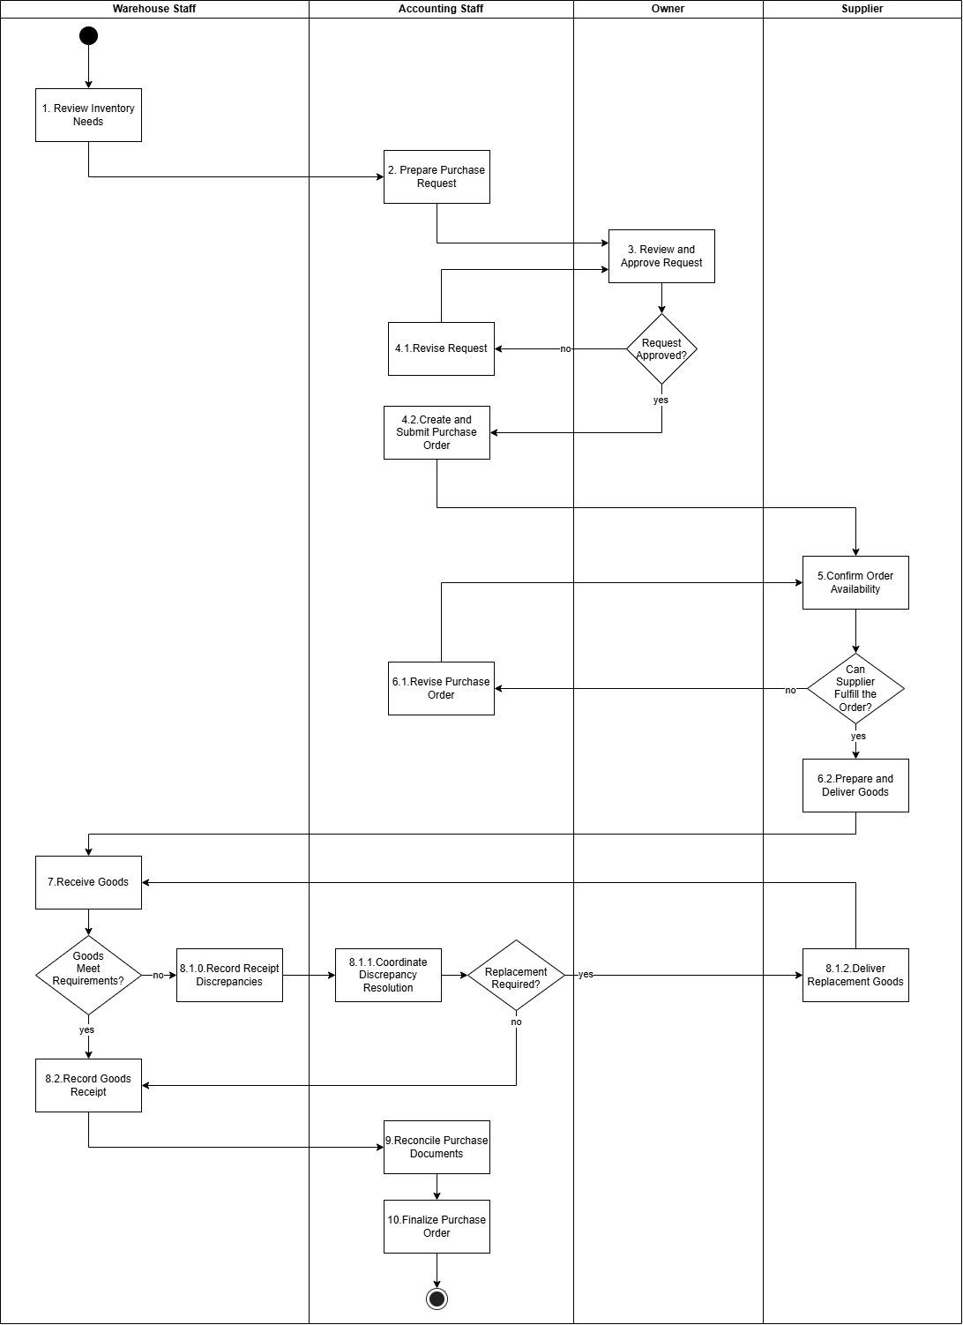
[Figure 1: Current purchasing and receiving workflow]

Step | Role | Description
1. Review Inventory Needs | Inventory Staff | Review current inventory levels and identify products that need replenishment.
2. Prepare Purchase Request | Accountant | Prepare a purchase request specifying the required products, quantities, and purchasing needs.
3. Review and Approve Request | Owner | Review the purchase request and decide whether to approve it based on business needs.
4.1. Revise Request | Accountant | Revise the purchase request based on the owner's feedback and resubmit it for approval.
4.2. Create and Submit Purchase Order | Accountant | Create a purchase order based on the approved request and submit it to the supplier.
5. Confirm Order Availability | Supplier | Check product availability and determine whether the purchase order can be fulfilled.
6.1. Revise Purchase Order | Accountant | Modify the purchase order when the supplier cannot fulfill the requested items or quantities.
6.2. Prepare and Deliver Goods | Supplier | Prepare the confirmed products and arrange delivery to the store.
7. Receive Goods | Inventory Staff | Receive the delivered goods and check whether they meet the purchase order requirements.
8.1.0. Record Receipt Discrepancies | Inventory Staff | Record any differences or problems found during receiving, such as missing, incorrect, or damaged goods.
8.1.1. Coordinate Discrepancy Resolution | Supplier | Prepare and deliver replacement goods to resolve the reported discrepancies.
8.2. Record Goods Receipt | Inventory Staff | Record the receipt of goods that meet the required conditions and quantities.
9. Reconcile Purchase Documents | Accountant | Compare purchase orders, goods receipt records, and related documents to verify the purchasing transaction.
10. Finalize Purchase Order | Accountant | Complete the purchase order after the related documents have been reviewed and reconciled.
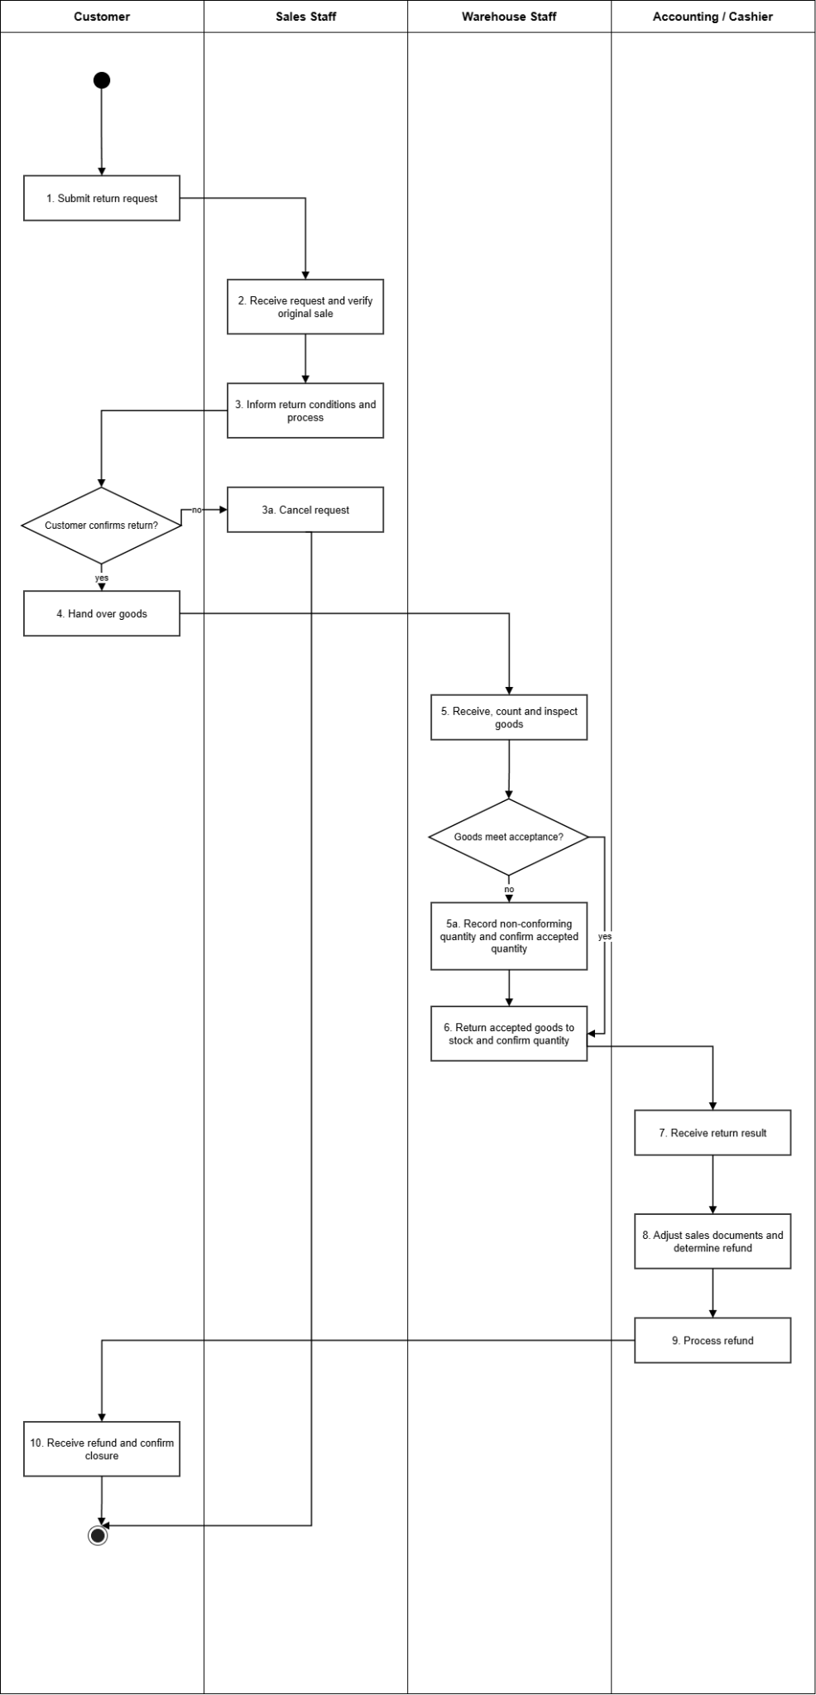

[Figure 2: Current customer return workflow]

Step | Role | Description
1. Submit return request | Customer | Customer requests a return and identifies the original sales transaction.
2. Receive request and verify original sale | Sales Staff | Sales staff checks the sales record and verifies the return details against the request.
3. Inform return conditions and process | Sales Staff | Sales staff informs the customer of the return conditions and process.
3a. Cancel request | Sales Staff | Customer declines; the request is cancelled and closed.
4. Hand over goods | Customer | The customer hands the goods over to the store.
5. Receive, count and inspect goods | Inventory Staff | Inventory Staff receives the goods, counts the quantity and inspects their condition against the request.
5a. Record non-conforming quantity and confirm accepted quantity | Inventory Staff | Damaged, unsuitable or differing quantities are recorded separately; the accepted quantity is confirmed.
6. Return accepted goods to stock and confirm quantity | Inventory Staff | Full quantity if all pass, otherwise the accepted portion confirms the quantity taken back to stock.
7. Receive return result | Accounting / Cashier | Accounting receives the warehouse return result.
8. Adjust sales documents and determine refund | Accounting / Cashier | Sales documents are adjusted and the refund amount is determined from the accepted quantity.
9. Process refund | Accounting / Cashier | The cashier processes the customer refund.
10. Receive refund and confirm closure | Customer | The customer receives the refund and confirms the return is closed.

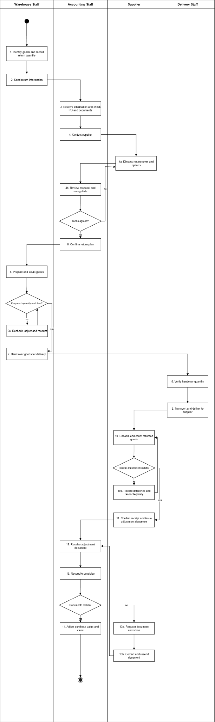
[Figure 3: Current supplier return workflow]

Step | Role | Description
1. Identify goods and record return quantity | Inventory Staff | Warehouse identifies wrong, excess or faulty goods and records the return quantity.
2. Send return information | Inventory Staff | Return information is sent to accounting.
3. Receive information and check PO and documents | Accountant | Accounting checks the related purchase order, receipt records and documents.
4. Contact supplier | Accountant | Accounting contacts the supplier about the return.
4a. Discuss return terms and options | Supplier | Supplier discusses the conditions and options for taking the goods back.
4b. Review proposal and renegotiate | Accountant | Accounting reviews the proposal and renegotiates quantity, timing and handover method until settled.
5. Confirm return plan | Accountant | Agreed quantity and handover plan are confirmed.
6. Prepare and count goods | Inventory Staff | Warehouse prepares and counts the agreed goods.
6a. Recheck, adjust and recount | Inventory Staff | Goods are rechecked, the prepared quantity adjusted and recounted until it matches.
7. Hand over goods for delivery | Inventory Staff | Goods are handed over to delivery staff.
8. Verify handover quantity | Delivery Staff | Delivery staff verifies the handed-over quantity.
9. Transport and deliver to supplier | Delivery Staff | Goods are transported and delivered to the supplier.
10. Receive and count returned goods | Supplier | Supplier receives and counts the returned goods.
10a. Record difference and reconcile jointly | Supplier | Shortage, damage or wrong-lot differences are recorded; delivery, warehouse, accounting and supplier reconcile and recheck the actual quantity.
11. Confirm receipt and issue adjustment document | Supplier | Matched receipt is confirmed and the adjustment document is issued.
12. Receive adjustment document | Accountant | Accounting receives the supplier adjustment document.
13. Reconcile payables | Accountant | Payables are reconciled against the returned goods.
13a. Request document correction | Accountant | Difference is identified and the supplier is asked to correct the document.
13b. Correct and resend document | Supplier | Supplier corrects and resends the document; accounting re-receives and re-reconciles (back to 12).
14. Adjust purchase value and close | Accountant | Purchase value is adjusted and the return transaction is closed.

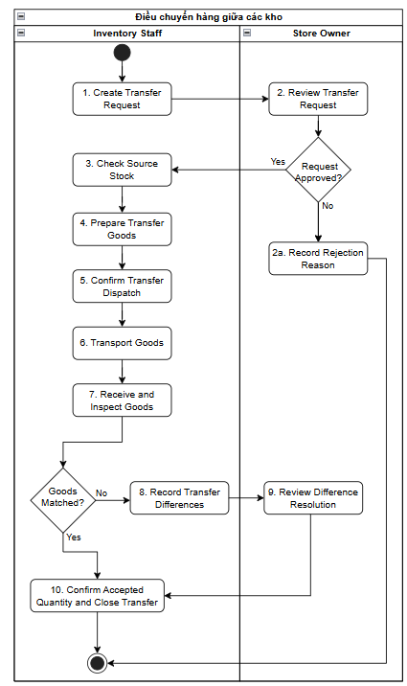
[Figure 4: Warehouse transfer workflow]

Step | Role | Description
1. Create Transfer Request | Inventory Staff | Xác định nhu cầu điều chuyển và lập yêu cầu, ghi rõ kho nguồn, kho đích, sản phẩm, lô hàng, số lượng cần chuyển, lý do và thời gian dự kiến. Sau đó gửi yêu cầu cho Store Owner xem xét.
2. Review Transfer Request | Store Owner | Kiểm tra nhu cầu điều chuyển, kho nguồn, kho đích, mặt hàng và số lượng yêu cầu. Nếu đồng ý, phê duyệt để Inventory Staff tiếp tục kiểm tra và chuẩn bị hàng. Nếu không đồng ý, chuyển sang bước 2a.
2a. Record Rejection Reason | Store Owner | Ghi nhận lý do từ chối, thông báo kết quả cho Inventory Staff và kết thúc yêu cầu điều chuyển.
3. Check Source Stock | Inventory Staff | Kiểm tra số lượng hàng hiện có tại kho nguồn theo sản phẩm, lô, vị trí và tình trạng hàng. Xác định số lượng có thể sử dụng cho yêu cầu điều chuyển.
4. Prepare Transfer Goods | Inventory Staff | Lấy hàng tại vị trí kho nguồn và chuẩn bị cho việc điều chuyển. Kiểm tra sản phẩm, lô, màu, kích thước, số lượng và tình trạng thực tế của hàng được lấy.
5. Confirm Transfer Dispatch | Inventory Staff | Kiểm đếm và xác nhận số lượng thực tế rời kho nguồn. Ghi nhận người xuất, thời gian xuất và thông tin hoặc chứng từ bàn giao liên quan.
6. Transport Goods | Inventory Staff | Tiếp nhận hàng từ kho nguồn, kiểm tra số lượng bàn giao và vận chuyển đến kho đích. Ghi nhận người phụ trách, thời gian bàn giao và bằng chứng nếu có.
7. Receive and Inspect Goods | Inventory Staff | Tại kho đích, tiếp nhận và kiểm tra hàng thực nhận. Đối chiếu sản phẩm, lô, số lượng và tình trạng hàng với thông tin xuất kho và bàn giao.
8. Record Transfer Differences | Inventory Staff | Thực hiện khi hàng thực nhận không khớp. Ghi nhận số lượng thiếu, thừa, sai sản phẩm, sai lô hoặc hàng hư hỏng; bổ sung nguyên nhân và bằng chứng nếu có. Sau đó gửi thông tin chênh lệch cho Store Owner xem xét.
9. Review Difference Resolution | Store Owner | Xem xét thông tin chênh lệch và bằng chứng. Xác nhận số lượng được chấp nhận tại kho đích và đưa ra phương án xử lý đối với phần thiếu, thừa, sai hoặc hư hỏng.
10. Confirm Accepted Quantity and Close Transfer | Inventory Staff | Xác nhận số lượng cuối cùng được chấp nhận tại kho đích, đưa hàng vào vị trí lưu kho phù hợp, hoàn thiện thông tin nhận hàng và kết thúc phiếu điều chuyển.

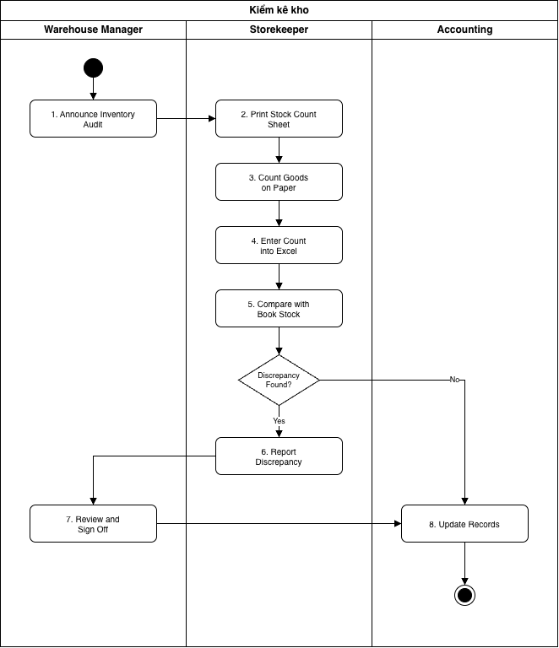
[Figure 5: Inventory audit workflow]
Step | Role | Description
1. Announce Inventory Audit | Warehouse Manager | Thông báo ngày kiểm kê cho thủ kho bằng lời nói hoặc tin nhắn. Không lập kế hoạch bằng văn bản; phạm vi kiểm (khu vực, nhóm hàng) do thủ kho tự xác định.
2. Print Stock Count Sheet | Storekeeper | Xuất danh sách tồn kho từ file Excel và in phiếu đếm. Tồn sổ sách không được chốt tại thời điểm kiểm, hàng vẫn được nhập/xuất trong lúc kiểm.
3. Count Goods on Paper | Storekeeper | Thủ kho tự đếm hàng do mình quản lý và ghi tay số lượng lên phiếu in. Thường chỉ đếm theo mã sản phẩm, không tách theo lô, màu, kích thước hay vị trí.
4. Enter Count into Excel | Storekeeper | Nhập lại số liệu từ phiếu giấy vào file Excel. Dễ sai sót do chép tay, không lưu lại người đếm và thời gian đếm.
5. Compare with Book Stock | Storekeeper | So sánh số lượng đếm được với tồn sổ sách bằng công thức Excel. Nếu có chênh lệch, chuyển sang bước 6; nếu không, chuyển sang bước 8.
6. Report Discrepancy | Storekeeper | Ghi số lượng lệch và lý do vào file Excel rồi gửi cho quản lý kho. Không lập biên bản, không đính kèm hình ảnh hay chứng từ.
7. Review and Sign Off | Warehouse Manager | Xem file chênh lệch và ký xác nhận. Không có bước từ chối hay yêu cầu kiểm đếm lại; lý do chênh lệch ít được xác minh.
8. Update Records | Accounting | Điều chỉnh sổ sách và giá trị tồn kho theo file Excel nhận được, lưu file. Phiếu kiểm kê không có trạng thái theo dõi và không lưu lịch sử kiểm kê.

[Figure 6: Current sales workflow]

III. Existing Solutions

KiotViet and MISA eShop are two existing retail management solutions relevant to the warehouse operations examined in this project. Both provide established capabilities for product management, purchasing, inventory tracking, stocktaking, transfers, and returns.

1. KiotViet
KiotViet Retail supports purchase ordering, multiple receipts against one order, goods tracking by lot/expiry date for enabled items, stock transfers, stock counts and supplier returns. The assessment below compares its documented retail workflows with the specific physical checks used at Tân Thương; it does not assert that the platform is incapable of configuration or extension.
Website / Link | https://www.kiotviet.vn
Target Users | Small and medium retailers and wholesalers using point-of-sale, purchase, inventory and supplier management.
Core Features | POS, supplier purchasing, purchase orders, repeated goods receipts, inventory by item, unit handling, optional lot/expiry tracking, warehouse transfers, stock counts, customer and supplier returns, and retail reports.
Strengths | The official purchase-order guide explicitly supports multiple goods receipts for one order and the statuses “Nhập một phần” and “Hoàn thành”. The retail transfer guide records dispatched and received quantities, allows a discrepancy note, and updates warehouse stock. Stock counting compares recorded and actual quantities before balancing.
Scope fit / limits | Suitable for standard procurement and stock control. The cited workflow descriptions do not establish one mandatory case-specific record joining tile tone, actual calibre, box-to-piece-to-m² conversion, quality inspection, exact storage position and evidence-based handling of exceptions. This is a project fit gap, not a claim that KiotViet lacks lot control or partial receiving.
GAP for this project | GAP-01: Multi-receipt PO tracking exists, but Tân Thương still needs per-arrival accepted/rejected/outstanding reconciliation.  GAP-02: Tile tone, actual calibre and package conversion must identify the same physical stock.  GAP-03: Warehouse inspection outcomes must control which received quantities are usable.  GAP-04: Each tile lot requires its real storage bin and a logged location move.  GAP-05: The store needs evidence across transfer dispatch, handover and destination discrepancy resolution.  GAP-06: Actual issue needs the source request, picked lot, bin and physical quantity.  GAP-07: Customer and supplier returns require a warehouse quality decision before release or dispatch.  GAP-08: Paper/Excel counts need a dated snapshot, investigation and controlled adjustment.  GAP-09: Physical warehouse evidence must be connected across the event trail, separate from retail sales records.
Official product guidance reviewed (12 October 2026): Purchase order & partial receipt | Transfer & receiving difference | Stock count | Lot/expiry

2. MISA eShop
MISA eShop is the retail platform already used by Tân Thương for product, sales and related records. Its official guides cover product variants, lot/expiry tracking, warehouse storage positions, warehouse receipts and transfers, stocktaking, and customer returns. The project therefore addresses the store's remaining end-to-end physical warehouse workflow, not an assumed absence of those standard functions.
The existence, configuration and edition-specific availability of each standard feature must be checked against the store's own MISA eShop account. The project gaps describe operational requirements that are not currently handled consistently in the store's working process; where a vendor guide does not establish a combined control, this is treated as a fit-to-process question rather than a proven product limitation.
Website / Link | https://www.misaeshop.vn
Target Users | Retail SMEs that need sales, stock, tax/invoicing and related operational records on one platform; this is the case store's current retail system.
Core Features | Product variants (including colour/size), lot/expiry tracking, multiple warehouses, structured storage positions (including parent position), warehouse receipts, transfers, stocktaking, retail returns, invoicing and reporting.
Strengths | MISA eShop documents creation of named warehouse positions and nested locations; the goods-receipt guide includes warehouse and storage-position fields. Product inventory can be viewed by warehouse, attribute and lot where configured. The inventory-count guide records actual counts, differences and causes; transfer-order and return workflows are also documented.
Scope fit / limits | MISA eShop is retained for retail and accounting transactions. Although product attributes, lots, storage locations, transfers and stock counts exist, Tân Thương currently also uses paper/separate warehouse records. The cited instructions do not by themselves verify that the installed configuration enforces a single inspection-to-bin-to-picking trail with case-specific proof at every physical checkpoint.
GAP for this project | GAP-01: The store must reconcile each supplier delivery and quality-accepted balance with its purchase record.  GAP-02: Standard attributes and lot tracking must be tied to tile-specific tone, actual calibre and unit conversions.  GAP-03: Receipt inspection must split usable, pending, damaged and rejected quantities by delivery.  GAP-04: Existing storage-position functions need consistent deployment and traceable physical relocations at Tân Thương.  GAP-05: Transfer orders need locally recorded dispatch, handover, arrival and discrepancy evidence.  GAP-06: Warehouse issues need actual picked lot, position and issued quantity against their source request.  GAP-07: Physical inspection and quarantine must precede retail return/accounting settlement.  GAP-08: Count cut-off, recount, cause and review are needed beyond the store's current paper/Excel method.  GAP-09: Warehouse proofs and exceptions must form one event history with MISA document references.
Official product guidance reviewed (12 October 2026): Storage positions | Goods receipt | Stock count | Transfer order

3. Consolidated Gaps and Section Summary
Gap ID | Operational mismatch with existing solutions and store practice | Business impact
GAP-01 | Partial supplier delivery reconciliation: KiotViet already documents partial goods receipts; MISA provides purchase-related receiving. At Tân Thương, delivered, quality-accepted, defective and outstanding quantities are not currently consolidated by supplier confirmation and each arrival. | A purchase order can appear settled while goods remain to be received or resolved.
GAP-02 | Tile-specific identity and unit consistency: The platforms support standard item attributes and lot-related inventory. The store needs its lot, tone, actual calibre, packaging specification and box/piece/m² equivalent recorded and validated together when goods are handled. | A matching item code can conceal a wrong tile batch or inconsistent stock quantity.
GAP-03 | Inspection-to-usable-stock separation: Retail receipts exist, but the store also checks packaging, tone, calibre and damage manually. Its separate notes do not consistently connect each inspection outcome to accepted, waiting, damaged or rejected quantity. | Unverified stock can be presented as available for picking.
GAP-04 | Position-level stock and movement trace: MISA eShop documents hierarchical storage positions; the case store has not yet maintained a consistent physical position map or logged every move by lot/status. | Staff cannot reliably locate the intended lot or explain a misplaced quantity.
GAP-05 | Transfer checkpoints and exception ownership: KiotViet documents dispatch/receipt and difference notes; MISA documents transfer orders. The store needs attributable evidence for dispatch, carrier handover and destination receipt, followed by a documented resolution of short or damaged quantities. | It is difficult to establish where a transfer discrepancy occurred and who must resolve it.
GAP-06 | Actual warehouse picking and issue: Existing retail sales and stock-issue functions do not replace the store's need to tie a physical issue request to the exact picked lot, location, quality status and issued quantity. | The posted issue may differ from what was actually handed over.
GAP-07 | Warehouse treatment of returns: Both products support returns as retail transactions. Tân Thương needs an independent physical check for customer-return quality and supplier-return quarantine, with accepted and rejected quantities recorded before stock disposition. | Damaged or unresolved returned goods may be mixed with usable stock.
GAP-08 | Stocktake cut-off and controlled adjustment: Both products support stock counts and variance handling. The store's described practice involves paper/Excel re-entry and transactions during the count, without a consistently recorded snapshot, recount, reason and review decision. | Discrepancies cannot be reconstructed reliably after a stock adjustment.
GAP-09 | Unified physical warehouse audit trail: MISA eShop provides retail documents and reports, but the store's physical inspection, bins, handovers and exception evidence remain partly in separate records. WMSD will keep source-document references rather than duplicate retail or financial processing. | An individual quantity cannot be followed across receiving, storage, movement, issue and return.
Section Summary. Both KiotViet and MISA eShop already offer established retail purchasing, inventory, transfer, return and stock-count functions; MISA eShop also documents structured warehouse positions. The nine GAPs above therefore describe the case store's unresolved physical controls and fragmented working records, rather than an absence of standard capabilities in either product. WMSD is proposed only for tile-specific inspection, traceable warehouse events, exception resolution and count accountability, while MISA eShop remains responsible for retail and financial records.

IV. Proposed Solution
WMSD is a responsive warehouse web application for the store owner, accounting staff and warehouse staff. It focuses on recording physical stock movements and resolving the nine process gaps established in Section III, while keeping sales, payments, refunds, invoicing and accounting in MISA eShop. The proposed functional response to each GAP is defined below.
Gap ID | Proposed solution | Operational handling | Major FE
GAP-01 | Purchase deliveries and outstanding balances | Record the supplier-confirmed order and each receipt separately. On each visit keep ordered, received, accepted, pending/rejected and unreceived quantities, then reconcile completion only when the remaining quantities are resolved. | FE-01
GAP-02 | Tile master / lot / conversion rules | Store material and dimensions, lot, tone, actual calibre, pack size and controlled conversions between boxes, pieces and m²; validate product specification when goods enter or leave the warehouse. | FE-02
GAP-03 | Receiving inspection and stock eligibility | Register actual receipt quantities, inspect tile attributes and box condition, classify accepted/pending/damaged/rejected quantities and allow picking only from usable stock. | FE-03
GAP-04 | Bin-level stock control | Maintain areas and positions; assign accepted stock by lot/tone/calibre/status and record every physical relocation with source and destination locations. | FE-04
GAP-05 | Evidence-based transfer reconciliation | Record transfer request and owner decision, actual dispatch, carrier handover and destination receipt; retain quantity, actor, time and supporting evidence, keeping differences open until resolved. | FE-05
GAP-06 | Request-linked warehouse issue | Reference the sales/warehouse source document, select eligible lot and bin, and post only actual picked and issued quantities, including any shortage or substitution note. | FE-06
GAP-07 | Quality-controlled returns | Inspect customer returns before re-admitting stock; isolate damaged or supplier-return quantities, then record the physical supplier-return handover against the original warehouse receipt. Financial refund and settlement remain outside WMSD. | FE-07
GAP-08 | Controlled inventory stocktake | Capture actual counts by location, lot and status against a dated book-stock snapshot; preserve later movements, variance, recount, cause and owner-reviewed adjustment before closure. | FE-08
GAP-09 | Cross-process warehouse trace and reporting | Link warehouse events with source documents, responsible person, timestamp, quantity and evidence; provide operational on-hand and exception reports while retaining manual references to MISA eShop records without live integration. | FE-09
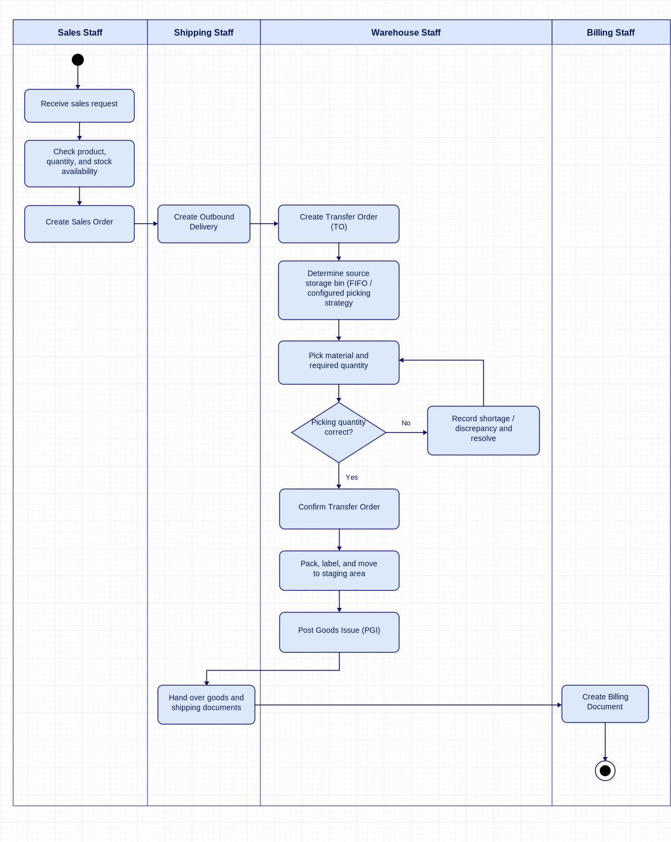
Figure 1. Proposed WMSD sales and goods issue process.
Action | Role | Action Description
Receive sales request | Sales Staff | Receive the customer's request to purchase tiles and collect the required product and quantity information.
Check product, quantity, and stock availability | Sales Staff | Verify the requested products, quantities, and available stock to determine whether the order can be fulfilled.
Create Sales Order | Sales Staff | Create a Sales Order containing the ordered products, quantities, and relevant customer and sales information.
Create Outbound Delivery | Shipping Staff | Create an Outbound Delivery based on the Sales Order, specifying the materials, quantities, and planned delivery details.
Create Transfer Order (TO) | Inventory Staff | Create a Transfer Order referencing the Outbound Delivery to instruct Inventory Staff to retrieve the required materials.
Determine source storage bin (FIFO / configured picking strategy) | Inventory Staff | Identify the appropriate source storage bin for picking materials according to the configured warehouse picking strategy, such as FIFO.
Pick material and required quantity | Inventory Staff | Retrieve the specified materials from the designated storage bins and pick the required quantities according to the Transfer Order.
Record shortage / discrepancy and resolve | Inventory Staff | Record any shortage, incorrect material, or quantity discrepancy identified during picking, investigate the issue, and resolve it before proceeding.
Confirm Transfer Order | Inventory Staff | Confirm the completed picking operation in the system, record the picked quantities, and update the warehouse stock information at the Warehouse Management level.
Pack, label, and move to staging area | Inventory Staff | Pack the picked materials, attach the necessary labels, and move the goods to the staging area for shipment.
Post Goods Issue (PGI) | Inventory Staff | Post the goods issue to record the shipment in the system, reduce inventory at the Inventory Management level, and generate the relevant material and accounting documents when applicable.
Hand over goods and shipping documents | Shipping Staff | Hand over the goods and relevant shipping documents to the carrier or delivery service for transportation to the customer.
Create Billing Document | Billing Staff | Create the Billing Document based on the relevant sales and delivery information to record the customer billing transaction.
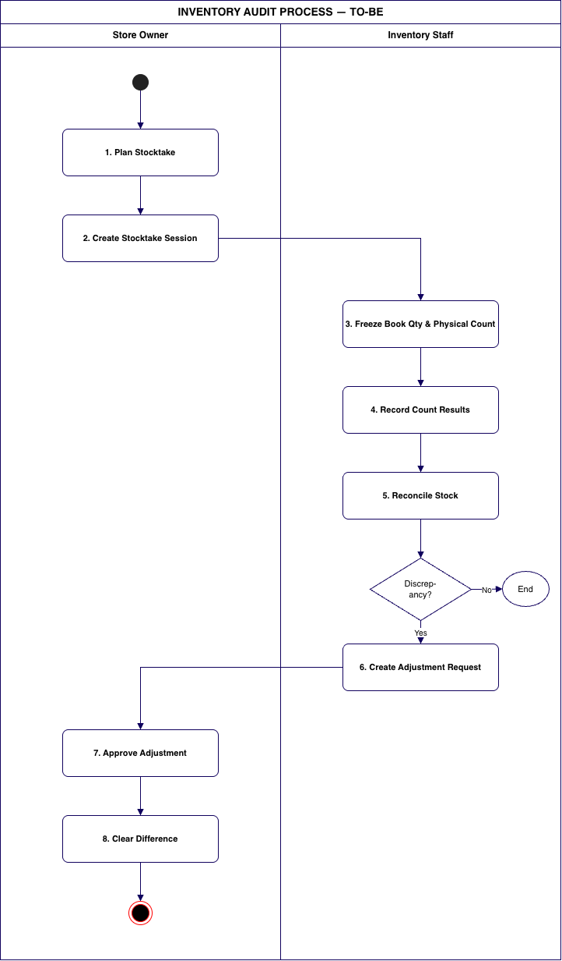
Figure 2. Proposed WMSD Inventory audit workflow.

Step | Role | Description
1. Plan Inventory Audit | Store Owner | Schedule inventory checks (regular/ad hoc) and define the scope: warehouse, zone/location, product group, and the data cut-off date.
2. Create Audit Ticket | Store Owner | Create the stocktake session, pick the count type (full / by zone / by product group / by product / cycle count) and assign the responsible warehouse staff. Session starts in status Draft.
3. Physical Count | Inventory Staff | Lock the book balance at the cut-off so later transactions cannot distort the comparison; session moves to Counting. Staff then count the physical quantity of every product/lot in the assigned zones.
4. Record Count Results | Inventory Staff | Enter the counted quantity per product/lot line into the system, save progress, and mark the count complete once every line has a result. Session moves to Counted.
5. Reconcile Stock | Inventory Staff | The system compares counted quantity against the frozen book quantity and computes the variance and variance rate for each line, highlighting every line where the difference is not zero.
6. Create Discrepancy Report | Inventory Staff | For each variance line, record a mandatory reason, then generate an adjustment request from the discrepancies. The request is submitted with status Pending approval; session moves to Adjustment created.
7. Approve Adjustment | Store Owner | Review the request against cost value, impact value and the product's 90-day variance history. Approve — optionally correcting the adjusted quantity per line and selecting the accounting account (normal shrinkage / loss / damage / data-entry error) — or reject with a reason.
8. Clear Difference | Store Owner | On approval the adjustment is applied: stock on hand is set to the actual counted quantity, inventory movements of type Adjustment are generated, and both the request and the stocktake session close as Completed.

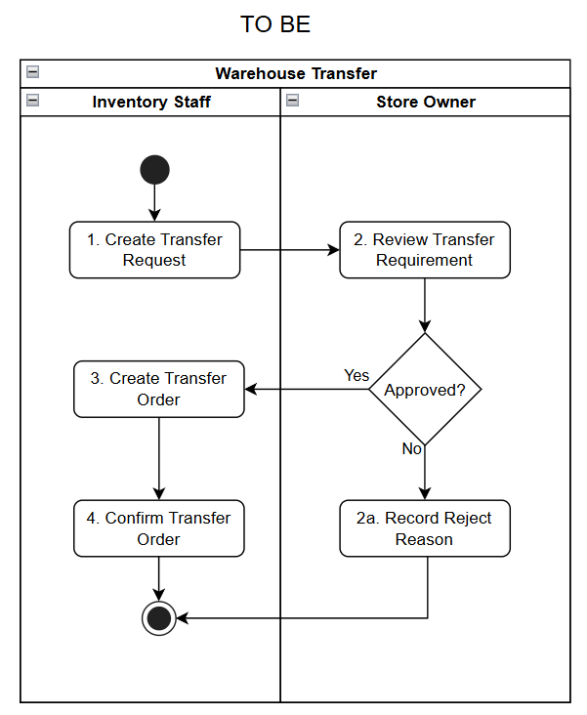
Figure 3. Proposed WMSD warehouse transfer.
Step | Role | Description
1. Create Transfer Request | Inventory Staff | Identify your shipping needs and create a transfer request. Enter the product, lot number, quantity, source warehouse or location, destination warehouse or location, reason for transfer, and estimated time; then submit the request for approval.
2. Review Transfer Requirement | Store Owner | Verify the requirements, product, quantity, source, and destination location. If approved, the request is forwarded to Inventory Staff to create a Transfer Order. If not approved, proceed to step 2a.
2a. Record Rejection Reason | Store Owner | Record the reason for not approving the Transfer Requirement, inform the Inventory Staff of the result, and close the transfer request.
3. Create Transfer Order | Inventory Staff | Create a Transfer Order from the approved request. Accurately identify the product, lot, quantity to be transferred, Source Bin, and Destination Bin; then retrieve the goods and proceed with the transfer according to the Transfer Order.
4. Confirm Transfer Order | Inventory Staff | After moving the goods, check and confirm the actual quantity transferred. Note any discrepancies or irregularities, update the inventory from the source to the destination, and complete the Transfer Order.

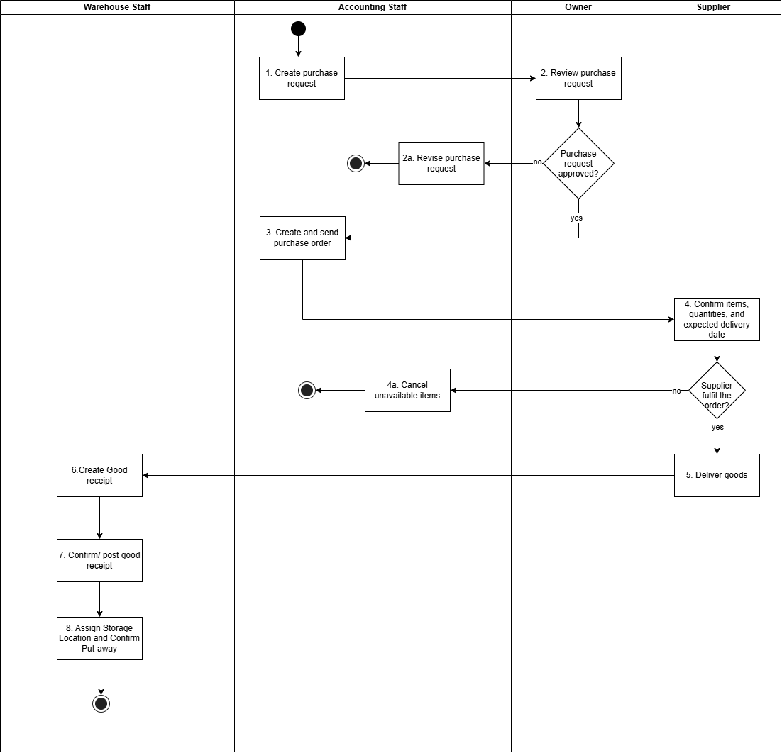

Figure 4. Proposed WMSD purchasing and receiving.

Step | Role | Description
1. Prepare purchase request | Accountant | Prepare a purchase request containing the required products, quantities, and purchasing information for approval.
2. Review purchase request | Owner | Evaluate the purchase request and decide whether it should be approved based on inventory needs and business requirements.
2a. Revise purchase request | Accountant | Revise the rejected purchase request based on the owner's feedback, save the updated information, and close the current purchasing process without resubmission.
3. Create and send purchase order | Accountant | Create a purchase order based on the approved request and send it to the selected supplier for confirmation.
4. Confirm items, quantities, and expected delivery date | Supplier | Verify the availability of requested products, confirm the quantities that can be supplied, and provide the expected delivery date.
4a. Cancel unavailable items | Accountant | Cancel the unavailable items based on the supplier's response, update the purchase order, and close the current purchasing process without proceeding to goods delivery.
5. Deliver goods | Supplier | Prepare and deliver the confirmed goods according to the agreed purchase order and delivery schedule.
6. Create Good receipt | Inventory Staff | Create a draft Goods Receipt based on the Purchase Order and delivered goods, recording product details, received quantities, and relevant delivery information. The record remains pending inspection and posting.
7. Confirm/ post good receipt | Inventory Staff | Perform the goods inspection sub-process to verify received quantities, product conditions, and discrepancies against the Purchase Order. Record inspection results and handle any identified issues. Once the inspection is completed, confirm and post the Goods Receipt with the appropriate quantities and stock statuses, updating inventory records and outstanding purchase order quantities.
8. Assign Storage Location and Confirm Put-away | Inventory Staff | Determine appropriate destination Storage Bins based on product, batch, stock status, and storage requirements. Create the necessary Transfer Order, physically move the goods to their assigned bins, and confirm the putaway to update warehouse stock locations.
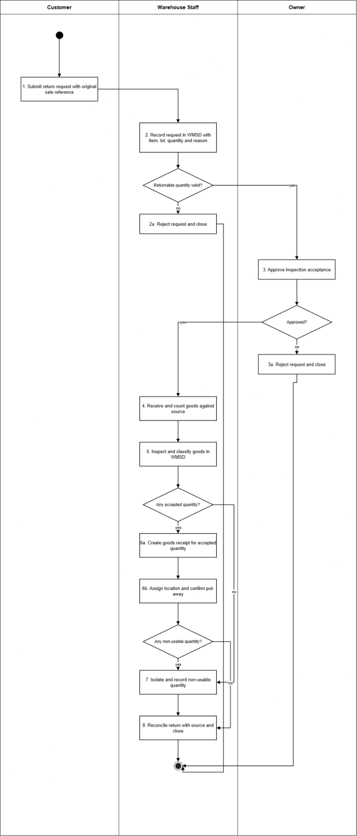
Figure 5. Proposed WMSD customer return.

Step | Role | Description
1. Submit return request with original sale reference | Customer | Request carries the source sale and outbound reference for traceability.
2. Record request in WMSD with item, lot, quantity and reason | Inventory Staff | Request is logged in WMSD with product, lot, tone/calibre where relevant, quantity, reason and source link.
2a. Reject request and close | Inventory Staff | Invalid source, over-claim or out-of-condition request is rejected with a reason. No stock change.
3. Approve inspection acceptance | Owner | Authorised approval to receive and inspect the goods. Approval covers inspection only, not the refund.
3a. Reject request and close | Owner | Rejected request is closed with a reason. No stock change.
4. Receive and count goods against source | Inventory Staff | Physical receipt is counted and compared with the source product, lot, colour/size and quantity.
5. Inspect and classify goods in WMSD | Inventory Staff | Each quantity is classified as usable, usable with conditions, damaged/write-off, or awaiting supplier return, with photo/notes where needed. Mixed classes never share one sellable line.
6a. Create goods receipt for accepted quantity | Inventory Staff | Inbound receipt for the accepted quantity, linked to the source outbound and the original lot with the accountant-confirmed value basis. On confirmation, usable stock rises and the average cost is updated.
6b. Assign location and confirm put-away | Inventory Staff | Accepted goods are stored at the assigned position and placement is confirmed. Goods become sellable only after put-away.
7. Isolate and record non-usable quantity | Inventory Staff | Quarantine, damaged or awaiting-supplier quantities are held in isolation, excluded from usable stock, with a damage dossier where needed. Awaiting-supplier quantities feed the supplier-return flow.
8. Reconcile return with source and close | Inventory Staff | Accepted plus isolated quantities are reconciled to the source; the request is closed.

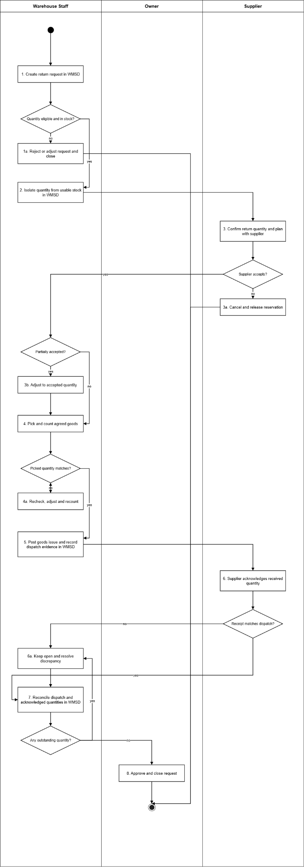
Figure 6. Proposed WMSD supplier return.

Step | Role | Description
1. Create return request in WMSD | Inventory Staff | Request records the supplier, source purchase order and inbound receipt, lot, location, quantity, reason and evidence.
1a. Reject or adjust request and close | Inventory Staff | Ineligible or insufficient-lot request is rejected or reduced with approval. No stock change.
2. Isolate quantity from usable stock in WMSD | Inventory Staff | Approved quantity is reserved and isolated by lot so sales or transfers cannot consume it.
3. Confirm return quantity and plan with supplier | Supplier | Supplier confirms the accepted quantity and plan (refund, debt reduction, exchange, or partial acceptance). Only the approved quantity proceeds.
3a. Cancel and release reservation | Supplier | Rejected return is cancelled and the reservation released after a quality recheck. No stock reduction.
3b. Adjust to accepted quantity | Inventory Staff | Request is reduced to the supplier-accepted quantity; the remainder returns to usable stock or stays isolated after checking.
4. Pick and count agreed goods | Inventory Staff | Agreed lot is picked by location and counted.
4a. Recheck, adjust and recount | Inventory Staff | Lot and goods are rechecked, adjusted and recounted until they match.
5. Post goods issue and record dispatch evidence in WMSD | Inventory Staff | Goods issue is posted with request and source-inbound links; physical stock is reduced at lot and location, the reservation released, and value taken at the current average. Old inbound and sales documents are never edited.
6. Supplier acknowledges received quantity | Supplier | Supplier confirms the quantity actually received.
6a. Keep open and resolve discrepancy | Inventory Staff | Discrepancy is kept open and resolved with the supplier; goods re-enter stock only if physically returned and reinspected.
7. Reconcile dispatch and acknowledged quantities in WMSD | Inventory Staff | Dispatched versus acknowledged quantities are reconciled in WMSD.
8. Approve and close request | Owner | Owner approves closure once quantity reconciliation is clear.

V. Project Scope & Limitations

1. Major Features
ID | Major Feature | Core business capability | Addressed Gaps
FE-01 | Purchase Delivery and Partial Receiving | Track supplier confirmation and each actual delivery; reconcile accepted, defective and outstanding quantities against one PO. | GAP-01
FE-02 | Tile Lot and Unit Traceability | Maintain tile lot, tone, actual calibre, packaging conversion and correct quantity identity across movements. | GAP-02
FE-03 | Goods Receiving Quality Control | Inspect inbound goods; separate accepted, pending, damaged and rejected quantities before release to usable stock. | GAP-03
FE-04 | Bin-level Inventory and Location Movement | Trace stock by warehouse position and tile lot/status; record put-away and relocations by physical source/destination. | GAP-04
FE-05 | Warehouse Transfer and Discrepancy Management | Record source dispatch, handover, destination receipt and evidence; keep differences unresolved until disposition. | GAP-05
FE-06 | Warehouse Picking and Goods Issue | Link warehouse requests to eligible picked lot/bin and actual goods issue; capture shortage or mismatch. | GAP-06
FE-07 | Customer and Supplier Return Stock Handling | Inspect returned quantities, quarantine unfit goods, and trace supplier-return dispatch to original receipt. | GAP-07
FE-08 | Stocktake, Recount and Adjustment | Count by lot/location/status against cut-off balance, investigate variance and record an owner-reviewed adjustment. | GAP-08
FE-09 | Warehouse Event Audit and Operational Reporting | Trace physical warehouse events with document, staff, quantity, time and evidence and report usable/unresolved stock. | GAP-09

These major features address the project GAPs directly; supporting access control and reference-data maintenance are treated as underlying system functions, not separate core business features.

2. Limitations & Exclusions
ID | Excluded Item | Reason
LI-01 | Multi-store retail management | The release serves one store. Warehouse-to-warehouse transfer applies only to configured warehouse locations used by that store.
LI-02 | Customer debt and full accounting | WMSD does not manage customer receivables, deposits, payments, refunds, supplier payment ledgers, general ledger, tax statements or sales-return financial adjustments.
LI-03 | Statutory invoicing and live MISA integration | MISA eShop remains the retail system. WMSD retains source document references; direct API synchronization and statutory e-invoice issuance are excluded.
LI-04 | Fleet and route management | Transfer records may identify the responsible carrier or vehicle; GPS, routing, dispatch optimization and fleet maintenance are excluded.
LI-05 | Complex purchase approval | WMSD records the purchase proposal, owner review and resulting supplier order. Multi-level approval policy, tendering and vendor-selection workflows are excluded.
LI-06 | Quotations, promotions and CRM | Sales orders and fulfillment, quotations, retail pricing, promotions, loyalty and CRM remain in MISA eShop/outside WMSD. The pricing rules in the source notes conflict, so price entry and margin calculation are deferred pending clarification.
LI-07 | Omnichannel and e-commerce integration | Marketplace order synchronization and public storefront features are excluded.
LI-08 | Prediction and automatic recommendations | Demand forecasting, automatic replenishment recommendation and dynamic pricing are excluded.
LI-09 | HRM and payroll | Accounts and roles support operational access only; HR and payroll are excluded.

